**Unit Test Document**

**Overview:** This is a test Application to add customer in the table. We are using below technologies:

**View:** HTML5, Bootstrap, Ng2-Smart-Table

**FrontEnd Development:** Angular 8 using Dotnet Core

**Backend Development:** Web Api using Dotnet Core

**Data Access Layer:**  Entity Framework. I am using public domain sql server so no need to do any changes to access the data.

**Database:** Sql Server, Table Name = dbo.Customer

**Sql Script:**

Create table dbo.Customer

(

Id Int Primary Key Identity(1,1),

Name Varchar(255),

DateOfBirth DateTime,

[Address] Varchar(2000)

)

Step 1: CustomerData solution has two projects:

* Customer App: FronEnd (Angular, HTML5, Bootstrap and Ng2-Smart-Table)
* CustomerData: Backend Code (Web Api + Entity Framework)

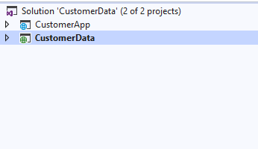

Step 2: Make CustomerData as Start up project and run the application to make api in the running state.

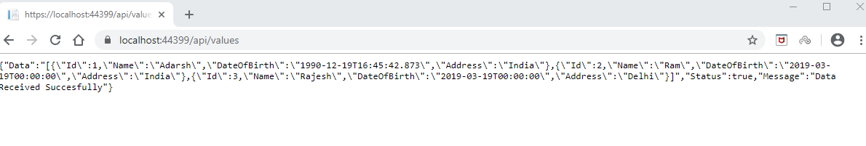

Step 3 : Open Command prompt. Go to the CustomerApp\ClientApp. Run the ng server by using ng serve –open command to open the Angular application.

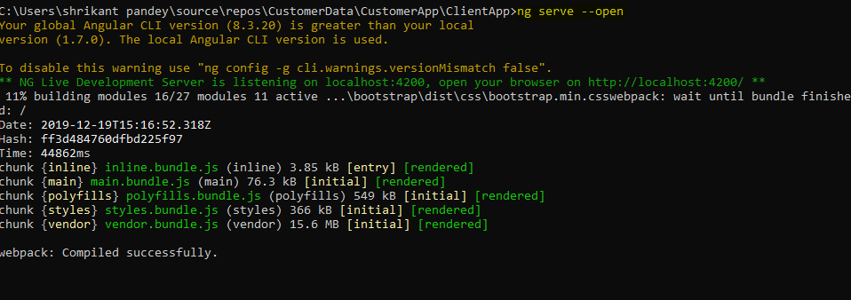

Step4: Angular Application will open with Home Page Selected. This is a default page of the Dotnet Core Angular application.

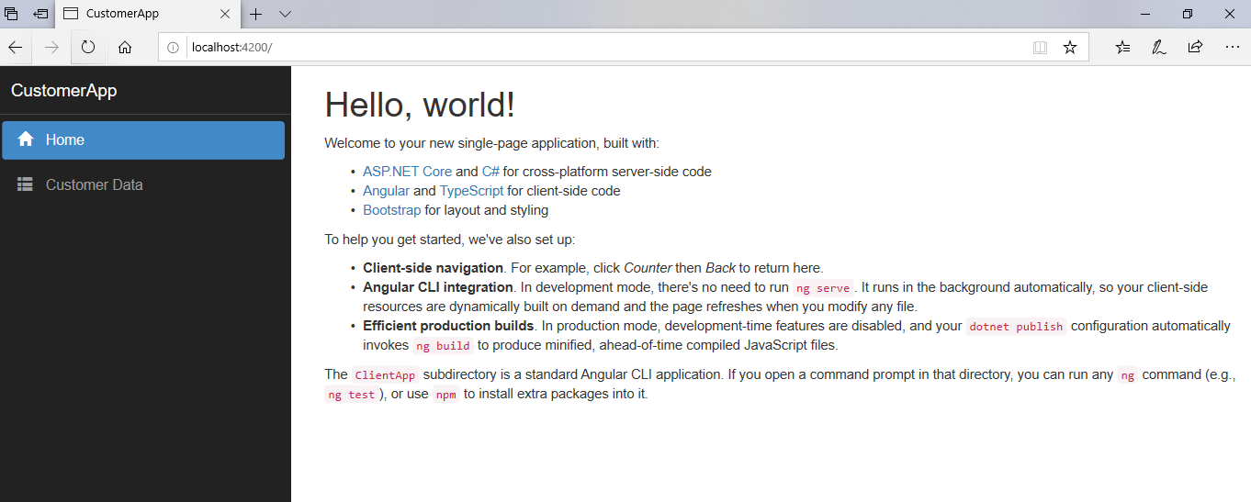

Step 5: Go to the “Customer Data” Navigation Link. Screen will open with Html and Bootstrap form and ng2-smart-table. By default table will show default data available in database.

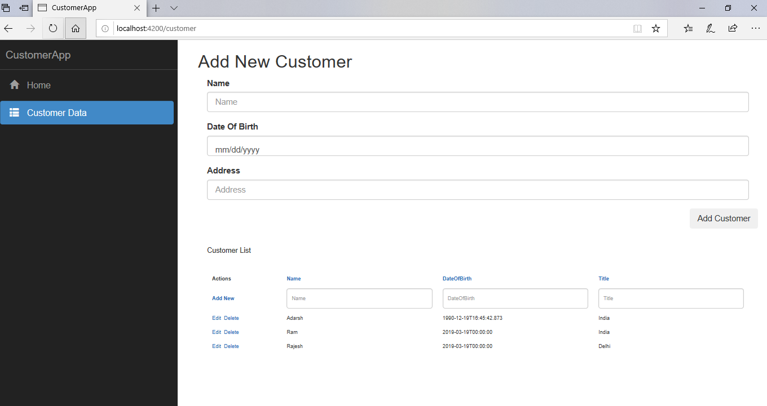

Step6: Now Add Customer Details and Click Add Customer Button.

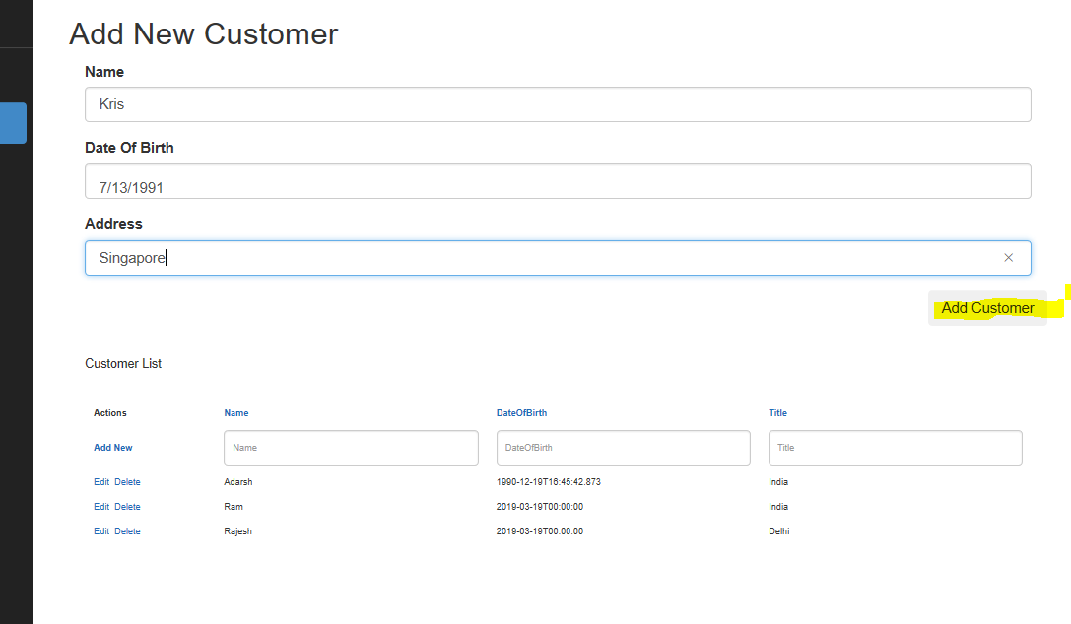

Step 7: Data will save and popup message will appear which indicate “Data Saved Successfully.”

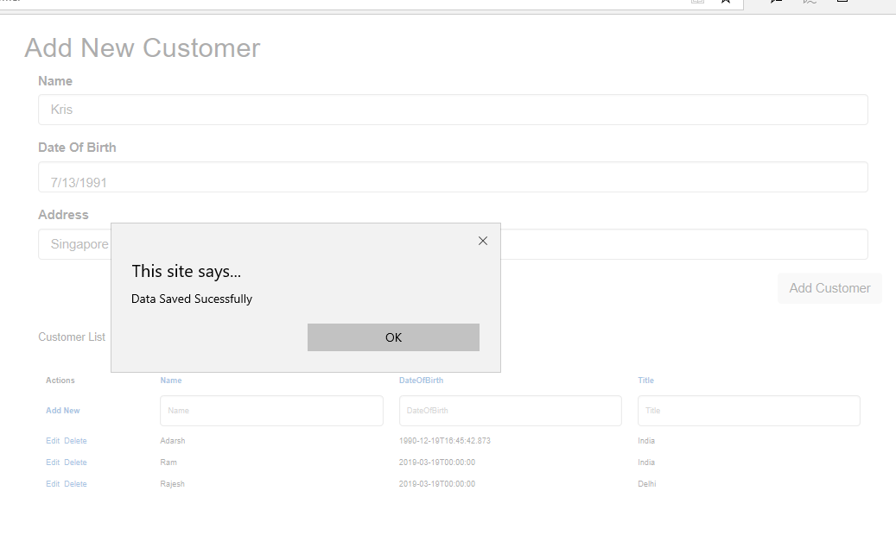

Step 8: Table data will update and New record will appear in the table.

