This guide details the steps required to set up a 3-tier application architecture on AWS, including VPC, subnets, EC2 instances, RDS, and necessary configurations. Here the visual representation of 3-Tier application working

Step 1:

Setup Networking Components 1.1 Create VPC Here we create VPC named as 3-tire-project with selecting option of VPC only and then provided the CIDR range 192.168.0.0/16

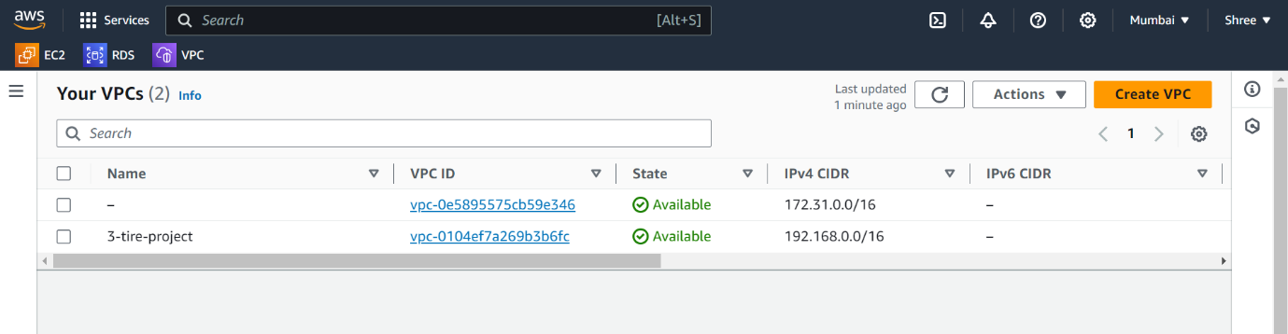

create on vpc and here your 3-tire-project is created.

Step 2:

Create 3 Subnets :- Public-Subnet-1a Ipv4 CIDR Block - 192.168.1.0/24

Private-Subnet-1b, Ipv4 CIDR Block - 192.168.2.0/24

Private-Subnet-1c, Ipv4 CIDR Block - 192.168.3.0/24

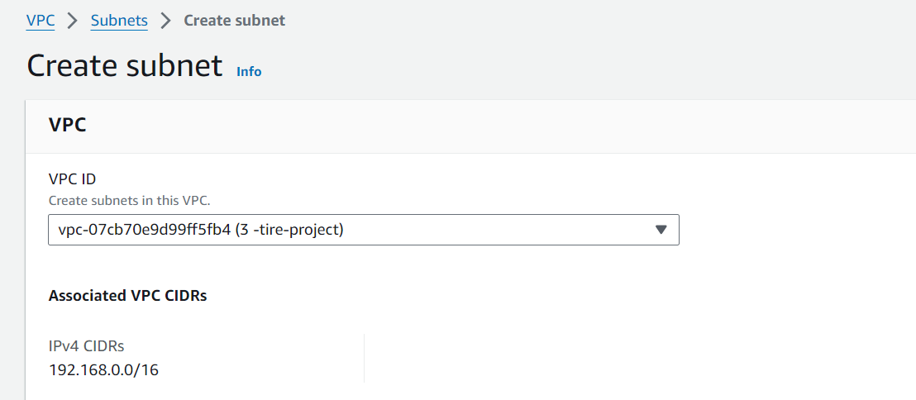

Public-Subnet- 1a,us east-1a Ipv4 CIDR Block - 192.168.1.0/24

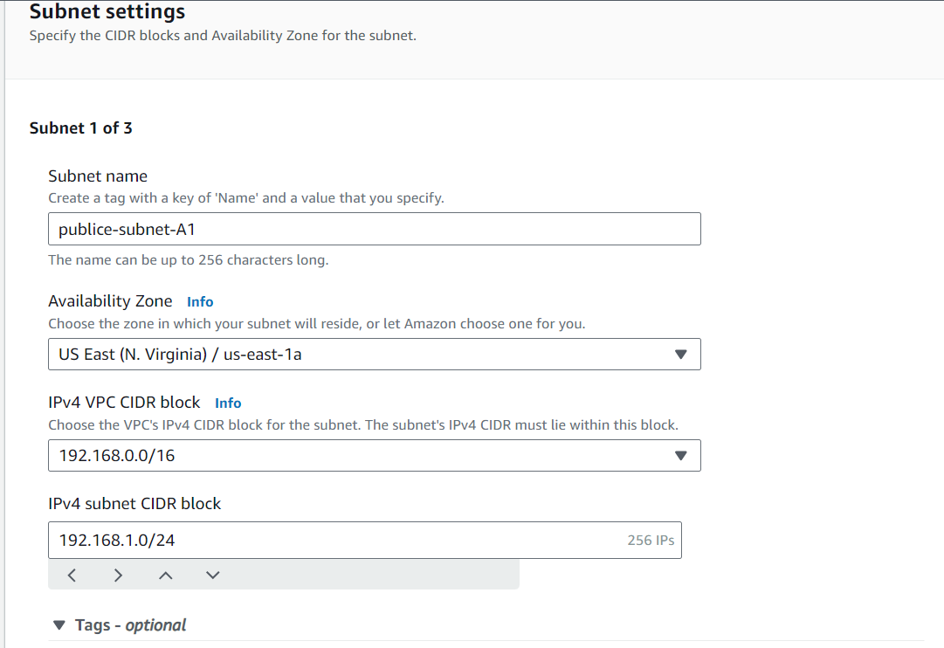

Private-Subnet-1b, us-eas-1b, Ipv4 CIDR Block - 192.168.2.0/24

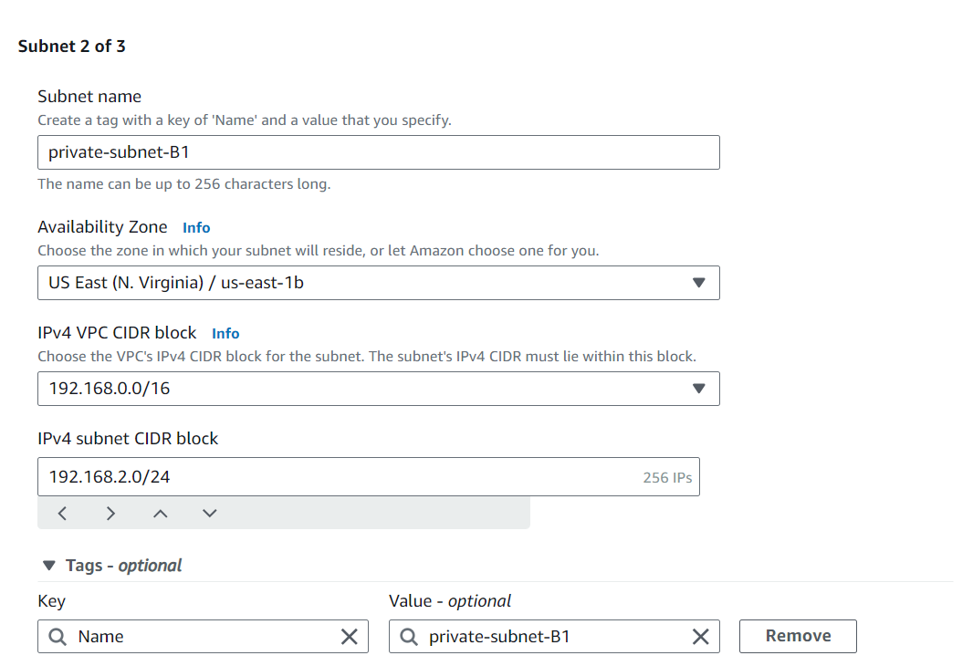

Private-Subnet-1c, Ipv4 CIDR Block - 192.168.3.0/24

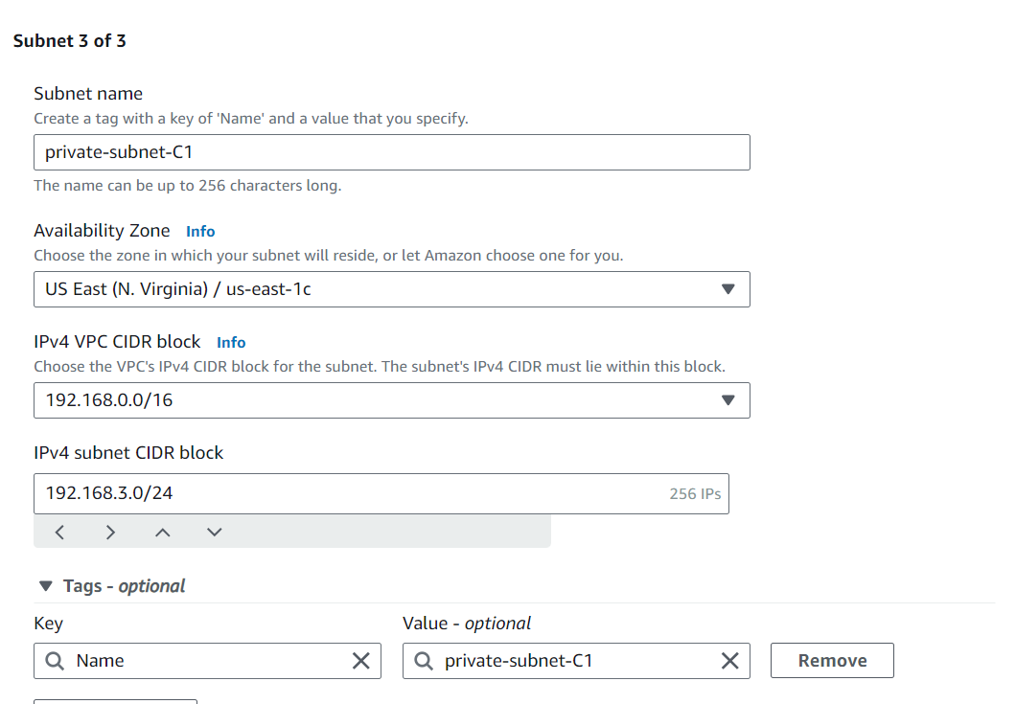

Step 3

You have successfully created 3-subnet

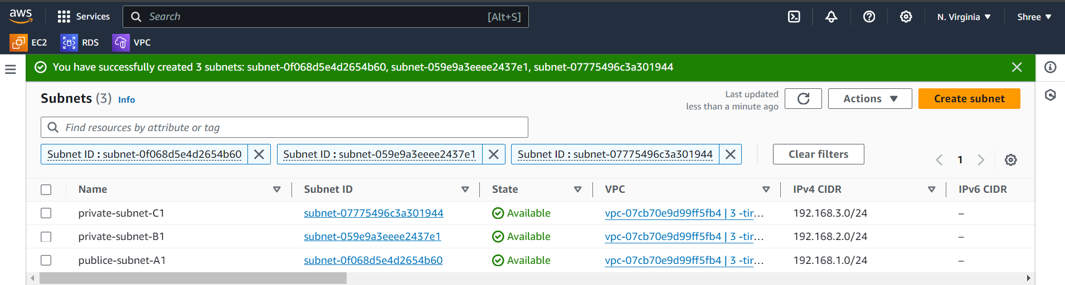

Step 4

Internet Gateways → Create Internet Gateway → Name Tag →my internet gateway

Attach Internet Gateway (my internet gateway) To VPC (3-tire-project)

Select VPC → Actions → Attach To VPC → Select VPC (3-tire-porject)

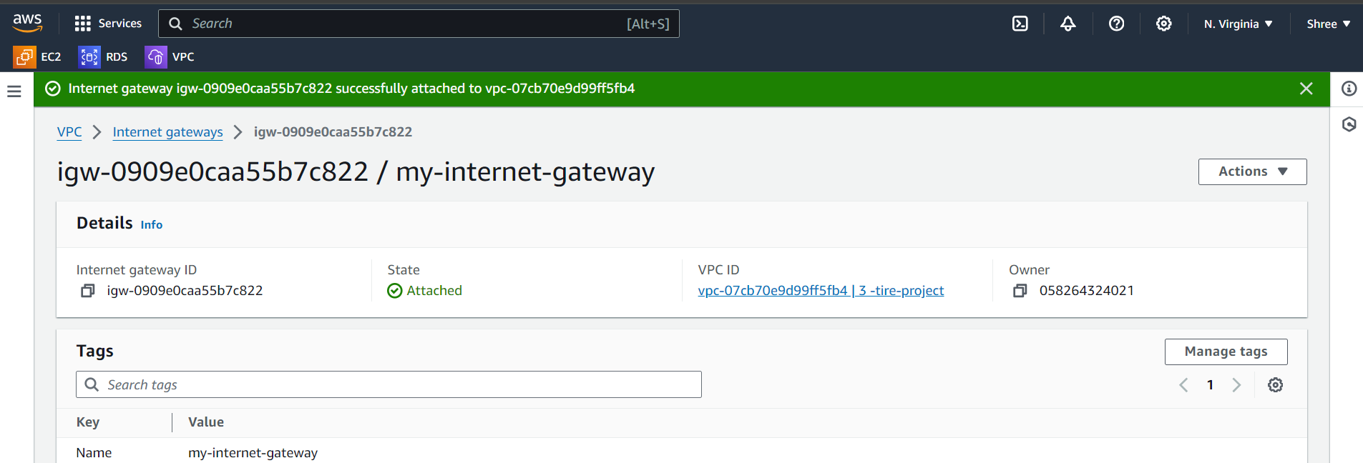

Step 5

Create the default round table and attached of IGW and public subnet.

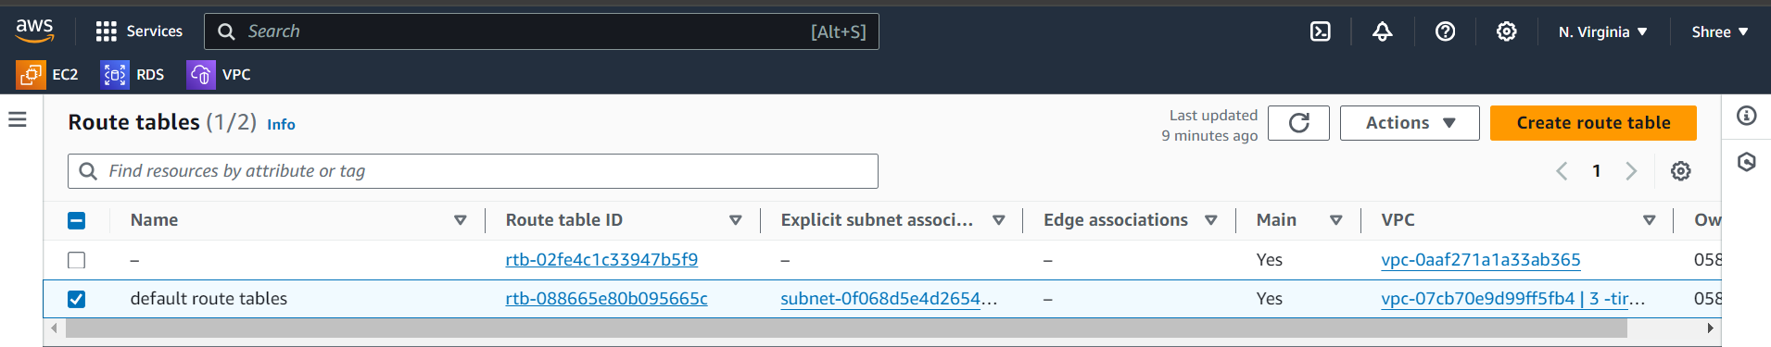

Step 6

Create a net gateway in public subnet

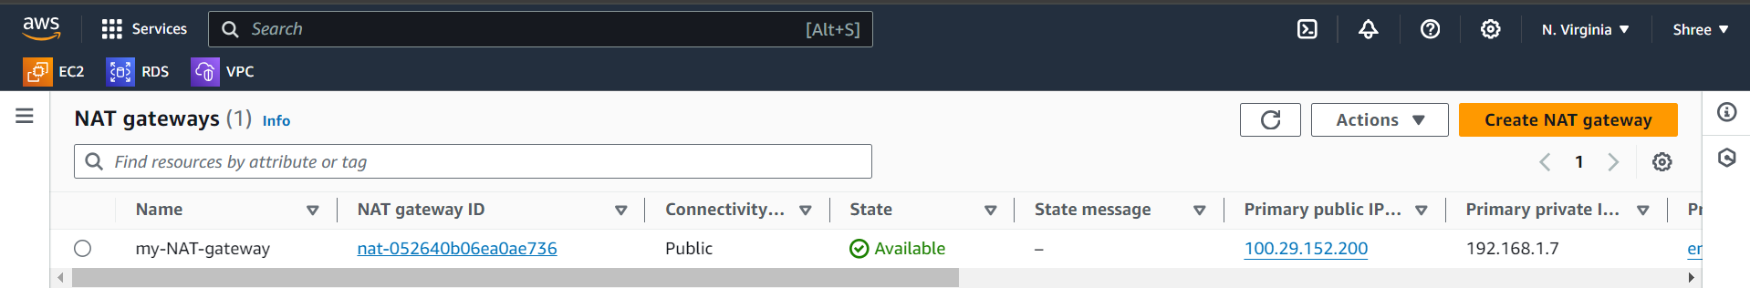

Step 7

Again create a route table and attach that route table to the my-NT-gateway and private subnet-b1, private subnet-c1

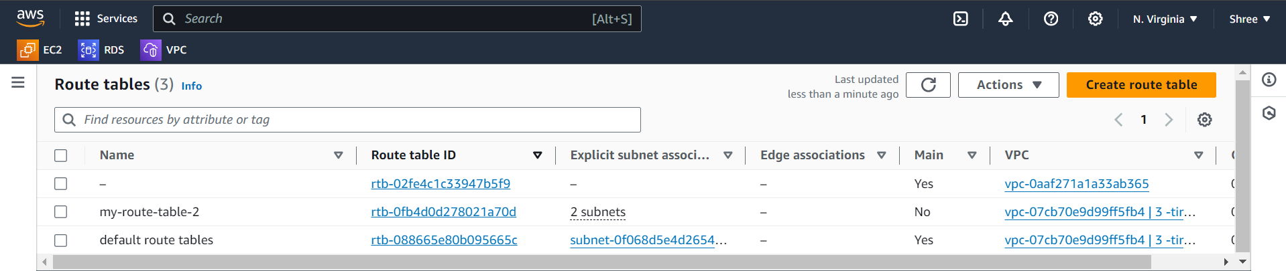

Step 8

Create 3 Instances :

Jump-Server-Instance, VPC (3-tire-project) → Subnet (Public-Subnet-A1) → Security Group (Allow Http/Nginx & SSH Ports) → Allocate Elastic Ip (Yes) → Create Instance.

Application-Server-Instance, VPC (3-tire-project) → Subnet (Private-Subnet-B1) → Security Group (Allow Tomcat & SSH Ports) → Create Instance

Db-Server-Instance, VPC (3-tire-project) → Subnet (Private-Subnet-C2) → Security Group (Allow Mysql/Aurora & SSH Ports) → Create Instance

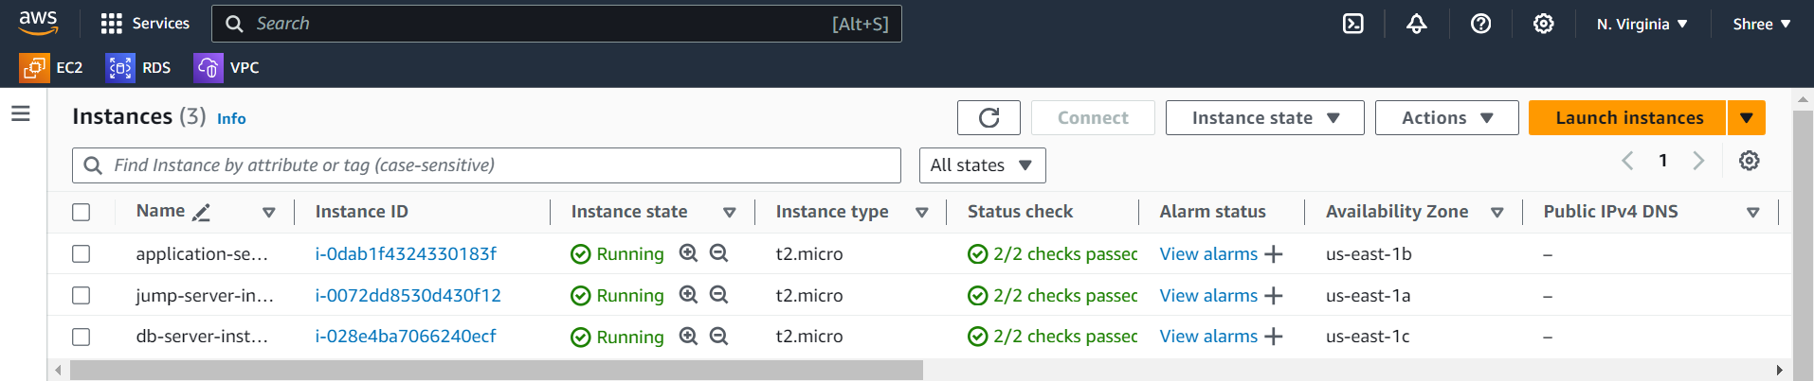

Step 8

Create a security group and add the ssh-22 port, mysql-3306 port

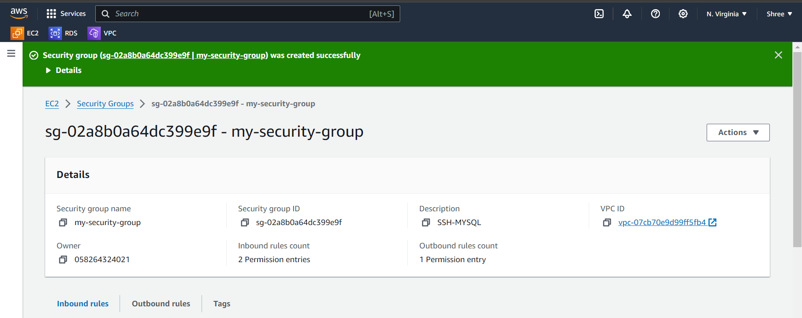

Step 9

Create one RDS service and add the security group (my security group)

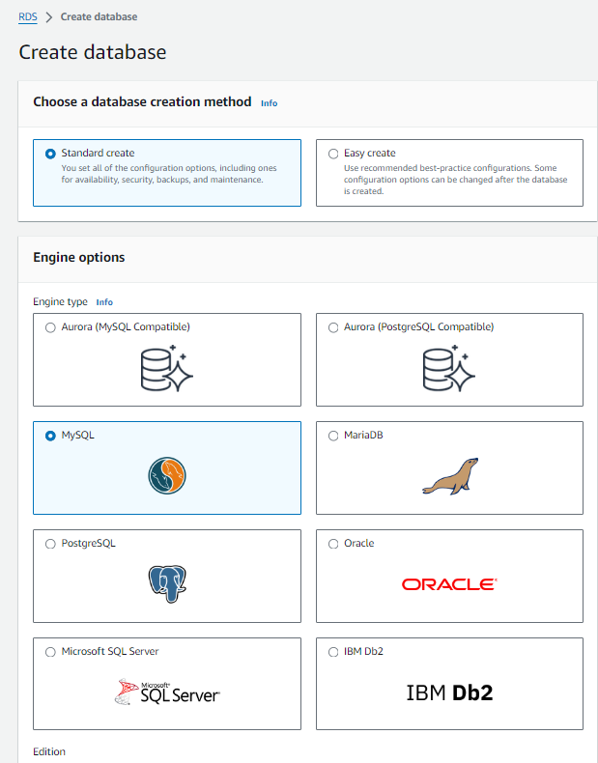

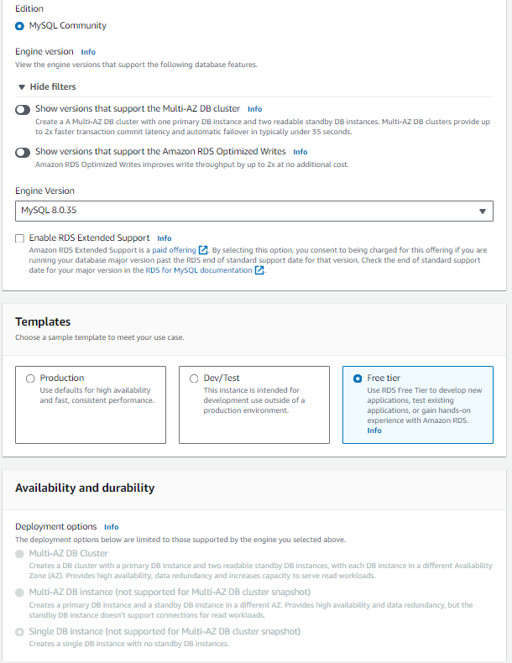

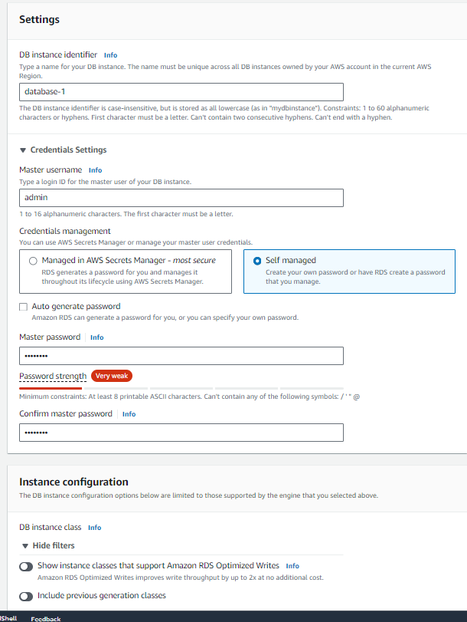

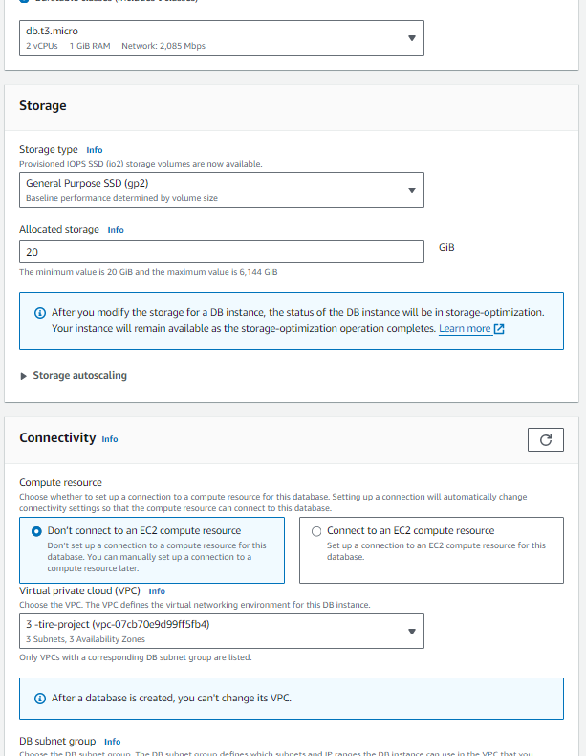

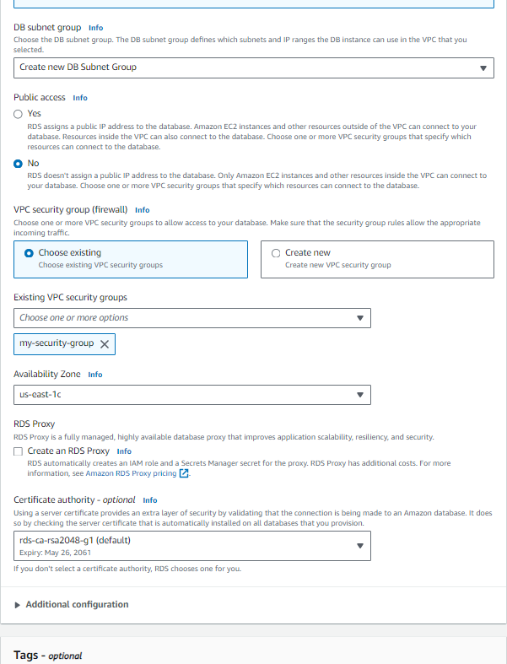

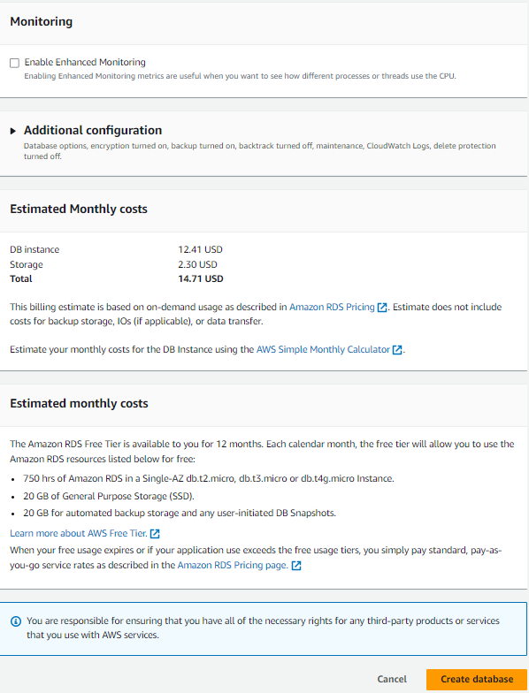

Step 10

• Connect our public instance (jump server) using ssh(mobaxterm)

• Sudo –i

• Yum install nginix –y

• Vim /etc/nginix/nginix.conf

• 49 no line= location / { proxy_pass <http://privateIPoftomcat:8080/student/>;

• Systemctl restart nginix

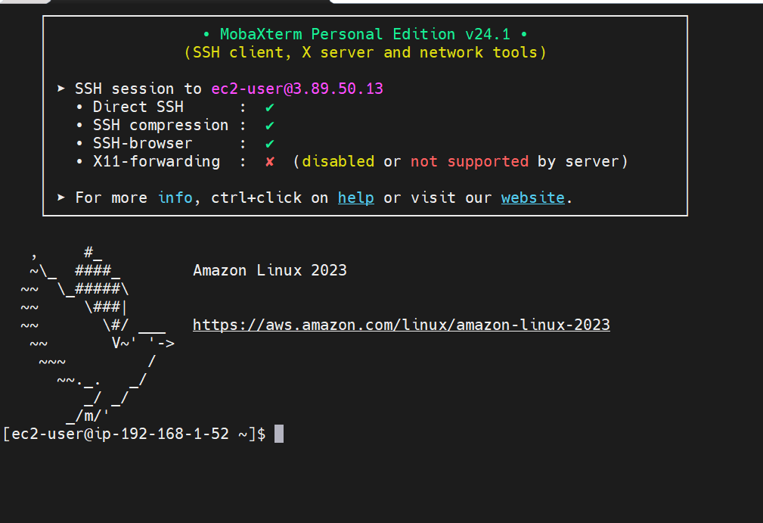

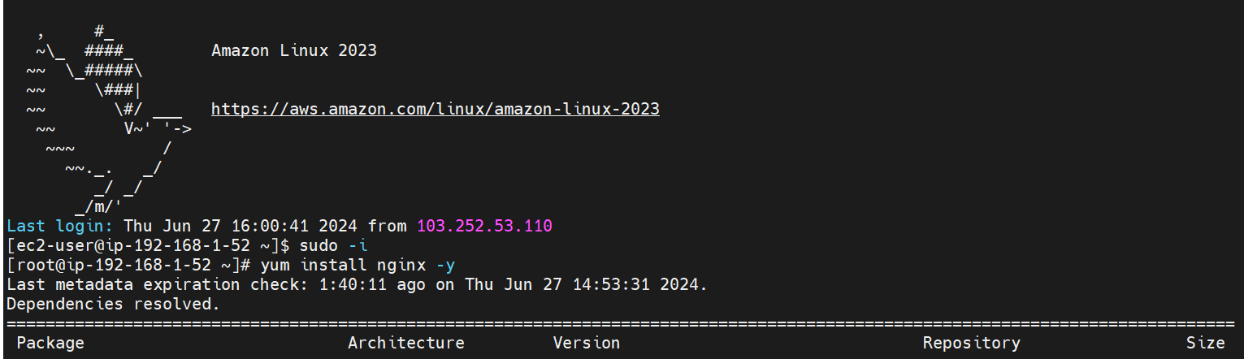

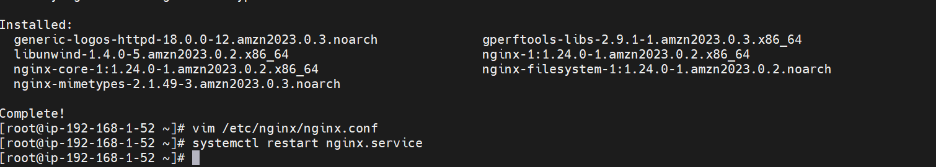

Step 11

Go to command prompt and copy our key

Cd downloads

Scp –i key-name key-name ec2-user@public-ip:/home/ec2-user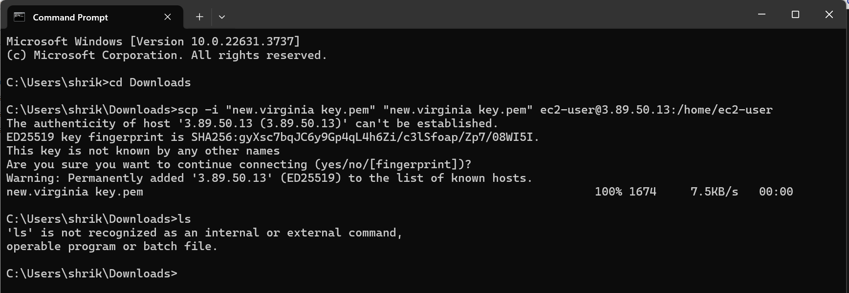

Step 12

Go to jump sever

Ls

Chmod 400 key-name

Ssh –i key-name ec2-user@ipofapplication (we go to jump server to application server)

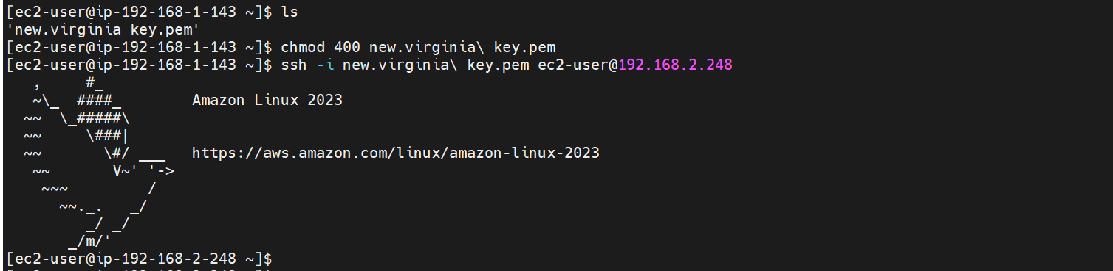

Step 13

• In application server

• Sudo –i

• Yum install java –y

• curl -O https://dlcdn.apache.org/tomcat/tomcat8/v8.5.100/bin/apache-tomcat-8.5.100.tar.gz

• Ls

• Tar –xvf apache-tomcat-8.5.100.tar.gz -C /opt

• Cd /opt

• Cd apache-tomcat-8.5.100/

• Cd webapps

• curl -O https://s3-us-west-2.amazonaws.com/studentapicit/student.war

• Cd ../lib

• curl -O https://s3-us-west-2.amazonaws.com/studentapi-cit/mysqlconnector.jar

• Ls(mysql-connector.jar)

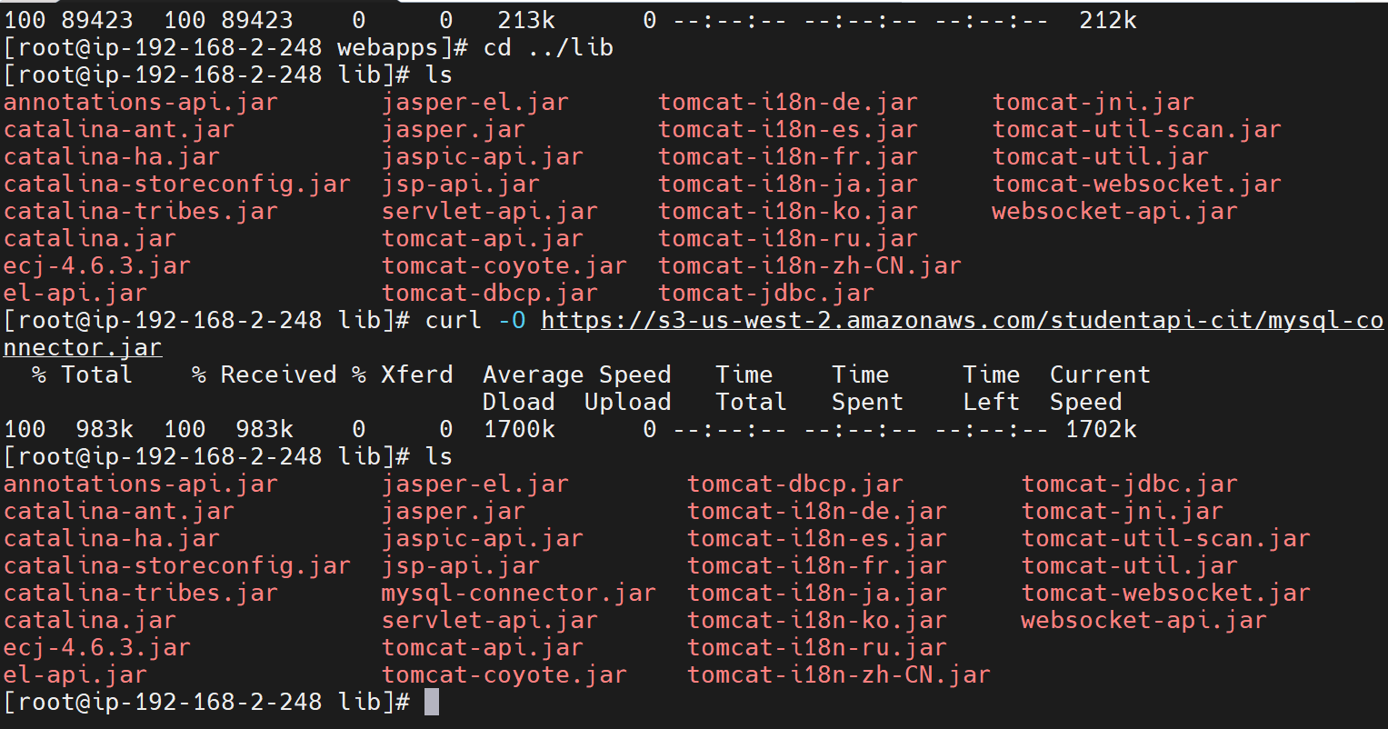

Step 14

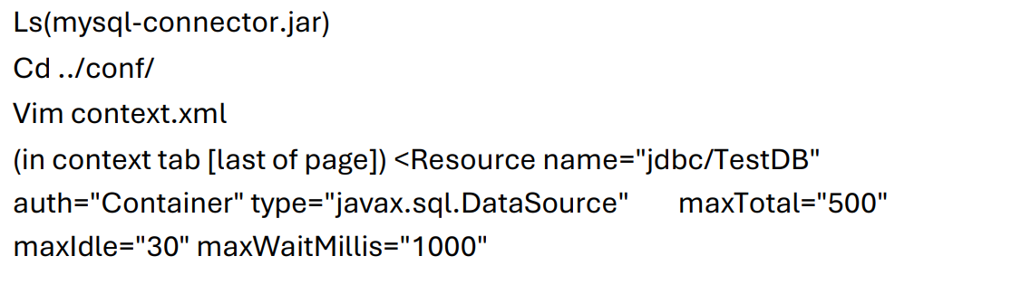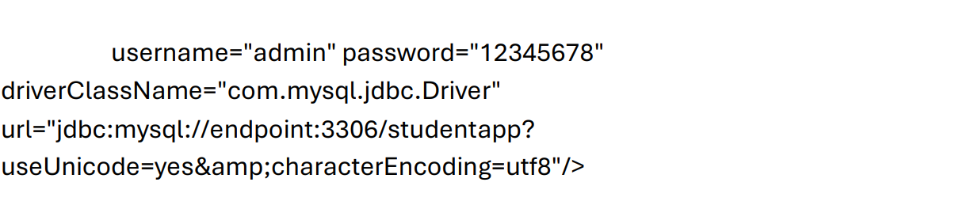

• Cd ../bin

• ./catalina.sh start

• Exit

Step 15

• Ssh –i key-name ec2-user@dbinstanceip (connected to db. instance)

• Yum install mariadb105 –y

• Mysql –h rdsendpoint –u admin –p(connected to RDS)

• Create database; (name database studentapp)

• Use database; (studentapp name)

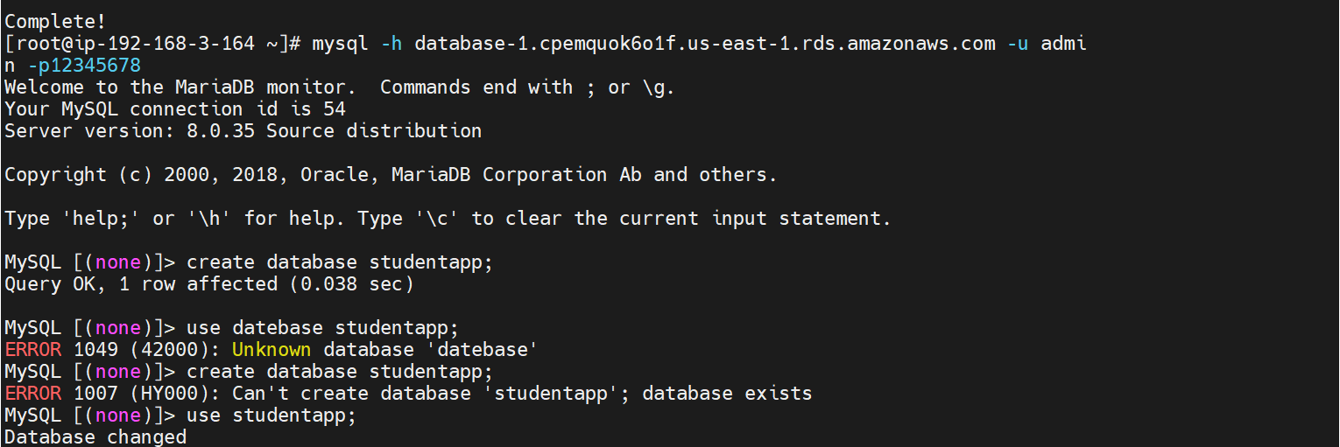

• CREATE TABLE if not exists students(student_id INT NOT NULL AUTO_INCREMENT,

student_name VARCHAR(100) NOT NULL,

student_addr VARCHAR(100) NOT NULL,

student_age VARCHAR(3) NOT NULL,

student_qual VARCHAR(20) NOT NULL,

student_percent VARCHAR(10) NOT NULL,

student_year_passed VARCHAR(10) NOT NULL, PRIMARY KEY (student_id) );

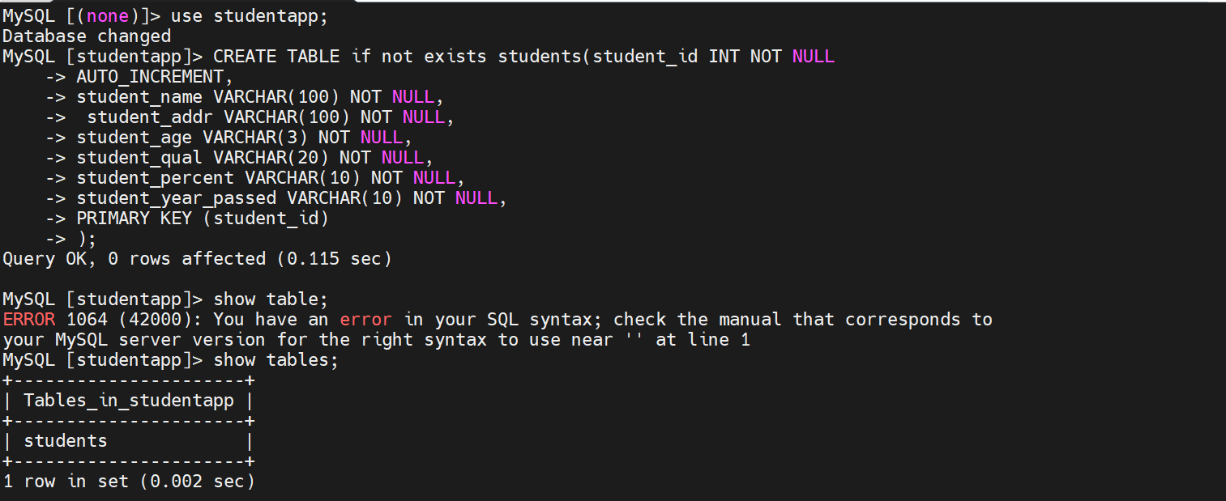

Step 16

Go to any web browser & hit the Jump-server-instance public IP

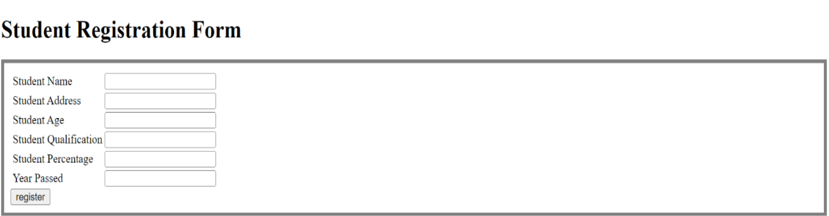

Step 17

Fill the Information in student Registration Form

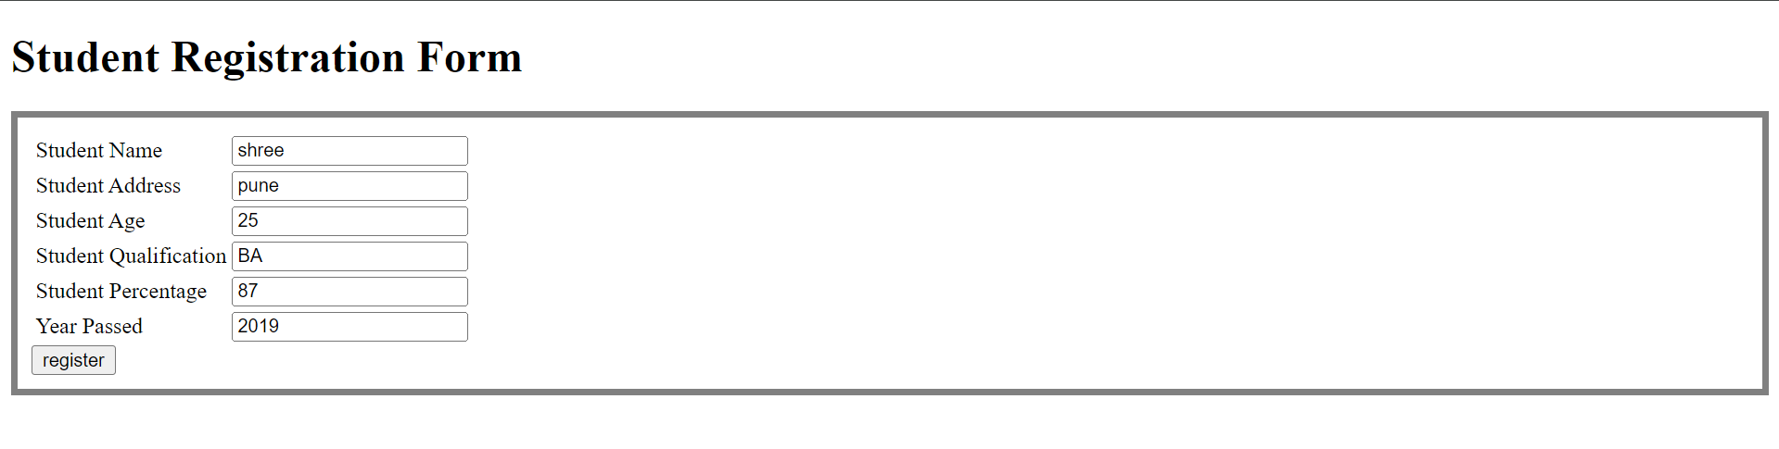

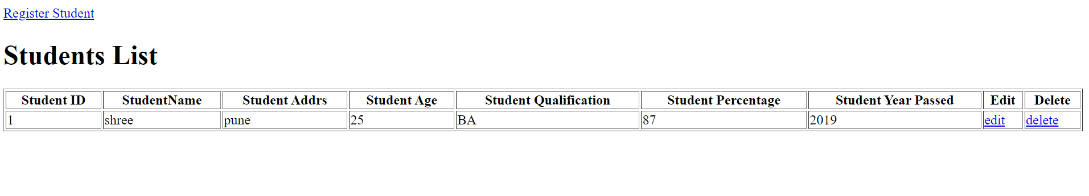

Step -18

MariaDB Configurations: (To view student registration form information)

Select * from students; 