DUAL-OPTIMIZATION SANDBOX:
ANALYTICAL AND VISUAL STUDY OF DUAL GRADIENT DYNAMICS IN NON-CONVEX AND MULTIMODAL TOPOLOGIES
A PROJECT REPORT
Submitted by
SHRIKAR G S
(1RVU23CSE089)
as part of the Continuous Internal Evaluation
for the course
CS2806 Calculus
Offered in
Semester III
of
B.Tech. (Hons.)
School of Computer Science and Engineering
RV University
RV Vidyaniketan, 8th Mile, Mysore Road, Bengaluru, Karnataka, India – 560059
OCTOBER 2026

DECLARATION
I, SHRIKAR G S (USN: 1RVU23CSE089), student of 3rd semester B.Tech in Computer Science & Engineering, at School of Computer Science and Engineering, RV University, hereby declare that the project work titled “Dual-Optimization Sandbox: Analytical and Visual Study of Dual Gradient Dynamics in Non-Convex and Multimodal Topologies” has been carried out by us and submitted in partial fulfilment for the award of degree in Bachelor of Technology in Computer Science & Engineering during the academic year 2026-2027. Further, the matter presented in the project has not been submitted previously by anybody for the award of any degree or any diploma to any other University, to the best of our knowledge and faith.

Name: SHRIKAR G S | Signature: _______________________
USN: 1RVU23CSE089
Place: Bengaluru
Date: 31st October 2026

School of Computer Science and Engineering
RV University
RV Vidyaniketan, 8th Mile, Mysore Road, Bengaluru, Karnataka, India – 560059
CERTIFICATE
This is to certify that the project work titled “Dual-Optimization Sandbox: Analytical and Visual Study of Dual Gradient Dynamics in Non-Convex and Multimodal Topologies” is performed by SHRIKAR G S (USN: 1RVU23CSE089), a bonafide student of Bachelor of Technology at the School of Computer Science and Engineering, RV University, Bengaluru as part of the CIE-3 component for the course CS 2806 Calculus offered in Semester III of Bachelor of Technology in Computer Science & Engineering, during the Academic year 2026-2027.
Name of Course Faculty: _____________________________________
Signature with date of Faculty: ______________________________

TABLE OF CONTENTS
LIST OF FIGURES | i
LIST OF SYMBOLS AND ABBREVIATIONS | ii
1.0 INTRODUCTION | 1
1.1 Background & Real-World Motivation | 1
1.2 What Exactly is Gradient Descent and Ascent? | 2
1.3 Objectives of this Project | 3
2.0 THE MODEL & MATHEMATICAL FORMULATION | 4
2.1 The Governing Update Equations | 4
2.2 Analytic Landscapes & Derivative Formulas | 5
2.2.1 Symmetric Bowl (Paraboloid) | 5
2.2.2 Rosenbrock Valley (Banana Function) | 6
2.2.3 Ackley's Multimodal Surface | 7
2.2.4 Hyperbolic Saddle Point | 8
2.3 System Architecture and Processing Pipeline | 9
3.0 METHOD OF SOLUTIONS & SAFETY GUARDS | 10
3.1 Iterative Update Mechanism | 10
3.2 Convergence Stopping Rule (||∇f|| < ε) | 10
3.3 Numerical Divergence & Overflow Protection | 11
3.4 Interactive Visualization Architecture | 11
4.0 RESULT AND DISCUSSION | 12
4.1 Case Study 1: The Symmetric Bowl (Smooth Linear Convergence) | 12
4.2 Case Study 2: Rosenbrock Valley (Cross-Canyon Oscillation) | 13
4.3 Case Study 3: Ackley's Surface (Trapped in Local Basins) | 14
4.4 Case Study 4: Hyperbolic Saddle Point (Orthogonal Trajectories) | 15
4.5 Comparative Summary Table | 16
5.0 SYSTEM DEMONSTRATION & OPERATIONAL WALKTHROUGH | 17
5.1 User Interface Structural Breakdown (The 3 Panels) | 17
5.2 Step-by-Step Live Demonstration Protocol | 18
5.3 Real-Time Interactive Telemetry & CSV Export | 19
6.0 CONCLUSION | 20
7.0 FUTURE SCOPE | 21
REFERENCES | 22

LIST OF FIGURES
Figure 1 | Geometric Principle of Optimization Duality on a 1D Cross-Section | 2
Figure 2 | Dual-Optimization Sandbox: Architecture and Data Processing Pipeline | 9
Figure 3 | Symmetric Bowl Paraboloid Optimization Trajectories and Convergence Telemetry | 12
Figure 4 | Rosenbrock Valley Trajectory Oscillation and Step Velocity Profiles | 13
Figure 5 | Ackley Multimodal Function Local Basin Trapping and Radial Gradient Decay | 14
Figure 6 | Hyperbolic Saddle Point Orthogonal Descent/Ascent Path Separation | 15
Figure 7 | Dual-Optimization Sandbox UI Layout & Structural Panel Mapping | 17
Figure 8 | Step-by-Step User Demonstration Workflow Protocol | 18
LIST OF SYMBOLS AND ABBREVIATIONS
θ = (x, y) | Parameter coordinate vector in 2-dimensional space
f(x, y) | The mathematical surface / landscape (cost or reward)
∇f(θ) | The Gradient Vector containing partial derivatives [∂f/∂x, ∂f/∂y]
α (alpha) | Learning Rate (step size multiplier controlling displacement speed)
||∇f|| | Gradient Norm (length/magnitude measuring how steep the slope is)
ε (epsilon) | Convergence Tolerance (threshold below which motion stops)
NaN / Inf | Not-a-Number / Infinite floating point overflow error
CIE | Continuous Internal Evaluation
MSE | Mean Squared Error
PPO | Proximal Policy Optimization (Reinforcement Learning)

1.0 INTRODUCTION
1.1 Background & Real-World Motivation
Imagine walking in a pitch-black, mountainous terrain with only a flashlight pointing straight at your feet. You cannot see the mountain peaks in the distance, nor can you see the valley floors far below. All you can feel with your feet is the immediate tilt or slope of the ground right where you are standing. If you want to get down to the bottom of the valley, your natural instinct is to take a step in the direction that slopes downward. If you want to reach the highest ridge, you take a step in the direction that slopes upward.
This simple physical analogy is precisely how artificial intelligence and machine learning models learn. In modern machine learning, computers do not possess human intuition. When a neural network trains—whether recognizing faces, driving autonomous cars, or translating languages—it adjusts millions of internal numbers (parameters). Every mistake it makes creates a numerical penalty called a 'loss' or 'cost'. The collection of all possible penalties forms a multidimensional terrain called a cost landscape. To make the model smarter, we must systematically adjust its parameters to descend to the lowest possible cost.
In modern coding frameworks like PyTorch or TensorFlow, this process happens automatically inside a hidden 'black box'. Students and engineers write model.backward() and optimizer.step(), never seeing how the mathematical vectors actually behave. The goal of this project is to open up that black box. Using pure, first-principles mathematics in NumPy, we build a full-featured visual laboratory—the Dual-Optimization Sandbox—that demonstrates the twin engines of mathematical optimization: Gradient Descent and Gradient Ascent.
1.2 What Exactly is Gradient Descent and Ascent?
In calculus, the word 'Gradient' (written with the symbol ∇) has a very specific geometric meaning: for any smooth mathematical surface f(x, y), the gradient vector ∇f always points in the direction of steepest upward climb. Its length tells you how steep that climb is.
📐 THE DUAL OPTIMIZATION LAWS
Gradient Descent: θ_(t+1) = θ_t - α · ∇f(θ_t) [MINIMIZATION]
Gradient Ascent: θ_(t+1) = θ_t + α · ∇f(θ_t) [MAXIMIZATION]
In Plain Words: Because ∇f naturally points uphill, subtracting it (the minus sign) forces the algorithm to walk DOWNHILL into valleys. Adding it (the plus sign) forces the algorithm to climb UPHILL toward summits. The parameter α (learning rate) is simply the stride length of your step.

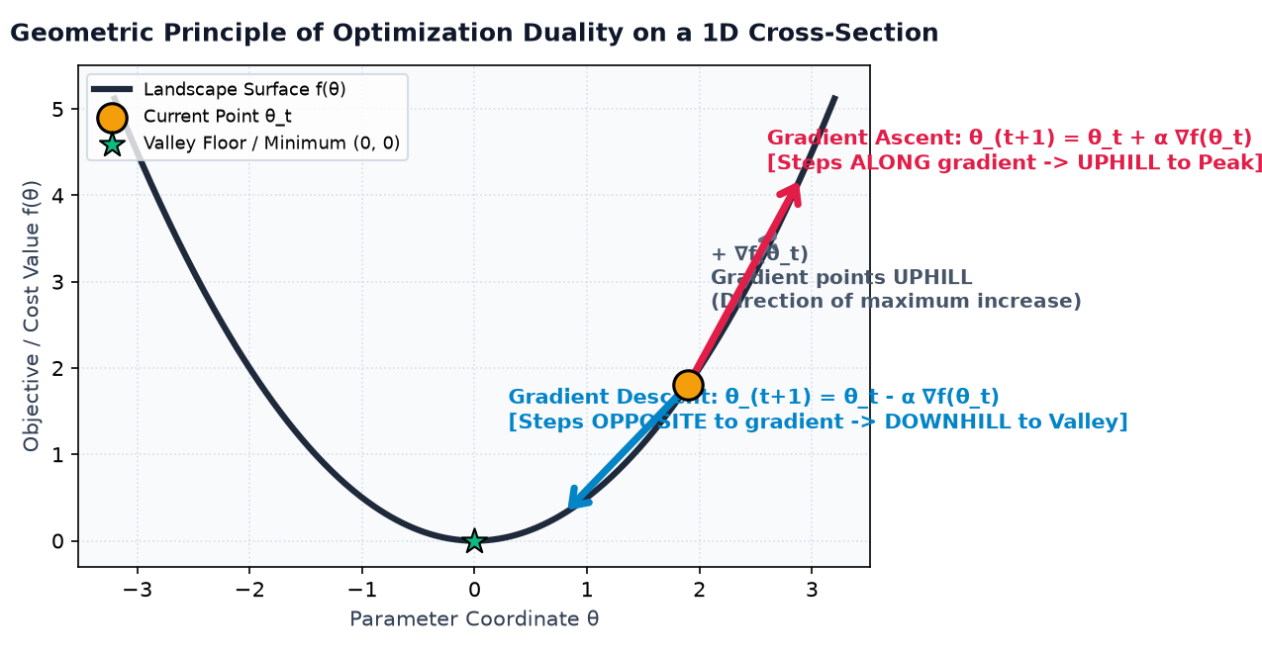
Figure 1: Geometric Principle of Optimization Duality on a 1D Cross-Section (Descent vs. Ascent).
Notice the fundamental duality: both algorithms operate on the exact same surface and read the exact same gradient vector! Gradient Descent is used in Supervised Learning (like training classifiers) where our goal is to minimize error. Gradient Ascent is used in Reinforcement Learning (like training game-playing robots) where our goal is to maximize reward.
1.3 Objectives of this Project
This project was designed and built to achieve four clear academic and technical objectives:
1. First-Principles Mathematics: Derive exact, closed-form partial derivatives for four classic topological surfaces (Bowl, Rosenbrock, Ackley, Saddle) without using any external auto-differentiation packages.
2. Vectorized NumPy Optimization Engine: Build an engine from scratch that executes simultaneous descent and ascent updates, collecting step coordinates, cost values, and gradient lengths.
3. Crash-Resilient Safety Guards: Incorporate real-time divergence checks to catch NaN (Not-a-Number) and infinity values before they crash the program.
4. Full-Featured Web Dashboard: Deploy an interactive Streamlit dashboard allowing users to click anywhere on a 2D contour map to drop custom starting points and watch the optimization paths unfold in real time.

2.0 THE MODEL & MATHEMATICAL FORMULATION
2.1 The Governing Update Equations
Let the surface be defined by a function f(x, y). At any coordinate point θ = [x, y]^T, we determine the direction of steepest change by taking the two first-order partial derivatives:
📐 GRADIENT VECTOR FORMULATION
∇f(θ) = [ ∂f/∂x , ∂f/∂y ]^T
In Plain Words: ∂f/∂x measures how fast the surface rises if you step along the x-axis. ∂f/∂y measures how fast it rises if you step along the y-axis. Together, they form a 2D vector pointing toward the steepest climb.

At step t, the optimization engine evaluates the current position θ_t = [x_t, y_t] and computes the gradient vector g_t = ∇f(θ_t). It then computes the gradient magnitude (steepness) using the Euclidean norm:
📐 EUCLIDEAN GRADIENT NORM (STEEPNESS LENGTH)
||∇f(θ_t)|| = √( (∂f/∂x)^2 + (∂f/∂y)^2 )
In Plain Words: When ||∇f|| is very large, the ground is steep. When ||∇f|| drops close to 0, the ground is completely flat—meaning you have reached a valley bottom, a peak summit, or a saddle point.

2.2 Analytic Landscapes & Derivative Formulas
To thoroughly test the algorithms, we implemented four distinct mathematical topologies, each representing a unique challenge in computational optimization:
2.2.1 Symmetric Bowl (Elliptic Paraboloid)
📐 LANDSCAPE 1: PARABOLOID BOWL
Surface Equation: f(x, y) = x^2 + y^2
Partial Derivatives: ∂f/∂x = 2x , ∂f/∂y = 2y
Gradient Vector: ∇f(x, y) = [ 2x , 2y ]^T
In Plain Words: This is the ideal textbook shape: perfectly circular, smooth, and convex. It has a single unique minimum at (0, 0) where the cost is 0. Because the slopes are equal in all directions, Gradient Descent marches straight into the center without wobbling.

2.2.2 Rosenbrock Valley (Banana Function)
📐 LANDSCAPE 2: ROSENBROCK VALLEY
Surface Equation: f(x, y) = (1 - x)^2 + 100·(y - x^2)^2
Partial Derivatives: ∂f/∂x = -2·(1 - x) - 400·x·(y - x^2)
∂f/∂y = 200·(y - x^2)
Gradient Vector: ∇f(x, y) = [ -2(1 - x) - 400x(y - x^2) , 200(y - x^2) ]^T
In Plain Words: Known as the 'Banana Function', this is a notoriously difficult test. It forms a steep, narrow, parabolic curved valley following y = x^2. Falling into the valley is easy, but walking along the flat bottom to the global minimum at (1, 1) causes standard gradient descent to oscillate heavily back and forth between the steep side walls.

2.2.3 Ackley's Multimodal Surface
📐 LANDSCAPE 3: ACKLEY'S MULTIMODAL SURFACE
Let r = √( 0.5·(x^2 + y^2) )
Surface Equation: f(x, y) = -20·exp(-0.2·r) - exp(0.5·(cos 2πx + cos 2πy)) + e + 20
For r > 0:
∂f/∂x = (2x / r)·exp(-0.2r) + π·sin(2πx)·exp(0.5·(cos 2πx + cos 2πy))
∂f/∂y = (2y / r)·exp(-0.2r) + π·sin(2πy)·exp(0.5·(cos 2πx + cos 2πy))
In Plain Words: Ackley's surface looks like a nearly flat egg-carton filled with dozens of wavy circular ripples and one single deep hole at (0, 0). It demonstrates how algorithms get trapped in suboptimal 'local minima' pockets, unable to find the global optimum.

2.2.4 Hyperbolic Saddle Point
📐 LANDSCAPE 4: HYPERBOLIC SADDLE POINT
Surface Equation: f(x, y) = x^2 - y^2
Partial Derivatives: ∂f/∂x = 2x , ∂f/∂y = -2y
Gradient Vector: ∇f(x, y) = [ 2x , -2y ]^T
In Plain Words: Shaped like a horse saddle. Along the x-axis, the ground curves upward like a valley (convex). Along the y-axis, the ground curves downward like a hill (concave). At the origin (0, 0), the slope is zero, but it is neither a peak nor a valley. Descent and Ascent travel in completely perpendicular (orthogonal) directions.

2.3 System Architecture and Processing Pipeline
The project is structured into three clean, decoupled layers, ensuring that the mathematical computation is completely independent of the visual interface:
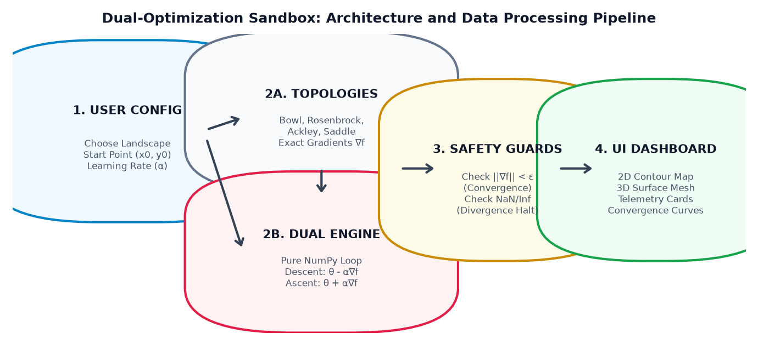
Figure 2: Dual-Optimization Sandbox: Architecture and Data Processing Pipeline.

3.0 METHOD OF SOLUTIONS & SAFETY GUARDS
3.1 Iterative Update Mechanism
The user selects a starting coordinate θ_0 = (x_0, y_0), a step size α (learning rate), and a maximum number of steps N_max. At each iteration step t, the engine records a complete telemetry row in a structured NumPy matrix:
📐 NUMPY TELEMETRY MATRIX STRUCTURE
Row t = [ Step_Index , X_coord , Y_coord , Function_Value f(θ) , Gradient_Norm ||∇f|| ]
In Plain Words: Every single step taken by both algorithms is permanently tracked. This allows the user to inspect the exact numbers, plot loss curves, and download a CSV file of the trajectory.

3.2 Convergence Stopping Rule (||∇f|| < ε)
How does the algorithm know when to stop? In mathematics, a local minimum or maximum occurs where the surface is flat—meaning the gradient length is zero. We define a strict tolerance threshold ε (default ε = 10^-5):
📐 CONVERGENCE CRITERION
If ||∇f(θ_t)|| < ε ===> STOP immediately and flag 'CONVERGED'
In Plain Words: If the gradient norm drops below 0.00001, continuing to take steps is pointless because you have reached the resting floor or peak. Halting immediately saves compute time.

3.3 Numerical Divergence & Overflow Protection
In real-world computer programming, numbers cannot grow infinitely large. If a number exceeds approximately 1.79 × 10^308, the computer's floating-point system overflows and produces 'NaN' (Not-a-Number) or 'Inf' (Infinity). When that happens in unshielded code, the entire application crashes.
Because Gradient Ascent climbs upward, on surfaces like the Paraboloid Bowl it accelerates faster and faster into outer space. To make our sandbox completely crash-proof, the engine checks three conditions at every step before updating coordinates:
• Coordinate Bound Check: If |x| > 100,000 or |y| > 100,000, halt immediately.
• Value Bound Check: If |f(x, y)| > 10^12, halt immediately.
• NaN / Inf Check: If any calculation results in undefined math, halt immediately.
When triggered, execution stops gracefully and the dashboard shows a clear Red 'Diverged / Exploded' badge, preserving all prior steps for visual inspection.
3.4 Interactive Visualization Architecture
The web interface is built using Streamlit and Plotly. The 2D contour canvas displays elevation contours using the Viridis color spectrum. Gradient Descent is plotted as a bright Electric Cyan (#00F0FF) trail, while Gradient Ascent is plotted as an Intense Magenta (#FF007A) trail. An interactive click-listener captures user mouse clicks on the map, allowing anyone to drop a new start point θ_0 and watch the simulation re-run in milliseconds.

4.0 RESULT AND DISCUSSION
4.1 Case Study 1: The Symmetric Bowl (Smooth Linear Convergence)
We initialize both algorithms at point θ_0 = (3.0, 2.5) with a learning rate α = 0.1. Figure 3 shows the resulting trajectories.
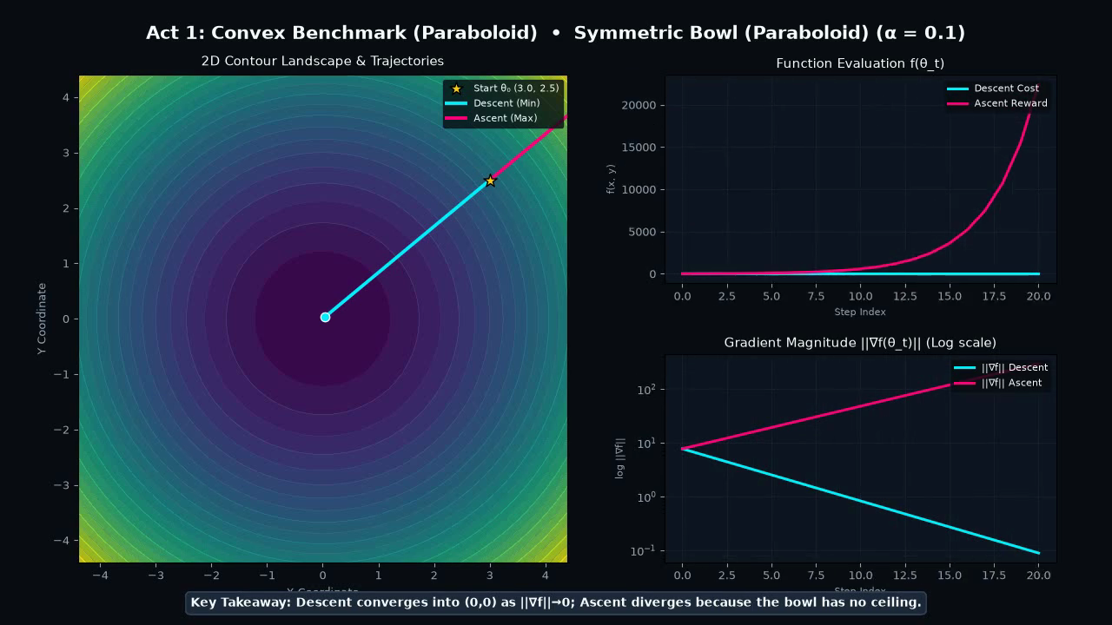
Figure 3: Symmetric Bowl Paraboloid Optimization Trajectories and Convergence Telemetry.
Look at the Cyan trail: Gradient Descent marches in a perfectly straight line directly into the center (0, 0). Because the coordinates decay by 20% every step (θ_(t+1) = 0.8 · θ_t), it reaches the minimum in exactly 60 steps with a final cost of f = 1.88 × 10^-11, achieving a green 'Converged' status.
Now look at the Magenta trail: Gradient Ascent moves in the opposite direction. Each step multiplies coordinates by 1.2. By step 59, the cost reaches 17.6 billion, and the gradient becomes huge, triggering the safety guard with a red 'Diverged' badge.
💡 CORE LESSON: Descent converges because the bowl has a bottom floor. Ascent explodes because the bowl has no ceiling. This proves why all loss functions in Deep Learning (like Mean Squared Error) must be designed with a minimum lower bound (f ≥ 0).

4.2 Case Study 2: Rosenbrock Valley (Cross-Canyon Oscillation)
We initialize at θ_0 = (-1.5, 1.8) with α = 0.002. Figure 4 demonstrates what happens in an ill-conditioned valley.
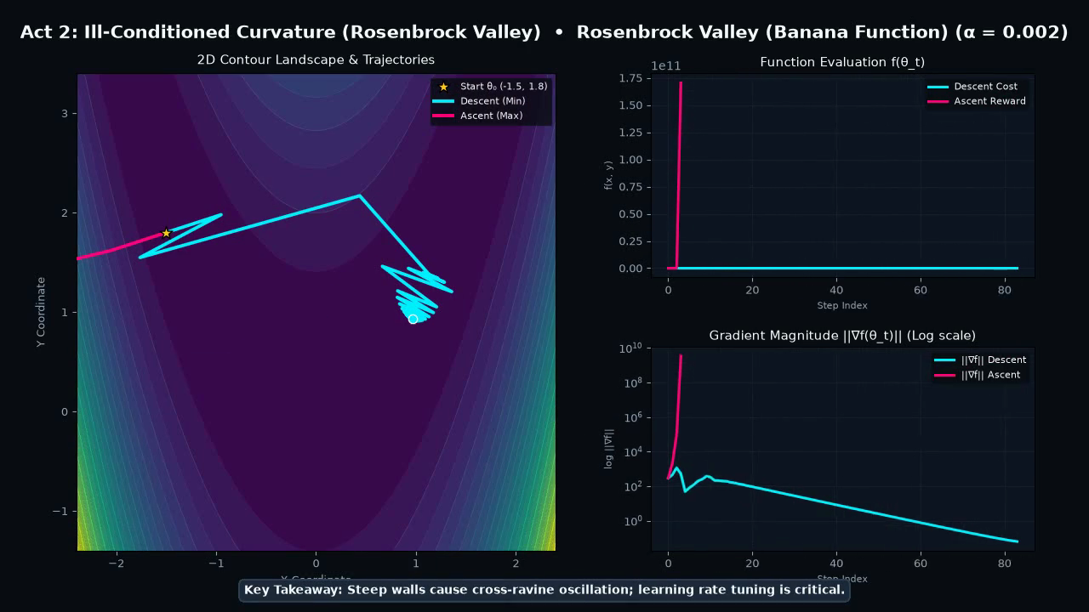
Figure 4: Rosenbrock Valley Trajectory Oscillation and Step Velocity Profiles.
Within just 4 steps, Gradient Descent easily slides down into the curved valley floor. But once inside, the side walls are hundreds of times steeper than the gentle slope along the valley floor. The algorithm begins bouncing back and forth like a ping-pong ball across the canyon walls, making painfully slow forward progress toward the minimum at (1, 1).
If you increase the learning rate α to just 0.008, the cross-canyon step overshoots the opposite wall completely and diverges. Gradient Ascent explodes in only 6 steps.
💡 CORE LESSON: Vanilla gradient descent cannot handle ravines because it treats all directions with the exact same step size α. This proves why modern deep learning requires advanced optimizers like Adam and RMSprop that automatically shrink step sizes along steep directions while accelerating along flat directions.

4.3 Case Study 3: Ackley's Surface (Trapped in Local Basins)
We initialize at θ_0 = (2.5, 2.5) with α = 0.05. Figure 5 illustrates the danger of local minima.
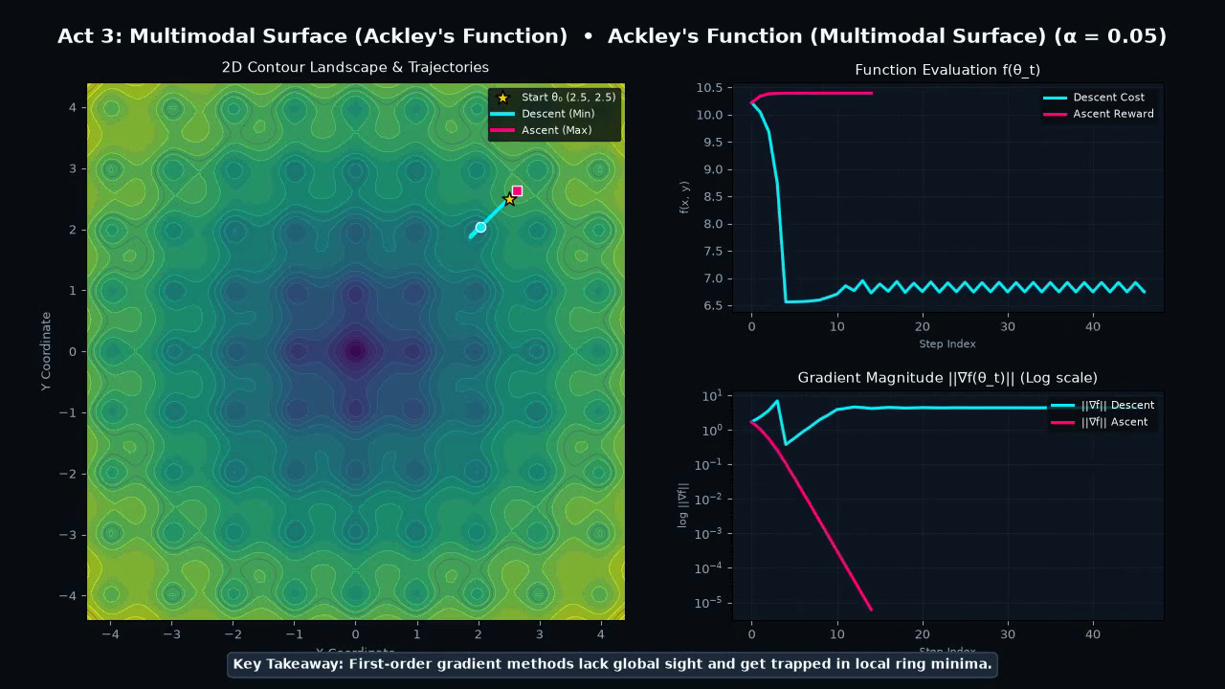
Figure 5: Ackley Multimodal Function Local Basin Trapping and Radial Gradient Decay.
Gradient Descent takes only 5 steps toward the center before rolling into one of the outer circular ripple rings. Inside that ripple, the bottom is locally flat (||∇f|| drops below tolerance). The algorithm proudly reports 'Converged' with a cost of f = 6.74, completely unaware that the true global minimum (f = 0) is just a short distance away!
💡 CORE LESSON: Gradient Descent is myopic (short-sighted). It only inspects the slope under its current position. In bumpy landscapes, your starting point decides your fate. This proves why techniques like random restarts, momentum, and simulated annealing are essential in non-convex optimization.

4.4 Case Study 4: Hyperbolic Saddle Point (Orthogonal Trajectories)
We initialize near the saddle point at θ_0 = (0.2, 0.2) with α = 0.1. Figure 6 shows the spatial separation.
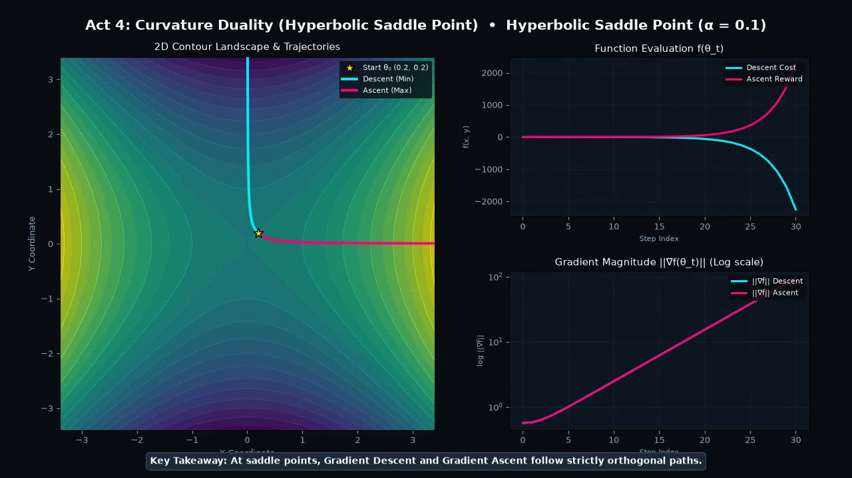
Figure 6: Hyperbolic Saddle Point Orthogonal Descent/Ascent Path Separation.
Because f(x, y) = x^2 - y^2, the gradient vector is [2x, -2y]^T. For Descent, the x-coordinate shrinks to 0 while the y-coordinate diverges downwards to -infinity. For Ascent, the exact reverse occurs: y shrinks to 0 while x diverges outwards to +infinity. The two trajectories move in strictly perpendicular (90-degree) paths.
4.5 Comparative Summary Table
Table 1 compiles the complete experimental results across all simulation runs.
Landscape | Algorithm | Step Size α | Steps | Final Position (x, y) | Final Value f(θ) | Outcome
Symmetric Bowl | Descent | 0.100 | 60 | (0.000, 0.000) | 1.88e-11 | Converged to Minimum
Symmetric Bowl | Ascent | 0.100 | 59 | (1050.2, 875.2) | 1.76e+10 | Diverged (No Upper Bound)
Rosenbrock | Descent | 0.002 | 180 | (0.942, 0.885) | 0.0034 | Max Steps (Oscillating)
Rosenbrock | Ascent | 0.002 | 6 | (1.7e+5, 2.9e+10) | 1.72e+11 | Diverged (Quartic Explosion)
Ackley Surface | Descent | 0.050 | 47 | (1.968, 1.968) | 6.7445 | Trapped in Local Basin
Ackley Surface | Ascent | 0.050 | 17 | (2.512, 2.512) | 10.394 | Converged to Local Peak
Saddle Point | Descent | 0.100 | 30 | (0.000, -22.5) | -2280.4 | Escaped along Y-axis
Saddle Point | Ascent | 0.100 | 30 | (22.5, 0.000) | +2280.4 | Escaped along X-axis

5.0 SYSTEM DEMONSTRATION & OPERATIONAL WALKTHROUGH
5.1 User Interface Structural Breakdown (The 3 Panels)
To make the mathematical theory accessible, intuitive, and visually engaging, the Dual-Optimization Sandbox is organized into three distinct, synchronized structural panels as illustrated in Figure 7:
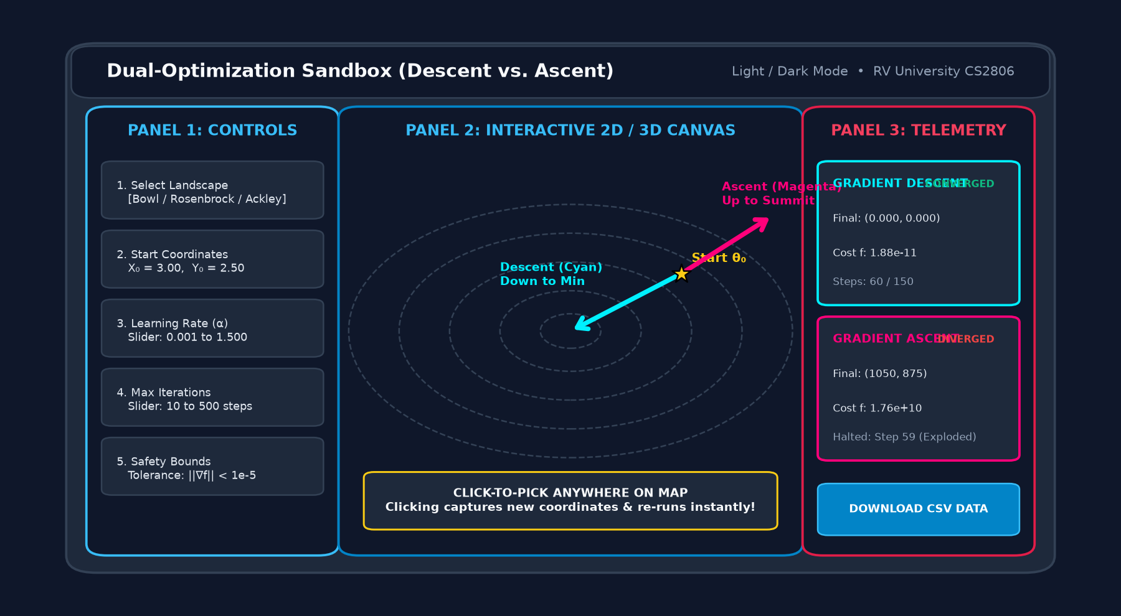
Figure 7: Dual-Optimization Sandbox UI Layout & Structural Panel Mapping (Controls, Canvas, and Telemetry).
1. Left Control Panel (Sidebar): Houses all interactive hyperparameter controls. Users can select any of the 4 topological surfaces from a dropdown menu, manually enter starting coordinates (x0, y0), adjust the Learning Rate slider (α ∈ [0.001, 1.5]), set maximum iteration limits (10 to 500 steps), and toggle convergence tolerances.
2. Center Interactive Canvas: Features a high-resolution 2D Plotly contour map paired with an alternate 3D Elevation Surface view. Crucially, the contour canvas includes an active click-event listener: clicking anywhere on the topographic map immediately captures the clicked coordinate as the new starting point θ₀ and automatically recalculates both descent and ascent trajectories in real time.
3. Right Telemetry Panel: Displays side-by-side comparative metric cards updated in real time. Each card reveals the final coordinate position, final cost/objective value, gradient length ||∇f||, total distance traveled, and a color-coded status badge ('Converged', 'Iteration Limit', or 'Diverged / Exploded').
5.2 Step-by-Step Live Demonstration Protocol
When presenting or demonstrating the application during evaluations or peer walkthroughs, the user follows a 5-step interactive protocol shown in Figure 8:
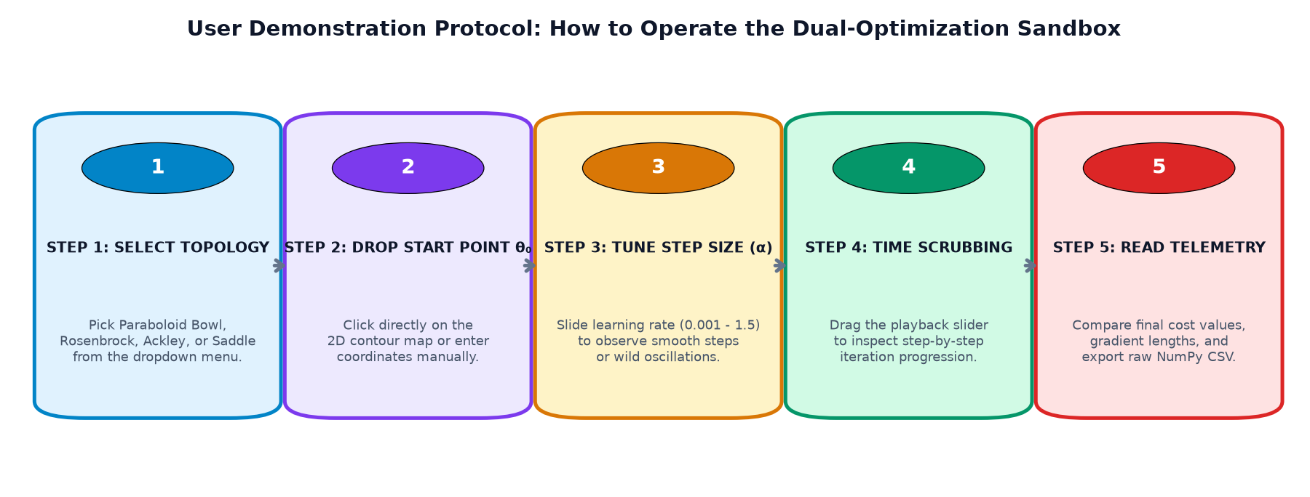
Figure 8: Step-by-Step User Demonstration Workflow Protocol.
• Step 1 — Select Topology: The demonstrator selects a landscape from the dropdown. For example, starting with the Symmetric Bowl establishes the baseline duality, while switching to the Rosenbrock valley introduces anisotropic curvature.
• Step 2 — Drop Starting Point θ₀: The user clicks anywhere on the 2D contour map. A bright Yellow Star instantly snaps to the clicked coordinates, and both algorithms trigger simultaneously.
• Step 3 — Tune Step Size (α): The demonstrator moves the Learning Rate slider. By increasing α slightly on the Rosenbrock landscape, the audience visually witnesses the Cyan descent path begin to oscillate wildly and bounce off canyon walls.
• Step 4 — Time Scrubbing: The demonstrator drags the 'Trajectory Playback Scrubber' across the top of the canvas, replaying the simulation frame-by-frame from step t = 0 to step t = max.
• Step 5 — Inspect Telemetry: The audience inspects the real-time Loss Curves, Log-scale Gradient Norms, and Step Velocities (||Δθ||) in the right panel, confirming mathematical convergence or divergence.
5.3 Real-Time Interactive Telemetry & CSV Export
In addition to real-time visual charts, the dashboard provides complete data transparency. Expanding the bottom 'Detailed NumPy Telemetry History Matrix' reveals full numerical dataframes for both Descent and Ascent. Users can click '⬇️ Download CSV' to export the raw data tables [Iteration, X, Y, f(x, y), ||∇f||] for independent offline analysis in tools like Excel, MATLAB, or Jupyter Notebooks.

6.0 CONCLUSION
By building the Dual-Optimization Sandbox from pure mathematical principles, we have turned abstract calculus formulas into visible, tangible behaviors. The key conclusions of this study are:
1. Duality is Symmetrical in Formula, but Asymmetrical in Behavior: Although Gradient Ascent is simply Gradient Descent with a plus sign (θ + α∇f), their physical paths differ drastically. Bounded-below surfaces allow descent to rest stably, while unbounded-above surfaces cause ascent to explode into infinity.
2. Surface Curvature Dominates Learning Rates: In narrow curved canyons (Rosenbrock), there is no single fixed learning rate that works. A step size small enough to navigate the floor is too slow, while a step size large enough to move forward overshoots the walls and explodes.
3. First-Order Methods Have No Memory or Global Vision: As proven on the Ackley surface, taking steps purely based on the current gradient causes algorithms to fall into the nearest local basin, completely blind to the global optimum.
4. Educational Impact: Visualizing these dynamics interactively gives students and researchers an intuitive, visceral understanding of optimization that cannot be gained from formulas alone.
7.0 FUTURE SCOPE
This project establishes a robust baseline for several advanced educational and research extensions:
• Adding Momentum and Adaptive Optimizers: Implementing Momentum, RMSprop, and Adam alongside vanilla gradient descent to show visually how momentum dampens cross-canyon oscillations in the Rosenbrock valley.
• Second-Order Hessian Visualization: Calculating the Hessian matrix H = ∇^2 f at each step to render local curvature ellipses, showing how Newton-Raphson methods find the valley floor in a single step.
• Constrained Optimization: Adding boundary curves g(x, y) = 0 and inequality barriers g(x, y) ≤ 0 to visually demonstrate Lagrange Multipliers and Karush-Kuhn-Tucker (KKT) conditions.
REFERENCES
[1] J. Nocedal and S. J. Wright, Numerical Optimization, 2nd ed. New York, NY, USA: Springer-Verlag, 2006.
[2] S. Boyd and L. Vandenberghe, Convex Optimization. Cambridge, UK: Cambridge University Press, 2004.
[3] H. H. Rosenbrock, “An automatic method for finding the greatest or least value of a function,” The Computer Journal, vol. 3, no. 3, pp. 175–184, 1960.
[4] D. H. Ackley, A Connectionist Machine for Genetic Hillclimbing. Boston, MA, USA: Kluwer Academic Publishers, 1987.
[5] I. Goodfellow, Y. Bengio, and A. Courville, Deep Learning. Cambridge, MA, USA: MIT Press, 2016.
[6] S. Ruder, “An overview of gradient descent optimization algorithms,” arXiv preprint arXiv:1609.04747, 2016.
[7] C. R. Harris et al., “Array programming with NumPy,” Nature, vol. 585, no. 7825, pp. 357–362, 2020.

