Contribution 3: Backlot

Repository Brief:
Backlot is a Python-based local mock API server built with FastAPI. It simulates complex third-party services like Google Workspace (Gmail, Drive, Docs) and Slack so developers can test their integrations completely offline without needing actual API credentials or worrying about hitting rate limits.

The Issue (Bug #391):
The mock Gmail API within Backlot was not correctly mirroring the real Gmail API's error behavior for attachments. When requesting an attachment using an invalid attachment ID, or from a non-existent message, Backlot was either returning fake binary bytes (a 200 OK) or a generic 404 Not Found error. However, the real Google API strictly returns a '400 Bad Request' with an 'Invalid attachment token' message in both of these scenarios.

The Solution:
We updated the Google errors module ('backlot/errors/google.py') to introduce a properly formatted 'invalid_attachment_token()' exception constructor. We then modified the 'gmail_attachment' endpoint logic in 'backlot/routers/google.py' to intercept requests for missing messages and missing attachments, raising the newly defined 400 error instead of attempting to serve fake bytes. The fix was successfully pushed and raised as Pull Request #394.
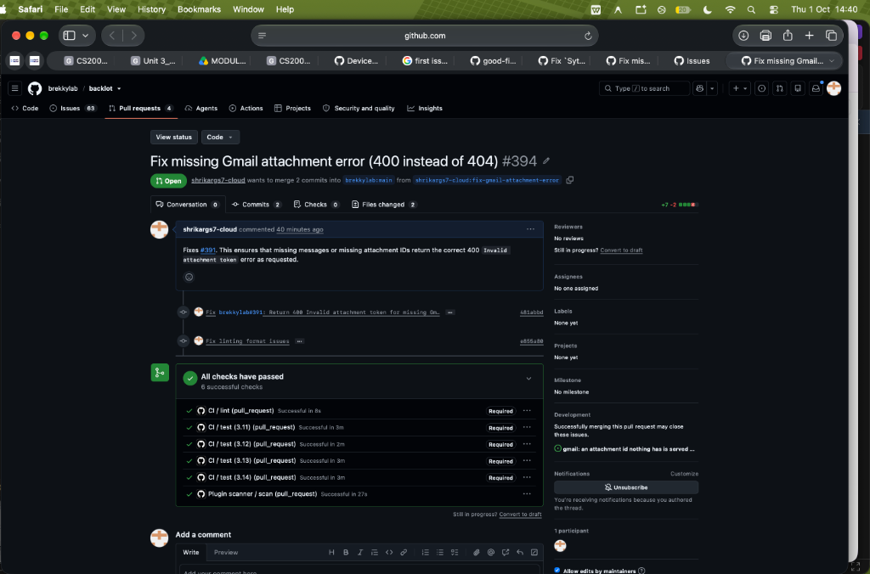
Figure: Backlot Pull Request #394 submitted successfully with all passing CI checks

