UCS2601- Internet Programming

Mini Project Report

InsightAI
Shivaanee SK - 3122235001123
Shrika SP Thota - 3122235001125
Siddarth P - 3122235001128

1. Problem Statement
In modern professional and educational environments, meetings are essential for collaboration, yet they often result in information overload. Participants frequently struggle to:
- Retain Information: Manually taking notes while actively participating in a discussion is difficult and leads to missed details.
- Identify Action Items: Sifting through lengthy meeting transcripts to find specific tasks is time-consuming and prone to error.
- Organize Follow-ups: There is often a disconnect between what is "discussed" and what is "actioned," leading to forgotten deadlines or ambiguous responsibilities.
- Track Progress: Without a centralized dashboard, monitoring the status of various tasks derived from different meetings becomes disorganized.
InsightAI was developed to bridge this gap by using Generative AI to transform raw conversational data into structured, actionable intelligence, ensuring that no insight or task is ever lost.

2. Tech Stack
The application is built using a robust full-stack architecture designed for scalability and performance.
- Frontend: * React JS: Utilized for building a dynamic, responsive user interface.
  - Tailwind CSS: Used for styling and implementing the seamless Light/Dark mode toggle.
  - Context API/Redux: For managing global state such as user authentication and theme settings.
- Backend:
  - Spring Boot (Java): Provides a secure and scalable RESTful API. It handles the business logic, integration with Google Gemini, and secure communication with the database.
- Database:
  - PostgreSQL: A powerful relational database used to store user profiles, meeting metadata, raw transcripts, AI-generated summaries, and task lists.
- AI Integration:
  - Google Gemini API: Leveraged for Natural Language Processing (NLP) to summarize transcripts and perform entity extraction to identify tasks.

3. Features

3.1 Authentication & Profile Management

Secure Access
Users can register and log in securely. Authentication is implemented using JWT (JSON Web Token), ensuring that only authorized users can access the system.

Profile Overview
Each user has a dedicated profile section displaying:
- Name
- Email
- Activity summary (meetings, tasks, summaries)

Editable Profiles
Users can update their personal information, making the system flexible and user-friendly.

3.2 Meeting Management

Meeting Creation
Users can create a meeting by providing:
- Title
- Date & Time
- Description
- Transcript

Data Storage
All meeting data is stored in the database for future reference.

AI-Powered Summary Generation
When the user clicks “Generate AI Summary”:
- The transcript is sent to the backend
- The backend calls the Gemini API
- The AI processes the text
- The system returns:
  - A concise summary
  - Key discussion points
This process converts unstructured text into meaningful insights.

3.3 Automated Task Generation

Task Extraction
The AI identifies actionable items from the transcript automatically.
Example:
“John will complete frontend by Friday”
This is converted into a task assigned to John.

Task Board
Tasks are displayed in a structured format with statuses:
- To Do
- In Progress
- Done
Users can update task status, enabling efficient workflow tracking.

3.4 Interactive Dashboard
The dashboard provides a quick overview of system activity.

Analytics
- Total meetings
- Total summaries
- Total tasks

Quick Navigation
- Recent meetings
- Pending tasks
- Direct links for fast access
This improves usability and overall productivity.

3.5 User Experience

Theming
Users can switch between:
- Light mode
- Dark mode
This enhances usability and user comfort.

Responsive Design
The application is fully responsive and works across:
- Desktop
- Tablet
- Mobile

4. System Workflow
- User logs in
- Creates a meeting and enters transcript
- Frontend sends data to backend API
- Backend sends transcript to Gemini API
- AI returns summary and tasks
- Backend stores data in PostgreSQL
- Frontend displays results

5. Project Structure
InsightAI/
├── backend/
│ ├── src/main/java/
│ │ └── com/insightai/
│ │ ├── config/
│ │ ├── controller/
│ │ ├── dto/
│ │ ├── entity/
│ │ ├── exception/
│ │ ├── repository/
│ │ ├── security/
│ │ └── service/
│ └── src/main/resources/
│ └── application.properties
│
├── frontend/
│ ├── app/
│ │ ├── dashboard/
│ │ ├── login/
│ │ ├── meetings/
│ │ ├── signup/
│ │ └── tasks/
│ ├── components/
│ ├── lib/
│ └── styles/
│
└── docs/
├── SETUP_AND_TEST.md
├── POSTMAN_COLLECTION.md
└── PROJECT_SUMMARY.md

6. Output Screenshots
- Welcome page & Login/SignUp : Allows users to Login/Sign Up to the application.
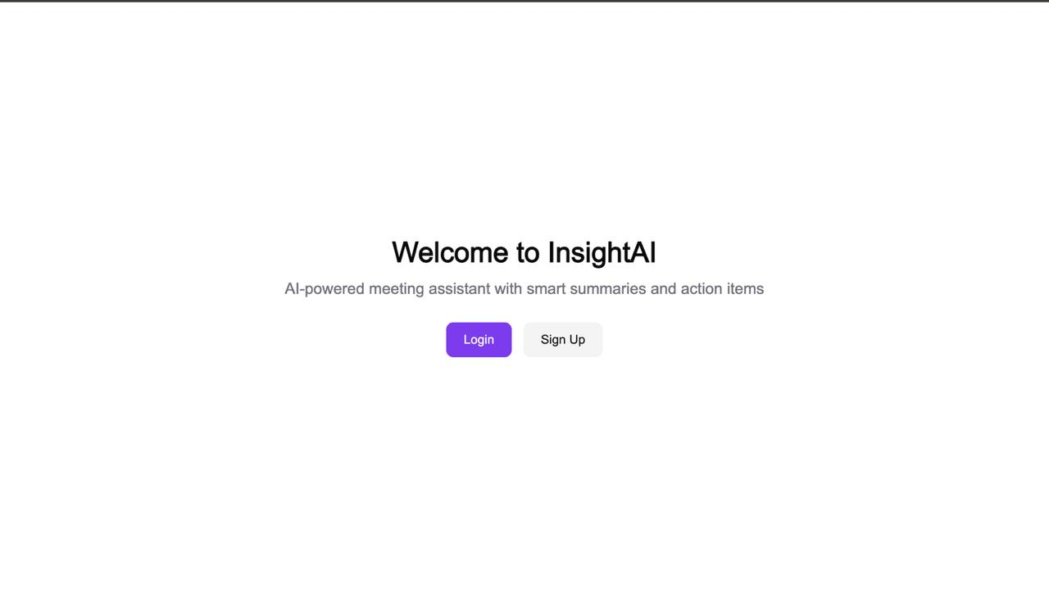 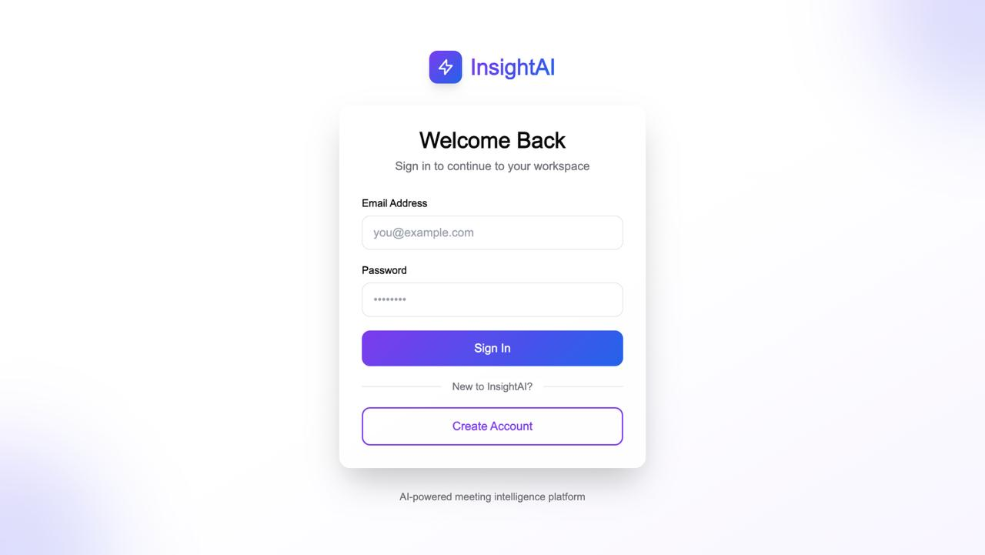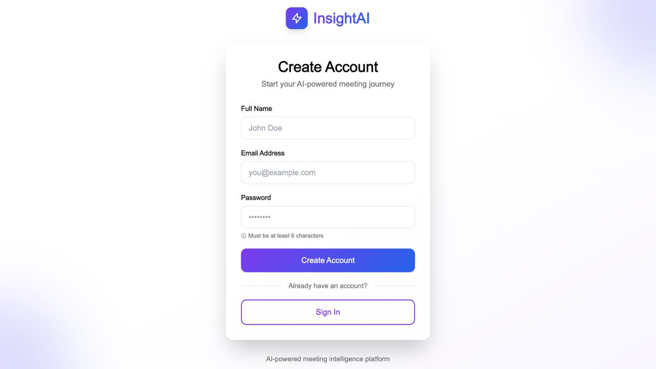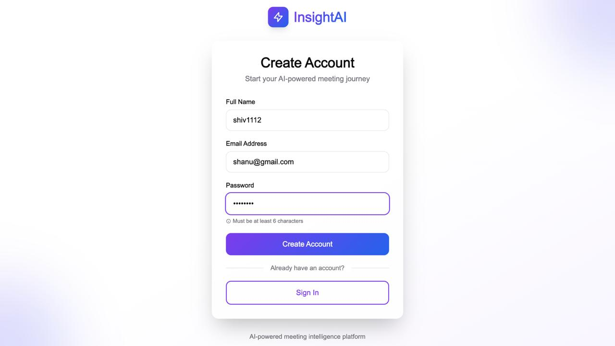
- Dashboard: showing the statistical cards (Total Meetings, Tasks) and the recent activity list.
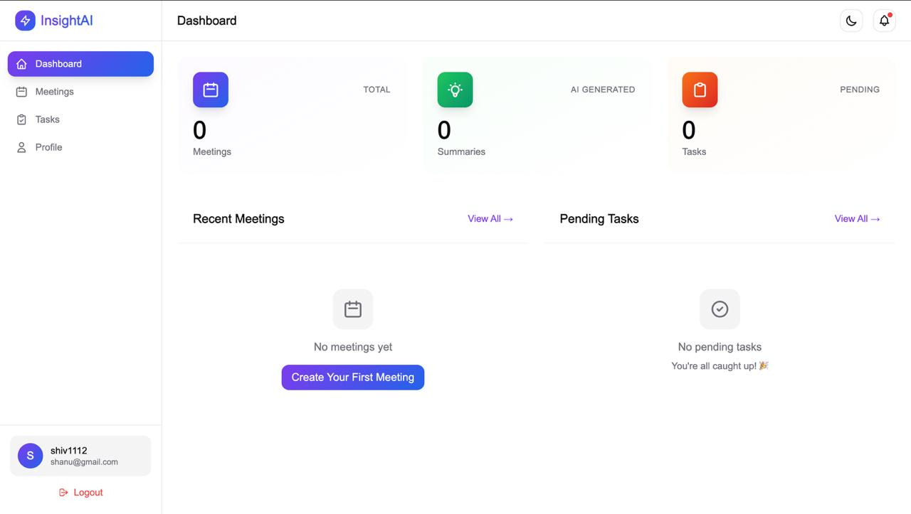
- Meeting Details: showcasing the raw transcript side-by-side with the AI-generated summary.
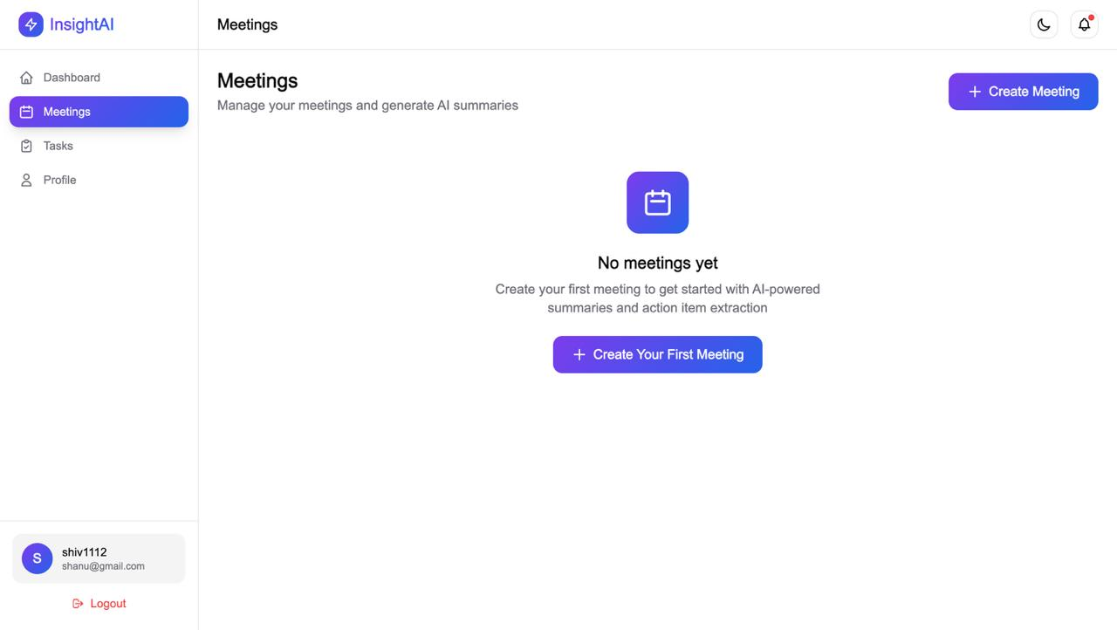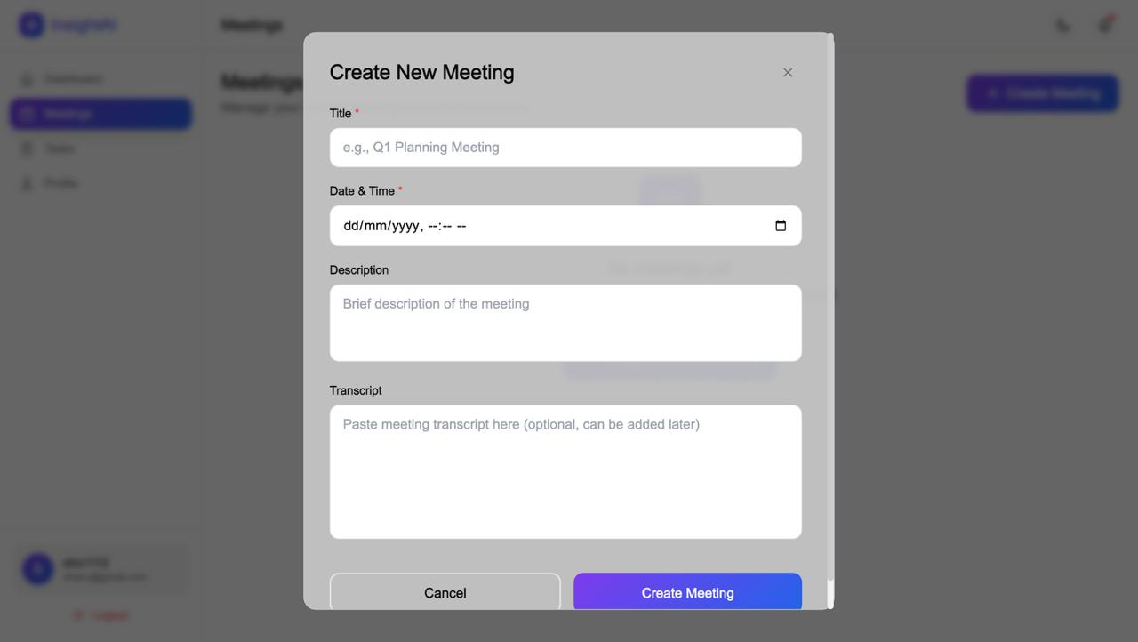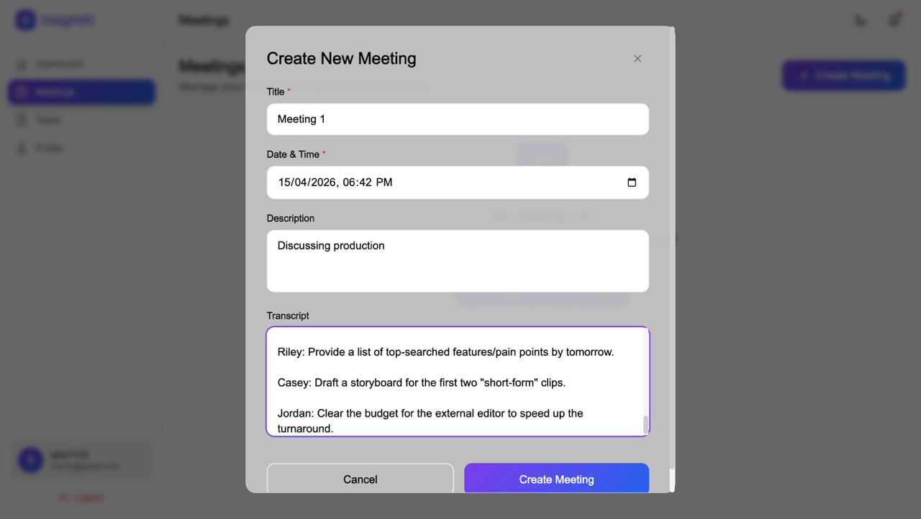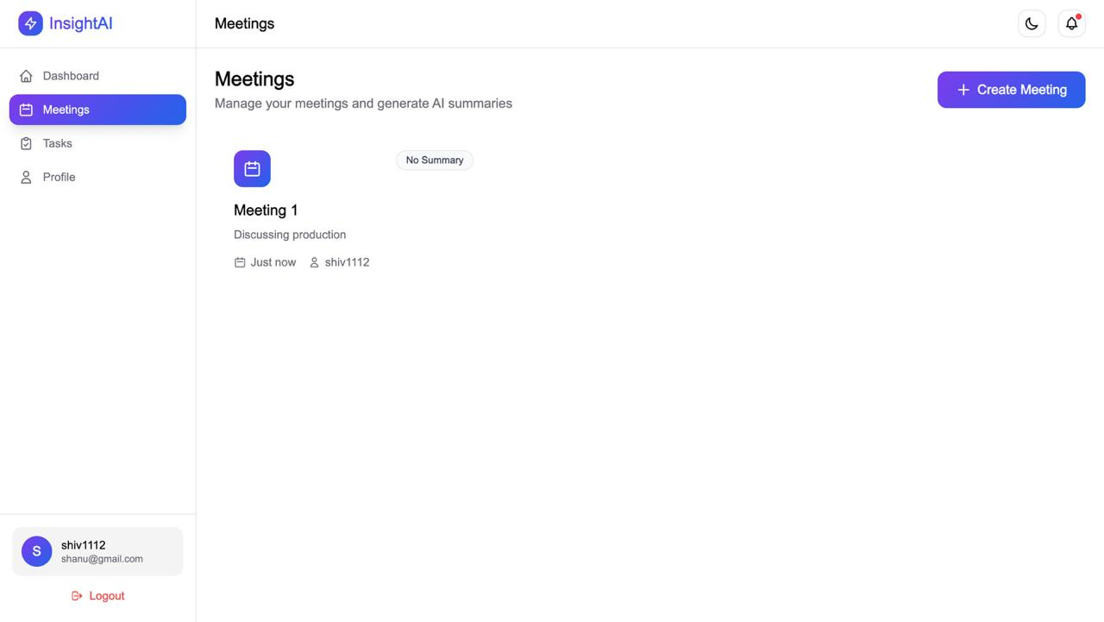
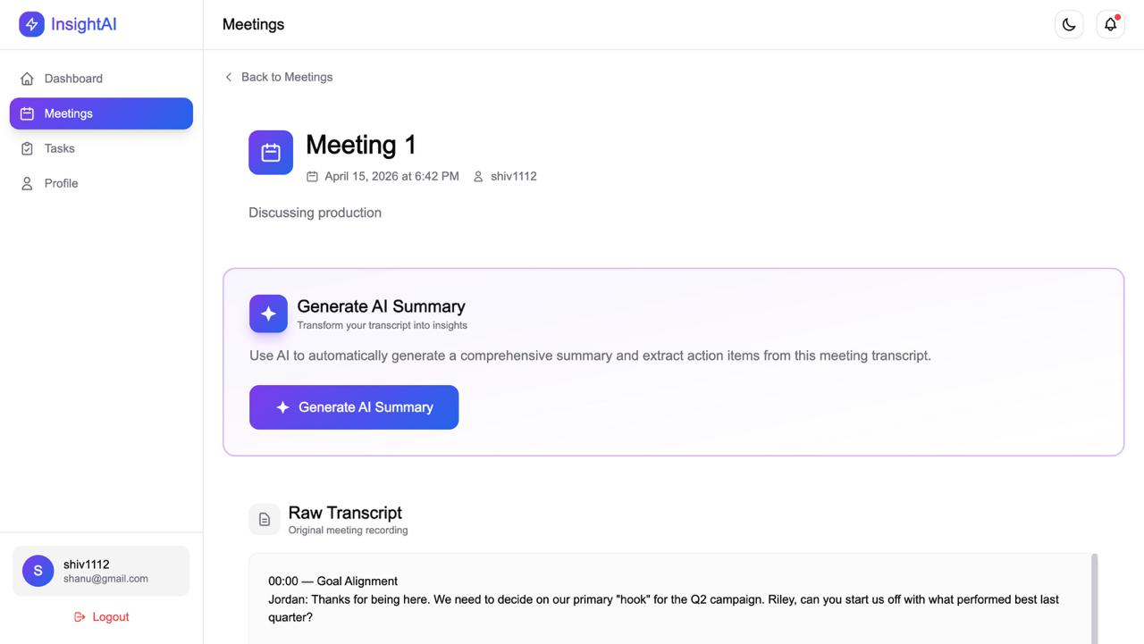Example Transcript: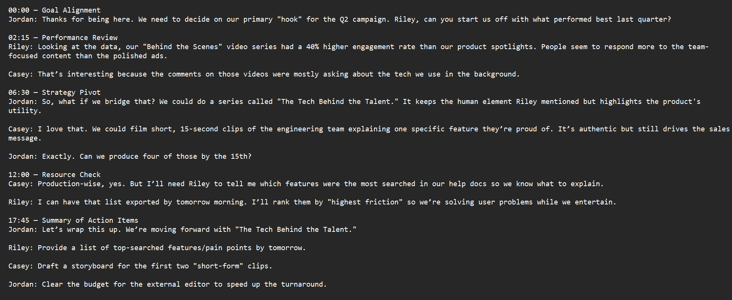
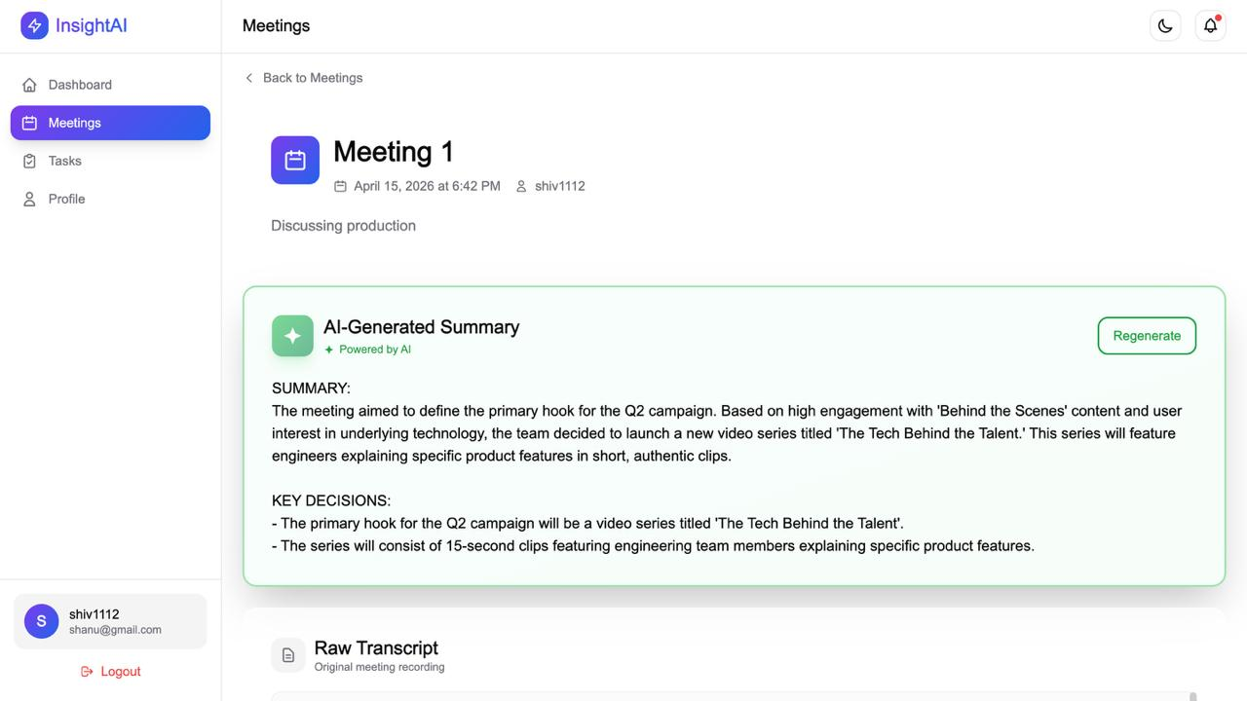
- Task Management: demonstrating the status-based To-Do list with different colored labels for "In Progress" or "Done."
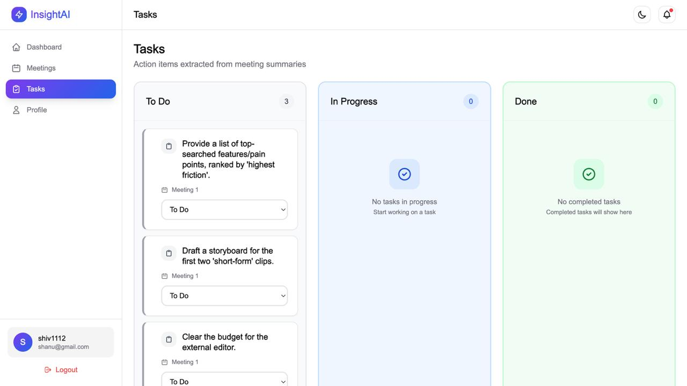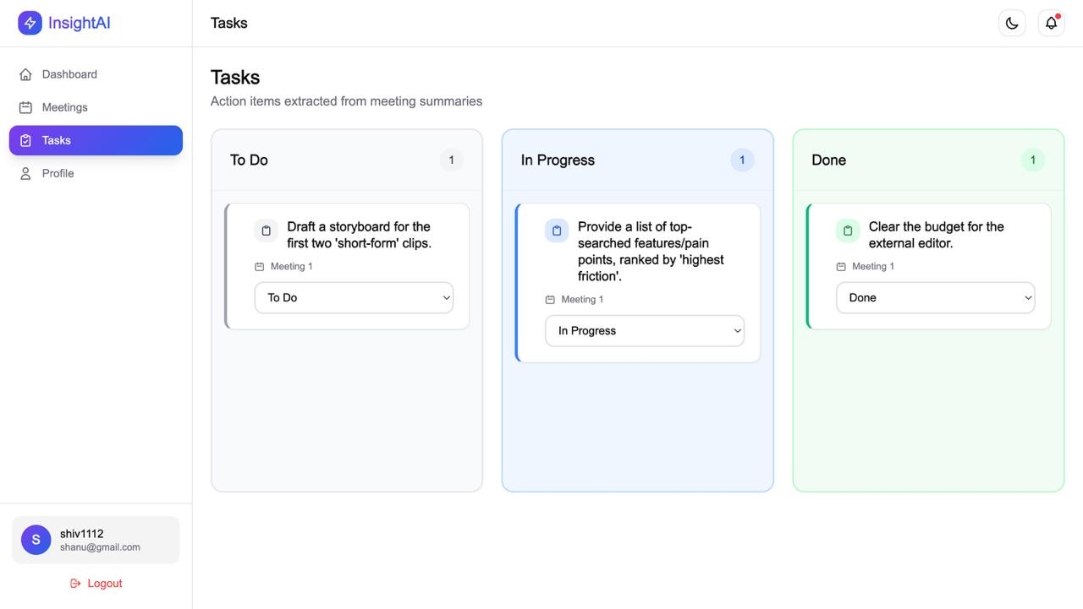
- Profile Section: showing the user's details and their total contribution metrics.
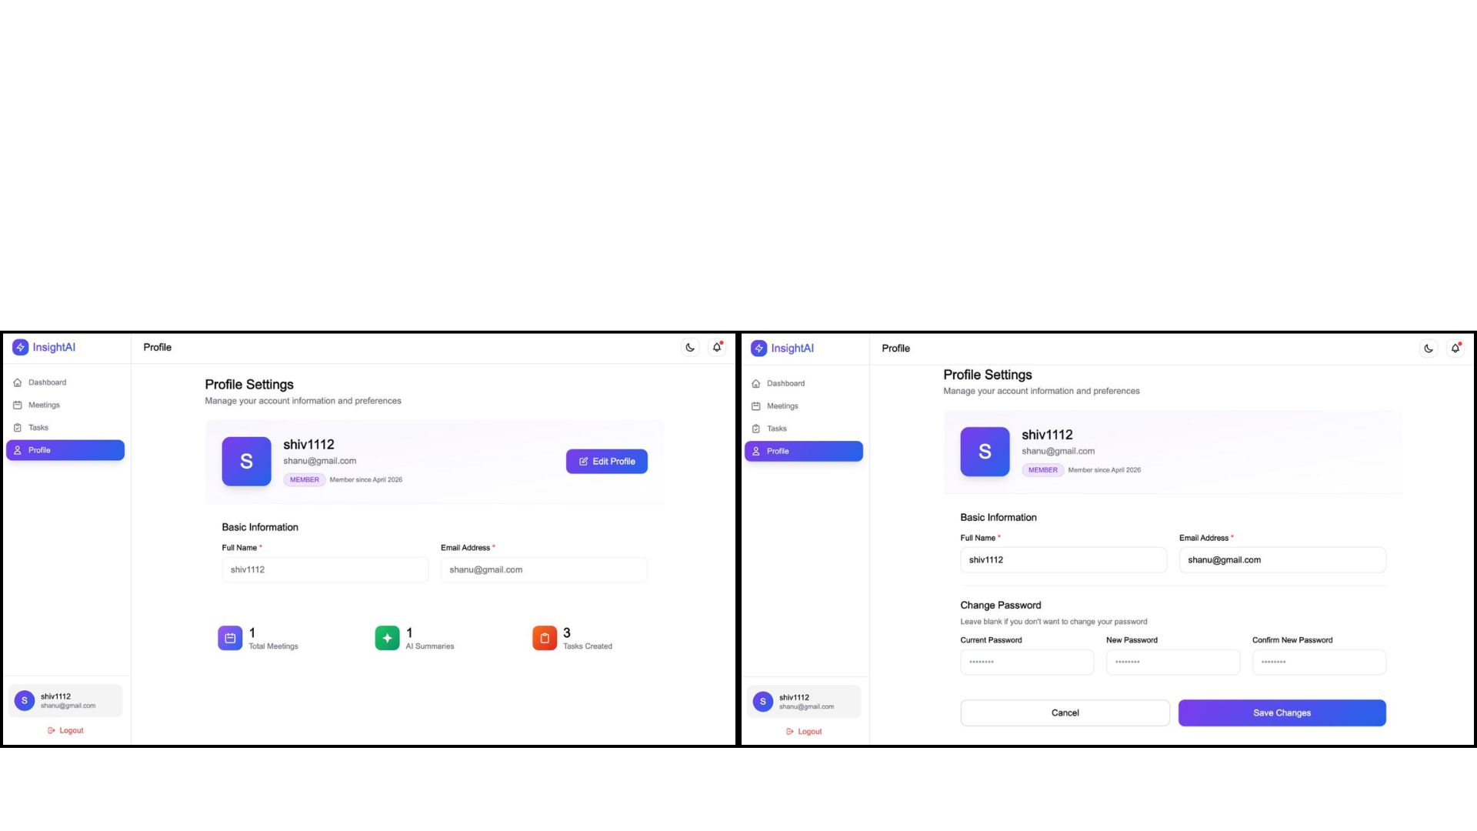
- Dark Mode Toggle: A side-by-side comparison of the UI in both themes.
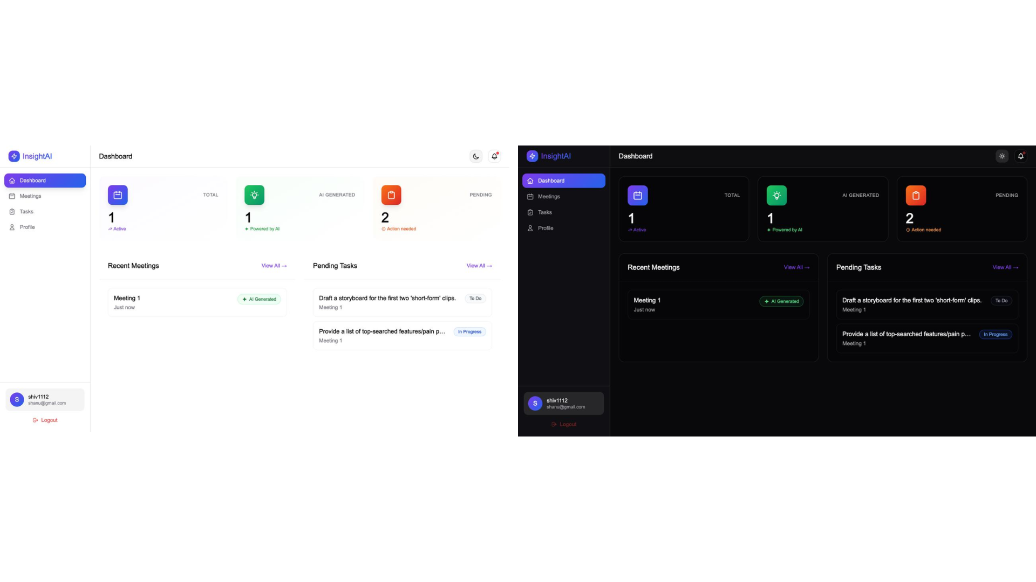

7. Future Enhancement
To further evolve InsightAI, the following features are planned for future releases:
- Audio-to-Text Integration: Allow users to upload MP3/WAV files directly for automatic transcription instead of providing raw text.
- Collaborative Meetings: Enable multiple users to join a single meeting entry to view shared summaries and assign tasks to specific team members.
- Calendar Integration: Sync generated tasks with Google Calendar or Outlook to set reminders and deadlines.
- Multi-Language Support: Expand the AI processing capabilities to summarize meetings conducted in languages other than English.
- Export Functionality: Allow users to export meeting summaries and task lists as PDF or CSV files for external reporting.

