**Sudoku Game Application - Java Project**

**Description**

This is a terminal-based Sudoku game built in Java that allows users to play and solve randomly generated Sudoku puzzles at different difficulty levels. The game includes user authentication and ensures each puzzle has a unique solution, offering an engaging experience for Sudoku enthusiasts.

**Features**

* Random Puzzle Generation: Each puzzle is generated with a unique, solvable solution, providing a new experience every time.
* Difficulty Levels: Choose from Easy, Medium, or Hard difficulty, each with varying degrees of puzzle complexity.
* Backtracking Algorithm: Ensures puzzles have a unique solution by applying a backtracking algorithm.
* User Authentication: Allows users to create accounts and log in to play.
* Input Validation: The game checks each user input for correctness, preventing invalid placements.
* User-Friendly Interface: A clean, easy-to-read, terminal-based interface displays the Sudoku grid and guides the user.

**Technologies Used**

* Java: Primary programming language used for the entire project.
* Object-Oriented Programming: Encapsulation, inheritance, and abstraction to organize and manage the game's components.
* Backtracking Algorithm: Ensures solvability of each randomly generated puzzle.
* Exception Handling: Manages input errors and prevents invalid game states.

**Installation**

1. Download the zip file and open it in any Java based IDE (Intellij,Eclipse,etc) i.e clone the project.
2. Alternatively you can open the project and clone it to any Source code editor (VS Code,Sublime Text Editor, etc) and then compile each file individually.

**Usage**

Run the program

java -cp bin sudoku.main.Main

If using an IDE, directly run sudoku.main.Main without creating a classpath.

Login or Sign Up

When prompted, you can either log in with existing credentials or create a new account.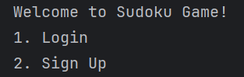

Select Difficulty Level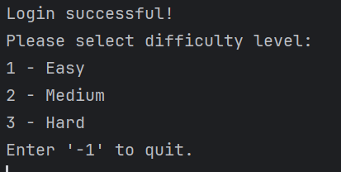

Choose your preferred difficulty:

* Easy
* Medium
* Hard

Gameplay

* A Sudoku puzzle will be generated and displayed in the terminal.
* To make a move, enter the row, column, and number (e.g., 0 4 3 to place the number 3 at row 0, column 4).
* If you make an invalid move, the game will notify you and ask you to try again.
* Complete the Puzzle
* Once you complete the puzzle, the game will validate your solution.
* Press -1 to exit the game for puzzle validation.
* If correct, you’ll receive a congratulatory message with your time taken..
* You can choose to play another puzzle or exit.
* If you exit the game without completion it will display time taken and show that your puzzle is incomplete.

**Project Structure**

SudokuGameApplication-18-25-39/

├── .idea/ # Project configuration files (IntelliJ IDEA)

├── out/ # Compiled Java class files (output directory)

├── src/ # Source code directory

│ └── sudoku/

│ ├── login/ # Login-related classes

│ │ ├── Login.java # Handles user authentication

│ │ └── logindetails # May contain user login information (likely a text or database file)

│ └── main/ # Main functionality for the Sudoku game

│ ├── Main.java # Entry point for the application

│ ├── Grid.java # Represents the Sudoku grid

│ ├── GridCopy.java # Possibly a backup or copy of the grid

│ ├── LevelEasy.java # Easy difficulty Sudoku grid generator

│ ├── LevelMedium.java # Medium difficulty Sudoku grid generator

│ ├── LevelHard.java # Hard difficulty Sudoku grid generator

│ ├── SudokuGrid.java # Generates a random Sudoku grid

│ └── SudokuSolver.java # Contains logic for solving Sudoku puzzles

**Future Enhancements**

* Leaderboard: Track player scores and completion times.
* Hints: Provide optional hints for players.
* GUI: Develop a graphical interface for a more intuitive playing experience.