Object Oriented Programming: 2018 a

End of semester Project: Michael Shriki , Kfir Matityahu

This program is a Pacman Game

===========================================================================

Design:

--------------------------------------------------------------------

**PACMAN**



Role: The character that in the control of the user, starts with 3 lives.

**DEAMON**



Role: The character that in the control of the "CPU", the game decides to make Smart Demon or Stupid Demon. (40% for the Smart and 60% for Stupid).

**WALL**

C:\Users\Michael\Desktop\wall.png

Role: A perimeter of the map, used as an obstacle, which the Pacman and Demon can't go through it.

**COOKIE**

C:\Users\Michael\Desktop\Cookie.png

Role: The Player's food. Player must to eat all of the cookies in the level to pass to the next level. **Green Cookie** UP Player speed for 14 sec, **Blue Cookie** DOWN Player speed for 7 sec

===========================================================================

Levels:

The levels must be in the following Directory: Pacman/Levels and the name must be lvl(number).txt (e.g. lvl1.txt), (number) represent the level number that you want.

To make your own levels for this game you can use [This tool](https://drive.google.com/open?id=1oKVId3HJp2kEAcvjG8f0eo9SKh1g3h-t) just follow the instructions.

Otherwise: Inside the .txt file you **must** give the size of the map in one line e.g. 20 20 for 20X20 map. (the game come with 4 levels by default).

Files:

--------------------------------------------------------------------

Board.h & Board.cpp

The manager of reading levels from file and create the objects.

Button.h & Button.cpp

In charge of create new button for the menus.

Character.h & Character.cpp

Abstract class for make object (Pacman | Demon) in the Game.

Collusion.h & Collusion.cpp

In charge of all the collusion between object and Static object in the game.

Cookie.h & Cookie.cpp

Class for make a new Cookie texture in the game.

Demon.h & Demon.cpp

Abstract class for make a Demon in the game.

EndGameMenu.h & EndGameMenu.cpp

In charge of the end of the game.

GameInfo.h & GameInfo.cpp

In charge of all the info in the running game (Lives | Score | Player name etc.).

GameManager.h & GameManager.cpp

The engine of the game, in charge of all character movements, start the game and menu manager.

gameText.h

Struct to load texture for the game.

ImageManger.h & ImageManger.cpp

In charge of load all game images

main.cpp

The main Game that we execute.

Menu.h & Menu.cpp

Abstract class for the game menus.

Pacman.h & Pacman.cpp

Class for make a new Pacman texture in the game.

PauseMenu.h & PauseMenu.cpp

In charge of the menu in the running game.

Player.h & Player.cpp

Abstract class for all moveable object.

PlayerD.h & PlayerD.cpp

In charge of demon movement (Stupid and Smart).

PlayerP.h & PlayerP.cpp

In charge of Pacman movement.

Settings.h:

Defines of all the Characters/Keys/Const/enum of the game.

SmartDemon.h & SmartDemon.cpp

In charge of the Smart Demon in the game.

SoundManager.h & SoundManager.cpp

In charge of all the sound in the game include mute and unmute.

StartMenu.h & StartMenu.cpp

In charge of the start screen menu in starting game.

StaticObject.h & StaticObject.cpp

Abstract class that in charge of the game static object (Wall | Cookie).

StupidDemon.h & StupidDemon.cpp

In charge of the Stupid Demon in the game.

UtilWindows.h & UtilWindows.cpp

In charge of the messages for the Player in the game.

Wall.h & Wall.cpp

Class for make a new Wall texture in the game.

===========================================================================

Remarkable Algorithms:

--------------------------------------------------------------------

All movement for the moveable object in the game e.g. move in Axis, teleports and bounds

Smart Demon movement

===========================================================================

Data Structures:

--------------------------------------------------------------------

We use C++ Vector for the Game Map

===========================================================================

Known Bugs:

None.

===========================================================================

Other notes:

Every time that Pacman ate 200 Cookie he got I more life.

Cheats:

Key 'S' - skip to the next Level

Key 'L' - add one more life to player

===========================================================================

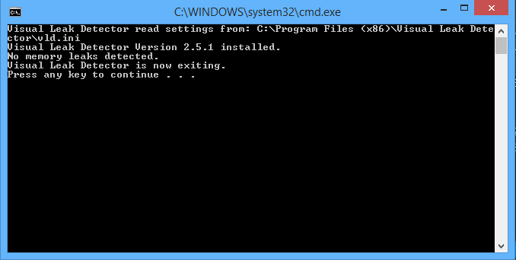Memory Leak State: