DOORBELL SYSTEM
SHRI LAKSHMI G
Electronics and Communication Engineering
Saranathan College of Engineering
ABSTRACT
The Smart Doorbell System is an Arduino Uno-based embedded system that detects a visitor's presence using an HC-SR04 ultrasonic sensor and an IR obstacle sensor. When a visitor is detected, the system displays a welcome message on a 16×2 LCD and turns ON an LED as an indication. The project provides a simple and cost-effective solution for automatic visitor detection and demonstrates the application of embedded systems in smart home automation.
INTRODUCTION
Smart home automation improves convenience and security by automatically detecting visitors and providing instant responses. This project uses an Arduino Uno, an HC-SR04 ultrasonic sensor, and an IR obstacle sensor to detect a person near the entrance. Based on the sensor readings, the Arduino controls a 16×2 LCD and an LED to greet visitors. The system demonstrates a simple and efficient embedded solution for visitor detection.
OBJECTIVE
- To detect visitors automatically.
- To display a welcome message.
- To indicate visitor detection using an LED.
- To implement a simple embedded system using Arduino.
- To improve convenience through automation.

COMPONENTS USED
Component | Purpose
Arduino Uno | Main controller
HC-SR04 Ultrasonic Sensor | Measures visitor distance
IR Obstacle Sensor | Detects nearby objects/persons
16×2 LCD Display | Displays messages
LED | Indicates visitor detection
Breadboard | Circuit assembly
Jumper Wires | Electrical connections
USB Cable | Power supply and programming

WORKING PRINCIPLE
- The Smart Doorbell System is developed using an Arduino Uno, an HC-SR04 ultrasonic sensor, an IR obstacle sensor, a 16×2 LCD display, and an LED. The Arduino Uno acts as the central controller, continuously monitoring the sensor inputs and controlling the output devices.
- When the system is powered ON, the Arduino initializes the LCD, ultrasonic sensor, IR sensor, and LED. The LCD initially displays the message "HAVE A GOOD DAY", indicating that the system is active and waiting for a visitor.
- The HC-SR04 ultrasonic sensor continuously measures the distance between the sensor and any object in front of it by transmitting ultrasonic waves and receiving the reflected echo. Simultaneously, the IR obstacle sensor detects the presence of a nearby object by sensing reflected infrared light.
- The Arduino continuously reads the outputs of both sensors. If the IR sensor detects an object or the ultrasonic sensor measures a distance less than 20 cm, the Arduino identifies that a visitor is present. It then turns ON the LED and updates the LCD to display the message "WELCOME", greeting the visitor.
- If no object is detected and the measured distance is greater than 20 cm, the Arduino turns OFF the LED and changes the LCD message to "HAVE A GOOD DAY".
- This process repeats continuously in the program loop, enabling real-time visitor detection and automatic message display. The system provides a simple, low-cost, and efficient solution for automatic visitor recognition using embedded system technology.
CODE DESCRIPTION
- Library Used: LiquidCrystal.h for interfacing the 16×2 LCD.
- Pin Definitions: Trig Pin (8), Echo Pin (9), IR Sensor (7), LED (13), LCD Pins (12, 11, 5, 4, 3, 2).
- Distance Calculation: The ultrasonic sensor calculates the visitor's distance.
- IR Detection: The IR sensor detects nearby objects.
- Decision: If the IR sensor is triggered or the distance is less than 20 cm, the LED turns ON and "WELCOME" is displayed.
- Display: Otherwise, the LCD displays "HAVE A GOOD DAY" and the LED remains OFF.
OUTPUT AND CIRCUIT CONNECTION

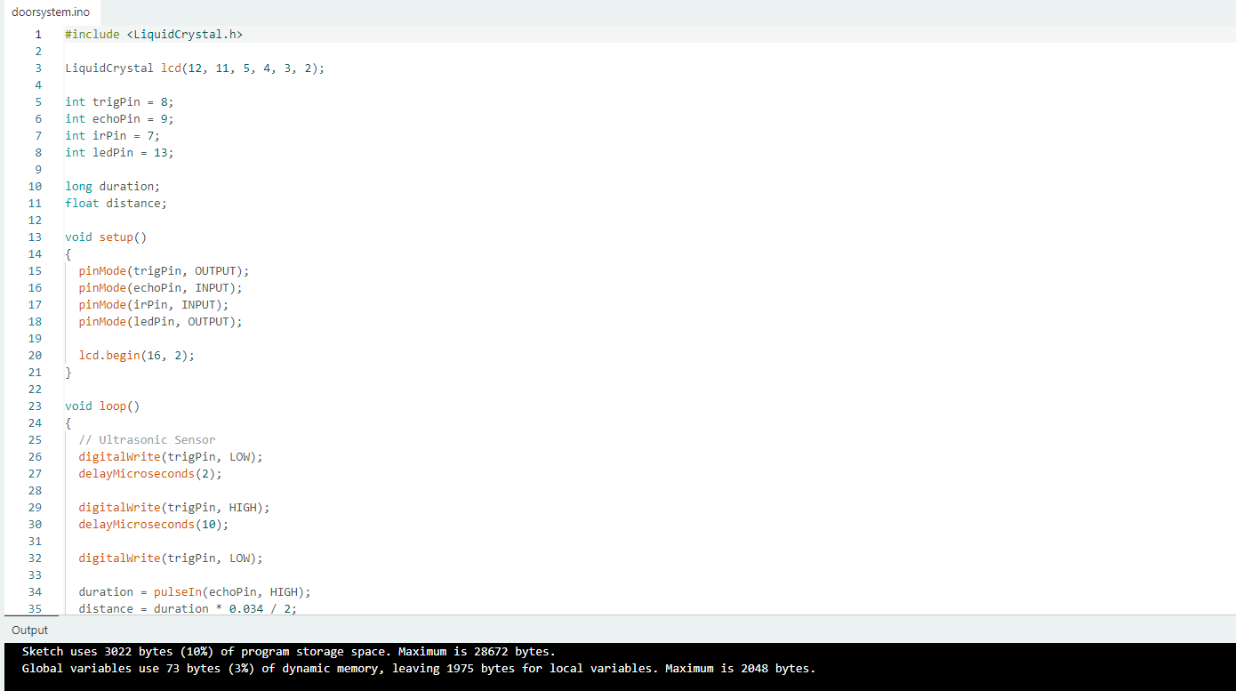

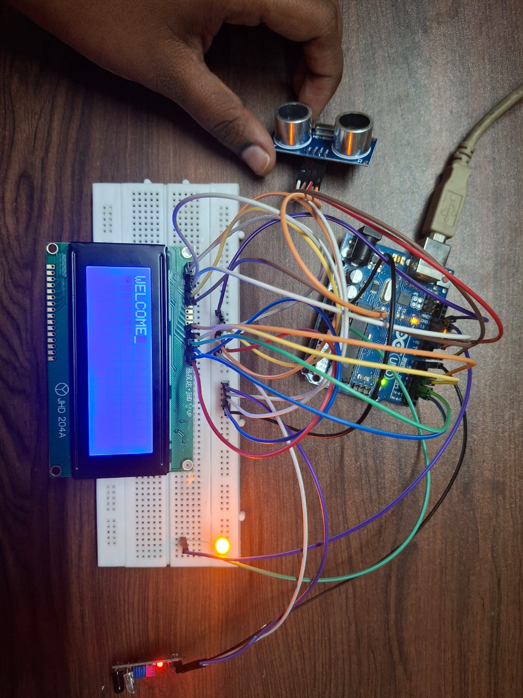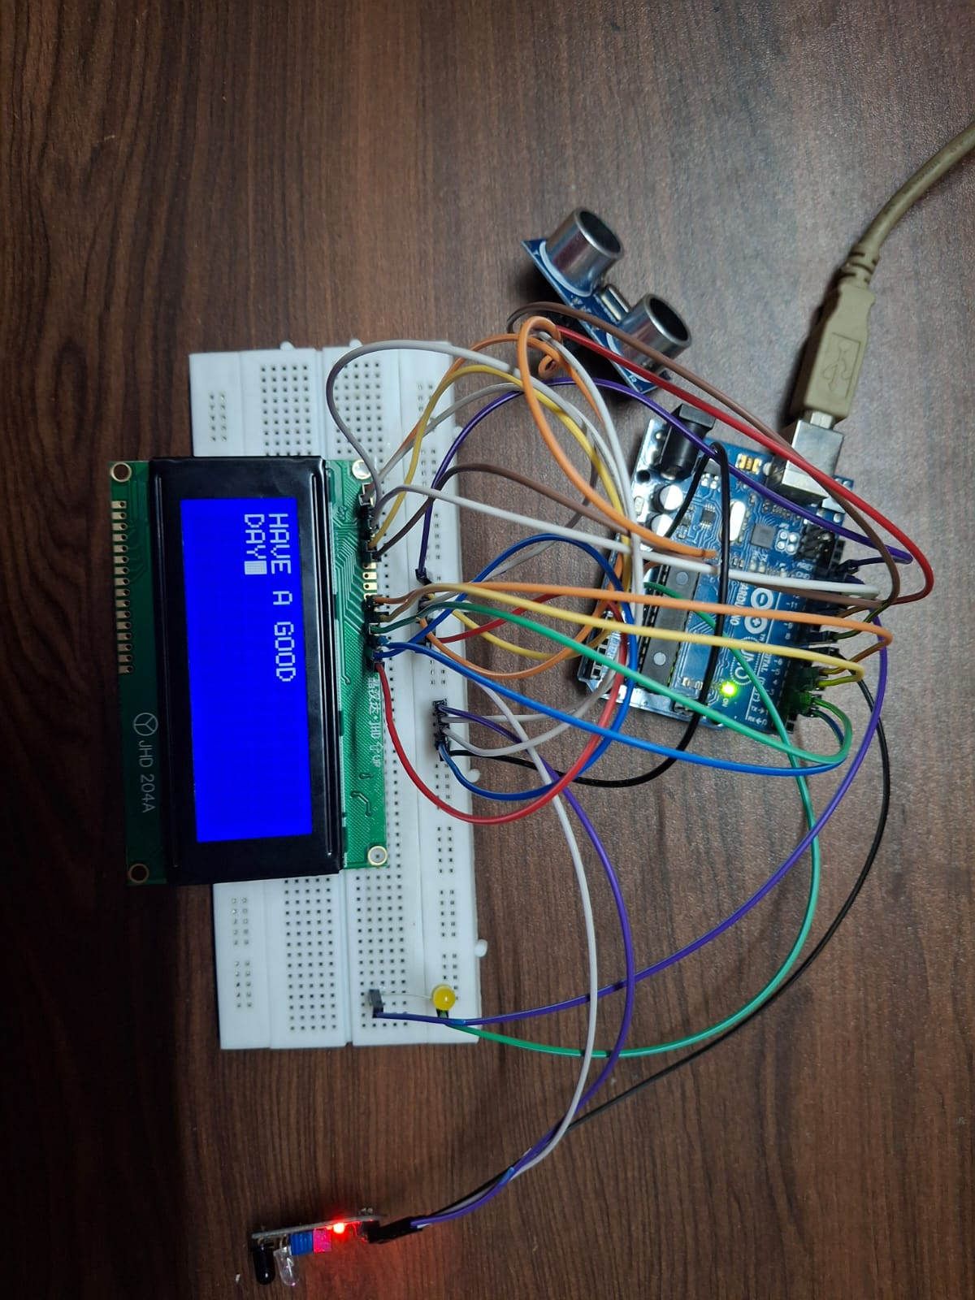

FLOWCHART
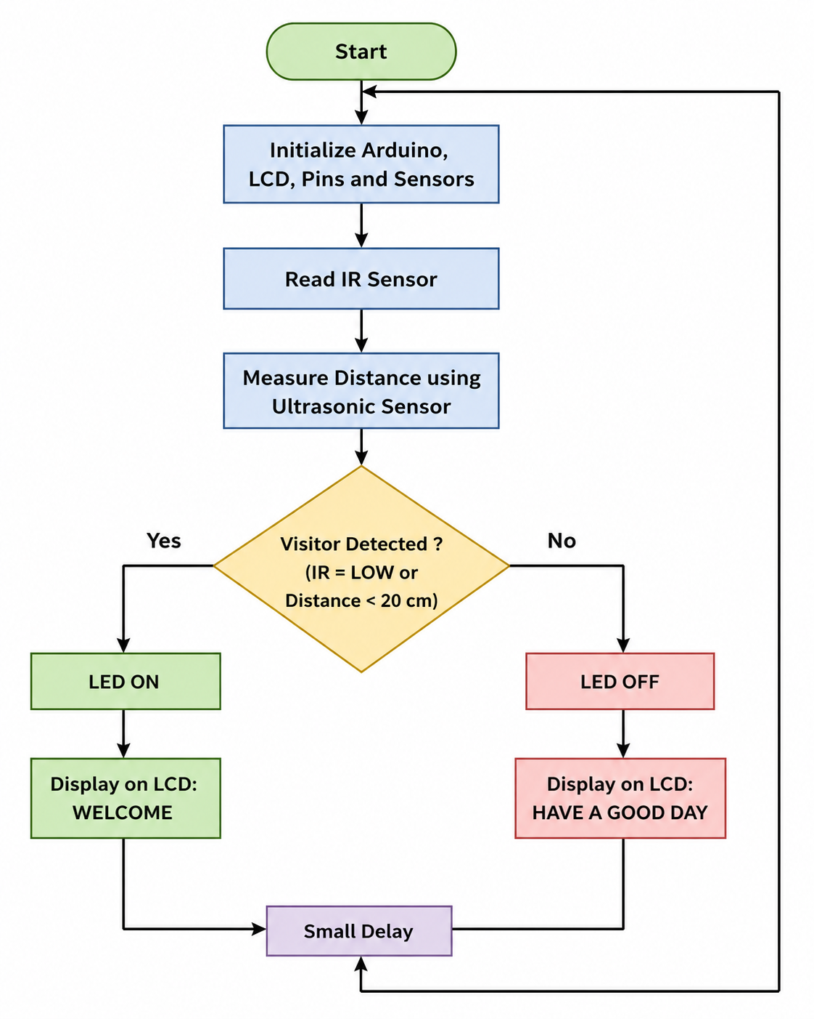

CONCLUSION
The Smart Doorbell System successfully detects the presence of a visitor using an HC-SR04 ultrasonic sensor and an IR obstacle sensor controlled by an Arduino Uno. When a visitor is detected, the system displays a welcome message on the LCD and turns ON the LED, providing an interactive and user-friendly experience. The project demonstrates the effective use of embedded systems and sensor technology for automatic visitor detection. It is a simple, reliable, and cost-effective solution that can be further enhanced with IoT features such as mobile notifications, cameras, or remote monitoring for smart home applications.

