Experiment No:2

Title: Evaluation Of Postfix Expression Using C.

Problem Statement: Evaluation Of Postfix Expression Using Stack.

Algorithm:

1) Add ) to postfix expression.

2) Read postfix expression Left to Right until ) encountered

3) If operand is encountered, push it onto Stack

[End If]

4) If operator is encountered, Pop two elements

i) A -> Top element

ii) B-> Next to Top element

iii) Evaluate B operator A

push B operator A onto Stack

5) Set result = pop

6) END

CODE:

#include <stdio.h>

#include <ctype.h>

#define MAX 100

#define POSTFIXSIZE 100

int stack[MAX];

int top = -1;

void push(int item)

{

if (top >= MAX - 1) {

printf("stack over flow");

return;

}

else {

top = top + 1;

stack[top] = item;

}

}

int pop()

{

int item;

if (top < 0) {

printf("stack under flow");

}

else {

item = stack[top];

top = top - 1;

return item;

}

}

void EvalPostfix(char postfix[])

{

int i;

char ch;

int val;

int A, B;

for (i = 0; postfix[i] != ')'; i++) {

ch = postfix[i];

if (isdigit(ch)) {

/\* we saw an operand,push the digit onto stack

ch - '0' is used for getting digit rather than ASCII code of digit \*/

push(ch - '0');

}

else if (ch == '+' || ch == '-' || ch == '\*' || ch == '/') {

A = pop();

B = pop();

switch (ch)

{

case '\*':

val = B \* A;

break;

case '/':

val = B / A;

break;

case '+':

val = B + A;

break;

case '-':

val = B - A;

break;

}

push(val);

}

}

printf(" \n Result of expression evaluation : %d \n", pop());

}

int main()

{

int i;

/\* declare character array to store postfix expression \*/

char postfix[POSTFIXSIZE];

printf("Press right parenthesis ')' for end expression : ");

printf(" \nEnter postfix expression,: ");

/\* take input of postfix expression from user \*/

for (i = 0; i <= POSTFIXSIZE - 1; i++) {

scanf("%c", &postfix[i]);

if (postfix[i] == ')')

{

break;

}

}

EvalPostfix(postfix);

return 0;

}

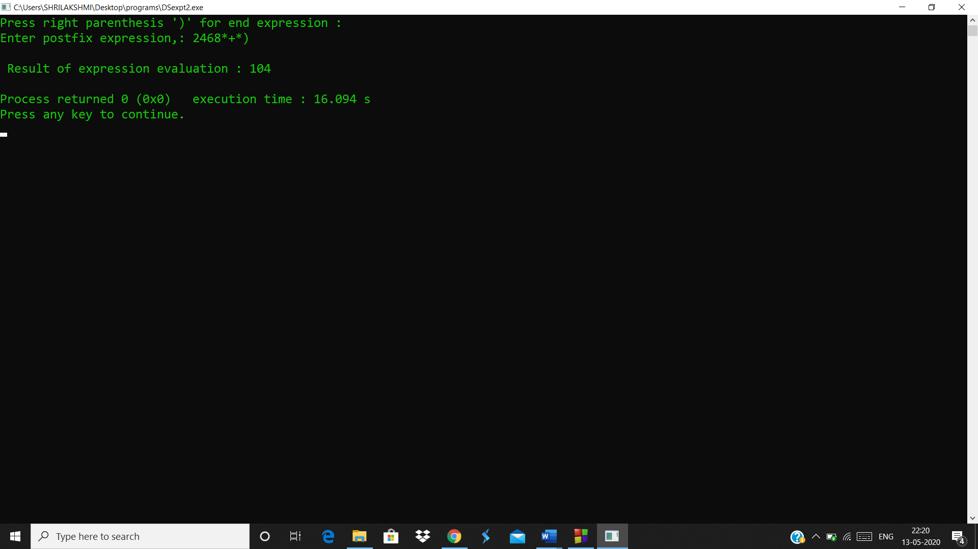

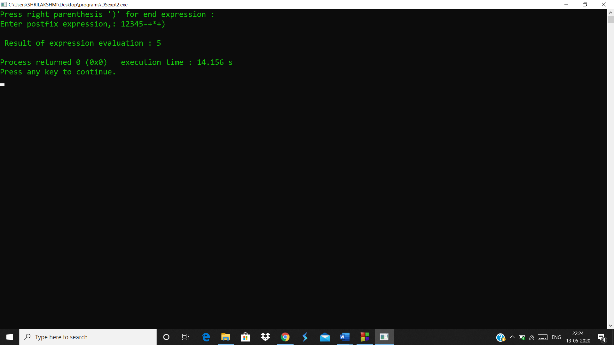

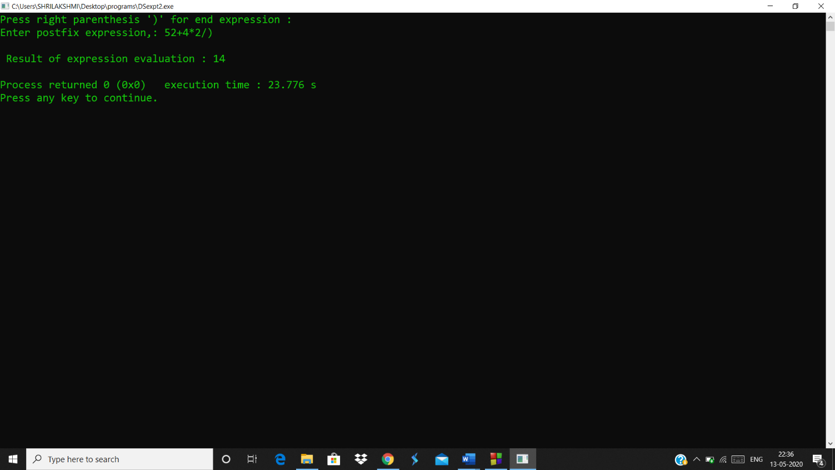

Analysis(Limitations):

* The program takes postfix expression from user and if any operation is not mentioned to be operated then it is unable to process.
* The numbers processed in the expression have to be single digit only.