**Experiment No. 3a**

**Title :** Factorial using recursion in C++.

**Problem Statement :** Implementing factorial of any number using recursion in C++.

**Algorithm :**

1. Start
2. Declare an integer variable and a function factorial()
3. Call the function in order to value whose factorial is to be found
4. Within the factorial function, if the integer is equal to 1 return else call the function by sending the value one less than previous integer.
5. Stop

**Code :**

#include<iostream>

using namespace std;

int fact(int n)

{

if(n == 1)

{

return(1);

}

else

return(n*fact(n-1));

}

int main()

{

int n,result;

cout<<"Enter the number : ";

cin>>n;

if(n==0)

cout<<"The factorial is : 1"<<endl;

result= fact(n);

cout<<"The factorial is : "<<result<<endl;

}

**Output :**

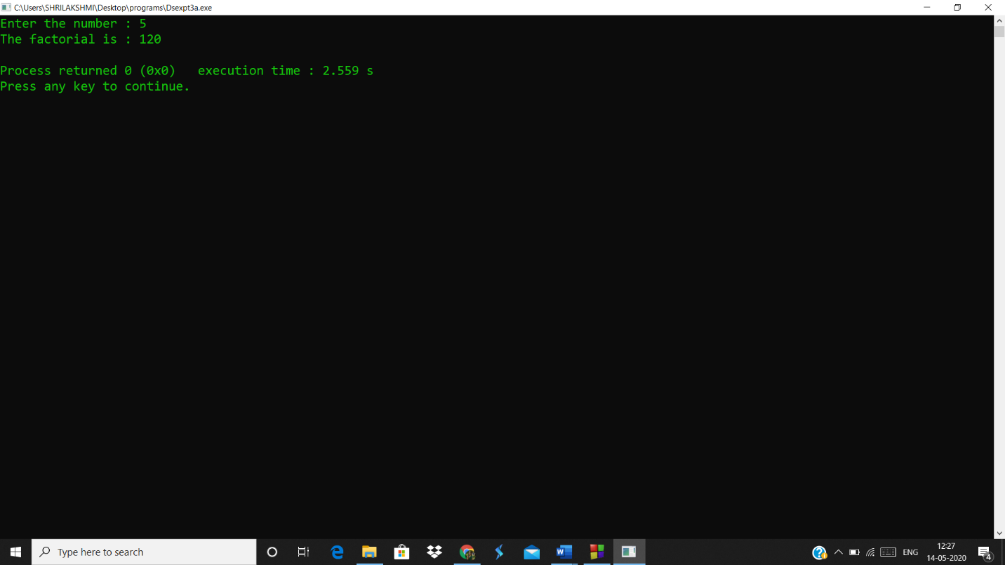

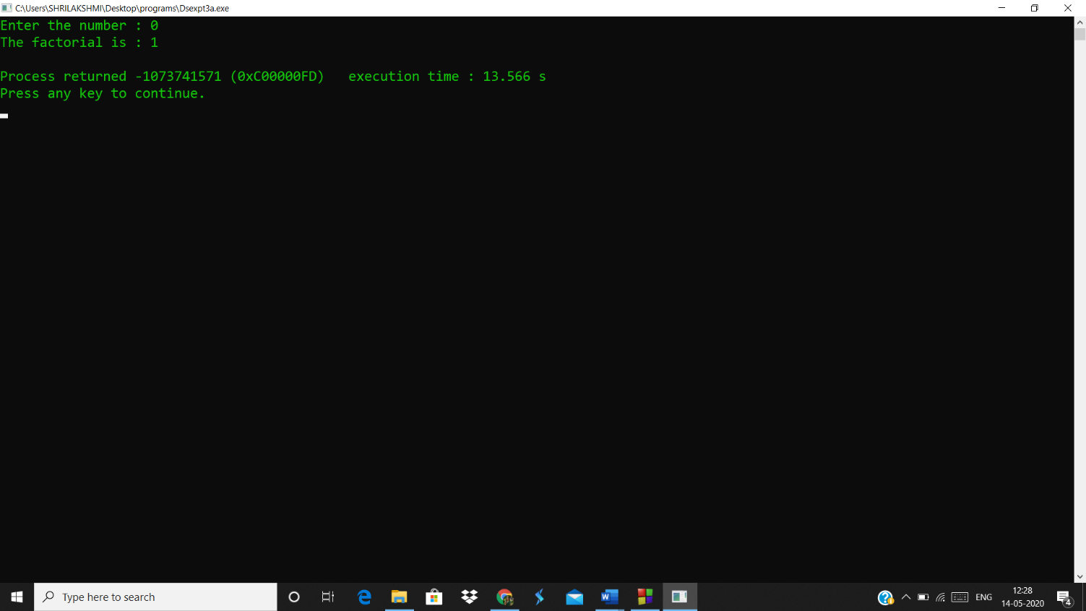

**Analysis(limitations)**

* Recursion is a very costly process when compared to looping because we can perform the operations using both.
* If the exit condition is not mentioned it will result in infinite loop.