**Experiment No.9**

**Title:** Implementation of Linear Search

Problem Statement: Write a C++ program to search an element in an array using Linear search

Algorithm:

**Step 1** **:** Start from the leftmost element of arr[] and compare x with each element of arr[].

Step 2 **:**If x matches with an element, return the index.

Step 3 : If x doesn’t match with any of elements, return -1.

Code:

#include<iostream>

using namespace std;

int main()

{

int arr[20],n,x,i,flag=0;

cout<<"How many elements?";

cin>>n;

cout<<"\nEnter elements of the array\n";

for(i=0;i<n;++i)

cin>>arr[i];

cout<<"\nEnter element to search:";

cin>>x;

for(i=0;i<n;++i)

{ if(arr[i]==x)

{ flag=1;

break;

}

}

if(flag)

cout<<"\nElement is found at position "<<i+1;

else

cout<<"\nElement not found";

return 0;

}

Results:

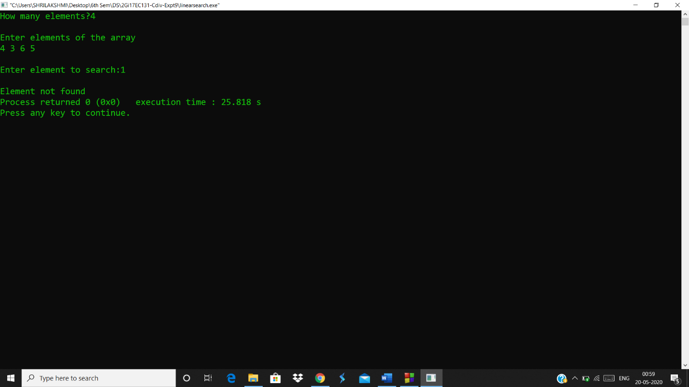

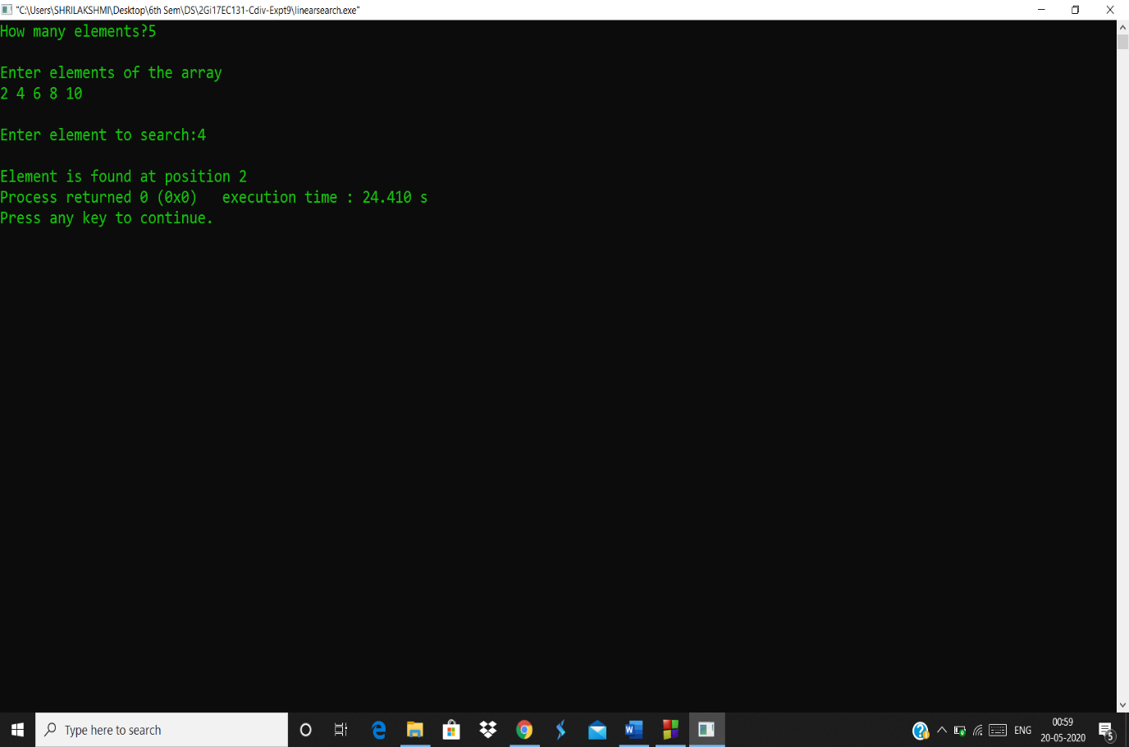

Analysis(Limitations):

* The worst case complexity is  O(n), sometimes known an O(n) search
* Time taken to search elements keep increasing as the number of elements are increased.