

{Title}
Proposal to {PartnerName} for {CustomerName}
Ver 1.0

Contents
Introduction 3
vuSmartMapsTM – Platform Overview 4
Scope of the Engagement 9
Solution Approach 15
Training 28
Post-implementation Support 29
Risk Management 31
Pricing 32
Appendix-1 – Functional Features 36

Change Log
Ver | Date | Description

Introduction
VuNet Systems is pleased to submit this proposal for implementing {Title} to {PartnerName} for {CustomerName}. We propose to deploy our Full Stack observability platform, vuSmartMaps™, to provide performance insights into applications and underlying infrastructure and the user experience
As part of this engagement, VuNet will deploy {ComponentNames} to deliver comprehensive Full Stack Unified Observability insights. This document outlines our understanding of {CustomerName}’s requirements and details VuNet’s solution approach, architecture, and execution approach to deliver enhanced real-time visibility and performance insights ensuring a unified, holistic view of operations.
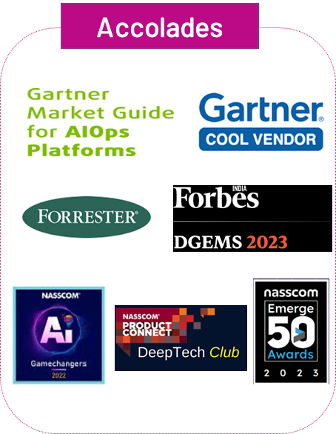
VuNet Systems is a recognized leader in Business Observability, specializing in delivering Deep Observability into Business Journeys. It empowers SRE and IT Ops teams to improve service success rates and application performance. Traceability empowers business teams and customer support teams with insights into business performance and customer experience. This enables faster incident detection and response. VuNet’s platform is highly scalable, flexible and intelligent for real time performance insights - all in a ‘single pane of intelligence’ powered by an advanced correlation engine handling millions of transactions per day.
VuNet’s Observability platform today handles over 28+ billion transactions worth $1500 Billion for leading banks and financial institutions. The company is Series B funded, part of NASSCOM DeepTech Club, awarded NASSCOM’s AI Gamechanger, recognized in Forbes DGEMS 200 and by several global analysts including Gartner, Omdia.

vuSmartMapsTM – Platform Overview
vuSmartMaps™ is VuNet’s flagship observability platform, built ground-up as a highly extensible Big Data and Machine Learning-based solution. It connects user experience, application performance, infrastructure, and IT operations into a unified visibility framework, enabling faster issue detection, root cause analysis, and operational insights.
The platform is designed to address the complex observability needs of modern digital enterprises, supporting large-scale, distributed and citizen scale environments.
Key Features of vuSmartMapsTM for Observability
- Observability Pipeline for Ingestion, Enrichment, and Routing
vuSmartMaps™ leverages its ContextStream data pipeline to ingest both structured and unstructured data, as well as events, from diverse sources. The platform supports data collection through agents, streaming queues, centralized repositories, and APIs. Once ingested, the data is enriched, transformed, and mapped to VuNet’s transaction schema, enabling comprehensive correlation, computation, and visualization across technology layers.
- Hyperscale Data Store
The platform features a composite columnar data store architecture designed for high-volume, real-time data processing. This layer efficiently manages storage and supports advanced data modeling requirements, ensuring performance at scale while enabling detailed analytics on large datasets.
- Data & Machine Learning Operations Layer
Utilizing 3T correlation (Transaction ID, Topology or Temporal) approach, the ingested data is correlated, transformed, and enriched to create an operational data lake. This foundation enables machine learning use cases such as anomaly detection, user experience indices, and delivering proactive and actionable insights.
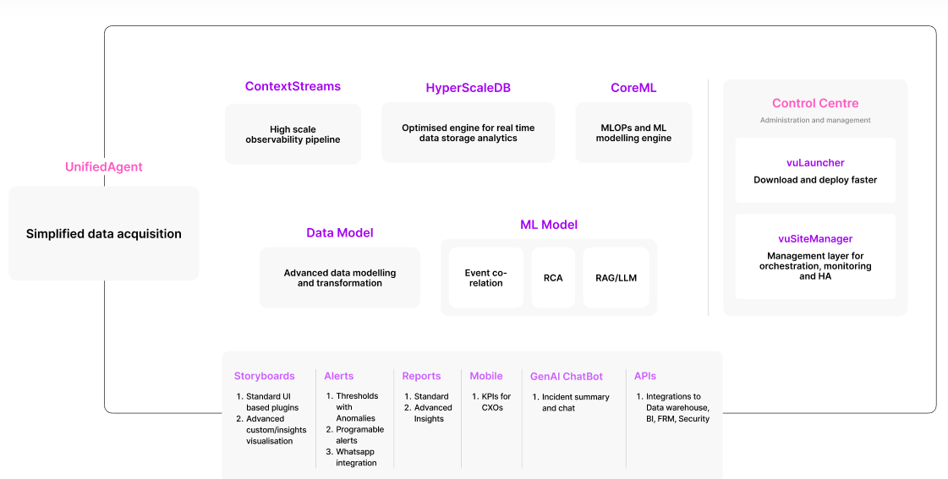
- Visualization Layer
vuSmartMaps™ provides pre-built storyboards for multiple teams and CXO dashboards. The platform supports customizable visualizations, role-based access, and dynamic views, allowing stakeholders at all levels to derive meaningful insights.
- Domain-Centric Adapters and Transaction Correlation for Financial Journeys
vuSmartMaps™ includes domain-centric adapters purpose-built for financial transaction journeys, designed specifically for BFSI environments characterized by heterogeneous applications and diverse messaging standards. These adapters provide native understanding of financial transaction semantics, enabling consistent decoding, enrichment, and correlation of transaction data across channels and systems. The adapters natively interpret industry and banking-specific constructs, including:
  - ISO 8583, ISO 20022, and proprietary banking message formats
  - Message types, response and reason codes
  - Processing stages and inter-system handoffs
  - Financial attributes such as transaction identifiers, amounts, channels, and transaction outcomes
By embedding domain intelligence directly at the ingestion layer, vuSmartMaps™ transforms raw technical telemetry into structured, business-relevant transaction data. This enables accurate end-to-end correlation of transactions, real-time visibility into transaction health and performance, and clear identification of failures, delays, and customer impact across complex financial journeys.
- Session and Transaction Identifier Correlation Across Touchpoints
In addition to domain-aware transaction parsing, vuSmartMaps™ provides native capabilities to correlate session identifiers and transaction identifiers across distributed systems and channels. The platform includes adapter-driven mapping and correlation functions that enable persistent tracking of a transaction or customer session as it traverses multiple touchpoints.
This capability supports correlation across channels, middleware layers and integration layers, core banking systems, payment switches, and downstream processors.
vuSmartMaps™ resolves identifier inconsistencies introduced by system-specific transformations, reformatting, or protocol differences. As a result, the platform can accurately reconstruct end-to-end transaction flows even in environments where transaction identifiers change across systems, logs are generated in different formats, or native correlation is unavailable within individual tools. This ensures reliable, end-to-end traceability of transactions and customer sessions across complex, multi-system financial journeys.
- Journey Workbench (JWB) – Transaction and Journey Modeling Framework
Journey Workbench (JWB) is vuSmartMaps™ native framework for modeling, correlating, and operationalizing end-to-end business transactions and payment flows. JWB enables teams to standardize how transactions are defined across applications, convert raw logs into structured transaction telemetry, and correlate multi-hop interactions across systems into complete, end-to-end journeys. Using schema libraries, transaction modeling utilities, and journey configuration tools, JWB ensures transactions and journeys are onboarded in a consistent, repeatable, and scalable manner. This provides real-time traceability, performance visibility, and impact analysis across complex payment flows, forming the foundation for production-grade Business Journey Observability.
Architecture
The vuSmartMaps™ platform is designed as a modular and extensible architecture, delivering Full-stack Observability and Enterprise Data Lake through specialized product modules. These include Real User Monitoring, Synthetic Monitoring, Infrastructure Observability, Application Observability and Log Analytics.
The platform’s comprehensive design ensures unified visibility across hybrid deployments, with utilities like O11ySources, Journey Workbench, and Control Center modules for simplified management, scalability, and ease of use.
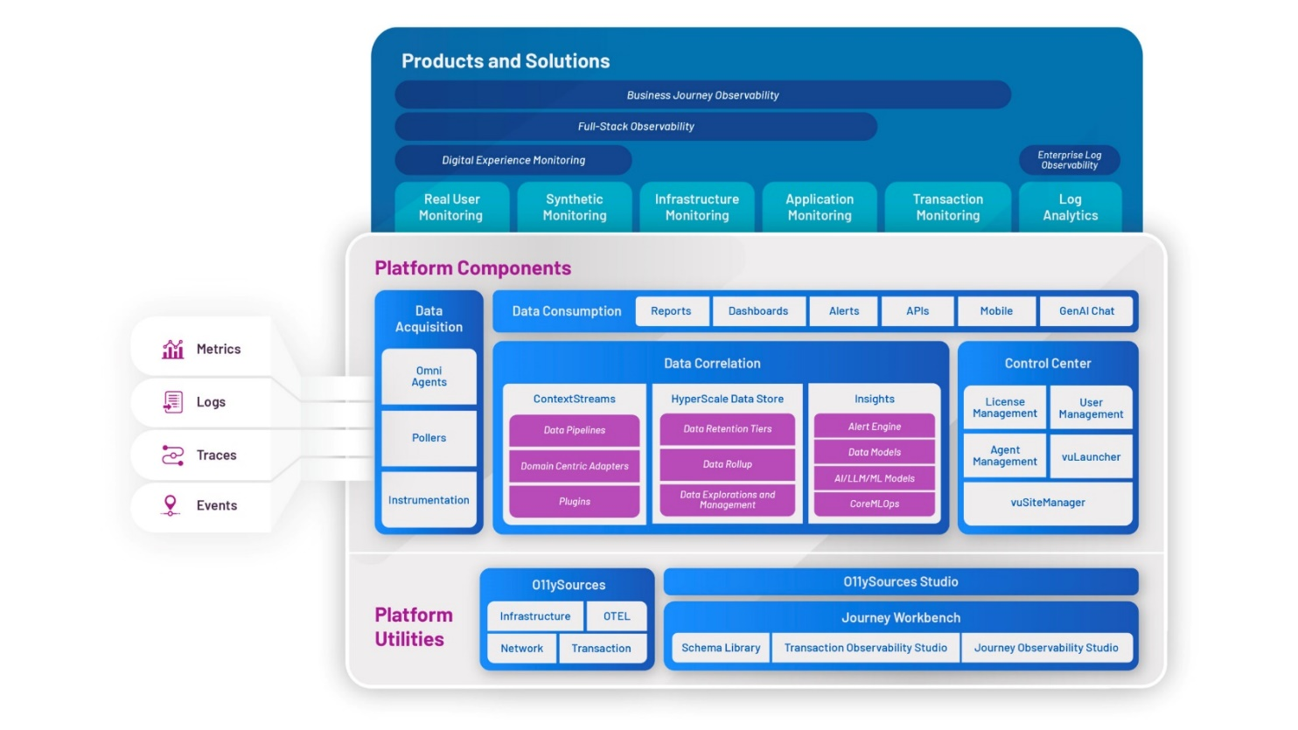
Based on the scope discussed and the proposed solution, VuNet will deploy its {ComponentNames} modules to enable Traceability and Observability of payment flows and enable comprehensive visibility across the digital ecosystem.
Based on the scope and the solution proposed, VuNet will enable {ComponentNames} to bring-in application traces from OTEL, digital experience metrics through RUM and Synthetic Monitoring, infrastructure metrics, system logs, application logs and error / exception logs to provide unified visibility of application performance.
Platform Differentiation
- Unified Observability – Infrastructure, application metrics, traces, and logs are correlated in a single platform and data model, not across loosely integrated tools—ensuring faster diagnosis with full context.
- Insights from Logs for RCA - Logs are analyzed and correlated in real time with metrics and traces, enabling teams to pinpoint root cause quickly, not after the incident.
- Domain Context - Telemetry is enriched with application & API context, helping teams understand business impact, not just technical symptoms.
- Lower TCO – One deployment, shared pipelines, and unified storage eliminate tool sprawl—delivering enterprise-scale observability at a significantly lower total cost.
- Domain-centric Design – Built from the ground up around business journeys and traceability of payment flows.
- Domain-Aware Intelligence – Natively understands payment standards such as ISO 8583 and ISO 20022, enabling context-aware interpretation of transaction data.

Scope of the Engagement
VuNet’s engagement with {CustomerName} will focus on Full Stack traceability with Log Analytics and Digital experience Observability with Real User Monitoring and synthetic monitoring across all in-scope application touchpoints.
- Inventory
S.No | Component | Units
1 | vuSmartMaps  Platform Instances:
2 | vuInfra360  Number of Infrastructure components, network devices and Database instances
3 | vuTXN360  Web and App server (Cores/vCPU)
4 | vuApp360  Web and App server (Cores/vCPU)
5 | vuLogX  Log size (GB/day)
6 | Digital experience Observability - Real User Monitoring (RUM)  No of user sessions per day
7 | Digital experience Observability - Browser based Synthetic Monitoring
8 | External tools to be integrated
9 | No of Business Journeys and touchpoints

- Applications and Tech stack in Scope
# | Application Name | Complete Tech Stack with Version  / OEM Name
1
2
3
4
5
6
7
8

- Retention
Retention | Comments
7 days - Hot | Real time Search Analytics
30 days - Warm
90 days - Cold | Data from Cold storage can be transferred to Hot Storage for real time views and Analytics

- Functional features
vuSmartMaps Core Platform Services | - Big Data cluster configuration and central platform – aggregation, correlation and visualization engine  - Data pipeline and ingestion capability from diverse data sources, common data schema, data enrichment capabilities and alerting engine.  - Integration to ITSM  - Role Based Access  - Reports
Transaction and Journey Observability (vuTXN360) | - Enables transaction-level visibility using logs and database records  - Where feasible, leverages unique identifiers and telemetry to stitch multi-hop applications into an end-to-end business journey view  - Helps correlate performance degradation or failures to business impact, supporting faster root cause analysis and incident prioritization  - Useful for transaction-heavy workflows where APM-based tracing is unavailable or incomplete
Application Observability | - Instrumentation and integration of traces for RED Metrics for all services (Rate, Error, Duration).  - Detailed context with method and class through stack trace for unhandled exceptions.  - Detailed error context through stack trace
Infrastructure Observability | - Health and performance monitoring of servers (Web, App, Database)  - Monitoring of Kubernetes environments, including container health and resource utilization  - Database monitoring for performance KPIs, long-running queries, top consumers, and resource usage  - Real-time dashboards for infrastructure metrics with historical comparison  - Alerting mechanisms for infrastructure anomalies and threshold breaches
Real-User Monitoring | - Comprehensive Performance Insights: Tracks page load times, Core Web Vitals (LCP, FID, CLS), long tasks, and API/XHR performance to provide end-to-end visibility into user experience.  - Error and Issue Detection: Monitors JavaScript errors, HTTP error codes, and API trace failures to pinpoint and troubleshoot frontend and backend issues effectively.  - Rich Visualization & Dashboards: Includes dashboards for applications, pages, api, sessions, long tasks, and trace maps, along with geo-maps for location-based performance analysis.  - Flexible Deployment & Integration: Offers lightweight JS SDK (SPA/MPA support), compatibility with OpenTelemetry, Docker/Kubernetes readiness, secure HTTPS transmission, and options for CDN
Browser based Synthetic Monitoring | - Automated browser tests at scheduled intervals or on demand  - Mimic user actions in web apps through simulated real user journeys  - Collection of telemetry data from browser interactions, including page load times, response times, and HTTP errors.  - Tracking every step to log, analyze, and diagnose failures in real user workflows.  - Measurement of total execution time and step-level response times  - Automated screenshot capture at failure points  - Execute multiple synthetic journeys in parallel to test high-traffic scenarios
vuLogX – Log Aggregation and Analytics | - Ability to perform live searches, queries, and dashboard operations on the logs.  - Additionally summarized metrics for KPIs, trends, patterns, and analytics  - Capability for free text searches in logs to locate matching entries, view and download with searches conducted over specified time periods.  - Availability of additional optional filters for refined searches, such as API, Transaction Type etc.  - Ability to extract deeper fields of interest
Alerting & Notifications | - Configuration of static and dynamic threshold-based alerts across infrastructure, applications, and user experience metrics  - Proactive notifications via Email and SMS to relevant stakeholders  - Centralized Alert Dashboards for incident visibility and tracking
Reporting & Analytics | - Standard KPI reports for infrastructure, application, and user experience performance  - Trend analysis for proactive capacity planning and performance optimization  - Scheduled and ad-hoc reporting for key stakeholder groups
Access Management & Governance | - Role-based access control (RBAC) for users  - Segregated views and dashboards for operations and infra & application owners
Deployment & Enablement | - Deployment of vuSmartMaps™ platform on {CustomerName}-provided infrastructure (on-premises)  - Agent installations and configurations for data collection from servers, databases, and application layers  - Training and handover to {CustomerName} teams for platform usage, dashboard management, and reporting  - Ongoing support to drive adoption of the platform
The detailed feature listing is provided in the Appendix -1 section of this document.

Solution Approach
VuNet will deploy its platform in the customer provided hardware and integrate performance & golden signals for all the touch points such as Web Server, App Server and DB Server. Data collected from these touch points will then provide the following -
- Operational Storyboards – IT Heads, ITOps and SRE
- Server, Network, Storage, Database and Application Health and Performance Dashboard
- Alert Dashboard
- Proactive Alerts in email and SMS
- Reports and trends
Implementation Approach
VuNet will follow its standard 4D implementation methodology for the engagement.
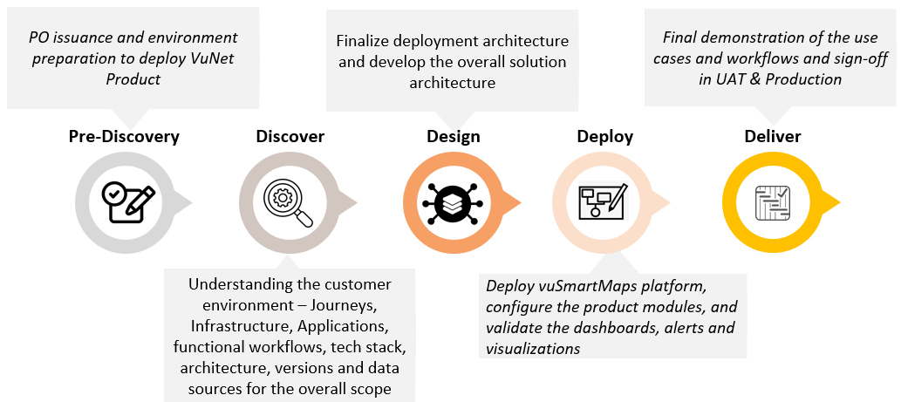
Deliverables
# | Stages | Deliverable
1 | Pre-Discovery | Sharing of Pre-requisite document, Inventory and requisite access requests
2 | Discover | Confirmation on the inventory, log walkthrough, verification of infra provided
3 | Design | Solution Design document
4 | Deploy | Showcase of configured dashboards, alerts, and workflow
5 | Deliver | Final showcase for sign-off in UAT, followed by production deployment & sign-off  User Guide and End User Training
VuNet proposes to deploy the platform in Production and configure the features in as per the implementation plan discussed and baselined as part of the Discover phase of the implementation. This baselined project plan mutually agreed by VuNet and {PartnerName} during the Pre-Discovery will become the basis for the implementation phase.
VuNet proposes to deploy the platform in Production and configure the features in 4 months post all the prerequisites (including access to infrastructure for VuNet platform and agent installation) have been provided and fulfilled. The initial verification will happen in UAT. This will be discussed and baselined as part of the Discover phase of the implementation.

Indicative Schedule is below:
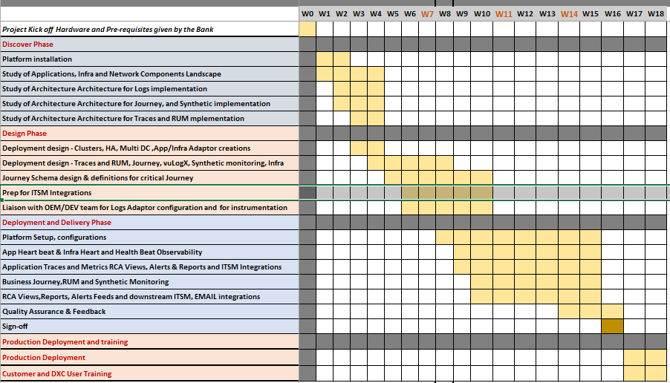
Production go-live schedule will be planned after discussions during Pre-discovery and Discovery
Pre-Discovery phase can start only after the following:
- All the Pre-requisites are fulfilled- including understanding application Technical stack and overall landscape, applicable logs, traces and metrics details, and Infrastructure nodes
- UAT hardware with root access
- Approval for Production Hardware
- Location and space for Onsite Resources if applicable.
- Access to the Application OEM for any instrumentation, Log walkthrough and agent installation in server
During Implementation the following needs to be taken care to achieve the schedule:
- Environment Access: VuNet will require appropriate approval from the {CustomerName} for timely access to the {CustomerName}’s environment (UAT/DC/DR) and relevant systems to carry out implementation activities efficiently. Access may be required during extended hours depending on scheduled activities.
- Access Provisioning prior to Implementation: VuNet would request the {CustomerName} to enable all necessary accesses, approvals, and credentials prior to the commencement of the implementation to ensure smooth and timely execution.
- Technology Stack & OTEL Readiness: It is assumed that the {CustomerName}’s applications and services are compatible with OpenTelemetry (OTEL) standards and generate required telemetry such as application, error and exception logs. The list of supported technologies is provided in Appendix-1. Any application using a non-standard technology stack or requiring manual instrumentation will fall outside the standard scope and may require separate evaluation.
- Consistency Across Environments: VuNet has based in the plan, efforts and schedule considering the technology stack and version of each application to remain consistent across all environments (UAT / DC / DR ). Support from {CustomerName} is expected to address any deviations identified during implementation immediately to avoid delays and the need for effort re-estimation and Change Request (CR) process.
- Completeness of Technical Details: VuNet would request that comprehensive details on application technology stacks, infrastructure, and network components be shared during infrastructure the discovery phase. Any requirement for non-standard or manual instrumentation identified during this stage may be considered outside the implementation scope.
- Telemetry Quality: VuNet would request the {CustomerName} to ensure the quality and completeness of telemetry generated by the {CustomerName}’s applications and supporting system, as the accuracy of KPIs and correlation depends on this. Supported technologies for traces and application observability are detailed in Appendix-1. In cases where telemetry is insufficient, unavailable, or originates from unsupported technology stacks, the resultant observability insights may be limited. This will be validated during the discovery phase.
FSO Roles and responsibilities – RACI:
# | Activity | Customer | Partner | VuNet
1 | Assign VuNet Engagement Manager | I | I | A/R
2 | Perform Current state assessment and Design the Deployment Architecture | C/I | C/I | A/R
3 | Provisioning hardware for FSO to deploy the VuNet platform | A | R | C/I
4 | Deployment of VuNet Observability Platform as per Technical Specifications and scope of work compliances | C/I | C/I | A/R
5 | Integrate VuNet Platform with ITSM, and Collaboration platform mentioned in scope | C/I | C/I | A/R
6 | Provide information on Integrations with ITSM etc.. | R | A | C/I
7 | Configure and perform End to End testing for the platform deployed | C/I | C/I | A/R
8 | Implement Role-Based Access Control and Data Segregation on VuNet Platform and Dashboards | C/I | C/I | A/R
9 | Providing Deployment Architecture for VuNet Platform | C/I | C/I | A/R
10 | VuNet platform deployment adherence to security and compliance requirements | C/I | C/I | A/R
11 | Facilitate the discovery session for VuNet to understand customer landscape | R | A | C/I
12 | Provide guidance and recommendations to application teams to improve the quality of performance telemetry and implementation of our adaptors | C/I | C/I | R/A
13 | VuNet Team provides pre-requisite lists for port opening for intra platform communication and platform to/from application environment communication | I | I | R/A
14 | Configure required firewall rules to open the ports listed above | A | R | C/I
15 | Setting up the agent rollout in the container environment | A | R | C/I
16 | Customer team to aid in identifying and configuring log file paths for log collection from API layers, micro services, and middleware | A | R | C/I
17 | VuNet Team to be provided with access details and read only access credentials for systems to which API/Data Integration will be done | A | R | C/I
18 | VuNet team setups the platform to collect data from JVMs, Databases (if any) device (load balancers) | - | C/I | R/A
19 | VuNet Team to be provided with access details and read only access credentials for systems to which performance/health metrics | A | R | C/I
20 | Details on alert configuration, notification and recipients | R | C/I | I/A
21 | VuNet Team sets up OOTB alert rules and alert notification channels | C/I | C/I | R/A
22 | Creation of RFCs (Request for Changes) or working on any documentation procedures to get access to customer environment | R | A | C/I
23 | VuNet Team provides training and documentation for managing alert notification/escalation channels and recipients | C/I | C/I | R/A
24 | VuNet Team sets up standard OOTB reports | C/I | C/I | R/A
25 | VuNet Team provides training and documentation for managing reports, reports scheduling and managing recipients | C/I | C/I | R/A
26 | VuNet Team provides training on using Dashboards and incident console | C/I | C/I | R/A
27 | Customer to provide category of user roles and role-based access controls required | A | R | C/I
28 | VuNet Team setups up user roles and access permissions in the platform | C/I | C/I | R/A
29 | Documentation & Training by VuNet Team | C/I | C/I | R/A
30 | Provide Standard instrumentation guide for Adaptors | C/I | C/I | R/A
31 | UAT Pre-deployment load simulation for VuNet Platform | C/I | C/I | R/A
32 | Testing and validation in UAT of SNMP traps for sudden load bursts caused by trap failures | R/A | C/I | C/I
33 | UAT Issue resolution | C/I | C/I | R/A
34 | User Acceptance Tests and Sign off – UAT and Production | R | A | C/I
35 | Quarterly capacity review and scale-up plan of VuNet platform as part of governance | C/I | C/I | R/A
36 | Enable Self-monitoring (vuSiteManager) for vuSmartMaps platform with alerts triggered for any incidents | C/I | C/I | R/A
37 | Assist DR Drills of the solution as and when required during implementation, and ensure RTO/RPO are met as per {CustomerName}’s BCP Policy. | C/I | A | R
Assumptions
- Customer to assign a dedicated SPOC for the implementation to support during project implementation and to enable faster data sharing.
- During the project Solutioning phase, it is possible that additional participation would be required by Functional Heads, Application and Infrastructure Support and other Domain experts to build appropriate IT Operation value dashboards.
- For each Deliverable, a sign off on the scope and deliverables will be done by the SPOCs in the stipulated time mentioned in the plan and mutually agreed, absence of which may invoke deemed sign off and ensuing payment release.
- Implementation will be done in a Remote model.
- Delays due to non-availability of data sources such as logs, DB data, metrics, device credentials, agent installation delays etc. for more than 2 days can cause timeline and cost escalations. Such delays will invoke a Change Request and impact mutually discussed.
- Remote access to the environment for deployment and ongoing management will be provided.
- The feasibility and quality of observability KPIs and correlation is dependent on the quality of the telemetry available in the customer environment and generated by the applications.
- If any custom dashboard needs to be created based on the data ingested from integrations with external systems, additional efforts will be involved, and this will be estimated separately.
Deployment Architecture
A high-level deployment view of the platform is depicted below:
The deployment architecture consists of:
- Data Collectors & Pipelines to ingest telemetry (metrics, logs, traces) from applications and infrastructure within each environment
- Data Store for storing and managing large volumes of observability data with optimized retention and roll-up mechanisms
- Analytics Engine for real-time processing, enrichment, and anomaly detection
- vuSmartMaps UI providing dashboards, reports, and alert consoles for various user personas
- Load Balancer (LB) to provide seamless user experience, routing user access across both instances

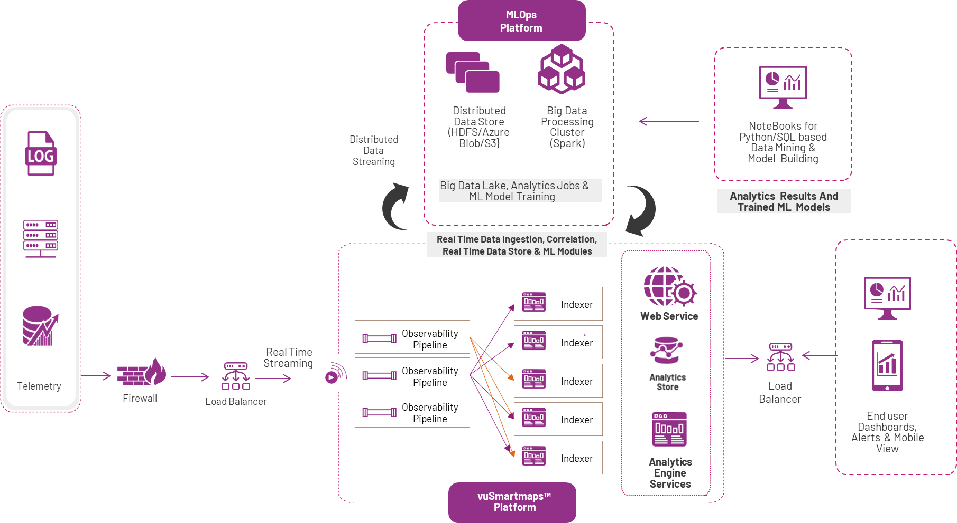
Multi-DC Deployment Architecture
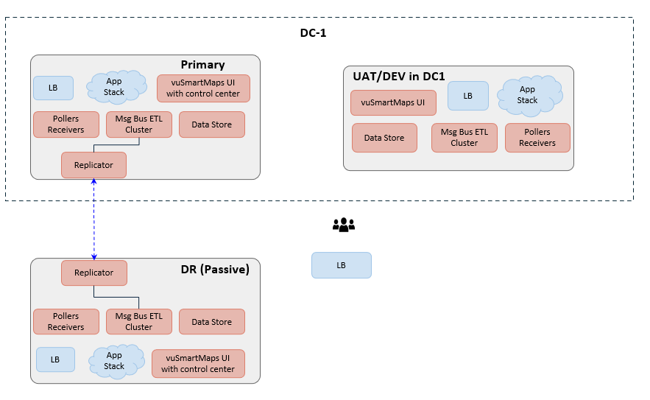

- vuSmartMaps deployment will be done in DC and DR with the instances operating in Active-Passive Mode
- Sizing/Installation in DC/DR are identical
- Active vuSmartMaps Site will provide real time observability to application stack and infrastructure from the application's active site/sites.
- vuSmartMaps Dashboards and analytics console available independently on DC and DR sites
- Data Receivers/Pollers deployed locally in each DC. Receivers/Pollers Sized to handle 100% of volumes. Data and configurations from Active DCs replicated to DR site in near real time.
Platform Release Version
- vuSmartMaps - SKU: VUN-VUSMART-2.16.0-NG
Pre-requisites
Each vuSmartMaps TM component can be deployed on managed K8S environment. VuNet’s software is shipped as a software appliance and requires no further licenses apart from vuSmartMapsTM to deploy and operate.
The following are the pre-requisites:
- Access to vuSmartMaps TM VMs using SSH.
- Depending upon the environment, permission might be required to install and run collector agents.
- Necessary ports are to be opened between Platform components and the monitored end-nodes if there is any firewall between them. Enablement of firewall policies on specific ports between vuSmartMapsTM IP and target monitored endpoints.
- Inventory details for the environments in scope
- Data Acquisition from endpoints via agent/agentless/trace instrumentation
- Access credentials for all integrations in scope.
- The sizing for hardware will be submitted by VuNet as part of Discovery phase upon finalization and alignment on scope & solution.
Hardware Requirements
VuNet’s platform will be deployed on an {PartnerName}/{CustomerName}-managed Kubernetes cluster. The sizing below represents the baseline production setup.
The indicative configuration is below and will be finalized during discovery phase
Year 1
Worker Group | vCPUs | Memory | Num VMs | Hot Storage  (GB) | Warm Storage (GB) | Cold Storage (GB) on S3 Compatible storage or single block storage
Storage | 16 | 64 | 2 | 2000 | 1000 | 1500
Pipelines | 8 | 16 | 1
Ingress and Core | 16 | 32 | 3
DataHub | 12 | 24 | 3
vuSiteManager | 8 | 16 | 1
TOTAL | 132 | 328 | 10 | 4500

Synthetic Monitoring
 | vCPUs | Memory | Num VMs | Storage (GB)
TOTAL | 16 | 32 | 2 | 200

UAT
 | vCPUs | Memory | Num VMs | Storage (GB)
TOTAL | 80 | 320 | 5 | 3000

Storage Type Recommendations:
Disks (Storage and Data Hub) | Low latency SSD, <25 ms, 20K IOPS, 250MBps sustained throughput, 1Gbps Burst Throughput
Disks (Warm and Others) | Medium Latency, <100 ms, 5k IOPS, 125 MBps sustained throughput, 1Gbps Burst Throughput
Network Bandwidth | 25Gbps
Platform Requirements | Managed K8S cluster with workers matching the estimated hardware sizing specifications
Assumptions for Hardware sizing in Primary DC (Year 1):
- VuNet Platform to be deployed on Managed K8s environment (To be provided by {PartnerName}/{CustomerName})
- 100 users of VuNet Platform
- Infrastructure components, Network devices, Database count - 364
- Transactions per day – 300,000
- Peak Transactions per second – 500
- Smart Sampling of traces– 20%
- Logs size: 47 GB / day
- Real user Monitoring – 885,000 user sessions per year
- Synthetic monitoring – 4,900,000 Synthetic runs per year
- The estimated/indicative Infrastructure sizing is based on current observability scope and expected data volumes. This will be reviewed periodically post-deployment, based on actual data ingestion, data retention and platform usage. Any adjustments, if required, will be discussed and aligned jointly to ensure optimal performance and scalability
- Hardware provided should be in the configurations mentioned above and in the same environment
- We should have a “/var” partition in all VMs with minimum 80GB to load the docker images.
- Ensure that all the partitions are being used by the same user and user group.
-sudo chown -R user:user group /data
- Supported OS –
  - Ubuntu – 20.04, 22.04
  - RHEL – 7.x, 8.x, 9.x
  - CentOS – 7.x,8.x
  - Oracle Linux – 7.x,8.x
- Retention
  - 7 days hot, 30 days warm and 90 days

Training
VuNet Systems will provide 5 days of certification program including product usage, technical hands-on session to the operations team. The training course will cover the following topics.
- Current State of IT Operations and Management
- Working with vuSmartMaps
- Configuring and Customizing vuSmartMaps TM to get smarter insights.
- End user training in consuming the Storyboards
- Navigating the KPIs and RCA dashboards
- Creation of new alerts, reports
- Administration – creation of users, groups, privileges etc.
- Exercises and hands-on sessions to reinforce learning.
At the end of the course, an assessment including a practical assignment will be conducted by VuNet and provide certifications.

Post-implementation Support
VuNet will provide remote Post-implementation Support upon sign-off of the implementation phase.
As part of the OEM Support, VuNet will provide remote services to address any incidents reported on the vuSmartMapsTM production deployment of the platform. The responsibilities will include addressing production Incidents attributed to VuNet platform and providing monthly reports of incidents reported along with SLAs.
Product Incident Support
For any production support issues, the following SLAs will be applicable.
PRIORITY |  | PRIORITY DEFINITION | RESPONSE TIME
1 | CRITICAL | Issues that cause a total system outage, critical business function failure, or severe security risk. These incidents impact all users or a significant part of the business and require immediate attention and resolution. | 60 Mins
2 | HIGH | Issues that significantly impact a portion of users or a critical component of the software. These problems need quick resolution but do not affect the entire system or business operations. | 90 Mins
3 | MEDIUM | Issues that affect specific users or non-critical components. The impact is moderate, and there may be workarounds available. These issues are important but not urgent. | 4 Hrs  (Business Hours)
4 | LOW | Minor issues or inconveniences that do not significantly impact business operations or user experience. These can be addressed during regular maintenance windows. | 8 Hrs  (Business Hours)
Product Incident Classification
VuNet is not liable for SLA in case the issue root cause is not related to the VuNet component. The customer support team will undertake the initial root cause analysis of the problem and in the event of it being established that a VuNet component is contributing to the incident, a call will be raised with the VuNet Support team.
The current description of the severities is provided below –
Severity | Description | Examples
S1  Fatal | - A service outage, degraded service or problem that has a major impact on business.  - Significant problem that affects multiple locations | - Application Crash
S2  Functional | - Limited Business Impact  - A degraded service or functionality | - Error in dashboard or report  - Increase in screen load time

Risk Management
This section outlines the responsibilities, rights, and remedies in the event of project delays.
Customer Delays
Delays caused by the Customer due to infrastructure readiness issues, port openings, firewall rules, failure to whitelist VuNet’s applications/agents in anti-virus software, inadequate hardware provisioning, infrastructure downgrades, errors in Customer applications, delays in clearance for VAPT/AppSec, or the unavailability of Customer SPOCs or dependent teams, will impact project timelines and will be addressed as follows:
- Notification Procedure: VuNet will notify the Customer via email of any delays, providing detailed documentation of the cause and impact on the project.
- Timeline Extension: VuNet will request a reasonable extension of the project timeline to accommodate Customer delays, supported by evidence of the delay and its impact on the project. If this extension affects VuNet’s overall estimated effort, a formal change request will be submitted.
- Resource De-boarding: If the Customer does not provide the requested extension or the necessary information within 5 working days, VuNet may deboard its resources from the project. Project execution will remain on hold until the Customer remedies the delay.
- Deemed Sign-Off by Customer: Upon completion of the knowledge transfer for each application, if VuNet does not receive formal communication from the Customer within 5 working days, the deliverables will be considered as accepted and signed off by the Customer.
VuNet Delays
In the event of a delay caused by VuNet, the process will be as follows:
- Notification Procedure: VuNet will notify the Customer via email of any delays, providing detailed documentation of the cause and impact on the project.
- Mitigation Efforts: VuNet will make reasonable efforts to mitigate the impact of the delay and complete the project as soon as practicable.
Force Majeure Events
In the event of delays caused by Force Majeure—events beyond the reasonable control of either party (e.g., natural disasters, war, terrorism, government regulations, strikes, epidemics/pandemics)—the affected party will be entitled to an extension of the project timeline proportional to the impact of the Force Majeure event.
Pricing
License Fee
The following will be the commercial considerations for the engagement.
- Recurring annual license fee for the platform
- One-time implementation fee for setting-up, configuring and customizing the platform.
Annual License Fee
# | Description | Scope Units | Fees (INR)
1 | vuSmartMaps - Base Platform  vuSmartMaps, vuTXN360, vuApp360,vuInfra360, vuLogX, RUM, Synthetic | - Refer Scope
 | Total
- To handle yearly growth in volumes a 10% revision is applied on license, and the summary is as follows:
Component | Year-1 | Year-2 | Year-3
Total License Fee

- The implementation fee for growth will be estimated and charged as mentioned in Change Management section
- For the implementation, VuNet proposes a one-time fixed fee of <Cost>
- Advanced support services for dedicated remote post-implementation support and drive adoption can be availed at ₹ 25,00,000 per annum.
Terms and Conditions
Inclusions:
- Upto 100 end-user licenses to access the platform.
- Product documentation
- All runtime software needed for the platform.
- Remote OEM standard product supports post go-live for the duration of the contract.
Exclusions:
- The underlying Hardware and Kubernetes cluster required for deploying the VuNet platform will be provisioned by {CustomerName}
- Applicable taxes and Government levies. (VAT etc.)
- Functionality not explicitly mentioned in scope – including Business journey Observability
- 3rd party integrations not mentioned in scope.
Term:
- Validity: Commercials are valid till <CommercialsValidityDate>
- The terms outlined, including engagement duration and licensing rates, are designed for a minimum commitment period of <CommitmentTenure>.
- The inventory / volume mentioned in the scope will be considered as the minimum count for the duration of the term.
- Post-implementation Advanced Support if availed
  - Resources will follow the customer working calendar.
  - Other than Bank holidays, 20 days of leave per resource per year is to be included. The same will be intimated in advance and agreed with {CustomerName} Lead /Manager.
  - In the event of an unavoidable, unplanned long leave of absence, VuNet will put in the best efforts to replace the resource within 10 working days.
  - Any exception to the above terms to be mutually agreed between VuNet and {CustomerName}.
  - VuNet reserves the right to identify and deploy personnel with the appropriate skills and experience, at its discretion. If any skill gap is observed during the engagement, the same will be formally communicated, and VuNet will provide a suitable replacement in mutual agreement with {CustomerName}
  - VuNet Resource will support version Upgradations/Patching of the VuNet Platform to the latest stable versions released as and when required without any additional cost to the {CustomerName}. In case of any hardware requirement during the upgradation, {CustomerName} will provide the required hardware, OS and DB licenses as per the recommendation from Vendor.
Payment Schedule:
- License Fee
  - 100% of the license fee is payable upon PO issuance and delivery of license keys.
  - The license validity is effective from 1st use of license in production environment.
  - The License fee for the following years is payable before commencement of the anniversary year. (12 months from license validity).
- Implementation fees:
  - 50% of total implementation fee towards resource mobilization upon issuance of PO.
  - 40% of total implementation fee upon completion of the basic configuration, based on the pre-requisite closed at the time of implementation.
  - 10% of total implementation fee upon sign-off of implementation.
  - License Fee and Implementation Payment Terms (Invoicing on first of Month):
Months from Implementation Start ( Month 0 ) * | License and Services Fees | Implementation
Month 1
Month 2
Month 3
Month 4
Month 5
Month 6
Month 13
Month 19
Total
- Post-implementation Advanced Support fee If applicable:
  - The fee will be payable quarterly in advance.
- All invoices are payable in Net 30 days.
Change Management:
- For any change requests and additional scope items requiring implementation efforts, a weekly rate of ₹ 25,000 per person-day will be applicable.
PO Issuance:
Separate PO’s to be issued for License, Implementation services and post-implementation Advanced Support Services.

Appendix-1 – Functional Features
- vuInfra360 - Infrastructure Observability

Sr. No. | Feature | Description
1 | Server Monitoring Requirements
1.1 | Server performance metrics | Monitoring and providing threshold-based alerts for metrics like: CPU utilization, CPU loads, no. of cores and each core utilization, memory utilization, SWAP memory utilization, storage utilization, file system utilization, socket information, server reachability, server uptime, NTP sync status, AD replication status, resource limits etc.
1.2 | Server status | Monitoring of running processes and their parameters, disk read/write performance, disk queues, disk space, system uptime etc.
1.3 | URL / Service / Port monitoring | Monitoring to check availability of URL, service and ports
2 | VM Monitoring Requirements
2.1 | VM cluster and datastore | Discovery of VM clusters and datastores, and monitoring of cluster and datastore metrics like alarms, properties, tags, status, size, read/write time, region etc.
2.2 | VM hypervisors (VMware, Hyper-V, KVM etc.) | Monitoring of performance metrics via hypervisor data, such as resource usage, hardware sensors, maintenance status, network interfaces etc.
2.3 | Guest VMs | Automatic discovery and monitoring of guest VMs for resource usage, attributes, and statuses
3 | Container Monitoring Requirements
3.1 | Containers and container images | Discovery of Docker containers and monitoring of resource usage, container status, container statistics, volume size, available images, image size etc.
3.2 | Cluster monitoring | Automatic discovery of Kubernetes clusters, and monitoring of nodes, pods, scheduler, kubelets, requests, controller manager, replicasets, namespaces, daemonsets, deployments and endpoints
4 | Database Monitoring Requirements
4.1 | DB monitoring | a) Visibility into all popular DBs such as Oracle, MS SQL, MySQL, Db2, MongoDB, Postgres, NoSQL etc.  b) Easily collect and analyze information on: DB uptime, DB service availability, concurrent user connections, Buffer pools, Locks and other details about lock resources, Server key events, Table space, Database State, Errors etc.
4.2 | DB space monitoring | Perform database space monitoring for both file group and Archive, Redo log (Warning threshold, Critical threshold as well as file group/log full)
4.3 | Monitoring of query metrics | a) Identify problematic queries and slow wait events with metrics such as average latency, total execution time, and number of rows queried
5 | Storage monitoring requirements
5.1 | Unified storage monitoring | a) Consolidate all the Storage Devices information in a single dashboard  b) Show the Storage space utilization of each storage device  C) Able to monitor the SAN/NAS storage boxes and SAN switches/SAN Fabric
5.2 | Storage performance monitoring | a) Provide health and performance of device ports, LUNs, controllers, physical disks, Arrays, RAID and disk groups  b) Provide density of I/O traffic on disk groups  c) Provide latency (read / write), Throughput (read/write), IOPS, utilization, queues  d) Use any Industry compliance protocols such as SMI-S, SNMP, SYSLOG or CLI to extract performance information from the storage devices
6 | Network monitoring requirements
6.1 | Collection of network metrics | a) Ability to ingest network metrics - SNMP polling, NetFlow, receiving SNMP traps  b) Collection of SNMP metrics around incoming and outgoing traffic, total bandwidth usage, packet loss and interface error rates, number of TCP connections, link latency, interface speed etc.  c) Store metrics, logs and events data in key-value databases, to be accessed and analyzed
7 | Errors and Exceptions Reporting
7.1 | Error and exceptions | Ingest logs to capture, visualize errors and exceptions from the server, device, database logs, access logs to aid in incident resolution.
- vuApp360 - Application Observability using OpenTelemetry Framework

Sr. No. | Feature | Description
1 | Monitoring and Visibility
1.1 | Unified application observability using OpenTelemetry Framework | Monitors all layers of the application to application errors and exceptions.
1.2 | Real-time performance metrics collection and tracking using distributed Traces | Collects and analyzes data in real-time to detect degradations and failures, providing visibility into key performance metrics such as request rate, error rate, and latency. Enables Issue identification through error and exception logs within traces, facilitating service-to-application mapping for assessing system health
1.3 | Instrumentation of Applications through OpenTelemetry | Seamless instrumentation of traces and telemetry using OpenTelemetry libraries without code modifications, enabling easy integration.
1.4 | Services Map - Application topology and service dependencies visualization | Provides a map-like view of inter-service connections and dependencies.
1.5 | Latency Visualizations | Provides a latency breakdown by hosts, services, and dependencies to identify slow operations
1.6 | Service Catalog | Simplifies managing microservices with filters and drill-down options to quickly resolve performance issues. The Service Catalog aggregates health data, offering a high-level view of all services and their status. Users can track the health of individual services using the "Service Summary" and monitor overall application health to identify issues and performance drops.
1.7 | Tracking of instrumented services | Ensure all instrumented services are easily tracked, providing a comprehensive view and their current operational status.
1.9 | Real-time error tracking | Collect and identifies multiple error types in real-time, providing visibility into errors across different services for quick troubleshooting.
1.10 | Error and exceptions | Ingest exception logs and stack traces to capture and visualize errors and exceptions in Traces views
2 | Distributed Tracing and Performance Analysis
2.1 | Complete transaction tracing | Tracks application requests from entry to response across various microservices and distributed systems.
2.2 | Language Compatibility Matrix | 1. Java - Java 8 or above  2. NodeJS - Node.JS v20 & above (older versions may work, but not tested for OpenTelemetry)  3. Go - Go 1.22 & above on Linux  4. NET Core - .NET Core 6.0, .NET Core 7.0, .NET Core 8.0  5. NET Framework - .NET Framework 4.6.2 or above  6. Python - 3.8 & above  7. ASP .NET Web Applications  - ASP .NET MVC – Supported  - ASP .NET Web API – Supported  - ASP .NET Web Forms – Not Supported  8. .NET Framework - WCF (Windows Communication Foundation ) Services - Not Supported  9. .NET Framework - WinForms / WPF - Not Supported
2.3 | Full-fidelity tracing with and without sampling | Captures all transaction data for complete visibility.
2.4 | Inefficient methods and SQL query identification | Pinpoints slow queries
2.5 | Database performance monitoring | Analyzes slow queries and correlates with Trace IDs.
2.6 | Hierarchy Breakdown through Trace Graph | A trace graph breaks down the hierarchy of distributed calls by visualizing the parent-child relationships between spans. Provides overview of the interactions and dependencies between services, helping to identify performance bottlenecks and trace errors.
3 | Service Discovery and Mapping
3.1 | Service discovery and dependency mapping | Discover and map applications and services. Visualize real-time interactions between different components. Correlate telemetry data for a complete view of workflows.
3.2 | Real-time application topology updates | Dynamically updates the application's topology and service dependencies in real-time when new services are instrumented.
4 | Dashboards and Reporting
4.1 | Customizable real-time dashboards | Provides rich storyboards for different user roles with ability to customize / build custom dashboards by end users.
4.2 | Automated report generation | Creates and distributes performance reports automatically.
4.3 | Flexible querying and data visualization | Supports custom queries and visualizations.
5 | Alerting and Notification
5.1 | Multi-channel alerting | Provides alerts via email, SMS, collaboration platforms a per scope
5.2 | Customizable alert rules | Allows specific alert rules and thresholds.
5.3 | Integration with existing alert mechanisms | Compatible with existing alert management systems.
5.4 | Out-of-box Alerts | Generates real-time alerts when request or error rates exceed defined thresholds.
- Real User Monitoring
# | Features | Description
1 | Page Load Times | Measures total page load time including DOM, resources, and render delays.
2 | Core Web Vitals (LCP, FID, CLS) | Captures Google's key UX metrics for visual stability and responsiveness.
3 | JavaScript Error Tracking | Captures uncaught JS exceptions and stack traces in the browser.
4 | Long Tasks | Detects UI-blocking tasks >50ms to improve responsiveness.
5 | XHR/API Performance | Captures API call timing, success/failure rates, and frequency.
6 | HTTP Error Codes | Logs 4xx and 5xx errors for deeper backend issue analysis.
7 | API Trace Visualization | Visualizes API call spans and their contribution to load time
8 | Event Sequence Timings | Breaks down DNS, TCP, SSL, and request/response durations.
9 | Unique User Sessions | Monitors each user's session with duration, actions, and errors.
10 | Browser & OS Segmentation | Tracks user sessions by browser name and operating system.
11 | Geo-location Insights | Identifies traffic and issues by region, country, and city.
12 | Session Correlation | Associates sessions with specific issues (e.g., long tasks, failed APIs).
13 | Application Overview Dashboard | High-level KPIs for monitored applications.
14 | Pages & APIs Dashboards | Detailed performance views by URL and endpoint.
15 | Session Dashboards | Lists and trends of sessions with errors and performance data.
16 | Trace Listing & Trace Maps | View and analyze individual traces and their components visually.
17 | Long Task Dashboards | Highlights slow, blocking browser operations.
18 | Geo Map | Visual performance heatmap by geography.
19 | JavaScript SDK (vunet-rum.js) | Lightweight script supports SPA, MPA setups
20 | CDN / Local Hosting | Script can be served via VuNet CDN or hosted locally
21 | Docker / Kubernetes Support | Easily integrate into containerized or orchestrated apps.
22 | OTEL Compatibility | Sends traces to OpenTelemetry collectors.
23 | SSL/TLS Encrypted Transmission | Secured telemetry in transit via HTTPS.
24 | Custom Alerting | Customized performance threshold alerts
- Browser Based Synthetic Monitoring
# | KPI | Description
1 | Journey Volumetrics | - Total Journeys  - Healthy Journeys  - Unhealthy Journeys  - Stale Journeys
2 | Journey Metrics | - Journey Name  - Status  - Total Runs  - Failure%  - Duration (s)  - Time Since Last Run
3 | Run Analytics | - Total Runs  - Success Runs  - Failed Runs  - In-Progress Runs
4 | Alert Analytics | - Alert Insights  - Active Alerts  - Alert Name  - Dimension  - Severity  - Active Since
5 | Error Metrics | - Error Messages  - Error count  - P95 Latency Trend For Top 5 Journey  - Failure % Trend For Top 5 Journey

6. vuLogX – Log Analytics
# | Feature | Description
1 | Data Ingestion
1.1 | Source Integrations with IT components using syslog, TCP, UDP Protocols | Ingests data from multiple sources including network devices, applications, and databases.
1.2 | Data Formats | Supports a wide variety of log formats and protocols (e.g., JSON, Syslog, CSV, XML)
1.3 | Device and App Support | Handles numerous data formats and protocols to accommodate diverse devices without intrusive monitoring
1.4 | No data loss | Capable of handling errors autonomously and can recover from operational failures without data loss.
2 | Data Cleansing
2.1 | Real-time/Dynamic Data Processing | Real-time data parsing and normalization for structured querying and analysis.
2.2 | Enrichment & Contextualization | Enrich the ingested logs at real-time for further analysis. Customizable data enrichment during ingestion, enabling the addition of computed fields, tagging, and categorization to enhance log data context and relevance.
2.3 | Data Deduplication | Implements deduplication processes to filter out redundant log entries and ensure that only unique and relevant data is stored, enhancing storage efficiency and data accuracy.
2.4 | Log Reduction | Solution should support removing unnecessary log lines to reduce the overall size of the log at source or during processing.
3 | Data Storage
3.1 | Configurable retention periods | Configurable retention policies enabling data lifecycle management from hot to cold storage based on age, size, or priority.
3.2 | Security | Industry-standard encryption protocols for securing data at rest and in transit.
3.3 | Data Compression (75%-85%) | Utilizes data compression techniques to reduce the size of log data, which helps in optimizing storage space and improving data retrieval times.
3.6 | Object Storage Integration | Integrates with cold storage solutions such as Amazon S3 to manage and archive older log data efficiently, optimizing cost and ensuring long-term retention of less frequently accessed logs.
4 | Data Analysis
4.1 | Searching | Robust full-text search capabilities across stored data for quick incident response and root cause analysis.
4.2 | VuNet Query Language Support | Ability to create easy and complex query using Standard Query Language for custom analysis
4.3 | Data Derivation | Offers flexible and powerful data transformation capabilities for transforming raw data into actionable insights.
4.4 | Live Log | Provides live log monitoring to view log data as it is collected for immediate visibility into incoming logs.
4.5 | Surrounding Logs Feature | Enables users to expand their analysis by including log lines adjacent to those of interest for a broader understanding.
5 | Data Reporting
5.1 | Custom Reports | Unified query application for custom reports for both real-time and historical data analysis.
5.2 | Report Exporting | Options to export reports in PDF, Excel and CSV
5.3 | Reporting Formats | Pre-built reports with the ability to create custom reports by end-users post training.
5.4 | Role Based Access Control | Rich visualization tools including pre-built dashboards and customizable reports for various personas.
5.5 | Notification via integration | Seamless integration into ITSM for alerting or collaboration channels for faster response.
5.6 | Alert Notifications | Capable of sending alerts through emails, Slack channels, SMS, WhatsApp, and MS Teams
6 | Data Retention
6.1 | Data Retention | Log retention is configured based on the pricing plans: Standard plans offer a 7-day retention period.
6.2 | Logs Archival | Logs older than the retention period based on event timestamps are automatically removed, and users can archive logs for extended retention.
6.3 | Report Frequency & Retention | Configurable retention policies enabling data lifecycle management from hot to warm to cold storage based on age, size, or priority.
6.4 | Log Rehydration from Object Storage | Retrieve and restore archived logs from long-term storage solutions, such as object storage, back into an active state for analysis and investigation.

vuTXN360 - Transaction Observability
# | Feature | Description
1 | Transaction Overview | Ability to correlate and visualize Transaction performance in real-time.
2 | Transaction performance by touchpoint | Provide insights into transaction performance at each application – transaction volumetrics (Volume, Value, Success, Failure, Turnaround Time)
3 | Transaction segmentation and analytics | Provide transaction performance by various applicable dimensions - drill-down by stage / business process etc.
4 | Trace individual transactions | Ability to search and trace individual transactions end-to-end, with drill-down by various stages of the transactions
5 | Link Business impact with IT performance | Provide correlated alerts that correlates the workflow impacted, its stages along with IT components potentially causing this impact.

