1. **Change your password to password you would like to use for the remainder of the semester.**

student@admins-iMac-2 ~ % passwd Changing password for student.

Old Password:

New Password:

Retype New Password:

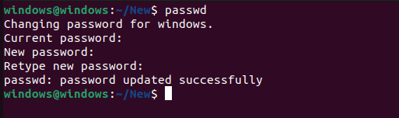

1. **Display the system’s date.**

student@admins-iMac-2 ~ % date Tue Jan 17 12:09:35 IST 2023



1. **Count the number of lines in the /etc/passwd file.**

student@admins-iMac-2 ~ % wc /etc/passwd

120 322 7630 /etc/passwd

student@admins-iMac-2 ~ % wc -l /etc/passwd 120 /etc/passwd

1. **Find out who else is on the system.**

student@admins-iMac-2 ~ % who student console Jan 17 12:01

student ttys000 Jan 17 12:04

1. **Direct the output of man pages for the date command to the file named mydate.**

student@admins-iMac-2 ~ % man date > mydate



1. **Create a subdirectory called mydir.**

student@admins-iMac-2 ~ % mkdir mydir

1. **Move the file mydate into new subdirectory.**

student@admins-iMac-2 ydir % mv mydate mydir

1. **Go to the subdirectory mydir and copy the file mydate to new file called ourdate.**

student@admins-iMac-2 mydir % cd mydir student@admins-iMac-2 mydir % cp mydate ourdate

1. **List the contents of mydir.**

student@admins-iMac-2 mydir % ls mydate ourdate



1. **Do a long-listing on the file ourdate and note the permission.**

student@admins-iMac-2 mydir % ls -l ourdate

-rw-r--r-- 1 student staff 12418 Jan 17 12:42 ourdate



1. **Display the name of the current directory starting from the root.**

student@admins-iMac-2 mydir % pwd



1. **Move the files in the directory mydir back to your home directory.**

student@admins-iMac-2 mydir % mv * /User/student usage: mv [-f | -i | -n] [-v] source target

mv [-f | -i | -n] [-v] source ... directory

1. **Display the first 5 lines of mydate.**

student@admins-iMac-2 mydir % head -5 mydate

DATE(1) BSD General Commands Manual DATE(1)

NAME

date -- display or set date and time

1. **Display the last 8 lines of mydate.**

student@admins-iMac-2 mydir % tail -8 mydate

The date utility is expected to be compatible with IEEE Std 1003.2 (``POSIX.2''). The -d, -f, -j, -n, -r, -t, and -v options are all exten- sions to the standard.

HISTORY

A date command appeared in Version 1 AT&T UNIX.

BSD May 7, 2015 BSD

1. **Remove the directory mydir.**

student@admins-iMac-2 mydir % rm mydir rm: mydir: No such file or directory

1. **Redirect the output of the long listing of the files to file named list.**

student@admins-iMac-2 mydir % ls -l > list

1. **Select any 5 capitals of states in India and enter them in a file named capitals1. Choose 5 more capitals and enter them in a file named capitals2. Choose 5 more capitals and enter them in a file named capitals3. Concatenate all 3 files and redirect the output to a file named capitals.**

student@admins-iMac-2 mydir % cat > capitals1.txt Amravati

Itanagar Dispur Patna Raipur

student@admins-iMac-2 mydir % cat > capitals2.txt Panaji

Gandhinagar

Chandigarh Shimla Ranchi

student@admins-iMac-2 mydir % cat > capitals3.txt Bengaluru

Thiruvananthapura Bhopal

Mumbai Shilong

student@admins-iMac-2 mydir % cat capitals1.txt capitals2.txt capitals3.txt > capitals.txt

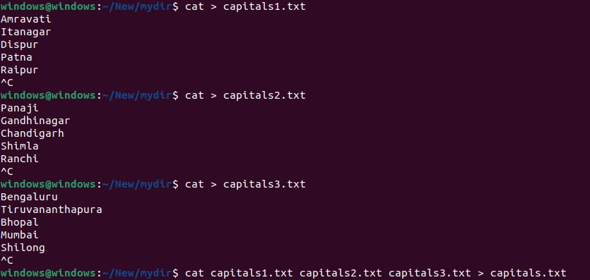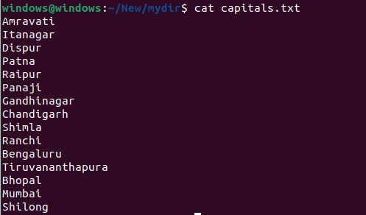

1. **Concatenate the file capitals2 at the end of file capitals.**

student@admins-iMac-2 ~ % cat capitals2.txt >> capitals.txt

1. **Give read and write permissions to all users for the file capitals.**



1. **Give read permissions only to the owner of the file capitals Open the file, make some changes and try to save it. What happens?**



1. **Create an alias to concatenate the 3 files capitals1, capitals2, capitals3 and redirect the output to a file named capitals. Activate the alias and make it run.**

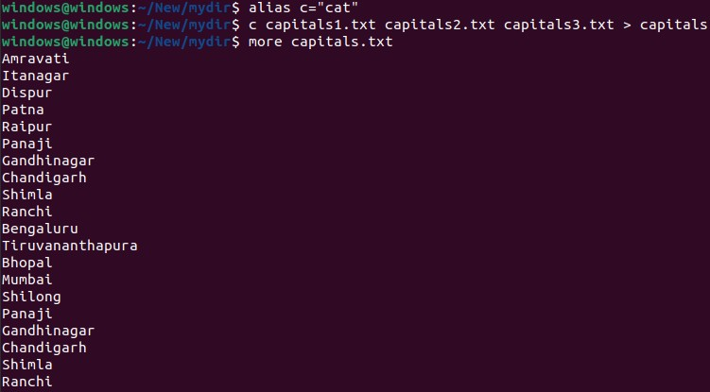

1. **Find out the number of times the string “the” appears in the file mydate.**



1. **Find out the line numbers on which the string “date” exists in mydate.**

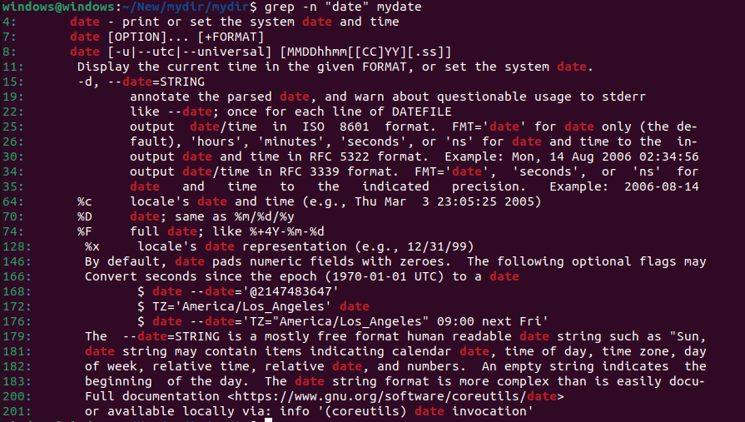

1. **Print all lines of mydate except those that have the letter “i” in them.**

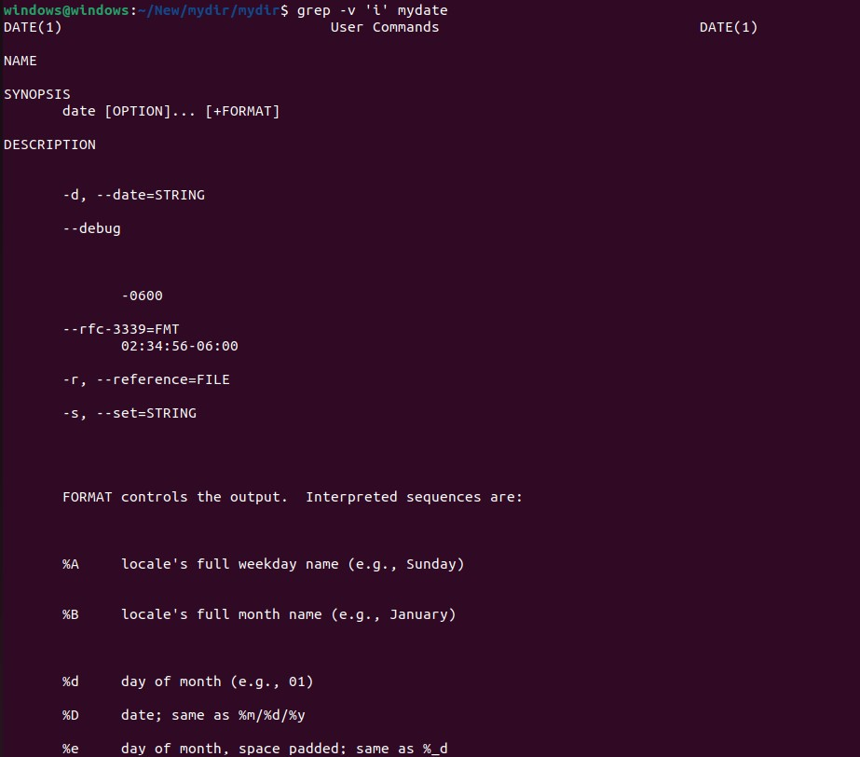

1. **List the words of 4 letters from the file mydate**

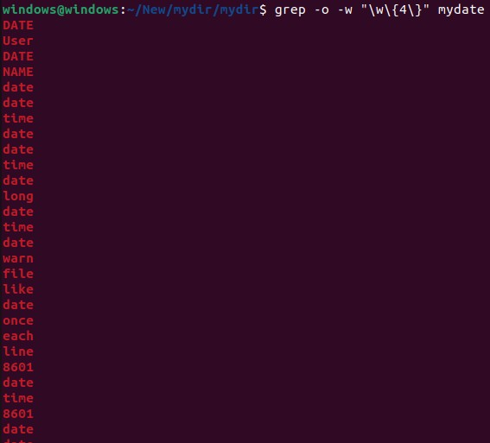

1. **List 5 states in north east India in a file mystates. List their corresponding capitals in a file mycapitals. Use the paste command to join the 2 files.**

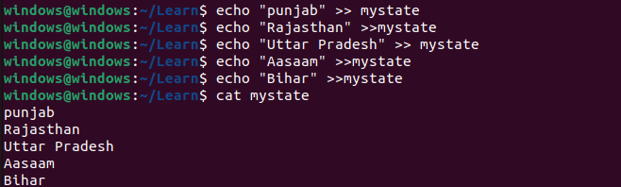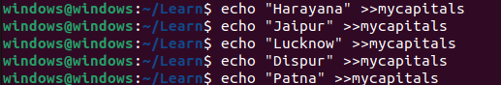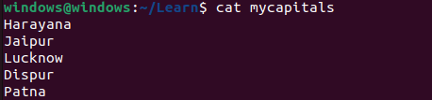

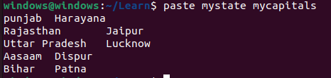

1. **Use the cut command to print the 1 st and 3 rd columns of the /etc/passwd file for all students in this class.**

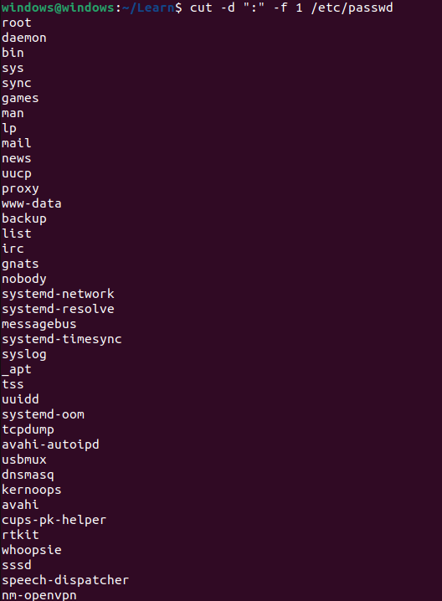

1. **Count the number of people logged in and also trap the users in a file using the tee command.**

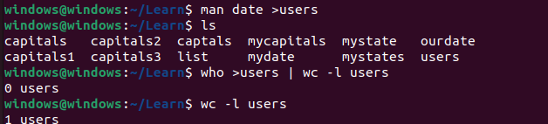

1. **Convert the contents of mystates into uppercase.**

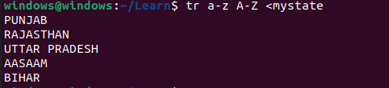

1. **Create any two files & display the common values between them.**

