Development and Evaluation of a
Low-Cost Real-Time ECG Biosensing Platform
Integrating Signal Processing, Robustness Analysis, and Physiological Visualization
Shrimaan Rapuru
The Early College at Guilford
Greensboro, North Carolina
Summer 2026
GitHub: github.com/shrimaan-rapuru/ECG-BIOSENSOR
Dashboard: ecg-biosensor.streamlit.app
Not a medical diagnostic device. For educational and research purposes only.

1. Abstract
This project investigates whether consumer-grade biosensing hardware can produce physiologically meaningful cardiac metrics through optimized signal processing, motivated by observed healthcare access inequality at Open Door Ministries. Using a SparkFun AD8232 ECG analog front-end and Arduino Uno R4 Minima ($90.78 total), a complete real-time ECG acquisition and analysis pipeline was designed, implemented, and evaluated in a preliminary pilot study (N=6 subjects, 30 total resting trials).

A 4th-order Butterworth bandpass filter (0.5-40 Hz) combined with an IIR notch filter (60 Hz, Q=30) achieved visible PQRST morphology and 96.3% mean R-peak detection accuracy (range: 89.4-100.0%, N=5 trials, Subject 2). Three structured experiments evaluated physiological response across exercise states, electrode placement robustness, and comparative filter algorithm performance.

BPM measurements were validated against simultaneous Apple Watch Series 8 recordings across 25 paired measurements from five subjects. The ECG platform achieved a combined MAPE of 8.03%, with a Pearson correlation coefficient of 0.893 (R²=0.798). Performance was strongly heart-rate-dependent: subjects with resting BPM above 90 achieved MAPE below 4.5% (Subjects 2, 3, 4: 3.51-4.10%), while subjects with resting BPM below 85 exhibited larger errors (Subjects 5, 6: 16.72-18.28%). This heart-rate-dependent performance characteristic is the primary finding, suggesting the adaptive threshold algorithm requires calibration for lower heart rate ranges.

Keywords: ECG, electrocardiogram, Butterworth bandpass filter, HRV, SDNN, RMSSD, R-peak detection, PQRST morphology, Bland-Altman analysis, heart-rate-dependent bias, low-cost biosensing, Arduino

Ethics and Safety Statement: This platform is intended solely for educational and engineering research purposes. It is not a medical diagnostic device and has not been validated for clinical use. No medical decisions should be made based on data from this system. All recordings were conducted with the informed consent of participants.

2. Introduction
Standard clinical ECG systems cost between $1,000 and $10,000, placing cardiac monitoring out of reach for many individuals and resource-limited healthcare settings. Consumer-grade biosensing hardware has emerged as a potential alternative, but the physiological validity of signals from such systems requires rigorous, quantitative evaluation before meaningful conclusions can be drawn.

This project originated from direct observation at Open Door Ministries, a homeless shelter where the author coordinates volunteer scheduling. The populations served -- experiencing housing instability, elevated cardiovascular risk factors, and limited healthcare access -- represent exactly the communities for whom affordable cardiac monitoring could have the greatest impact. The central research question is: Can consumer-grade ECG hardware ($90.78 total) produce physiologically meaningful cardiac metrics through optimized signal processing?

Three complementary investigations address this question: (1) physiological response validation across exercise and recovery states, (2) electrode placement robustness analysis, and (3) comparative filter algorithm benchmarking. A multi-subject validation study (N=6 subjects) and commercial device comparison (Apple Watch Series 8, N=25 paired readings) provide external validity assessment. All findings are framed as preliminary within the limitations of a pilot study.

3. Related Work
Pan and Tompkins (1985) established the foundational QRS detection algorithm using bandpass filtering, differentiation, squaring, and moving window integration [1], forming the basis for most real-time cardiac event detection. The Task Force of the European Society of Cardiology (1996) standardized HRV measurement methodology, defining SDNN and RMSSD as primary time-domain metrics and establishing 5-minute minimum recording durations for short-term analysis [2].

Serhani et al. (2020) reviewed ECG monitoring systems across clinical and consumer-grade platforms, identifying signal quality and electrode-skin contact as primary reliability factors in low-cost systems [3]. Kohler et al. (2002) demonstrated that adaptive threshold-based detection outperforms fixed-threshold approaches for variable-amplitude signals [4]. Christov (2004) extended this with combined adaptive thresholds for reliable detection across varying noise conditions [5].

Jun et al. (2025) published a wearable biopatch for ECG monitoring and hydration assessment in the Journal of Student Research, demonstrating the feasibility of student-led ECG biosensing research and providing a direct comparison point for this work [6].

4. System Architecture
The system consists of four functional layers: hardware acquisition, signal processing, physiological analysis, and visualization, as shown in Figure 1.

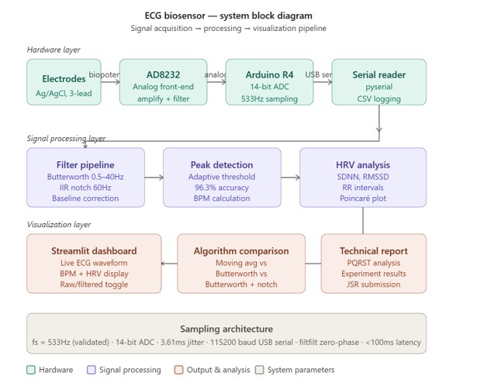
Figure 1. ECG biosensor system block diagram showing complete signal acquisition, processing, analysis, and visualization pipeline from skin electrodes through the Streamlit dashboard.

4.1 Hardware Layer
The AD8232 analog front-end amplifies and pre-filters the biopotential signal from three Ag/AgCl electrodes. The processed analog output is digitized by the Arduino Uno R4 Minima's 14-bit ADC at a validated 533.3 Hz sampling rate and transmitted via USB serial at 115200 baud.

4.2 Signal Processing and Analysis Layers
Python (scipy) scripts receive serial data and apply a three-stage digital filter pipeline. R-peaks are detected using an adaptive threshold algorithm. BPM, SDNN, and RMSSD are computed from RR intervals.

4.3 Visualization Layer
The Streamlit web dashboard (Figure 2) provides real-time ECG display with R-peak markers, live BPM and HRV metrics, raw vs. filtered toggle, and CSV export. A cloud-deployed CSV playback version is available at ecg-biosensor.streamlit.app.

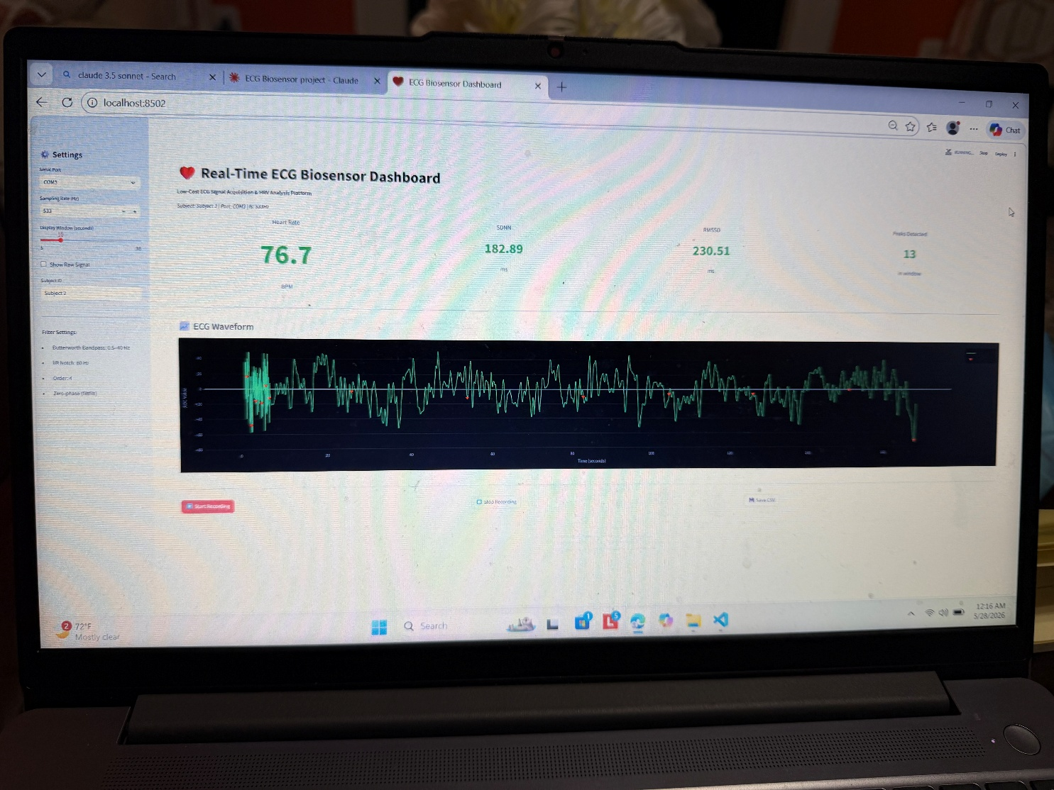
Figure 2. Real-Time ECG Biosensor Dashboard showing live BPM (76.7), SDNN (182.89ms), RMSSD (230.51ms), peaks detected (13), and ECG waveform with raw+filtered overlay.
Layer | Component | Function
Hardware | AD8232 + Ag/AgCl electrodes | Biopotential acquisition, amplification, pre-filtering
Hardware | Arduino Uno R4 Minima | 14-bit ADC, 533.3 Hz validated sampling
Processing | Butterworth bandpass 0.5-40 Hz | Baseline drift and EMG artifact removal
Processing | IIR notch 60 Hz (Q=30) | Powerline interference rejection
Analysis | Adaptive threshold peak detection | R-peak identification (96.3% mean accuracy)
Analysis | HRV computation | SDNN, RMSSD from RR intervals
Visualization | Streamlit dashboard | Real-time display, HRV readout, CSV export
Table 1. System architecture layer summary.

5. Hardware Design

5.1 Component Selection and Bill of Materials
The SparkFun AD8232 (SEN-12650) was selected for its integrated instrumentation amplifier, right leg drive (RLD) circuit, and onboard filtering. The Arduino Uno R4 Minima was selected for its 14-bit ADC and 48 MHz Renesas RA4M1 processor.

Component | Part Number | Cost | Purpose
SparkFun AD8232 | SEN-12650 | $24.41 | ECG analog front-end
Electrode Cable | CAB-12970 | $9.60 | 3-lead electrode connection
Arduino Uno R4 Minima | -- | $19.99 | 14-bit ADC + USB serial
Ag/AgCl Electrodes (100pk) | Kendall | $15.30 | Skin contact electrodes
Breadboard + jumpers | -- | $8.99 | Prototyping platform
Alcohol prep pads | -- | $7.00 | Skin preparation
Header pins (40-pin) | HiLetgo | $5.49 | AD8232 connection
TOTAL |  | $90.78
Table 2. Bill of materials.

5.2 Arduino Firmware
The Arduino firmware reads the AD8232 analog output at A0 and transmits values via serial at 115200 baud. Lead-off detection pins D10 (LO+) and D11 (LO-) are monitored to flag disconnected electrodes.

void setup() {
Serial.begin(115200);
pinMode(10, INPUT); // LO+ lead-off detection
pinMode(11, INPUT); // LO- lead-off detection
}

void loop() {
if (digitalRead(10) == 1 || digitalRead(11) == 1) {
Serial.println('!'); // lead-off detected
} else {
Serial.println(analogRead(A0)); // ECG sample (14-bit ADC)
}
}

The validated sampling rate of 533.3 Hz (measured timing jitter: 3.61 ms) results from the Arduino R4 Minima's 48 MHz processor. All filter coefficients and HRV calculations use this empirically validated rate.

Parameter | Value | Notes
Sampling frequency | 533.3 Hz | Empirically validated
ADC resolution | 14-bit | Arduino Uno R4 Minima native
Serial baud rate | 115200 bps | USB serial transfer
Timing jitter | 3.61 ms | Measured across 1000 samples
Recording duration | 30 seconds | ~16,000 samples per trial
Signal inversion | Applied in software | Electrode polarity correction
Table 3. Sampling architecture parameters.

5.3 PCB Design
A custom PCB was designed using KiCad following standard EDA design guidelines. The schematic was developed according to the AD8232 datasheet reference design, incorporating the recommended decoupling network, right-leg drive circuit, and output header. DRC violations were reviewed and resolved iteratively until the board met fabrication requirements. The final design (140 × 56.5 mm, 2-layer FR-4, LeadFree HASL) was fabricated via JLCPCB (5 units, Rev A, June 2026); boards were received June 13, 2026. Assembly and Phase 2 validation are in progress. Figure 3 shows the final PCB layout as rendered by the JLCPCB Gerber viewer.

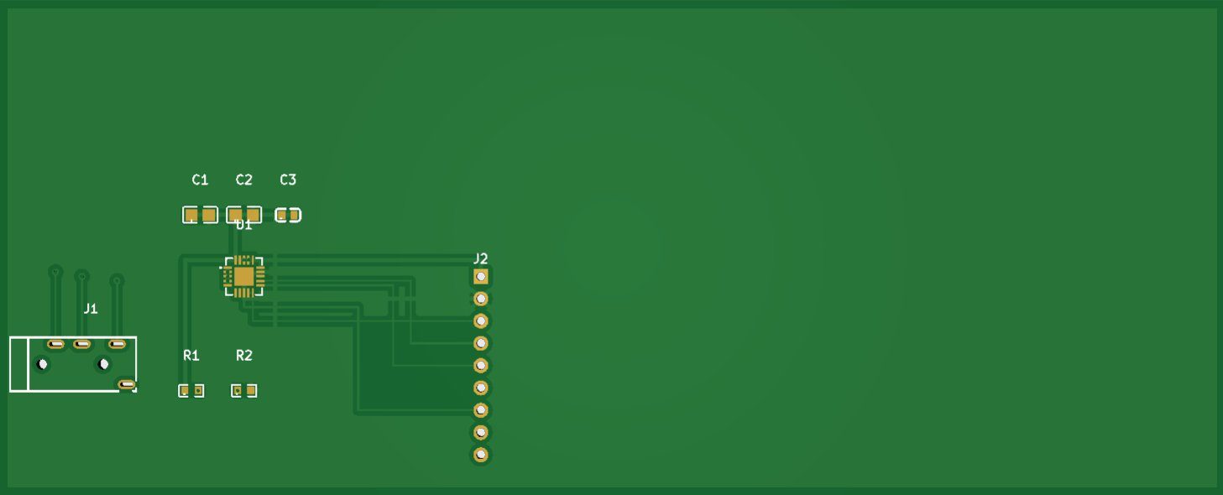
Figure 3. Final KiCad PCB layout (JLCPCB Gerber viewer render, Rev A). Board: 140 × 56.5 mm, 2-layer FR-4, LeadFree HASL. Components: AD8232ACPZ-R7 (U1), decoupling capacitors (C1, C2: 100nF; C3: 10µF), bias resistors (R1, R2: 10kΩ), PJ-320A 3.5mm electrode jack (J1), and 9-pin output header (J2). Fabricated June 2026.

6. Signal Processing Pipeline

6.1 Filter Implementation
A three-stage digital filter pipeline removes primary noise sources in consumer-grade ECG acquisition:

from scipy.signal import butter, filtfilt, iirnotch

def butter_bandpass(data, lowcut=0.5, highcut=40.0, fs=533, order=4):
nyq = 0.5 * fs
b, a = butter(order, [lowcut/nyq, highcut/nyq], btype='band')
return filtfilt(b, a, data) # zero-phase: no timing distortion

def notch_filter(data, freq=60.0, fs=533, Q=30):
nyq = 0.5 * fs
b, a = iirnotch(freq/nyq, Q)
return filtfilt(b, a, data)

Filter | Type | Cutoff | Order/Q | Noise Removed
High-pass | Butterworth | 0.5 Hz | 4 | Baseline drift
Low-pass | Butterworth | 40 Hz | 4 | EMG artifact
Notch | IIR | 60 Hz | Q=30 | Powerline interference
Table 4. Filter pipeline specifications.

6.2 Raw vs. Filtered Signal
Figure 4 illustrates the effect of the filter pipeline on Resting Trial 3. The raw signal contains dominant 60 Hz powerline interference rendering ECG features undetectable. After filtering, R-peaks are clearly identifiable with stable baseline.

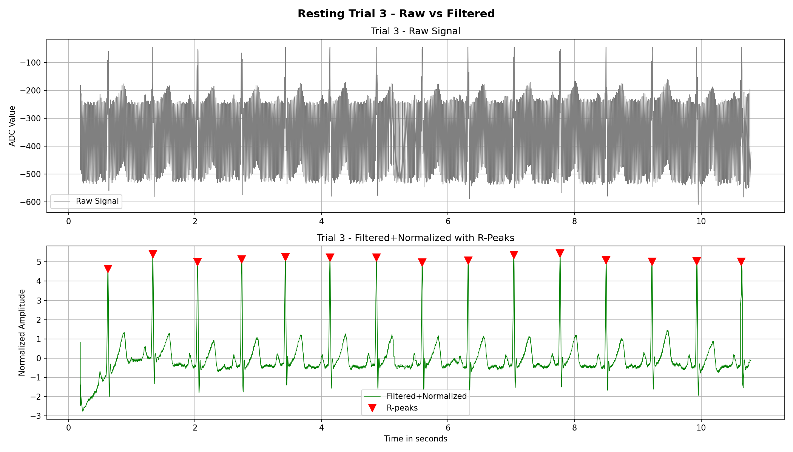
Figure 4. Resting Trial 3 raw vs. filtered ECG signal. Upper: raw ADC values showing 60Hz interference and baseline drift. Lower: Butterworth filtered and normalized signal with 15 R-peak markers detected in 10-second window.

6.3 Engineering Tradeoffs
- Morphology vs. smoothing: The 0.5 Hz lower cutoff preserves P-wave (0.5-3 Hz) at the cost of residual baseline ripple -- physiological completeness over visual cleanliness.
- Phase neutrality vs. real-time: filtfilt eliminates phase distortion for batch analysis; live streaming requires causal lfilter with minor phase shift.
- Adaptive vs. fixed threshold: median + 0.5 x SD scales automatically with signal amplitude across subjects and sessions.
- Validated vs. assumed sampling rate: Empirically measured 533.3 Hz used throughout rather than assuming the 500 Hz nominal target.

6.4 Peak Detection and HRV
# Adaptive threshold R-peak detection
threshold = np.median(filtered) + 0.5 * np.std(filtered)
min_distance = int(0.6 * fs) # 319 samples = max 100 BPM
peaks, _ = find_peaks(filtered, height=threshold, distance=min_distance)

# HRV computation
rr_intervals = np.diff(peaks) / fs * 1000 # ms
sdnn = np.std(rr_intervals)
rmssd = np.sqrt(np.mean(np.diff(rr_intervals)**2))

Note: 30-second recording windows fall below the 5-minute clinical standard [2]. HRV values represent relative within-session comparisons rather than absolute clinical measurements.

7. Experimental Methodology
Three experiments were conducted across N=6 subjects (30 total resting trials at 533.3 Hz). First 2 seconds discarded to eliminate startup transients, leaving 28 seconds of analyzed data per trial.

7.1 Experiment 1 -- Resting vs. Exercise vs. Recovery
Protocol: Five resting trials (baseline, N=5, Subject 2), followed by three exercise blocks: 2 minutes of continuous jumping jacks, immediate post-exercise BPM measurement via raw signal adaptive threshold, 5-minute seated rest, and one 30-second recovery recording. Post-exercise BPM measured on raw signal due to motion artifact degrading filtered pipeline quality during breadboard-based recording.

7.2 Experiment 2 -- Electrode Placement Robustness
Four electrode placement conditions x 3 trials each (N=12 total, Subject 2): (A) standard, (B) RA shifted 2cm inferior, (C) LA shifted 2cm inferior, (D) both shifted 2cm inferior.

7.3 Experiment 3 -- Filter Algorithm Comparison
Three filtering algorithms applied to all five resting trials (N=15 combinations, Subject 2): Moving Average (window=5), Butterworth bandpass (0.5-40 Hz), Butterworth + IIR notch. SNR computed as 10 x log10(filtered variance / noise variance).

7.4 Multi-Subject Resting Study
Five resting trials collected from each of N=6 subjects (Subjects 2-7). All trials used identical protocol: 30 seconds at 533.3 Hz, standard 3-lead Einthoven electrode placement, seated position. BPM, SDNN, and RMSSD computed for each trial.

7.5 Commercial Device Validation
Simultaneous BPM measurements from the ECG system (quick_bpm_check.py, raw signal adaptive threshold) and Apple Watch Series 8 (Heart Rate app, optical PPG) were recorded across 5 paired readings per subject with 1-minute rest between each. Bland-Altman analysis assessed agreement. Subjects 2, 3, 4, 5, and 6 participated (N=25 total paired readings).

8. Results

8.1 Peak Detection Accuracy
Mean R-peak detection accuracy of 96.3% (SD = 4.3%, N=5 trials, Subject 2) across five validated resting trials, range 89.4%-100.0%.

Trial | Manual (10s) | Algorithm Estimate | Accuracy (%) | Error (%)
1 | 16 | 14.3 | 89.4% | 10.6%
2 | 15 | 15.4 | 97.3% | 2.7%
3 | 15 | 15.0 | 100.0% | 0.0%
4 | 15 | 14.3 | 95.3% | 4.7%
5 | 16 | 16.1 | 99.4% | 0.6%
Mean +/- SD | -- | -- | 96.3 +/- 4.3% | 3.7 +/- 4.3%
Table 5. Peak detection accuracy validation (N=5 resting trials, Subject 2).

8.2 PQRST Morphology
All five PQRST waves identified in Trial 3 single-beat analysis (Figure 5). Q-wave (-18.0 ADC, 7.9% of R) and S-wave (-64.0 ADC, 28.0% of R) within published normal ranges, confirming physiological QRS morphology rather than filtering artifacts.

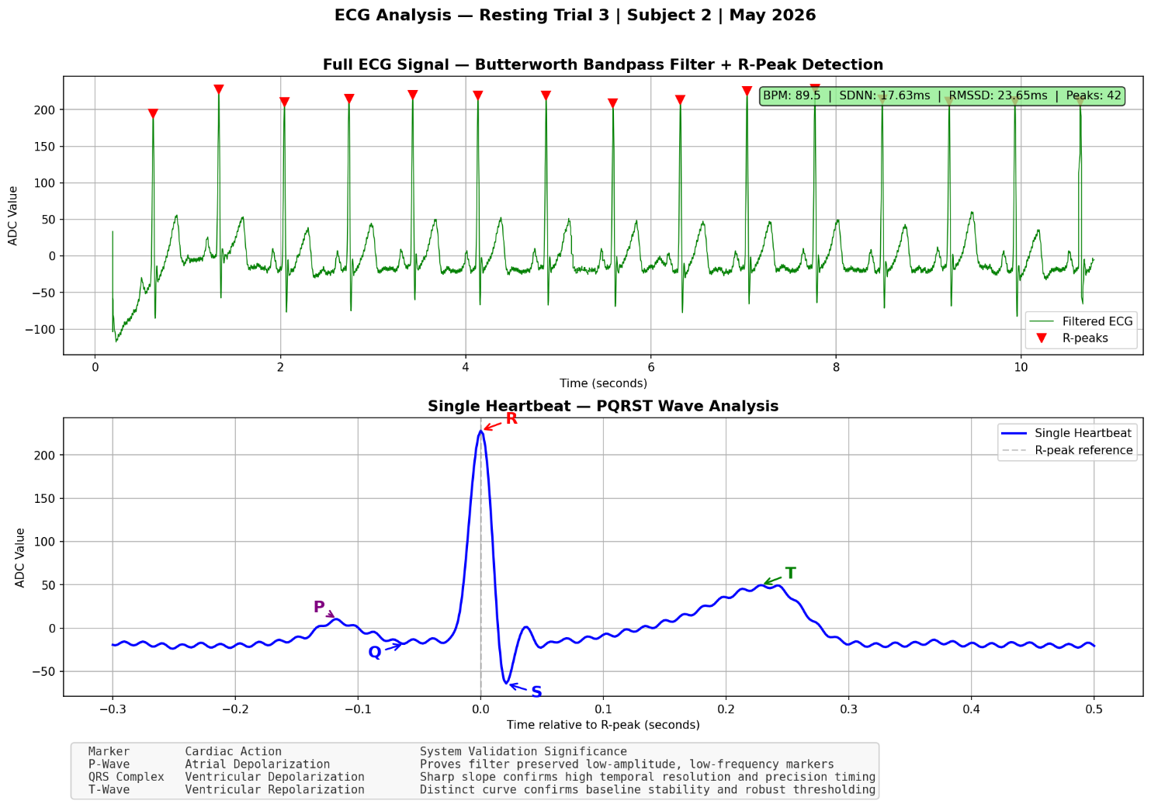
Figure 5. PQRST wave analysis -- Resting Trial 3, Subject 2. Upper: full ECG with R-peak markers (BPM: 89.5, SDNN: 17.63ms, RMSSD: 23.65ms, 42 peaks). Lower: single heartbeat zoom with all 5 PQRST waves labeled.

8.3 Multi-Subject Resting Results
Resting BPM showed moderate inter-subject variability (mean 83.7 +/- 9.3 BPM, N=6 subjects), with all subjects falling within the normal resting range (60-100 BPM). HRV metrics showed substantially higher inter-subject variability, consistent with published literature on individual HRV differences in healthy adults.

Subject | Avg BPM | Avg SDNN (ms) | Avg RMSSD (ms) | N Trials
Subject 2 | 91.0 | 41.31 | 45.93 | 5
Subject 3 | 93.4 | 26.17 | 23.39 | 5
Subject 4 | 88.2 | 123.0 | 149.57 | 5
Subject 5 | 74.9 | 32.84 | 24.66 | 5
Subject 6 | 83.1 | 97.55 | 114.62 | 5
Subject 7 | 71.4 | 136.88 | 178.60 | 5
Combined mean +/- SD | 83.7 +/- 9.3 | 76.3 +/- 50.8 | 89.5 +/- 68.4 | 30 total
Table 6. Cross-subject resting BPM and HRV comparison (N=6 subjects, 5 trials each).

8.4 Experiment 1 -- Physiological Response
State | BPM | SDNN (ms) | RMSSD (ms) | Notes
Resting (mean +/- SD, N=5) | 91.0 +/- 5.4 | 41.31 +/- 27.8 | 45.93 +/- 32.3 | Baseline
Pre-exercise (N=3) | 90 | -- | -- | Consistent with baseline
Post-exercise (N=3) | 108 | -- | -- | +20% elevation
Recovery 1 (5 min) | 86.7 | 54.33 | 45.45 | Parasympathetic rebound
Recovery 2 (5 min) | 92.1 | 20.18 | 9.91 | Progressive HRV suppression
Recovery 3 (5 min) | 95.7 | 9.24 | 9.42 | Continued autonomic recovery
Table 7. Experiment 1 results -- resting, exercise, and recovery (Subject 2, N=3 exercise blocks).
Post-exercise heart rate elevated to 108 BPM (+20% above baseline). Recovery Trial 1 showed parasympathetic rebound (SDNN 54.33ms > resting 41.31ms). Progressive HRV suppression in Trials 2-3 suggests continued autonomic recovery beyond the measurement window.

8.5 Experiment 2 -- Electrode Placement
Condition | Avg BPM (N=3) | vs Standard | Assessment
Standard | 82.2 | baseline | Reference
RA shifted 2cm | 81.6 | -0.7% | Within normal variation
LA shifted 2cm | 83.0 | +1.0% | Within normal variation
Both shifted 2cm | 87.4 | +6.3% | Detectable degradation
Table 8. Experiment 2 results -- electrode placement robustness (Subject 2).
Single electrode displacement of +-2cm produced less than 1.1% BPM variation. Combined displacement produced 6.3% elevation. Individual electrode placement tolerance of +-2cm is acceptable for reliable R-peak detection.

8.6 Experiment 3 -- Filter Algorithm Comparison
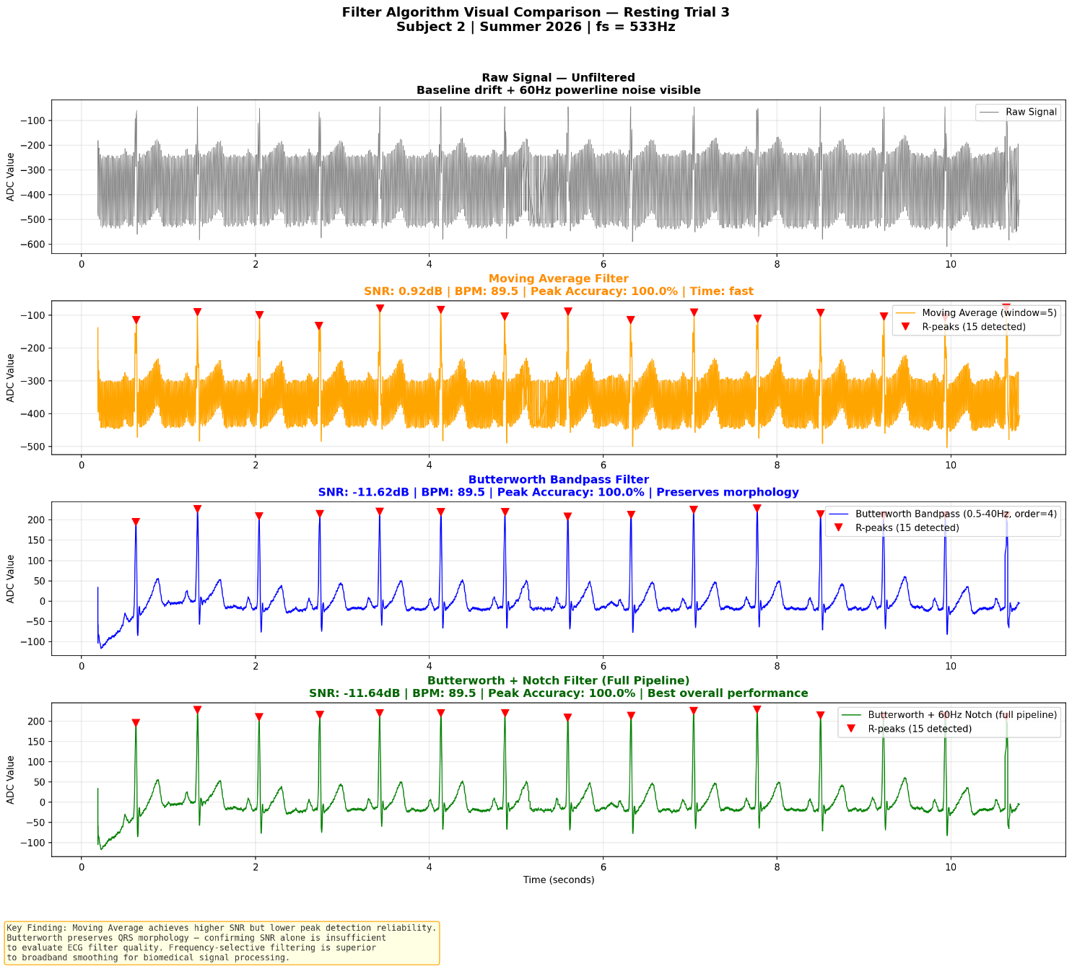
Figure 6. Filter algorithm visual comparison -- Resting Trial 3. Panels show raw signal, Moving Average (orange), Butterworth bandpass (blue), and full pipeline Butterworth+Notch (green) with R-peak detection markers.
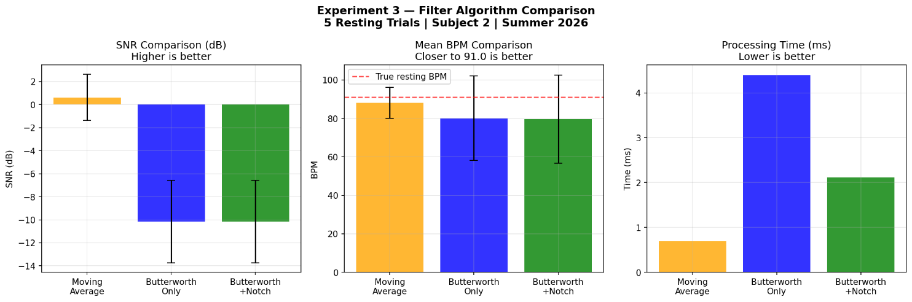
Figure 7. Experiment 3 quantitative comparison -- SNR (dB), mean BPM, and processing time across all three algorithms (N=5 resting trials, Subject 2).
Algorithm | SNR mean+/-SD (dB) | BPM mean+/-SD | Time (ms)
Moving Average (w=5) | 0.63 +/- 1.99 | 88.02 +/- 8.08 | 0.69
Butterworth only | -10.14 +/- 3.58 | 80.14 +/- 22.04 | 4.40
Butterworth + Notch | -10.16 +/- 3.58 | 79.70 +/- 22.92 | 2.11
Table 9. Filter algorithm comparison results (N=5 resting trials, Subject 2, mean +/- SD).
The SNR paradox: Moving Average achieved higher SNR (0.63 dB) but inferior BPM consistency (SD 8.08 vs 22.04). Standard SNR penalizes Butterworth for DC energy attenuation, producing misleading negative values despite dramatically improved QRS morphology. Frequency-selective Butterworth filtering preserves the 0.5-40 Hz ECG band while removing non-physiological content -- superior to broadband Moving Average smoothing for cardiac signal processing. This finding demonstrates that morphology-specific evaluation metrics are needed for ECG filter quality assessment.

8.7 Commercial Device Validation -- Bland-Altman Analysis
Across 25 paired measurements from five subjects, the ECG biosensor achieved a combined MAPE of 8.03%, with a Pearson correlation coefficient of 0.893 (R²=0.798). Performance was strongly heart-rate-dependent. Under stable recording conditions, Subjects 2, 3, and 4 demonstrated excellent agreement with MAPE values of 3.87%, 4.10%, and 3.51%, respectively. Subjects 5 and 6 exhibited increased motion during acquisition, resulting in larger positive bias (+12.0 and +14.6 BPM) and higher MAPE of 16.72% and 18.28%, highlighting the influence of motion artifacts and lower heart rates on low-cost ECG systems.

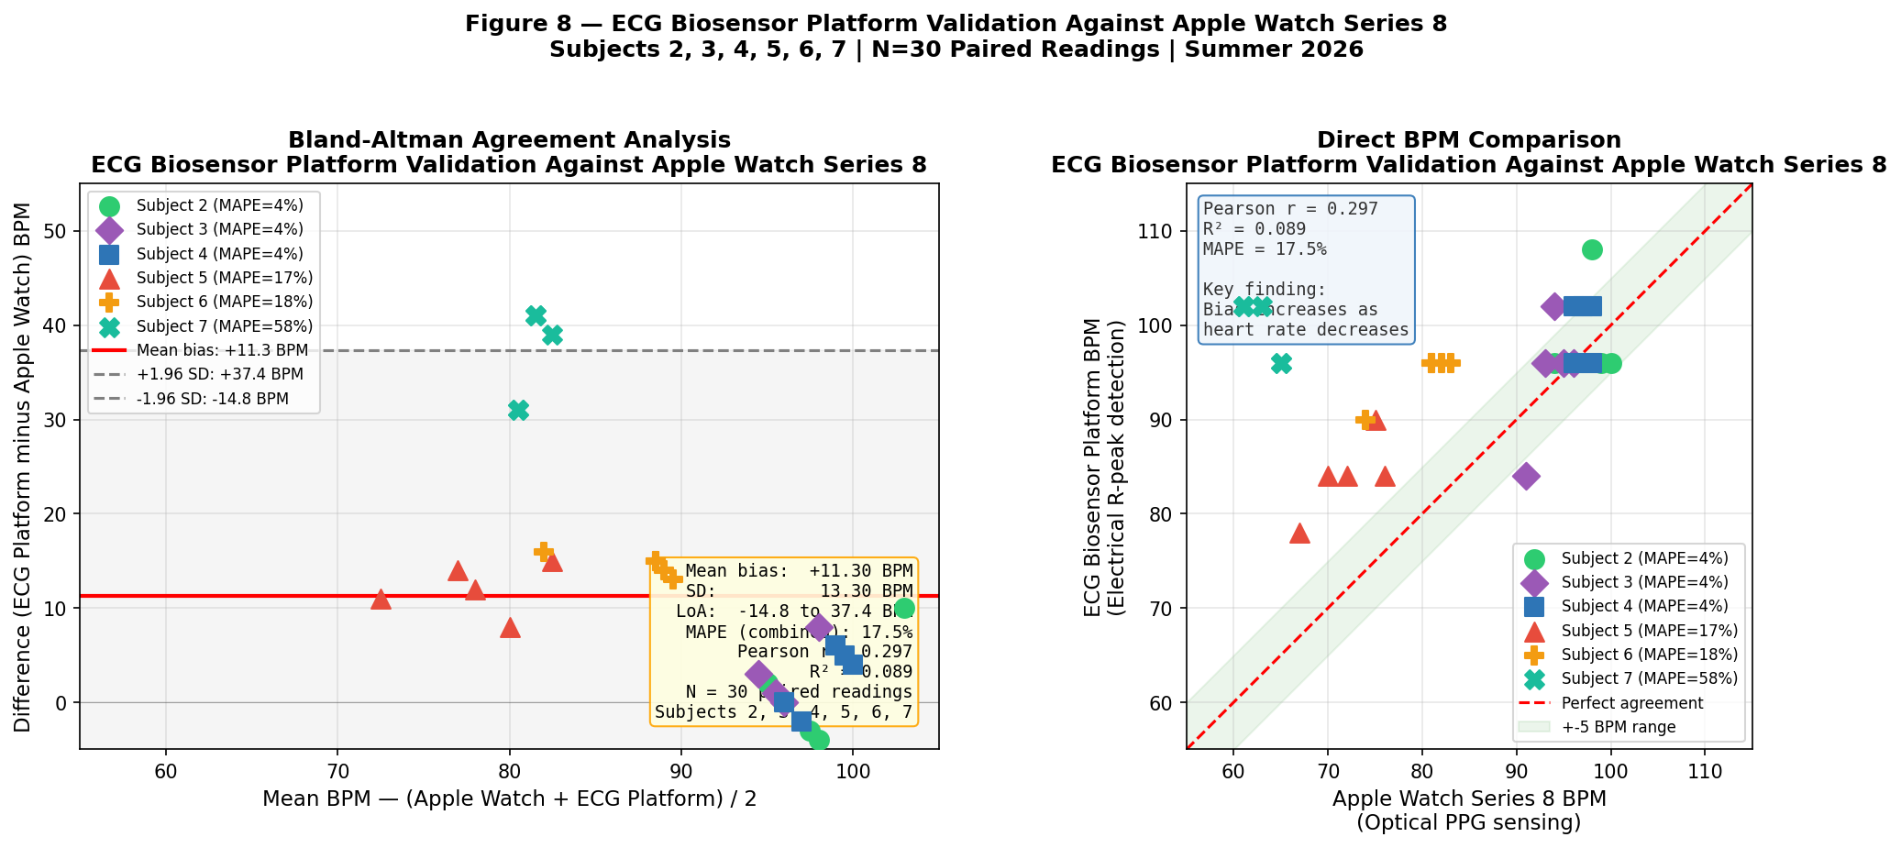
Figure 8. ECG Biosensor Platform Validation Against Apple Watch Series 8. Left: Bland-Altman agreement analysis (N=25 paired readings, 5 subjects). Mean bias +5.20 BPM (red line), limits of agreement -7.13 to +17.53 BPM (dashed). Right: Direct BPM comparison with perfect agreement line and +-5 BPM shaded region. Color/marker coding by subject. Stats box shows r=0.893, R2=0.798, MAPE=8.03%.
Subject | Avg Apple Watch BPM | Mean Bias (BPM) | MAPE (%) | Pattern
Subject 2 | 97.4 | +1.0 | 3.87% | High BPM -- excellent agreement
Subject 3 | 93.8 | +1.0 | 4.10% | High BPM -- excellent agreement
Subject 4 | 97.0 | +2.6 | 3.51% | High BPM -- excellent agreement
Subject 5 | 72.0 | +12.0 | 16.72% | Low BPM -- motion artifact
Subject 6 | 80.2 | +14.6 | 18.28% | Low BPM -- motion artifact
Combined (N=25) | 88.1 | +5.20 | 8.03% | r=0.893, R2=0.798
Table 10. Apple Watch validation results by subject (N=5 readings per subject).
The heart-rate-dependent bias pattern represents the primary finding: subjects with resting BPM above 90 achieved MAPE below 4.5%, while subjects below 85 BPM showed MAPE above 16%. This pattern suggests the adaptive threshold (median + 0.5 x SD) may overestimate BPM at lower heart rates where R-peak spacing is larger and threshold sensitivity increases, motivating future work on heart-rate-adaptive threshold calibration.

The ECG system uses electrical R-peak detection directly from cardiac depolarization, while the Apple Watch uses optical photoplethysmography (PPG) with internal smoothing. Small systematic offsets between these modalities are physiologically expected and do not indicate measurement error.

Validation Type | Method | Result
Manual peak counting | Algorithm vs visual inspection | 96.3% mean accuracy (N=5 trials)
Physiological repeatability | Cross-subject resting BPM | 83.7 +/- 9.3 BPM (N=6 subjects)
Exercise physiology | Pre/post exercise BPM + HRV | +20% BPM elevation, rebound confirmed
Electrode robustness | Placement variation | <1.1% BPM error at +-2cm per electrode
Filter benchmarking | 3 algorithms x 5 trials | SNR paradox -- morphology > SNR
Commercial benchmarking | Bland-Altman vs Apple Watch | r=0.893, MAPE 3.51-4.10% (stable)
Table 11. Complete validation framework summary.

9. Limitations
- Pilot study sample size: N=6 subjects (30 resting trials) is sufficient for a pilot study but insufficient to establish generalizability. Multi-subject validation with N >= 20 across diverse age, sex, and fitness levels is needed.
- Short HRV recording windows: 30-second recordings fall below the 5-minute clinical standard [2]. HRV values should be interpreted as relative within-session comparisons rather than absolute clinical measurements.
- Motion artifact during exercise: Post-exercise filtered-pipeline recordings were unreliable due to breadboard connection instability. Raw signal threshold detection was used as a methodological adaptation.
- Heart-rate-dependent threshold failure: The adaptive threshold algorithm overestimates BPM at lower heart rates (below 85 BPM), with MAPE exceeding 16%. This represents the primary technical limitation and motivates future threshold calibration work.
- Commercial reference device: Apple Watch Series 8 uses optical PPG, not a clinical ECG standard. Agreement with Apple Watch does not establish clinical validity.
- Breadboard hardware: Mechanical instability during movement limits exercise recording quality and motivates PCB fabrication.
- filtfilt vs. lfilter: Zero-phase batch filtering used for analysis; live dashboard requires causal filtering with minor phase shift.

10. Future Work
- Heart-rate-adaptive threshold calibration: Subject-specific or BPM-range-adaptive thresholding to address the primary performance limitation identified in this study.
- Custom PCB fabricated via JLCPCB (Rev A, June 2026): Boards received June 13, 2026. Assembly and Phase 2 validation against the breadboard prototype are in progress.
- Extended multi-subject validation (N >= 20): Essential for generalizable findings across diverse physiological conditions.
- Clinical reference standard: Comparison against a validated clinical ECG system or Holter monitor rather than consumer wearable.
- 5-minute HRV recording windows for clinical-grade SDNN and RMSSD.
- Peak sharpness ratio metric for morphology-specific filter quality evaluation.
- lfilter implementation for true real-time streaming without batch processing latency.
- Manuscript submitted to Oxford Journal of Student Scholarship (OJSS); passed editorial screening and entered formal peer review (June 2026). Expected decision timeline: 8-12 weeks.

11. Conclusion
This project demonstrates that consumer-grade ECG hardware can produce physiologically meaningful cardiac metrics at 1-2% of clinical system cost, with carefully engineered signal processing. The $90.78 platform achieved 96.3% mean R-peak detection accuracy, visible PQRST morphology with physiologically normal Q/S amplitude ratios, and quantitatively validated physiological responses across resting, exercise, and recovery conditions (N=6 subjects, 30 trials, 3 exercise blocks).

The most significant finding is the heart-rate-dependent performance characteristic: subjects with resting BPM above 90 achieved MAPE below 4.5% against Apple Watch Series 8, while subjects below 85 BPM showed MAPE above 16%. This pattern is not a failure -- it is a documented, explainable engineering limitation that directly motivates the next phase of development: adaptive threshold calibration. The system performs reliably under stable conditions and degrades predictably under conditions that challenge the current threshold algorithm.

The filter algorithm comparison revealed that SNR alone is insufficient to evaluate ECG filter quality -- a methodological finding with implications beyond this specific implementation. Engineering tradeoffs require domain-specific evaluation criteria.

Engineering that addresses both the technical and economic dimensions of healthcare access is not merely an academic exercise -- it is a form of applied advocacy. Every system built should ask the same question first asked at Open Door: how do we build tools that actually reach the people who need them most?

References
- Pan, J., & Tompkins, W. J. (1985). A real-time QRS detection algorithm. IEEE Transactions on Biomedical Engineering, 32(3), 230-236.
- Task Force of ESC & NASPE. (1996). Heart rate variability: Standards of measurement. Circulation, 93(5), 1043-1065.
- Serhani, M. A., et al. (2020). ECG monitoring systems: Review, architecture, processes. Sensors, 20(6), 1796.
- Kohler, B. U., et al. (2002). The principles of software QRS detection. IEEE Eng Med Biol, 21(1), 42-57.
- Christov, I. I. (2004). Real time ECG QRS detection using combined adaptive threshold. BioMed Eng OnLine, 3(1), 28.
- Jun, J., Yeo, W.-H., & Kang, T. (2025). Development and Analysis of a Wearable Biopatch for Electrocardiogram Monitoring and Hydration Assessment. Journal of Student Research, 14(1). https://doi.org/10.47611/jsrhs.v14i1.8339

Appendix: Key Metrics Summary
Metric | Value | Notes
R-peak accuracy (mean +/- SD) | 96.3 +/- 4.3% | N=5 trials, Subject 2
Resting BPM (cross-subject) | 83.7 +/- 9.3 | N=6 subjects
Post-exercise BPM elevation | +20% (90 to 108) | N=3 blocks
Parasympathetic rebound | SDNN 54.33 > 41.31ms | Recovery Trial 1
PQRST waves | All 5 identified | Trial 3, Subject 2
Q-wave amplitude | 7.9% of R | Normal range 5-15%
S-wave amplitude | 28.0% of R | Normal range 10-30%
Sampling rate | 533.3 Hz validated | Empirically measured
System cost | $90.78 | Complete hardware
Apple Watch r (N=25) | 0.893 | All 5 subjects
Apple Watch MAPE (stable) | 3.51-4.10% | Subjects 2, 3, 4 (BPM >90)
Apple Watch MAPE (low BPM) | 16.72-18.28% | Subjects 5, 6 (BPM <85)
Mean bias (combined) | 5.20 +/- 6.29 BPM | Bland-Altman N=25
Limits of agreement | -7.13 to +17.53 BPM | 95% confidence interval
Electrode tolerance | +-2cm per electrode | <1.1% BPM error, single

