BIG DATA LAB 4
24/5/2022

SHRIMAN
1NT19IS150

1. Create a directory named by your name

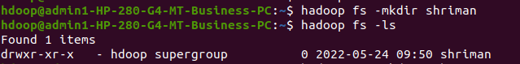

2. Add two empty files into it
3. List all the files in the directory that you have created
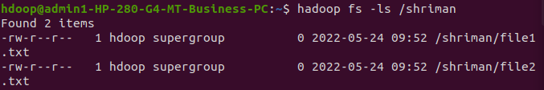

4 Create one more directory by your usn and put that inside the directory of your name

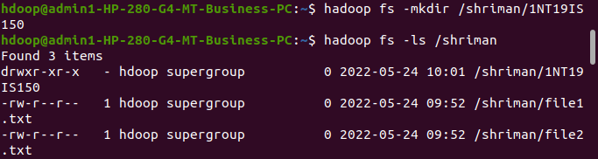

5. Create a file in your local system by the name_usn.txt and add the contents as
"Syntax to list Is command is hadoop fs -Is "
Tasks To complete contd...
►Put the file usn_name.txt in your hdfs directory called usn

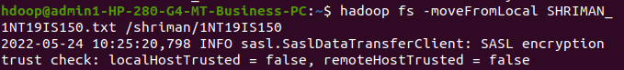

►Put empty file of hdfs into the local file system

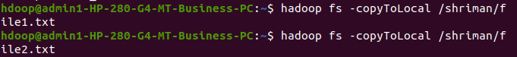

►mv command to move files within hdfs :

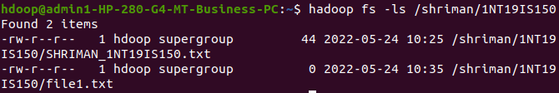
► To find the size of the directory in the directory]

►Start command to check modified time of the directory

