BD LAB 26-04-2022
1NT19IS150 SHRIMAN

> db.shriman.find().pretty()
{
"_id" : ObjectId("6254f37aa80a8c171233069f"),
"name" : "shriman",
"dept" : "ise"
}
{
"_id" : ObjectId("6254f389a80a8c17123306a0"),
"name" : "pratheek",
"college" : "NMIT",
"dept" : "cse"
}

Aggregate Functions:
COUNT:

now one student’s department is updated with ise

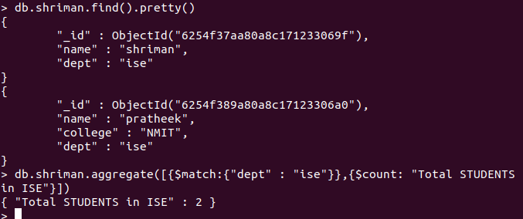

MAXIMUM MARKS :

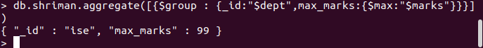

MINIMUM MARKS:

MARKS GREATER THAN 50 :

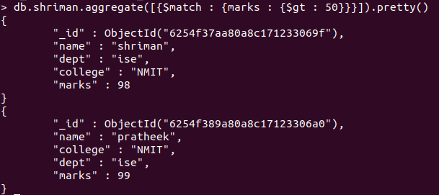

MARKS LESS THAN 99 :

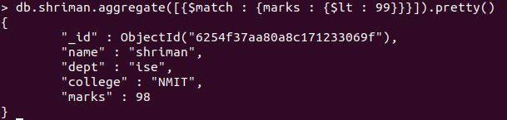

SORTING :

marks : 1 => ascending order

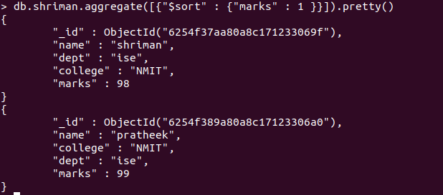

marks : -1 => descending order

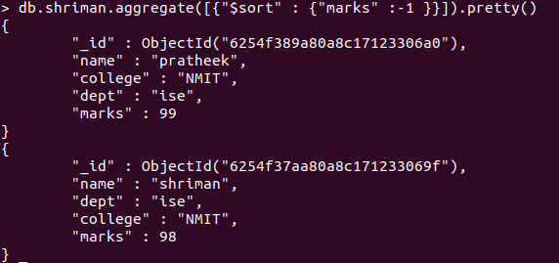

SUM OF ALL MARKS IN THE COLLLECTION :

AVERAGE OF ALL MARKS IN THE COLLECTION :

