SHRIMAN 12/04/2022
1NT19IS150

db.shriman.find({$or: [{dept: "cse"},{dept:"ise"}]}).pretty()
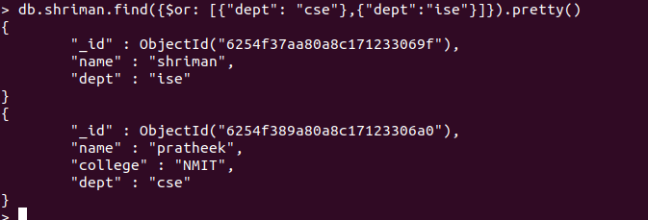

> db.shriman.find({$and:[{dept:"cse"},{name:"pratheek"}]}).pretty()

