Given a list of numbers, write a Python program to print all even numbers in the given list.

**Example:**

**Input:** list1 = [2, 7, 5, 64, 14]

**Output:** [2, 64, 14]

**Input:** list2 = [12, 14, 95, 3]

**Output:** [12, 14]

**Method 1:**[Using for loop](https://www.geeksforgeeks.org/loops-in-python/)

Iterate each element in the list using for loop and check if num % 2 == 0. If the condition satisfies, then only print the number.

Python3

|  |
| --- |
| # Python program to print Even Numbers in a List    # list of numbers  list1 **=** [10, 21, 4, 45, 66, 93]    # iterating each number in list  **for** num **in** list1:        # checking condition  **if** num **%** 2 **==** 0:          print(num, end**=**" ") |

**Output**

10 4 66

**Time Complexity:** O(N)  
**Auxiliary Space:** O(1), As constant extra space is used.

**Method 2:**[Using while loop](https://www.geeksforgeeks.org/loops-in-python/)

Python3

|  |
| --- |
| # Python program to print Even Numbers in a List    # list of numbers  list1 **=** [10, 24, 4, 45, 66, 93]  num **=** 0    # using while loop  **while**(num < len(list1)):        # checking condition  **if** list1[num] **%** 2 **==** 0:          print(list1[num], end**=**" ")        # increment num      num **+=** 1 |

**Output**

10 24 4 66

**Time Complexity:**O(N)  
**Auxiliary Space:** O(1), As constant extra space is used.

**Method 3:**[Using list comprehension](https://www.geeksforgeeks.org/python-list-comprehension-and-slicing/)

Python3

|  |
| --- |
| # Python program to print even Numbers in a List    # list of numbers  list1 **=** [10, 21, 4, 45, 66, 93]    # using list comprehension  even_nos **=** [num **for** num **in** list1 **if** num **%** 2 **==** 0]    print("Even numbers in the list: ", even_nos) |

**Output**

Even numbers in the list: [10, 4, 66]

**Time Complexity:** O(N)  
**Auxiliary Space:**O(1), As constant extra space is used.

**Method 4:**[Using lambda expressions](https://www.geeksforgeeks.org/python-lambda-anonymous-functions-filter-map-reduce/)

Python3

|  |
| --- |
| # Python program to print Even Numbers in a List    # list of numbers  list1 **=** [10, 21, 4, 45, 66, 93, 11]      # we can also print even no's using lambda exp.  even_nos **=** list(filter(**lambda** x: (x **%** 2 **==** 0), list1))    print("Even numbers in the list: ", even_nos) |

**Output**

Even numbers in the list: [10, 4, 66]

**Time Complexity:** **O(n)** as we are iterating through each element of the list only once.

**Space Complexity: O(n)** as a new list is created to store the even numbers from the given list.

**Method 5:**Using [Recursion](https://www.geeksforgeeks.org/recursion/)

Python3

|  |
| --- |
| # Python program to print  # even numbers in a list using recursion      **def** evennumbers(list, n**=**0):      # base case  **if** n **==** len(list):          exit()  **if** list[n] **%** 2 **==** 0:          print(list[n], end**=**" ")      # calling function recursively      evennumbers(list, n**+**1)      list1 **=** [10, 21, 4, 45, 66, 93]  print("Even numbers in the list:", end**=**" ")  evennumbers(list1) |

**Output**

Even numbers in the list: 10 4 66

**Time complexity: O(n),** The time complexity of this algorithm is O(n), where n is the length of the list, since it traverses the list only once.  
**Auxiliary Space: O(n),** The auxiliary space is O(n) as the recursion needs to store the list and the parameters of the function in the call stack.

**Method: Using enumerate function**

Python3

|  |
| --- |
| list1 **=** [2, 7, 5, 64, 14]  **for** a, i **in** enumerate(list1):  **if** i **%** 2 **==** 0:  **print**(i, end**=**" ") |

**Output**

2 64 14

Time Complexity: O(n)  
Auxiliary Space: O(1)

**Method: Using pass**

Python3

|  |
| --- |
| list1 **=** [2, 7, 5, 64, 14]  **for** i **in** list1:  **if** (i **%** 2 !**=** 0):  **pass**  **else**:  **print**(i, end**=**" ") |

**Output**

2 64 14

**Time complexity: O(n)**, where n is total number of values in list1.

**Auxiliary Space: O(1)**

**Method: Using numpy.array**

Python3

|  |
| --- |
| # Python code To print all even numbers  # in a given list using numpy array  **import** numpy as np    # Declaring Range  temp **=** [2, 7, 5, 64, 14]  li **=** np.array(temp)    # printing odd numbers using numpy array  even_num **=** li[li **%** 2 **==** 0]  print(even_num) |

**Output:**

[ 2 64 14]

**Method: Using not and Bitwise & operator**

we can find whether a number is even or not using & operator. We traverse all the elements in the list and check if **not element&1**. If condition satisfied then we say it is an even number

Python3

|  |
| --- |
| #python program to print all even no's in a list  #defining list with even and odd numbers  list1**=**[39,28,19,45,33,74,56]  #traversing list using for loop  **for** element **in** list1:  **if** **not** element&1:  #condition to check even or not      print(element,end**=**' ') |

**Output**

28 74 56

**Time Complexity: O(N)**  
**Auxiliary Space: O(1), As constant extra space, is used.**

**Method: Using bitwise | operator**

we can find whether a number is even or not using | operator. We traverse all the elements in the list and check if not element | 1 == element. If the condition satisfied, then we say it is an odd number.

Python3

|  |
| --- |
| #python program to print all even no's in a list  #defining list with even and odd numbers  list1**=**[39,28,19,45,33,74,56]  #traversing list using for loop  **for** element **in** list1:  **if**  element|1 !**=** element: #condition to check even or not          print(element,end**=**' ') |

**Output**

28 74 56

**Time Complexity: O(N)**  
**Auxiliary Space: O(1), As constant extra space, is used.**

**Method: Using reduce method:**

Python3

|  |
| --- |
| # Using the reduce function from the functools module  **from** functools **import** reduce  list1 **=** [39,28,19,45,33,74,56]  even_numbers **=** reduce(**lambda** x, y: x **+** [y] **if** y **%** 2 **==** 0 **else** x, list1, [])  **for** num **in** even_numbers:  **print**(num, end**=**" ")      #This code is contributed by Jyothi pinjala |

**Output**

28 74 56

**Time Complexity: O(n)**  
**Auxiliary Space: O(n)**

[Python | Filter even values from a list - GeeksforGeeks](https://www.geeksforgeeks.org/python-filter-even-values-from-a-list/)

40. [How to Use SELF in Python (hubspot.com)](https://blog.hubspot.com/website/python-self#:~:text=SELF%20represents%20the%20instance%20of,it%20by%20any%20other%20name.)

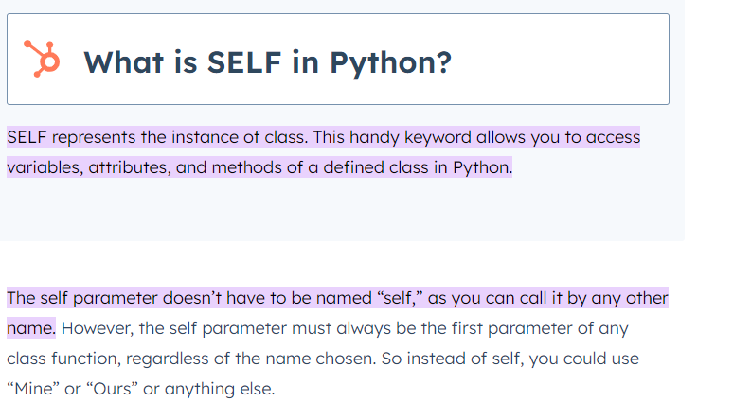

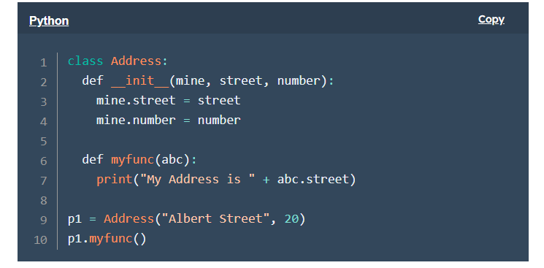

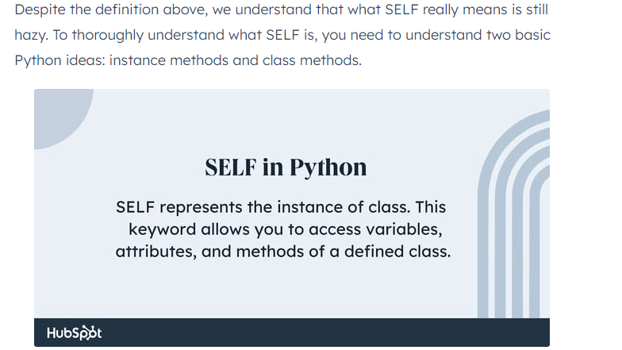

41. [Python Data Types (With Complete List) | DigitalOcean](https://www.digitalocean.com/community/tutorials/python-data-types)

[Swap three variables without using temporary variable - GeeksforGeeks](https://www.geeksforgeeks.org/swap-three-variables-without-using-temporary-variable/?ref=rp)