🧠 What you’re pointing out:
✅ Even if DVC reproduces the pipeline and generates new artifacts (e.g. cleaned data, TFRecords, model.pkl),
✅ You still need those outputs for downstream tasks like:
- model deployment
- model monitoring
- reporting or evaluation
- retraining triggers
And that’s exactly what happens in a real MLOps setup.

🎯 Role of DVC-produced artifacts:
Think of DVC as managing versioning and caching of all intermediate files:
- 🧮 DVC stages produce versioned artifacts (data/clean.csv, model.pkl, etc.).
- 🧮 DVC stores these outputs in its cache and optionally in a remote (S3, GCS) — so you never recompute the same thing twice.

🏭 Role of the orchestrator:
Your orchestrator (e.g. Airflow/Kubeflow) would:
- ✅ Trigger the DVC pipeline (dvc repro)
- ✅ Pick up the resulting artifacts (e.g. model.pkl) once DVC is done
- ✅ Push them onward — for deployment, validation, inference serving, model registry, etc.

🔄 Typical downstream flow:
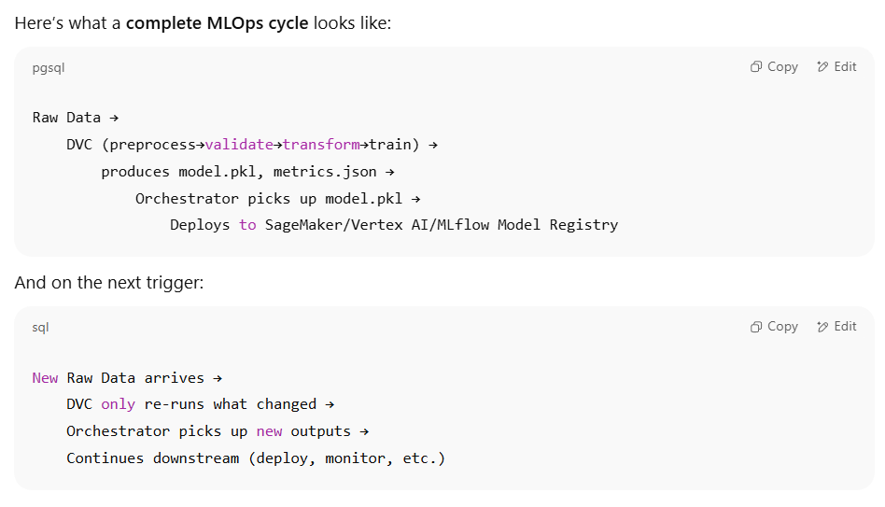

🎯 Why this is better than manual:
✅ DVC handles the “what changed” part efficiently.
✅ The orchestrator handles “when and where to run it” and “what to do next.”
That way:
- You never redo work unnecessarily.
- You have a version history for all data & models.
- The orchestrator still controls the bigger picture.

🎨 Example End-to-End MLOps Flow
Imagine a typical ML pipeline with new data every day:

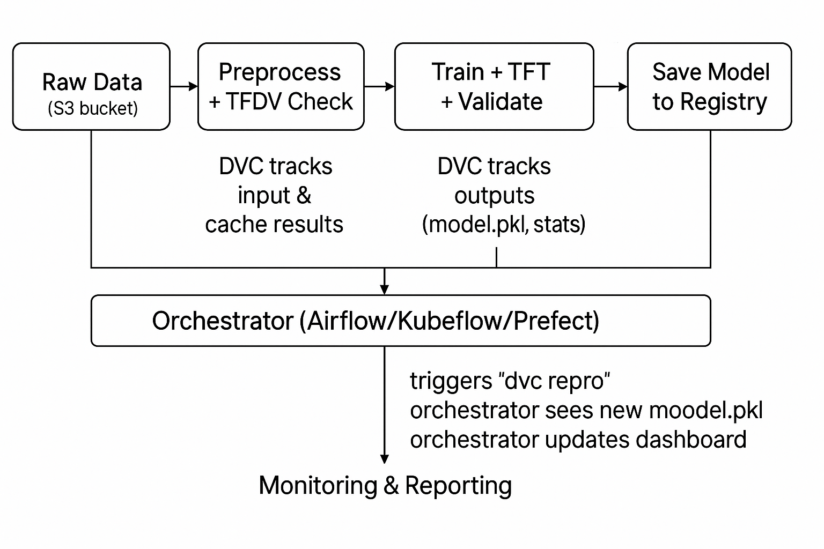

🎯 Key points:
✅ DVC stages version data & cache heavy work (preprocess, tft, train).
✅ Orchestrator triggers DVC (dvc repro) and handles what to do after, like:
- uploading the model to a model registry,
- launching a deployment job,
- sending Slack notifications, etc.

🔄 What happens next time new data arrives?
✅ Orchestrator triggers pipeline again
✅ DVC sees new raw data → re-run preprocessing and training
✅ Orchestrator grabs new model → deploys new version

