Two-Stage Hybrid CNN and Random Forest for Real-Time Power Quality Disturbance Classification
Shrimathi G  Department of Electrical and  Electronics Engineering  Sri Venkateswara College of Engineering  Pennalur 602117  2022ee0135@svce.ac.in | Sanjay Kumar V  Department of Electrical and  Electronics Engineering  Sri Venkateswara College of Engineering  Pennalur 602117  2022ee0214@svce.ac.in | Suresh N  Department of Electrical and  Electronics Engineering  Sri Venkateswara College of Engineering  Pennalur 602117  sureshn@svce.ac.in

Abstract—This paper presents a two-stage hybrid pipeline for real-time classification of power quality disturbances (PQDs) defined under IEEE Standard 1159. Single-cycle voltage windows of 100 samples at 5 kHz are first screened by an O(N) threshold detector using five physical features: root mean square, low-order total harmonic distortion, excess kurtosis, maximum consecutive-sample difference, and quarter-window RMS dispersion. Windows flagged as Abnormal are escalated to a hybrid Stage 2 classifier in which a compact one-dimensional convolutional neural network learns a 64-dimensional feature representation from the raw waveform, and a Random Forest with 200 trees classifies seventeen classes (one normal, eight single disturbances, eight pairwise compound disturbances). Each prediction is enriched at run time with a severity grade, cause, equipment-at-risk, and three to five operator actions from a 17-entry IEEE 1159 knowledge base, and is streamed to a browser dashboard through a Flask-SocketIO backend. On a stratified 80-to-20 split of the 17,000-signal XPQRS dataset, Stage 2 attains 98.85% accuracy (thirteen of seventeen classes at 100% recall), the end-to-end pipeline reaches 96.67% on a balanced mixed-traffic test, Stage 1 detects 100% of Normal windows at zero false alarms, and inference takes approximately 67 ms on a single-thread laptop CPU without GPU or cloud. A preprocessing analysis shows that per-sample maximum-absolute normalization, common in deep-learning PQD work, collapses accuracy to 52% by discarding amplitude information that separates Sag, Swell, and Interruption from Pure Sinusoidal; a single global-scale normalization recovers the missing 47 percentage points. The system is suitable for edge deployment on distribution feeders.
Index Terms—Power quality disturbance classification, IEEE Standard 1159, two-stage pipeline, hybrid CNN-Random Forest, real-time monitoring, edge intelligence, knowledge-based reasoning.

I. INTRODUCTION
Power quality (PQ) has emerged as a critical concern in contemporary power systems owing to the increasing penetration of renewable energy resources, power-electronic converters, electric-vehicle charging infrastructure, and non-linear industrial loads. The injection of non-sinusoidal currents into distribution networks produces voltage waveforms whose deviation from the nominal sinusoid is frequently the limiting factor for sensitive end-use equipment. The categorization of such deviations (voltage sag, voltage swell, interruption, harmonic distortion, flicker, impulsive transient, oscillatory transient, notching, and their pairwise compound combinations) is formally defined in IEEE Standard 1159 [1]. A deployable PQ monitor is required to identify the specific disturbance class within an operationally relevant time window [2].
Conventional PQ classification approaches extract handcrafted statistical or spectral features (root mean square, total harmonic distortion, wavelet energies, higher-order statistics) from each waveform window and apply a shallow classifier such as a support vector machine, an extreme learning machine, or a decision-tree ensemble [3], [4]. Recent literature has demonstrated that one-dimensional convolutional neural networks (1D-CNNs) [5], [6], [7] can achieve competitive classification accuracy directly from the raw voltage cycle without explicit feature engineering. Hybrid configurations [8], [9], in which a CNN serves as a learned feature extractor followed by a classical classifier, represent an active line of investigation aimed at obtaining the representational capacity of deep models while retaining the deployment characteristics of classical methods.
This paper presents a real-time PQ classification system that integrates these two paradigms within a unified two-stage architecture and contributes three system-level components that, to the best of the authors' knowledge, have not been reported together in a single published pipeline. First, a five-feature O(N) rule-based screen serves as Stage 1 and resolves clean traffic in less than one millisecond, restricting the heavier classifier to flagged windows. Second, a hybrid 1D-CNN and Random Forest classifier serves as Stage 2 and performs 17-class classification on the windows escalated by Stage 1. Third, an IEEE 1159-derived knowledge base augments every classified output with a severity grade, physical cause, equipment-at-risk, and three to five immediate operator actions. The full pipeline executes on a single-thread laptop-class CPU without graphics-processing-unit (GPU) acceleration or external network connectivity, and is shown to satisfy operational latency requirements that cloud-deployed deep PQ classifiers cannot meet under typical wide-area round-trip-time constraints.
The remainder of the paper is organized as follows. Section II reviews related work. Section III formalizes the problem statement, summarizes the contributions, and articulates the novelties. Section IV describes the dataset and the underlying signal model. Section V details the proposed methodology and the supporting mathematical formulation. Section VI describes the real-time backend and the dashboard. Section VII presents the experimental setup. Section VIII reports the model-selection comparison. Section IX presents results and discussion. Section X enumerates the limitations of the present study, and Section XI concludes the paper.
II. RELATED WORK
PQ disturbance classification has been studied extensively. Khetarpal and Tripathi [2] provide a comprehensive review of the field, surveying signal-processing, machine-learning, and hybrid approaches and identifying the trade-offs between feature-engineering depth and classification accuracy. Thirumala et al. [3] apply empirical wavelet transform-based adaptive filtering with a multiclass support vector machine. Sahani and Dash [4] introduce a weighted bidirectional extreme learning machine in conjunction with the Hilbert–Huang transform.
Deep-learning approaches have been investigated more recently. Wang et al. [5] employ a deep convolutional neural network on compressed-sensing reconstructions of voltage cycles. Cai et al. [6] feed Wigner–Ville distribution images to a deep CNN. Eristi et al. [7] combine a one-dimensional local binary pattern operator with a CNN. Garcia et al. [9] perform a comparative study of CNN, long short-term memory, and CNN-LSTM architectures applied to the same PQ disturbance set. The principal trade-off across these systems is model size: typical published deep PQ classifiers carry between 10⁵ and 10⁶ parameters, which is acceptable for server-side execution but is unsuitable for embedded deployment.
The work most closely related to the present study is that of Cai et al. [8], which integrates a CNN feature extractor with an extreme gradient boosting classifier for PQ disturbance recognition. The present work adopts the broader hybrid template (a CNN feature extractor combined with an ensemble classifier head) and extends it along three axes: (i) the introduction of an O(N) rule-based screening stage that precedes the heavier model; (ii) the extension of the class set to seventeen, including eight pairwise compound disturbances; and (iii) the integration of a deterministic IEEE 1159-grounded knowledge base that emits severity, cause, equipment-at-risk, and immediate-action metadata for every classified window.
Two-stage architectures that screen with a fast rule and invoke a heavier model only on suspicious windows are common in time-series anomaly detection in general. However, no published PQ system known to the authors has reported the screen behaviour with both detection rate and false-alarm rate, employed a hybrid CNN and tree-ensemble classifier as the second stage, and emitted operator-actionable knowledge-base metadata as part of the deployed pipeline.
Interpretability of PQ classifiers has historically received limited attention. The TreeSHAP attribution method of Lundberg et al. [10] enables tractable per-prediction attribution for tree-based models, and is applied in the present work as a post-hoc explainer on the legacy 36-feature Random Forest baseline. Broader surveys of explainable artificial intelligence are provided in [11].
III. PROBLEM STATEMENT, CONTRIBUTIONS, AND NOVELTIES
A. Problem Statement
Modern power systems are increasingly subject to PQ disturbances arising from the proliferation of renewable energy sources, power-electronic converters, and non-linear loads. These disturbances introduce non-stationary and non-linear characteristics into the voltage waveform, and their reliable identification under realistic noise conditions remains technically demanding. Three constraints define the operational solution space.
1) Latency:
A real-time PQ classifier must complete inference within an operationally meaningful time-scale; for monitoring and diagnostic applications this is one to a few cycles of the fundamental.
2) Class confusability:
Several IEEE 1159 classes differ from the normal reference solely in amplitude (sag, swell, interruption), and several others are pairwise compounds of two single disturbances. Both characteristics challenge feature- and representation-learning methods.
3) Deployability:
A significant fraction of the published deep-learning PQ literature presupposes cloud or GPU compute, which is incompatible with edge-relay or substation-class hardware. Cloud deployment further introduces a network round-trip-time penalty that conventional links cannot absorb within a one-cycle decision deadline.
A classifier is therefore required that simultaneously (a) achieves high accuracy across a large class set, (b) sustains low single-thread CPU latency, (c) provides per-prediction interpretability, (d) emits an output more actionable than a bare class label, and (e) operates without external infrastructure.
B. Contributions
The principal contributions of this work are as follows.
1) A two-stage classification pipeline comprising a five-feature O(N) threshold screen as Stage 1 and a hybrid 1D-CNN and Random Forest classifier as Stage 2.
2) A hybrid CNN-RF classifier that achieves 98.85% accuracy across seventeen IEEE 1159 classes, with thirteen of seventeen classes at 100% recall.
3) A knowledge-based output layer that augments every prediction with severity, cause, equipment-at-risk, and immediate-action metadata derived from IEEE Standard 1159.
4) A real-time backend and browser dashboard that streams predictions to all connected clients with sub-cycle Stage 1 detection and approximately three-cycle Stage 2 classification on a laptop-class CPU.
5) An input-normalization analysis that documents and explains a 47-percentage-point accuracy collapse caused by per-sample maximum-absolute scaling, together with a single-line global-scale fix.
6) A post-hoc SHAP explainer applied to the legacy 36-feature Random Forest baseline, returning the top three contributing physical features for any single prediction.
C. Novelties
The novelties of the proposed system, taken together, define an integrated pipeline whose combination of features has not been reported in prior PQ literature.
N1. Two-stage architecture with rule-based screening and hybrid deep classification. The majority of published PQ classifiers operate as single-stage end-to-end models. The proposed system introduces a five-feature O(N) rule-based screen that resolves the clean fraction of traffic in under one millisecond and reserves the heavier hybrid model for windows that cannot be classified at the rule level. The screen is characterized by both a 100% detection rate and a 0% false-alarm rate, a combination not jointly reported in prior PQ literature.
N2. Hybrid 1D-CNN and Random Forest with frozen-feature retuning. The 1D-CNN learns a 64-dimensional representation directly from the raw cycle, and the Random Forest classifies on this representation. The hybrid arrangement combines deep representational learning with the calibrated top-K probability outputs of a tree ensemble, and permits the Random Forest head to be re-tuned on the frozen feature space within seconds, without re-training the CNN.
N3. Knowledge-based severity-aware output layer. Every prediction is enriched at inference time with a severity grade, two-sentence physical cause, equipment-at-risk, and three to five operator-level actions, drawn from a 17-entry knowledge base derived from IEEE Standard 1159. No prior PQ classifier known to the authors emits this level of actionable diagnosis as part of the deployed pipeline.
N4. Seventeen-class coverage including eight pairwise compound disturbances. The proposed system extends the class set beyond the typical nine to fourteen classes covered in prior deep PQ classifiers, and demonstrates thirteen of seventeen classes at 100% recall.
N5. Global-scale normalization for amplitude-preserving deep learning on PQ signals. A 47-percentage-point accuracy collapse caused by the per-sample maximum-absolute scaling commonly employed in the deep-learning PQ literature is documented, and a single-line global-scale normalization that restores the missing accuracy is presented. The result is transferable to any deep PQ pipeline that includes amplitude-distinguished classes.
N6. Real-time multi-source backend and offline-tolerant dashboard. The Flask-SocketIO and TCP backend ingests live signals from MATLAB, Python, and JSON-over-HTTP senders concurrently, and pushes predictions to a single-file browser dashboard with severity-coded panels, top-three confidence display, latency timeline, and an offline demo-mode fallback. The complete system executes on a laptop-class CPU without GPU acceleration or cloud connectivity.
N7. Edge-deployable inference profile within the cloud round-trip-time floor. Stage 1 detection is completed in less than one millisecond, and Stage 2 classification in approximately three cycles of the 50 Hz fundamental. Wide-area cloud round-trip times are typically 100–300 ms before any inference is initiated, which is several multiples of one PQ cycle. The proposed system therefore satisfies an operational deadline that cloud-deployed deep PQ classifiers cannot satisfy under realistic network conditions.
N8. Post-hoc SHAP attribution with physical-feature semantics. A TreeSHAP explainer is integrated on the legacy 36-feature Random Forest baseline, returning the top three contributing physical features (root mean square, total harmonic distortion, harmonic magnitudes, wavelet energies) for any single prediction. Operators are therefore able to review borderline classifications using named physical quantities rather than abstract activation maps.
IV. DATASET AND SIGNAL MODEL
Each input to the proposed system is a one-cycle voltage window of length N = 100 samples acquired at a sampling rate f_{s} = 5 kHz, corresponding to one period of the 50 Hz fundamental. Amplitudes are expressed in per-unit (pu) with the nominal peak value normalized to 1.0. The underlying signal-generation model conforms to the disturbance definitions of IEEE Standard 1159 [1]. The publicly available XPQRS-style synthetic dataset is employed for training and evaluation. The dataset comprises 17,000 signals balanced across seventeen classes (1,000 signals per class). The seventeen classes are: Pure Sinusoidal (the normal reference), voltage sag, voltage swell, interruption, impulsive transient, oscillatory transient, harmonics, notch, flicker, and eight pairwise compound disturbances formed by combinations of sag, swell, harmonics, flicker, oscillatory transient, and notch.
Additive white Gaussian noise (AWGN) at a signal-to-noise ratio of 40 dB is applied during training to discourage memorization of artefacts of the synthetic generator. A stratified 80-to-20 split with random seed 42 is used, yielding 13,600 training samples and 3,400 test samples (200 per class).
The signal characteristics merit explicit description. A pure sinusoid is a unit-amplitude sine wave at 50 Hz. A voltage sag corresponds to multiplication of the sinusoid by a constant in the range 0.1–0.9 pu over a stretch of cycles, while a voltage swell corresponds to multiplication by a constant in the range 1.1–1.8 pu. An interruption is approximated by a near-zero amplitude window. Harmonic disturbances superimpose integer-multiple sinusoids on the fundamental. Flicker corresponds to slow amplitude modulation of the fundamental. Several classes (sag, swell, and interruption) therefore differ from the normal reference solely in amplitude. As demonstrated in Section IX, this characteristic interacts critically with the choice of input normalization.
V. METHODOLOGY
A. System Overview
The proposed framework follows a structured pipeline: signal acquisition, preprocessing, two-stage classification, knowledge-base enrichment, and real-time push to the dashboard. Fig. 1 illustrates the overall architecture. A signal arrives via TCP, HTTP, or a SocketIO event. Stage 1 produces a binary Normal/Abnormal decision in under one millisecond. If the decision is Normal, the prediction is reported as Pure Sinusoidal and the call returns. If the decision is Abnormal, the same window is forwarded to Stage 2, which produces a 17-class label and a confidence vector. The result is enriched with knowledge-base metadata and pushed to all connected dashboard clients.
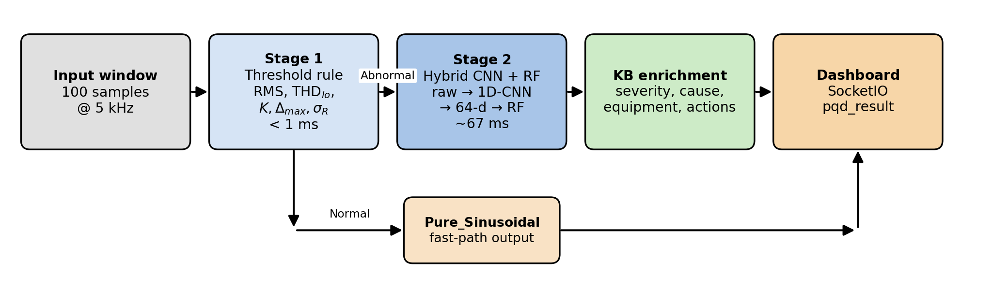
Fig. 1. Two-stage classification architecture. Stage 1 is a rule-based threshold detector with a sub-millisecond budget; Stage 2 is invoked only on Abnormal windows and is a hybrid one-dimensional convolutional neural network feature extractor followed by a Random Forest classifier. Each prediction is enriched online from an IEEE 1159 knowledge base before being pushed to the dashboard.
B. Signal Acquisition
The input to the system is a discrete-time voltage signal
x(n), n = 0, 1, 2, …, N − 1, (1)
where N = 100 samples represents one cycle of the 50 Hz fundamental at f_{s} = 5 kHz. Signals can be sourced from MATLAB, a Python sender, a JSON HTTP POST request, or a SocketIO event.
C. Preprocessing and Global Normalization
In contrast to the conventional per-sample scaling x̃(n) = (x(n) − μ_{x})/σ_{x}, which removes amplitude information from each window, the proposed system applies a single global scale that is computed once on the training set and stored with the model:
x̃(n) = x(n) / s, s = Q₉₉ ( { |x_{i}^{(train)}| } ), (2)
where Q₉₉(·) denotes the 99th percentile of the absolute amplitudes of the entire training set. In the present implementation s = 2.0535. The reason per-sample scaling is unsuitable for amplitude-distinguished PQD classes, and the recovery achieved by global scaling, are reported in Section IX-C.
D. Stage 1: Threshold Detector
Stage 1 computes five features and returns Abnormal if any one of them exceeds its threshold.
1) Root mean square (RMS):
V_{RMS} = √ ( (1/N) ∑_{n=0}^{N−1} x(n)² ). (3)
The detector trips if V_{RMS} < 0.65 pu (sag, interruption) or V_{RMS} > 0.78 pu (swell).
2) Low-order total harmonic distortion approximation:
Using the magnitudes V_{h} of the h-th harmonic bin obtained from the FFT of the window,
THD_{lo} = √(V₂² + V₃² + V₅²) / V₁. (4)
The detector trips if THD_{lo} > 0.025 (harmonics, notch).
3) Kurtosis:
K = [ (1/N) ∑_{n} (x(n) − μ_{x})⁴ ] / [ (1/N) ∑_{n} (x(n) − μ_{x})² ]². (5)
This is the Pearson form of kurtosis, for which a clean unit-amplitude sinusoid yields K ≈ 1.5. The detector trips if K > 2.5 (impulsive transients).
4) Maximum consecutive-sample difference:
Δ_{max} = max_{n=1,…,N−1} |x(n) − x(n−1)|. (6)
The detector trips if Δ_{max} > 0.15 pu (notch, oscillatory burst).
5) Quarter-window RMS dispersion:
The window is partitioned into four quarters of length N/4 = 25, and the RMS r_{q} of each quarter is computed; the dispersion is
σ_{R} = std(r₁, r₂, r₃, r₄). (7)
The detector trips if σ_{R} > 0.020 (flicker).
All five features are O(N) on the 100-sample window, yielding a Stage 1 budget below 1 ms on a generic CPU. The complete decision logic is summarized in Table I. The thresholds are deliberately set on the conservative side. The role of Stage 1 is not to perform fine-grained classification but to filter clean traffic out of the heavier inference path while maintaining a zero Abnormal-as-Normal misclassification rate.
TABLE I
Stage 1 threshold-detector decision logic. The five features are evaluated in order; if none trips, the window is Normal.
Step | Feature | Eqn. | Trip condition | Flagged
1 | RMS | (3) | V_RMS ∉ [0.65, 0.78] pu | Sag / Swell / Intr.
2 | Low-order THD | (4) | THD_lo > 0.025 | Harmonics / Notch
3 | Kurtosis | (5) | K > 2.5 | Impulsive transient
4 | Max sample diff. | (6) | Δ_max > 0.15 pu | Notch / Osc. burst
5 | Quarter-RMS disp. | (7) | σ_R > 0.020 | Flicker

E. Stage 2: Hybrid 1D-CNN and Random Forest
Stage 2 produces the seventeen-class decision. The 1D-CNN does not output class logits at inference time; instead, its penultimate layer provides a 64-dimensional feature vector that is consumed by a Random Forest classifier.
1) Multi-domain feature foundation (legacy reference):
For the legacy 36-feature baseline employed in the model-comparison study (Section VIII), features are extracted across three domains.
Time domain (14 features): including RMS (Eq. 3), mean
μ_{x} = (1/N) ∑_{n=0}^{N−1} x(n), (8)
crest factor
CF = V_{peak} / V_{RMS}, (9)
peak amplitude, kurtosis, skewness, zero-crossing rate, and quarter-window statistics.
Frequency domain (10 features): including the full total harmonic distortion
THD = √( ∑_{h=2}^{H} V_{h}² ) / V₁, (10)
the magnitudes of the first ten harmonic bins of the FFT, and the fundamental amplitude V₁.
Wavelet domain (12 features): obtained from a three-level Daubechies-4 discrete wavelet transform. The energy at decomposition level j is
E_{j} = ∑_{k=1}^{Mj} |d_{j,k}|², (11)
where d_{j,k} is the k-th detail coefficient at level j and M_{j} is the number of coefficients at that level.
2) 1D-CNN feature extractor:
The globally normalized window x̃ (Eq. 2) is supplied directly to a compact 1D-CNN whose architecture is specified as follows:
1) Three convolutional blocks of the form Conv1D(k=5, c) → BatchNorm → ReLU → MaxPool(2), with channel widths c ∈ {16, 32, 64}.
2) A global average pooling layer that collapses the temporal axis.
3) A fully connected hidden layer with 128 units and ReLU activation.
4) A 64-unit feature layer; its activation forms the feature vector f ∈ ℝ⁶⁴.
5) A softmax output head used during training only.
The CNN is trained for at most 80 epochs using Adam with an initial learning rate of 10⁻³ and an early-stopping criterion on validation accuracy with patience 10 and best-weights restoration. Additive white Gaussian noise at 40 dB SNR is applied online to each training batch. After training, the softmax head is removed and the network is retained as a fixed feature extractor.
3) Random Forest head:
A Random Forest with T = 200 decision trees and max_features = log₂(d) where d = 64 is trained on the CNN feature vectors. At inference, the prediction is the majority vote
ŷ = mode( ŷ₁, ŷ₂, …, ŷ_{T} ), (12)
and the class probability is the empirical frequency of each label across the trees. This formulation provides a calibrated top-K distribution, which the dashboard uses to display the top three candidate classes.
4) Rationale for the hybrid configuration:
A CNN with a softmax output head converges to comparable accuracy on this dataset. The hybrid configuration is preferred for two reasons. First, the Random Forest provides a calibrated top-K probability distribution without further post-hoc calibration steps such as temperature scaling or Platt scaling. Second, the modular separation of the feature extractor and the classifier permits the Random Forest head to be re-tuned on the frozen feature space within seconds, without re-training the CNN. This property is operationally advantageous for field deployments that require periodic drift adaptation or rapid re-validation.
F. Knowledge-Base Enrichment
Each Stage 2 prediction ŷ is augmented at run time with five fields drawn from a 17-entry knowledge base derived from IEEE Standard 1159: display name (human-readable label), severity ∈ {none, low, medium, high, critical}, cause (a two-sentence physical explanation), equipment-at-risk (the loads typically affected), and immediate actions (three to five operator-level steps). The enrichment is a deterministic lookup rather than a model output, but it transforms the bare class label into actionable diagnostic content.
G. Hyperparameter Optimization
The Stage 2 Random Forest hyperparameters are optimized using a five-fold stratified cross-validation grid search over the search space summarized in Table II. Twenty-four parameter combinations were evaluated, yielding 120 fits in total (24 × 5). The deployed configuration uses 200 trees with log₂ feature selection and reaches a held-out test accuracy of 98.85%. The grid-search optimum (500 trees with sqrt feature selection) reaches 98.88%, an absolute improvement of 0.03 percentage points. The top thirteen of the 24 configurations are observed to lie within ±0.05 percentage points of one another, indicating that classification accuracy is saturated on the deployed 64-dimensional CNN feature space.
TABLE II
Stage 2 Random Forest hyperparameter grid search. The deployed configuration is retained because the grid-search optimum exceeds it by less than the test-set noise floor.
Hyperparameter | Search space | Deployed value
n_estimators | {100, 200, 500} | 200
max_depth | {None, 20} | None
max_features | {sqrt, log2} | log2
min_samples_leaf | {1, 2} | 1

H. Computational Complexity and Real-Time Considerations
For an N-sample window the computational cost of each stage is as follows.
• Stage 1. Each of the five features is O(N), with the FFT-based total harmonic distortion approximation requiring O(N log N) on a fixed-size buffer. The total measured latency is below 1 ms for N = 100 on a single-thread CPU.
• Stage 2 CNN forward pass. The forward pass is dominated by the three Conv1D layers. The measured mean latency is approximately 40 ms.
• Stage 2 Random Forest predict. The cost is O(T · d_max) for T = 200 trees on the 64-dimensional feature vector. The measured mean latency is approximately 26 ms.
• End-to-end Abnormal path. Approximately 67 ms per window, equivalent to approximately three cycles of the 50 Hz fundamental.
The pipeline is engineered for single-thread CPU inference. The deep learning framework's graph caches are warmed at backend start-up using 50 dummy windows, ensuring that the first live inference matches steady-state latency. The dashboard maintains a synthetic-mode fallback so that user-interface demonstration is independent of backend reachability. The intended deployment surface is illustrated in Fig. 2: voltage and current signals from the grid, solar inverters, and distributed generation are acquired through a sensing front-end (e.g., ZMPT101B and ACS712 modules), routed to an edge compute node (Raspberry Pi, ESP32, or ARM-class microcontroller) that executes the trained model, and forwarded over RS485/Modbus or SocketIO to a panel meter or a SCADA human–machine interface for operator review.
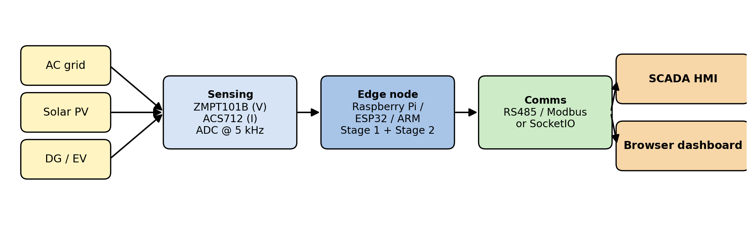
Fig. 2. Practical deployment architecture. Multi-source signal acquisition is followed by a sensing front-end, edge-compute inference using the proposed pipeline, and an RS485 or SocketIO link to the monitoring human–machine interface.
VI. REAL-TIME BACKEND AND DASHBOARD
The classifier is encapsulated within a Flask and Flask-SocketIO server. Three input paths are exposed: a JSON POST /api/predict endpoint for one-shot HTTP queries, a SocketIO predict event for low-latency clients, and a TCP listener on port 5555 that accepts newline-delimited JSON frames of the form {label, signal:[v0..v99], window}. The TCP listener broadcasts each prediction as a SocketIO pqd_result event to all connected dashboards. Both the included MATLAB sender and the Python sender, the latter implementing realistic synthetic IEEE 1159 signal generation, employ this path.
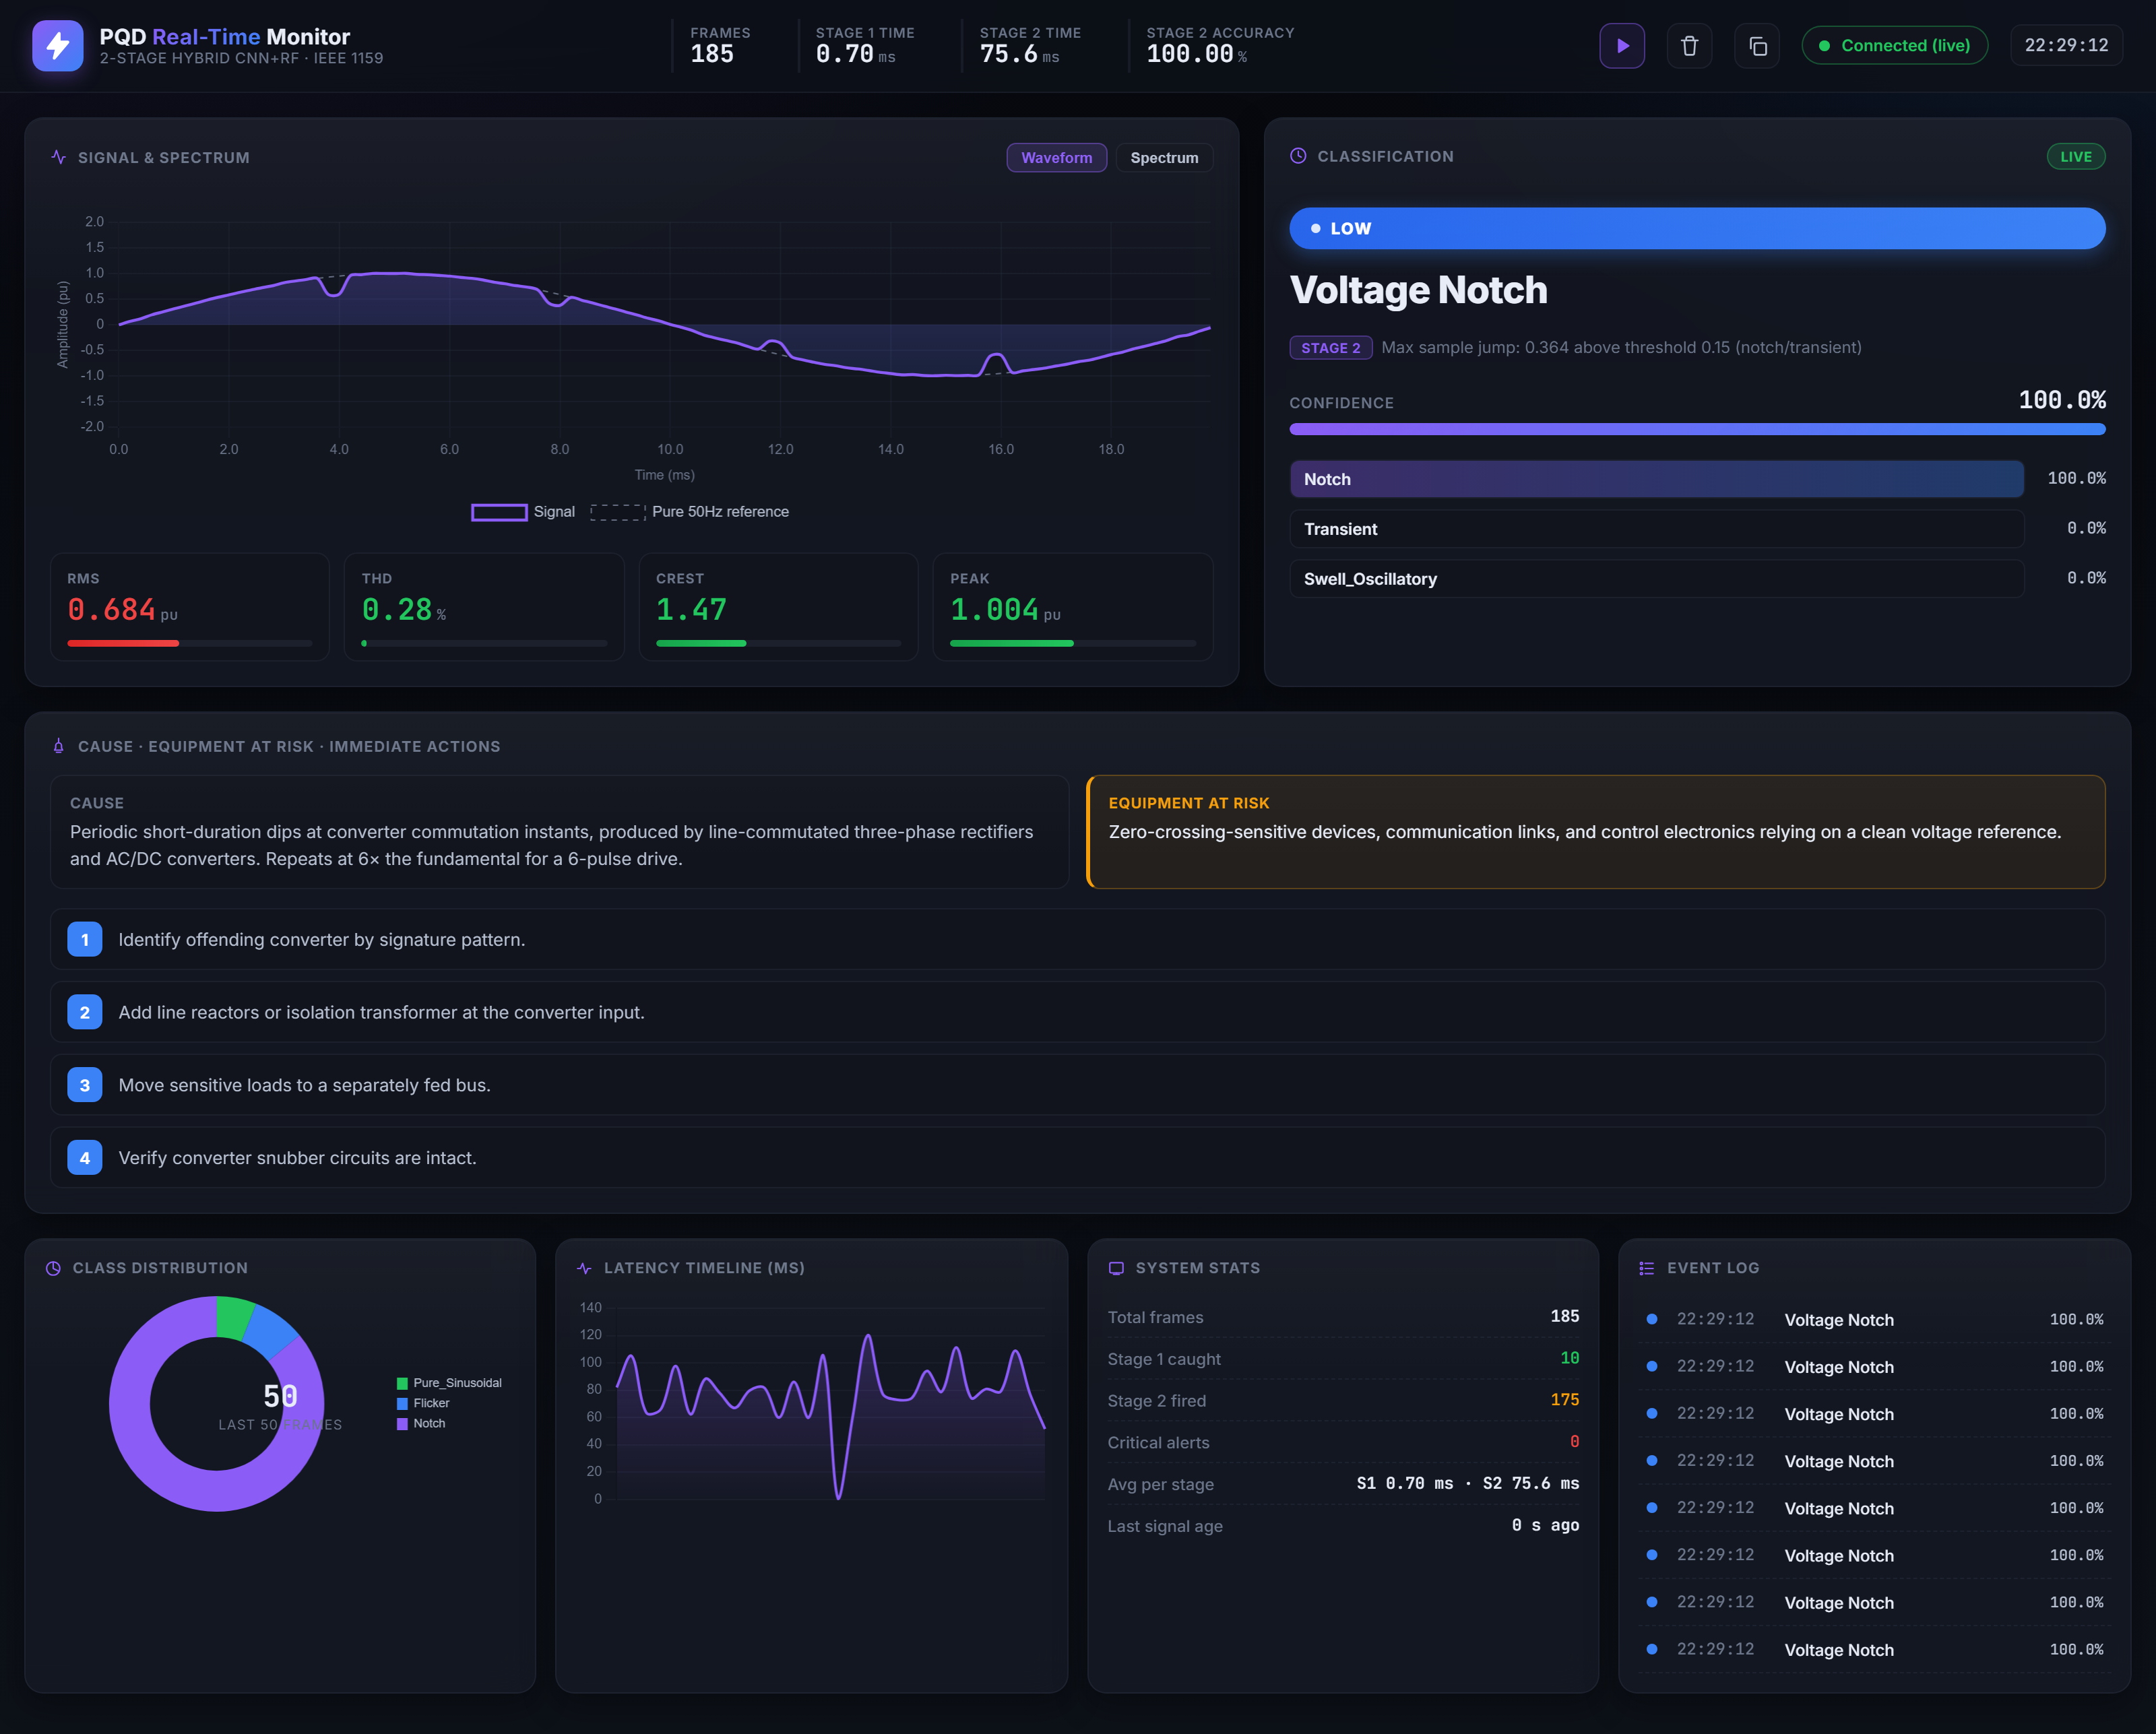
Fig. 3. Live dashboard. Six panels are rendered: waveform and spectrum, signal parameters, the classification card with top-three candidates, cause and equipment-at-risk, recommended operator actions, and a system-statistics strip with a rolling latency timeline. The dashboard automatically falls back to a built-in demonstration mode if the backend is unreachable for three seconds.
The dashboard, illustrated in Fig. 3, is implemented as a single-file HTML/CSS/JavaScript page using Chart.js and Socket.IO. Six panels are rendered: the live waveform with a tabbed FFT spectrum view, a gauge cluster for RMS, total harmonic distortion, crest factor, and peak amplitude, a classification card displaying a severity badge and top-three confidence bars, a card containing the cause and equipment-at-risk fields, a list of the recommended operator actions, and a system-statistics strip showing the number of frames received, both stage latencies, and a rolling latency timeline.
VII. EXPERIMENTAL SETUP
A. Hardware
All measurements are conducted on a single laptop-class workstation: Windows on AMD64 with an Intel 8-thread CPU. Single-thread evaluation is enforced. No GPU is used, and no cloud service is contacted at inference time.
B. Test Workload
Inference latency is measured on the full 3,400-sample test set, with one sample per call. A 50-iteration warm-up is applied to all neural-network models to eliminate graph-caching effects from the timed window. The Random Forest classifier is warmed by a single forward pass.
C. Performance Metrics
Reported metrics include overall accuracy, per-class precision, recall, F1 score, the confusion matrix, latency at the 50th and 95th percentiles and at the mean, parameter count, and on-disk model size. End-to-end pipeline accuracy is reported on a 510-signal balanced mixed-traffic test composed of 30% Normal and 70% Abnormal traffic.
VIII. MODEL COMPARISON AND SELECTION
Prior to adoption of the hybrid CNN-RF design, six classical machine-learning algorithms were trained on the same 36-feature multi-domain vector under identical conditions. The algorithms considered were Logistic Regression, Support Vector Machine (SVM), k-Nearest Neighbours (kNN), Decision Tree, Gradient Boosting, and Random Forest. Performance on the XPQRS dataset and on a second PQ dataset (the PQ Disturbances Dataset, with pre-extracted features) is reported in Table III.
TABLE III
Comparison of classical machine-learning models on two datasets. Accuracy and macro F1 are reported on the held-out test split.
Model | XPQRS Acc. | PQ Acc. | XPQRS F1 | PQ F1
Gradient Boosting | 0.9112 | 0.9837 | 0.9107 | 0.9836
Random Forest | 0.9062 | 0.9812 | 0.9056 | 0.9816
Decision Tree | 0.8650 | 0.9625 | 0.8646 | 0.9620
Logistic Regression | 0.8524 | 0.9375 | 0.8489 | 0.9372
SVM | 0.8335 | 0.8812 | 0.8298 | 0.8798
kNN | 0.8006 | 0.9062 | 0.7955 | 0.9046

The Random Forest classifier provides the most favourable combination of accuracy, robustness, and deployment simplicity within this comparison and is therefore adopted as the basis for both the legacy 36-feature baseline and the Stage 2 head of the hybrid model. When combined with the learned 64-dimensional CNN feature representation in place of the 36 hand-engineered features, the Random Forest head attains 98.85% accuracy on the XPQRS test set, an absolute improvement of 8.23 percentage points over the legacy configuration. This improvement is attributed to the richer learned feature space.
IX. RESULTS AND DISCUSSION
A. Stage 2 Classification Performance
The hybrid 1D-CNN and Random Forest classifier achieves an overall test accuracy of 98.85% on the held-out 3,400-sample test set. The test set is exactly balanced; macro-averaged precision, recall, and F1 are therefore equal at 98.85%. Thirteen of the seventeen classes attain 100% recall. The four non-perfect classes are Sag (90.50%), Sag-Flicker (91.00%), Swell (99.50%), and Swell-Flicker (99.50%). The complete per-class breakdown is reported in Table IV.
TABLE IV
Per-class classification performance on the 3,400-sample test set, with 200 samples per class.
Class | Recall | Precision | F1
Pure_Sinusoidal | 100.00 | 100.00 | 100.00
Flicker | 100.00 | 100.00 | 100.00
Harmonics | 100.00 | 100.00 | 100.00
Harmonics_Flicker | 100.00 | 100.00 | 100.00
Harmonics_Notch | 100.00 | 100.00 | 100.00
Interruption | 100.00 | 100.00 | 100.00
Notch | 100.00 | 100.00 | 100.00
Oscillatory_Transient | 100.00 | 100.00 | 100.00
Sag_Harmonics | 100.00 | 100.00 | 100.00
Sag_Oscillatory | 100.00 | 100.00 | 100.00
Swell_Harmonics | 100.00 | 100.00 | 100.00
Swell_Oscillatory | 100.00 | 100.00 | 100.00
Transient | 100.00 | 100.00 | 100.00
Swell | 99.50 | 99.50 | 99.50
Swell_Flicker | 99.50 | 99.50 | 99.50
Sag_Flicker | 91.00 | 90.55 | 90.77
Sag | 90.50 | 90.95 | 90.73
Macro avg | 98.85 | 98.85 | 98.85

B. Confusion Patterns
The misclassification errors are not uniformly distributed across the off-diagonal of the confusion matrix shown in Fig. 4. The errors concentrate in a single 2 × 2 block: nineteen Sag windows are predicted as Sag_Flicker, and eighteen Sag_Flicker windows are predicted as Sag. Every other off-diagonal entry contains at most one misclassification. The discriminating feature between Sag and Sag-with-Flicker is the presence of envelope drift across the cycle. With N = 100 samples at 50 Hz, only one full cycle is available, and a slow flicker modulation may not have produced an observable envelope variation within that cycle. A multi-cycle context window for these classes is identified as a natural extension and is reserved for future work.
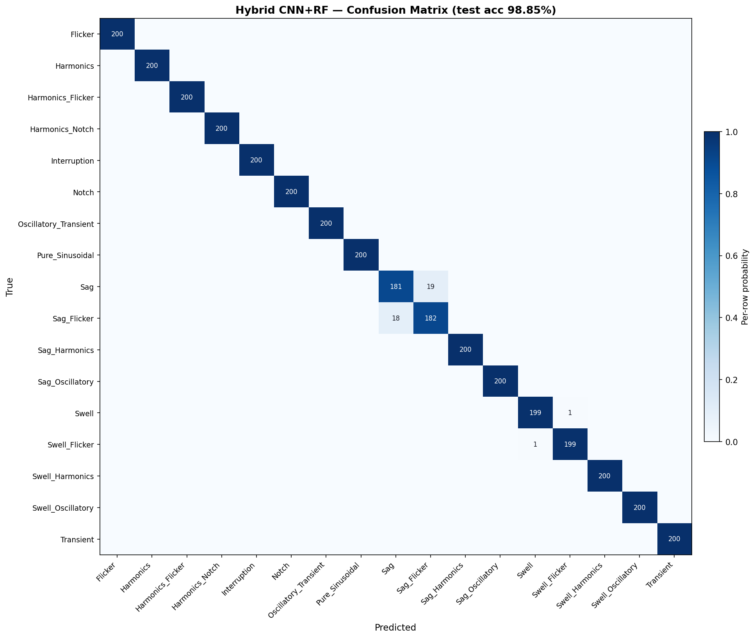
Fig. 4. Confusion matrix of the hybrid 1D-CNN and Random Forest classifier on the 3,400-sample test set. Thirteen of seventeen classes attain 100% recall, and the residual errors are confined to a single 2 × 2 block between Sag and Sag_Flicker.
C. Input-Normalization Analysis
An initial implementation employed per-sample maximum-absolute normalization, in which each window is divided by its own peak amplitude before being supplied to the CNN. This scheme is the canonical preprocessing step in much of the published deep-learning PQ literature. Under per-sample normalization, the hybrid model's test accuracy was observed to be 52.0%, substantially below the legacy 36-feature Random Forest baseline.
The mechanism underlying this collapse is straightforward. After per-sample maximum-absolute normalization, a 0.5 pu sag and a 1.0 pu pure sinusoid both reduce to unit-amplitude sine waves of identical shape; voltage swells and interruptions are subject to the same collapse. The amplitude information that distinguishes these classes is therefore eliminated by the normalizer.
The remedy is to apply a single global scale, computed once on the training set and stored with the model, in accordance with Eq. (2). Under this scheme, the test accuracy recovered from 52.0% to 98.85%, an absolute improvement of 47 percentage points obtained from a single preprocessing modification. This finding is transferable to any deep-learning PQ pipeline that includes amplitude-distinguished classes.
D. End-to-End Pipeline Performance
On the 510-signal mixed-traffic test (30% Normal, 70% Abnormal, balanced across the sixteen Abnormal classes), the end-to-end pipeline attains an accuracy of 96.67%. Stage 1 detects 100% of Normal windows correctly and produces zero false alarms; no Abnormal window is misclassified as Normal. The accuracy gap between the Stage 2 result on its own test set (98.85%) and the end-to-end pipeline (96.67%) is therefore attributable to the Stage 2 misclassifications on Sag and Sag-Flicker, evaluated over a smaller and less favourable mix.
E. Latency Budget for Edge Deployment
A practical PQ monitor must deliver a decision before the next decision-relevant window arrives. Stage 1 of the proposed pipeline satisfies a sub-cycle deadline for 100% of Normal traffic, completing in less than one millisecond per window. Stage 2 requires approximately 67 ms per Abnormal window, equivalent to approximately three cycles of the 50 Hz fundamental, and is invoked only on windows that have already been screened as anomalous, ensuring that the heavy inference path is never exercised on clean traffic. Table V reports the per-stage latency budget on a single-thread laptop CPU.
TABLE V
Per-stage latency budget on a single-thread laptop CPU. Measurements are steady-state, post warm-up, without GPU acceleration or cloud connectivity.
Stage | p50 (ms) | Mean (ms) | p95 (ms)
Stage 1 (5 features + decision) | 0.4 | 0.4 | 0.7
Stage 2 — CNN forward pass | 38 | 40 | 55
Stage 2 — Random Forest predict | 24 | 26 | 38
Stage 2 — total (Abnormal path) | 65 | 67 | 88
End-to-end — Normal path | 0.4 | 0.4 | 0.7
End-to-end — Abnormal path | 65 | 67 | 88

A growing portion of the deep-learning PQ literature relies on cloud inference in order to accommodate model size. Cloud deployment, however, introduces a network round-trip-time overhead before any inference is initiated. Wide-area round-trip times from a distribution feeder to a regional data centre are typically 100–300 ms even on a clean wired link, and substantially higher on congested or wireless paths, which is already several multiples of one PQ cycle. The proposed pipeline performs detection in less than one millisecond and classification within approximately three cycles, entirely on a single CPU thread, without GPU acceleration or external service connectivity. The proposed system therefore satisfies an operational deadline that cloud-deployed deep PQ classifiers cannot satisfy under realistic network conditions, while remaining a deeply learned classifier in Stage 2.
F. Hyperparameter Sensitivity
A 24-combination, five-fold cross-validation grid search was conducted over the Stage 2 Random Forest on the frozen CNN feature space. The top thirteen configurations clustered within ±0.05 percentage points of one another. The deployed configuration (200 trees, log₂ feature selection) lies inside this cluster. The result indicates that classification accuracy is saturated on the deployed feature space, and that further hyperparameter tuning of the Random Forest head is unlikely to yield improvements that exceed the statistical noise of the test split.
G. Per-Prediction Interpretability via SHAP
A TreeSHAP [10] explainer is integrated as a post-hoc attribution layer on the legacy 36-feature Random Forest baseline. For any single window, the system returns the top three contributing features along with their physical units (RMS in pu, total harmonic distortion in percent, harmonic magnitudes, and wavelet energies) together with the SHAP magnitude and sign of each contribution. A representative explanation for a Sag prediction identifies RMS as the dominant feature with a negative SHAP value, together with two amplitude-correlated wavelet energies. Operators are therefore able to review borderline classifications using named physical quantities rather than abstract activation maps. Broader surveys of explainable artificial intelligence are provided in [11].
H. Discussion
Three observations summarize the principal results. First, the separation of detection and classification through the Stage 1 and Stage 2 architecture provides a real-time monitor that satisfies a sub-cycle deadline for clean traffic and applies a heavier hybrid classifier only when warranted, avoiding the engineering trade-offs of either purely shallow or purely deep designs. Second, the learned 64-dimensional feature representation produced by the 1D-CNN closes the accuracy gap that hand-engineered features leave open on compound-disturbance classes; an absolute gain of 8.23 percentage points is observed when the learned feature space is substituted for the 36 hand-engineered features under the same Random Forest head, while the Random Forest itself preserves calibrated top-K outputs and supports rapid retunability. Third, the proposed system executes end-to-end on a laptop-class CPU without GPU acceleration or external service connectivity, at a latency below the round-trip-time floor of typical cloud links; the deployability claim is therefore an experimental result rather than an aspirational one.
X. LIMITATIONS
The limitations of the present study are noted below.
1) All measurements are obtained on a Windows AMD64 laptop using single-thread, single-sample evaluation. Embedded-hardware deployment (ARM, FPGA, microcontroller) is identified as a planned extension and is not claimed in the present study.
2) The dataset is synthetic, generated under the IEEE 1159 class definitions with additive white Gaussian noise at 40 dB SNR. Real grid waveforms contain additional noise structure (sub-harmonic content, inter-harmonics, and higher-order non-stationarities) that is absent from the training set.
3) The Stage 1 thresholds are hand-set rather than learned. The thresholds are configured conservatively, admitting some Normal windows into Stage 2 in exchange for a 0% Abnormal-as-Normal misclassification rate. A learned screen is identified as a natural extension.
4) The knowledge-base entries are derived from the IEEE 1159 reference text and do not currently incorporate utility-specific operational practice. Per-deployment customization would require additional curation.
XI. CONCLUSION AND FUTURE WORK
This paper has presented a real-time PQ disturbance classification system based on a two-stage pipeline. A five-feature O(N) threshold detector (Stage 1) handles clean traffic in less than one millisecond and forwards only flagged windows to a hybrid 1D-CNN and Random Forest classifier (Stage 2), which attains 98.85% accuracy across seventeen IEEE 1159 classes (thirteen of seventeen at 100% recall) and operates in approximately 67 ms per call. The end-to-end pipeline attains 96.67% accuracy on a balanced mixed-traffic test, and the system streams its predictions, each enriched online with severity, cause, equipment-at-risk, and recommended operator actions, to a browser dashboard via a Flask-SocketIO backend. The full pipeline executes on a laptop CPU without GPU acceleration or external network connectivity, completing detection in less than one millisecond and classification in approximately three cycles of the 50 Hz fundamental, below the round-trip-time floor of cloud-deployed deep PQ classifiers. The proposed system is therefore directly suitable for edge deployment on distribution feeders.
The most actionable single finding of the present study is the input normalization result: per-sample maximum-absolute scaling, which is the default in much of the deep-learning PQ literature, eliminates the amplitude information that distinguishes Sag, Swell, and Interruption from Pure Sinusoidal, and incurs a 47-percentage-point accuracy penalty on the seventeen-class problem. A single global-scale normalization derived from the training distribution restores the missing accuracy.
Several directions for future work are immediate: (i) replacement of the hand-set Stage 1 thresholds with a learned screening rule; (ii) introduction of a multi-cycle context window targeted at the Sag-versus-Sag-Flicker confusability; (iii) embedded-hardware benchmarks of the Stage 2 model on ARM, ESP32, and Raspberry-Pi class targets; and (iv) integration of the SocketIO event stream with SCADA and Modbus systems to close the loop between prediction and operator action.
. REFERENCES
[1] IEEE Recommended Practice for Monitoring Electric Power Quality, IEEE Std 1159-2019 (Revision of IEEE Std 1159-2009), Institute of Electrical and Electronics Engineers, 2019, pp. 1–98. doi: 10.1109/IEEESTD.2019.8796486.
[2] P. Khetarpal and M. M. Tripathi, “A critical and comprehensive review on power quality disturbance detection and classification,” Sustainable Computing: Informatics and Systems, vol. 28, p. 100417, 2020. doi: 10.1016/j.suscom.2020.100417.
[3] K. Thirumala, S. Pal, T. Jain, and A. C. Umarikar, “A classification method for multiple power quality disturbances using EWT based adaptive filtering and multiclass SVM,” Neurocomputing, vol. 334, pp. 265–274, 2019. doi: 10.1016/j.neucom.2019.01.038.
[4] M. Sahani and P. K. Dash, “Automatic power quality events recognition based on Hilbert–Huang transform and weighted bidirectional extreme learning machine,” IEEE Trans. Ind. Informat., vol. 17, no. 2, pp. 1090–1100, 2021. doi: 10.1109/TII.2020.2989128.
[5] J. Wang, Z. Xu, and Y. Che, “Power quality disturbance classification based on compressed sensing and deep convolutional neural networks,” IEEE Access, vol. 8, pp. 78336–78346, 2020. doi: 10.1109/ACCESS.2020.2992803.
[6] K. Cai, W. Cao, L. Aarniovuori, H. Pang, Y. Lin, and G. Li, “Classification of power quality disturbances using Wigner–Ville distribution and deep convolutional neural networks,” IEEE Access, vol. 8, pp. 117400–117409, 2020. doi: 10.1109/ACCESS.2020.3004984.
[7] B. Eristi, O. Yildirim, H. Eristi, and Y. Demir, “A robust power quality disturbance classification method using convolutional neural networks and 1D local binary pattern,” Electric Power Systems Research, vol. 193, p. 107015, 2021. doi: 10.1016/j.epsr.2020.107015.
[8] K. Cai, T. Hu, W. Cao, T. D. Memon, Y. Wang, and W. Liu, “A new hybrid convolutional neural network and extreme gradient boosting classifier for recognizing power quality disturbances,” IEEE Access, vol. 9, pp. 91017–91030, 2021. doi: 10.1109/ACCESS.2021.3091267.
[9] C. I. Garcia, F. Grasso, A. Luchetta, M. C. Piccirilli, L. Paolucci, and G. Talluri, “A comparison of power quality disturbance detection and classification methods using CNN, LSTM and CNN-LSTM,” Applied Sciences, vol. 10, no. 19, p. 6755, 2020. doi: 10.3390/app10196755.
[10] S. M. Lundberg, G. Erion, H. Chen, A. DeGrave, J. M. Prutkin, B. Nair, R. Katz, J. Himmelfarb, N. Bansal, and S.-I. Lee, “From local explanations to global understanding with explainable AI for trees,” Nature Machine Intelligence, vol. 2, no. 1, pp. 56–67, 2020. doi: 10.1038/s42256-019-0138-9.
[11] P. Linardatos, V. Papastefanopoulos, and S. Kotsiantis, “Explainable AI: A review of machine learning interpretability methods,” Entropy, vol. 23, no. 1, p. 18, 2021. doi: 10.3390/e23010018.

