**KIN_BUSINESS REPORT**

**Mathilde Frachon**

**Annabelle Goldsworthy**

**Alberto Pacheco**

**Lana Sladovic**

**Joao Camarao**

**KEA - November 2017**

# 

# Table of Content

**Table of Content** **1**

**Introduction** **2**

1_Concept 2

2_Purpose 2

3_Effect 3

4_Market Opportunity & Competitors 4

**Analysis** **5**

1_Personas 5

2_Target Audience 6

3_Receiving audience 6

4_Survey Analysis 7

5_Customer Journey 9

6_Structure of Kin 10

7_Communication Environment 11

8_Media Elements 11

9_Selling Propositions 12

**Conclusion** **13**

**Appendix** **14**

1_Kanban Chart 14

2_Business Model Canvas 15

3_Brainstorming Pictures 15

# Introduction

**Good! Good layout!**

## 1_Concept

Leaving home and family for the first time is always difficult. For students, living alone can be a real challenge. Dealing with paperwork, maintenance around the apartment, cleaning, cooking and taking care of a car are all suddenly things students need to care for by themselves for the first time.

That’s when the student starts calling their mother and father for every issue they meet. Google it? No. They want their parent’s solution because their way of doing it is always best.

That’s where Kin comes in. Kin, the app provides a shared space for entire families to connect, communicate and share knowledge with one another. Kin is a place young adults can share, question and gather the tools they need to survive away from home. It has different interfaces if you are the parent or the child. When the user creates their account, all they need to do is appoint who their family members are and what relation they have to them i.e. a brother, father, etc.

What’s the purpose to have mission vision and values?

## 2_Purpose

Kin wants to create a product that will benefit and help different generations in our society. One that applies and embodies all of the core values that the foundation of Kin is built upon. By creating Kin, we hope to strengthen the bonds between family members.

**Mission**

Kin’s mission is to provide digital products that enable people of all generations to connect and share with each other; to teach and learn from each other; to maintain and strengthen the bonds between their closest relations.

**Vision**

We want to cut the barrier between technology and relationships by finding new, simple and funs way to connect them.

**Values**

Innovation, friendship, nurturing relationship, teamwork, communication.

=> seems good but miss a bit of introduction in mission vision values : what is the purpose of having this ? why are we making a mission vision value statement ? Are we gonna use it in our communication ?

=> having a brief introduction on why we need this

## 3_Effect

Kin wants to inspire a change in attitude towards family bonding upon using our product in a way that families can be more helpful to each other, therefore making young adults more willing to communicate with their family in an easy and fun way.

=> It is not clear that this is from the communication plan.

Explain that the structure of the report is like one big communication plan.

## 4_Market Opportunity & Competitors

Through research and surveys, the Kin team realised one important product that was missing from the market - a place solely for families (with members of a more mature age) to communicate, coordinate and share things amongst themselves. A place for young adults to gather family knowledge in one place, which they can refer to as a survival guide when they move out for the first time.

There are apps today that have the purpose of helping families organise themselves and ease communication between them. One of these apps ‘Cozi’ (www.cozi.com) – is a family planner and journal, that helps a family coordinate schedules, to-do lists, share family photos and track where the kids are - however, this app is aimed at families with younger children.

There’s ‘Snapchat’ - the app created for sending snapshots of your life to friends and perhaps family, that will disappear in the blink of an eye. Great for letting people know what’s happening in life, however what happens when the user accidentally sends their parents that picture of them on a wild night out?

Many families use ‘Whatsapp’ to communicate with each other, however, the messages become one long thread. If the user needs some information that was previously mentioned they either need to ask again, or they find themselves endlessly scrolling through the mass amounts of messages that were exchanged.

Finally, ‘Facebook’ is another network used frequently within families, but a lot of people use it to keep in touch with friends. Many young adults would prefer not to have their parents on social media, because they feel their parents may see something they’re not supposed to or will embarrass them. Vice versa, there are some parents who would prefer not to see certain things from their children.

But what about a private family-sharing space? One that relieves the social pressure young people feel, to not share certain things or to hide things from their parents? One where young adults can gather and save all the family secrets and wisdom they wish they remembered when they’ve moved out? One where families can coordinate schedules and remind each other of important events and tasks?

# Analysis

## 1_Personas

The personas it’s a useful exercise to understand how the target audience thinks (BEHAVE) and what is their opinion about the concept. Each person has different opinions and ideas but when comparing them we can see several common concepts and analyse it better.

Also by asking what needs and motivations do they have we can add or solve several problems with our work by realizing what the audience really wants to do with this kind of concept.

We tried to involve all kinds of people but within the subject so that our personas are family members that can relate with our idea and make every aspect of this exercise useful to our work. => GOOD

*Here is few example of our Personas:*

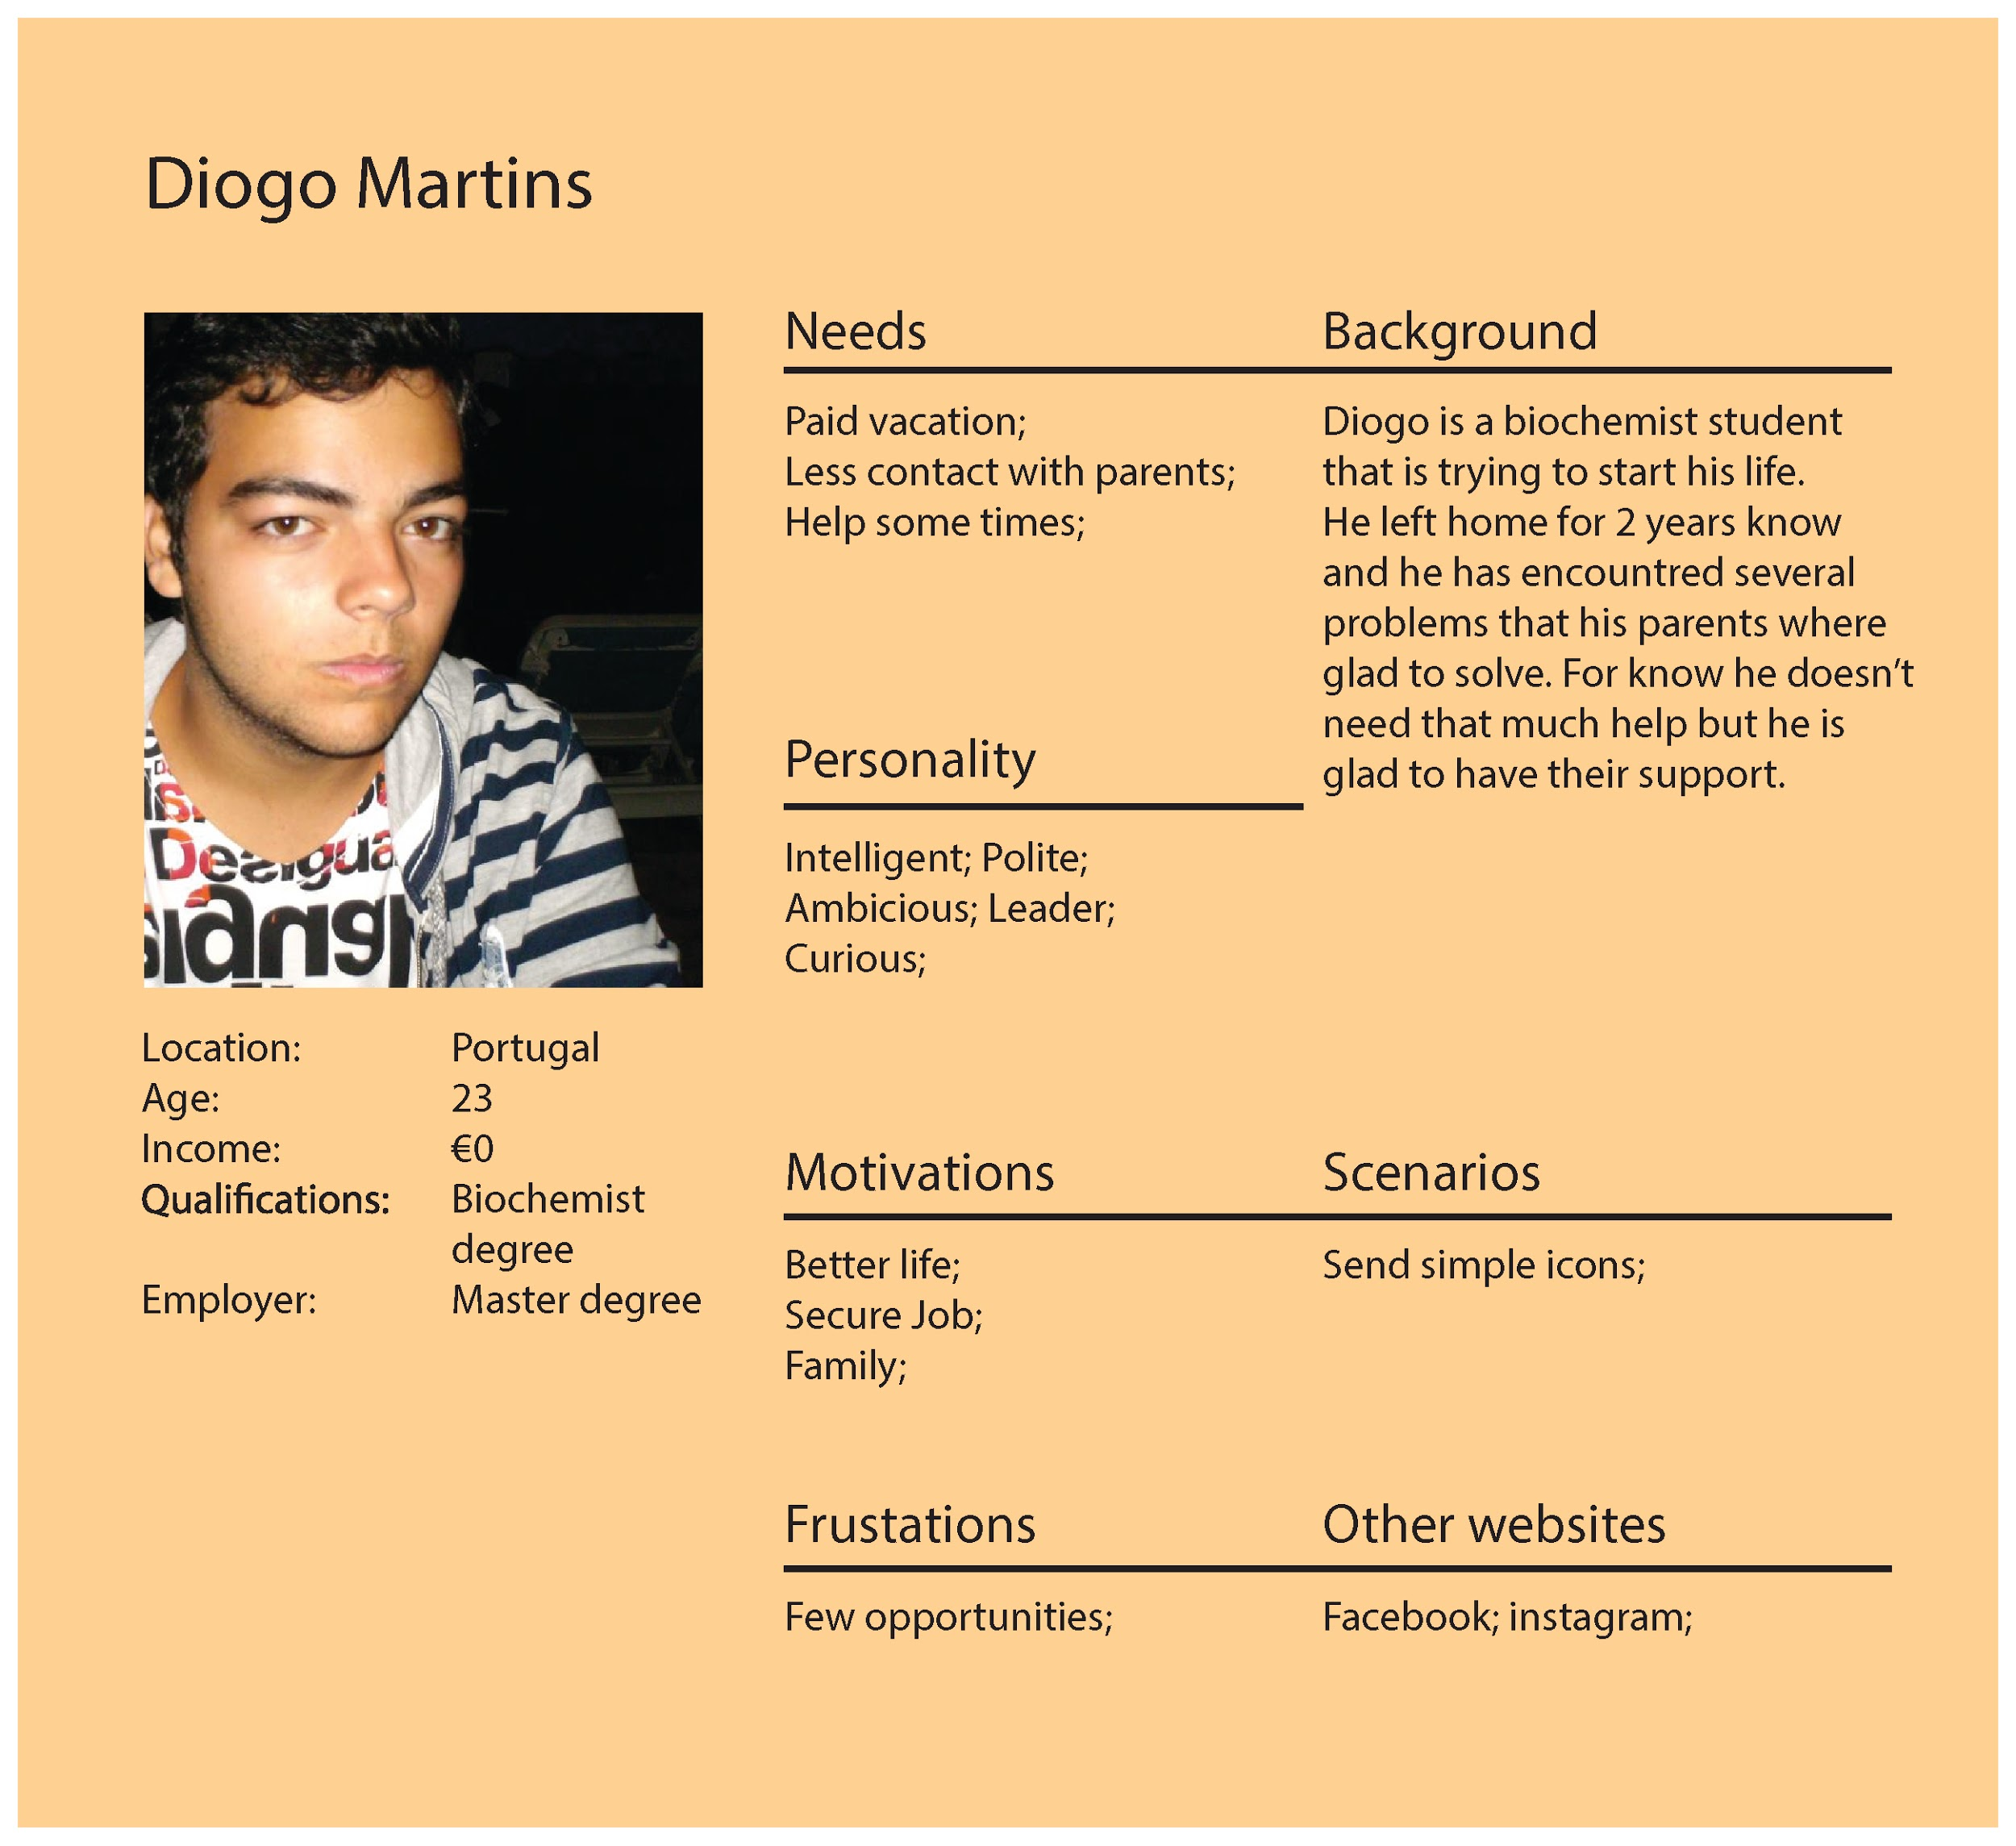

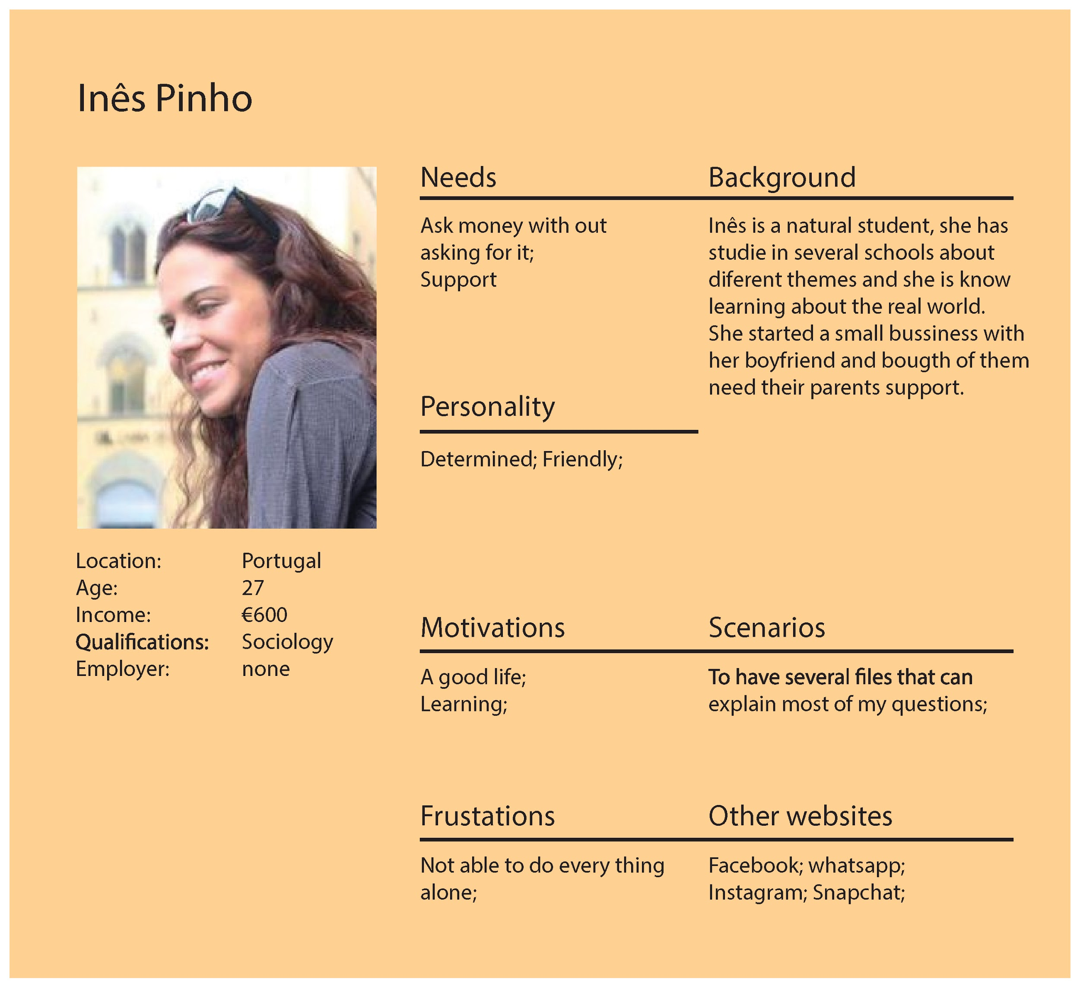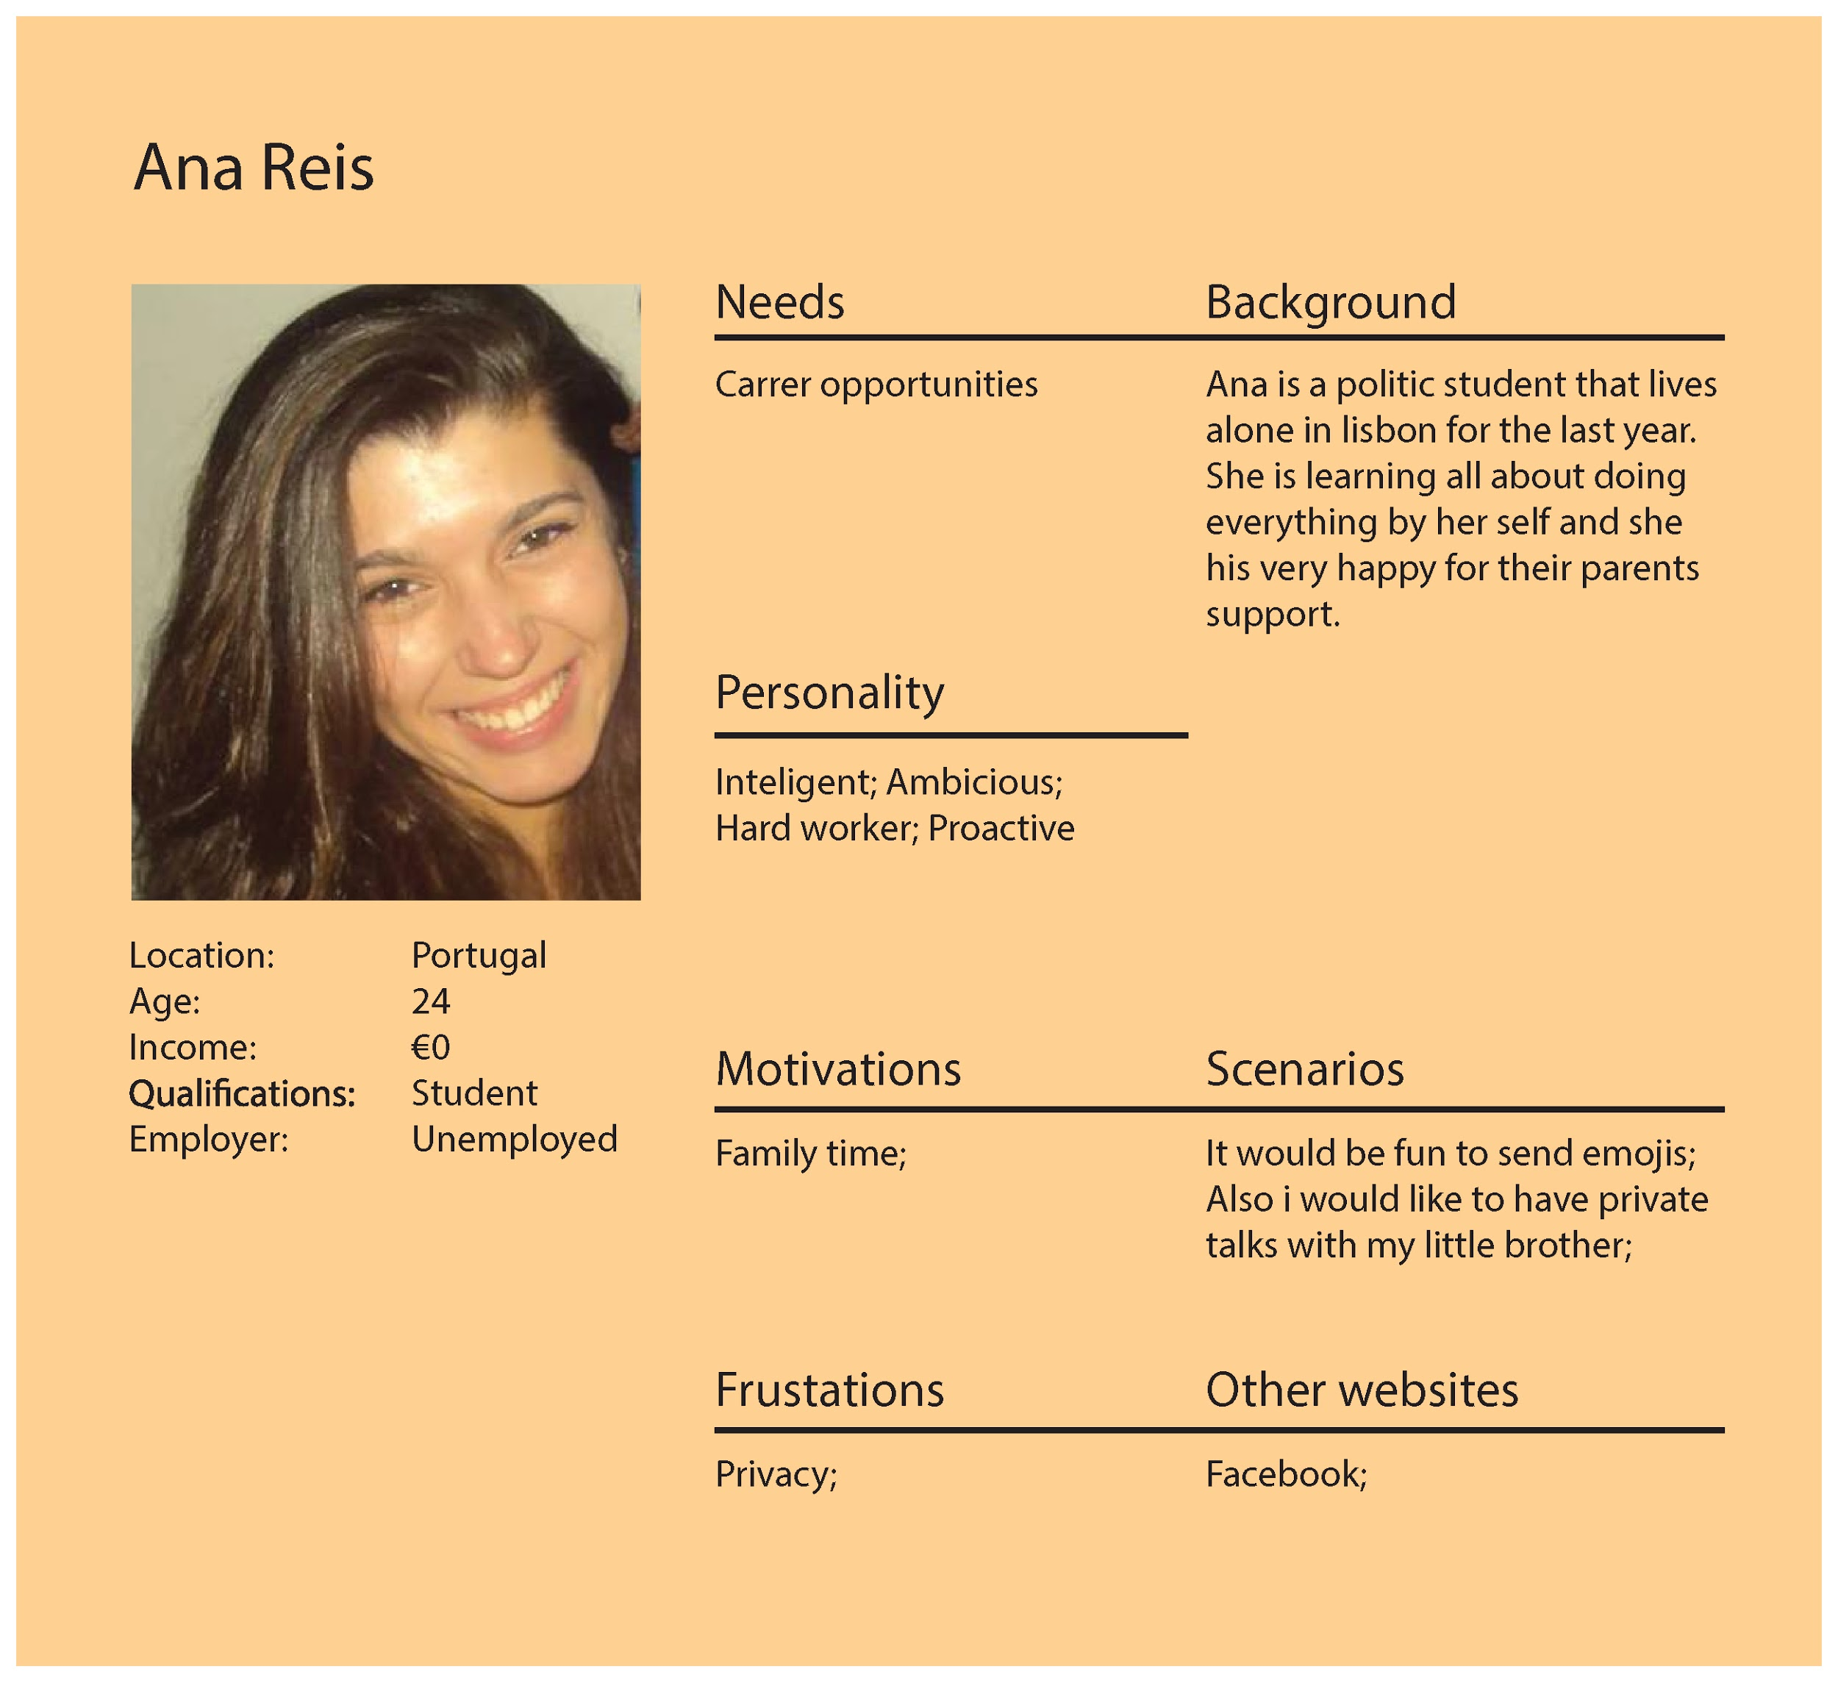

## => WHY 3 PERSONAS - WHY THESE ONES ?

Why they are different ?

No example for the parernt

## 2_Target Audience

The target audience is primarily 18-25 year olds that have moved or are moving out of their parents home for the first time. Some are moving to dorms others to apartments. Kin is targeting students and young professionals who are moving out locally and internationally. They frequently use social media and phone calls to contact their parents, asking for help in their daily lives or to share what’s happening in their life and many of them have to use multiple different platforms to communicate with their parents.

## 3_Receiving audience

The receiving audience which is the result of the target audience are adults who are parents, as the app would not work if the young adults did not add their parents on the platform. As parents are always trying to help their children and most of them are not so technologically advanced, this target will be more brought into the app by the target group than be the one to discover it. However it could work the other way around too.

## 4_Survey Analysis

The survey was a really important part of the work because it revealed that some aspects where less important or even irrelevant and it caused some changes in the work.

As the app is for families, the survey was divided in two parts; the parent ́s answers and the children ́’s. In this way it was possible to understand both sides and solve problems that the designers couldn’t do alone.

**Survey structure:**

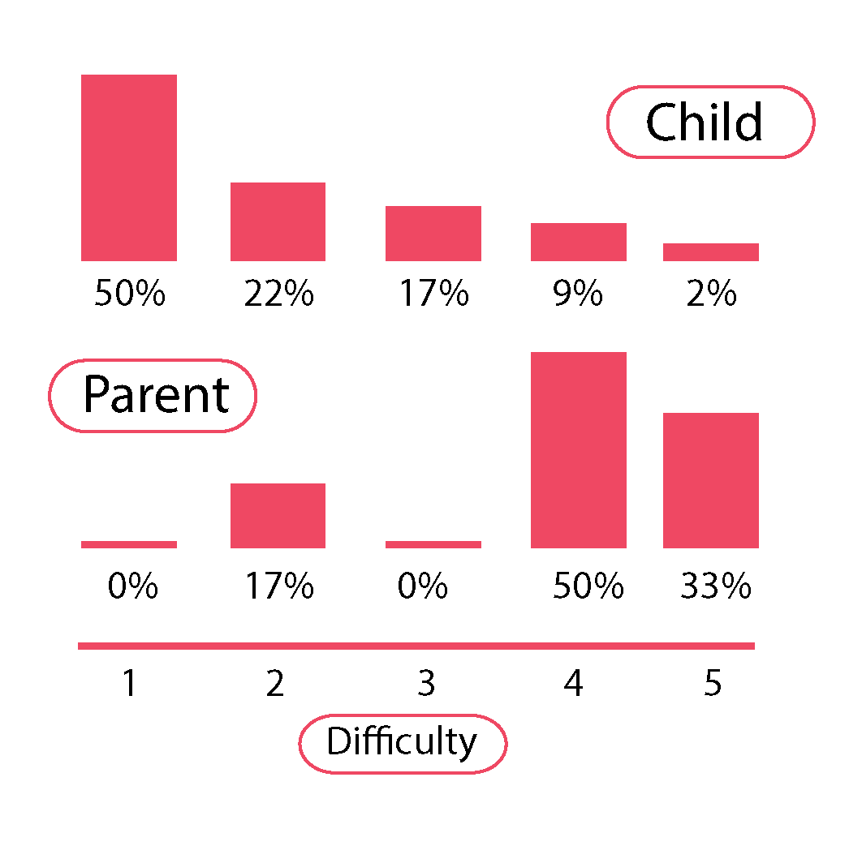

**Question 3**

Was it difficult to leave your parent’s home? (Child)

Was it difficult for you when he/she left? (Parent)

**Question 5**

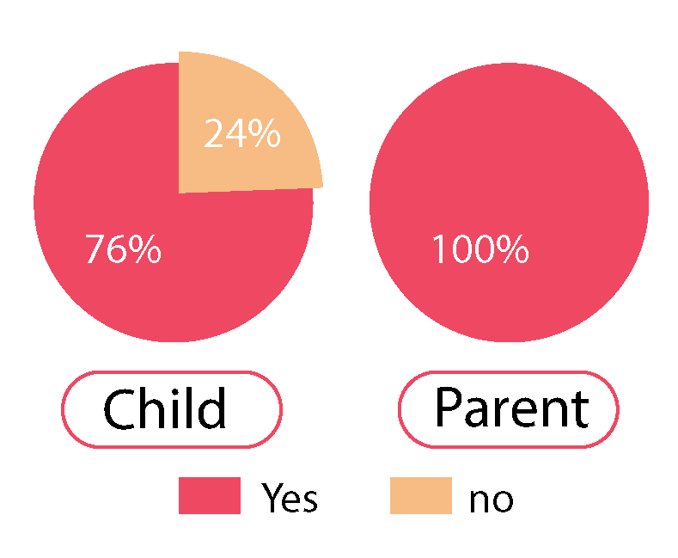

Do you think it would be useful to gather all this advice in one app?

This question helped to understand if the app would

be embraced by both parts.

**Question 8**

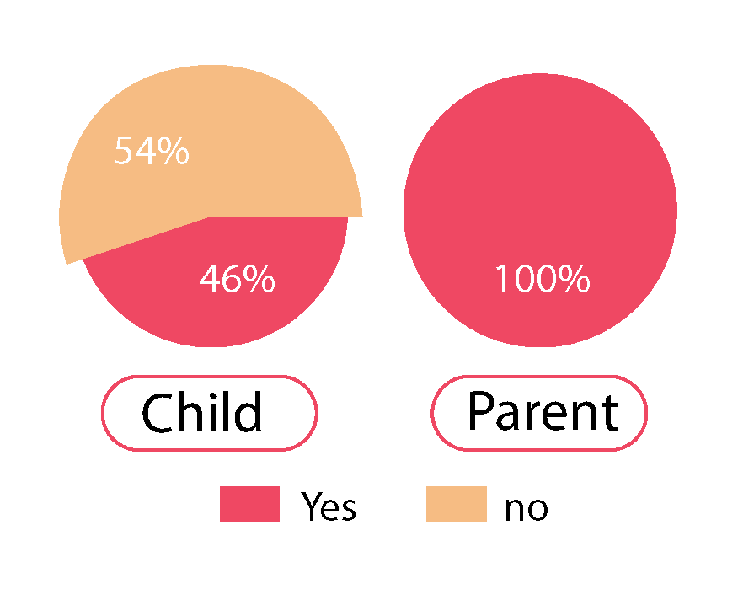

Do you think it would be helpful to send instantaneous messages to your parents instead of short calls?

For this case we realise that for the child it is not that important to send quick messages but for parents is so we need to make a more appealing approach

for the child.

**Question 11/12**

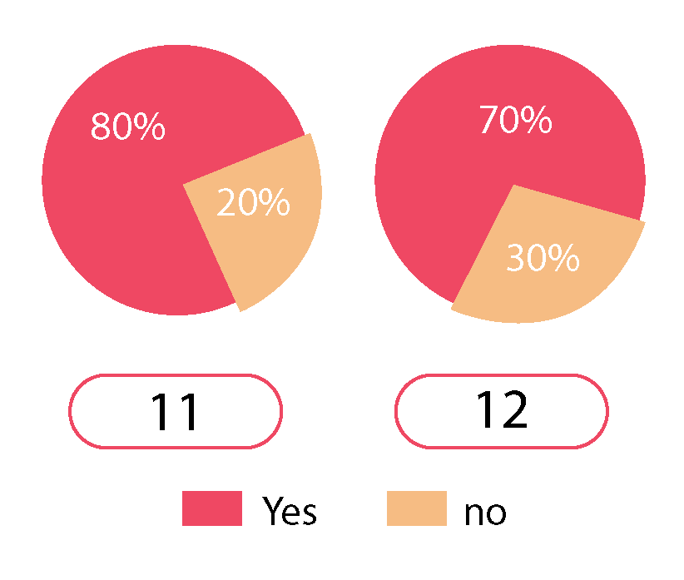

Do you think smartphones and social media are an obstacle to social

family life?

Do you use social media with your family?

Both of these questions explained to us if the audience is interested in using social media to

communicate and also to see who are our competitors in the market since the 12

questions also asked what apps they use.

**Question 14**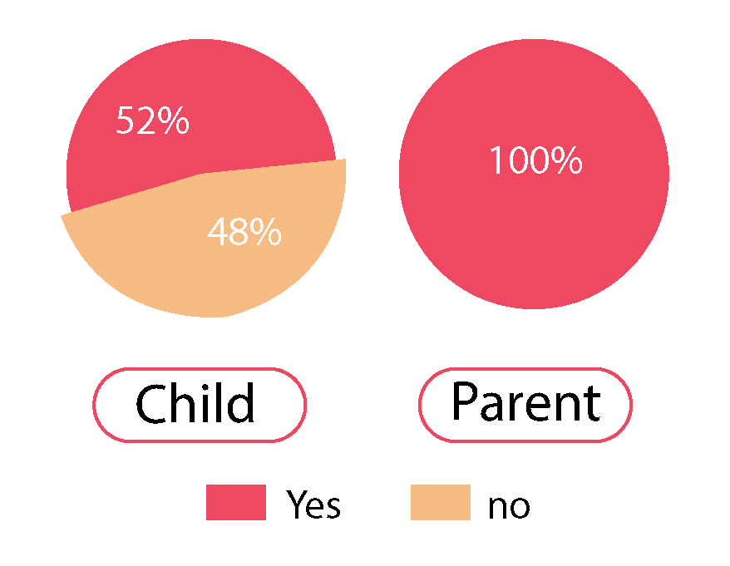

Would you like having a private space to share with your family?

Once again we realise that one of the parts is more interested in the entire concept than the other. This means that we need to work on the child part so that it creates more interest.

**Survey reflections:**

From the answers we also concluded that some of our ideas were very important for the building of the app since the percentages were just too clear.

For example the question about if the family should share a calendar both sides answer that was very important and useful.

For every idea there are strong and weak points, the survey helped us to unmask them, giving us some of the tools to solve the weak ones or to better the strong.

It’s very important to know the target audience and to understand their points of view. It’s not easy to analyze a group without this kind of exercise and in the end we managed to take all kinds of information to make sure that our research and work will be well structured so that the nal work would be a good piece of design.

=> what was irrelevant ? we say that we have some in the introduction and not in the structure. Don’t forget talking on negative points !

=>Add examples

=> Otherwise good survey

## 5_Customer Journey

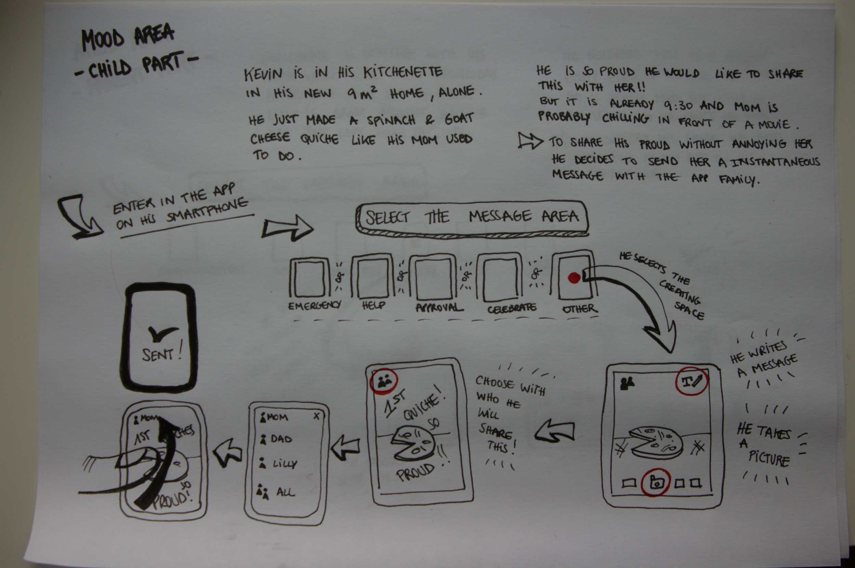

By creating our customer journey we found some issues with the structure of our idea and we made a lot of choices in order to make the app simpler, more specific and clear for the user.

The first problem was about how we connect family members to each other. We wanted to create two different interfaces for the app depending on if you are a child or a parent. But what if you want to teach something to your parents ? (f.x. how to use iTunes). What if you want to keep the app when you become a parent yourself ?

The user is now asked to link people to themselves instead of deciding who they are

to other people. In this manner, everybody can be the child or the parent to someone else.

We also clarified how to use each of the features, from the user’s problem to the solution in order to understand how everything works. Thus, we created a «request a tip» button and we decided to connect the camera to the tips and messages areas.

We also tried to know and understand how we could be different from a classic social media and for what particular reasons the user should use our app.

=> GOOD

## 6_Structure of Kin

*Kin offers three features to the users:*

**Tips**

Every member of the family can add tip notes in categories such as cooking, cleaning, mechanics, administration, DIY, healthcare, laundry, etc. The family member writing the tip can choose to send it to all members of the family or select the members they wish to receive the tip. Once the members receive the tip, it is stored in a database where they can refer back to the tips for future reference. If a family member no longer wishes to have a certain tip, they may delete it from their account. Looking for specific tips on the database? Users can select the family member who wrote the tip, search with filters or ask Siri or voice control to find a specific tip. If a user needs a tip that is not yet in the database, they can send a request asking for a tip to a family member(s) that will show up as a notification for the other members.

**Reminders**

Users can create lists, schedules and plans for one or several members of the family. It’s also possible to send reminders to individual family members. Always forgetting someone’s birthday? Brothers and sisters can create a reminder and send it to each other or other family members as a ‘poke’ or notification. Members can also send tasks to each other and once the task has been completed, the sender will receive a notification saying ‘Complete’.

**Creative Messaging**

This is a creative space where the users can send each other predefined mood notes (happy, angry, disappointed, upset, etc.), words of encouragement and pictures as a one-time-message/poke/notification (like Snapchat). The child’s bank account is empty and it’s the middle of the month? The mother has seen it and sends their child a red angry screen! No calls necessary, the child knows their mother is mad and it serves as a warning for next month…

## 7_Communication Environment

As the target group is young student and their parents, the most likely environment where they would find and hear about the app/site would be their home, school when on their own.

Another possible environment is family/friend gatherings and work space, as those are the places where our target can hear about it from current users.

=> Back to the communication plan which is confusing - if we really need to have it here we should make more transitions.

=> maybe make the communication plan seperatly and write “previsouly stated in the report” for the repeting parts.

## 8_Media Elements

Taking in consideration the target group has different age spectrums we have to grab the attention of both young adults that just moved away and also their parents. The young people need more visual stimulators than adults as they are need more visual content to be interested in staying on our page.

For these reasons these are the following media elements in use:

**· Pictures:** Pictures can send a stronger and a more visual message to young users, to get their attention, so they would stay longer on our webpage.

**· Graphical elements:** We will do this by creating an extremely visual interface that consists of simple functions by using icons and shapes to help the user navigate easily.

**· Interactive materials:** by adding interactive materials to our website, we want to bring it closer to the user. We will have prototype on the website so the visitor can try and interact with the product.

## 9_Selling Propositions

=> introduction : what is it ? why do we need it ? how it will help us ?

What is the difference between these selling proposition and the key message ? is it the same ? no ? why ? where will we use it ?

**USP**: Kin is the first sharing space for families to help each other even from the other side of the globe.

For our USP we focused on the unique benefits of the product such as the personal tips and knowledge from your family no matter where you are or what time it is.

**ESP**: It is always better to get advice from the ones who know you best.

With this ESP we wanted to strongly target the feeling of need for your family advice, therefore cutting any other offer you might find from other competitors that would just work as any other advice and not the one you are familiarised with.

# Conclusion

When students are leaving their parents’ home for the first time, they can feel a little lost by all these new daily matters they are responsible for. How does Mom usually take care of my leather jacket? When do I have to take care of the car insurance? Communication between family members can be much easier than a call, when it comes to asking all the little things we always need. Kin is an app which enables families to communicate in a new way and to gather the information they want to share.

Except for classic social medias (facebook, instagram, whatsapp, snapchat... ), no mobile app offers a space to share information and communicate like this smaller simple concept. Kin is different in its way of sharing tips, advice and its particular features that makes communicating easier, playful and short-lived.

That is what the survey targeted on young peoples and their parents illustrates: having an online space to gather these personal tricks, to help members of one family to encourage themselves and give each other reminders, are things the user will find useful. Through the conclusion of the results, we were able to further develop and refine Kin. We clarified aspects of our design proposal that we were unclear about and we simplified the app to make the users experience more enjoyable.

Overall Kin is ready to connect families within each other.

# Appendix

## 1_Kanban Chart

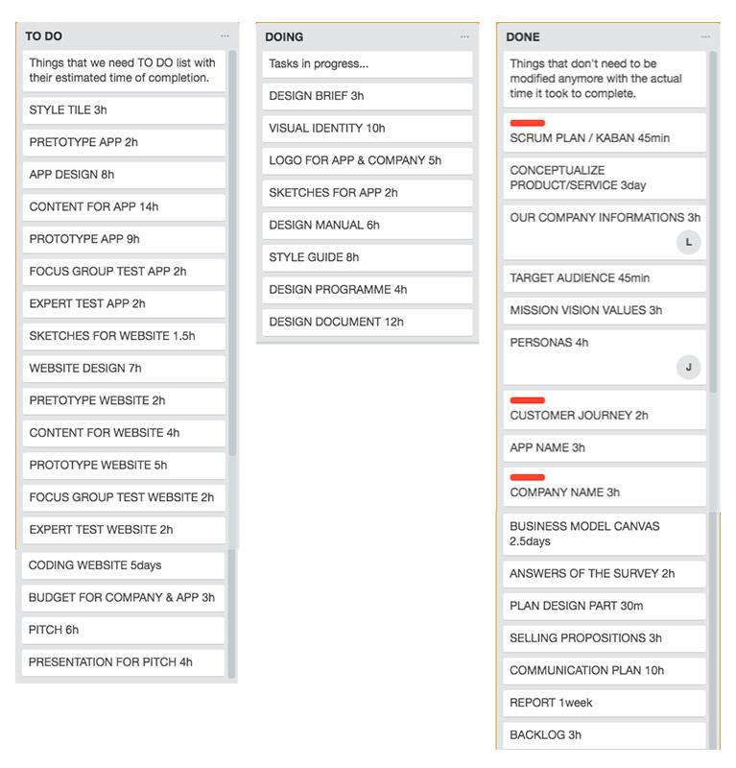

## 2_Business Model Canvas

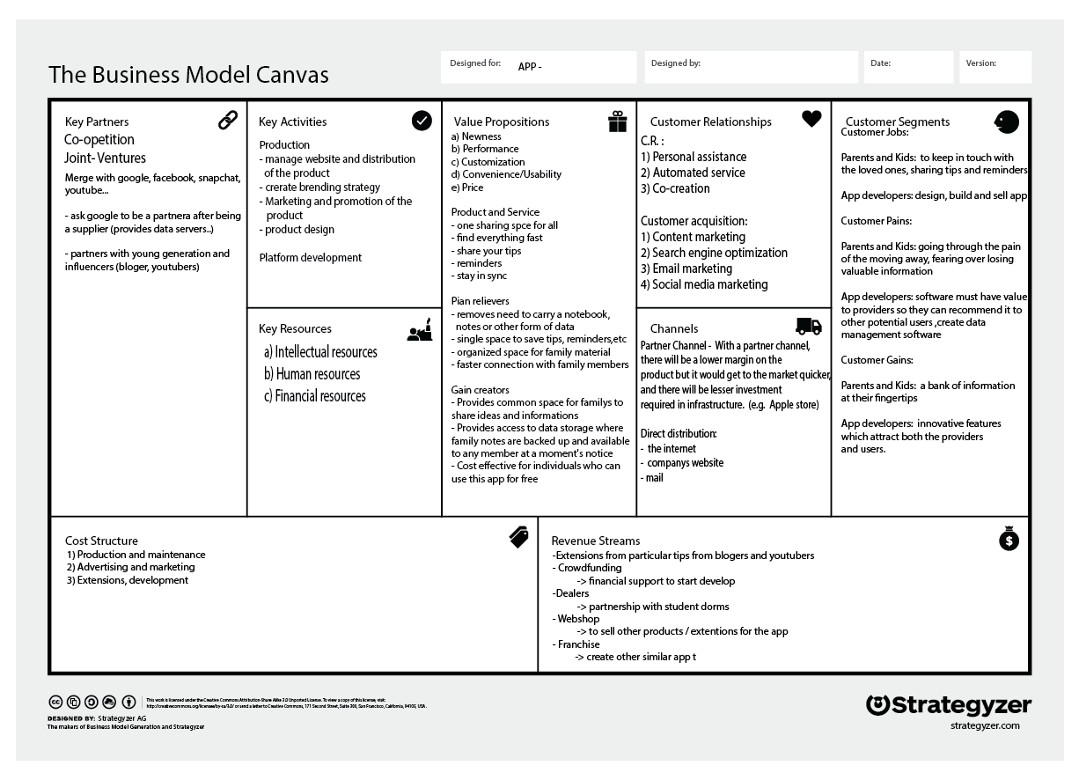

## 3_Brainstorming Pictures

