Test Report

# Summary

Our website is <http://www.1stpizzadirect.co.uk/>, we were exploring and came to some conclusions.

Generally the structure of the website is confusing. The navigation bar has too many options that could fit together, most of the text is not readable and the most important information for the user is hard to find in some cases.

All of our users are classmates so they all have a small background on the subject.

# 5 second test

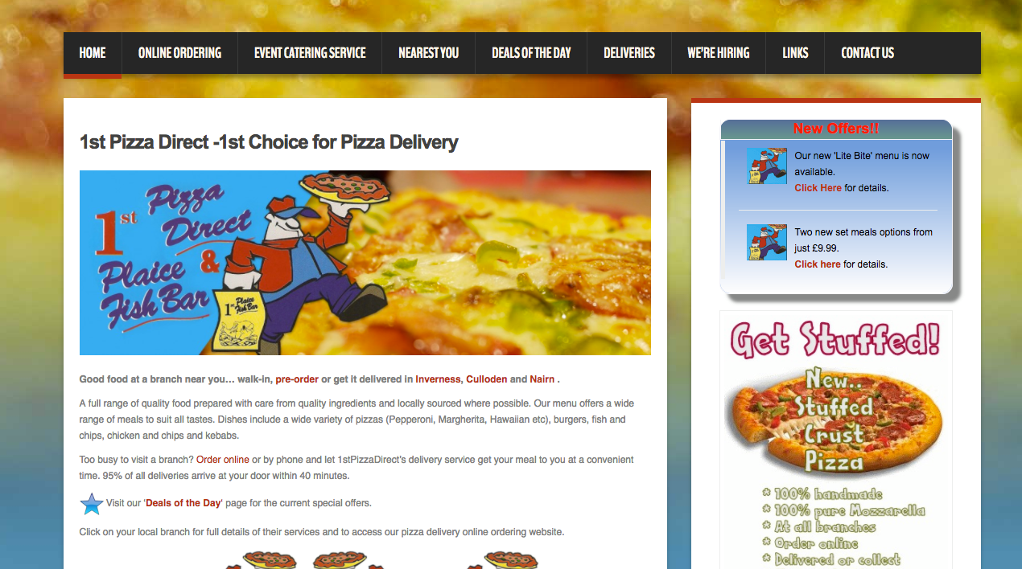

Questions:

1. What was the name of the company?
2. What can you do on this page?
3. What was the most prominent element on the page?

Answers:

1. dont know, it starts with C (i think)

pizza direct

I do not know

1. Order pizza

Buy/order pizza

order pizza, maybe also other food

1. the guy with the pica in his hand

the blurred out background

Pizza picture

# Trunk test

At any page, point out as fast as possible:

1. What is this? (Site ID)
2. What page am I on? (Page name)
3. What are the major sections of this site?
4. What are my options at this level?  
   (local navigation)
5. Where am I in the scheme of things?  
   (indicators, e.g. “crumbs path”)
6. How can you search?

User 1:

1.Pizza Restaurant website

2.Home(correct)

3.The navigaton bar

4. Online ordering, Event Catering service, nearest you, deals of the day, deliveries, we're hiring, links contact us

5. Home, there is a small red bar saying that we are in home page

6. There is no search bar

User 2:

1. Pizza restaurant website

2. Daily deals and special offers (correct)

3. Main image and the menu

4. All options on the navigation bar and order now on the special offer squares,

5. Deals of the day, small red bar under the letters on the navigation bar

6. Can’t find a search bar

User 3:

1. Pizza restaurant site

2. Contact (wrong, 1st Pizza Direct Nairn – Fast Food Delivery and Takeaway)

3. Main image

4. Everywhere in the navigation bar and order through the big order button

5. There is not pointer to know where i am.

6. No way to search

# Expert review

Some of the main aspects that we noticed during the navigation of the website was that the main picture on the front page and most of the other pages takes a lot of the users attention, distracting them from the name of the company and relevant information of the website.

There is also a lot on unnecessary information in the text, that can be taken off without the site losing any consistency.

When navigating through the site we also found that there are “you are here” elements missing in some pages, even though in most of the pages there is a small red bar on the navigation bar on the page we are on.

Relating to the readability we found that most text on the webpage its unreadable and confusing. The ordering menu has too many elements witch can make the user confused.

Also in our opinion the colors contrast wasn’t the best one for the type of service, we have noticed that most franchises use red as predominant color.