DOMAIN : INTERNET OF THINGS

TEAM NO : 09

PROJECT TITLE : SMART WATER MANAGEMENT

PHASE :04 SUBMISSION

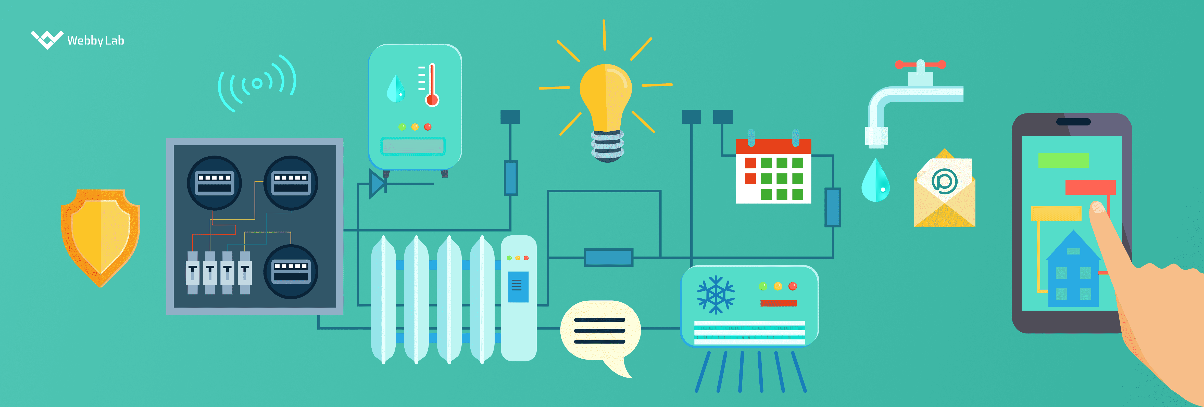

Frontend (HTML, CSS, JavaScript):

1. Create the HTML Structure:

Design the web page layout and structure to display water consumption data. Use HTML to create elements for headers, charts, and data visualization.

2. Style with CSS:

Use CSS to style the platform, including fonts, colors, and layout. Make it visually appealing and user-friendly.

3. Real-Time Updates with JavaScript:

Use JavaScript to implement real-time updates. You can use technologies like WebSocket for live data updates from IoT sensors.

4. Interactive Data Visualization:

Implement interactive charts and graphs to display water consumption data. Libraries like Chart.js or D3.js can be useful for creating dynamic visualizations.

5. User Interaction:

Add user-friendly features like filtering data by location (parks, residential buildings, offices), date, and time. Allow users to select the data they want to see.

6. Promote Water Conservation:

Include messages or visual cues that encourage water conservation efforts. Display real-time statistics on water usage and provide tips on how to save water.

Code for the above given details :

Welcoming page:

<!DOCTYPE html>

<html lang="en">

<head>

<meta charset="UTF-8">

<meta name="viewport" content="width=device-width, initial-scale=1.0">

<link rel="stylesheet" href="style.css">

<title>Smart Water Management Indicator</title>

</head>

<body>

<div class="container">

<h1>Welcome to Smart Water Management</h1>

<p>Select the area you want to monitor:</p>

<form action="dashboard.html" method="get">

<label for="area">Choose an area:</label>

<select id="area" name="area">

<option value="parks">Parks</option>

<option value="residential">Residential Buildings</option>

<option value="offices">Offices</option>

</select>

<button type="submit">Monitor</button>

</form>

</div>

</body>

</html>

Css for the welcoming page :

body {

background-color: #f2f2f2;

font-family: Arial, sans-serif;

text-align: center;

margin: 0;

padding: 0;

}

.container {

background-color: #fff;

border-radius: 8px;

box-shadow: 0 0 10px rgba(0, 0, 0, 0.2);

max-width: 400px;

margin: 100px auto;

padding: 20px;

}

h1 {

font-size: 24px;

}

p {

font-size: 16px;

}

form {

margin: 20px 0;

}

label {

font-size: 16px;

}

select, button {

font-size: 16px;

padding: 10px;

}

button {

background-color: #007BFF;

color: #fff;

border: none;

cursor: pointer;

}

button:hover {

background-color: #0056b3;

}

SAMPLE :

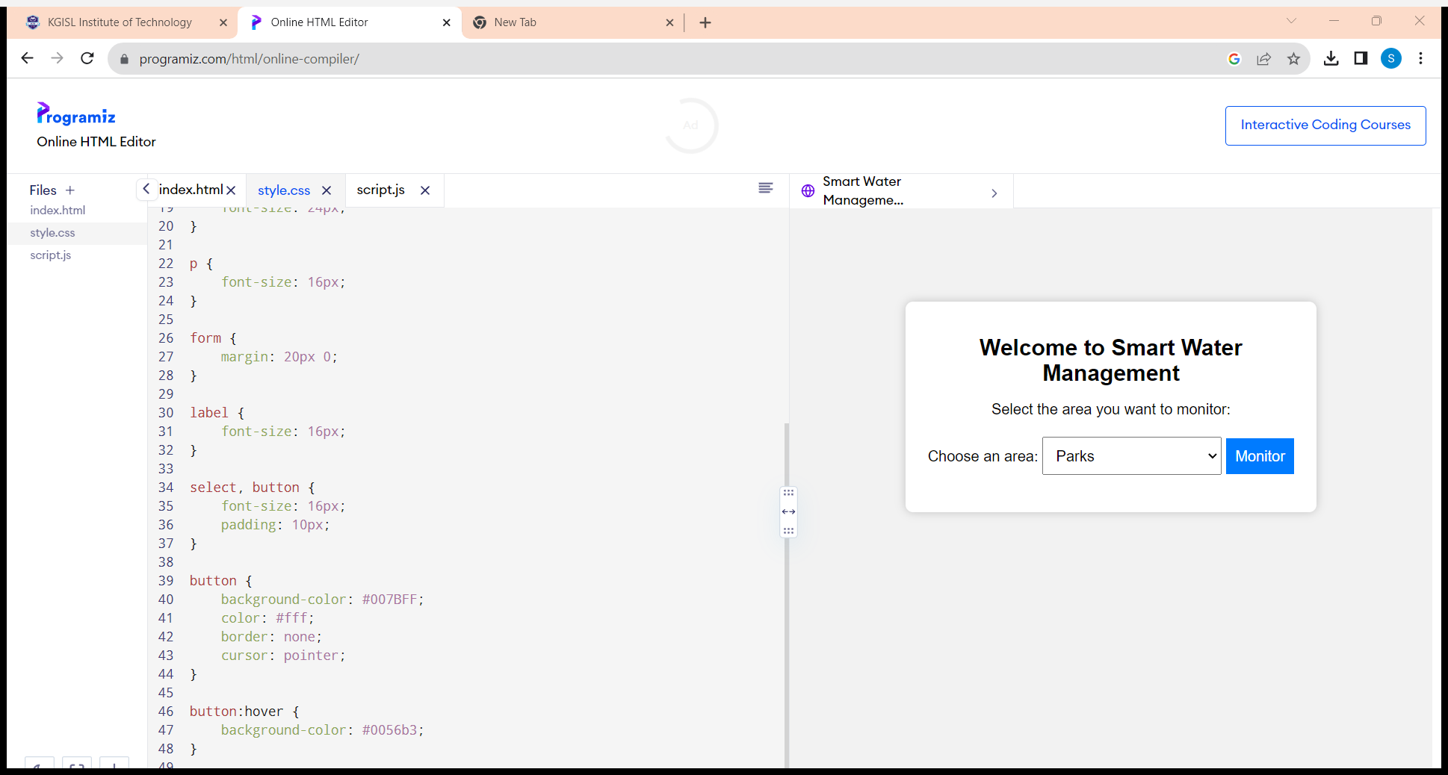

FILE STRUCTURE :

project_folder/

|- app.py # Flask Backend

|- templates/ # HTML Templates

|- index.html # Main Dashboard

|- static/ # Static Files (CSS, JS)

|- style.css # Stylesheet

App.py(flash backend) :

from flask import Flask, render_template, request, jsonify

from random import uniform

import time

app = Flask(__name__)

# Dummy sensor data (Replace with real data from IoT sensors)

sensor_data = {

'parks': [uniform(10, 50) for _ in range(24)],

'residential': [uniform(5, 30) for _ in range(24)],

'offices': [uniform(15, 60) for _ in range(24)]

}

@app.route('/')

def index():

return render_template('index.html')

@app.route('/get_data', methods=['GET'])

def get_data():

location = request.args.get('location')

if location in sensor_data:

data = sensor_data[location]

return jsonify(data)

return jsonify([])

if __name__ == '__main__':

app.run(debug=True)

TEMPLATE/INDEX.HTML :

<!DOCTYPE html>

<html lang="en">

<head>

<meta charset="UTF-8">

<meta name="viewport" content="width=device-width, initial-scale=1.0">

<link rel="stylesheet" href="{{ url_for('static', filename='style.css') }}">

<title>Smart Water Management</title>

</head>

<body>

<h1>Water Consumption Dashboard</h1>

<div class="controls">

<label for="location">Select Location:</label>

<select id="location">

<option value="parks">Parks</option>

<option value="residential">Residential</option>

<option value="offices">Offices</option>

</select>

</div>

<div class="chart-container">

<canvas id="water-chart"></canvas>

</div>

<script src="https://cdn.jsdelivr.net/npm/chart.js"></script>

<script src="https://code.jquery.com/jquery-3.6.0.min.js"></script>

<script src="{{ url_for('static', filename='script.js') }}"></script>

</body>

</html>

Static /styles.css :

body {

font-family: Arial, sans-serif;

text-align: center;

margin: 20px;

}

h1 {

font-size: 24px;

}

.controls {

margin: 20px;

}

.chart-container {

width: 80%;

margin: 0 auto;

}

#water-chart {

width: 100%;

max-width: 800px;

}

Script.js for data visualisation :

$(document).ready(function () {

var ctx = document.getElementById('water-chart').getContext('2d');

var chart;

// Initial data

var location = 'parks';

// Create chart

chart = new Chart(ctx, {

type: 'line',

data: {

labels: Array.from({ length: 24 }, (_, i) => i),

datasets: [{

label: 'Water Consumption',

data: [],

borderColor: 'blue',

borderWidth: 2,

fill: false

}]

},

options: {

responsive: true,

maintainAspectRatio: false

}

});

// Function to update chart with data from the server

function updateChart(location) {

$.get('/get_data', { location: location }, function (data) {

chart.data.datasets[0].data = data;

chart.update();

});

}

// Event listener for location selection

$('#location').on('change', function () {

location = $(this).val();

updateChart(location);

});

// Initial chart update

updateChart(location);

});