Agent Installation & Uninstallation

Sr. No. | Agent Name | Server IP | Wss URL | Path
1 | Appname_APP_Server_1 |  | wss://172.30.90.23:7919 | D:\Launch_Agent  /home/~User /Launch_Agent
2 | Appname_DB_Server_1 |  | wss://172.30.90.23:7919 | D:\Launch_Agent  /home/~User /Launch_Agent
3 | Appname_Web_Server_1 |  | wss://172.30.90.23:7919 | D:\Launch_Agent  /home/~User /Launch_Agent

Windows Agent_Installation

PreRequisites
Create folders
D:\Launch_Agent and D:\Launch_backup
Download agent file in D:\Launch_Agent https://cicd.ltfs.com/tools/devops-deploy-agent.zip
Unzip devops-deploy-agent.zip
D:\Launch_Agent\launch-agent 7.3.1\launch-agent-install>.\install-agent.bat
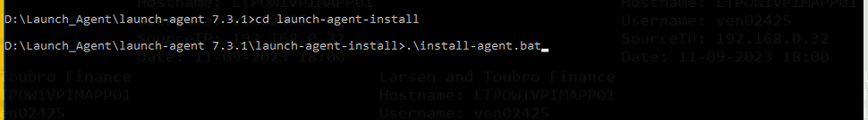
Buildfile: D:\Launch_Agent\launch-agent 7.3.1\launch-agent-install\install.with.groovy.xml
check-classpath-includes:
define-groovy-classpath-include:
define-groovy-classpath-no-include:
taskdef-groovy:
default-props-exists:
loadproperties-default:
props-exists:
loadproperties:
install-agent:
[echo] Enter the directory where agent should be installed. [Default: C:\Program Files\agent]
D:\Launch_Agent (Specify the path)
[echo] Sniffed JAVA_HOME source: jvm
[echo] Please enter the home directory of the JRE/JDK used to run this agent. [Default: C:\Program Files\Java\jdk-11]
Enter
[echo] JAVA_HOME: C:\Program Files\Java\jdk-11
[echo] Will the agent connect to an agent relay instead of directly to the server? y,N [Default: N]
Enter
[echo] Enable the agent to verify the server HTTPS certificate? If enabled, you must import the server certificate to the JRE keystore on the agent. y,N [Default: N]
Enter
[echo] Enter the web agent communication URL for your HCL Launch server. It must begin with 'wss://'. [Default: wss://localhost:7919]
wss://172.30.90.23:7919 (Specify the IP with Port)
[echo] Do you want to configure another failover server connection? y,N [Default: N]
Enter
[echo] Enter the name for this agent. [Default: ltfsgcpwpmlapp2.LNTFINSVCS.COM]
Merc_PROD_Ops2-hcl-launchagent (Specify the Agent Name)
[echo] The agent can be added to one or more teams when it first connects to the server. Changing this setting after initial connection to the server will not have any effect. You can also add a specific type associated with a team by using the format <team>:<type>
[echo] Enter teams (and types) to add this agent to, separated by commas. [Default: None]
Enter
[echo] Do you want to install the Agent as Windows service? y,N [Default: N]
y
[echo] Enter the user account name including domain path to run the service as (for local use '.\' before login), The local system account will be used by default. [Default: .\localsystem]
[echo] Do you want to start the service automatically? y,N [Default: N]
Y

Windows _How to Uninstall HCL Launch Services
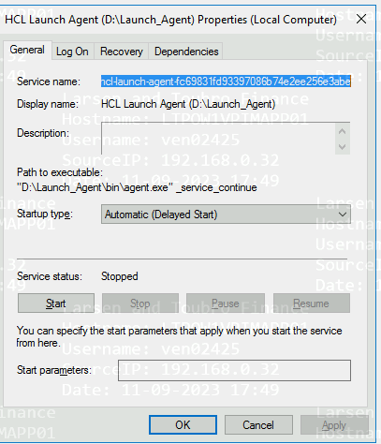
Open command prompt: run as Administrator
D:\Launch_Agent\bin>.\agent.exe uninstall-service <service name>
For Example: D:\Launch_Agent\bin>.\agent.exe uninstall-service “hcl-launch-agent-fc69831fd93397086b74e2ee256e3abe”
Note: If HCL agent not uninstall then try to delete forcefully by following command
D:\Launch_Agent\bin>.\agent.exe del-service <service name>
For Example: D:\Launch_Agent\bin>.\agent.exe del-service “hcl-launch-agent-fc69831fd93397086b74e2ee256e3abe”

Linux Servers
Create two directory in home folder of application user
mkdir $user/Launch_Agent
mkdir $user/Launch_Backup

cd $user/Launch_Agent
(Download agent file https://cicd.ltfs.com/tools/devops-deploy-agent.zip )
$unzip devops-deploy-agent.zip

Update the example.agent.install.properties provided by devops team
$vi example.agent.install.properties
locked/agent.home=$user/Launch_Agent
locked/agent.name=agent
agentcomm.server.uri=wss://172.30.90.23:7919

$ install-agent-from-file.sh example.agent.install.properties

Uninstall / remove agent
Stop the agent services
ps -ef |grep Launch_Agent
sh /$user/Launch_Agent/bin/agent stop

rm -rf $user/Launch_Agent

