Standard Operating Procedure:

“GitHub Repository Management”

Private & Confidential - This process note is the property of L&T Finance. The document is to be used for internal purposes only. Any unauthorized, copying, disclosure, use or distribution of the material is strictly forbidden.
Document Properties
Process Owner | DevOps Team
Stakeholders
Effective from | 02-04-2025
Version No. | Version 1.0

Revision Description
Version | Date | Remarks
1.0 | 02-04-2025 | Initial SOP

Drafted by

Department | Name | Signature
IT Control Units | Laxman Kamble

Reviewed by

Department | Name | Signature
IT Control Units | Dhaval Shah

Approved by

Department | Name | Signature
IT Control Units | Michael Franco

Content
Standard Operating Procedure: 1
1. Introduction 4
2. Purpose and scope 4
3. Responsibilities 4
4. Policy 4
4.1 Access Control 4
4.2 Repository Management 6
4.3 Branch Protection Rules 6
4.4 Security Practices 6
4.5 Documentations and Training 6
4.6 Incident Response 6
5. Branching Strategies and Policies 7
5.1 Branching Strategies. 7
5.2 Branch Polices & Naming 8
6. Webhook Integration with Jenkins 10
6.1 Overview 10
6.2 Setup Instruction 10
7. Release Process 10
8. Compliance 10
9. Review and Revision 10

1. Introduction

This Standard Operating Procedure (SOP) outlines the GitHub Admin Policy for L&T Finance. It serves as a comprehensive guide for managing GitHub repositories effectively while ensuring code security, facilitating collaborative development, and streamlining the deployment process. By establishing clear guidelines on access control, repository management, branching strategies, integration with CI/CD tools like Jenkins, and release management through tagging, this SOP aims to promote best practices and foster a productive development environment for all team members.

2. Purpose and scope

The purpose of this SOP is to establish a clear and consistent policy for the administration of GitHub repositories, ensuring secure, efficient, and effective management of code and collaboration within the organization
This policy applies to all employees, contractors, and third-party personnel who have administrative access to the organization’s GitHub repositories.

3. Responsibilities

- GitHub Administrators: Responsible for managing repository settings, user access, and ensuring adherence to policies.
- Developers and Contributors: Responsible for following the guidelines and best practices set forth in this policy.
- IT Security Team: Responsible for monitoring compliance and conducting audits.

4. Policy

4.1 Access Control

- Authorized Personnel: Only designated GitHub Administrators should have admin access. For example, in a 10-member development team, access might be limited to the Team Lead and Senior Developers.
- Principle of Least Privilege: Assign access based on roles. For instance, junior developers may only have write access to a specific feature branch.
- Regular Reviews:
  - Conduct quarterly access log reviews to ensure compliance with security policies.
  - Assess user access levels against their current roles.
  - Identify and revoke access for inactive or unnecessary accounts (e.g., former employees, role changes).
- Purging Policy:
  - Inactive User Accounts: Purge accounts that have been inactive for a predetermined period (e.g., 90 days).
  - Revocation Process: Establish a clear process for promptly removing access when users no longer need it due to role changes or departures.
Role | Access Privileges
Owner | Full administrative access
Owner | Manage all aspects of the repository
Owner | Invite and manage collaborators
Owner | Delete or transfer the repository
Owner | Change repository settings and permissions
Owner | Access and manage billing information
Owner | Configure webhooks and integrations
Admin | Manage repository settings
Admin | Invite and manage collaborators
Admin | Configure webhooks and integrations
Admin | Manage branches and pull requests
Admin | Access repository insights
Maintain | Manage repository settings
Maintain | Manage branches (e.g., merge pull requests, release management)
Maintain | Invite contributors and manage their access
Maintain | Manage repository projects
Write | Push to non-protected branches
Write | Create and manage pull requests
Write | Edit files and commit changes
Read | View the repository and its contents
Read | Comment on issues and pull requests
Read | Pull repository code
Read | Fork the repository
Triage | Manage issues and pull requests
Triage | Label, assign, and close issues
Triage | Comment on issues and pull requests
Triage | Review and suggest edits to pull requests
NoAccess | No permissions to view, modify, or interact with the repository

Documentation: Keep records of access changes and reasons for purges for transparency.
Notifications: Inform users of their access rights and any changes made during the review process.

4.2 Repository Management

- Centralized Creation: All repositories must be created under the company’s GitHub organization account (e.g., `github.com/YourCompany`).
- Naming Conventions: Follow a standardized naming convention (e.g., `project-feature`) to maintain organization.
- Visibility Management: Manage repository visibility carefully, keeping sensitive repositories private until they are ready for broader access.

Example Scenario:
When launching a new project on user analytics, the project lead will create the repository named `user-analytics-dashboard` under the organization’s account and keep it private.

4.3 Branch Protection Rules
- Enable Branch Protection: Main branches (like `main` or `release`) must have protection enabled, preventing unauthorized changes.
- Require pull request reviews before merging.
- Require status checks (e.g., CI builds) to pass before merging.
- Enforce linear history if using rebase policy.
- Prevent force pushes and direct pushes to protected branches.

Example Configuration:

A protection rule could enforce:

1. PRs for merging into the `main` and `release` branch.
2. At least one approval needed before merging.
3. Successful status checks before completion.

4.4 Security Practices

- Implement 2FA: Require two-factor authentication for all users with administrative access.
- Dependency Management: This refers to the practices and tools used to handle external libraries and packages that a software project relies on. Effective dependency management is crucial for ensuring that the project remains secure, maintainable, and functional.
Dependabot: This is an integrated GitHub tool that automatically checks for outdated dependencies and alerts you to their updates. It can also create pull requests to update your project’s dependencies safely.

4.5 Documentations and Training
- Maintain Documentation: Have a centralized repository for guidelines on coding standards and workflows.
- Training Sessions: Offer onboarding training for new GitHub users to educate them on best practices.

4.6 Incident Response

- Reporting Security Incidents: If unauthorized changes are detected, report immediately to the GitHub Administrator and IT Security Team.
Unauthorized Access: Unauthorized users gain entry to repositories, often through compromised credentials or security vulnerabilities.

- Code Injection/Modification: Malicious actors modify or inject harmful code, which can introduce vulnerabilities or lead to software malfunctions.

- Insider Threats: Employees may intentionally or accidentally create security issues, such as unauthorized code changes or data leaks.

- Compromised Dependencies: Third-party libraries or packages may have known vulnerabilities, exposing the project to potential risks.

- Phishing Attacks: Users are targeted with fraudulent emails to steal their GitHub credentials, leading to unauthorized account access.

- Data Breaches: Sensitive information, like credentials and proprietary code, can be accessed or leaked by unauthorized parties.

- Timely reporting and following the Incident Response Plan are essential to mitigate these incidents, reduce damage, and restore security.

- Execution of Incident Response Plan: Utilize the organization's Incident Response Plan.

5. Branching Strategies and Policies

5.1 Branching Strategies.
Effective branching strategies help manage concurrent development while ensuring code quality. The following strategies are recommended for use within the organization

All Application teams need to follow below GitHub branching strategy for configuring end to end CICD Pipeline.
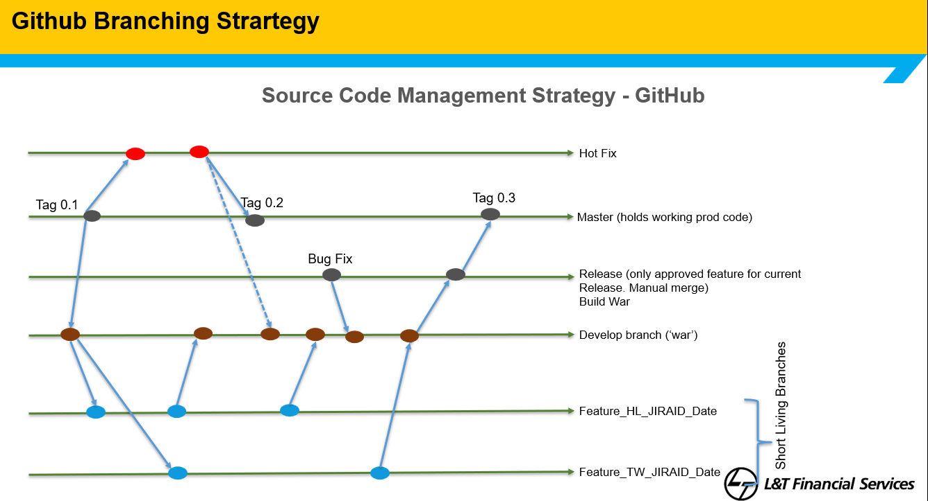
Sr. No. | Branch name | Roles and Responsibility
1 | Master Branch | Branch having existing Production code
2 | Release Branch | DevOps release, manual merge request
3 | Release_2 Branch | This branch would be exclusively used for only fast track changes for all DevOps pipeline and all triggers would be referring to this branch only.
4 | Development/Feature Branch ( should be created by Jira ) | Ongoing Development code or any new feature
5 | Hotfix Branch | Created from `main` to address production issues immediately
Application code needs to maintain separate properties files separate for the UAT/Pre-Prod/PROD/DR environment (wherever possible).
- Master Branch: It holds the current production code., this is the current code state which is running on production. All new development should start with clone of the master branch only.
- Release Branch: This branch would be exclusively used for all DevSecOps pipeline and all triggers would be referring to this branch only.
- Release_2 Branch: This branch would be exclusively used for only fast track changes for all DevSecOps pipeline and all triggers would be referring to this branch only. Release_2 Branch for this requirement, for which we would establish a distinct build pipeline. This branch will facilitate a build process separate from, but parallel to, the Release branch. It is important to ensure that branch protection rules are configured with assistance from the Github administrator.The application owner will have the sole responsibility for managing code merges when implementing changes on a fast-track basis.
- Development/Release Branch: This branch would be used by Developer folks all the features/new releases into the application. Once the Development is concluded they need to manually merge the code to Release for further deployment process to the UAT environment.

- Hotfix Branches: Created from `main` to address production issues immediately (e.g., `hotfix/fix-login-bug`).

5.2 Branch Polices & Naming
- Create a Separate Branch per Change Request:
Each new feature, bug fix, Hot fix or change request should have its own dedicated branch created from the main branch. This isolation helps in managing and reviewing changes independently.
- Branch Naming Convention:
Use clear and consistent branch names, e.g., feature/CR-1234-description or bugfix/CR-5678-description, or hotfix/CR-91011-description making it easy to identify the purpose of each branch.
- Frequent Commits with Descriptive Messages:
Commit changes regularly with meaningful messages to capture incremental progress and reasoning.
- Code Reviews and Testing on Branch:
Conduct code reviews and run tests in the feature branch before merging, ensuring that only verified changes enter the main branch.
- Merge Back Using Pull Requests:
Use pull requests for merging branches back into the main branch to maintain a clear audit trail of what was changed and why.
All changes must be merged via pull requests (PRs) to facilitate code reviews. A code merge from a hotfix branch involves integrating urgent bug fixes or critical patches into other branches, typically the main branch and potentially other relevant branches (e.g., develop, release branches). This process ensures that the fixes are applied consistently across the project without affecting ongoing development.

Example Scenario:
While using Git Flow, a developer working on a new feature would create a branch called `feature/user-profile`. They would then develop the feature, regularly push to this branch, and finally open a PR to merge into `develop`, where it will undergo further testing before being released.

5.2.1 Merge Conflict
A merge conflict occurs when changes from two or more branches cannot be automatically merged by Git, usually because they involve conflicting edits to the same lines of code or files.
- Common Causes
1. Concurrent Edits: Multiple contributors modify the same line in a file.
2. File Deletion: One branch deletes a file while another makes changes to it.
3. Nearby Changes: Edits are made to adjacent lines, causing ambiguity.
4. Rebasing Issues: Conflicts during rebasing from overlapping changes.
- Identifying Merge Conflicts
When merging branches (e.g., via a pull request), GitHub will indicate files with conflicts, marking the pull request as unmergeable.
- Steps to Resolve Merge Conflicts
1. Check Out the Target Branch: $ git checkout main
2. Attempt the Merge: $ git merge feature-branch
3. Open Conflicted Files: Conflicted files will show markers as (<<<<<<<, =======, >>>>>>>).
4. Resolve Conflicts: Manually edit the files to select or combine changes and remove conflict markers.
5. Mark Resolved: Add the resolved files: $ git add <file-name>
6. Complete the Merge: Commit the changes: $ git commit -m "Resolved merge conflict"
7. Push Changes: $ git push origin main
- Best Practices to Avoid Conflicts
- Frequent Updates: Regularly pull recent changes into your feature branches.
- Clear Communication: Coordinate with team members on overlapping changes.
- Smaller Pull Requests: Limit pull requests to specific changes.
Conclusion
Merge conflicts are a normal part of collaborative development in GitHub. Understanding how to manage and resolve them effectively is essential for maintaining a smooth workflow.

6. Webhook Integration with Jenkins

6.1 Overview

Automate the CI/CD pipeline by integrating GitHub repositories with Jenkins using webhooks. This integration allows Jenkins to automatically trigger builds and deployments based on code changes.

6.2 Setup Instruction

6.2.1 Create a Webhook in GitHub:
- Navigate to the repository’s settings.
- Select Webhooks from the sidebar and click on Add webhook.
- Enter the Jenkins URL followed by `/github-webhook/` (e.g., `https://your-jenkins-url/github-webhook/`).
- Select Just the push event to trigger builds on code pushes.
- Click Add webhook to save.

7. Release Process

1. After completing features and testing, merge the `develop` branch into `main`.
2. Create a tag for the release on `main`.
3. Optionally, inform stakeholders of the release using GitHub Releases or appropriate notifications.

Example Scenario:
After merging changes into the `main` branch following extensive testing, the release manager tags the commit as `v1.0.0`, marking it as production-ready, and informs the team of the new release.

8. Compliance

Failure to comply with this policy may lead to disciplinary action, including termination of access rights or other consequences. Additionally, no code should be shared outside the network of LTF; failing which, LTF reserves the right to take legal action.

9. Review and Revision
This policy is reviewed annually or as needed. Changes must be documented and approved.

Example Revision Scenario:
If GitHub introduces new features, the SOP will be updated to include these.

