DEPARTMENT OF COMPUTER APPLICATIONS
NATIONAL INSTITUTE OF TECHNOLOGY KURUKSHETRA,
KURUKSHETRA, HARYANA, INDIA



Web Technology Lab (MCA-234)
LAB RECORDS (2025 - 2026)

SUBMITTED BY: SUBMITTED TO:
Name: Suraj Pandey Dr. Munish Bhatia
Roll No: 524110023
Program: MCA
Semester:4th
Group: G-2, Serial No.6

INDEX

Program 1: Create a simple webpage using HTML that includes images, tables, and hyperlinks.
Program 2: Use CSS to style the webpage created in exercise 1 by adding selectors, applying styles to text, links, tables, and lists.
Program 3: Create a form in HTML and use CSS to style it.
Program 4: Use JavaScript to create a program that prompts the user for their name and then displays a personalized greeting.
Program 5: Create a program in JavaScript that calculates the area of a circle based on user input.

Program 1: Create a simple webpage using HTML that includes images, tables, and hyperlinks.
Code:
index.html
<!DOCTYPE html>
<html lang="en" dir="ltr">
<head>
<title>Mini Product Catalog</title>
</head>

<body
bgcolor="#f5f5f5"
text="#000000"
link="blue"
vlink="purple"
alink="red"
>

<center>
<h1 title="Main heading of the page">Mini Product Catalog</h1>
<p title="Introduction Text">Browse our latest product and great deals!</p>

<hr width="80%" size="3" color="gray" noshade>
<h2>Featured Products</h2>

<!--Product Images-->
<table width="80%" cellspacing="20" bgcolor="#ffffff" border="0">
<tr align="center" valign="middle">
<td width="33%" title="SmartWatches">
<img src="https://global-uploads.webflow.com/5ed07a970e867a2f9277b52f/62aa4b19bc32214b2c3179e6_00_HSW3_HERO_Black_v01%201200x1200.jpg" width="150" height="150" alt="Smartwatch" loading="lazy">
<br><b>Smartwatch</b>
</td>
<td width="33%">
<img src="https://m.media-amazon.com/images/I/41JACWT-wWL.jpg" width="150" height="150" alt="Wireless Headphones" >
<br><b>Wireles Headphones</b>
</td>
<td>
<img src="https://images-na.ssl-images-amazon.com/images/I/71ZtJFKJghL.jpg" width="150" height="150" alt="Sneakers">
<br><b>Sneakers</b>
</td>
</tr>
</table>

<br>
<!--Product Details Table-->
<table border="1" width="80%" cellpadding="10" cellspacing="0" align="center" bgcolor="#ffffff" rules="all" frame="box">
<tr bgcolor="#cce0ee">
<th>Product</th>
<th>Price</th>
<th>Available</th>
<th>Buy Now</th>
</tr>
<tr align="center">
<td>Smartwatch</td>
<td>$99</td>
<td>In Stock</td>
<td><button type="button">Buy Now</button></td>
</tr>

<tr align="center">
<td>Wireless Headphones</td>
<td>$59</td>
<td>Out of Stock</td>
<td><button type="button" disabled>Buy Now</button></td>
</tr>

<tr align="center">
<td>Sneakers</td>
<td>$199</td>
<td>In Stock</td>
<td><button type="button" onclick="alert('Thank you for your purchase!')">Buy Now</button></td>
</tr>
</table>

<br><br>
<hr width="80%">

<p>© 2026 Mini Product Catalog</p>
</center>
</body>
</html>

Output:
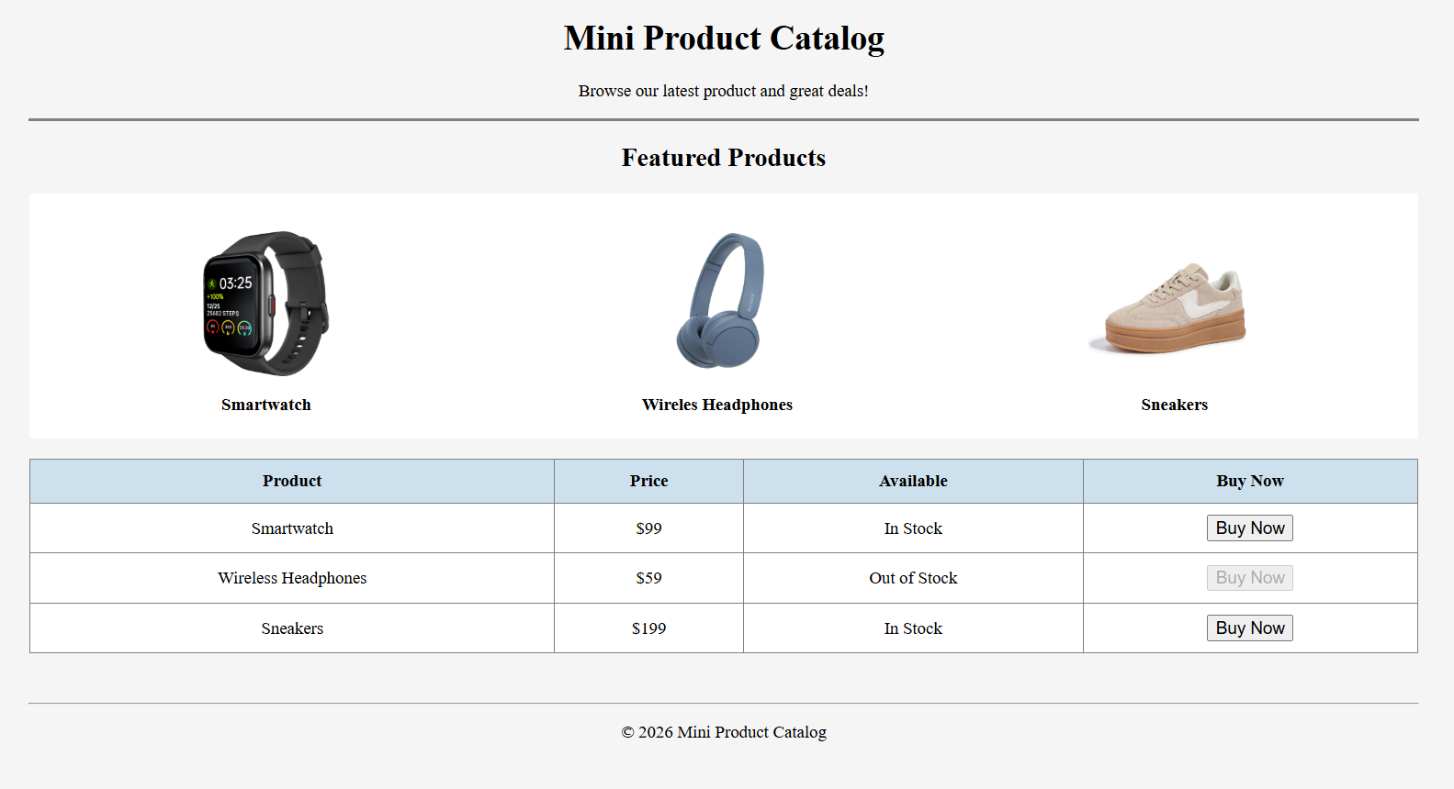

Program 2: Use CSS to style the webpage created in exercise 1 by adding selectors, applying styles to text, links, tables, and lists.
Code:
Index.html
<!DOCTYPE html>
<html lang="en">
<head>
<meta charset="UTF-8" />
<meta name="viewport" content="width=device-width, initial-scale=1.0" />
<title>Mini Product Catalog</title>

<!-- External CSS File -->
<link rel="stylesheet" href="style.css">
</head>

<body>
<div class="page">
<header class="header">
<h1 title="Main heading of the page">Mini Product Catalog</h1>
<p class="subtitle" title="Introduction Text">
Browse our latest products and great deals!
</p>

<a href="#products" class="top-link">Go to Products ↓</a>
</header>

<hr class="line">

<section class="section" id="products">
<h2>Featured Products</h2>

<!-- Product Images (cards) -->
<div class="product-grid">
<div class="product-card" title="Smartwatch">
<img src="https://global-uploads.webflow.com/5ed07a970e867a2f9277b52f/62aa4b19bc32214b2c3179e6_00_HSW3_HERO_Black_v01%201200x1200.jpg"
alt="Smartwatch" loading="lazy">
<h3>Smartwatch</h3>
<p class="desc">Track fitness, steps and notifications.</p>
</div>

<div class="product-card" title="Wireless Headphones">
<img src="https://m.media-amazon.com/images/I/41JACWT-wWL.jpg"
alt="Wireless Headphones">
<h3>Wireless Headphones</h3>
<p class="desc">Noise-free music and clear calls.</p>
</div>

<div class="product-card" title="Sneakers">
<img src="https://images-na.ssl-images-amazon.com/images/I/71ZtJFKJghL.jpg"
alt="Sneakers">
<h3>Sneakers</h3>
<p class="desc">Comfortable shoes for daily wear.</p>
</div>
</div>
</section>

<section class="section">
<h2>Quick Highlights</h2>

<!-- Styled List -->
<ul class="highlight-list">
<li>Fast Delivery</li>
<li>Secure Payments</li>
<li>Best Deals Everyday</li>
</ul>
</section>

<section class="section">
<h2>Product Details</h2>

<!-- Product Details Table -->
<div class="table-box">
<table class="product-table">
<thead>
<tr>
<th>Product</th>
<th>Price</th>
<th>Available</th>
<th>Buy Now</th>
</tr>
</thead>

<tbody>
<tr>
<td>Smartwatch</td>
<td>$99</td>
<td><span class="status in-stock">In Stock</span></td>
<td>
<button class="btn buy-btn" type="button">
Buy Now
</button>
</td>
</tr>

<tr>
<td>Wireless Headphones</td>
<td>$59</td>
<td><span class="status out-stock">Out of Stock</span></td>
<td>
<button class="btn buy-btn disabled" type="button" disabled>
Buy Now
</button>
</td>
</tr>

<tr>
<td>Sneakers</td>
<td>$199</td>
<td><span class="status in-stock">In Stock</span></td>
<td>
<button class="btn buy-btn" type="button">
Buy Now
</button>
</td>
</tr>
</tbody>
</table>
</div>
</section>

<footer class="footer">
<p>© 2026 Mini Product Catalog</p>
</footer>
</div>
</body>
</html>

Styles.css
* {
margin: 0;
padding: 0;
box-sizing: border-box;
}

html {
scroll-behavior: smooth; /* interactive smooth scroll */
}

body {
font-family: Arial, sans-serif;
background: #ffffff;
color: #111;
line-height: 1.6;
}

/* ===== Page Container ===== */
.page {
width: 90%;
max-width: 1100px;
margin: 25px auto;
padding: 20px;
}

/* ===== Header ===== */
.header {
background: white;
padding: 20px;
text-align: center;
border-radius: 12px;
box-shadow: 0 4px 14px rgba(0, 0, 0, 0.12);
}

.header h1 {
font-size: 2.2rem;
color: #2b2b2b;
margin-bottom: 8px;
}

.subtitle {
font-size: 1rem;
color: #666;
margin-bottom: 14px;
}

.top-link {
display: inline-block;
text-decoration: none;
background: #0077ff;
color: white;
padding: 10px 16px;
border-radius: 8px;
transition: 0.3s;
font-weight: bold;
}

.top-link:hover {
background: #005ad1;
transform: scale(1.05);
}

/* ===== Section Styles ===== */
.section {
margin-top: 25px;
background: white;
padding: 20px;
border-radius: 12px;
box-shadow: 0 4px 14px rgba(0, 0, 0, 0.08);
}

.section h2 {
text-align: center;
margin-bottom: 18px;
color: #333;
}

/* ===== HR Line ===== */
.line {
margin: 20px auto;
border: none;
height: 3px;
width: 80%;
background: gray;
border-radius: 5px;
}

/* ===== Product Cards Grid ===== */
.product-grid {
display: flex;
gap: 20px;
justify-content: center;
flex-wrap: wrap;
}

.product-card {
width: 280px;
padding: 16px;
background: #fafafa;
border-radius: 14px;
text-align: center;
border: 1px solid #ddd;
transition: 0.3s;
cursor: pointer;
}

.product-card:hover {
transform: translateY(-8px);
box-shadow: 0 10px 18px rgba(0, 0, 0, 0.15);
border-color: #0077ff;
}

.product-card img {
width: 150px;
height: 150px;
border-radius: 10px;
object-fit: cover;
transition: 0.3s;
}

.product-card:hover img {
transform: scale(1.06);
}

.product-card h3 {
margin-top: 12px;
font-size: 1.2rem;
color: #222;
}

.desc {
font-size: 0.9rem;
color: #555;
margin-top: 6px;
}

/* ===== List Styling (Interactive) ===== */
.highlight-list {
list-style: none;
display: flex;
gap: 12px;
justify-content: center;
flex-wrap: wrap;
}

.highlight-list li {
background: #eef6ff;
color: #004a99;
padding: 10px 14px;
border-radius: 10px;
font-weight: bold;
transition: 0.3s;
border: 1px solid #cce0ee;
}

.highlight-list li:hover {
background: #0077ff;
color: white;
transform: scale(1.05);
}

/* ===== Table Styling ===== */
.table-box {
overflow-x: auto;
}

.product-table {
width: 100%;
border-collapse: collapse;
margin-top: 10px;
}

.product-table th,
.product-table td {
padding: 12px;
text-align: center;
border-bottom: 1px solid #ddd;
}

.product-table thead th {
background: #cce0ee;
color: #333;
font-size: 1rem;
}

.product-table tbody tr {
transition: 0.2s;
}

.product-table tbody tr:hover {
background: #f0f8ff;
}

/* ===== Status Labels ===== */
.status {
padding: 5px 10px;
border-radius: 20px;
font-size: 0.9rem;
font-weight: bold;
display: inline-block;
}

.in-stock {
background: #d4f8d4;
color: #146b14;
}

.out-stock {
background: #ffd6d6;
color: #aa0000;
}

/* ===== Buttons (Interactive) ===== */
.btn {
border: none;
padding: 10px 14px;
border-radius: 8px;
cursor: pointer;
font-weight: bold;
transition: 0.3s;
}

.buy-btn {
background: #0077ff;
color: white;
}

.buy-btn:hover {
background: #005ad1;
transform: scale(1.06);
}

.buy-btn:active {
transform: scale(0.95);
}

.disabled {
background: #999 !important;
cursor: not-allowed;
}

/* ===== Footer ===== */
.footer {
text-align: center;
margin-top: 25px;
padding: 14px;
color: #444;
font-weight: bold;
}

Output:
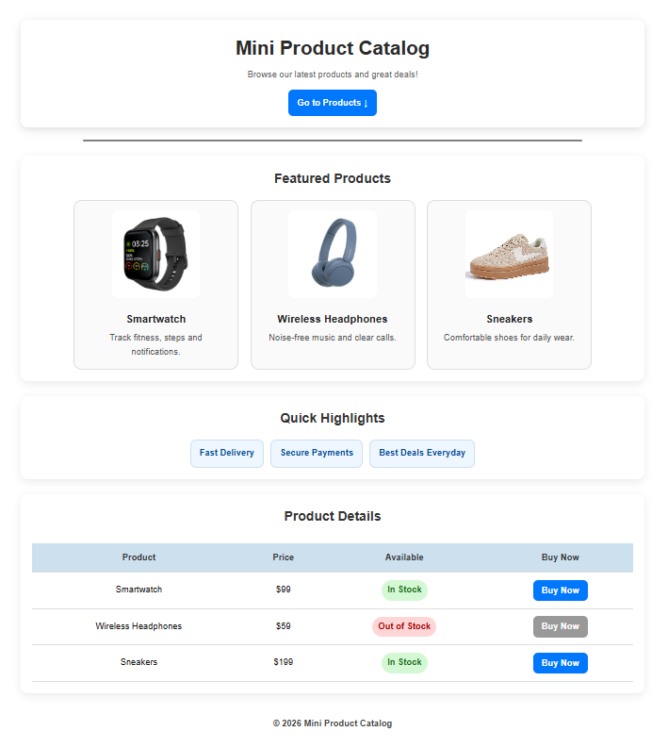

Program 3: Create a form in HTML and use CSS to style it.
Index.js
<!DOCTYPE html>
<html lang="en">
<head>
<meta charset="UTF-8">
<title>Contact Form</title>

<style>
/* ===== Page Background ===== */
body {
font-family: Georgia, serif;
background-color: #fdf6ee;
display: flex;
justify-content: center;
padding: 40px 20px;
}

/* ===== The Form Card ===== */
.form-card {
background-color: #ffffff;
border: 2px solid #e8d5b7;
border-radius: 12px;
padding: 40px;
width: 100%;
max-width: 480px;
box-shadow: 4px 4px 0px #c9a97a;
}

/* ===== Title ===== */
h1 {
font-size: 26px;
color: #3b2a1a;
margin-bottom: 6px;
}

p.subtitle {
color: #7a6350;
font-size: 14px;
margin-bottom: 28px;
}

/* ===== Each Field Group ===== */
.field {
margin-bottom: 20px;
}

label {
display: block; /* Label on its own line */
font-size: 14px;
font-weight: bold;
color: #3b2a1a;
margin-bottom: 6px;
}

/* ===== Text Inputs & Textarea ===== */
input, textarea, select {
width: 100%;
padding: 10px 14px;
font-size: 15px;
font-family: Georgia, serif;
border: 2px solid #d4b896;
border-radius: 8px;
background-color: #fffaf4;
color: #3b2a1a;
box-sizing: border-box; /* Width includes padding */
transition: border-color 0.2s;
}

/* Highlight border when user clicks into a field */
input:focus, textarea:focus, select:focus {
outline: none;
border-color: #c9845a;
}

textarea {
height: 110px;
resize: vertical; /* Let user resize up/down only */
}

/* ===== Submit Button ===== */
button {
width: 100%;
padding: 12px;
font-size: 16px;
font-family: Georgia, serif;
background-color: #c9845a;
color: #ffffff;
border: none;
border-radius: 8px;
cursor: pointer;
transition: background-color 0.2s;
}

button:hover {
background-color: #a8643e;
}
</style>
</head>

<body>

<div class="form-card">
<h1>Contact Us</h1>
<p class="subtitle">Fill in the form below and we'll get back to you.</p>

<form>

<!-- Name Field -->
<div class="field">
<label for="name">Your Name</label>
<input type="text" id="name" placeholder="e.g. Alex Johnson">
</div>

<!-- Email Field -->
<div class="field">
<label for="email">Email Address</label>
<input type="email" id="email" placeholder="e.g. alex@email.com">
</div>

<!-- Dropdown -->
<div class="field">
<label for="topic">Topic</label>
<select id="topic">
<option value="">-- Choose a topic --</option>
<option value="general">General Question</option>
<option value="support">Support</option>
<option value="feedback">Feedback</option>
</select>
</div>

<!-- Message Field -->
<div class="field">
<label for="message">Message</label>
<textarea id="message" placeholder="Write your message here..."></textarea>
</div>

<!-- Submit Button -->
<button type="submit">Send Message</button>

</form>
</div>

</body>
</html>

OUTPUT:

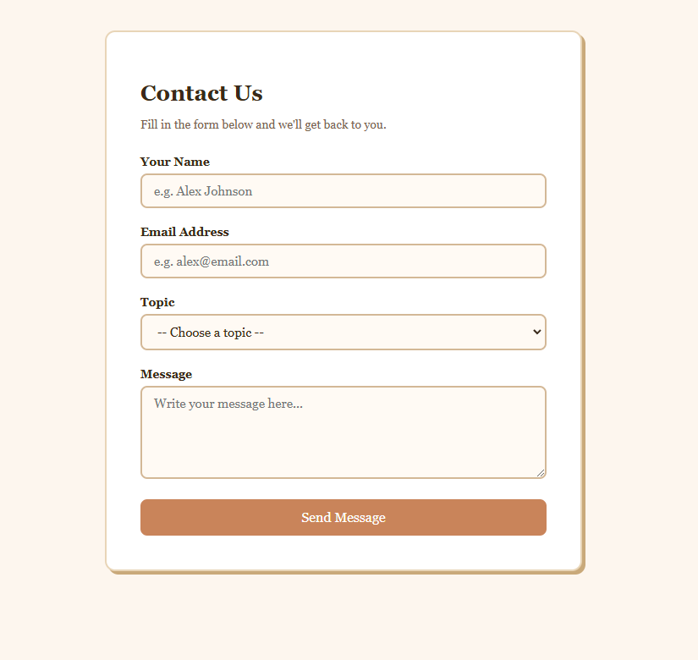
Program 4: Use JavaScript to create a program that prompts the user for their name and then displays a personalized greeting.

Index.html:

<!DOCTYPE html>
<html lang="en">
<head>
<meta charset="UTF-8">
<title>Greeting App</title>

<style>
/* ===== Page Background ===== */
body {
font-family: Georgia, serif;
background-color: #fdf6ee;
display: flex;
justify-content: center;
padding: 60px 20px;
}

/* ===== Card ===== */
.card {
background-color: #ffffff;
border: 2px solid #e8d5b7;
border-radius: 12px;
padding: 40px;
width: 100%;
max-width: 420px;
box-shadow: 4px 4px 0px #c9a97a;
text-align: center;
}

h1 {
font-size: 26px;
color: #3b2a1a;
margin-bottom: 8px;
}

p.subtitle {
color: #7a6350;
font-size: 14px;
margin-bottom: 28px;
}

/* ===== Input ===== */
input {
width: 100%;
padding: 10px 14px;
font-size: 15px;
font-family: Georgia, serif;
border: 2px solid #d4b896;
border-radius: 8px;
background-color: #fffaf4;
color: #3b2a1a;
box-sizing: border-box;
margin-bottom: 16px;
transition: border-color 0.2s;
}

input:focus {
outline: none;
border-color: #c9845a;
}

/* ===== Button ===== */
button {
width: 100%;
padding: 12px;
font-size: 16px;
font-family: Georgia, serif;
background-color: #c9845a;
color: #ffffff;
border: none;
border-radius: 8px;
cursor: pointer;
transition: background-color 0.2s;
}

button:hover {
background-color: #a8643e;
}

/* ===== Greeting Message (hidden at first) ===== */
.greeting {
margin-top: 28px;
padding: 18px;
background-color: #fff4e6;
border: 2px dashed #c9845a;
border-radius: 10px;
color: #3b2a1a;
font-size: 18px;

/* Hidden by default */
display: none;
}
</style>
</head>

<body>

<div class="card">
<h1>👋 Hello!</h1>
<p class="subtitle">Enter your name to get a personalized greeting.</p>

<!-- Text input for the name -->
<input type="text" id="nameInput" placeholder="Type your name here...">

<!-- Button that triggers the greeting -->
<button onclick="showGreeting()">Greet Me!</button>

<!-- This box is hidden until the user clicks the button -->
<div class="greeting" id="greetingBox"></div>
</div>

<script>
// This function runs when the button is clicked
function showGreeting() {

// Step 1: Get what the user typed
let name = document.getElementById("nameInput").value;

// Step 2: Check if the input is empty
if (name === "") {
alert("Please enter your name first!");
return; // Stop here if no name was entered
}

// Step 3: Build the greeting message
let message = "Hello, " + name + "! 🎉 Welcome, great to have you here!";

// Step 4: Put the message inside the greeting box
document.getElementById("greetingBox").innerText = message;

// Step 5: Make the greeting box visible
document.getElementById("greetingBox").style.display = "block";
}
</script>

</body>
</html>

OUTPUT:

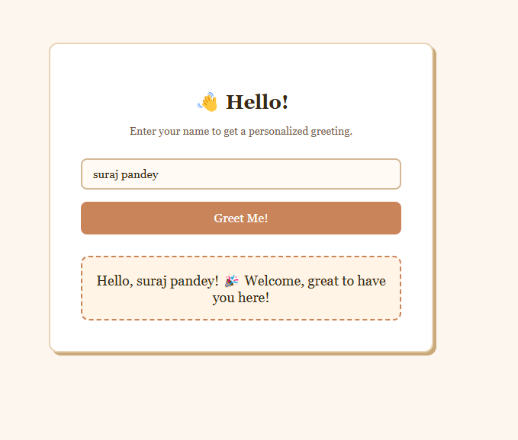

Program 5: Create a program in JavaScript that calculates the area of a circle based on user input.

Index.html

<!DOCTYPE html>
<html lang="en">
<head>
<meta charset="UTF-8">
<title>Circle Area Calculator</title>

<style>
/* ===== Page Background ===== */
body {
font-family: Georgia, serif;
background-color: #fdf6ee;
display: flex;
justify-content: center;
padding: 60px 20px;
}

/* ===== Card ===== */
.card {
background-color: #ffffff;
border: 2px solid #e8d5b7;
border-radius: 12px;
padding: 40px;
width: 100%;
max-width: 420px;
box-shadow: 4px 4px 0px #c9a97a;
text-align: center;
}

h1 {
font-size: 26px;
color: #3b2a1a;
margin-bottom: 8px;
}

p.subtitle {
color: #7a6350;
font-size: 14px;
margin-bottom: 28px;
}

/* ===== Label ===== */
label {
display: block;
text-align: left;
font-size: 14px;
font-weight: bold;
color: #3b2a1a;
margin-bottom: 6px;
}

/* ===== Input ===== */
input {
width: 100%;
padding: 10px 14px;
font-size: 15px;
font-family: Georgia, serif;
border: 2px solid #d4b896;
border-radius: 8px;
background-color: #fffaf4;
color: #3b2a1a;
box-sizing: border-box;
margin-bottom: 16px;
transition: border-color 0.2s;
}

input:focus {
outline: none;
border-color: #c9845a;
}

/* ===== Button ===== */
button {
width: 100%;
padding: 12px;
font-size: 16px;
font-family: Georgia, serif;
background-color: #c9845a;
color: #ffffff;
border: none;
border-radius: 8px;
cursor: pointer;
transition: background-color 0.2s;
}

button:hover {
background-color: #a8643e;
}

/* ===== Result Box (hidden at first) ===== */
.result {
margin-top: 28px;
padding: 18px;
background-color: #fff4e6;
border: 2px dashed #c9845a;
border-radius: 10px;
color: #3b2a1a;
font-size: 17px;
display: none; /* Hidden until calculation runs */
}

/* ===== Circle Drawing ===== */
.circle-wrap {
margin-top: 20px;
display: none; /* Hidden until calculation runs */
}

canvas {
border-radius: 50%;
}
</style>
</head>

<body>

<div class="card">
<h1>⭕ Circle Area</h1>
<p class="subtitle">Enter the radius to calculate the area of a circle.</p>

<!-- Input for radius -->
<label for="radiusInput">Radius (in units)</label>
<input type="number" id="radiusInput" placeholder="e.g. 5" min="0">

<!-- Calculate button -->
<button onclick="calculateArea()">Calculate Area</button>

<!-- Result appears here -->
<div class="result" id="resultBox"></div>

<!-- Visual circle -->
<div class="circle-wrap" id="circleWrap">
<canvas id="circleCanvas" width="160" height="160"></canvas>
</div>
</div>

<script>
function calculateArea() {

// Step 1: Get the radius the user typed, convert text → number
let radius = parseFloat(document.getElementById("radiusInput").value);

// Step 2: Validate — must be a positive number
if (isNaN(radius) || radius <= 0) {
alert("Please enter a valid positive number for the radius.");
return;
}

// Step 3: Apply the formula → Area = π × r²
let area = Math.PI * radius * radius;

// Step 4: Round to 2 decimal places for a clean display
let rounded = area.toFixed(2);

// Step 5: Show the result message
document.getElementById("resultBox").innerHTML =
"Radius: <strong>" + radius + "</strong> units<br>" +
"Area = π × " + radius + "² = <strong>" + rounded + " sq units</strong>";

document.getElementById("resultBox").style.display = "block";

// Step 6: Draw a visual circle on the canvas
drawCircle();
}

function drawCircle() {
// Show the canvas wrapper
document.getElementById("circleWrap").style.display = "block";

// Get the canvas and its drawing context (like a paintbrush)
let canvas = document.getElementById("circleCanvas");
let ctx = canvas.getContext("2d");

// Clear any previous drawing
ctx.clearRect(0, 0, canvas.width, canvas.height);

// Draw a filled circle in the center of the canvas
ctx.beginPath();
ctx.arc(80, 80, 70, 0, 2 * Math.PI); // (centerX, centerY, radius, startAngle, endAngle)
ctx.fillStyle = "#ffe0c2";
ctx.fill();
ctx.strokeStyle = "#c9845a";
ctx.lineWidth = 3;
ctx.stroke();
}
</script>

</body>
</html>

Output:
