Experiment 1: To implement DDA algorithm for line and circle
Program Code (Python):
import math
import matplotlib.pyplot as plt
# Circle parameters
xc, yc = 0, 0
r = 10
# Number of steps to approximate the circle
steps = int(2 * math.pi * r)
x_points = []
y_points = []
theta = 0
theta_increment = (2 * math.pi) / steps
for _ in range(steps + 1):
x = xc + r * math.cos(theta)
y = yc + r * math.sin(theta)
x_points.append(x)
y_points.append(y)
theta += theta_increment
plt.figure(figsize=(6,6))
plt.plot(x_points, y_points, marker='o')
plt.title("Circle drawn using DDA-like algorithm")
plt.axis('equal')
plt.grid(True)
plt.show()

Program Code (Python):
import matplotlib.pyplot as plt
# Line coordinates
x1, y1 = 2, 3
x2, y2 = 15, 10
# Calculate dx, dy
dx = x2 - x1
dy = y2 - y1
# Number of steps
steps = max(abs(dx), abs(dy))
# Calculate increments
x_inc = dx / steps
y_inc = dy / steps
# Generate points
x_points = []
y_points = []
x, y = x1, y1
for _ in range(steps + 1):
x_points.append(round(x, 2)) # keep decimals for smooth plotting
y_points.append(round(y, 2))
x += x_inc
y += y_inc
# Plot line
plt.figure(figsize=(6,6))
plt.plot(x_points, y_points, marker='o', color='r')
plt.title("Line drawn using DDA algorithm")
plt.grid(True)
plt.show()

Output:
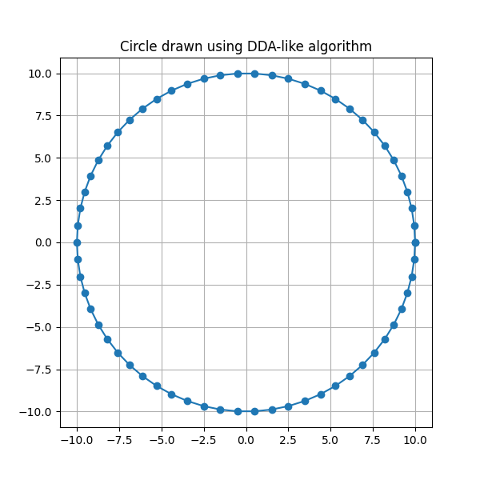

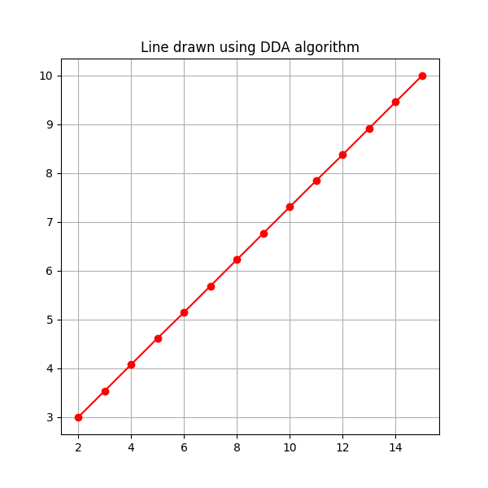

Experiment 2: To implement Bresenham’s algorithms for line, circle and ellipse drawing
Program Code (Python): Bresenham’s Line Drawing Algorithm
import matplotlib.pyplot as plt
def bresenham_line(x1, y1, x2, y2):
points = []
dx = abs(x2 - x1)
dy = abs(y2 - y1)
sx = 1 if x1 < x2 else -1
sy = 1 if y1 < y2 else -1
err = dx - dy
while True:
points.append((x1, y1))
if x1 == x2 and y1 == y2:
break
e2 = 2 * err
if e2 > -dy:
err -= dy
x1 += sx
if e2 < dx:
err += dx
y1 += sy
return points
# Example usage
line_points = bresenham_line(2, 3, 20, 15)
x, y = zip(*line_points)
plt.figure(figsize=(6,6))
plt.scatter(x, y, color='red', s=20)
plt.title("Bresenham Line Drawing")
plt.grid(True)
plt.show()

Program Code (Python): Bresenham’s Circle Drawing Algorithm
import matplotlib.pyplot as plt

def bresenham_circle(xc, yc, r):
x = 0
y = r
d = 3 - 2 * r
points = []

while x <= y:
points.extend([
(xc+x, yc+y), (xc-x, yc+y),
(xc+x, yc-y), (xc-x, yc-y),
(xc+y, yc+x), (xc-y, yc+x),
(xc+y, yc-x), (xc-y, yc-x)
])
if d < 0:
d += 4 * x + 6
else:
d += 4 * (x - y) + 10
y -= 1
x += 1
return points

# Example usage
circle_points = bresenham_circle(0, 0, 20)
x, y = zip(*circle_points)

plt.figure(figsize=(6,6))
plt.scatter(x, y, color='blue', s=20)
plt.title("Bresenham Circle Drawing")
plt.gca().set_aspect('equal', adjustable='box')
plt.grid(True)
plt.show()
Program Code (Python): Bresenham’s Ellipse Drawing Algorithm
import matplotlib.pyplot as plt

def bresenham_ellipse(xc, yc, rx, ry):
x = 0
y = ry
rx2 = rx * rx
ry2 = ry * ry
two_rx2 = 2 * rx2
two_ry2 = 2 * ry2
px = 0
py = two_rx2 * y
points = []

# Region 1
p = round(ry2 - (rx2 * ry) + (0.25 * rx2))
while px < py:
points.extend([
(xc+x, yc+y), (xc-x, yc+y),
(xc+x, yc-y), (xc-x, yc-y)
])
x += 1
px += two_ry2
if p < 0:
p += ry2 + px
else:
y -= 1
py -= two_rx2
p += ry2 + px - py

# Region 2
p = round(ry2 * (x + 0.5) ** 2 + rx2 * (y - 1) ** 2 - rx2 * ry2)
while y >= 0:
points.extend([
(xc+x, yc+y), (xc-x, yc+y),
(xc+x, yc-y), (xc-x, yc-y)
])
y -= 1
py -= two_rx2
if p > 0:
p += rx2 - py
else:
x += 1
px += two_ry2
p += rx2 - py + px
return points

# Example usage
ellipse_points = bresenham_ellipse(0, 0, 40, 20)
x, y = zip(*ellipse_points)

plt.figure(figsize=(7,6))
plt.scatter(x, y, color='green', s=20)
plt.title("Bresenham Ellipse Drawing")
plt.gca().set_aspect('equal', adjustable='box')
plt.grid(True)
plt.show()

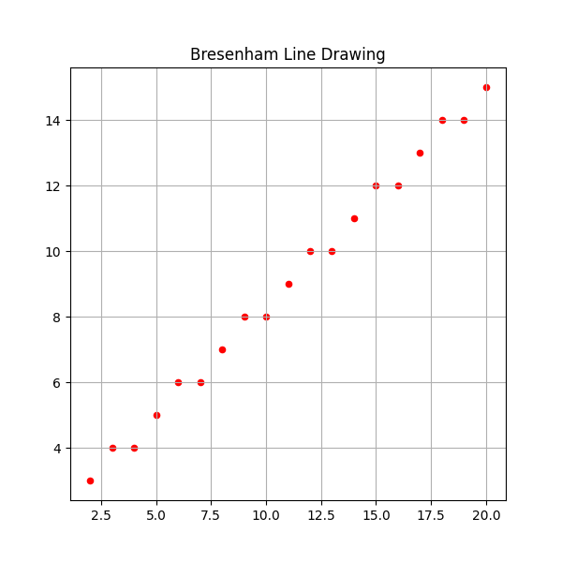
Output:

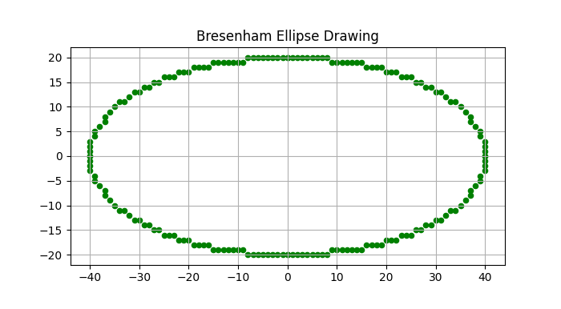

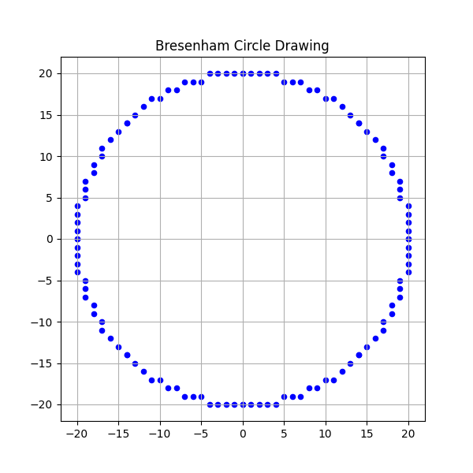

Experiment 3: To implement Mid-Point circle algorithm
Program Code (Python):
import matplotlib.pyplot as plt
def midpoint_circle(xc, yc, r):
x = 0
y = r
p = 1 - r # Initial decision parameter
points = []
while x <= y:
# 8-way symmetry
points.extend([
(xc + x, yc + y), (xc - x, yc + y),
(xc + x, yc - y), (xc - x, yc - y),
(xc + y, yc + x), (xc - y, yc + x),
(xc + y, yc - x), (xc - y, yc - x)
])
x += 1
if p < 0:
p += 2 * x + 1
else:
y -= 1
p += 2 * (x - y) + 1
return points

# Example usage
circle_points = midpoint_circle(0, 0, 20)
x, y = zip(*circle_points)

plt.figure(figsize=(6,6))
plt.scatter(x, y, color='blue', s=20)
plt.title("Mid-Point Circle Drawing Algorithm")
plt.gca().set_aspect('equal', adjustable='box')
plt.grid(True)
plt.show()

Output:

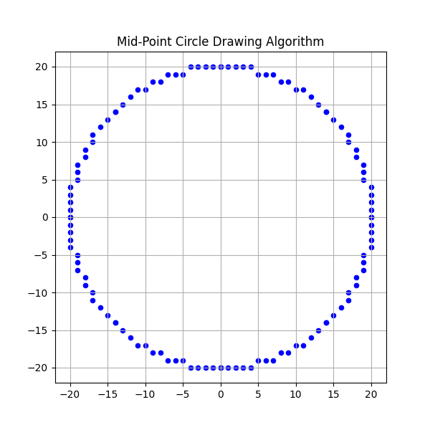

Experiment 4: To implement Mid-Point ellipse algorithm
Program Code (Python):
import matplotlib.pyplot as plt
def midpoint_ellipse(xc, yc, rx, ry):
points = []
x = 0
y = ry

# Region 1
d1 = (ry**2) - (rx**2 * ry) + (0.25 * rx**2)
dx = 2 * (ry**2) * x
dy = 2 * (rx**2) * y

while dx < dy:
# 4-way symmetry
points.extend([
(xc + x, yc + y), (xc - x, yc + y),
(xc + x, yc - y), (xc - x, yc - y)
])

if d1 < 0:
x += 1
dx = dx + (2 * (ry**2))
d1 = d1 + dx + (ry**2)
else:
x += 1
y -= 1
dx = dx + (2 * (ry**2))
dy = dy - (2 * (rx**2))
d1 = d1 + dx - dy + (ry**2)

# Region 2
d2 = ((ry**2) * ((x + 0.5) ** 2)) + ((rx**2) * ((y - 1) ** 2)) - (rx**2 * ry**2)

while y >= 0:
points.extend([
(xc + x, yc + y), (xc - x, yc + y),
(xc + x, yc - y), (xc - x, yc - y)
])
if d2 > 0:
y -= 1
dy = dy - (2 * (rx**2))
d2 = d2 + (rx**2) - dy
else:
y -= 1
x += 1
dx = dx + (2 * (ry**2))
dy = dy - (2 * (rx**2))
d2 = d2 + dx - dy + (rx**2)
return points
# Example usage
ellipse_points = midpoint_ellipse(0, 0, 40, 20)
x, y = zip(*ellipse_points)

plt.figure(figsize=(7,6))
plt.scatter(x, y, color='green', s=20)
plt.title("Mid-Point Ellipse Drawing Algorithm")
plt.gca().set_aspect('equal', adjustable='box')
plt.grid(True)
plt.show()

Output:

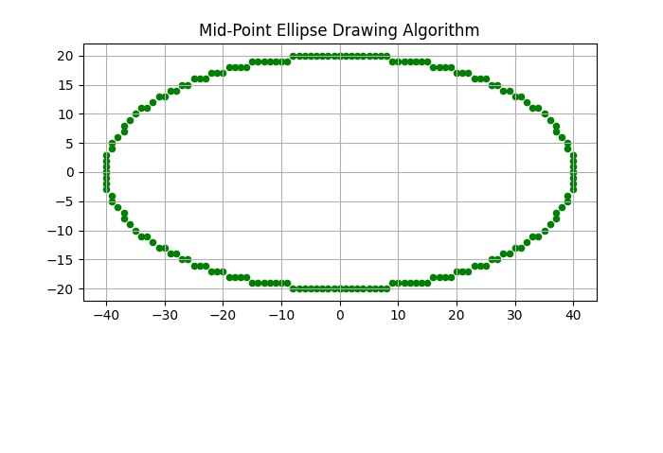

Experiment 5: To perform 2D Transformations such as translation, rotation, scaling, reflection and shearing
Program Code (Python):Scaling
import numpy as np
import matplotlib.pyplot as plt
def scale(points, sx, sy):
"""
Scale points by sx and sy along x and y axes.
"""
scaling_matrix = np.array([[sx, 0],
[0, sy]])
return points.dot(scaling_matrix.T)

# Original points (a rectangle)
points = np.array([[1, 1], [3, 1], [3, 2], [1, 2], [1, 1]]) # closed rectangle

# Perform scaling
scaled_up = scale(points, sx=2, sy=1.5) # scale up x by 2 and y by 1.5
scaled_down = scale(points, sx=0.5, sy=0.5) # scale down by half

# Plotting
plt.figure(figsize=(8, 6))
plt.axis('equal')

plt.plot(points[:, 0], points[:, 1], 'bo-', label='Original')
plt.plot(scaled_up[:, 0], scaled_up[:, 1], 'ro-', label='Scaled Up (2x, 1.5x)')
plt.plot(scaled_down[:, 0], scaled_down[:, 1], 'go-', label='Scaled Down (0.5x, 0.5x)')

plt.legend()
plt.title('2D Scaling')
plt.grid(True)
plt.show()

Program Code (Python): Shearing
import numpy as np
import matplotlib.pyplot as plt
def shear_x(points, shx):
"""
Shear points horizontally by shx.
"""
shear_matrix = np.array([[1, shx],
[0, 1]])
return points.dot(shear_matrix.T)
def shear_y(points, shy):
"""
Shear points vertically by shy.
"""
shear_matrix = np.array([[1, 0],
[shy, 1]])
return points.dot(shear_matrix.T)
# Original points (a rectangle)
points = np.array([[1, 1], [3, 1], [3, 2], [1, 2], [1, 1]]) # closed rectangle
# Apply shearing
sheared_x = shear_x(points, shx=1) # shear horizontally by 1
sheared_y = shear_y(points, shy=0.5) # shear vertically by 0.5
# Plotting
plt.figure(figsize=(8, 6))
plt.axis('equal')
plt.plot(points[:, 0], points[:, 1], 'bo-', label='Original')
plt.plot(sheared_x[:, 0], sheared_x[:, 1], 'ro-', label='Sheared Horizontally (shx=1)')
plt.plot(sheared_y[:, 0], sheared_y[:, 1], 'go-', label='Sheared Vertically (shy=0.5)')

plt.legend()
plt.title('2D Shearing')
plt.grid(True)
plt.show()

Program Code (Python): Rotation and translation
import numpy as np
import matplotlib.pyplot as plt
def translate(points, tx, ty):
translation_vector = np.array([tx, ty])
return points + translation_vector
def rotate(points, theta):
rotation_matrix = np.array([
[np.cos(theta), -np.sin(theta)],
[np.sin(theta), np.cos(theta)]
])
return points.dot(rotation_matrix.T)
# Original points (a square around origin)
points = np.array([[1, 0], [0, 1], [-1, 0], [0, -1], [1, 0]]) # Close the shape by repeating first point
# Perform transformations
translated_points = translate(points, tx=2, ty=3)
rotated_points = rotate(points, theta=np.pi/4)
translated_then_rotated = rotate(translated_points, theta=np.pi/4)
# Plotting
plt.figure(figsize=(8, 8))
plt.axis('equal')
# Original points
plt.plot(points[:, 0], points[:, 1], 'bo-', label='Original')
# Translated points
plt.plot(translated_points[:, 0], translated_points[:, 1], 'ro-', label='Translated')
# Rotated points
plt.plot(rotated_points[:, 0], rotated_points[:, 1], 'go-', label='Rotated')
# Translated then rotated points
plt.plot(translated_then_rotated[:, 0], translated_then_rotated[:, 1], 'mo-', label='Translated + Rotated')
plt.legend()
plt.title('2D Transformation: Translation and Rotation')
plt.grid(True)plt.show()
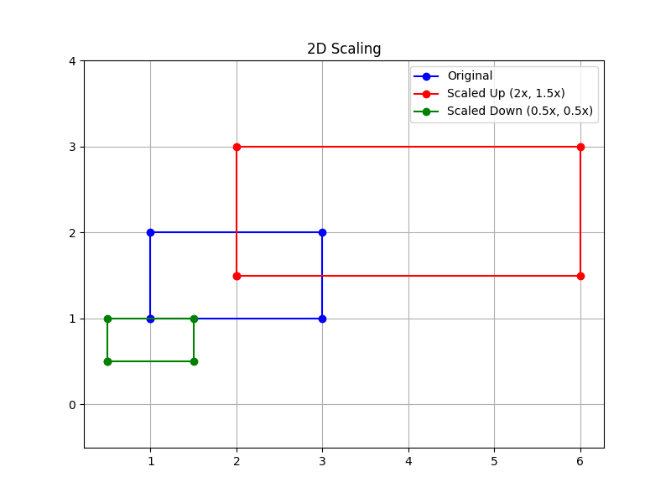
OUTPUT:

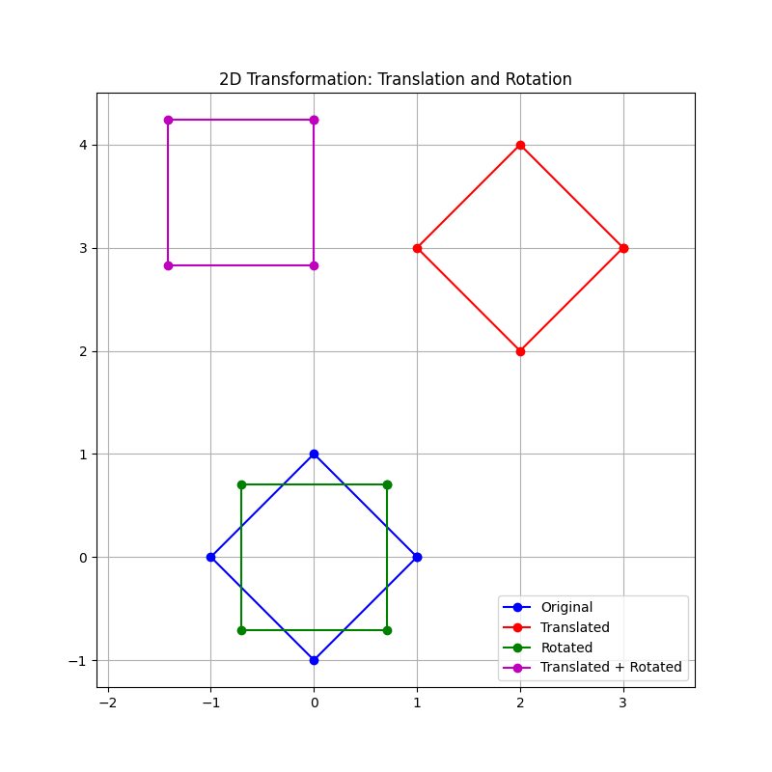

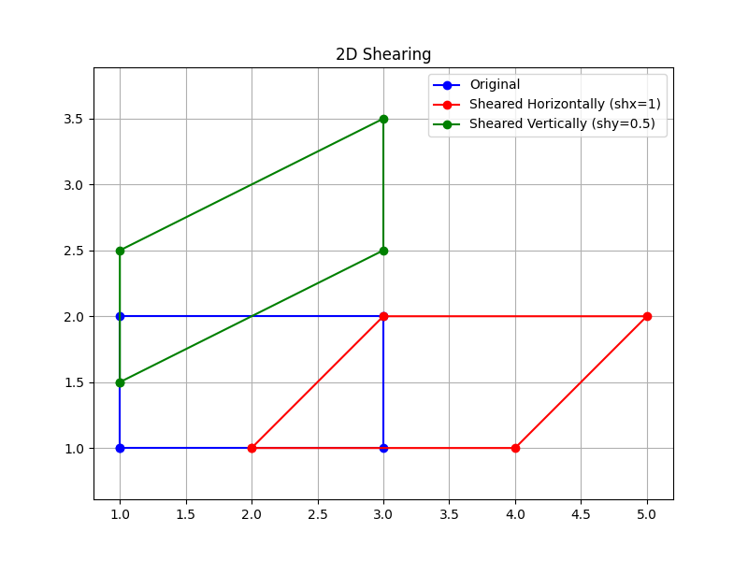

Experiment 6: To implement Cohen–Sutherland 2D clipping and window–viewport mapping
Program Code (Python):
import matplotlib.pyplot as plt
# Region codes
INSIDE, LEFT, RIGHT, BOTTOM, TOP = 0, 1, 2, 4, 8
# Function to compute region code
def compute_code(x, y, x_min, y_min, x_max, y_max):
code = INSIDE
if x < x_min: # to the left
code |= LEFT
elif x > x_max: # to the right
code |= RIGHT
if y < y_min: # below
code |= BOTTOM
elif y > y_max: # above
code |= TOP
return code
# Cohen–Sutherland Line Clipping Algorithm
def cohen_sutherland_clip(x1, y1, x2, y2, x_min, y_min, x_max, y_max):
code1 = compute_code(x1, y1, x_min, y_min, x_max, y_max)
code2 = compute_code(x2, y2, x_min, y_min, x_max, y_max)
accept = False
while True:
if code1 == 0 and code2 == 0: # Trivially accepted
accept = True
break
elif (code1 & code2) != 0: # Trivially rejected
break
else: # Needs clipping
if code1 != 0:
code_out = code1
else:
code_out = code2

if code_out & TOP:
x = x1 + (x2 - x1) * (y_max - y1) / (y2 - y1)
y = y_max
elif code_out & BOTTOM:
x = x1 + (x2 - x1) * (y_min - y1) / (y2 - y1)
y = y_min
elif code_out & RIGHT:
y = y1 + (y2 - y1) * (x_max - x1) / (x2 - x1)
x = x_max
elif code_out & LEFT:
y = y1 + (y2 - y1) * (x_min - x1) / (x2 - x1)
x = x_min

if code_out == code1:
x1, y1 = x, y
code1 = compute_code(x1, y1, x_min, y_min, x_max, y_max)
else:
x2, y2 = x, y
code2 = compute_code(x2, y2, x_min, y_min, x_max, y_max)

if accept:
return (x1, y1, x2, y2)
else:
return None
# Window to viewport mapping
def window_to_viewport(x, y, xw_min, yw_min, xw_max, yw_max, xv_min, yv_min, xv_max, yv_max):
sx = (xv_max - xv_min) / (xw_max - xw_min)
sy = (yv_max - yv_min) / (yw_max - yw_min)

xv = xv_min + (x - xw_min) * sx
yv = yv_min + (y - yw_min) * sy
return xv, yv
# Example: window and viewport
xw_min, yw_min, xw_max, yw_max = 10, 10, 200, 200 # clipping window
xv_min, yv_min, xv_max, yv_max = 300, 300, 500, 500 # viewport
# Original line
x1, y1, x2, y2 = 50, 50, 250, 250
# Perform clipping
clipped_line = cohen_sutherland_clip(x1, y1, x2, y2, xw_min, yw_min, xw_max, yw_max)

plt.figure(figsize=(8,8))
plt.title("Cohen–Sutherland Line Clipping & Window-Viewport Mapping")
plt.axis("equal")
plt.grid(True)
# Draw clipping window
plt.plot([xw_min, xw_max, xw_max, xw_min, xw_min],
[yw_min, yw_min, yw_max, yw_max, yw_min],
'k-', label="Clipping Window")
# Original line
plt.plot([x1, x2], [y1, y2], 'r--', label="Original Line")
# Clipped line inside window
if clipped_line:
cx1, cy1, cx2, cy2 = clipped_line
plt.plot([cx1, cx2], [cy1, cy2], 'g-', linewidth=2, label="Clipped Line")

# Map clipped line to viewport
vx1, vy1 = window_to_viewport(cx1, cy1, xw_min, yw_min, xw_max, yw_max, xv_min, yv_min, xv_max, yv_max)
vx2, vy2 = window_to_viewport(cx2, cy2, xw_min, yw_min, xw_max, yw_max, xv_min, yv_min, xv_max, yv_max)
# Draw viewport
plt.plot([xv_min, xv_max, xv_max, xv_min, xv_min],
[yv_min, yv_min, yv_max, yv_max, yv_min],
'b-', label="Viewport")
# Line in viewport
plt.plot([vx1, vx2], [vy1, vy2], 'm-', linewidth=2, label="Line in Viewport")

plt.legend()
plt.show()

Output:

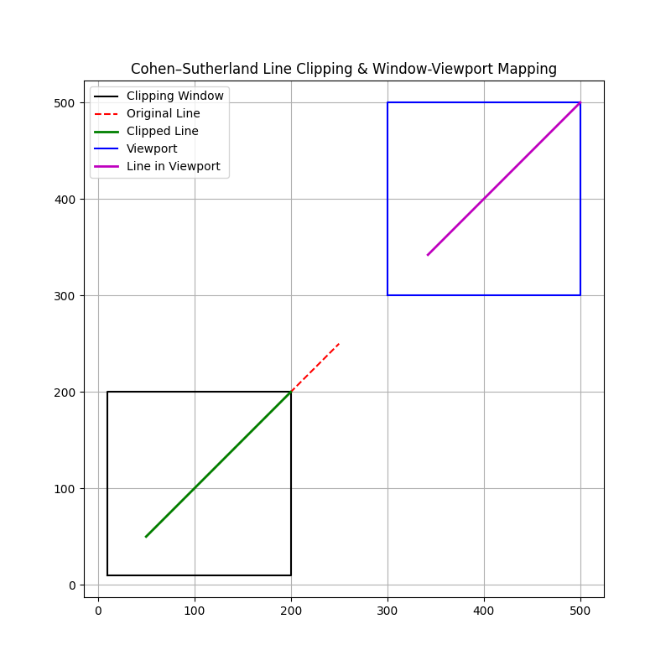

Experiment 7: To implement Liang Barsky line clipping algorithm
Program Code (Python):
import matplotlib.pyplot as plt
def liang_barsky(x1, y1, x2, y2, x_min, y_min, x_max, y_max):
dx = x2 - x1
dy = y2 - y1
p = [-dx, dx, -dy, dy]
q = [x1 - x_min, x_max - x1, y1 - y_min, y_max - y1]
u1, u2 = 0.0, 1.0
for i in range(4):
if p[i] == 0: # Line is parallel
if q[i] < 0:
return None # Line is outside
else:
u = q[i] / p[i]
if p[i] < 0:
u1 = max(u1, u) # entering
else:
u2 = min(u2, u) # leaving

if u1 > u2:
return None
cx1 = x1 + u1 * dx
cy1 = y1 + u1 * dy
cx2 = x1 + u2 * dx
cy2 = y1 + u2 * dy
return (cx1, cy1, cx2, cy2)
# Example: clipping window
x_min, y_min, x_max, y_max = 50, 50, 200, 200
# Line to be clipped
x1, y1, x2, y2 = 30, 120, 220, 180

# Perform Liang–Barsky clipping
clipped_line = liang_barsky(x1, y1, x2, y2, x_min, y_min, x_max, y_max)

plt.figure(figsize=(8,8))
plt.title("Liang–Barsky Line Clipping Algorithm")
plt.axis("equal")
plt.grid(True)
# Draw clipping window
plt.plot([x_min, x_max, x_max, x_min, x_min],
[y_min, y_min, y_max, y_max, y_min],
'k-', label="Clipping Window")
# Draw original line
plt.plot([x1, x2], [y1, y2], 'r--', label="Original Line")
# Draw clipped line
if clipped_line:
cx1, cy1, cx2, cy2 = clipped_line
plt.plot([cx1, cx2], [cy1, cy2], 'g-', linewidth=2, label="Clipped Line")
plt.legend()
plt.show()

Output:
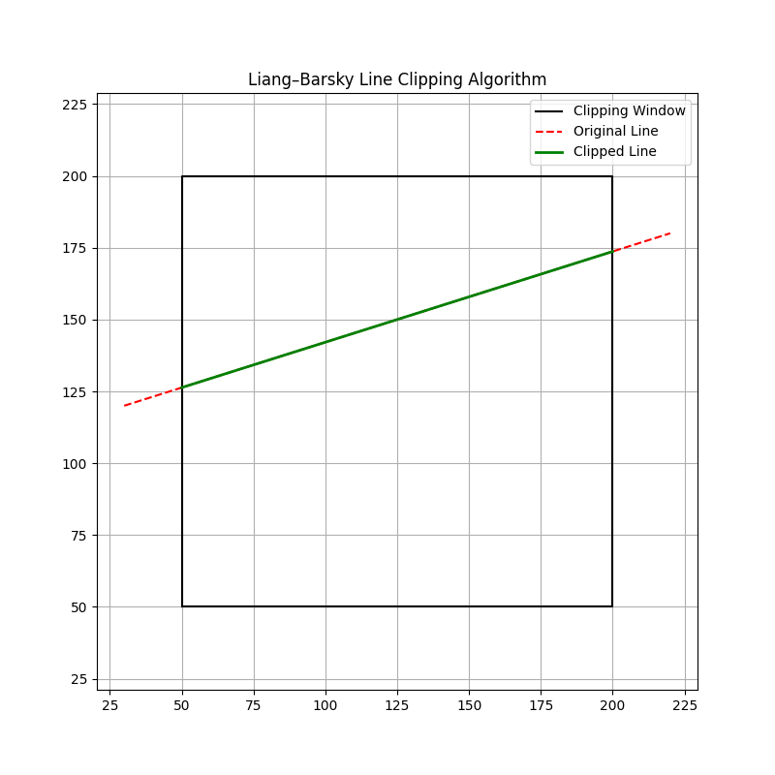

Experiment 8: To perform 3D Transformations such as translation, rotation and scaling
Program Code (Python):Rotation
import numpy as np
import matplotlib.pyplot as plt
from mpl_toolkits.mplot3d import Axes3D # for 3D plotting

def rotate_3d_z(points, theta):
"""
Rotate 3D points around Z-axis by angle theta (radians).

points: numpy array of shape (n_points, 3)
theta: rotation angle in radians
"""
rotation_matrix = np.array([
[np.cos(theta), -np.sin(theta), 0],
[np.sin(theta), np.cos(theta), 0],
[0, 0, 1]
])
return points.dot(rotation_matrix.T)

# Cube corner points
points = np.array([
[0, 0, 0],
[1, 0, 0],
[1, 1, 0],
[0, 1, 0],
[0, 0, 1],
[1, 0, 1],
[1, 1, 1],
[0, 1, 1]
])

# Rotate cube 45 degrees around Z-axis
theta = np.pi / 4 # 45 degrees in radians
rotated_points = rotate_3d_z(points, theta)

# Plotting
fig = plt.figure(figsize=(10, 8))
ax = fig.add_subplot(111, projection='3d')

# Function to draw cube edges
def draw_cube(ax, pts, color, label):
edges = [
(0,1),(1,2),(2,3),(3,0), # bottom face
(4,5),(5,6),(6,7),(7,4), # top face
(0,4),(1,5),(2,6),(3,7) # vertical edges
]
for edge in edges:
p1, p2 = pts[edge[0]], pts[edge[1]]
ax.plot([p1[0], p2[0]], [p1[1], p2[1]], [p1[2], p2[2]], color=color)
ax.scatter(pts[:,0], pts[:,1], pts[:,2], color=color, label=label)

# Draw original and rotated cubes
draw_cube(ax, points, 'blue', 'Original Cube')
draw_cube(ax, rotated_points, 'red', 'Rotated Cube')

ax.set_xlabel('X')
ax.set_ylabel('Y')
ax.set_zlabel('Z')
ax.set_title('3D Rotation around Z-axis')
ax.legend()
plt.show()

Program Code (Python):translation
import numpy as np
import matplotlib.pyplot as plt
from mpl_toolkits.mplot3d import Axes3D # needed for 3D plotting
def translate_3d(points, tx, ty, tz):
"""
Translate 3D points by (tx, ty, tz).
points: numpy array of shape (n_points, 3)
tx, ty, tz: translation distances
"""
translation_vector = np.array([tx, ty, tz])
return points + translation_vector
# Original 3D points (a cube corners)
points = np.array([
[0, 0, 0],
[1, 0, 0],
[1, 1, 0],
[0, 1, 0],
[0, 0, 1],
[1, 0, 1],
[1, 1, 1],
[0, 1, 1]
])
# Translate by (2, 3, 4)
translated_points = translate_3d(points, tx=2, ty=3, tz=4)
# Plotting
fig = plt.figure(figsize=(10, 8))
ax = fig.add_subplot(111, projection='3d')
# Plot original points
ax.scatter(points[:, 0], points[:, 1], points[:, 2], color='blue', label='Original Points')

# Plot translated points
ax.scatter(translated_points[:, 0], translated_points[:, 1], translated_points[:, 2], color='red', label='Translated Points')

# Optionally connect points to form cube edges
def draw_cube(ax, pts, color):
edges = [
(0,1),(1,2),(2,3),(3,0), # bottom face
(4,5),(5,6),(6,7),(7,4), # top face
(0,4),(1,5),(2,6),(3,7) # vertical edges
]
for edge in edges:
p1, p2 = pts[edge[0]], pts[edge[1]]
ax.plot([p1[0], p2[0]], [p1[1], p2[1]], [p1[2], p2[2]], color=color)

draw_cube(ax, points, 'blue')
draw_cube(ax, translated_points, 'red')

ax.legend()
ax.set_xlabel('X')
ax.set_ylabel('Y')
ax.set_zlabel('Z')
ax.set_title('3D Translation')

plt.show()

Program Code (Python): Shearing
import numpy as np
import matplotlib.pyplot as plt

def shear_3d(points, shxy=0, shxz=0, shyx=0, shyz=0, shzx=0, shzy=0):
"""
Shear 3D points with given shear factors.

Parameters:
- shxy: shear of x relative to y
- shxz: shear of x relative to z
- shyx: shear of y relative to x
- shyz: shear of y relative to z
- shzx: shear of z relative to x
- shzy: shear of z relative to y
"""
shear_matrix = np.array([
[1, shxy, shxz],
[shyx, 1, shyz],
[shzx, shzy, 1 ]
])
return points.dot(shear_matrix.T)

# Cube corner points
points = np.array([
[0, 0, 0],
[1, 0, 0],
[1, 1, 0],
[0, 1, 0],
[0, 0, 1],
[1, 0, 1],
[1, 1, 1],
[0, 1, 1]
])

# Apply 3D shearing: example shear factors
sheared_points = shear_3d(points, shxy=1.0, shyz=0.5, shzx=0.2)

# Plotting
fig = plt.figure(figsize=(10, 8))
ax = fig.add_subplot(111, projection='3d')

def draw_cube(ax, pts, color, label):
edges = [
(0,1),(1,2),(2,3),(3,0), # bottom face
(4,5),(5,6),(6,7),(7,4), # top face
(0,4),(1,5),(2,6),(3,7) # vertical edges
]
for edge in edges:
p1, p2 = pts[edge[0]], pts[edge[1]]
ax.plot([p1[0], p2[0]], [p1[1], p2[1]], [p1[2], p2[2]], color=color)
ax.scatter(pts[:,0], pts[:,1], pts[:,2], color=color, label=label)

# Draw original and sheared cubes
draw_cube(ax, points, 'blue', 'Original Cube')
draw_cube(ax, sheared_points, 'red', 'Sheared Cube')

ax.set_xlabel('X')
ax.set_ylabel('Y')
ax.set_zlabel('Z')
ax.set_title('3D Shearing')
ax.legend()
plt.show()

Program Code (Python): Scaling
import numpy as np
import matplotlib.pyplot as plt

def scale_3d(points, sx, sy, sz):
"""
Scale 3D points by sx, sy, sz along each axis.

points: numpy array of shape (n_points, 3)
sx, sy, sz: scaling factors
"""
scaling_matrix = np.array([
[sx, 0, 0],
[0, sy, 0],
[0, 0, sz]
])
return points.dot(scaling_matrix.T)

# Cube corner points
points = np.array([
[0, 0, 0],
[1, 0, 0],
[1, 1, 0],
[0, 1, 0],
[0, 0, 1],
[1, 0, 1],
[1, 1, 1],
[0, 1, 1]
])

# Scale factors (e.g., double x, half y, triple z)
scaled_points = scale_3d(points, sx=2, sy=0.5, sz=3)

# Plotting
fig = plt.figure(figsize=(10, 8))
ax = fig.add_subplot(111, projection='3d')

def draw_cube(ax, pts, color, label):
edges = [
(0,1),(1,2),(2,3),(3,0), # bottom face
(4,5),(5,6),(6,7),(7,4), # top face
(0,4),(1,5),(2,6),(3,7) # vertical edges
]
for edge in edges:
p1, p2 = pts[edge[0]], pts[edge[1]]
ax.plot([p1[0], p2[0]], [p1[1], p2[1]], [p1[2], p2[2]], color=color)
ax.scatter(pts[:,0], pts[:,1], pts[:,2], color=color, label=label)

# Draw original and scaled cubes
draw_cube(ax, points, 'blue', 'Original Cube')
draw_cube(ax, scaled_points, 'red', 'Scaled Cube')

ax.set_xlabel('X')
ax.set_ylabel('Y')
ax.set_zlabel('Z')
ax.set_title('3D Scaling')
ax.legend()
plt.show()

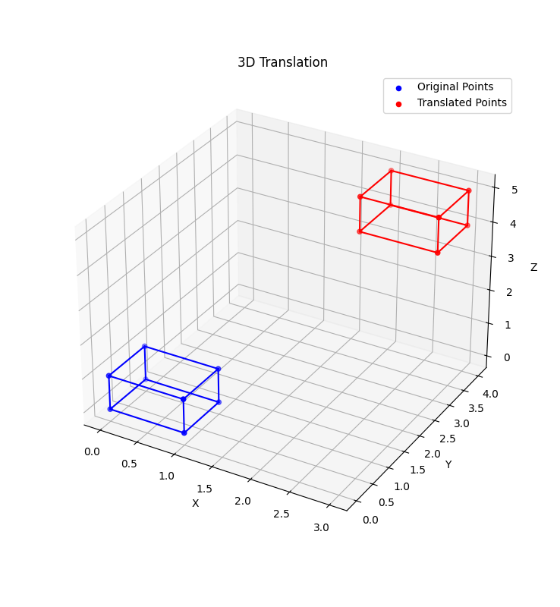
Output:

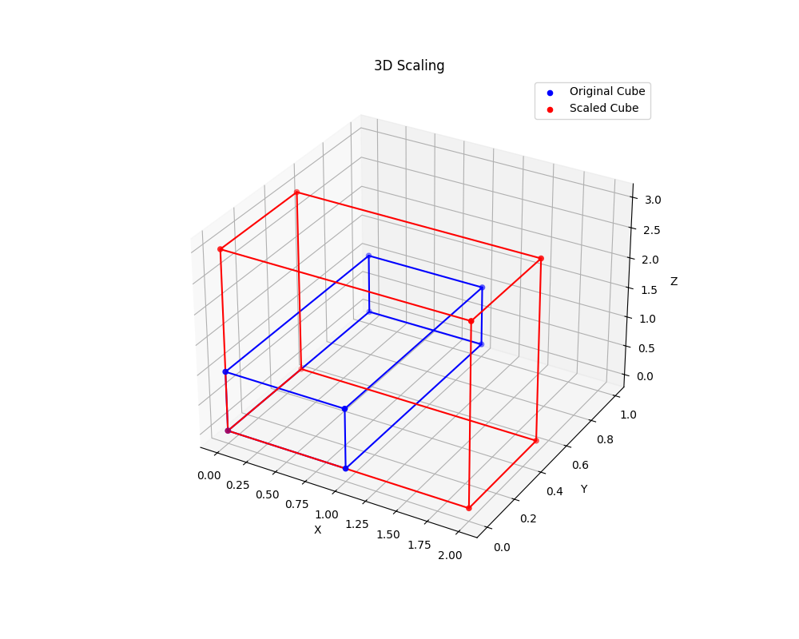

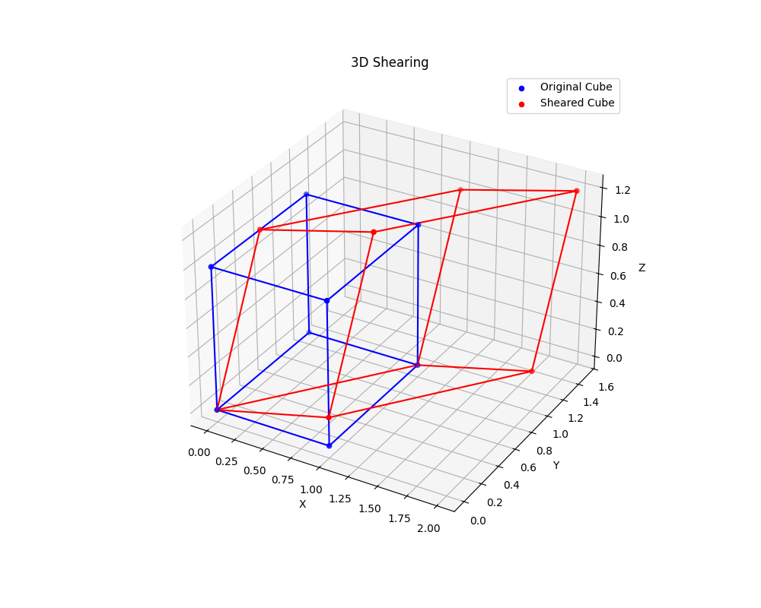

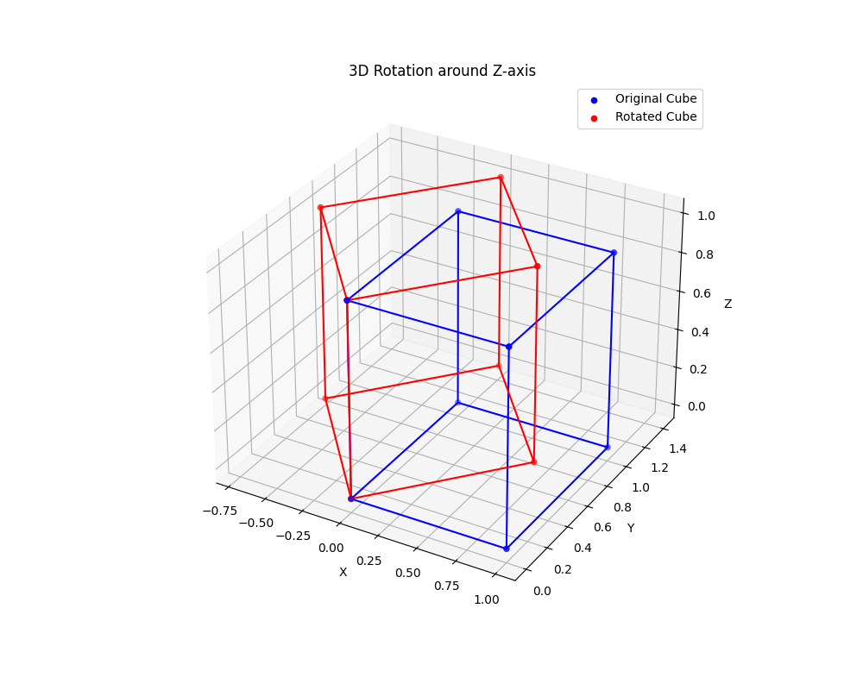

Experiment 9: To draw different shapes such as hut, face, kite, fish etc.
Program Code (Python):
import matplotlib.pyplot as plt
from matplotlib.patches import Rectangle, Circle, Polygon
from matplotlib.patches import Ellipse
fig, axes = plt.subplots(2, 2, figsize=(10, 10))
# ---- Hut ----
ax = axes[0, 0]
# base
ax.add_patch(Rectangle((0.3, 0.2), 0.4, 0.3, edgecolor='brown', facecolor='tan'))
# roof
ax.add_patch(Polygon([[0.25, 0.5], [0.75, 0.5], [0.5, 0.8]], edgecolor='maroon', facecolor='red'))
# door
ax.add_patch(Rectangle((0.45, 0.2), 0.1, 0.18, edgecolor='saddlebrown', facecolor='peru'))
ax.set_title("Hut")
ax.set_xlim(0, 1)
ax.set_ylim(0, 1)
ax.set_aspect('equal')
ax.axis('off')
# ---- Face ----
ax = axes[0, 1]
# face outer circle
ax.add_patch(Circle((0.5, 0.55), 0.3, edgecolor='black', facecolor='yellow'))
# eyes
ax.add_patch(Circle((0.4, 0.65), 0.05, edgecolor='black', facecolor='white'))
ax.add_patch(Circle((0.6, 0.65), 0.05, edgecolor='black', facecolor='white'))
# mouth
ax.add_patch(Polygon([[0.43, 0.45], [0.57, 0.45], [0.5, 0.4]], edgecolor='red', facecolor='red'))
ax.set_title("Face")
ax.set_xlim(0, 1)
ax.set_ylim(0, 1)
ax.set_aspect('equal')
ax.axis('off')
# ---- Kite ----
ax = axes[1, 0]
# kite body
ax.add_patch(Polygon([[0.5, 0.8], [0.7, 0.5], [0.5, 0.2], [0.3, 0.5]], edgecolor='blue', facecolor='cyan'))
# cross lines
ax.plot([0.5, 0.5], [0.8, 0.2], color='purple')
ax.plot([0.3, 0.7], [0.5, 0.5], color='purple')
# tail
ax.plot([0.5, 0.5], [0.2, 0.05], color='brown')
ax.set_title("Kite")
ax.set_xlim(0, 1)
ax.set_ylim(0, 1)
ax.set_aspect('equal')
ax.axis('off')
# ---- Fish ----
ax = axes[1, 1]
# body
ax.add_patch(Ellipse((0.5, 0.5), 0.4, 0.2, edgecolor='green', facecolor='lightgreen'))
# tail
ax.add_patch(Polygon([[0.3, 0.5], [0.2, 0.6], [0.2, 0.4]], edgecolor='teal', facecolor='teal'))
# eye
ax.add_patch(Circle((0.65, 0.55), 0.025, edgecolor='black', facecolor='white'))
ax.set_title("Fish")
ax.set_xlim(0, 1)
ax.set_ylim(0, 1)
ax.set_aspect('equal')
ax.axis('off')
plt.tight_layout()
plt.show()

Output:

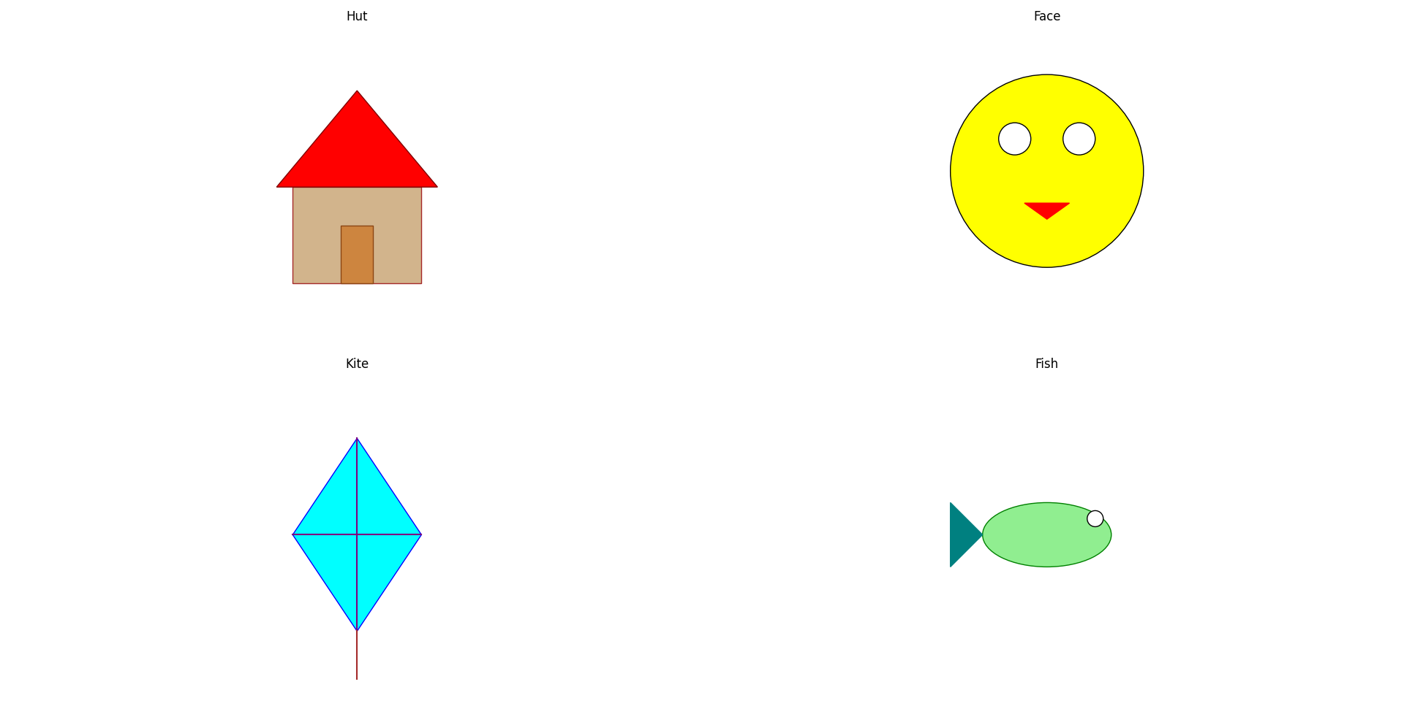

Experiment 10: To produce animation effect of triangle transform into square and then circle
Program Code (Python):
import turtle
import math
import time

# Setup turtle screen
screen = turtle.Screen()
screen.title("Triangle to Square to Circle Animation")
screen.bgcolor("white")
screen.setup(width=600, height=600)

# Create the turtle pen
pen = turtle.Turtle()
pen.speed(10) # Set drawing speed to fastest
pen.pensize(3) # Set pen thickness
pen.color("blue") # Pen color
pen.hideturtle() # Hide the turtle cursor

def draw_shape(points):
"""
Draws a closed shape connecting all points in the list.
"""
pen.clear() # Clear previous drawing
pen.penup() # Lift pen to move without drawing
pen.goto(points[0]) # Move to the first point
pen.pendown() # Put pen down to start drawing

# Draw lines to each subsequent point
for pt in points[1:]:
pen.goto(pt)

pen.goto(points[0]) # Close the shape by returning to the first point

def interpolate_points(points_start, points_end, t):
"""
Linearly interpolates between two lists of points.
t is interpolation parameter between 0 and 1.
Returns a new list of interpolated points.
"""
return [((1 - t) * sx + t * ex, (1 - t) * sy + t * ey)
for (sx, sy), (ex, ey) in zip(points_start, points_end)]

def morph_points(points_start, points_end, steps=60):
"""
Morphs shape from points_start to points_end over a number of steps.
For each step, interpolates the points and redraws the shape.
"""
for i in range(steps + 1):
t = i / steps # interpolation fraction from 0 to 1
points = interpolate_points(points_start, points_end, t) # get intermediate points
draw_shape(points) # draw the intermediate shape
screen.update() # update the screen with new drawing
time.sleep(0.034) # pause to create animation effect

def duplicate_points(points, target_len):
"""
Given a list of points, returns a new list with target_len points.
This is done by interpolating points along the perimeter to match the desired length.
This is useful to have same number of points for morphing.
"""
n = len(points) # original number of points
result = []

for i in range(target_len):
# Map i to position along the points perimeter (fractional index)
pos = i * n / target_len

# Index of current segment start point
j = int(pos) % n

# Index of next point (wrap around)
next_j = (j + 1) % n

# Fractional distance between points[j] and points[next_j]
frac = pos - j

# Linear interpolation between points[j] and points[next_j]
x = (1 - frac) * points[j][0] + frac * points[next_j][0]
y = (1 - frac) * points[j][1] + frac * points[next_j][1]

result.append((x, y))
return result

def main():
turtle.tracer(0, 0) # Turn off automatic screen updates for smoother animation

# Define triangle points (equilateral triangle)
tri_size = 200
tri_pts = [
(0, tri_size / math.sqrt(3)), # Top vertex
(-tri_size/2, -tri_size / (2*math.sqrt(3))), # Bottom-left vertex
(tri_size/2, -tri_size / (2*math.sqrt(3))) # Bottom-right vertex
]

# Define square points (4 vertices)
sq_size = 200
square_pts = [
(-sq_size/2, sq_size/2), # Top-left
(-sq_size/2, -sq_size/2), # Bottom-left
(sq_size/2, -sq_size/2), # Bottom-right
(sq_size/2, sq_size/2) # Top-right
]

# Define circle points - 60 points around a circle
circle_points_count = 60
r = sq_size / 2
circle_pts = []
for i in range(circle_points_count):
angle = 2 * math.pi * i / circle_points_count
x = r * math.cos(angle)
y = r * math.sin(angle)
circle_pts.append((x, y))

# Duplicate last point of triangle to match square's 4 points
tri_pts_dup = tri_pts + [tri_pts[-1]]

# Morph from triangle to square
morph_points(tri_pts_dup, square_pts, steps=60)
time.sleep(2) # Pause before next morph

# Duplicate square points to match circle points count (60 points)
square_pts_dup = duplicate_points(square_pts, circle_points_count)

# Morph from square to circle
morph_points(square_pts_dup, circle_pts, steps=80)
time.sleep(1) # Pause at final circle shape

# Draw final circle shape
draw_shape(circle_pts)
screen.update()

turtle.done() # Wait for user to close window

if __name__ == "__main__":
main()

Output:
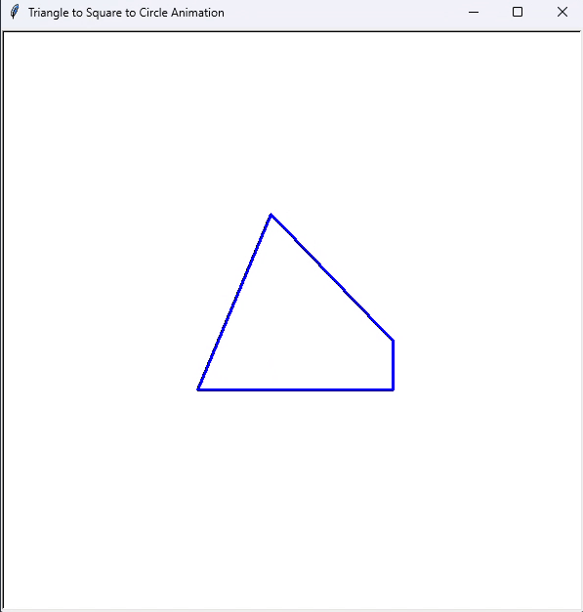
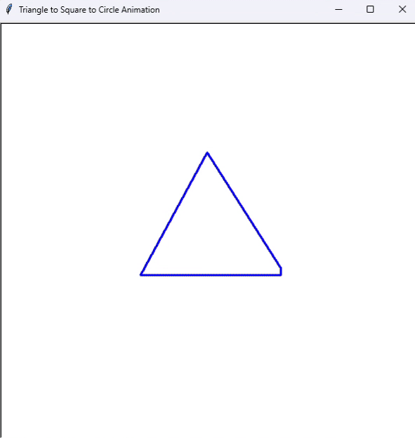

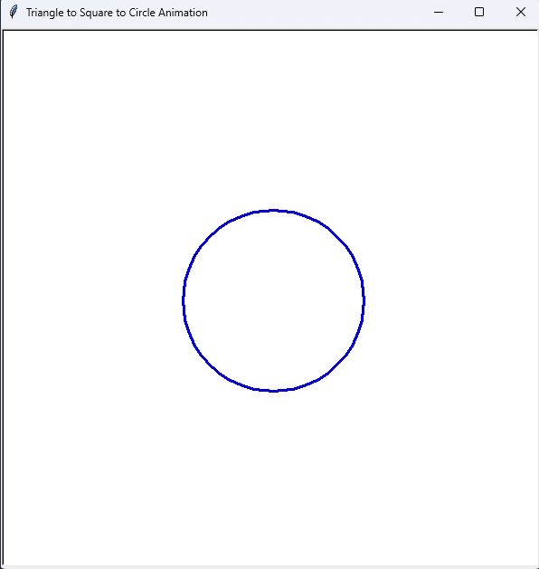
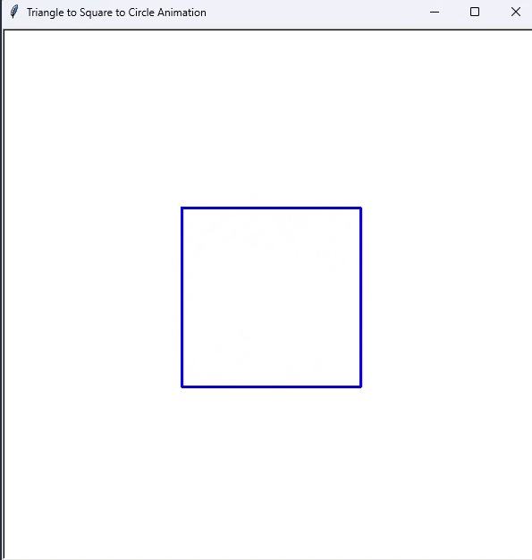

Experiment 12: Create an animation of an arrow embedded into a circle revolving around its center
Program Code (Python):
import pygame
import math
import sys

pygame.init()

# Window dimensions
W, H = 600, 600
screen = pygame.display.set_mode((W, H))
clock = pygame.time.Clock()

center = (W // 2, H // 2)
radius = 150
angle = 0

def draw_arrow(surf, c, pos, ang, length=120, width=10):
"""
Draw an arrow on surface 'surf' with color 'c', starting at 'pos',
pointing in direction 'ang' (radians), with specified length and width.
"""
end = (pos[0] + length * math.cos(ang), pos[1] + length * math.sin(ang))
pygame.draw.line(surf, c, pos, end, width // 2)

hl, hw = width * 3, width * 2

left = (end[0] - hl * math.cos(ang) + hw * math.sin(ang) / 2,
end[1] - hl * math.sin(ang) - hw * math.cos(ang) / 2)

right = (end[0] - hl * math.cos(ang) - hw * math.sin(ang) / 2,
end[1] - hl * math.sin(ang) + hw * math.cos(ang) / 2)

pygame.draw.polygon(surf, c, [end, left, right])

while True:
for e in pygame.event.get():
if e.type == pygame.QUIT:
pygame.quit()
sys.exit()

screen.fill((255, 255, 255))
pygame.draw.circle(screen, (0, 0, 0), center, radius, 3)

# Calculate arrow start position on circle edge
arrow_start = (center[0] + radius * math.cos(angle), center[1] + radius * math.sin(angle))

# Draw arrow pointing inward toward center
draw_arrow(screen, (220, 50, 50), arrow_start, angle + math.pi)

angle = (angle + 0.02) % (2 * math.pi)

pygame.display.flip()
clock.tick(60)

Output:

