Implement of different Network Topologies. Locating different interfaces, routers and switches. Studying different pools of IP addresses.

Star Topology
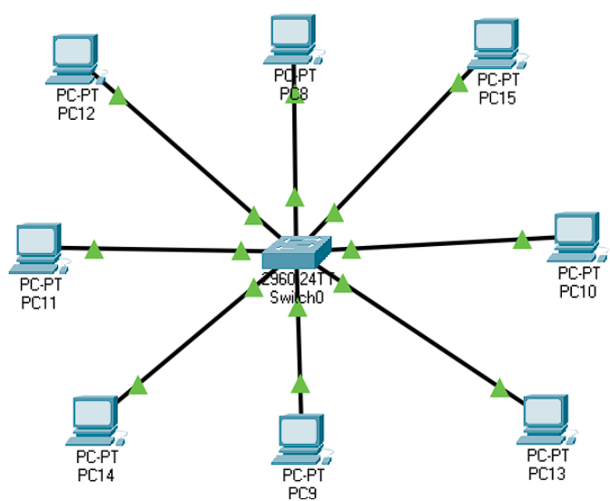
In a star topology, every device connects individually to a central hub using its own dedicated cable. This central hub acts as the main node, linking all devices together. The hub may be passive, simply relaying signals like a basic broadcasting unit, or active, with built-in repeaters to boost signal strength. Commonly, coaxial or RJ-45 cables are utilized for these connections. Star topology networks typically use Ethernet LAN protocols that support features like collision detection and carrier sense multiple access (CSMA) for efficient communication
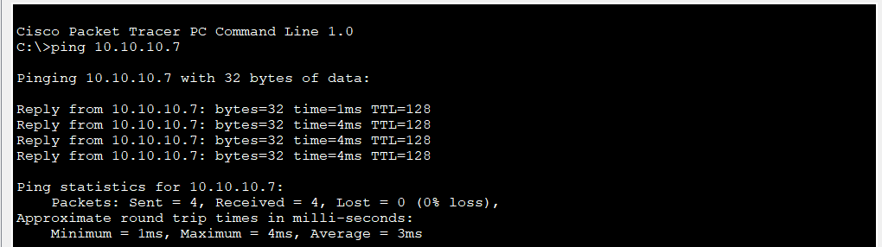

Bus Topology
In a bus topology, all computers and network devices are connected along a single communication line or backbone, forming one continuous cable that carries signals in both directions. This setup allows multiple devices to share the same transmission medium, but it has a major drawback: if the central cable experiences a failure, the entire network is disrupted. Bus networks are considered multipoint connections, where each device taps into the main cable. Several Media Access Control (MAC) methods used in this topology include techniques like TDMA (Time Division Multiple Access), CDMA (Code Division Multiple Access), and Pure Aloha, which help control access and manage potential data collisions within the network.

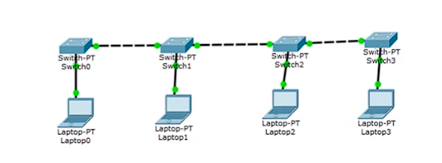

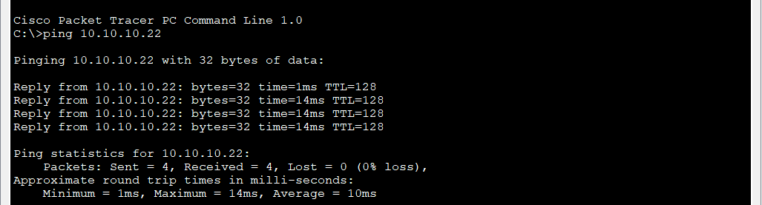

Ring Topology
In a ring topology, each device is linked to exactly two other devices, creating a closed loop that resembles a ring. When the network contains many devices, repeaters are often installed to boost signals as data may need to travel through several nodes—such as crossing 99 devices to reach the 100th. This helps prevent signal degradation or data loss.Computer_Networks_File.pdf
Data transmission in basic ring topologies is usually unidirectional, flowing in a single direction around the ring. However, the system can be upgraded to dual ring topology by connecting each device to its neighbors in both directions, enhancing redundancy and fault tolerance. The token passing method is the main access technique, where a special data packet, called a token, circulates the network. Only the device possessing the token is allowed to send data, minimizing the chance of packet collisions.Computer_Networks_File.pdf
Working Principles
- A designated station acts as the monitor, overseeing management tasks and error control.
- To send data, a station must first acquire the token; once the transmission is complete, the token is released so other stations can transmit.
- If no station is transmitting, the token continues to circulate along the ring.
- There are two ways to release the token: early token release (right after data is sent) and delayed token release (after receiving acknowledgment from the recipient)

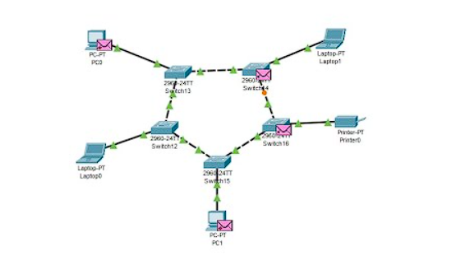

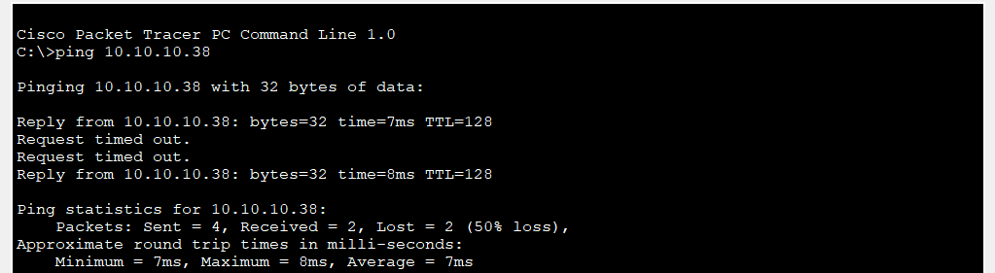

Mesh Topology
In a mesh topology, every device is connected to another device via a particular channel. Every device is connected to another via dedicated channels. These channels are known as links. In Mesh Topology, the protocols used are AHCP (Ad Hoc Configuration Protocols), DHCP (Dynamic Host Configuration Protocol).Suppose, the N number of devices are connected with each other in a mesh topology, the total number of ports that are required by each device is N-1.The total number of ports required = N * (N-1).

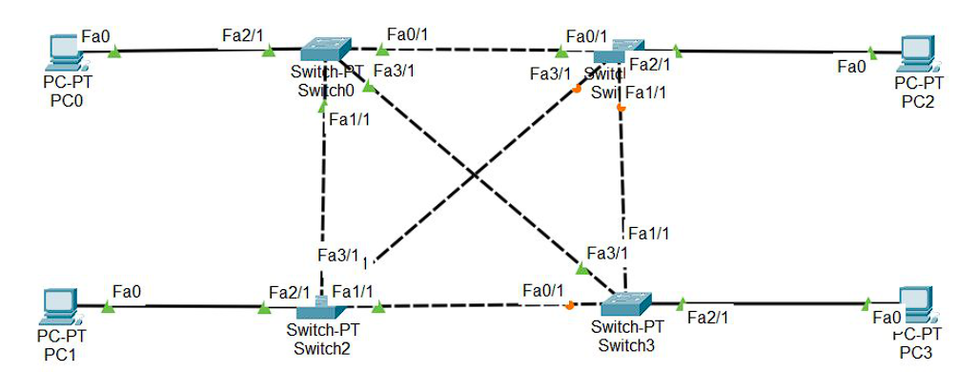

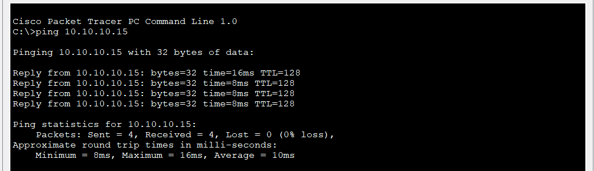

Hybrid Topology
Hybrid Topology is the combination of all the various types of topologies we have studied above. Hybrid Topology is used when the nodes are free to take any form. It means these can be individuals such as Ring or Star topology or can be a combination of various types of topologies seen above.
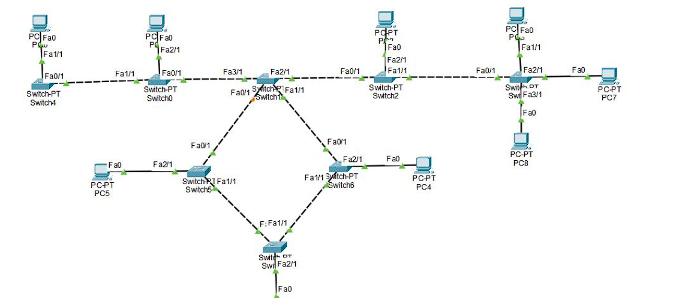

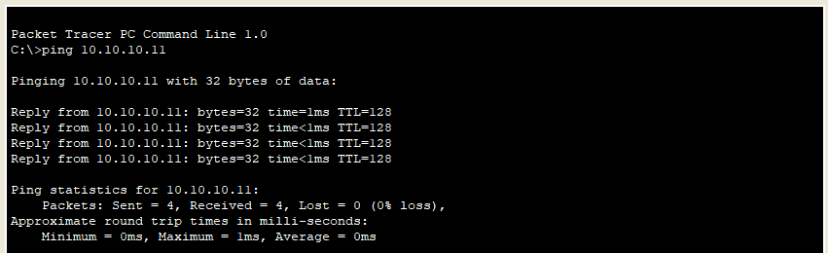

Network Commands

- IPCONFIG / IFCONFIG Command
  - Definition: ipconfig (Windows) and ifconfig (Linux) display and configure network interface details.
  - Working:
    - Shows IPv4/IPv6 address, subnet mask, and default gateway.
    - Provides information about MAC address and DHCP configuration.
    - Used to troubleshoot connectivity issues.
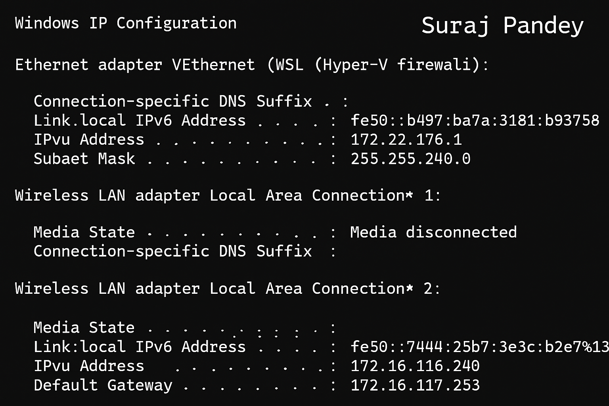

PING Command
  - Definition: PING (Packet Internet Groper) is used to check connectivity between two hosts.
  - Working: It uses ICMP Echo Request and Echo Reply messages to measure:
    - Whether the destination host is reachable
    - Round-trip time (latency)
    - Packet loss percentage

Example:
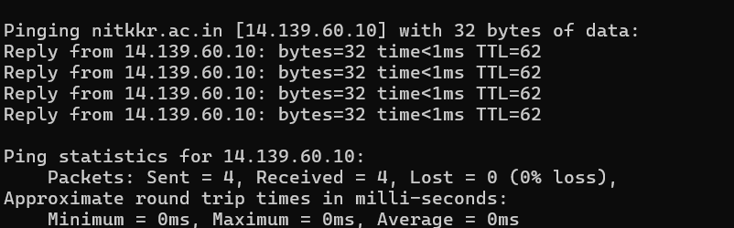

TRACEROUTE Command
  - Definition: TRACEROUTE is used to trace the path packets take from source to destination.
  - Working:
    - It sends packets with increasing TTL (Time-to-Live) values.
    - Each router along the path decreases TTL by 1 and sends back an ICMP message when TTL reaches zero.
    - This way, all routers in the path can be identified.

Example:

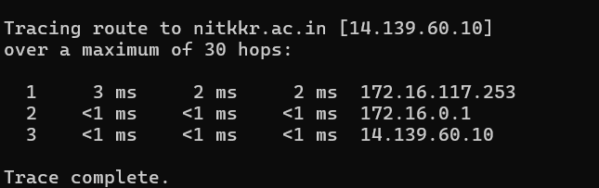

NETSTAT Command
  - Definition: NETSTAT (Network Statistics) displays active connections, routing tables, listening ports, and interface statistics.
  - Working:
    - Helps administrators check open ports and running services.
    - Can be used to detect suspicious connections.
    - Displays TCP/UDP statistics and process IDs.

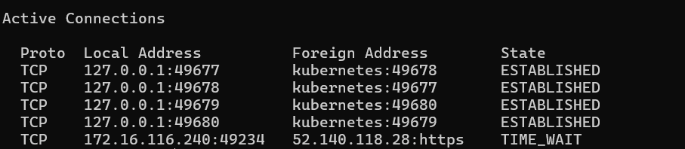

TELNET Command
  - Definition:
TELNET (Teletype Network) is a protocol used for remotely logging into another computer or network device over a network connection, enabling users to interact with the remote device as if they were directly connected via a terminal.
  - How It Works:
      - TELNET typically operates over port 23 on the target machine and uses a client-server model where the client initiates the session and the server responds.
      - Once connected, users gain access to a command-line interface on the remote system, allowing for configuration, management, or troubleshooting tasks.
      - All communication with TELNET, including usernames and passwords, occurs in plain, unencrypted text—meaning data can be intercepted by eavesdroppers.
        - Because of this security risk, TELNET is not recommended for sensitive tasks or public networks and has largely been replaced by SSH (Secure Shell), which encrypts communication.
      - TELNET is still sometimes used to manage legacy systems, test network services, or verify if certain TCP ports are open on remote devices
  - Additional Points:
      - Easily allows remote device management but exposes major vulnerabilities due to its lack of encryption and authentication strength.
        - Mainly found today in specialized, isolated, or legacy environments where newer protocols are unsupported.
      - SSH should be preferred whenever security is required, as it protects credentials and data from interception

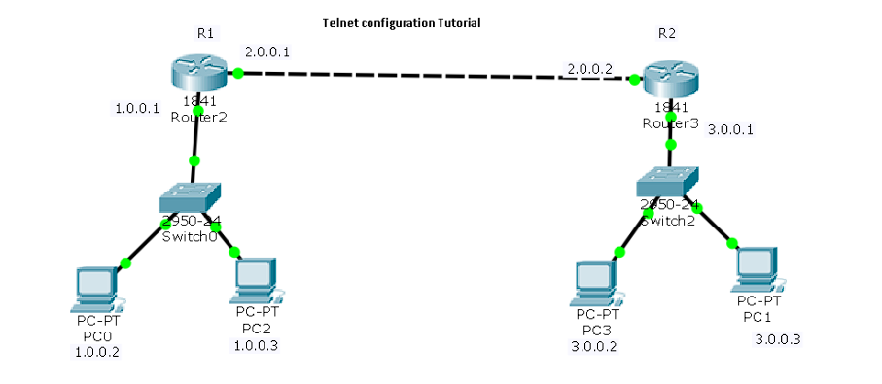

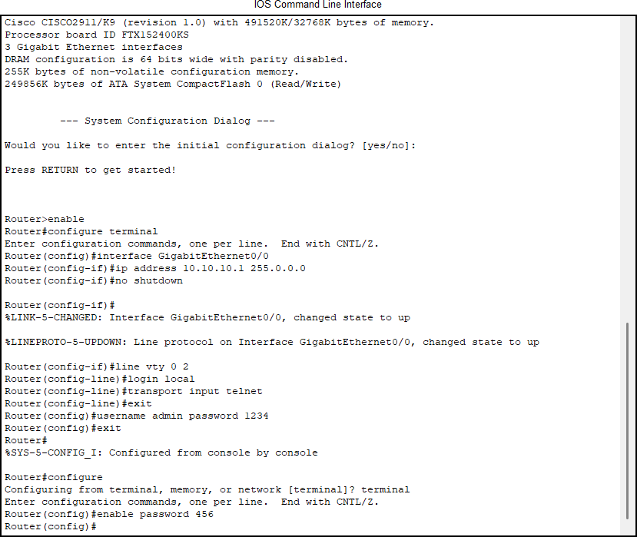

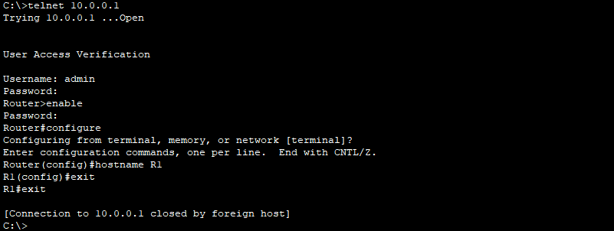

HTTP And FTP Protocol

HTTP (Hypertext Transfer Protocol)
HTTP (Hypertext Transfer Protocol) is a fundamental protocol used on the web to transfer various types of content such as web pages, images, videos, and other files between a client (usually a web browser) and a web server. It operates on a client-server model where the client sends requests and the server responds with the requested resources or error messages.
Key Features:
- Stateless Protocol: HTTP treats each request independently, without retaining any memory of previous interactions, making it scalable and simple. Sessions and state management are typically handled using cookies or other mechanisms outside the core protocol.
- Client-Server Model: The client initiates communication by sending requests, and the server processes those requests and returns a response, which might be the requested data or an error message.
Common HTTP Methods:
- GET: Retrieves data from the server without modifying it; commonly used to request web pages or files.
- HEAD: Similar to GET but only requests headers, useful for checking resource metadata without downloading the body.
- POST: Sends data to the server, often used for submitting forms, and can create or update server-side resources.
- PUT: Replaces an existing resource or creates one if it does not exist.
- DELETE: Removes a specified resource from the server.
- OPTIONS: Requests information about communication options supported by the server for a specific URL or the server itself.
Overall, HTTP facilitates efficient and flexible communication on the web, enabling the seamless exchange of content between clients and servers.

Analyzing HTTP Requests and Responses Using Wireshark
- Get Request
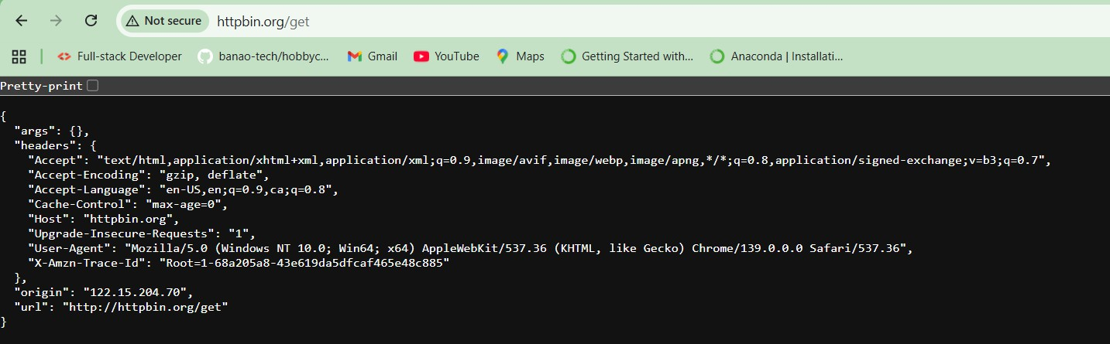

Captured HTTP GET request in Wireshark:
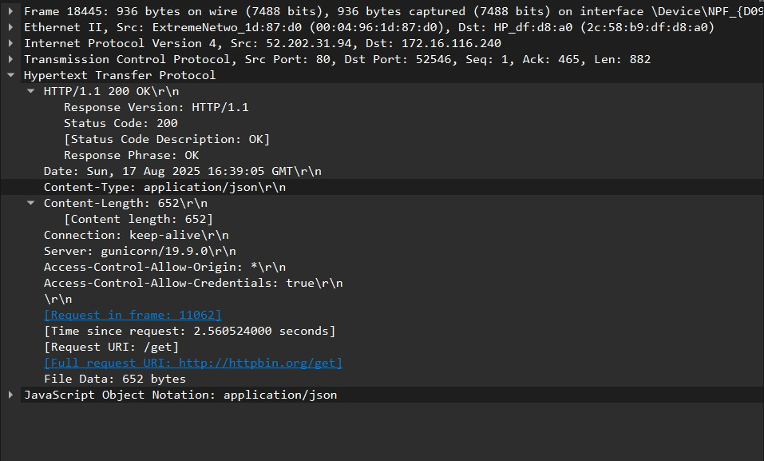

- Head Request
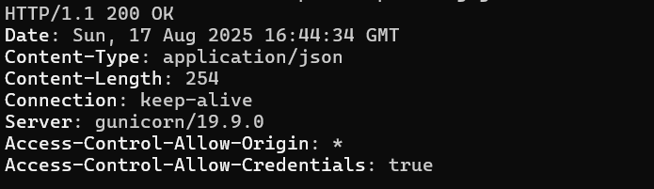

Captured HTTP Head request in Wireshark:
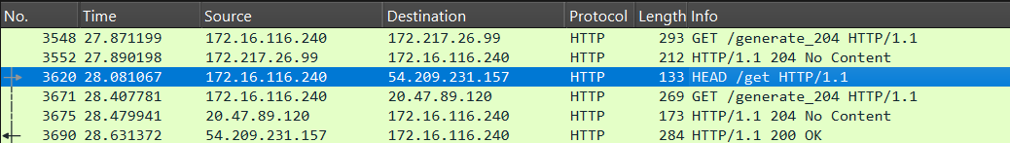

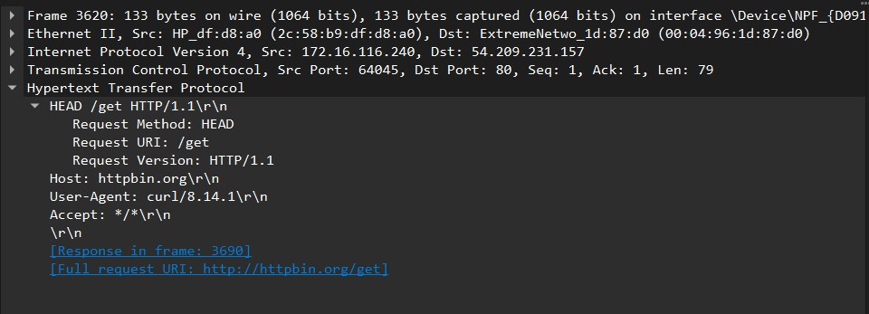

- Post Request
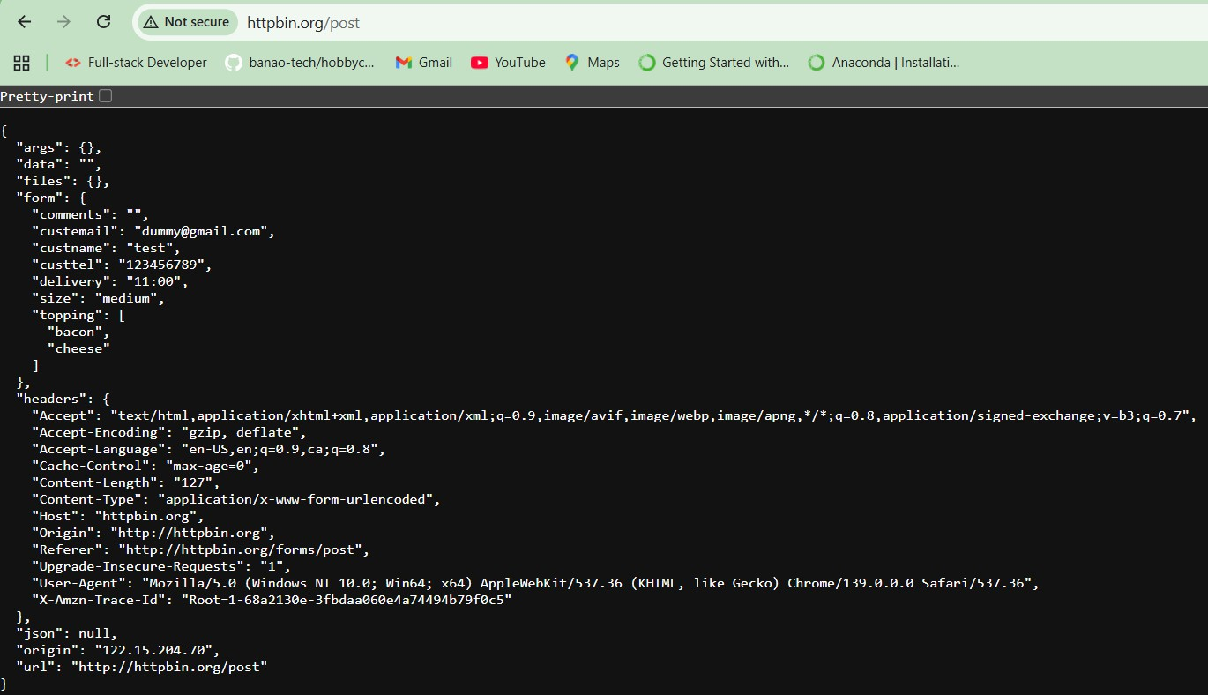
Captured HTTP POST request in Wireshark:

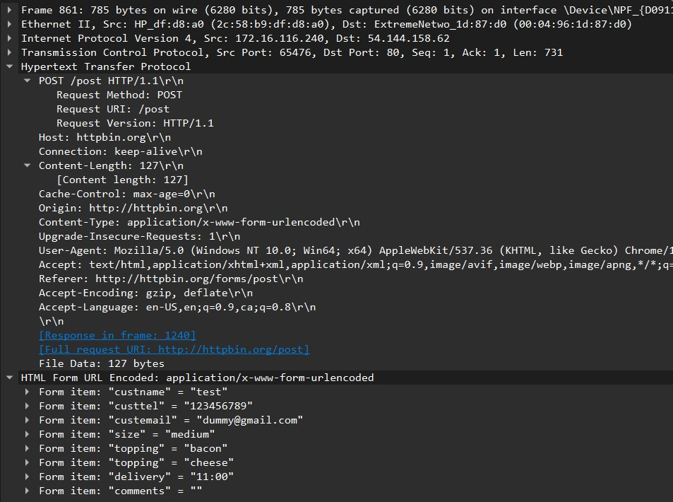

2.FTP (File Transfer Protocol)
FTP (File Transfer Protocol) is a widely used network protocol designed to transfer files between a client and a server over TCP/IP networks, including the Internet and private networks.
How FTP Operates:
- FTP functions on a client-server model: the client initiates communication to upload or download files, while the server manages and responds to these requests.
- FTP uses two distinct communication channels:
  - Command Channel (Port 21): This channel handles control information such as user authentication, directory navigation, and commands for file operations like uploading, downloading, renaming, or deleting files.
  - Data Channel (Port 20): This separate channel is specifically used for the actual transfer of file data between the client and server.
This separation allows FTP to manage commands and data transfers independently, resulting in efficient and organized file transmission. FTP supports both active and passive transfer modes to accommodate different network configurations, especially those with firewalls. Users usually authenticate with a username and password, but some servers allow anonymous access with limited permissions. FTP remains popular for managing large file transfers, website content updates, and remote file operations.

Analyzing FTP Requests and Responses Using Wireshark Setting up a temporary FTP server:
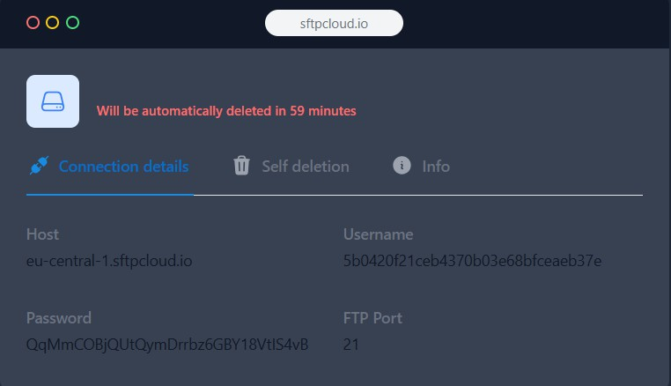

Connecting to FTP server:
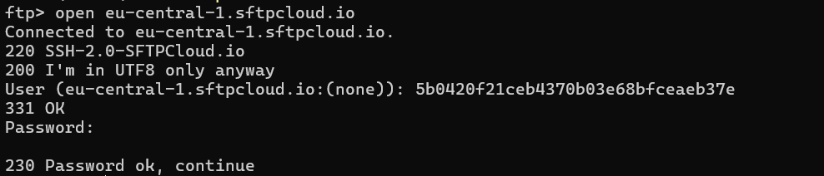

Uploading file to FTP server
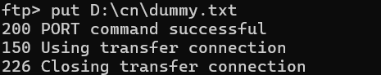

Listing files in FTP server
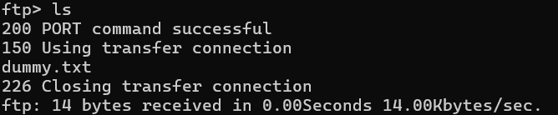
Downloading files from FTP server
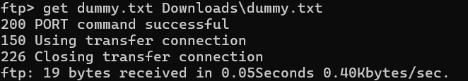

Closing connection to FTP server
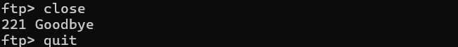

Captured FTP requests in Wireshark
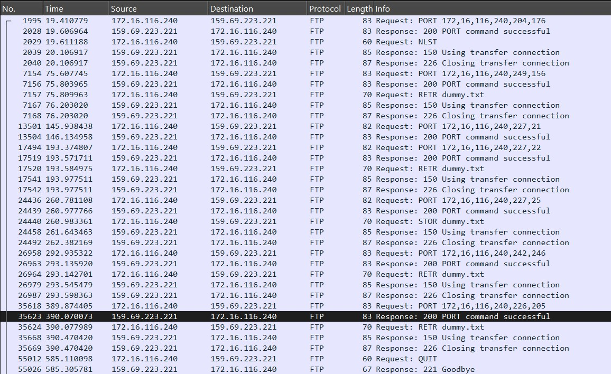

4.Working with client-server scenario. Observing the difference between UDP and TCP servers.
Client-server communication is a core concept in computer networking where a client requests services or data, and the server responds by providing the requested resources. This interaction typically takes place over transport layer protocols, mainly Transmission Control Protocol (TCP) and User Datagram Protocol (UDP), each with its distinct features and suitability for different applications.
This practical experiment aims to explore the behavioral distinctions between TCP and UDP within a simulated client-server setup using Cisco Packet Tracer. By examining how these protocols handle data transmission in a controlled network environment, one can better understand their strengths, weaknesses, and the scenarios where they are most effective. TCP offers reliable, ordered, and error-checked communication, making it ideal for applications requiring data integrity. In contrast, UDP provides faster, connectionless transmission with lower overhead, favored in time-sensitive uses where some data loss is acceptable, such as streaming or gaming. This comparison enhances comprehension of how protocol choice impacts network performance and application behavior.
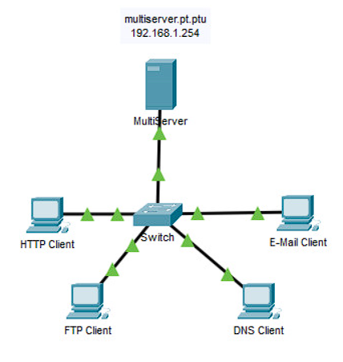

Understanding TCP and UDP
TCP (Transmission Control Protocol)
- Connection-oriented: Establishes a reliable connection before data transmission through a three-way handshake.
- Reliability: Ensures data packets are delivered correctly and in order; lost packets are retransmitted.
- Ordered delivery: Data arrives at the destination in the same sequence it was sent.
- Error checking and recovery: Uses acknowledgments (ACK) and checksums to detect and correct errors.
- Flow and congestion control: Regulates data transmission rates to avoid overwhelming the network.
- Use cases: Ideal for applications that require accuracy and completeness, such as:
  - Web browsing (HTTP/HTTPS)
  - Email (SMTP, IMAP, POP3)
  - File transfers (FTP)
- Higher overhead: Due to connection setup, reliability, and control mechanisms, TCP uses more bandwidth and processing.
- Slower speed: The added reliability mechanisms result in slower transmission compared to UDP.
UDP (User Datagram Protocol)
- Connectionless: No formal connection is established before data is sent; packets are sent independently.
- Unreliable: No guarantee of packet delivery, ordering, or retransmission of lost packets.
- No flow or congestion control: Transmits data as quickly as possible without regulating traffic.
- Lightweight: Minimal protocol overhead, resulting in faster transmissions.
- Best-effort delivery: Suitable for applications where speed is critical and some data loss is acceptable.
- Use cases:
  - Voice over IP (VoIP)
  - Online gaming
  - Live video streaming
  - DNS (Domain Name System)
- No acknowledgment: Does not perform error correction or require acknowledgments from the receiver.
- Faster speed: Due to reduced control mechanisms and no connection setup, UDP transmits data faster.
Summary
- TCP is preferred where data integrity and reliability are paramount.
- UDP is chosen when low latency and speed are more important than perfect accuracy.
This detailed contrast helps in choosing the suitable protocol based on application needs and network conditions

Client-Server Implementation in Cisco Packet Tracer
Network Setup
In this practical, a simple network was created in Cisco Packet Tracer with the following components:
- One server configured with both TCP and UDP services.
- Two clients (PCs) connected to the server through a switch or router.
- IP addressing done statically for easy configuration.
- Protocol-specific services enabled:
  - TCP Service: Web Server (HTTP)
  - UDP Service: DNS Server
Steps Performed
- Configured Server:
  - Assigned IP address (e.g., 192.168.1.1)
  - Enabled HTTP and DNS services.
- Configured Clients:
  - Assigned IP addresses (e.g., 192.168.1.2 and 192.168.1.3)
  - Configured DNS settings to point to server IP
  - Used the browser to access the server’s web page (TCP)
  - Used the command prompt to perform DNS lookup (UDP)
- Captured Packet Flow:
  - Used the simulation mode to capture and analyze TCP and UDP packets.
  - Observed the three-way handshake in TCP.
  - Observed the single-request-response behavior in UDP.

