**SOLAR PANEL ADJUSTER**

(ARDUIno mini project)

Name : Shrey Sinha

Roll no : 2101AI31

Course :cs210 aRCHITECTURE lab

REPORT ON Solar panel adjuster

**ABSTRACT** :

Solar panel adjuster is one of the most important aspects of today’s world. A solar panel adjuster is a model which rotates the solar panel in the direction of the sunlight that is the direction with highest light intensity. It is designed to move automatically. It uses LDRs to know the direction with maximum light intensity. The servo motor makes its movement precise and flexible.Two LDRs are connected to the ends of the solar panel(one on each end) to measure the intensity of light and rotates towards the end with more light intensity.It can be used to extract maximum energy possible from the sun rotating in the direction with maximum light intensity means very very less wastage of energy.

**INTRODUCTION** :

Solar panel adjuster is a device through which the solar panels can rotate in the direction with maximum light intensity.The two LDRs at the end take the light intensity as input at each and every moment and keep calculating their difference which helps to know the direction in which the light intensity is more.It can be used to get maximum energy from the sun as other energy sources such as coal are depleting day by day. Line Follower is one of the most important aspects of robotics.It is designed to move automatically.It is used to reduce the dependency of humans to do such work. Human power is great but a large amount of solar panels is needed to produce the same energy that we can get from a few KGs of coal so practically it is not possible or cost efficient to keep that many people to do the same job so this model is very essential in today’s world.

**OBJECTIVE**

***The objectives of the project are:***

* It should be capable of taking various degrees of turns.
* The model must be insensitive to environmental factors such as lighting and noise.
* Scalability must be a primary concern in the design.

**COMPONENTS SPECIFICATIONS**

1. **Arduino Uno R3 model**

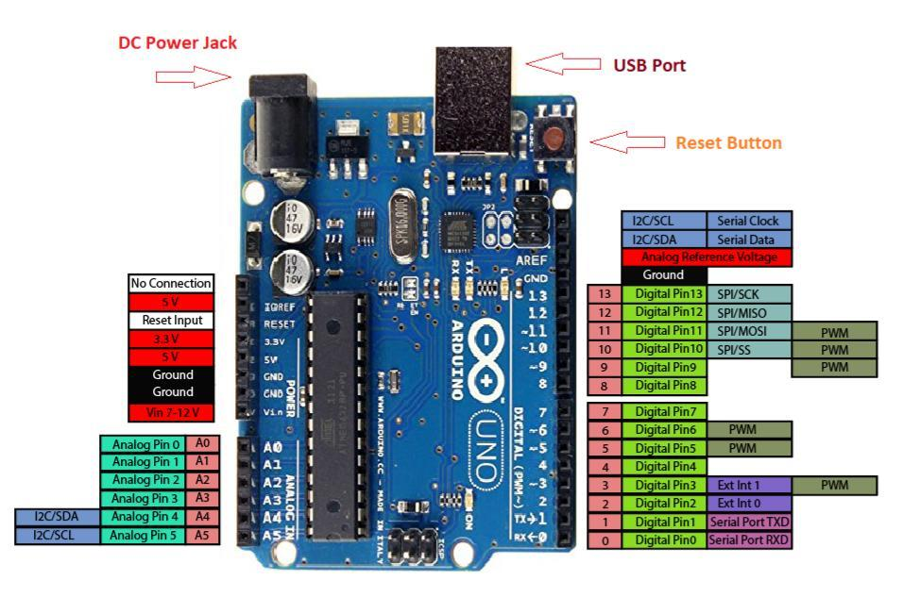

Arduino UNO is a microcontroller board based on the **ATmega328P**. It has 14 digital input/output pins (of which 6 can be used as PWM outputs), 6 analog inputs, a 16 MHz ceramic resonator, a USB connection, a power jack, an ICSP header and a reset button. It contains everything needed to support the microcontroller; simply connect it to a computer with a USB cable or power it with a AC-to-DC adapter or battery to get started. You can tinker with your UNO without worrying too much about doing something wrong, worst case scenario you can replace the chip for a few dollars and start over again.

**Here you will find the technical specifications for the Arduino UNO R3.**

|  |  |  |
| --- | --- | --- |
| **Board** | **Name** | Arduino UNO R3 |
| **SKU** | A000066 |
| **Microcontroller** | ATmega328P | |
| **USB connector** | USB-B | |
| **Pins** | **Built-in LED Pin** | 13 |
| **Digital I/O Pins** | 14 |
| **Analog input pins** | 6 |
| **PWM pins** | 6 |
| **Communication** | **UART** | Yes |
| **I2C** | Yes |
| **SPI** | Yes |
| **Power** | **I/O Voltage** | 5V |
| **Input voltage (nominal)** | 7-12V |
| **DC Current per I/O Pin** | 20 mA |
| **Power Supply Connector** | Barrel Plug |
| **Clock speed** | **Main Processor** | ATmega328P 16 MHz |
| **USB-Serial Processor** | ATmega16U2 16 MHz |
| **Memory** | **ATmega328P** | 2KB SRAM, 32KB FLASH, 1KB EEPROM |
| **Dimensions** | **Weight** | 25 g |
| **Width** | 53.4 mm |
| **Length** | 68.6 mm |

* **COMPATIBILITY**

### **Software & Cloud**

The following software tools allow you to program your board both online and offline.

* ARDUINO IDE
* ARDUINO CLI
* WEB EDITOR
* **WORKING OF PROJECT**

In this I have used two LDRs, a servo motor , two resistors, a solar panel , an arduino uno with power cable and jumper wires.

Light dependent resistors, LDRs or photoresistors are electronic components that are often used in electronic circuit designs where it is necessary to detect the presence or the level of light.

An LDR is made up of a semiconductor

material with high resistance. As light falls on the semiconductor, the light photons are absorbed by the semiconductor lattice and some of their energy is transferred to the electrons.

A **servo motor** is a type of motor that can rotate

with great precision.

If you want to rotate an object at some specific

angles or distance, then you use a servo motor.

It is just made up of a simple motor which runs

through a **servo mechanism**.

All motors have three wires coming out of them.

Out of which two will be used for Supply (positive

and negative) and one will be used for the signal

that is to be sent from the MCU.

**CODE FOR THE PROJECT**

**#include <Servo.h> //including the library of servo motor**

**Servo myservo;**

**int initial_position = 90;**

**int LDR1 = A0; //connect The LDR1 on Pin A0**

**int LDR2 = A1; //Connect The LDR2 on pin A1**

**int error = 5;**

**int servopin=9; //You can change servo just makesure its on arduino's PWM pin**

**void setup()**

**{**

**myservo.attach(servopin);**

**pinMode(LDR1, INPUT);**

**pinMode(LDR2, INPUT);**

**myservo.write(initial_position); //Move servo at 90 degree**

**delay(2000);**

**}**

**void loop()**

**{**

**int R1 = analogRead(LDR1); // read LDR 1**

**int R2 = analogRead(LDR2); // read LDR 2**

**int diff1= abs(R1 - R2);**

**int diff2= abs(R2 - R1);**

**if((diff1 <= error) || (diff2 <= error)) {**

**} else {**

**if(R1 > R2)**

**{**

**initial_position = --initial_position;**

**}**

**if(R1 < R2)**

**{**

**initial_position = ++initial_position;**

**}**

**}**

**myservo.write(initial_position);**

**delay(100);**

**}**

**CIRCUIT CONNECTION EXPLAINED BELOW:**

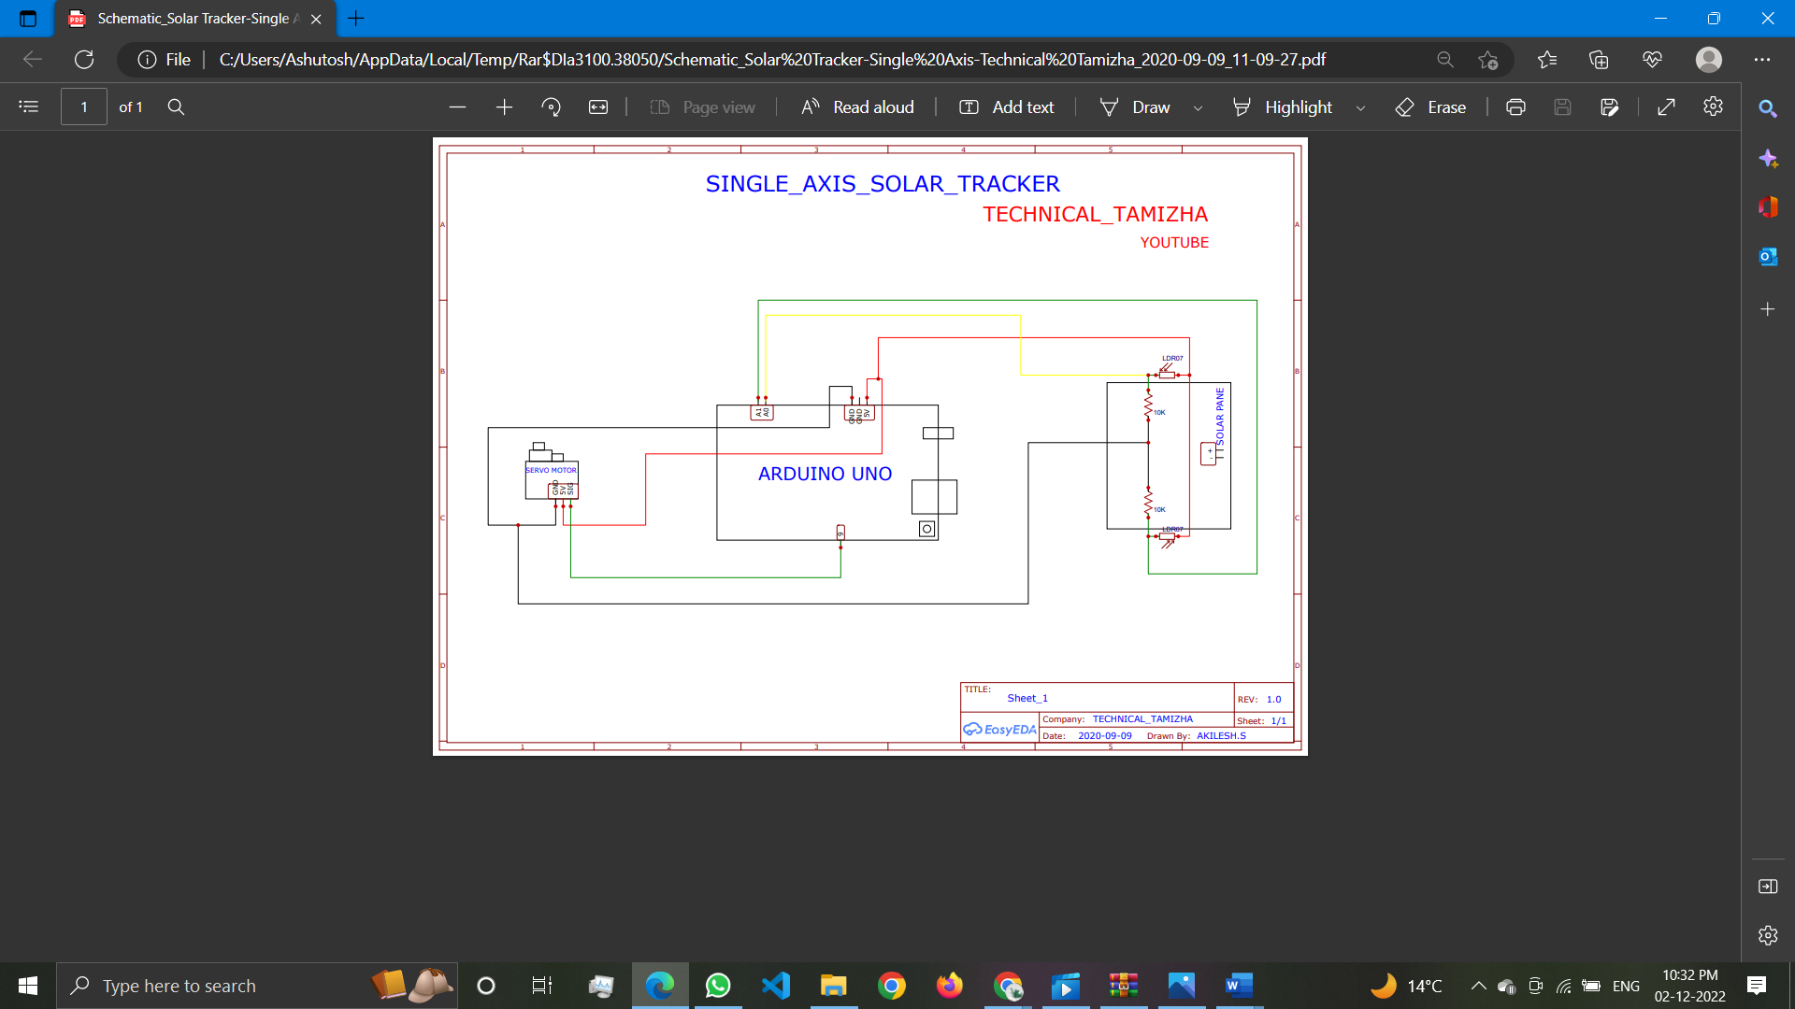

**APPLICATIONS OF PROJECT**

Nowadays as the source which provides energy, mostly coal is on the verge of depletion and there is a need for a different source. Through solar panels we convert the sun's heat into energy and the sun's heat is gonna be present for millions of years to come.

As the sun keeps moving from east to west through the day, the solar panel needs to move accordingly. That is where this model comes into play and rotates the solar panel so that it faces the direction in which maximum light intensity is present.