**AUTO-SCALING-GROUPS**

**“ASG IS USED TO SCALE UP AND SCALE DOWN INSTANCES BASED UPON CERTAIN METRICS”**



**WE HAVE TWO TYPES OF SCALING:**

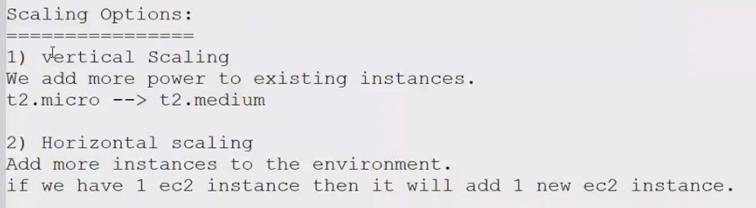

**VERTICAL SCALING:**

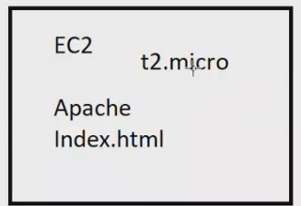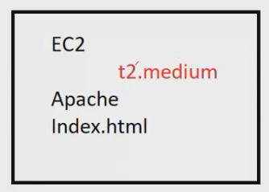

**HORIZINOTAL SCALING:**

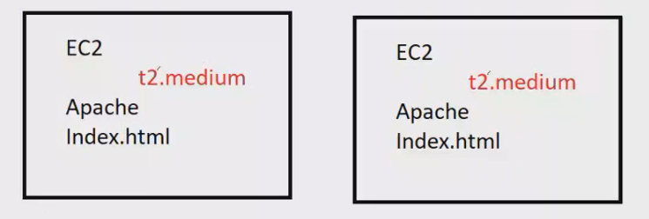

**ASG WORKS BASED ON LAUNCH CONFIGURATIONS AND TEMPLATE;**

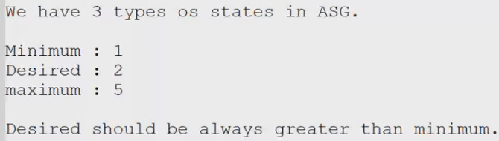

**LAUNCH TEMPLATE AND LAUCH CONFIGURATIONS;**

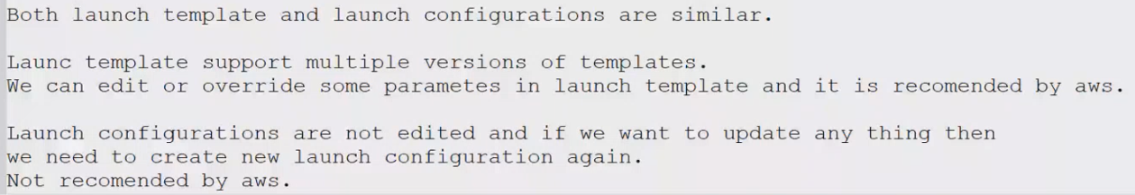

**CREATION OF LAUNCH TEMPLATE IN AWS with “httpd” installation;**

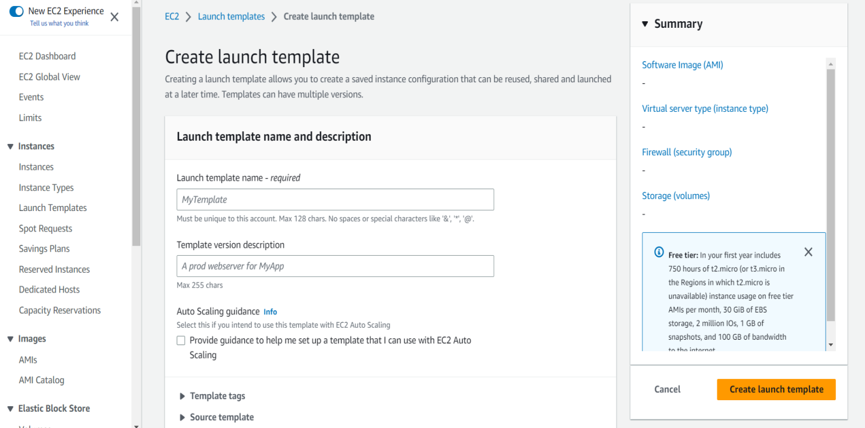

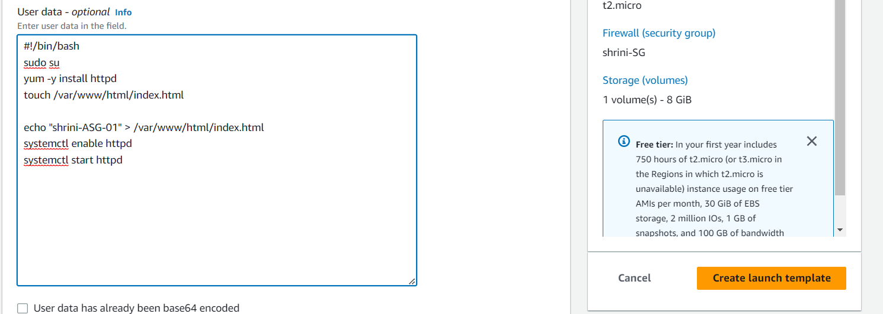

**NOW WE WILL CREATE “ASG” WITH USING ABOVE TEMPLATE**

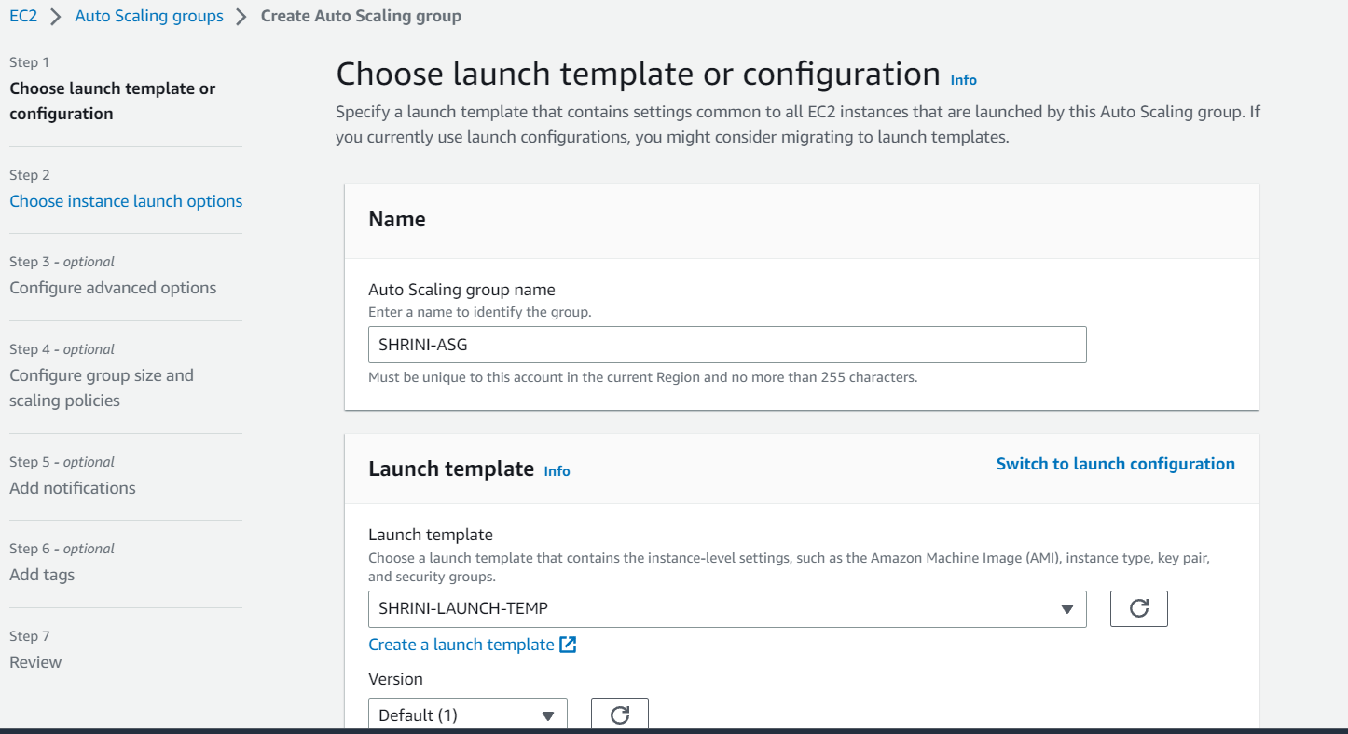

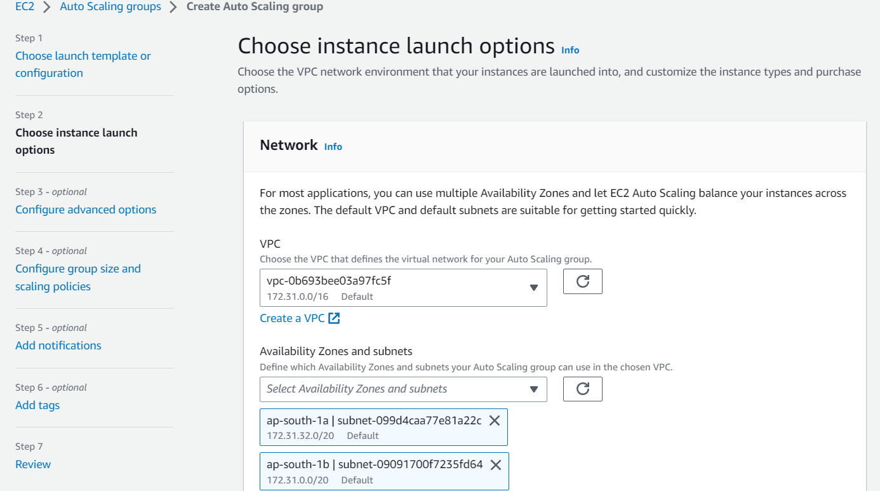

**WE CAN OVERRIDE OUR TEMPLATE IN NETRWORK STAGE;**

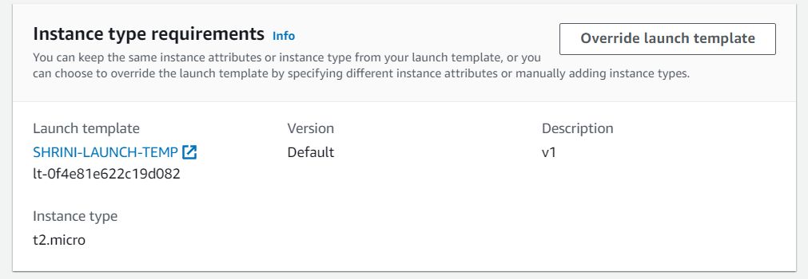

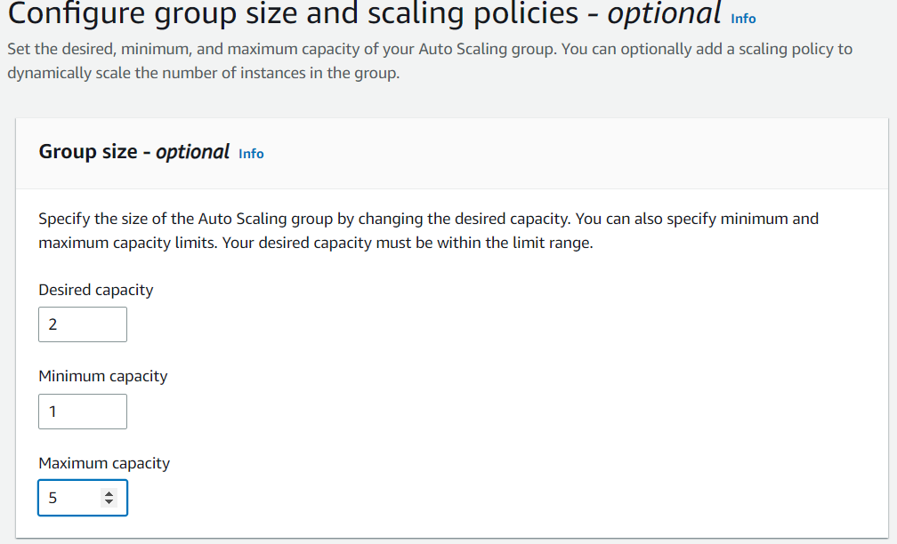

**THEN WE HAVE TO MENTION SCALING POLICIE TO “SCALE UP/DOWN”**

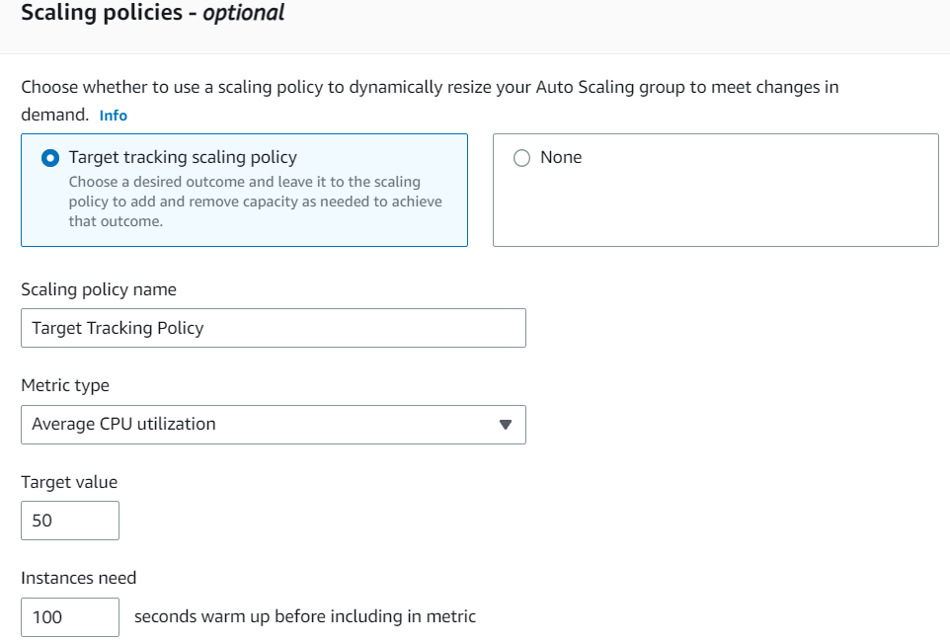

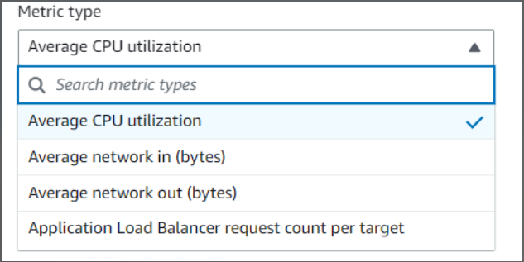

**AFTER CREATION OF “ASG” WE CAN CHECK THE 2-INSTANCES BECAUSE WE MENTIOED OUR DESIRED STATE TO “TWO”**

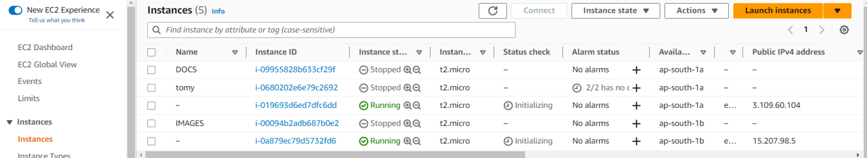

**WE CAN CHECK THE ACTIVITY OF OUR AUTO SCALING GROUPS AND LAUCH-TEMPLATE;**

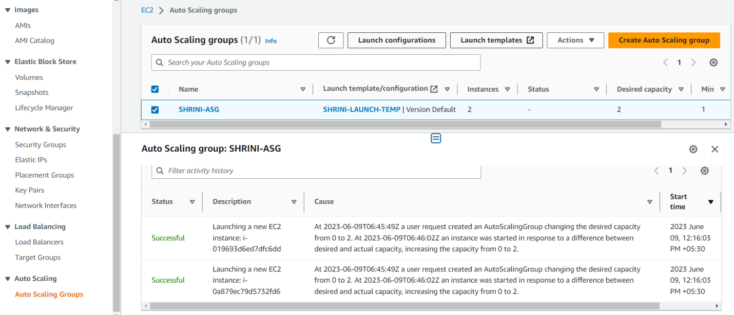

**\*\* NOW I AM TRYING TO DELETE TWO INSTANCES AND WE CAN CHECK THE LOGS IN ACTIVITY SECTION OF AUTO-SCALING GROUP;**

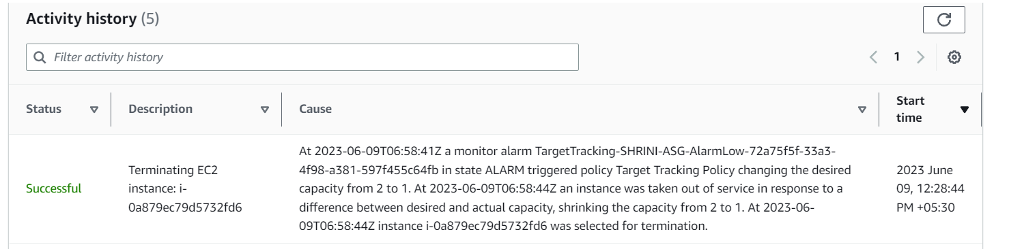

**IT WILL CREATE AUTOMATICALLY ONE INSTANCE BECAUSE WE MENTIONED OUR GROUP SIZE TO MINIMUM “1” IN THE TEMPLATE;**

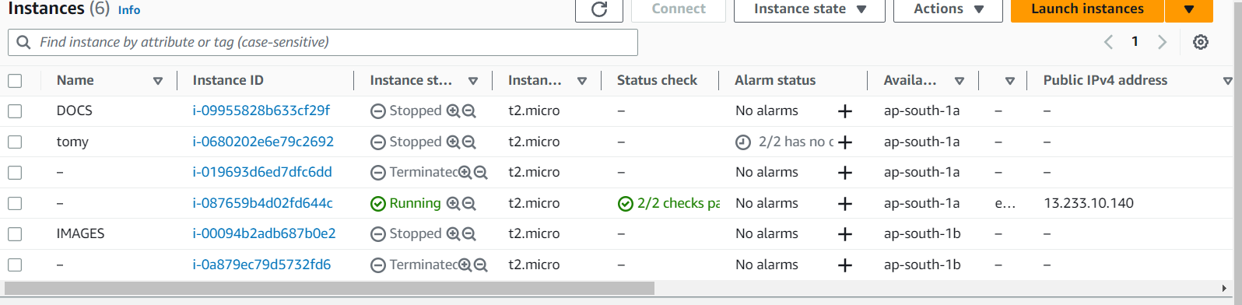

**SO NOW I WANT TO “EDIT OR OVERRIDE” ANY PARAMETERS WE CAN DO IT BY LAUNCHING TEMPLATE WITH THE NEW VERSION “2”;  
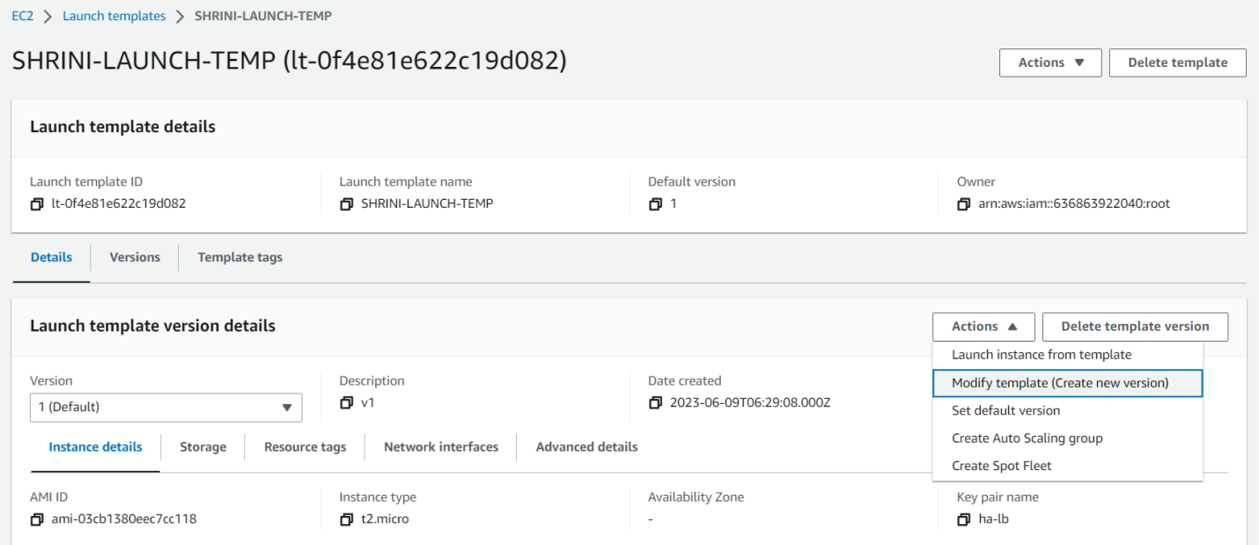**

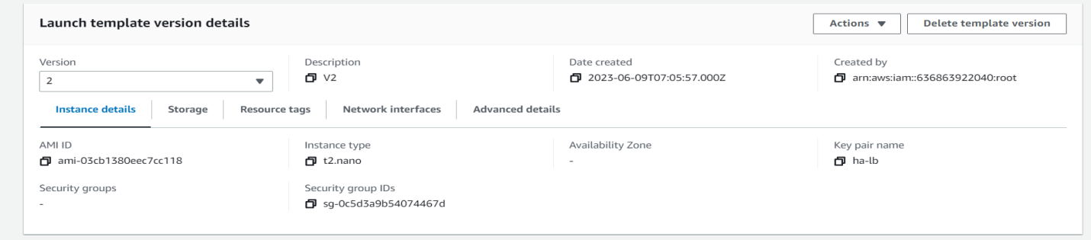**”WE CAN MAKE AS A DEFAULT VERSION ON ACTION SIDE”**

**THEN, WE HAVE TO MAKE CHANGES ON AUTO SCALING GROUP IN LAUNCH TEMPLATE SIDE TO USE (2) VERSION with “t2.nano”  
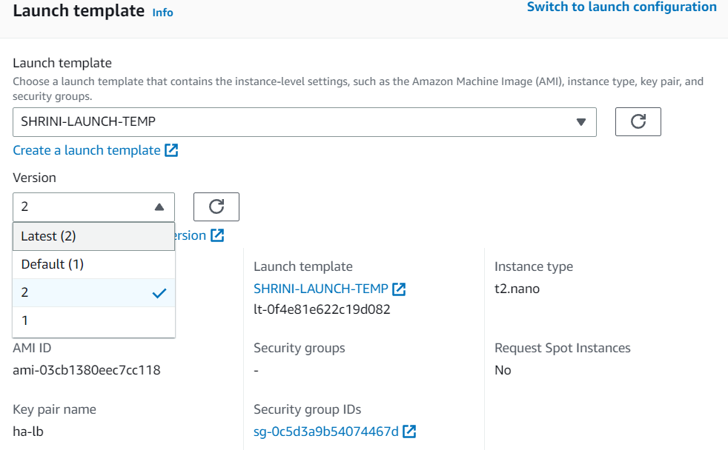**

**We get the instances with “t2.nano”;**



**And if we want to work on launch configuration then we have to only switch to the “launch configuration on ASG”;**

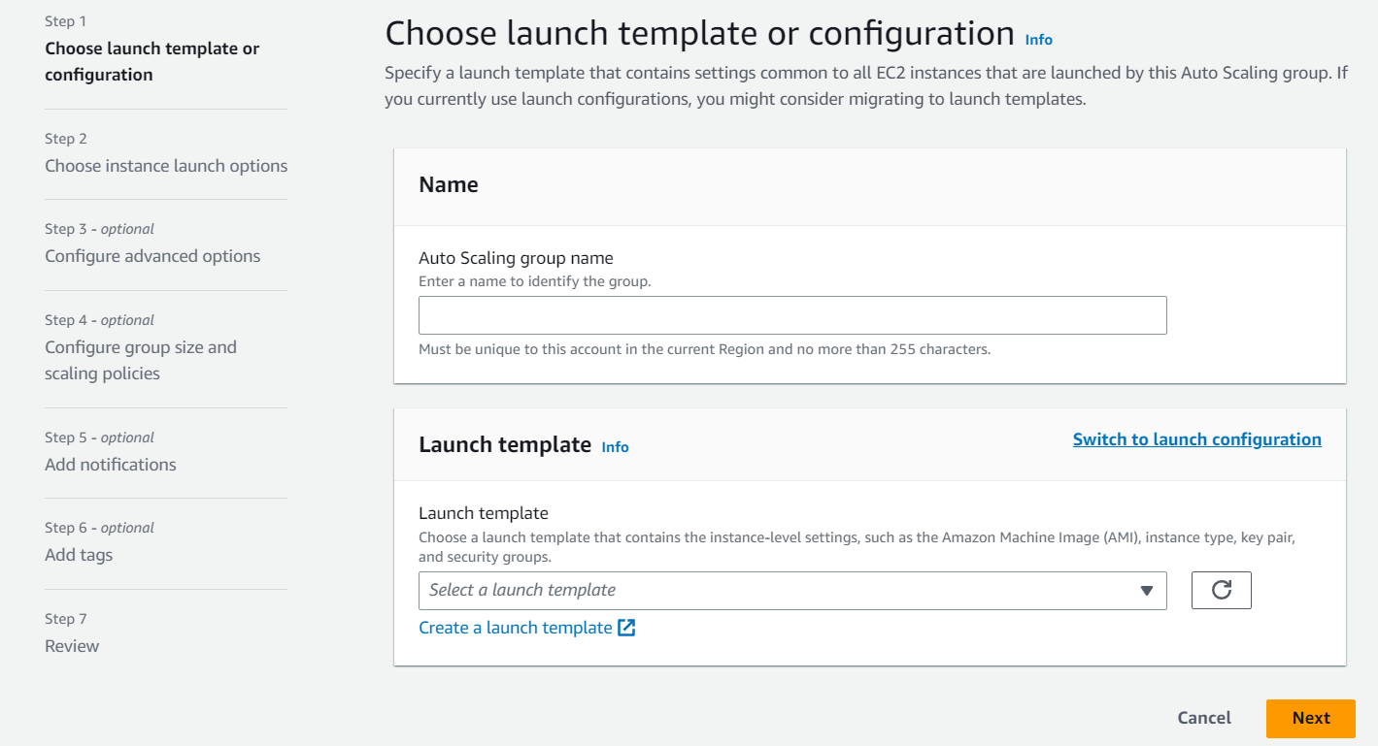

**1. Launch on ec2 and install (httpd) and take snapshot;**

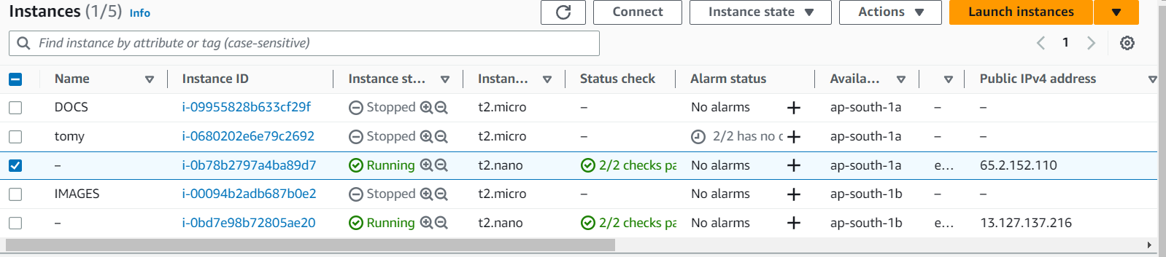

**THIS IS MY INDEX.HTML FILE WHICH MEANS HTTPD IS INSTALLED WORKING FINE;**

**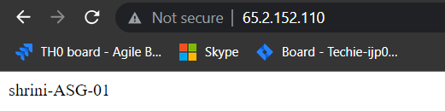  
THEN I AM TAKING SNAPSHOT OF MY HTTPD EC2-INSTANCES;**

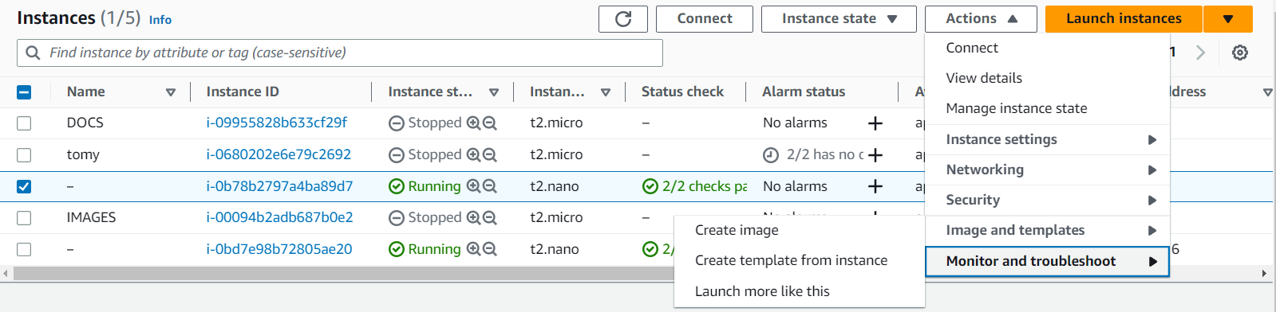

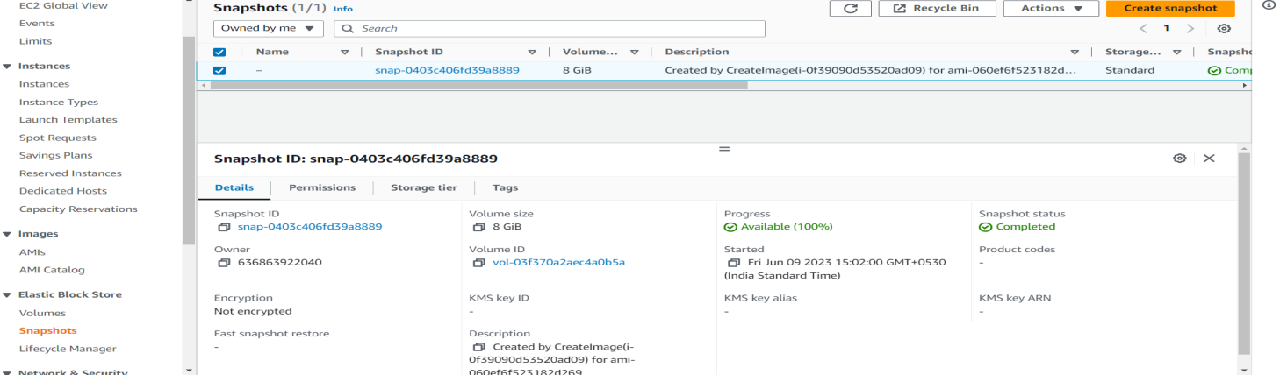

**2. Creating one launch template using the customized ec2.**

* **First I take the image snapshot of “httpd” and using in template;**

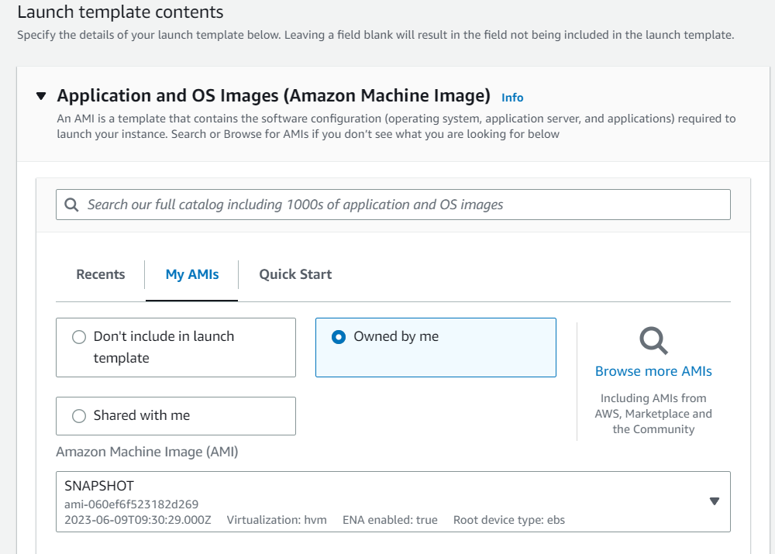

* **Second I take the volume snapshot of httpd and using as volume in template;**

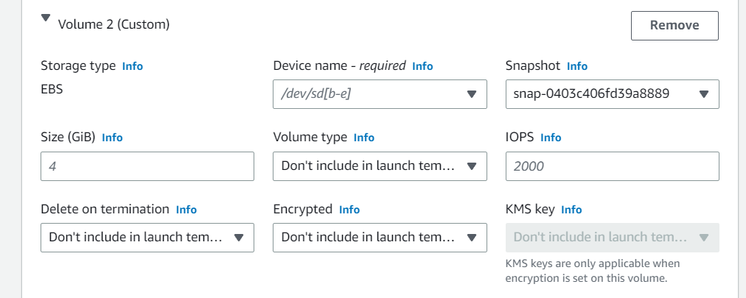

**3.** **Attaching the ASG to Load balancer;**

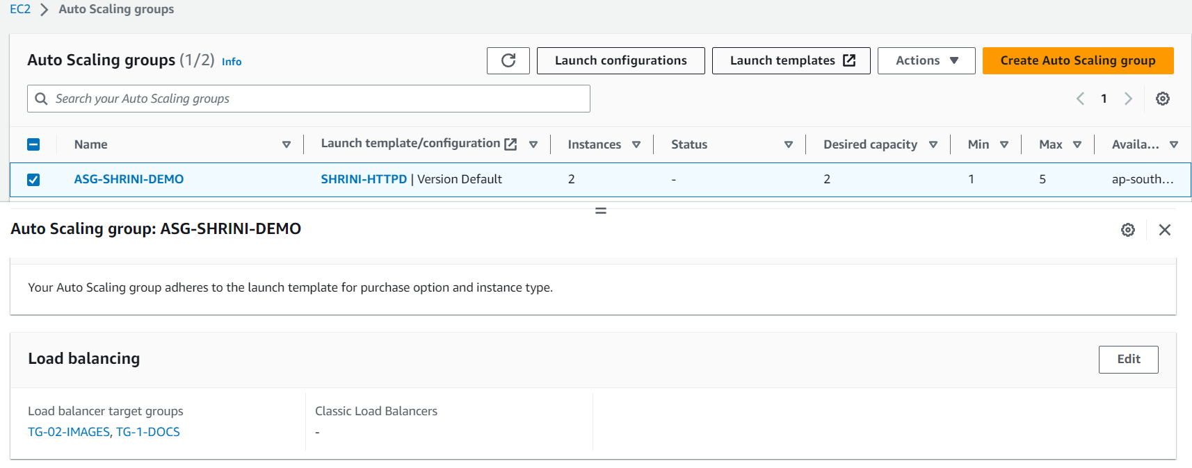

**We can attach LB while creating ASG and after creation also by adding like below in the details section;**

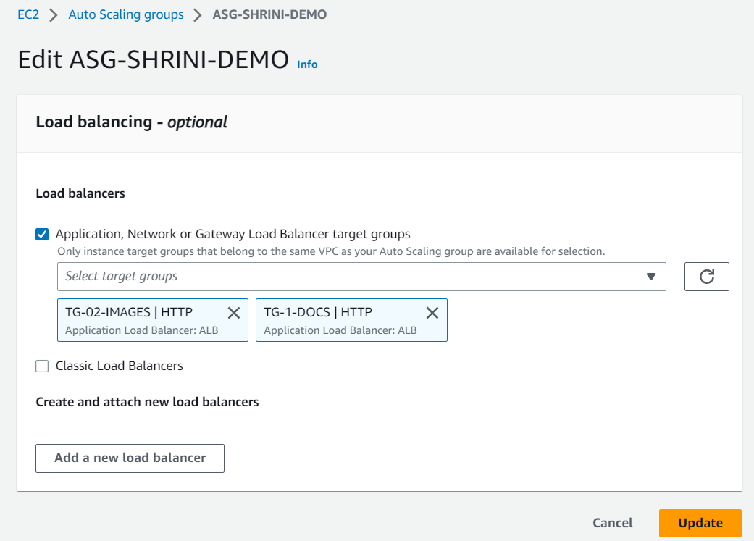

**4. Push the load balancer logs to S3 bucket.**

* **We have to go attributes and edit in the monitoring level;**

