**1) Create VPC with 2 priavate and 2 public subnets.**









**2) Enable DNS Hostname in VPC**

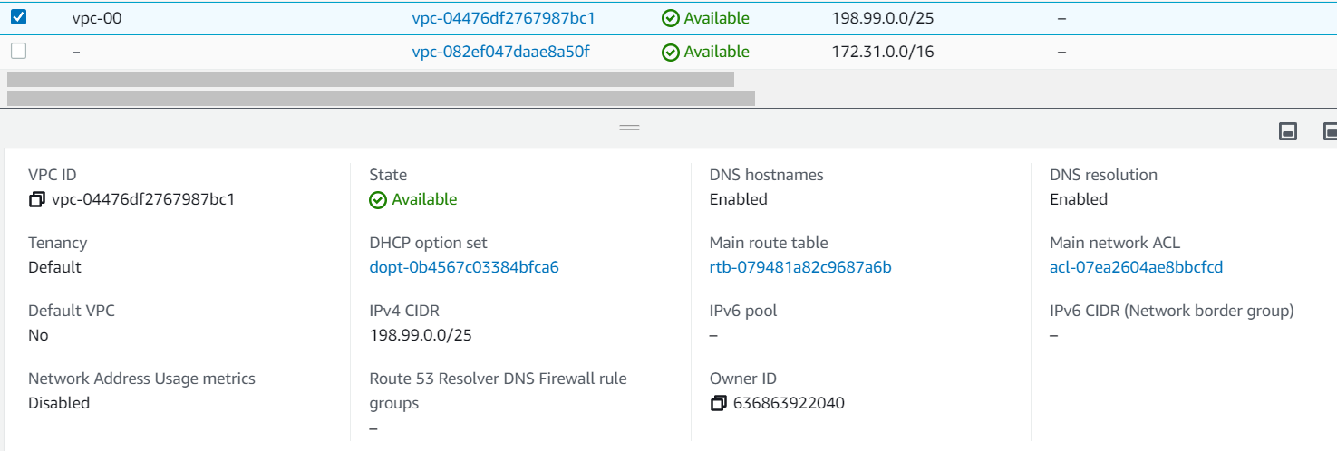

**3)** **Enable Auto Assign Public ip in 2 public subnets**

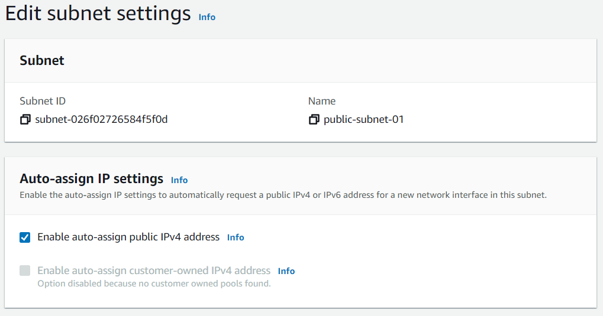

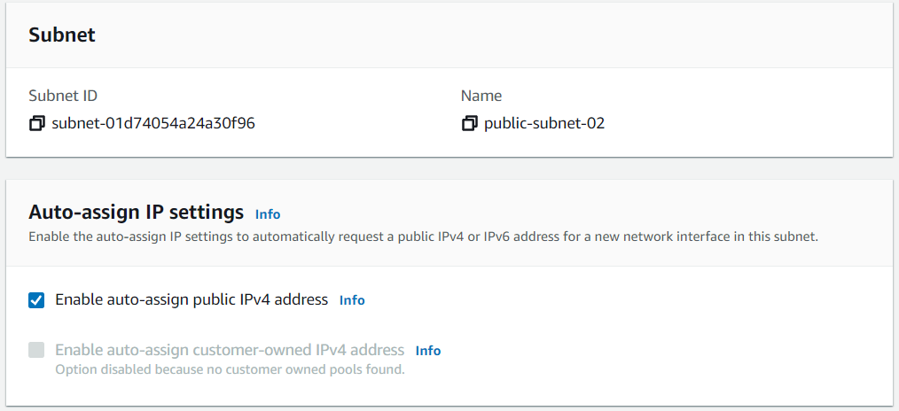

**4)** **Add 2 PUBLIC subnets in public route table**

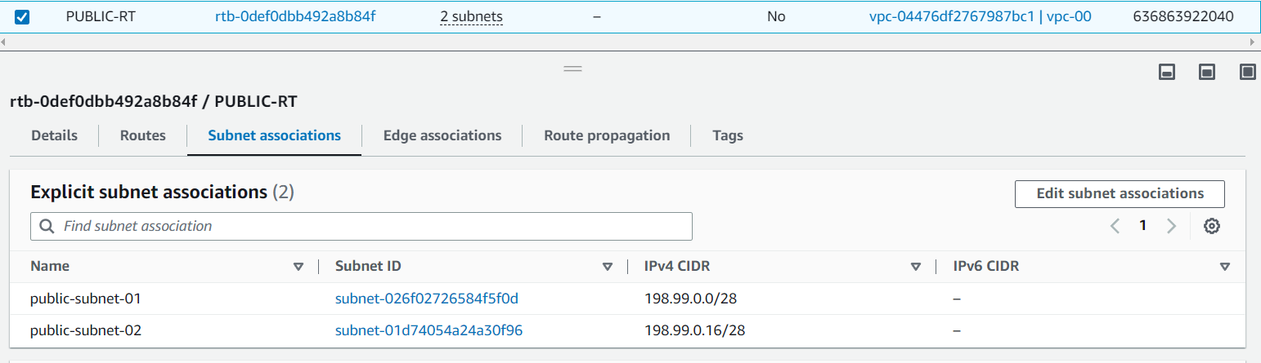

**5) Add 2 private subnets in private route table**

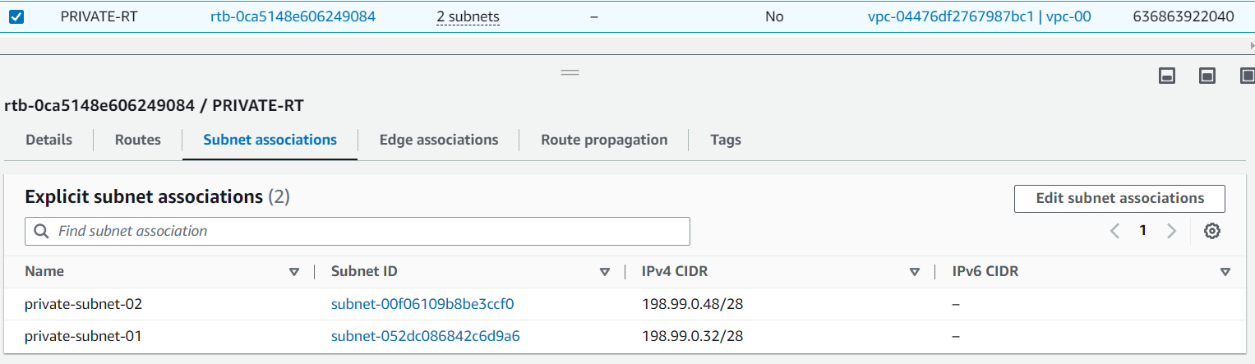

**6) Public route table will have the routes to internet and local**

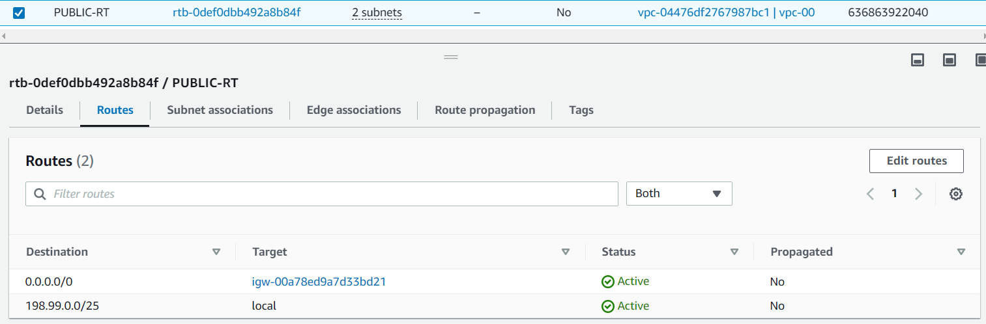

**7)** **Create Ec2 in public subnet with t2micro and install php**

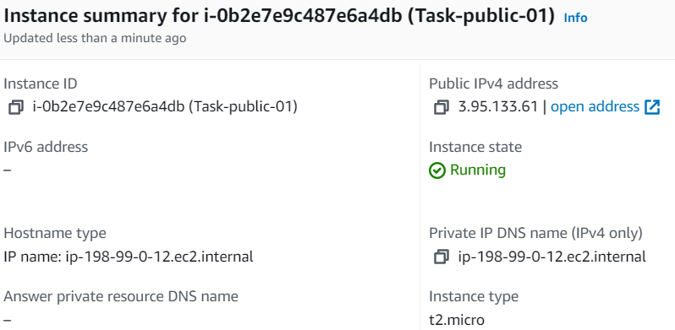

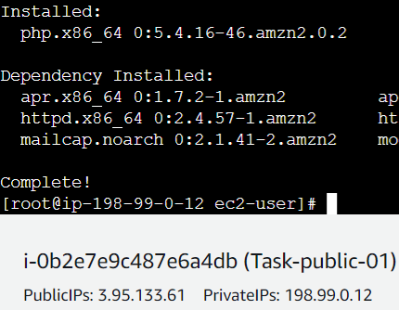

**8) Configure Nat gateway in public subnet and connect to private Instance**

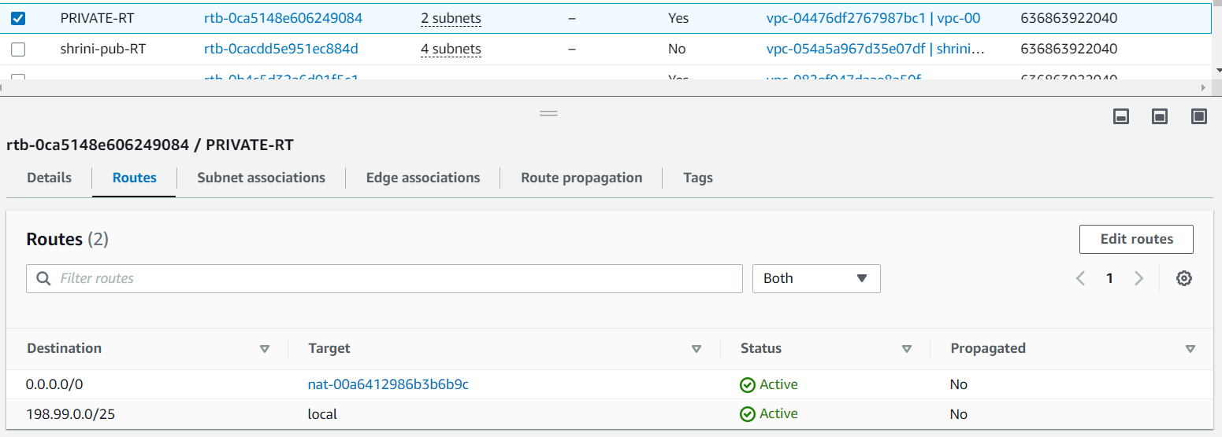

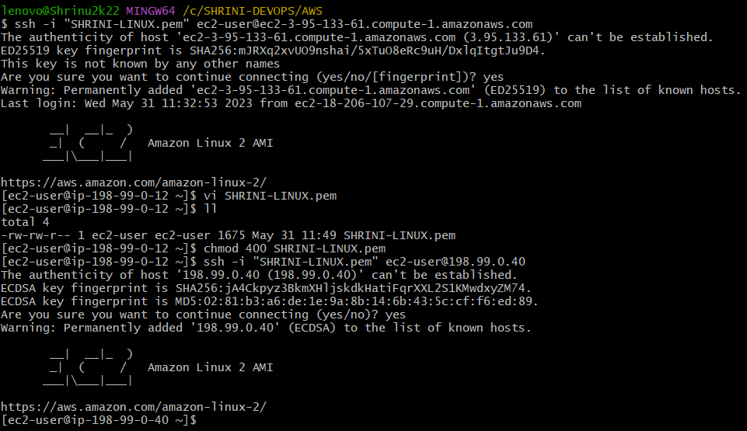

**9. Install Apache Tomcat in private ec2 and deploy a sample app.**

