**CLOUDTRAIL**

**DEFINATION**

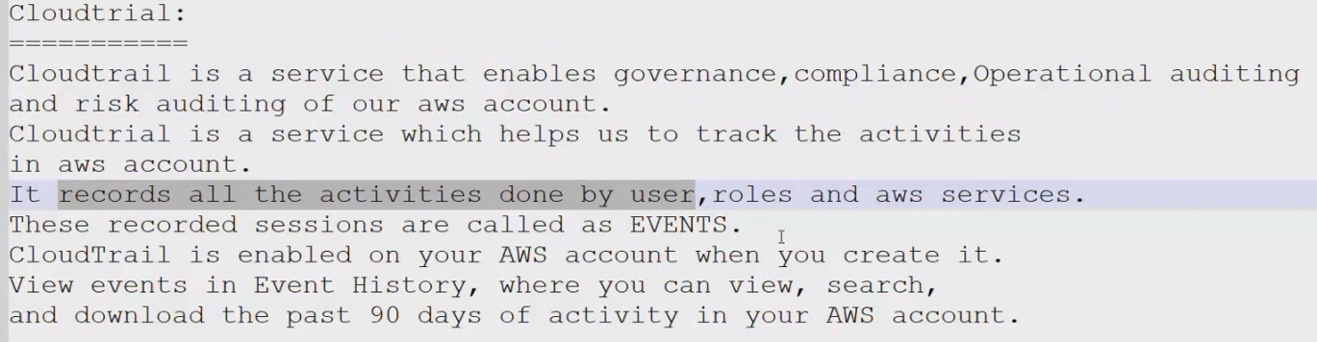

**AWS-CLOUDTRAIL;**

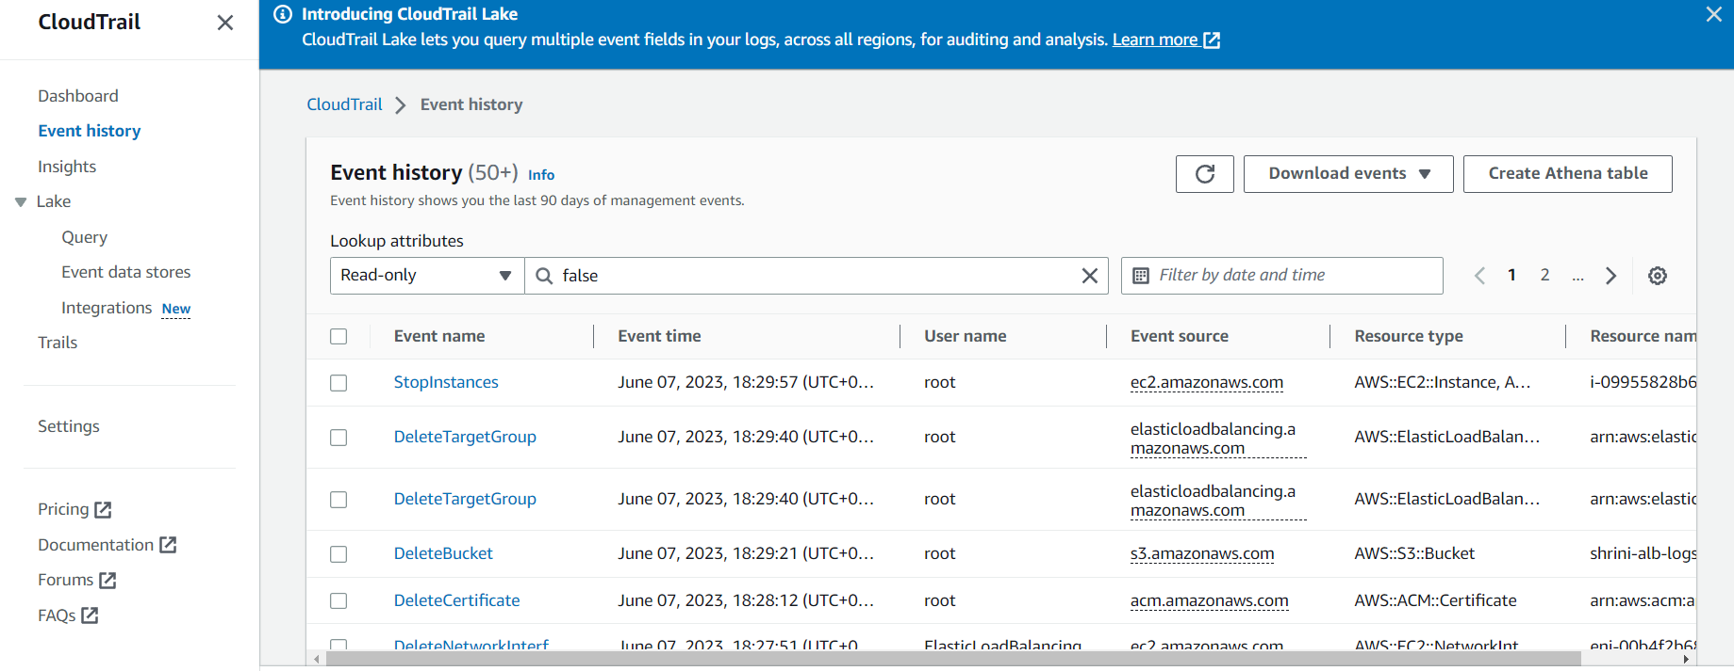

**TYPES OF LOG EVENTS;**

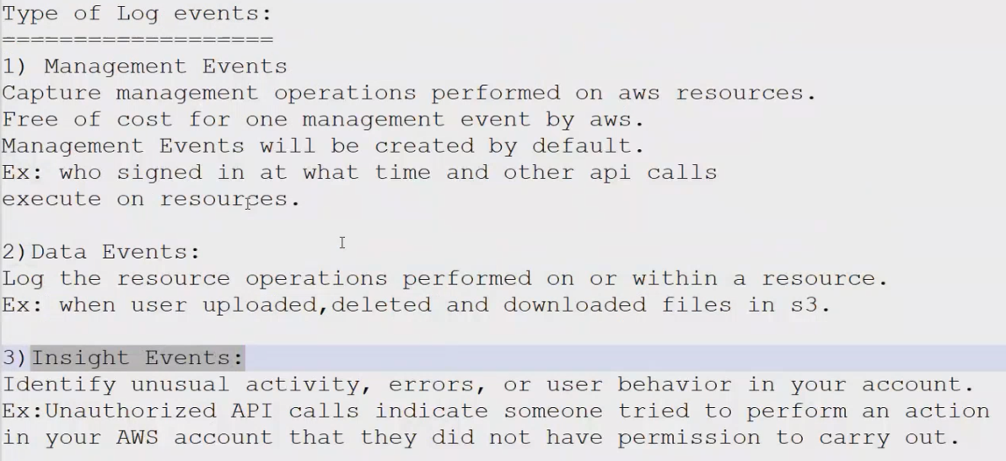

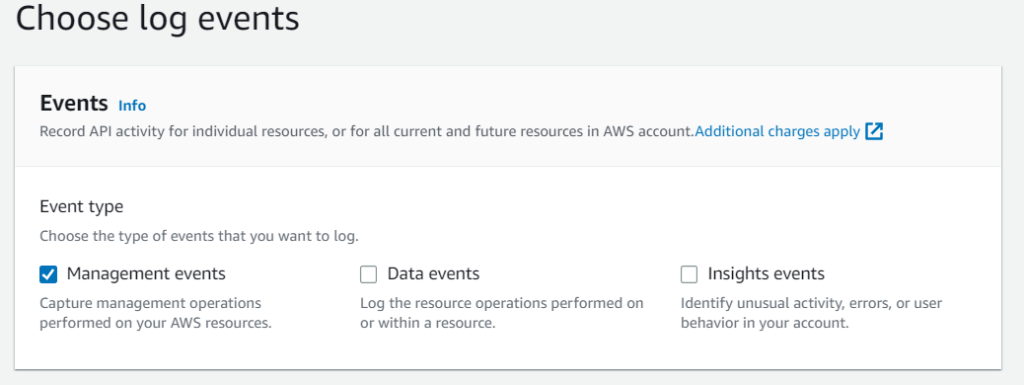

**\*\*CREATION OF CLOUDTRAIL;**

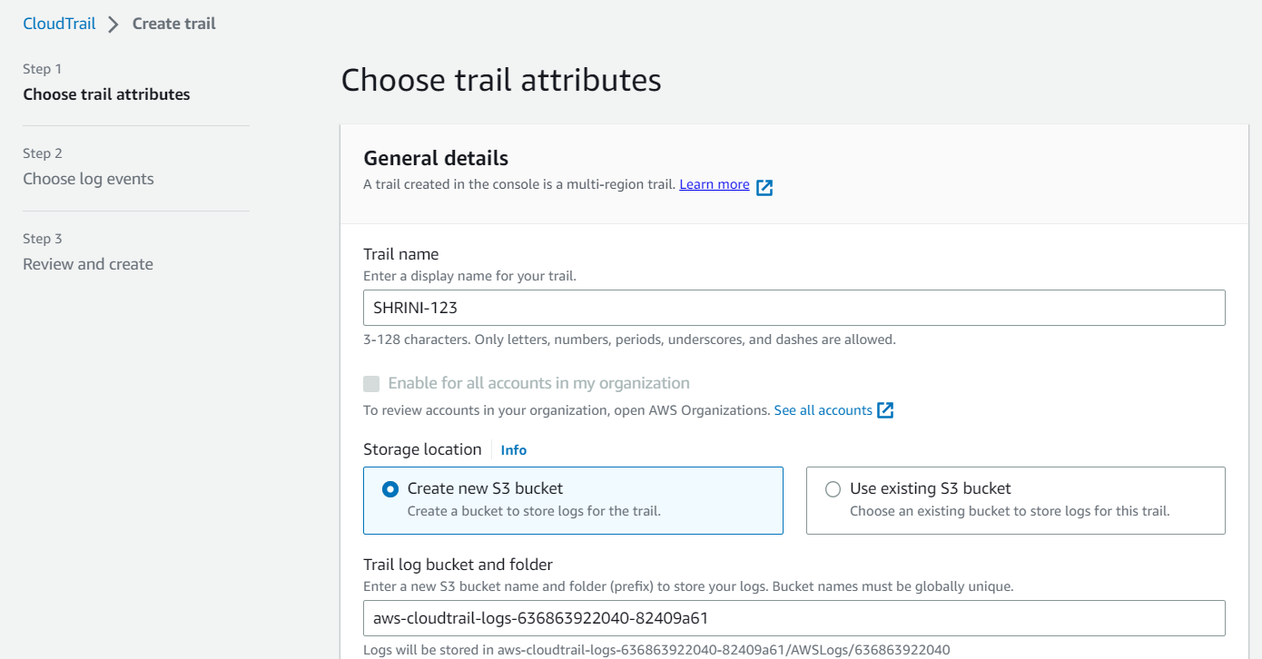

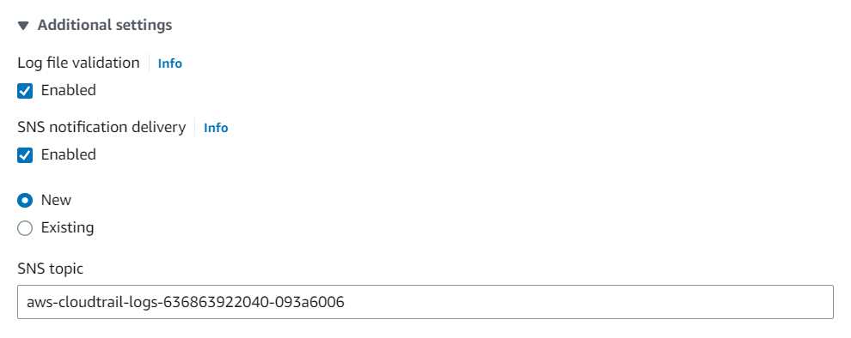

**\*\***

**\*\*EXPLANTION:**

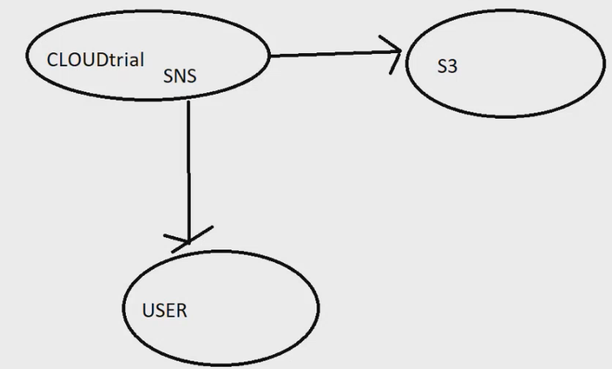

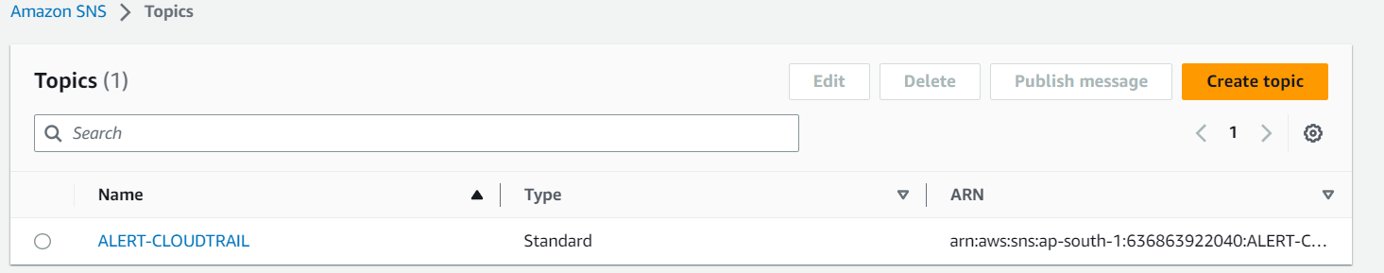

**\*\*Receiving messages via Gmail after enabling “SNS”**

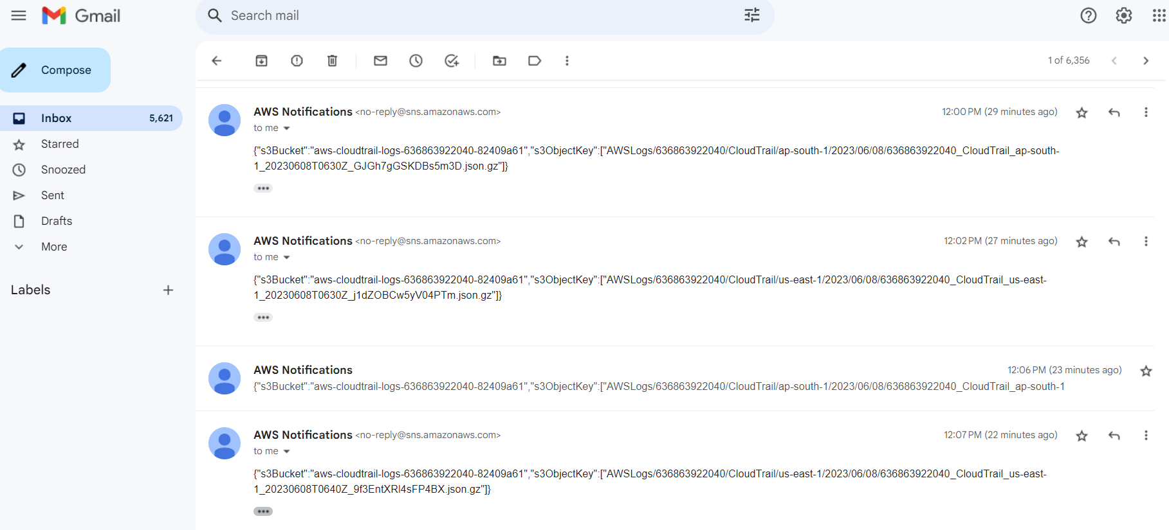

**\*\* WITH THE HELP OF CLOUDWATCH WE WILL GET THE LOGS**

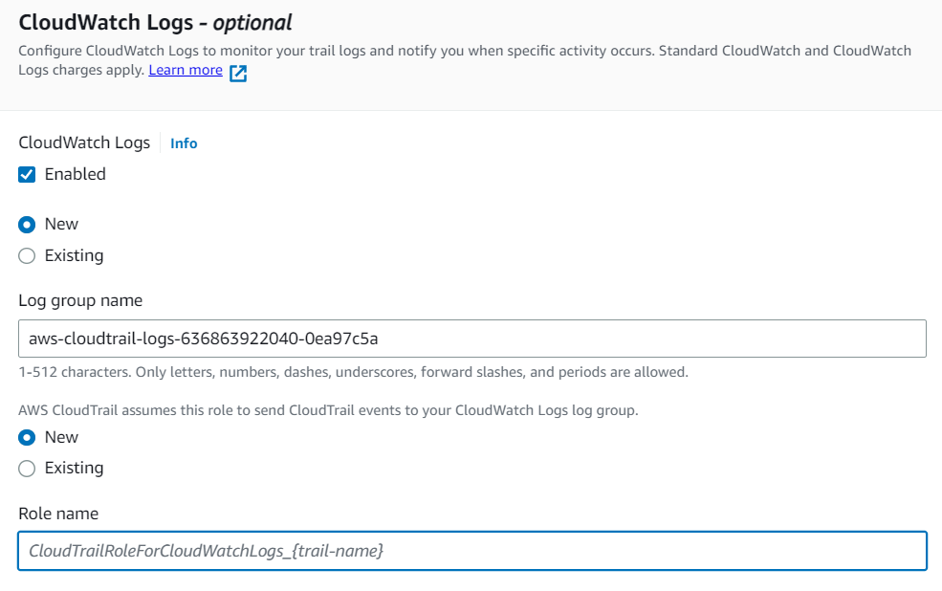

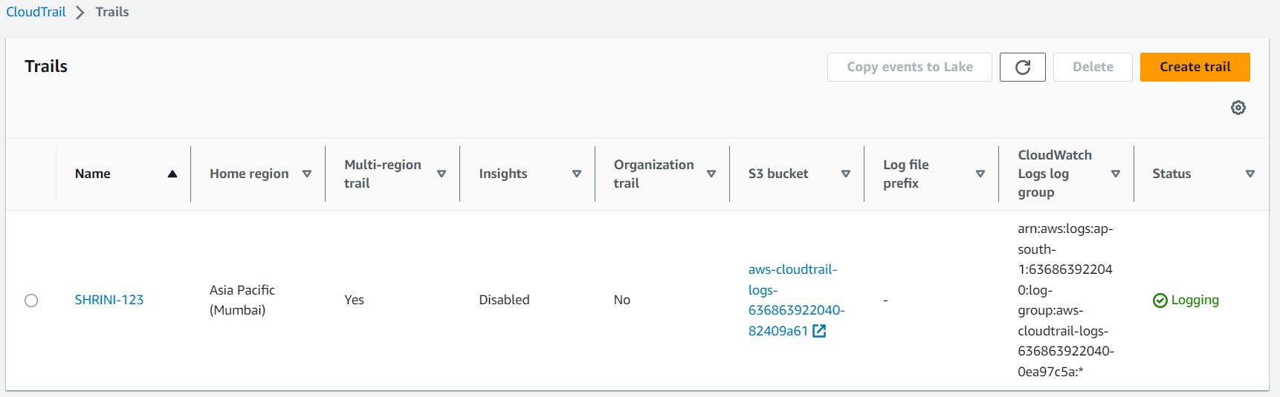

**\*\*In Cloud-trail we save the logs in two forms   
 1. Cloud-watch**

**2. S-3**

**1. CLOUDWATCH:**

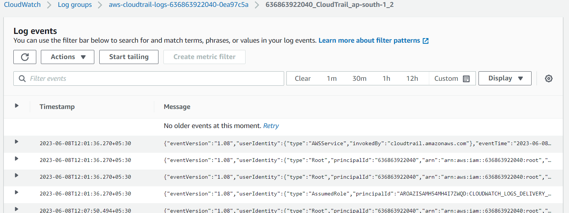

**2. S3-BUCKET:**

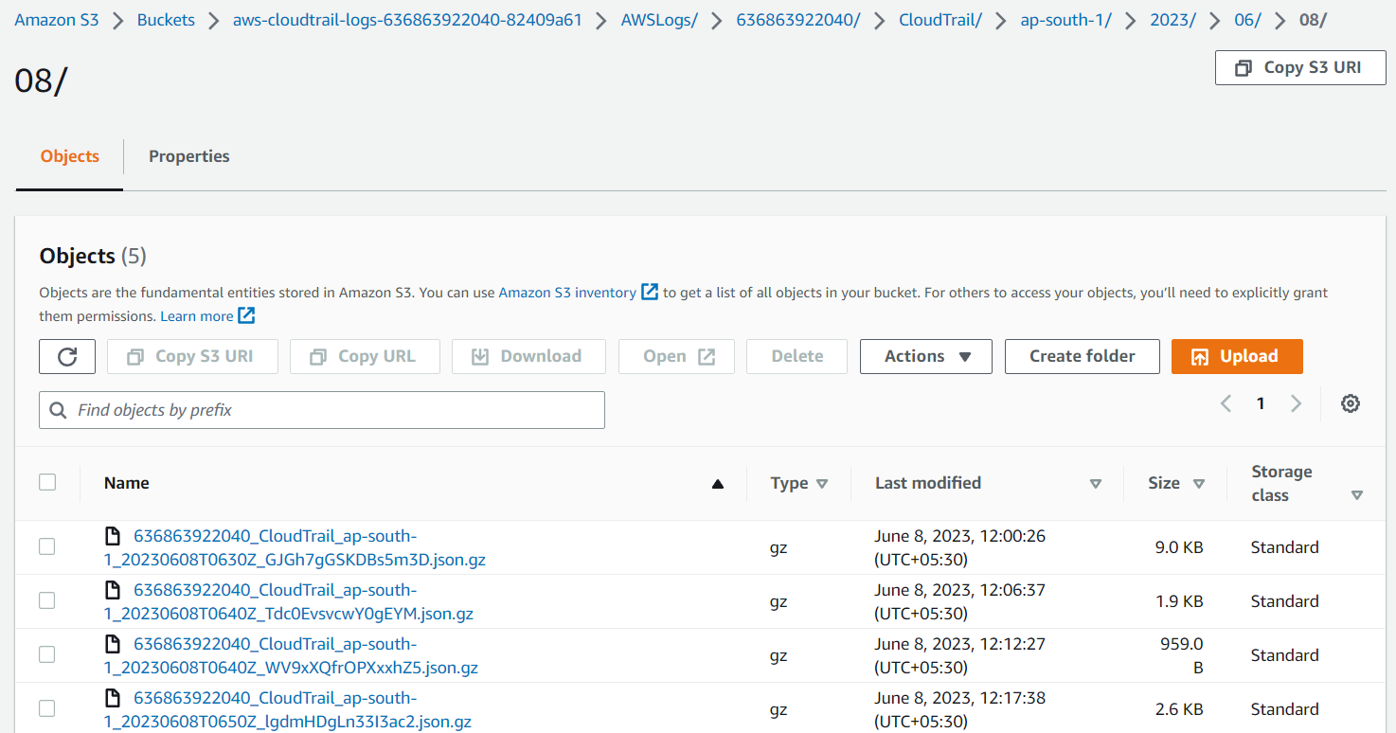

**CLOUDWATCH**

**DEFINATION;**

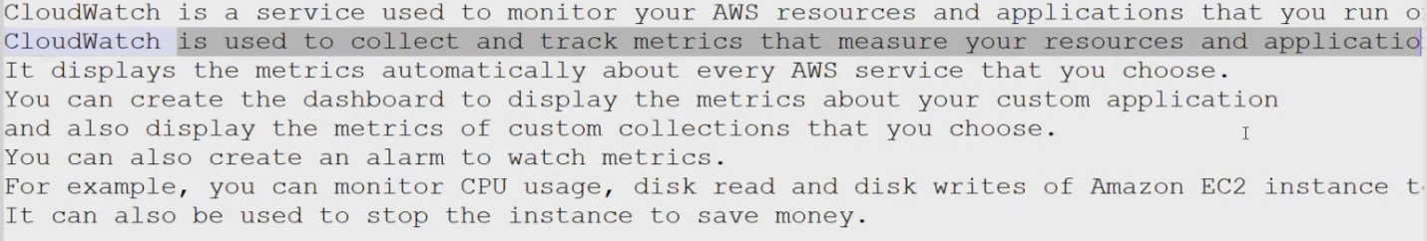

**USE-CASE IN EC-2;**

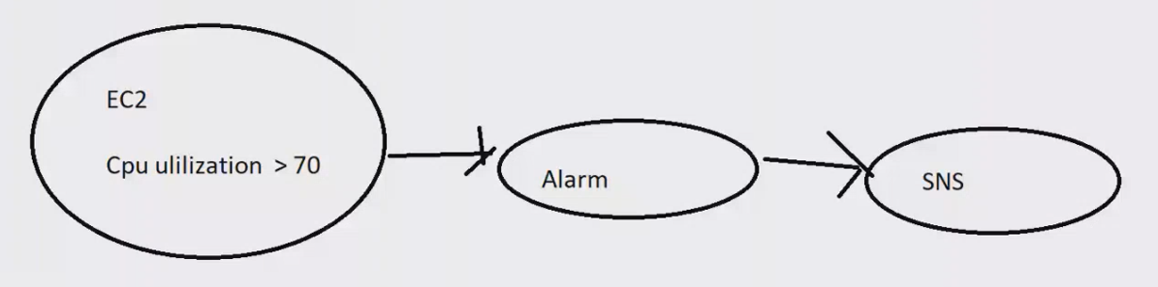



**\*\* DIFFERENCE BETWEEN CLOUD-TRAIL/WATCH;-**

**“Cloud-trail service is used to monitor your aws account activities**

**Cloud watch is used to monitor your aws resources example ec2**

**Account activities means who had create, deleted, update ec2,s3 and other services”**

**We are increasing the load of ec2 and monitoring by cloud-watch;**

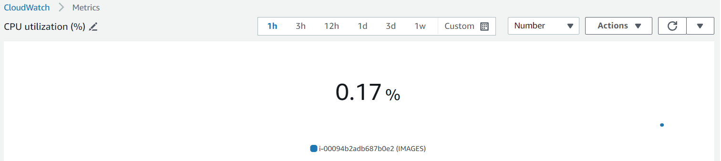

**Putting Fake stress in ec-2 /and making CPU utilization with 99%**

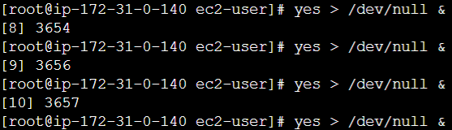

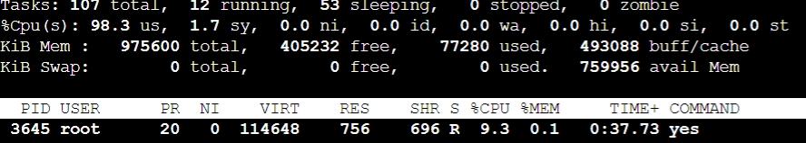

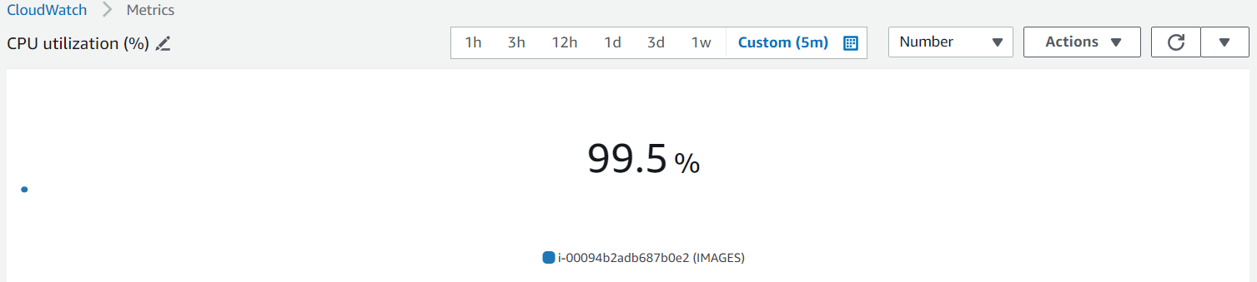

**\*\*(We can make alarm and make our environment stable with the help of cloud-watch)**

**\*\*Creating cloud-watch dashboard for CPU utilizations ec2-instances;**

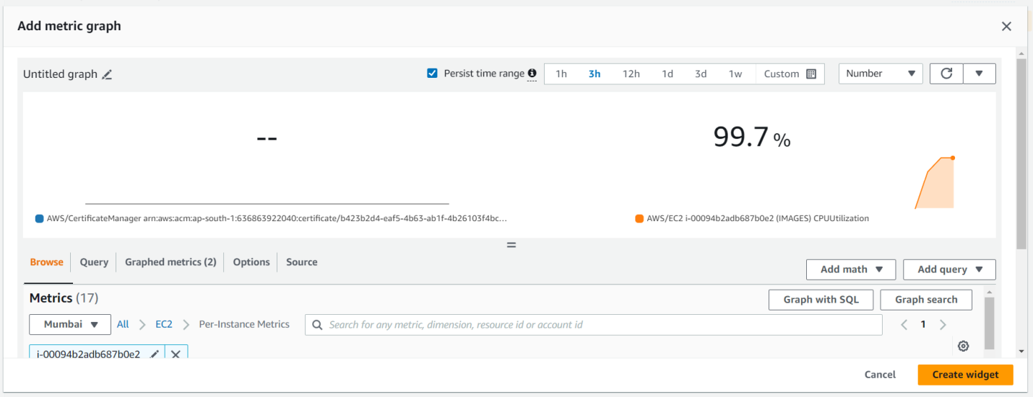

**We can change our widget also;**

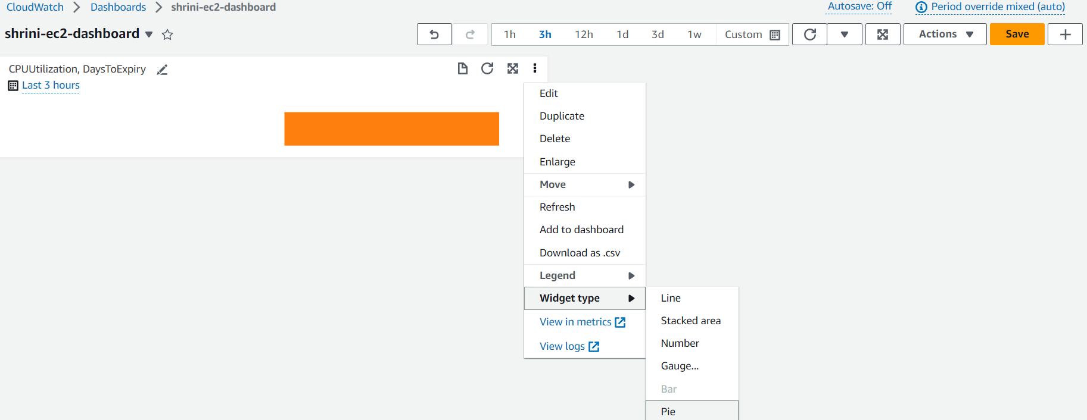

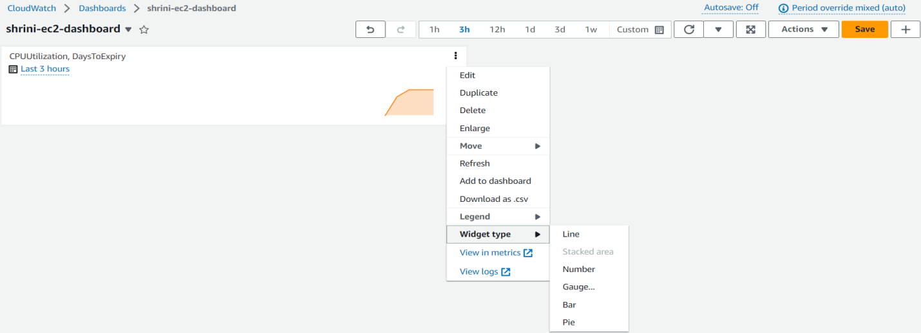

**NOW I WANT TO CREATE AN ALARM IF MY CPU UTLIZATION IS ABOVE 70%;**

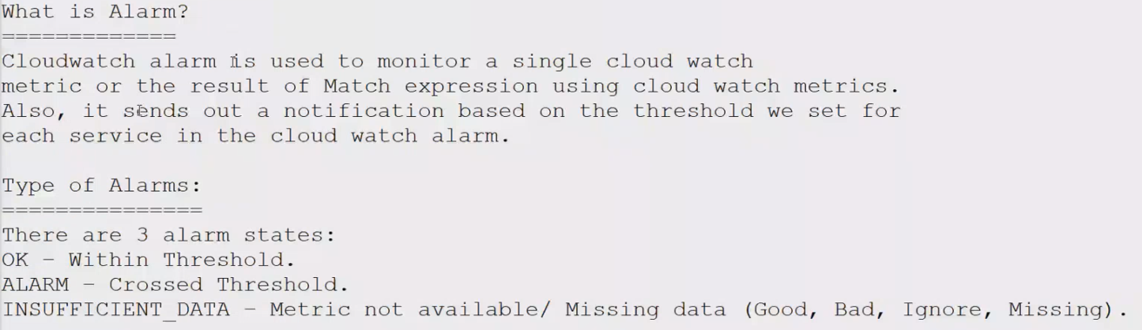

**CREATING ALARM:**

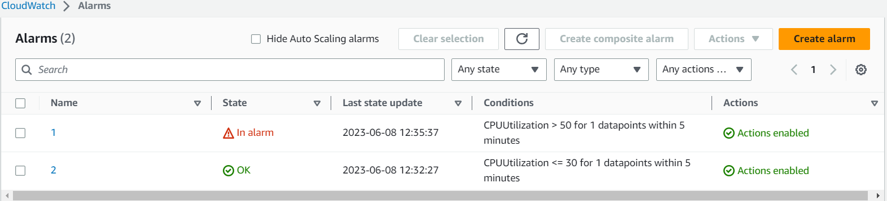

**WE CAN DEFINE OUR CONDITIONS:**

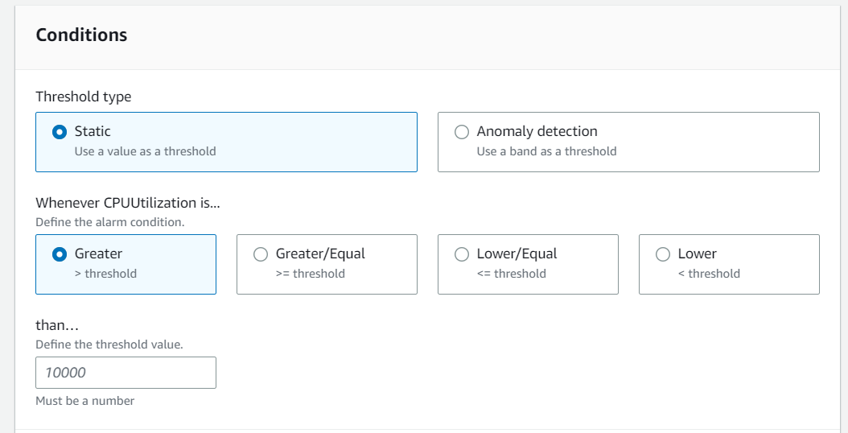

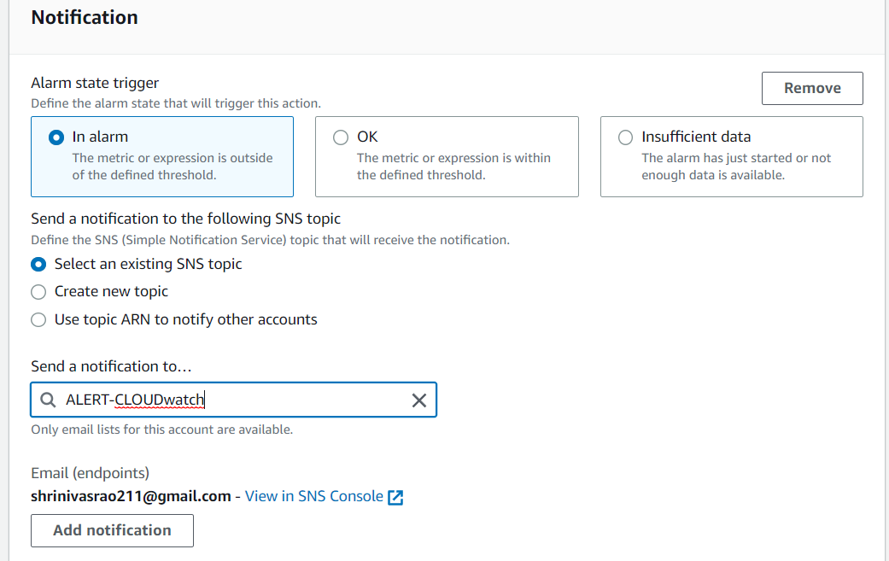

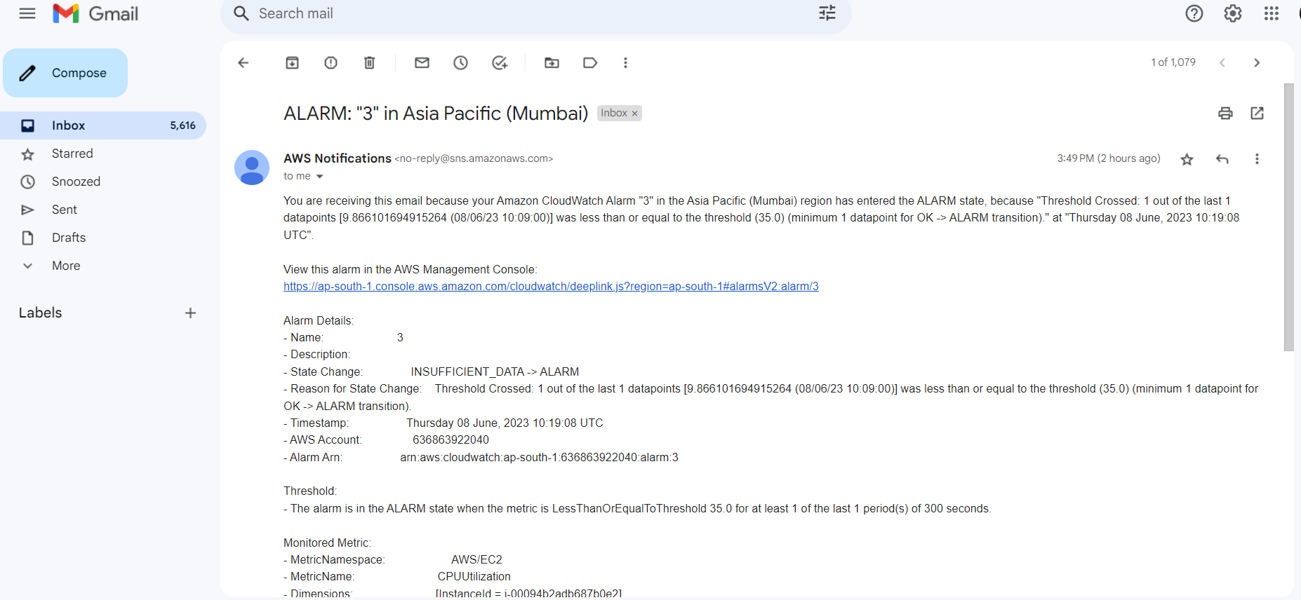

**\*\*Using custom metrics to check the status of tomcat in cloud watch by bash script;**

**1. Downloading tomcat with all dependencies**

**2. After that I have to configure aws in bin**

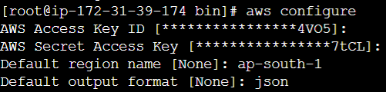

**3. Then creating a bash script for checking the status of tomcat;**

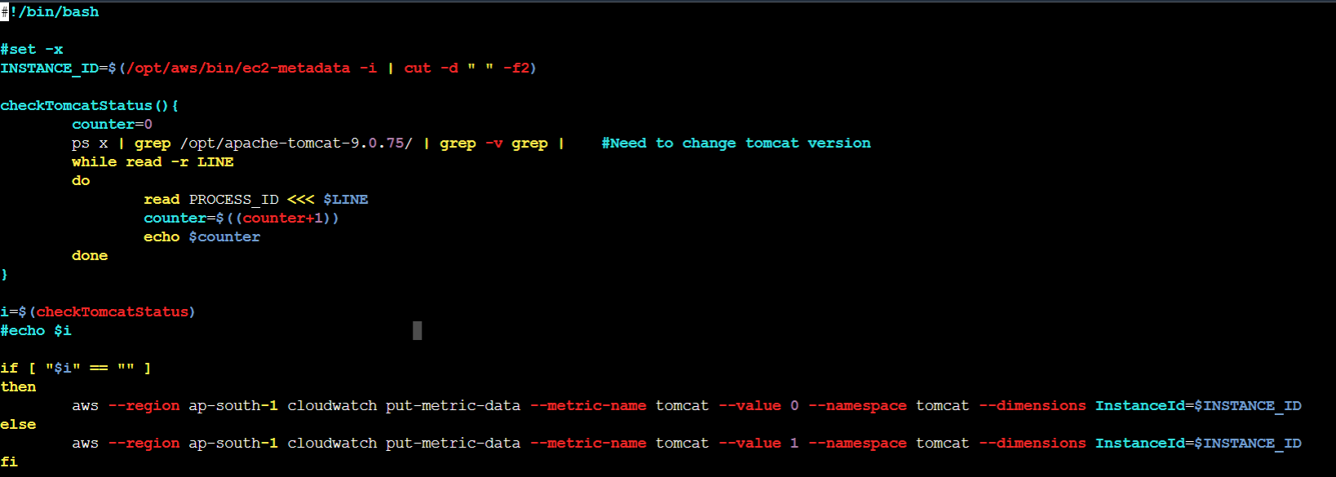

**4. And create a dashboard in cloudwatch and check the status value (if 1 = running , 0 = not running);**

