**ELASTIC-LOAD-BALANCER**

**“TO CONTOL/ DISTURBUTE THE TRAFFIC IN MULTIPLE ZONES”**

**1. Write down notes on ELB**

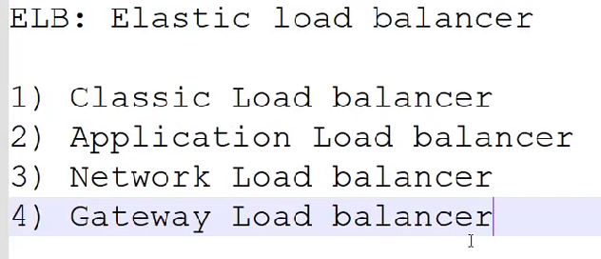

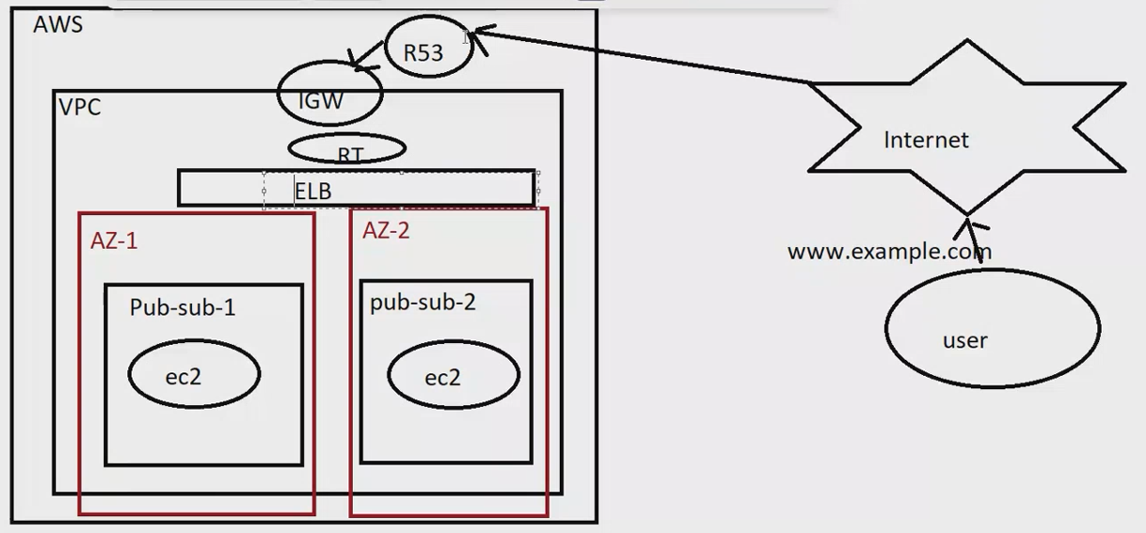

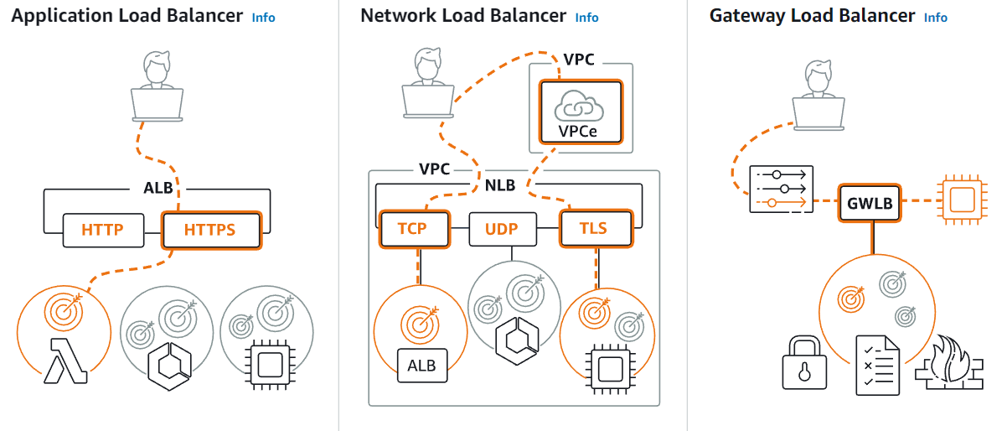

**A) CLASSIC-LOAD-BALANCER**

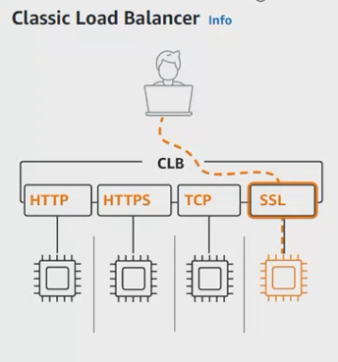

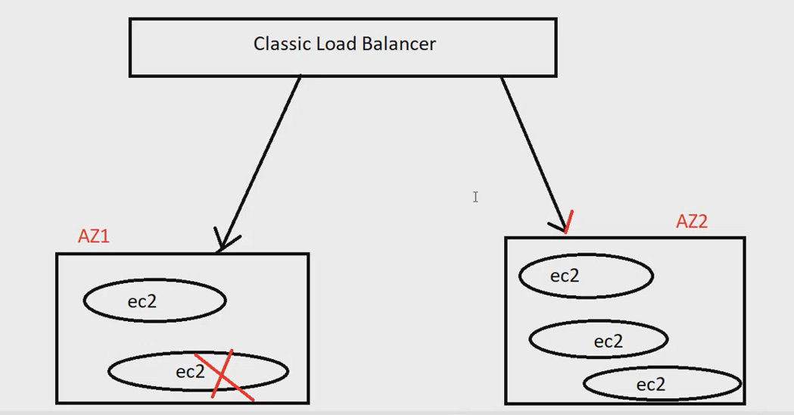

** TO USE CLB WE HAVE TO CONFIGURE EQUAL NO. OF EC2-SERVER IN BOTH THE ZONE

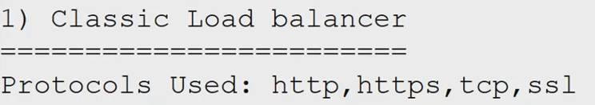

** WE CANNOT CONFIGURE MULTIPLE LISTNERS (80,81,82 IT ONLY WORKS ON 80 PORT)

** Bootstraping = It helps to create any applications in ec2 on launching period with the help of bash script  
** we can’t edit the script once it’s created

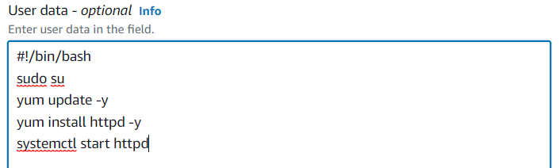

**For health checks of instances should be IN-SERVICE so we have to make the security group with the same security group in LOAD BALANCER

“EC-2 SECURITY GROUP”

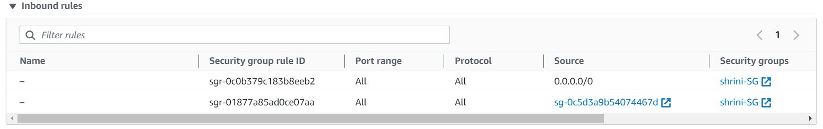

“CLB- HEALTH CHECK”

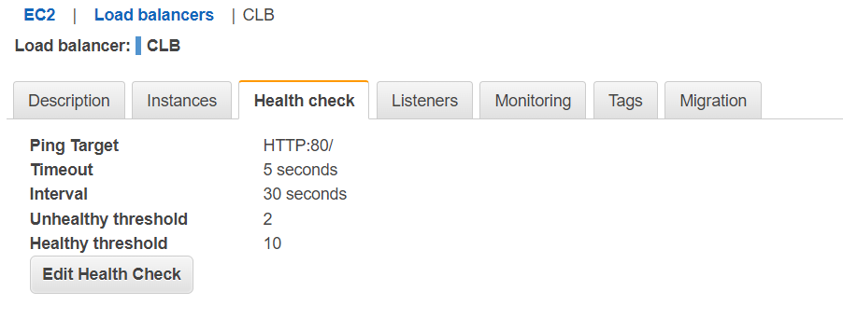

**B) APPLICATION-LOAD-BALANCER**

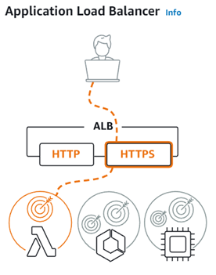

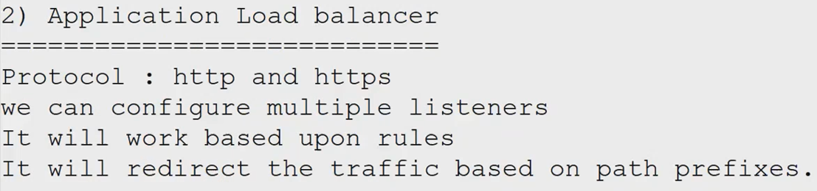

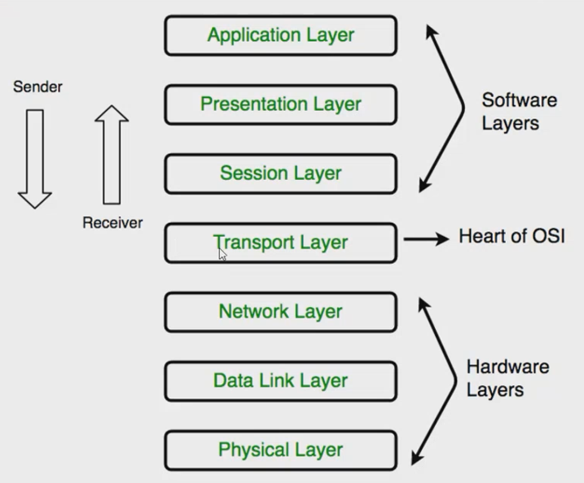

**\*\* IT WORKS ON APPLICATION LAYER**

**IF WE WANT TO REDIRECT THE TRAFFFIC BASED ON PATH PREFIX:**

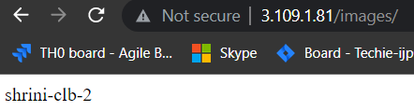

**“PREFIX will works on different port no. of any services”**

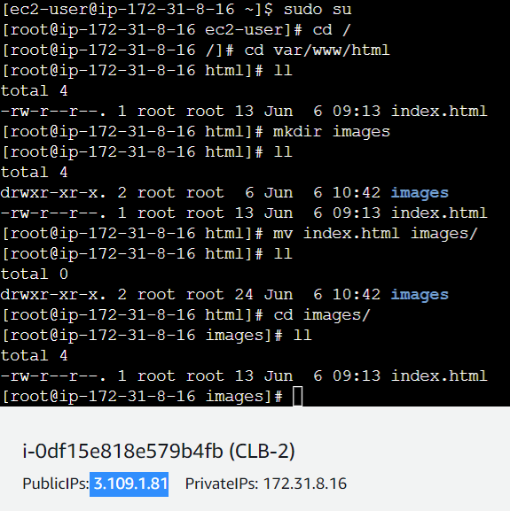

**TO RUN IN MULTIPLE LISTENERS we use APPLICATION LOAD BALANCER WITH THE HELP OF “RULES”**

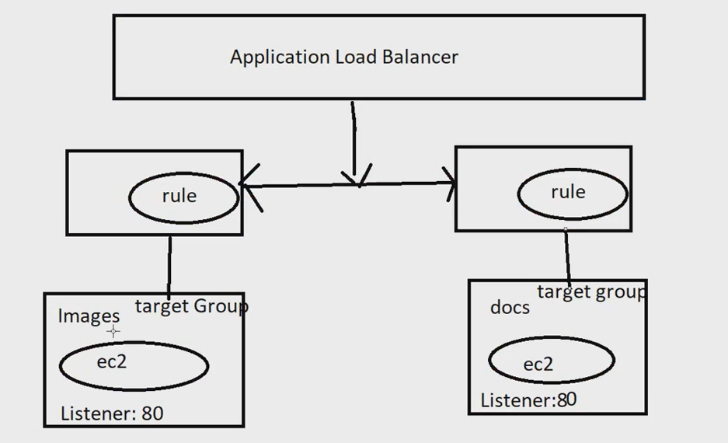

**“ALB ONLY WORKS ON HTTP AND HTTPS ”**

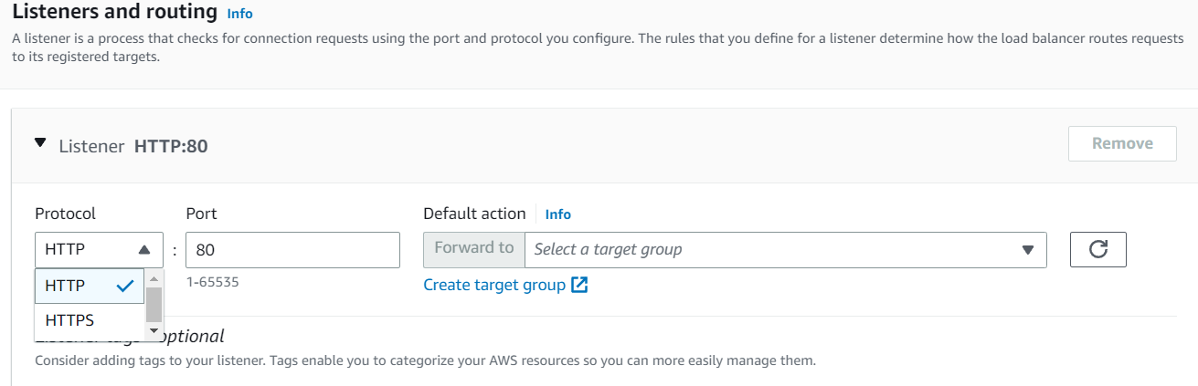

**“TARGET GROUPS”**

**Target groups route requests to one or more registered targets, such as EC2 instances, using the protocol and port number that you specify**

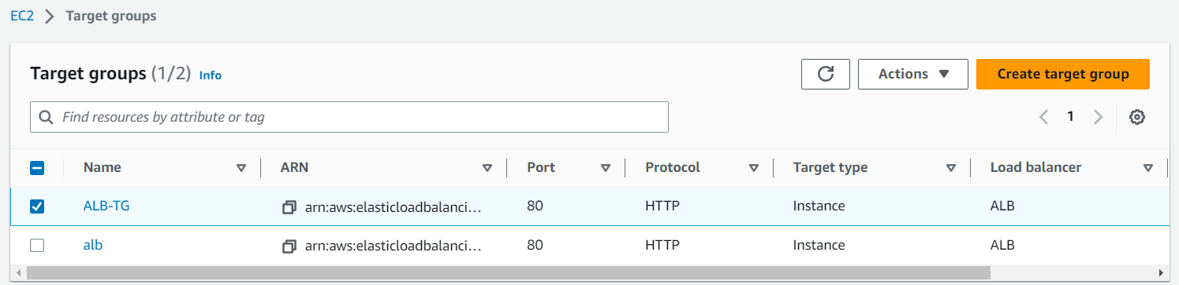

**C) NETWORK-LOAD-BALANCER**

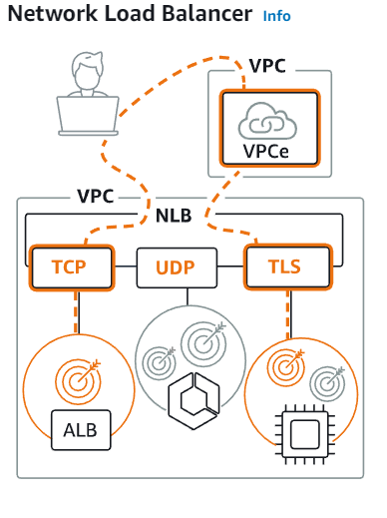

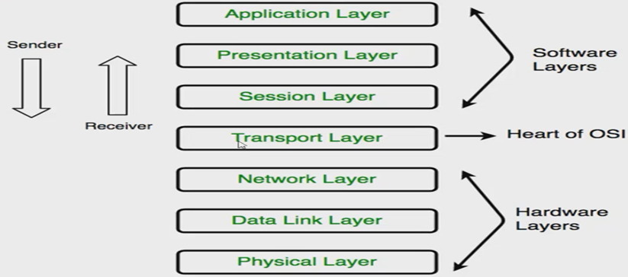

**\*\* IT WORKS ON SESSION LAYER and WE CAN ASSIGN ELASTIC IP TO NLB”**

**\*\* AND OTHER ALL PARAMETERS ARE SAME TO THE APPLICATION LB**

**2. Configure Classic Load balancer.**

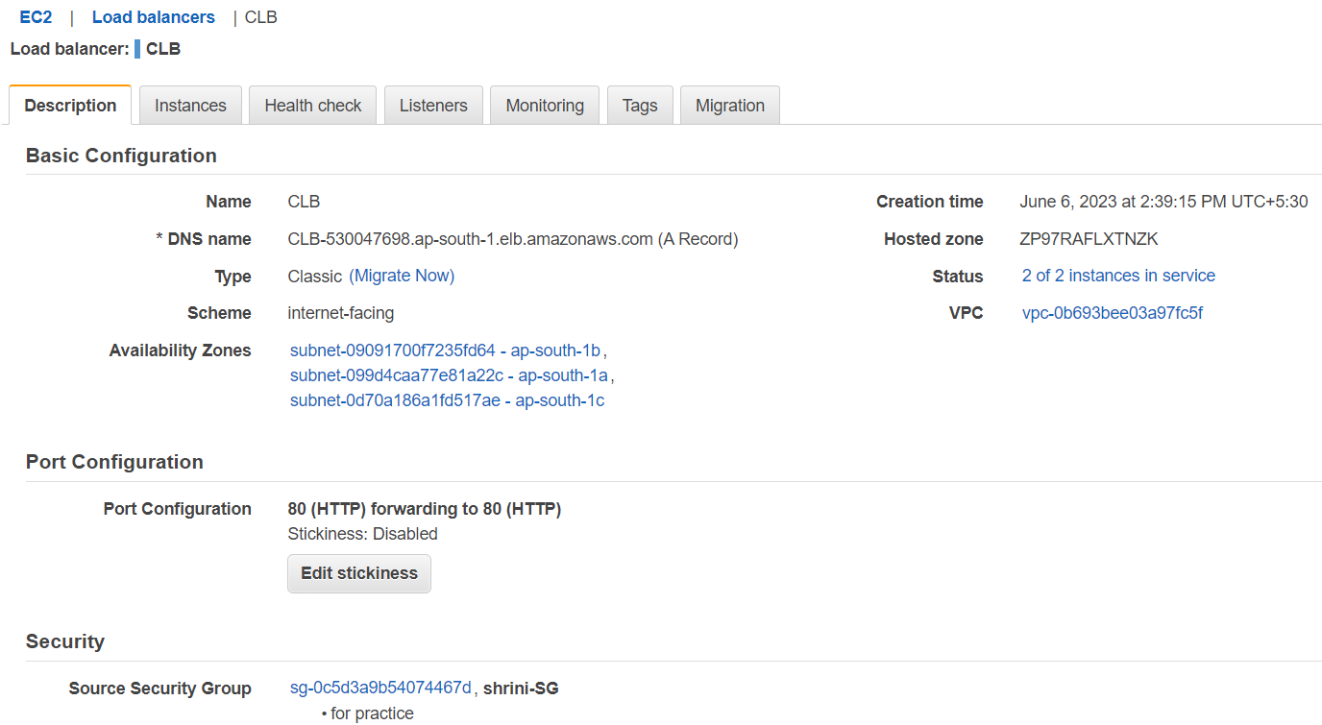

**\*\*if any one server having issue then CLB gives 300 seconds to hold on it**

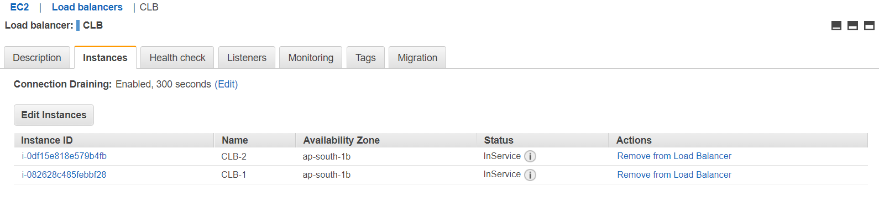

**\*\*With the help of CLB-DNS we can see the check it is controlling the traffic:  
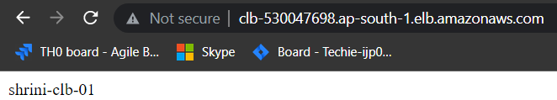**

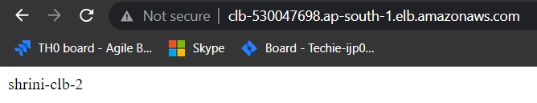

**3. Configure Application Load balancer**

* **We have to use prefix for verifying the ALB**
* **We have to create TARGET GROUP with proper configuration and also we can increase the health check status time by “200-499”**
* **After creating TG we have to connect the TG with the ALB**
* **In the listeners we are adding the port and rules to perform the ALB**

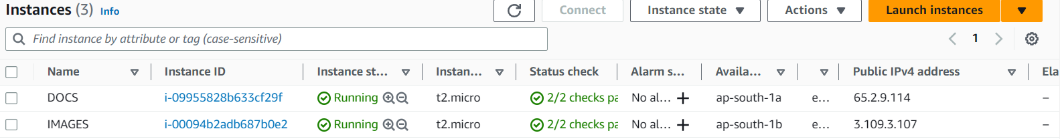

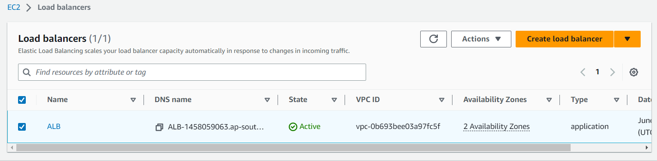

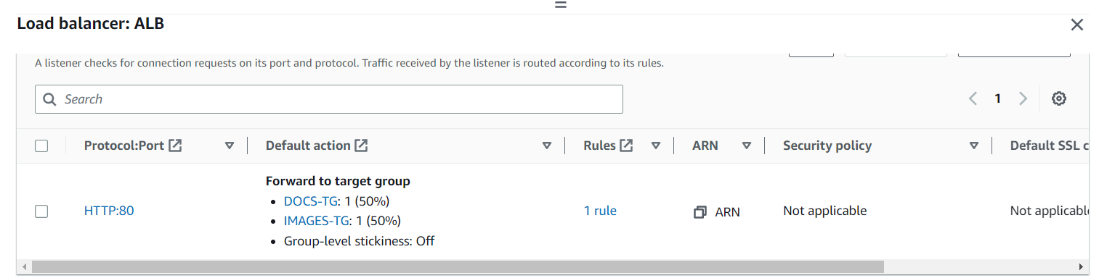

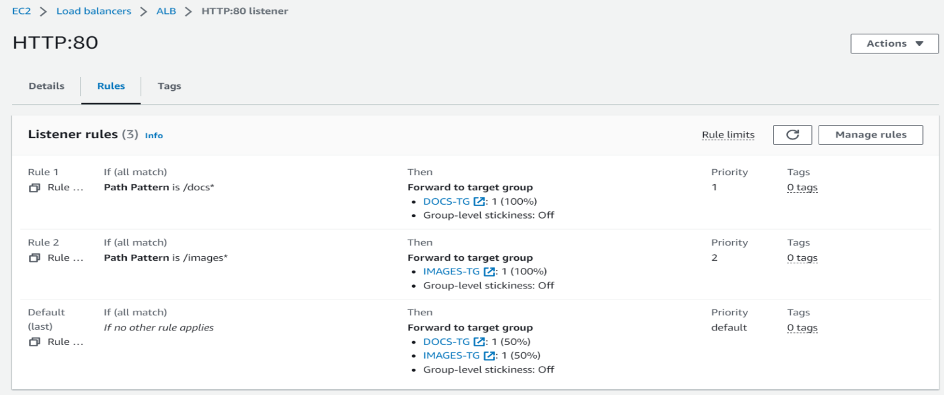

**TARGET GROUP**

**“A target group tells a load balancer where to direct traffic to : EC2 instances, fixed IP addresses, When creating a load balancer, you create one or more**[**listeners**](https://docs.aws.amazon.com/en_pv/elasticloadbalancing/latest/application/load-balancer-listeners.html)**and configure**[**listener rules**](https://docs.aws.amazon.com/en_pv/elasticloadbalancing/latest/application/listener-update-rules.html)**to direct the traffic to one target group.”**

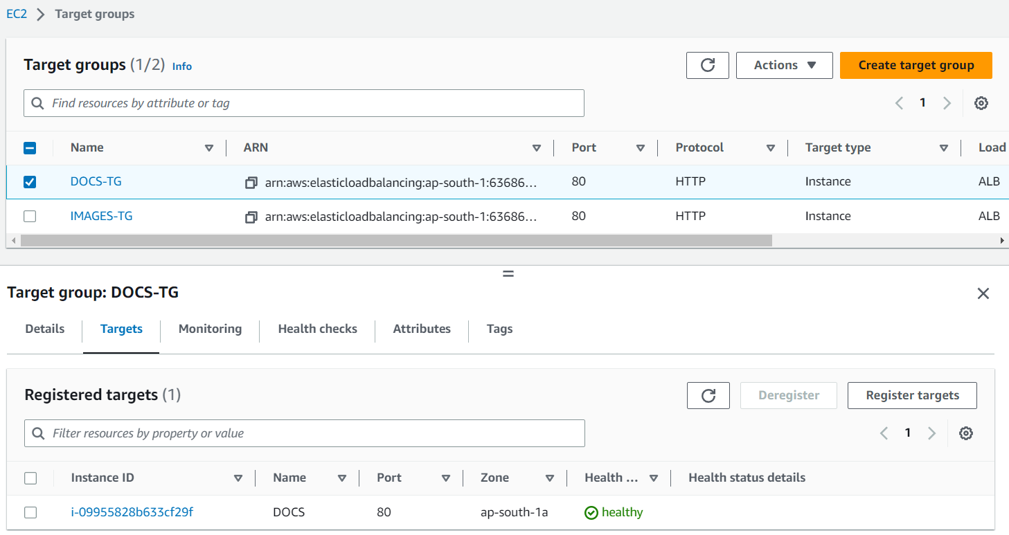

**4. Configure NETWORK Load balancer**

* **It only works on TCP and UDP(53) NETWORK PROTOCOL**
* **So we have to change the port of instances/Target Group with TCP and UDP**

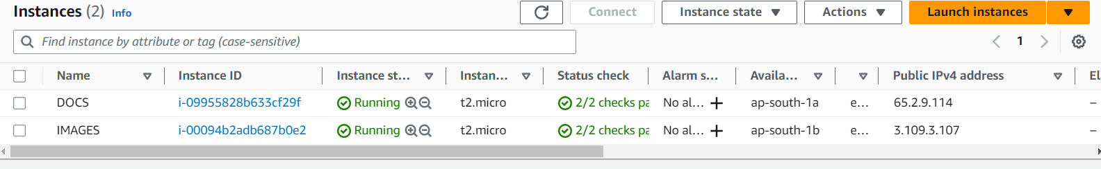

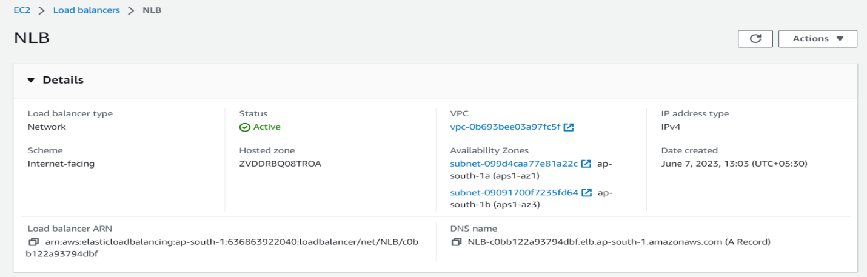

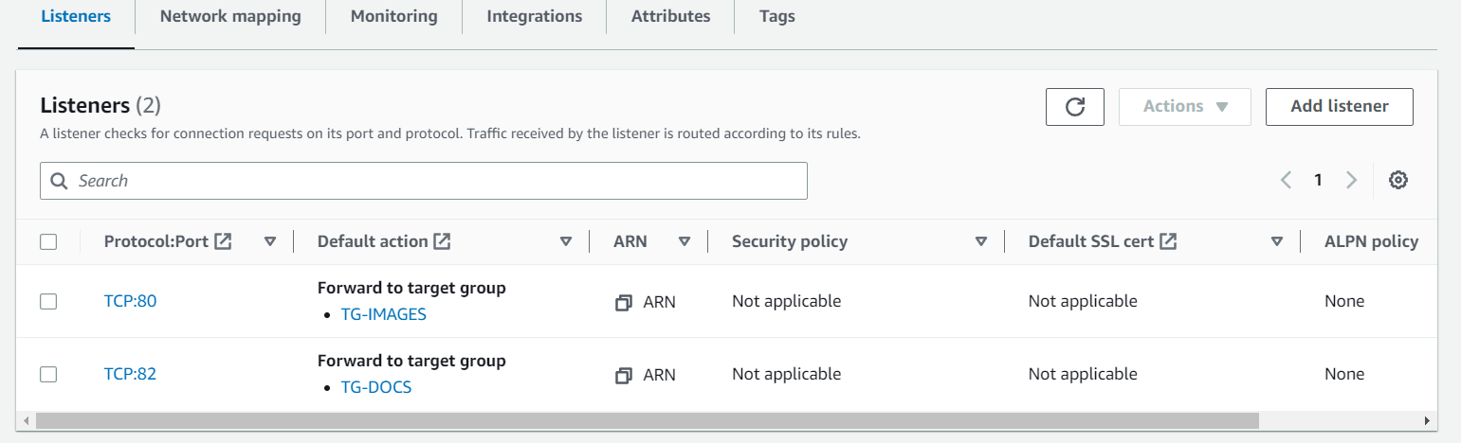

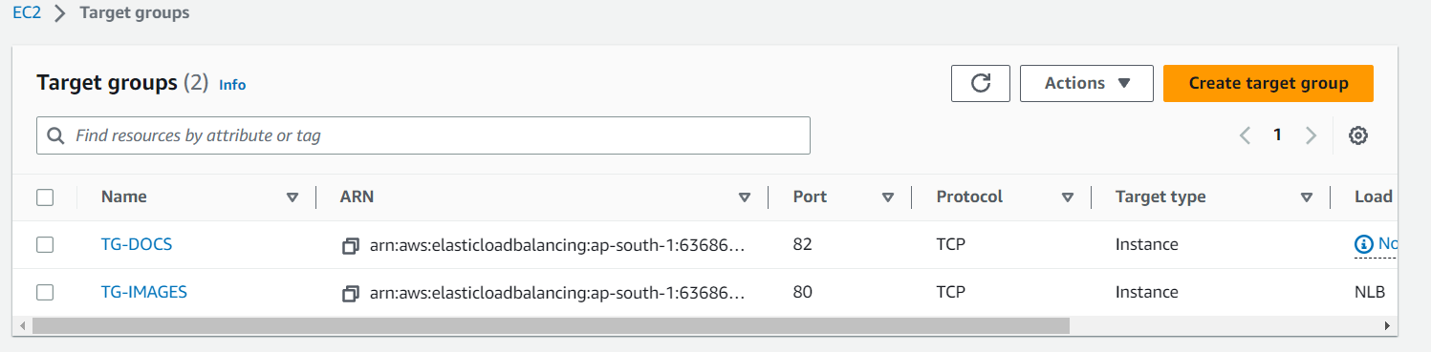

**5. Map any one Load balancer with R53 and also attach ssl certificate to Load balancer.**

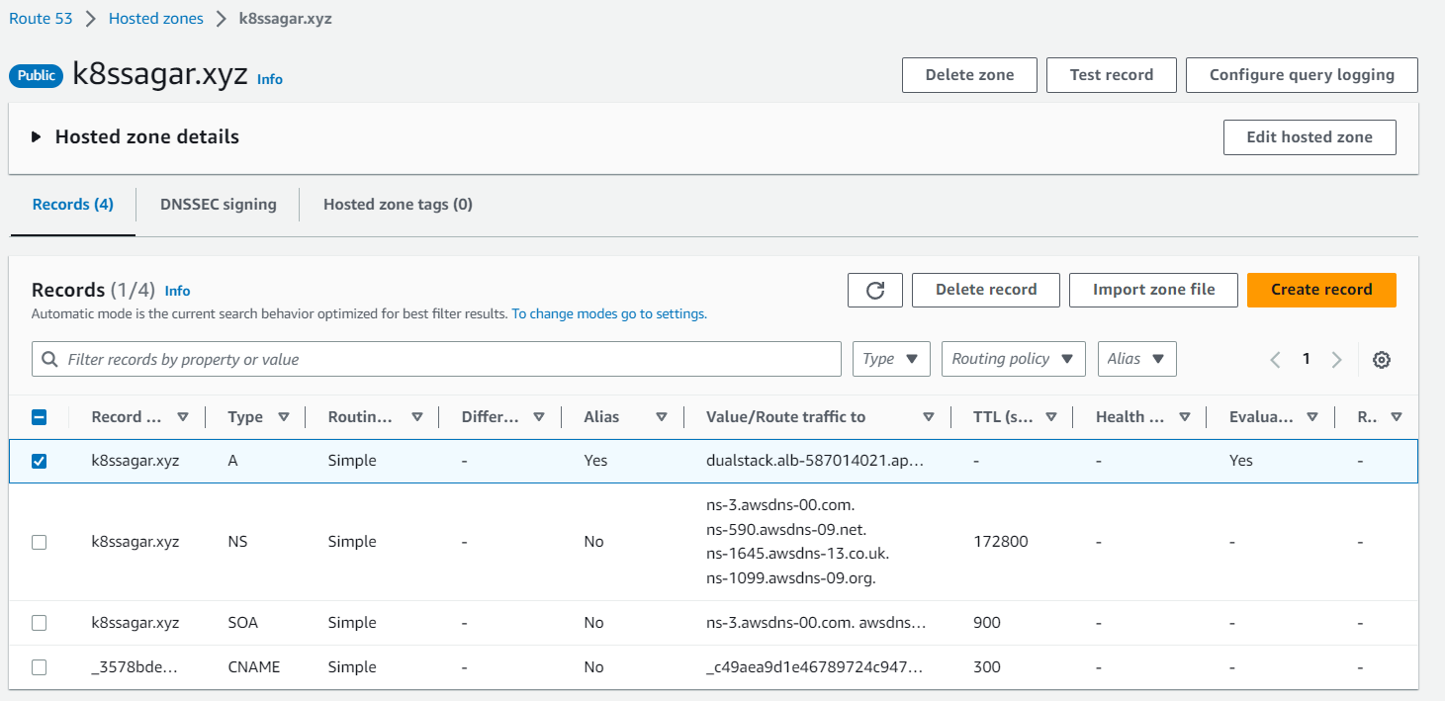

**DOMAIN NAME : k8ssagar.xyz /we have to add the HTTPS listeners to ALB   
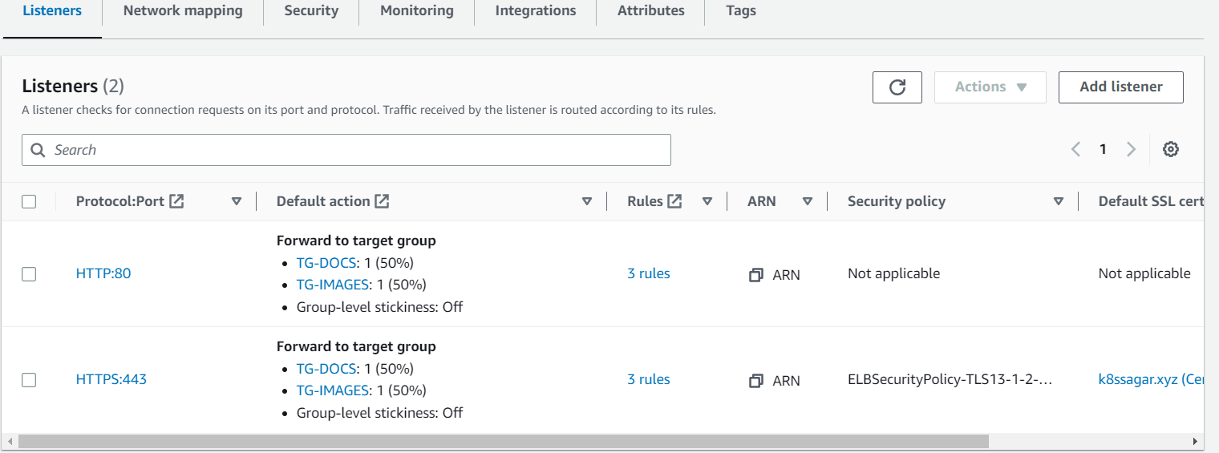**

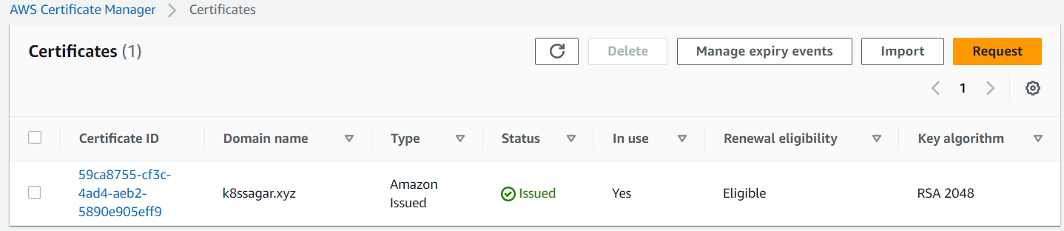

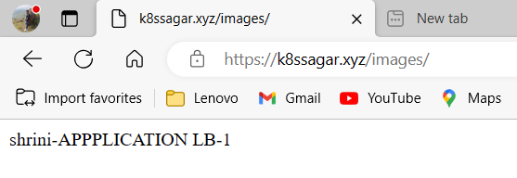

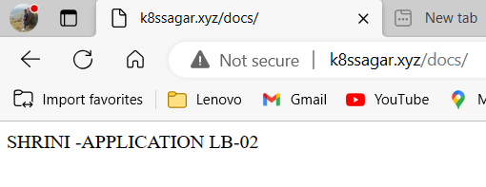

**6. Push application load balancer logs to s3 bucket.**

**FIRST GIVE A POLICY TO THE BUCKET AS GIVEN BELOW:-**

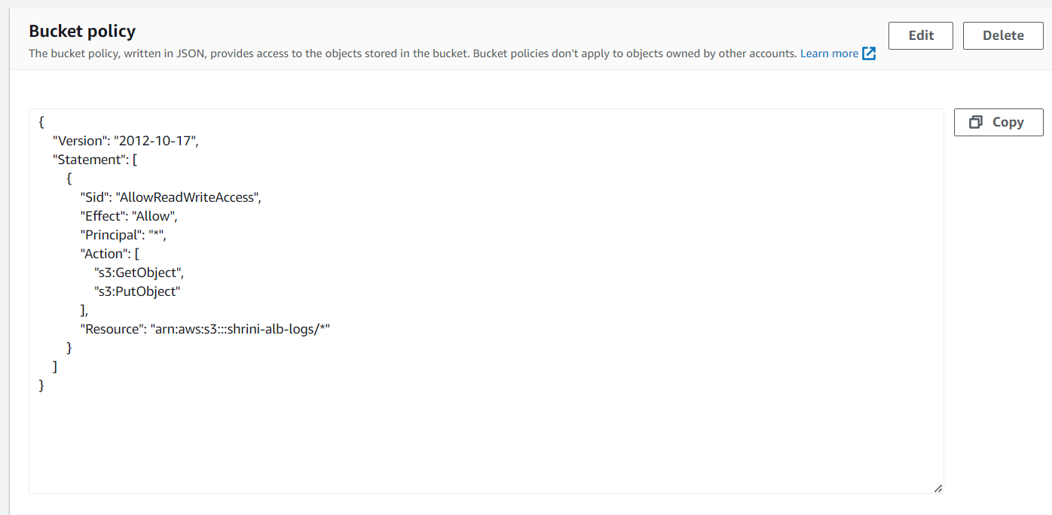

**THEN ON THE ATTRIBUTES OF YOUR “LB” JUST GIVE THE PERMISSION OF MONITORING ACESS LOG WITH THE GIVEN BUCKET URI  


