**1) Watch the video and write down notes**

**IAM USERS/GROUP/ROLES**

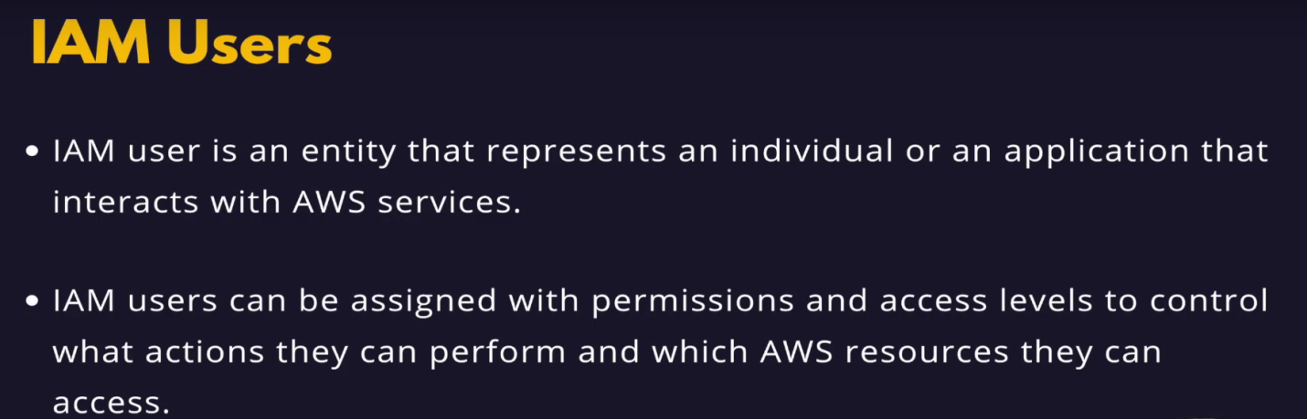

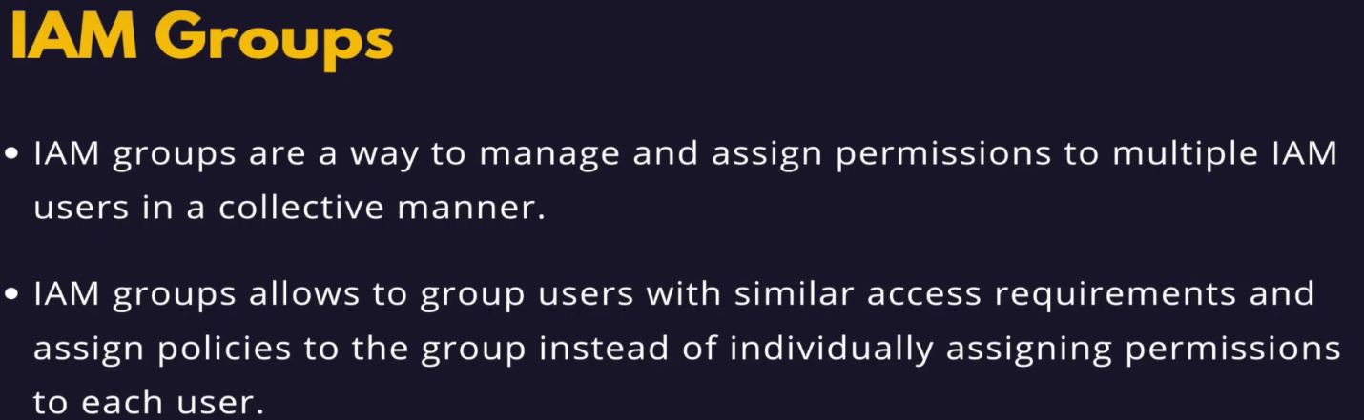

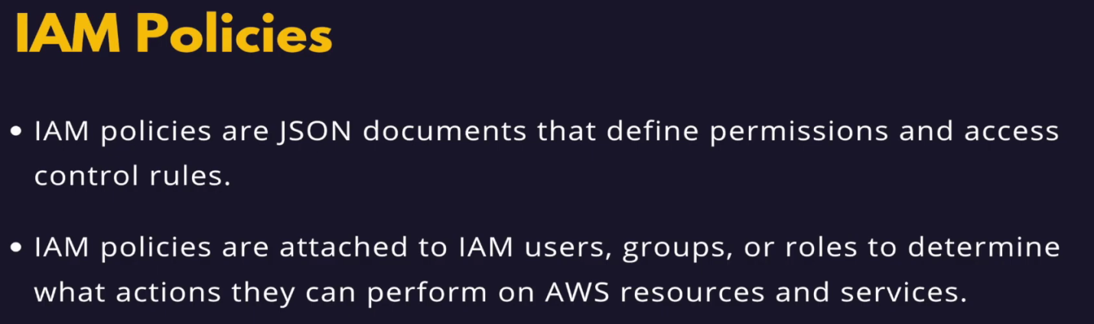

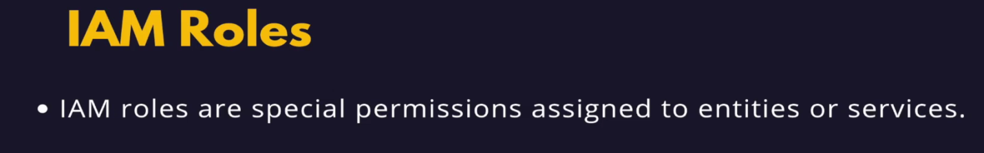

**2) Implement iam policy, roles and user**

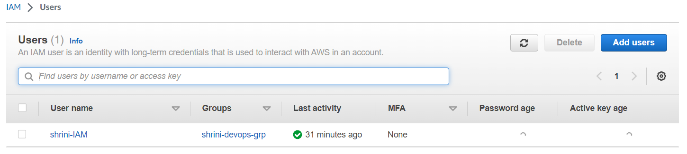

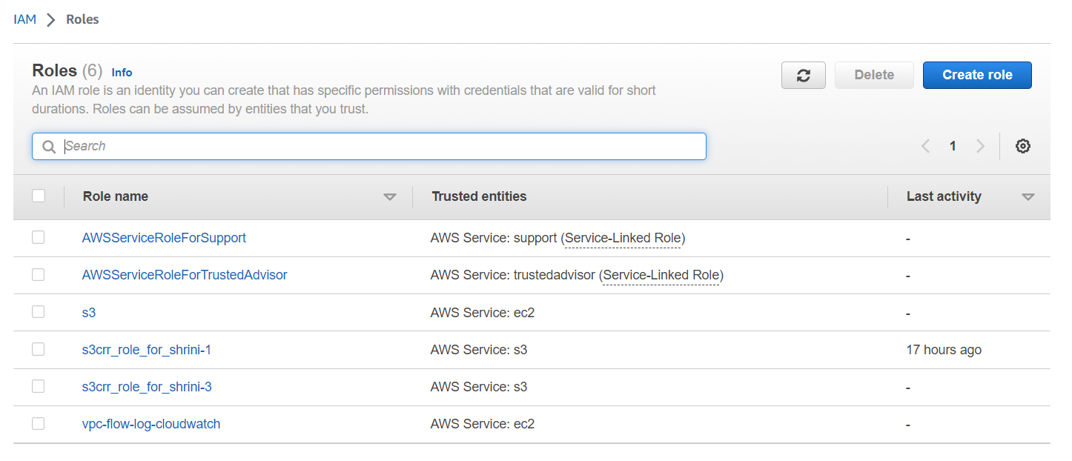

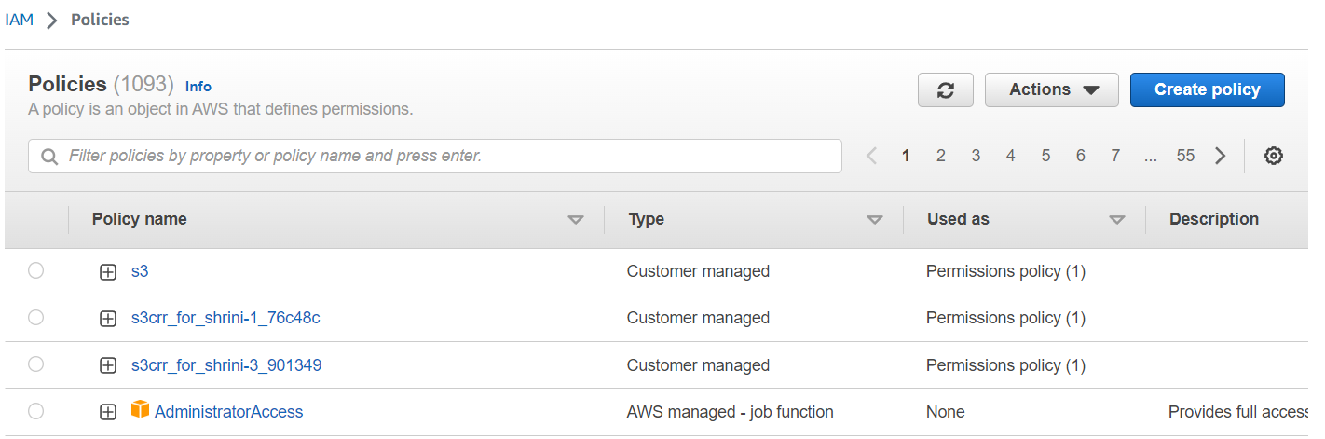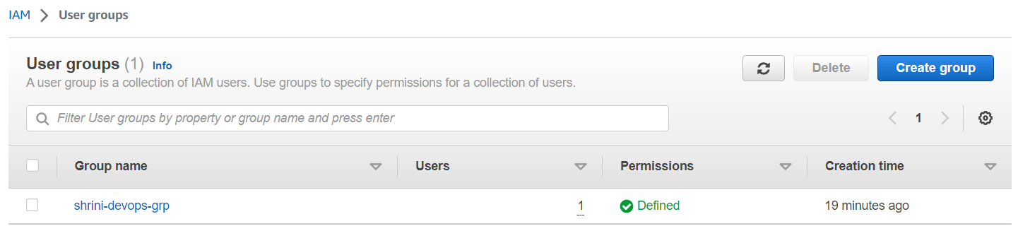

**3)** **Extend the instance type and volume of ec2**

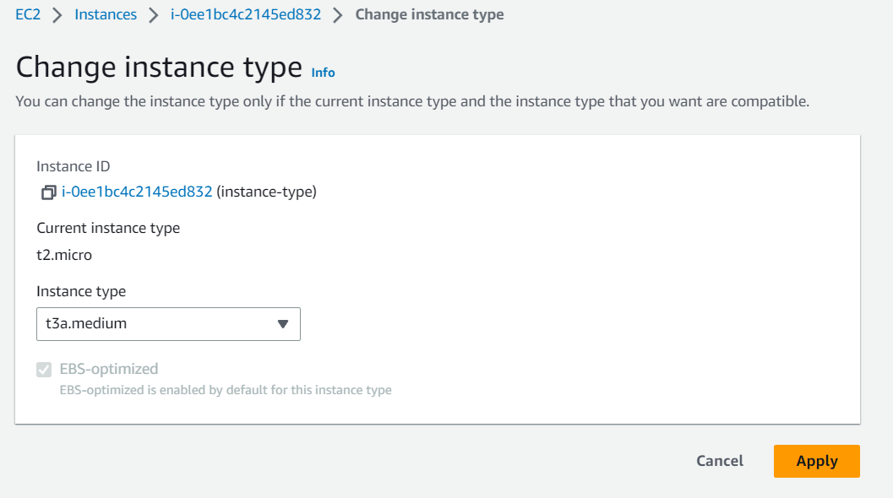

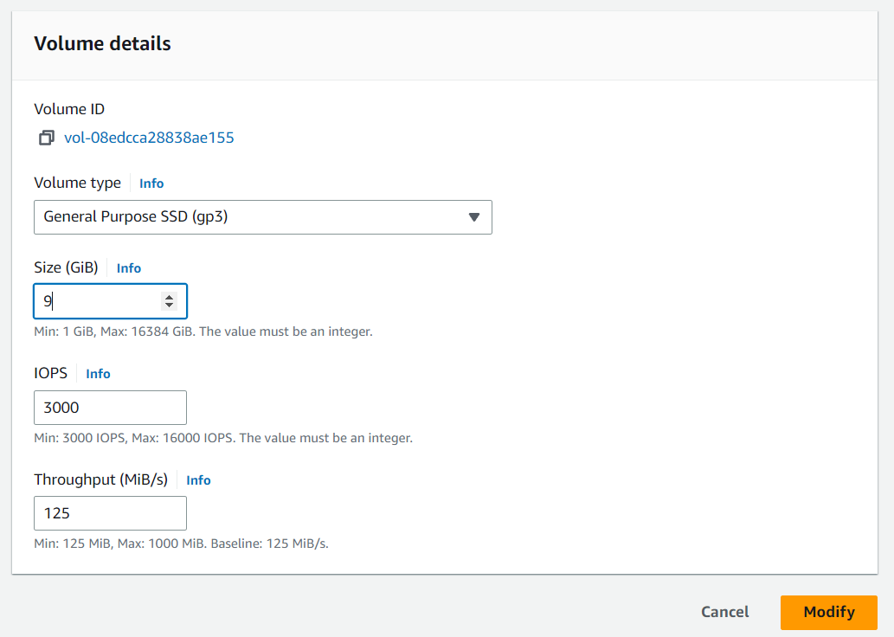

**4) Take snapshot of ec2 and launch new ec2**

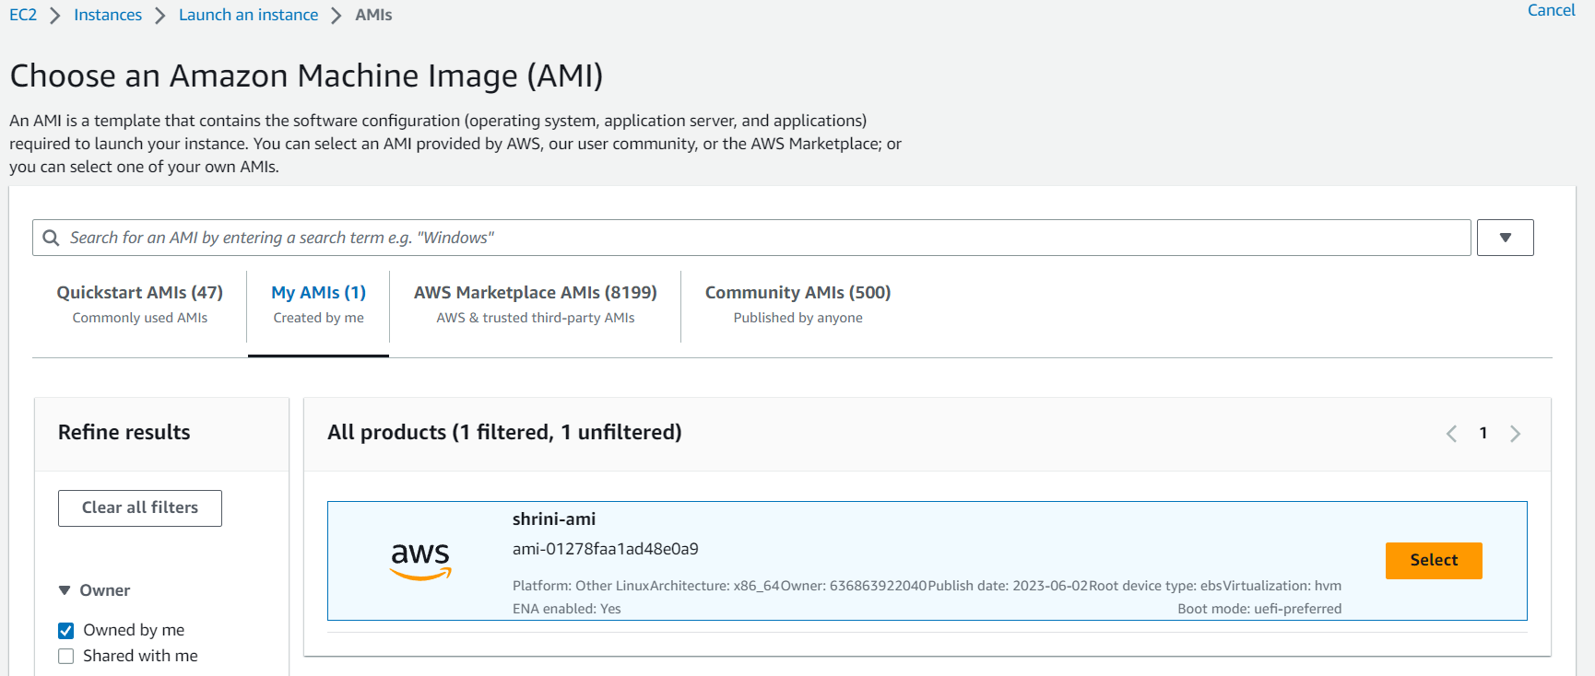

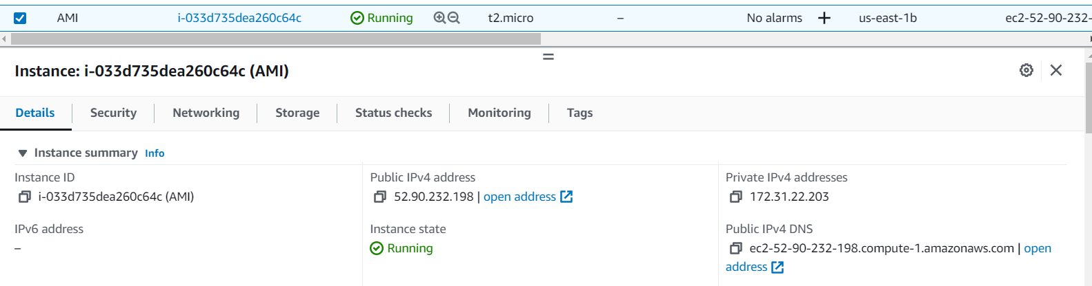

**5) Take snapshot of EBS volume**

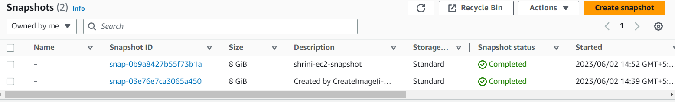

**6) Attach multiple volumes to one ec2**

