**1. Create s3 bucket and upload some random files and enable versioning, add bucket policy to make all objects public and attach lifecycle rules to s3 bucket**.

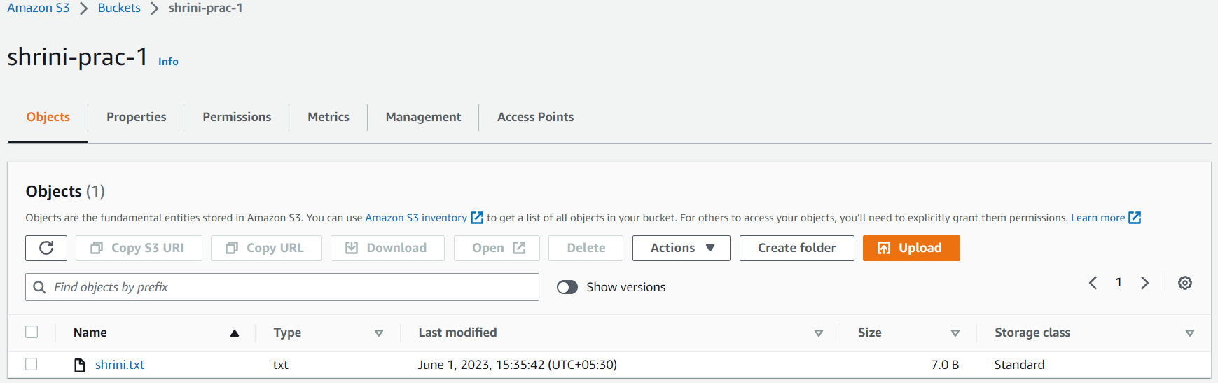

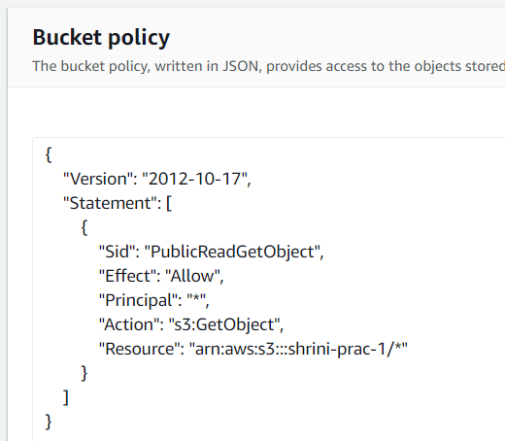

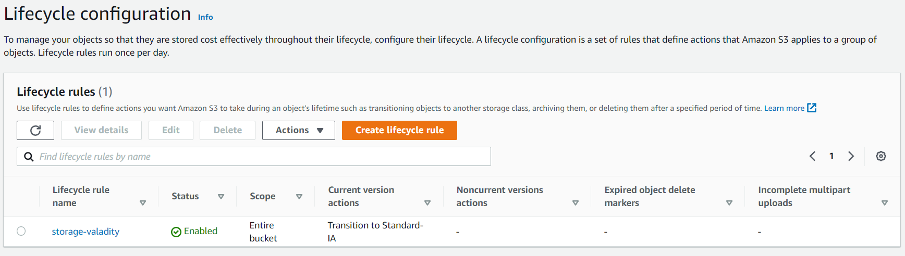

**2. Create s3 bucket and deploy static bucket in s3.**

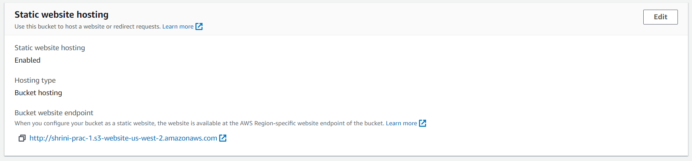

**3. Work on s3 cross region replication.**

