1) Installing GIT on a dir

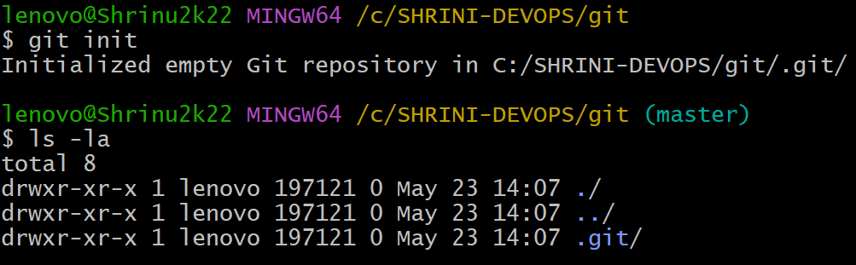

2) Creating a repo with Readme.md with .gitignore file

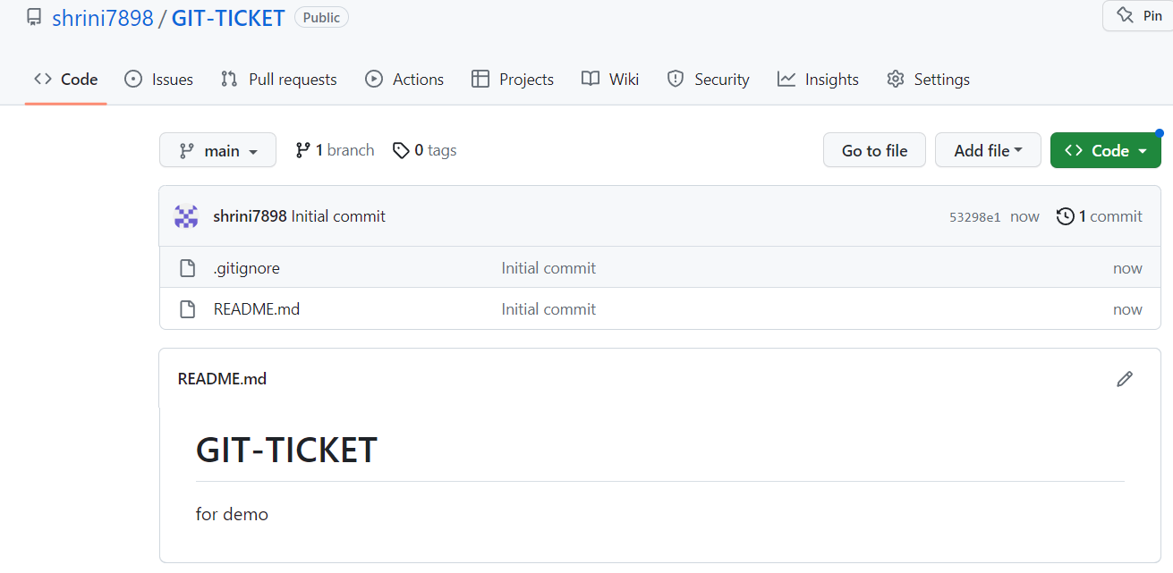

3) Clone the created repo to local.

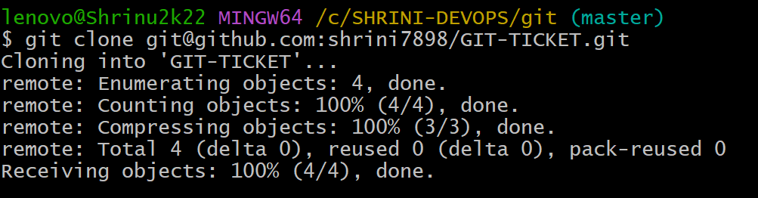

4) Create two files in local repo.

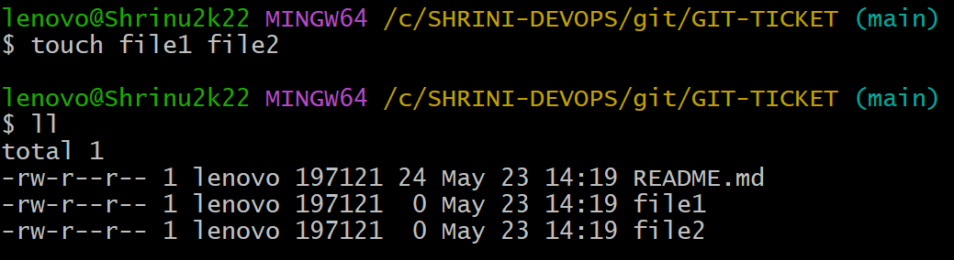

5) Commit two files and push to central Repository.

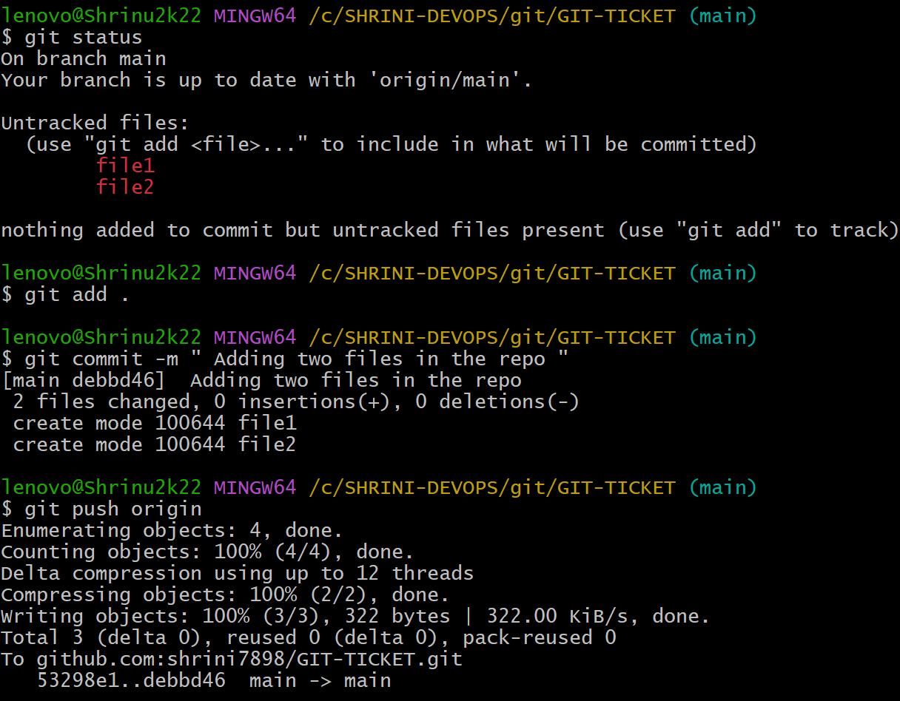

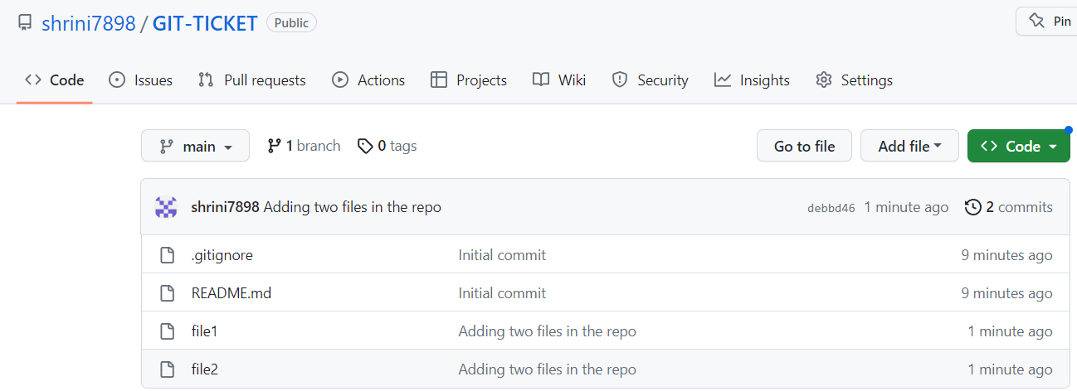

6) Create a branch in local and create a sample file and push to central.

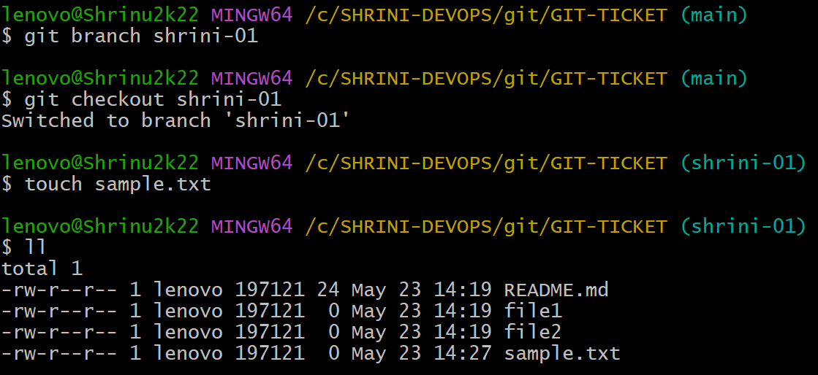

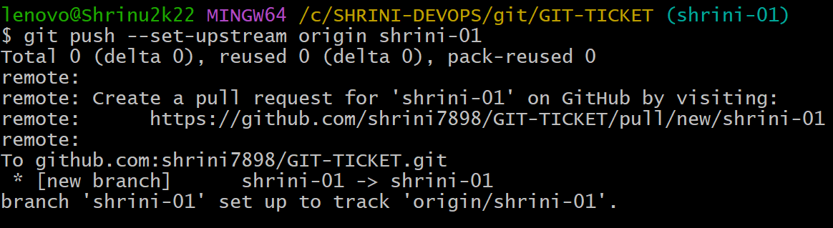

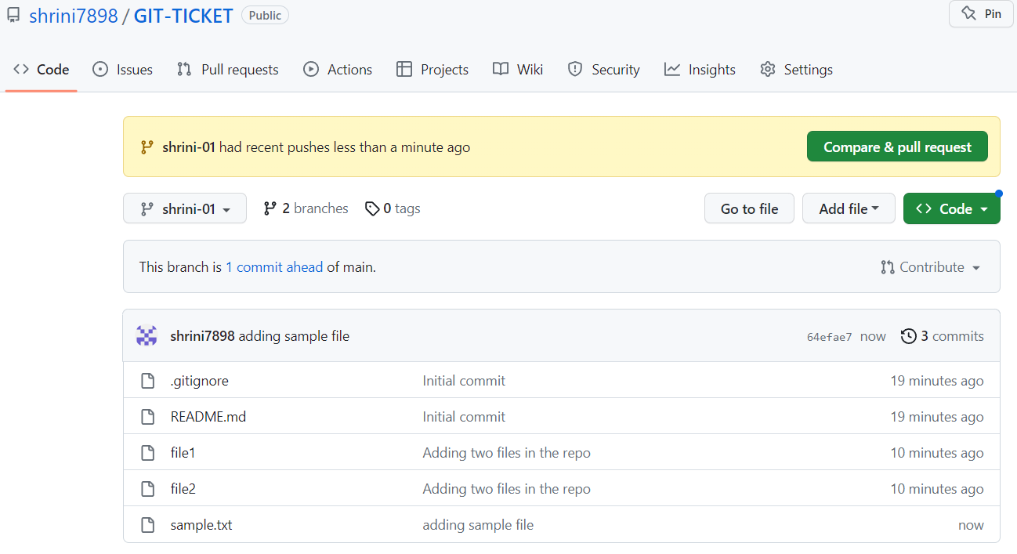

7) Create a branch in github and clone that to local.

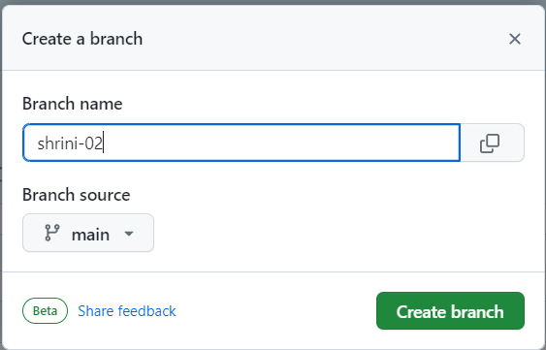

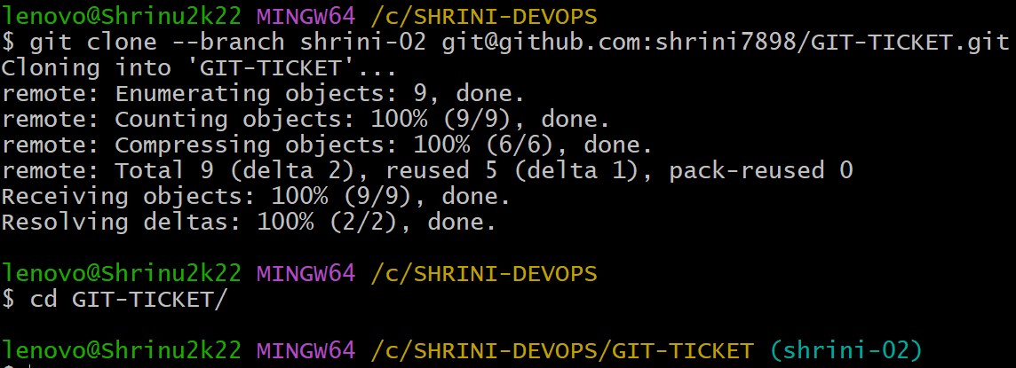

8) Merge the created branch with master in github by sending a pull request.

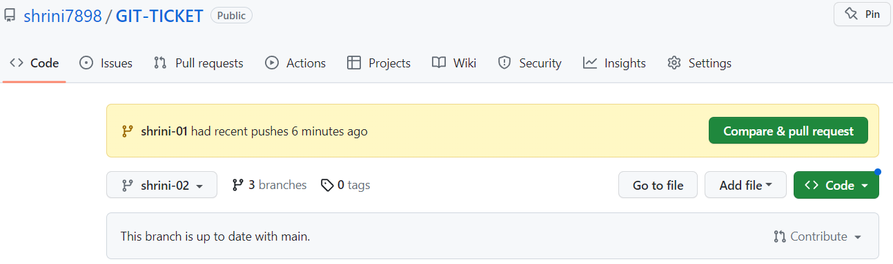



9) create a file in local and send that to branch in github.

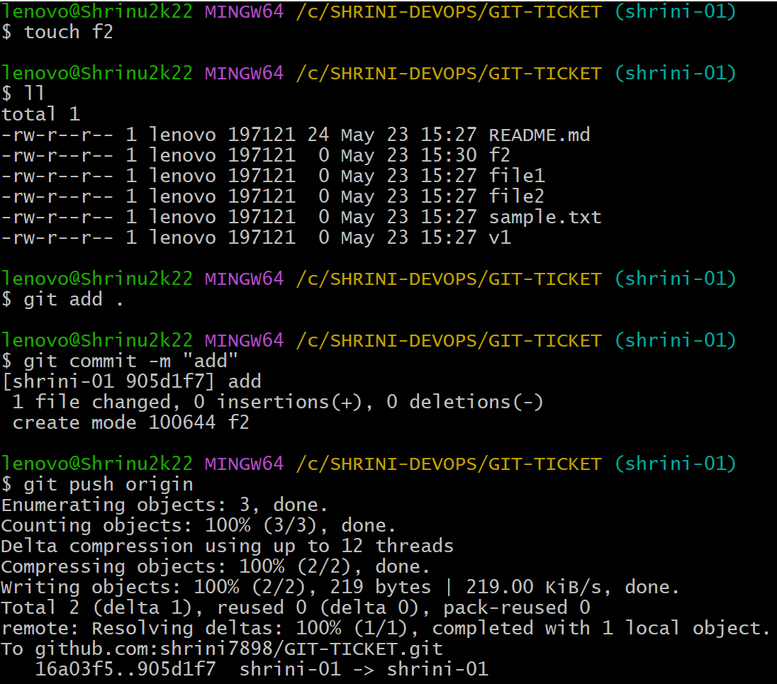

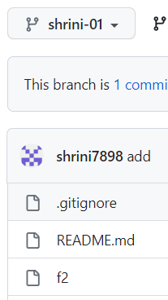

10) clone only a branch from github to local.

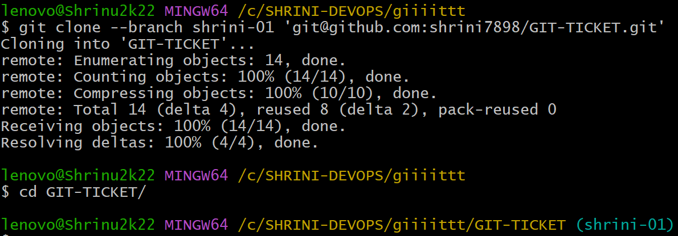

11) Revert a commited commit to the older version.

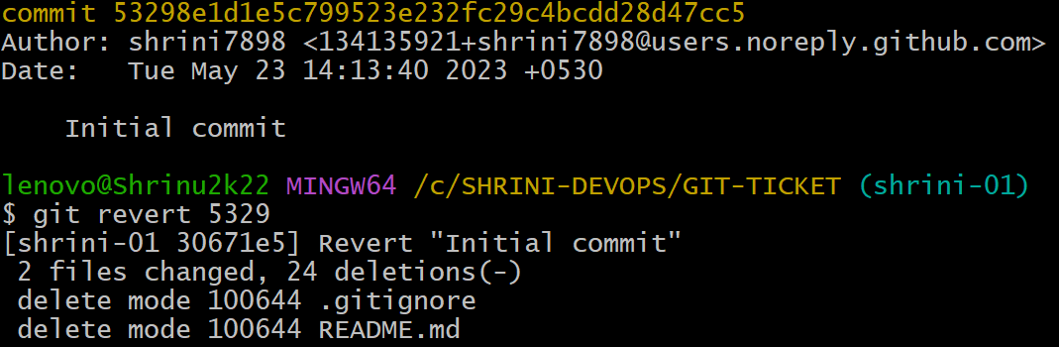

12) Check all the logs of git.

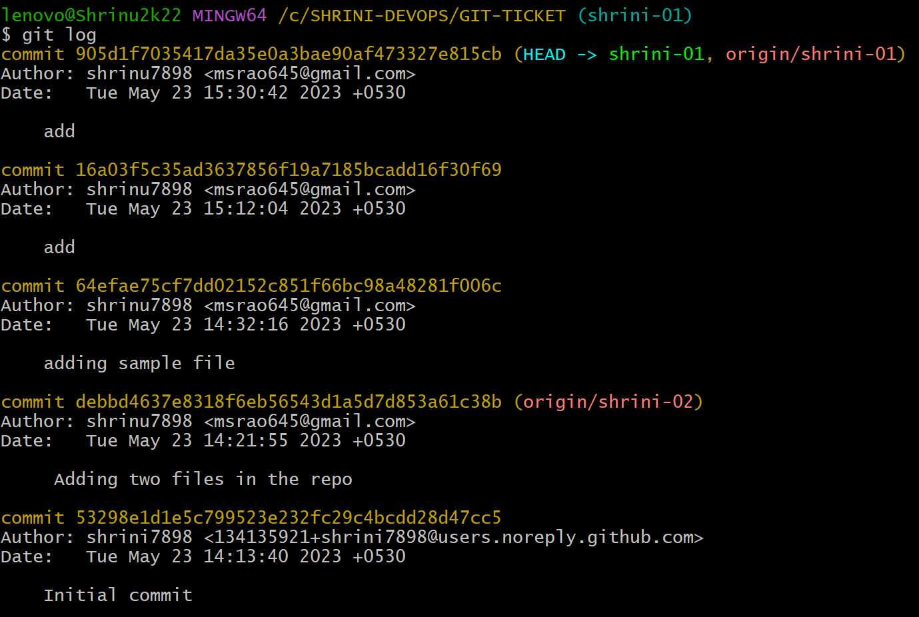

13) generate a ssh-keygen and configure into github.

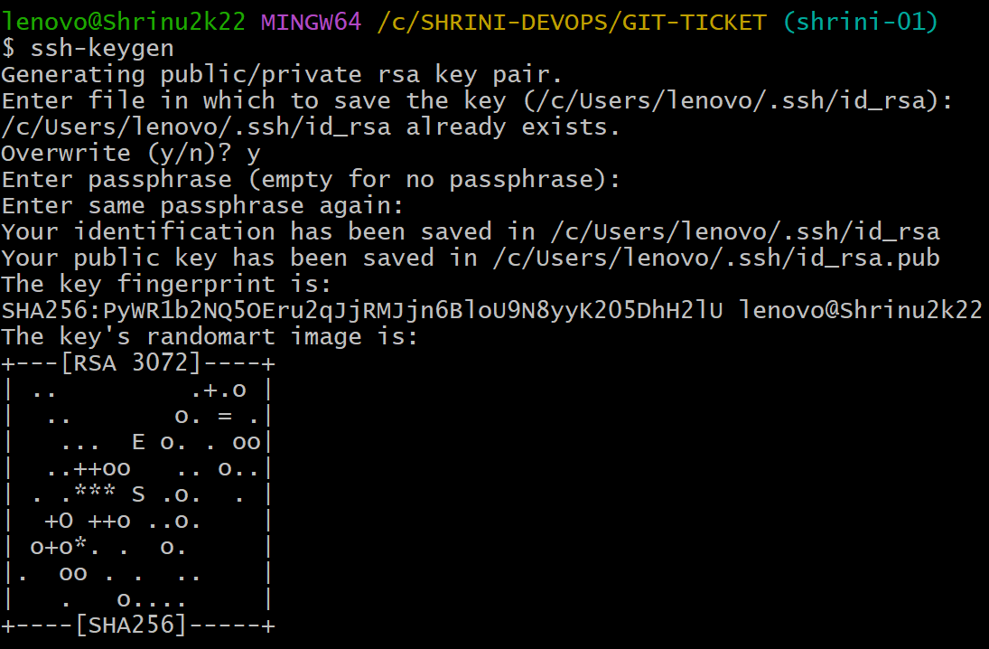

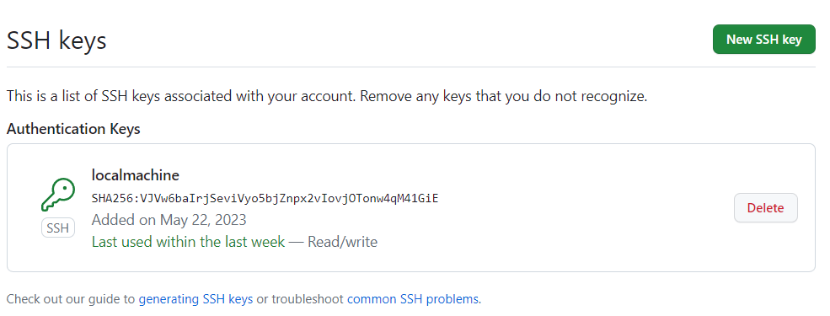

14) Basic understanding of .git file.

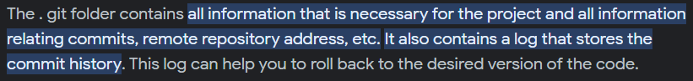

15) make a commit and make that commit reset without savings changes.

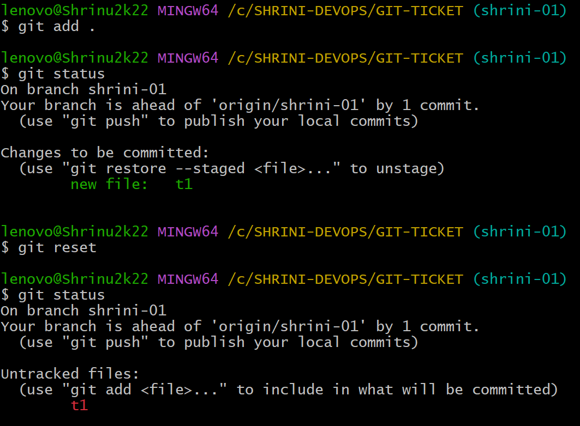

16) configure webhooks to github.

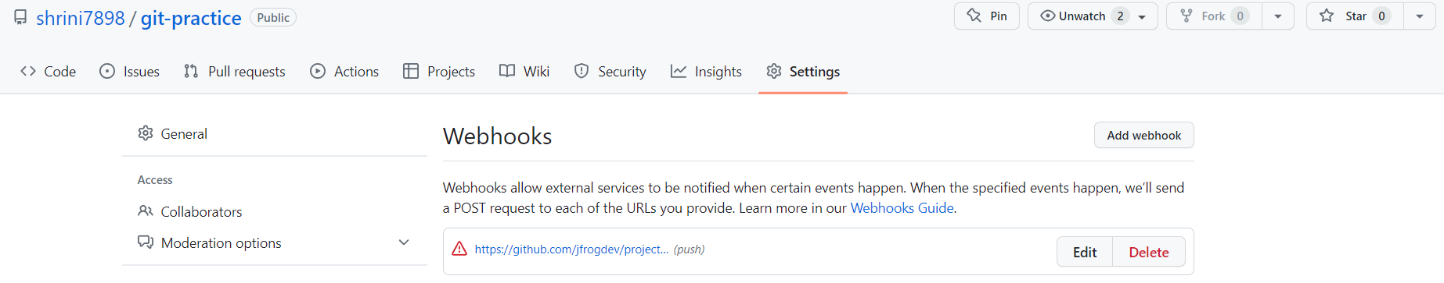

17) push a file to stack without savings the changes and work on another file.

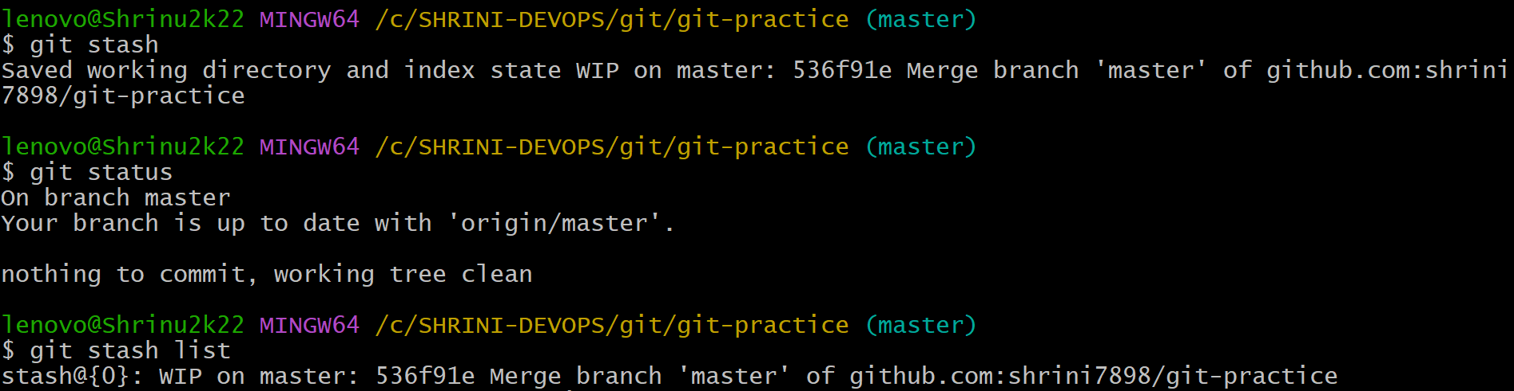

18) undo the stack file and start working on that again.

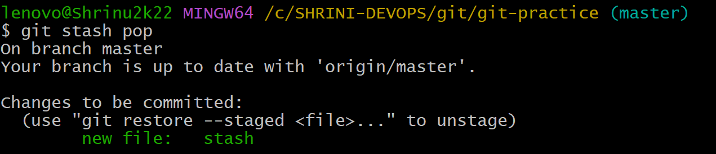

19) create a file with all passwords and make that untrackable with git

