**GIT**

**Git is a version control system that tracks changes in any set of computer files, usually used for coordinating work among programmers collaboratively developing source code during software development**

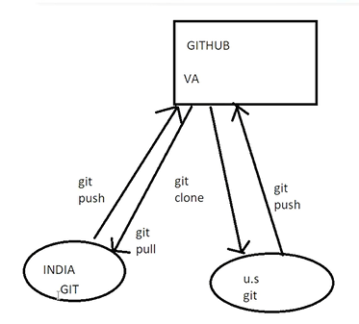

**GITHUB**

**Git hub is a web-based interface of git, it is open source version control software that lets multiple people make separate changes to web-page at the same time**

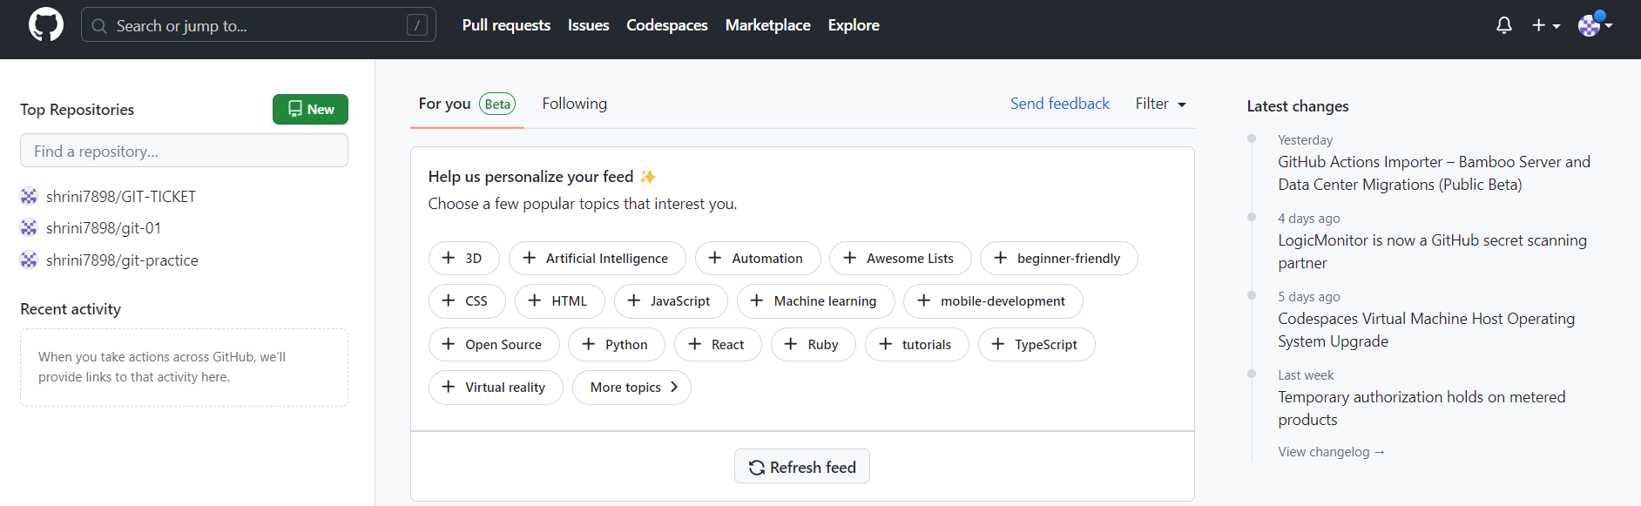

**GIT-BASH**

**Git Bash is an application for Microsoft Windows environments which provides an emulation layer for a Git command line experience.**

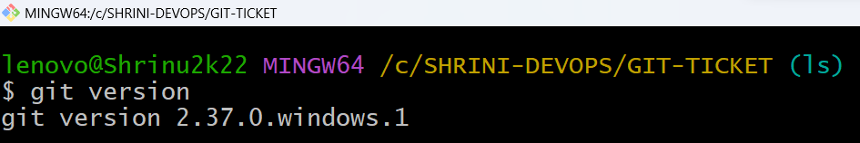

**Here are the top 18 Git commands which we use in daily-cases:-**

**1) git init**

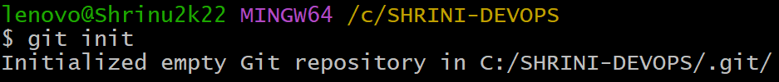**2)** **git add**

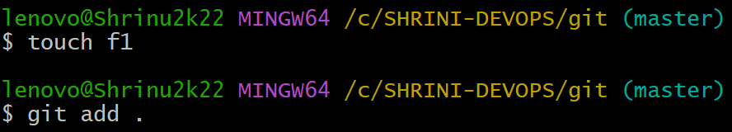**3)** **git commit**

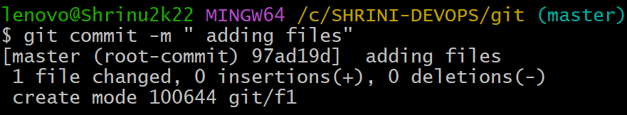**4)** **git status**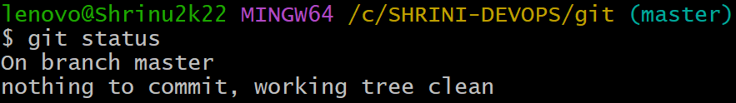

**5) git remote add origin  
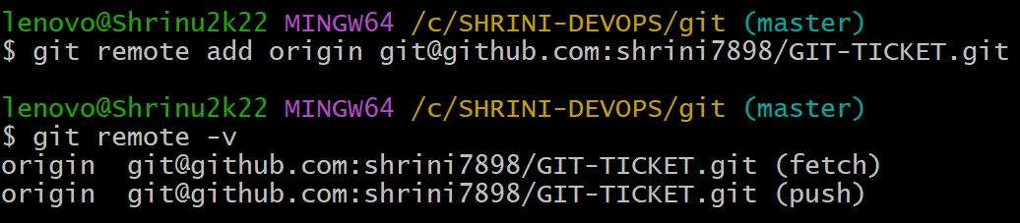 6) ssh-keygen  
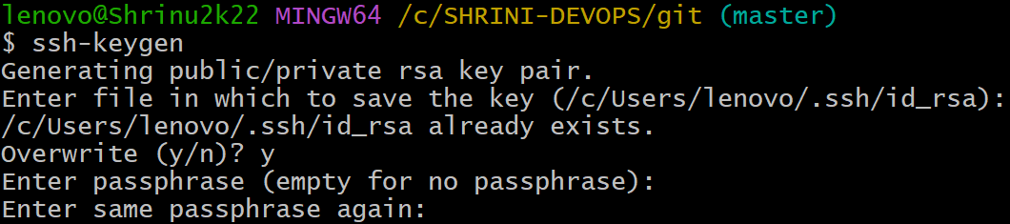7)** **git push –set-upstream origin master  
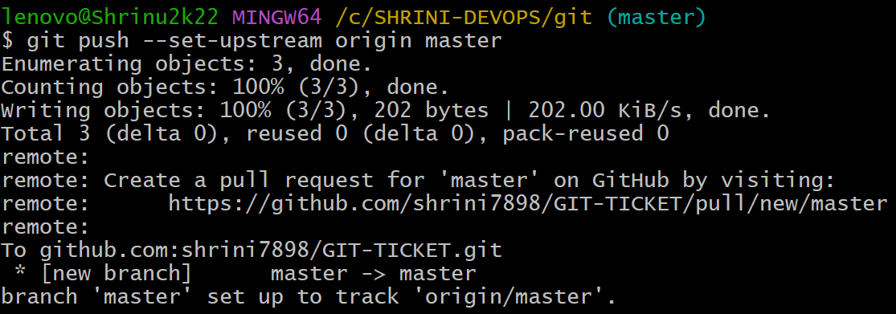8) git branch /git branch -m  
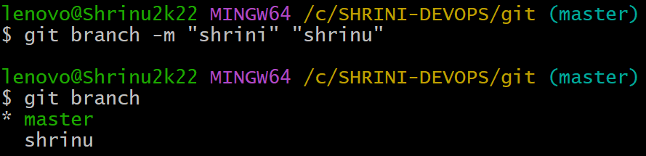9)** **git checkout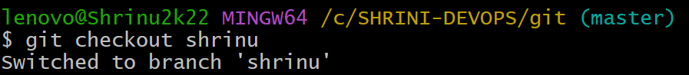10)** **git log/log -1  
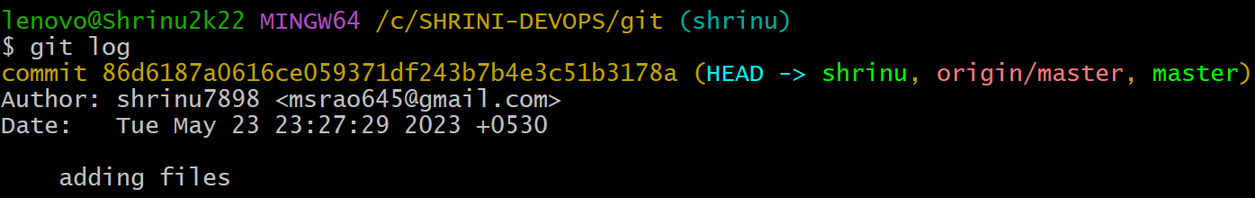11)** **git revert  
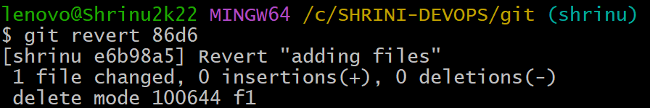12)** **git reset  
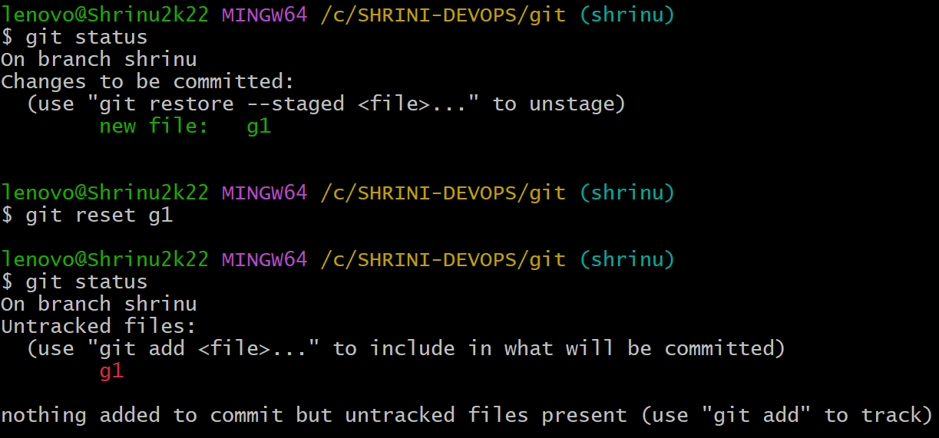13)** **git clone  
