**EKS  
ELASTIC KUBERNETES SERVICE**

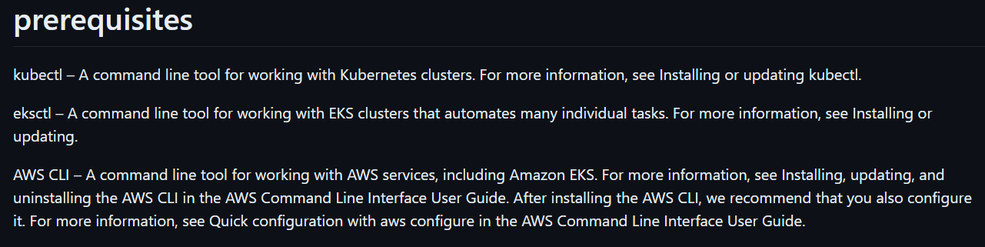

**EKSCTL -- INSTALLATION:**

[**https://github.com/eksctl-io/eksctl/blob/main/README.md#installation**](https://github.com/eksctl-io/eksctl/blob/main/README.md#installation)

**AWSCLI – INSTALLATION:**

[**https://docs.aws.amazon.com/cli/latest/userguide/getting-started-install.html**](https://docs.aws.amazon.com/cli/latest/userguide/getting-started-install.html)

**After installing aws cli we have to configure AWS account in our local terminal,**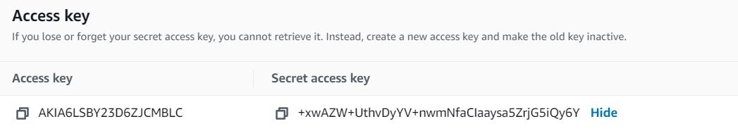

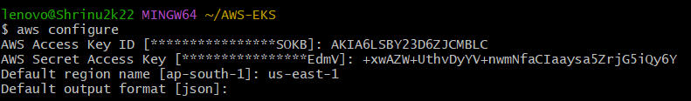

**Creation:**

**EKSCTL it’s a command line utility by which we can create our cluster.**

**[ eksctl create cluster --name demo-cluster --region us-east-1 –fargate ]**

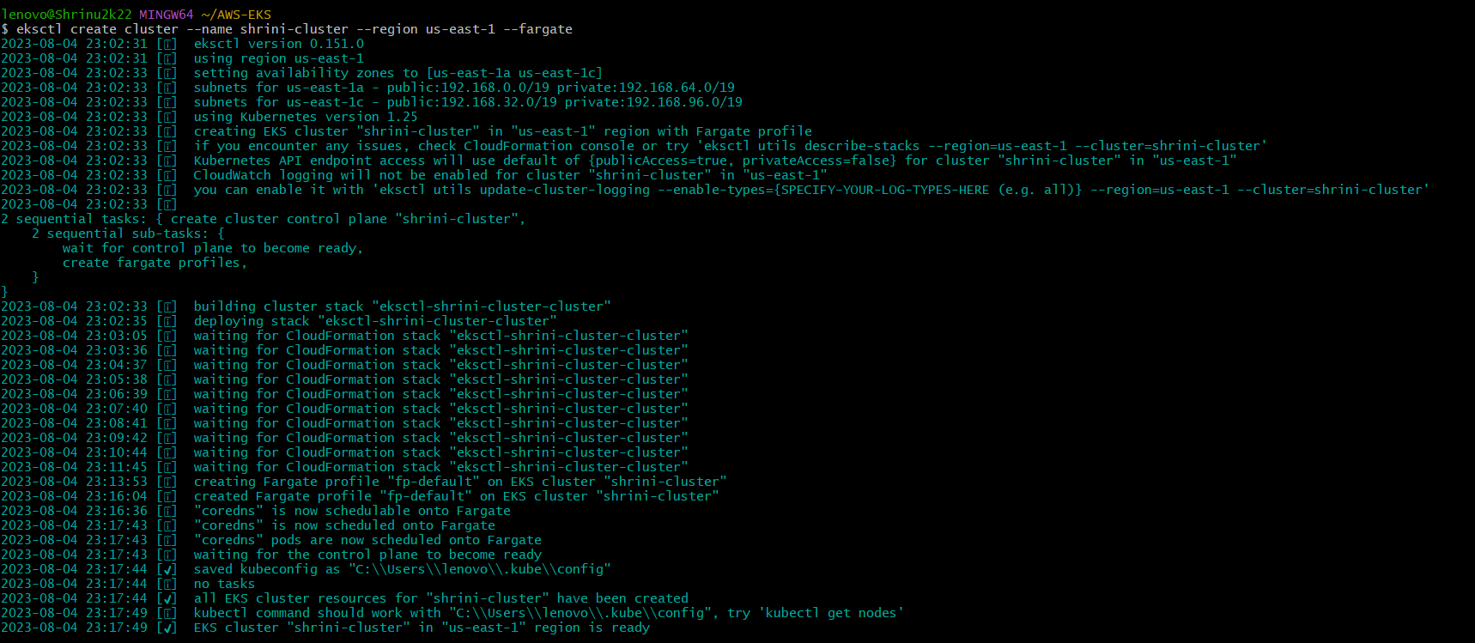

**It will create all the networking and configurations which is required to create EKS cluster like: VPC, SUBNETS (PUB, PRIVATE, NODES) etc**

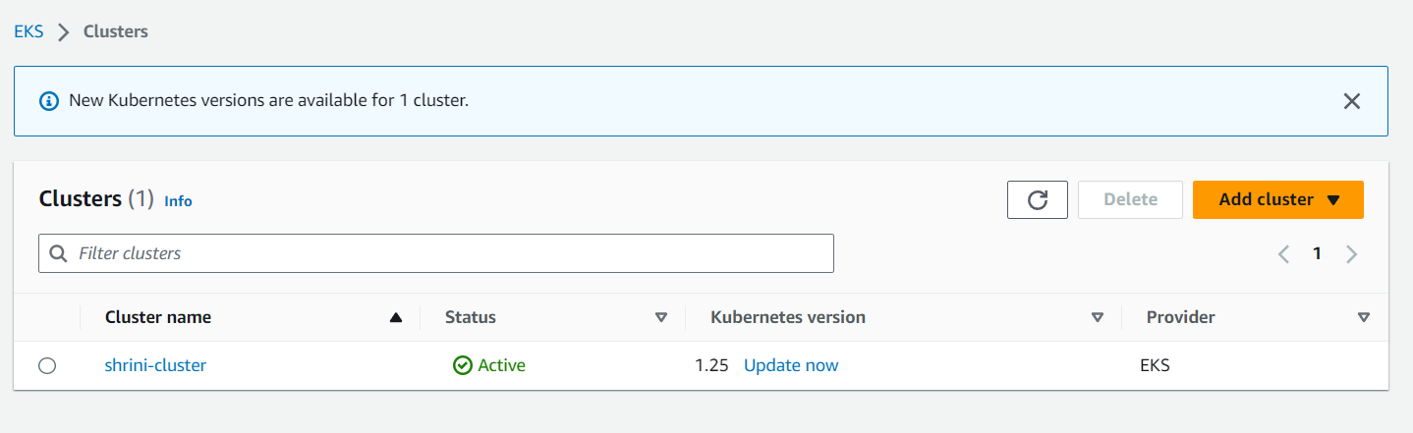

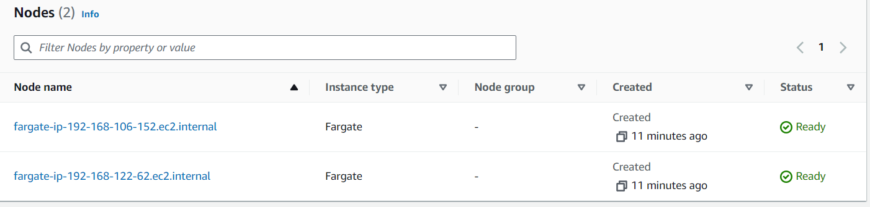

**And it also creates our contexts which are getting saved by “.kube/config file”.**

**We can also create by AWS console side but it will easier to create by eksctl because it can manage all the required details:**

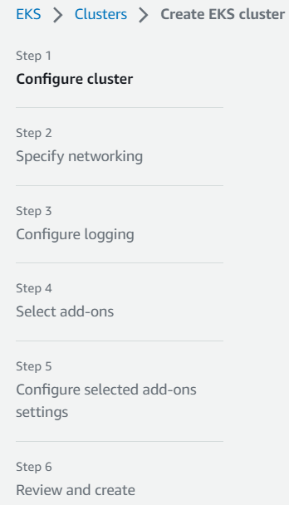

**Another advantage of EKS it provides dashboard also of k8s:**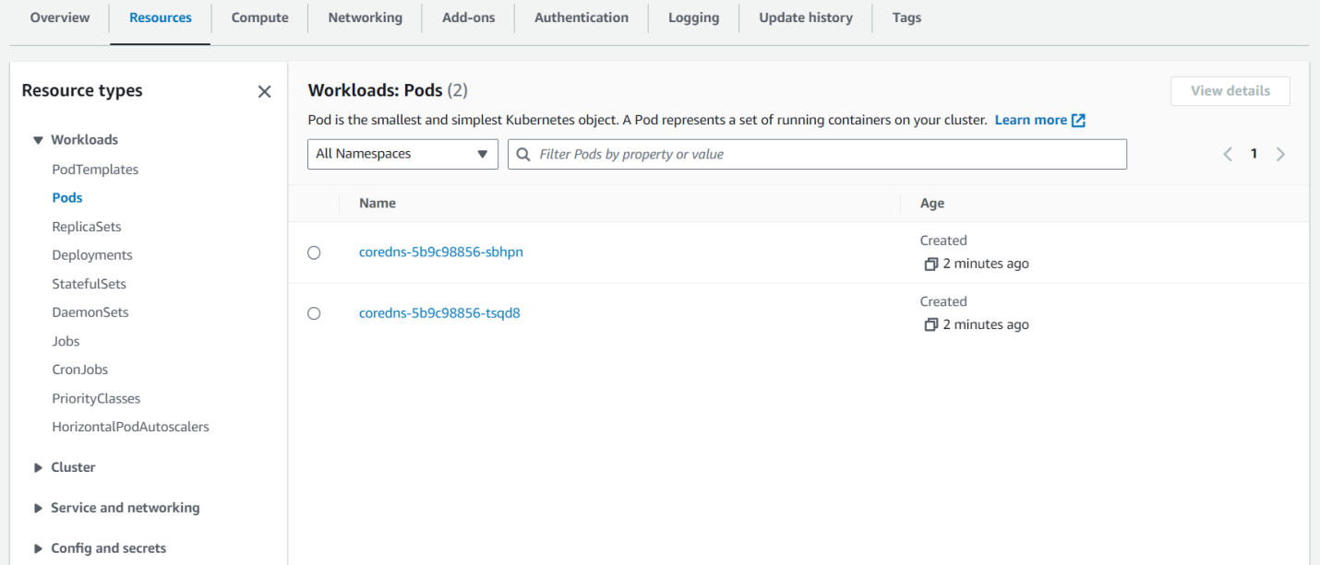

**Cluster details:**

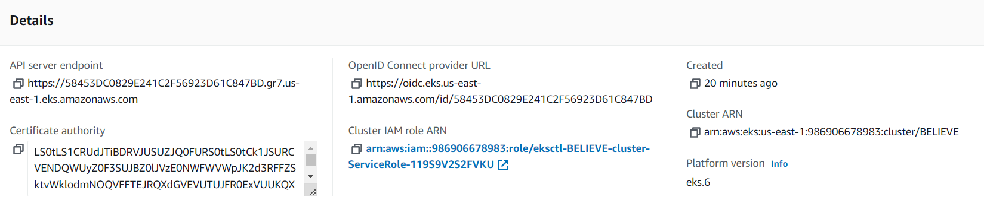

**OpenID Connect Provider URL:**

**In our cluster we can add any identity provider like keycloack, octa, and identity provider is used for authorization purpose, we are using IAM identity provider to get the access of all aws resources.**

**For e.g login with FB, GMAIL so these are working by Identity provider**

**And after this if we want to do this activities from my local machine like to do kubectl commands so for this we have to create kube-config file by run the below command:**

[aws eks update-kubeconfig --name BELIEVE --region us-east-1]

**And you can check here we are executing kubectl command:**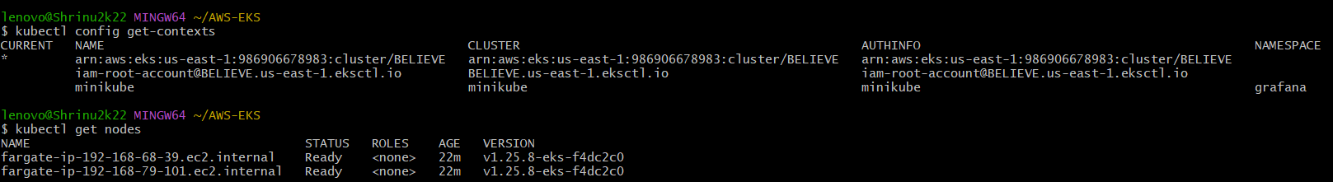

**Now we are deploying our application into pods by using below command it create some resources which we mentioned on our manifest YAML file:**

**[kubectl apply -f https://raw.githubusercontent.com/kubernetes-sigs/aws-load-balancer- controller/v2.5.4/docs/examples/2048/2048_full.yaml ]**



**Our application is also deployed in the pod:**

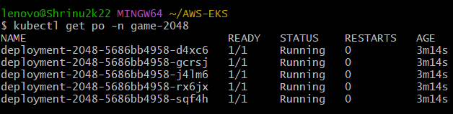

**Then if you want to access this application outside the cluster with our desired DNS so we have to create ingress controller: 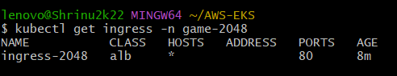  
Because as you see in above there is no address on it so we have to configure and for that we to create IAM OIDC,**

**Before installing controller we have prerequisite of OIDC which can install by running these command:**

* **export cluster_name=BELIEVE**
* **eksctl utils associate-iam-oidc-provider --cluster $cluster_name –approve**

**Now, we can install ALB-CONTROLLER FOR INGRESS:For this we have to create IAM policy and attached to the cluster you can find out by these URL:**[**https://raw.githubusercontent.com/kubernetes-sigs/aws-load-balancer-controller/v2.5.4/docs/install/iam_policy.json**](https://raw.githubusercontent.com/kubernetes-sigs/aws-load-balancer-controller/v2.5.4/docs/install/iam_policy.json)****

**Now after downloading the policy we have to create it by these commands:**

**aws iam create-policy \**

**--policy-name AWSLoadBalancerControllerIAMPolicy \**

**--policy-document** **file://iam_policy.json**

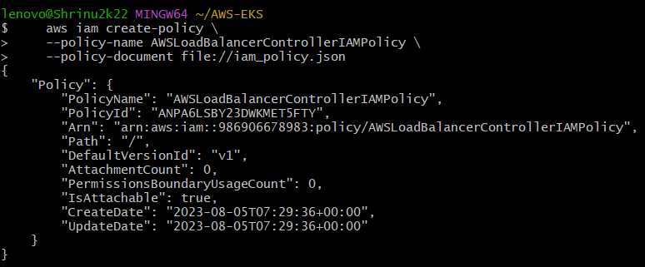**After creating the policy we have to attached it to the cluster:**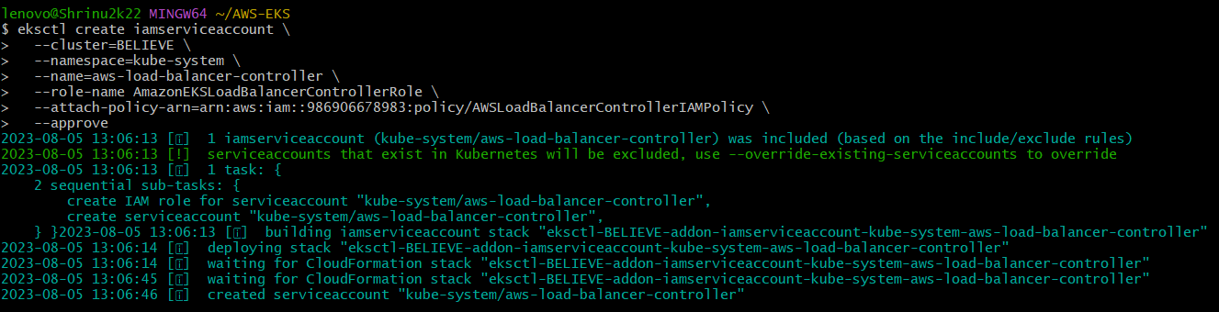

**Now, we will DEPLOY ALB Controller:**

* **helm repo add eks** [**https://aws.github.io/eks-charts**](https://aws.github.io/eks-charts)
* **helm repo update eks**
* **kubectl get deployment -n kube-system aws-load-balancer-controller**

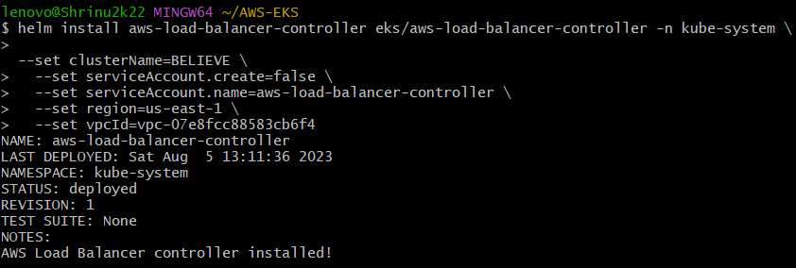

**After creating Load Balancer we get the address to access our applications:** 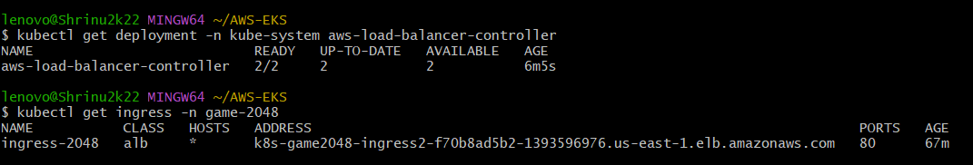

**And, then we can access our application by this above address if we want to mention our address then on route53 we have to host our domain and then by sub domain we can access our application:**

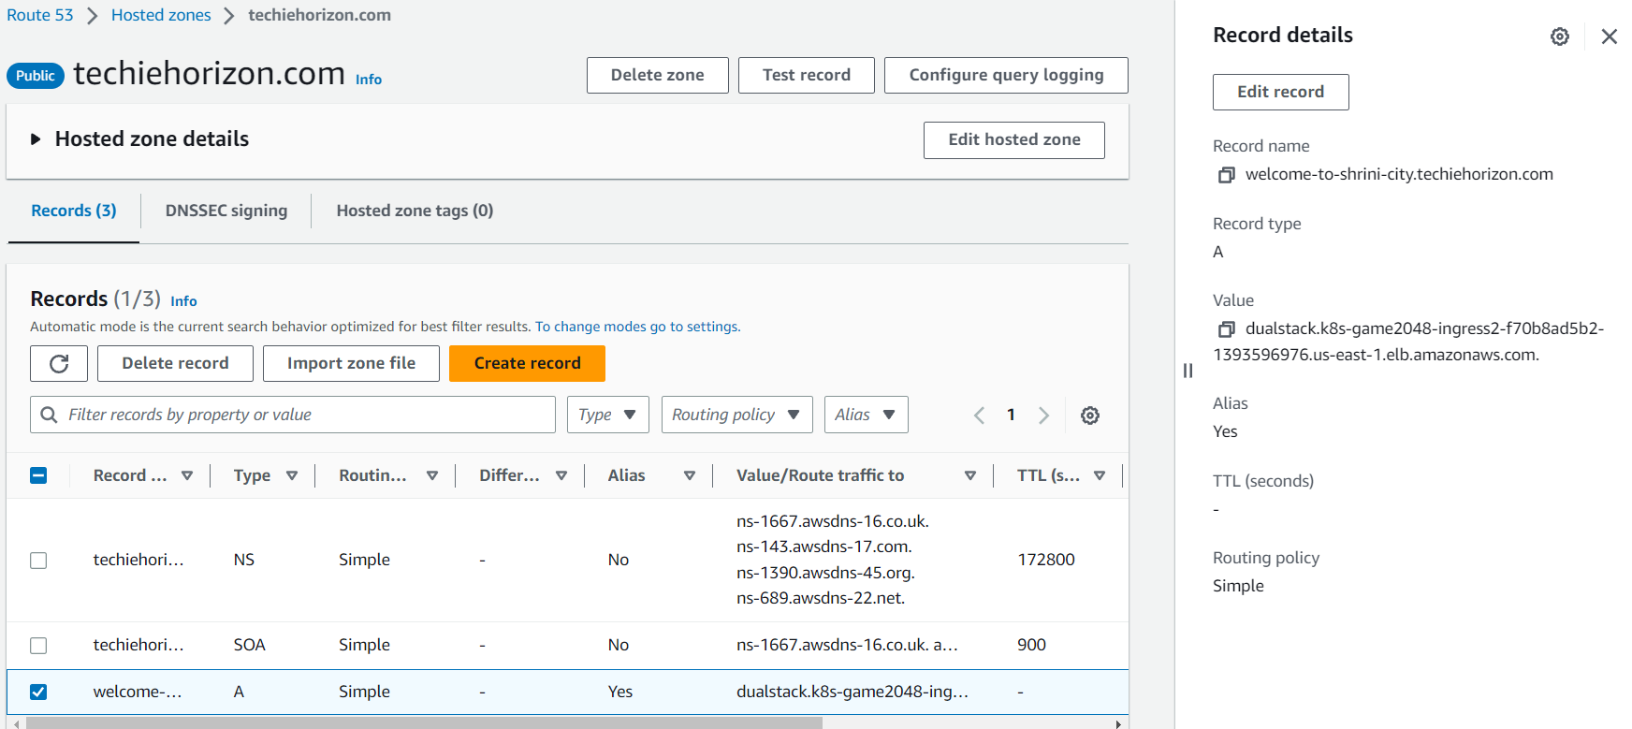

**With the help of ingress, if we have multiple applications and want to access through web-url then we can do this process by single LOAD-BALANCER value**

**Now, we can check our application through desired web-url:**

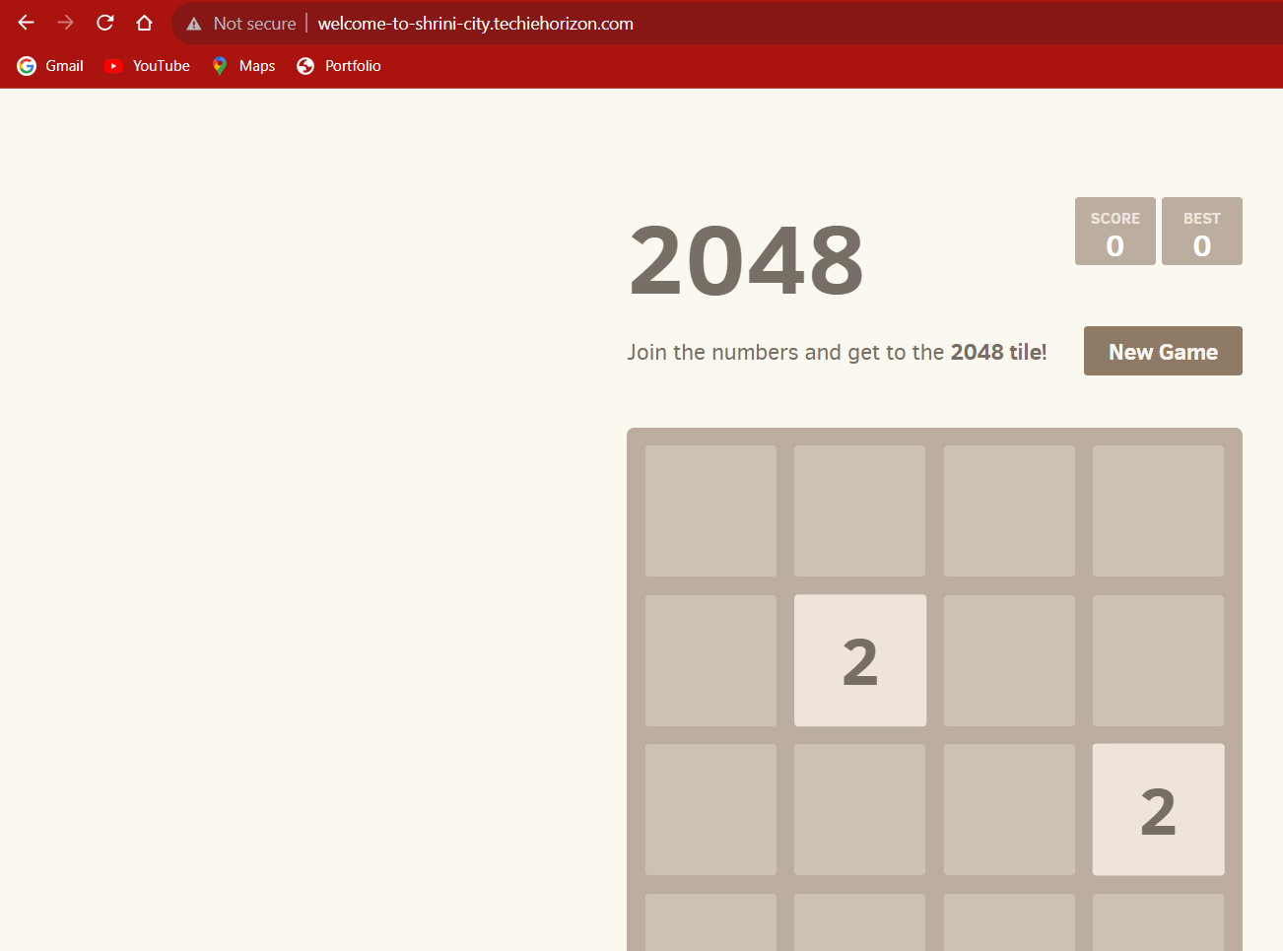

**---------------------->>ENJOY THE GAME <<---------------------**