**Kubernetes-07**

**VOLUMES:**

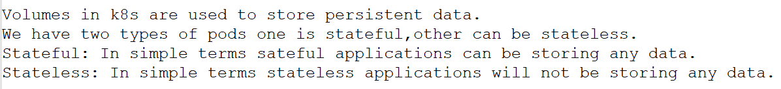

**We will be using 4 different types of volumes in k8s.**

**1) EmptyDir:**



**Example:**

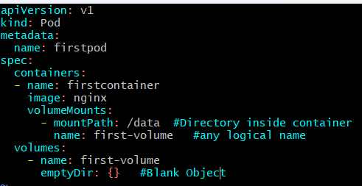

**How to test:**

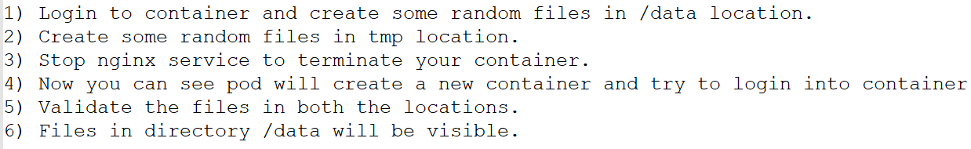

**After creating pod with the volume mounts we add some data into the container:**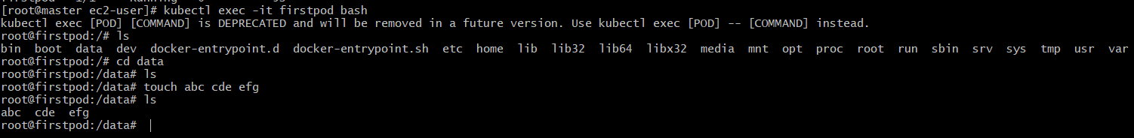





**After making changes it will get restart our pod and all the data will kept save as it is,**

**Which means whatever location we mention under the volume mount path it will get save the data even pod get restarted:**

**Problem with empty dir is if the pod got deleted then we will be losing all our data.**

**2) Host path:**



**We are creating our volume outside the pod it means on the worker node location it will get created by which if pod get deleted it won’t affect to the volume.**

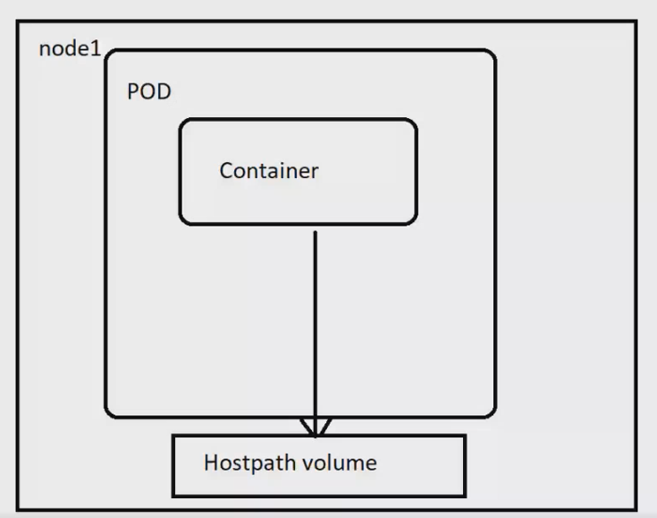

**How to test:**

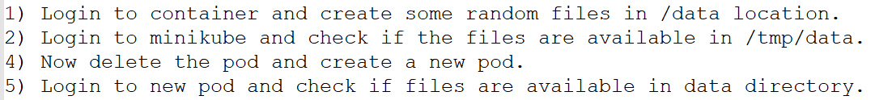

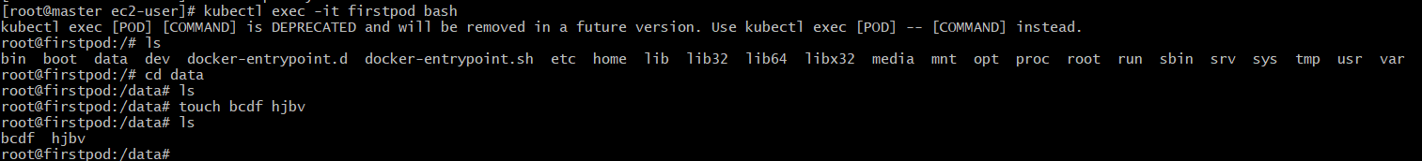

**We created two files in the container and these will store in the location of worker-02 place;**

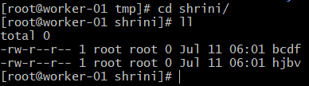

**With the help of below yaml files:**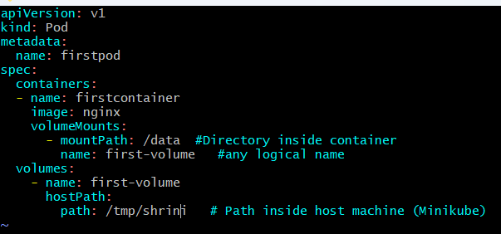

**If we have multiple nodes then the other nodes will not be able to access the volume created on node.**

**3) Amazon Elastic Block Storage:**



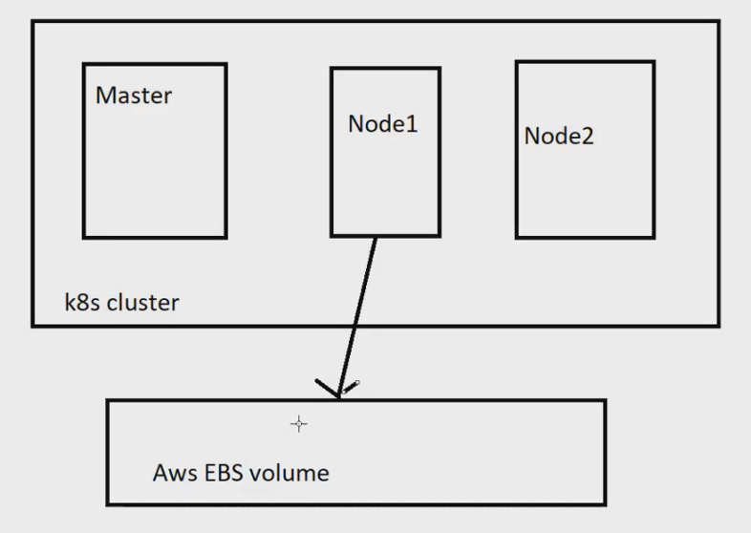

**Setup for EBS Storage:**

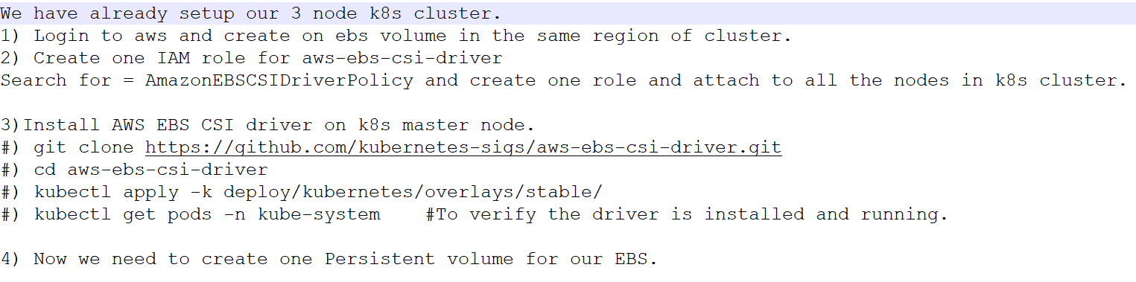

**Creating ebs volume in the same region of cluster.**

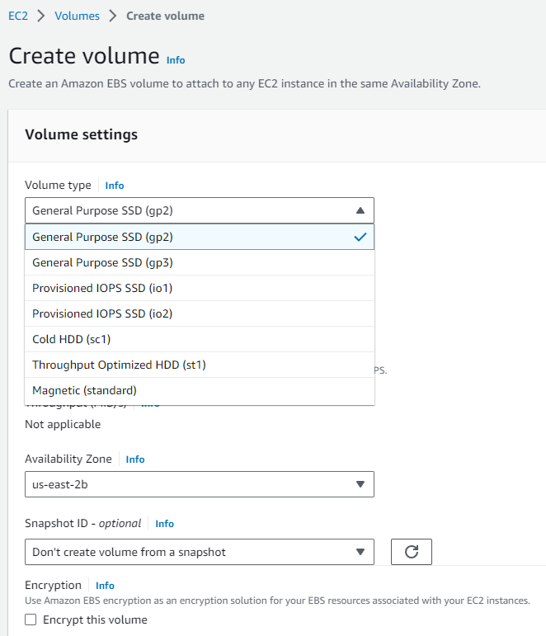





**The different states of volumes in Amazon EBS:**

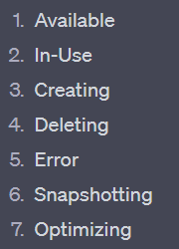

**IAM role for aws-ebs-csi-driver:**

**With the help of above role the ebs can automatically attach or detach the volume to the EC2**

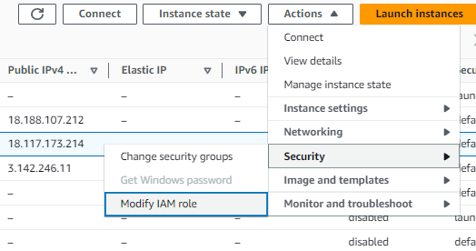

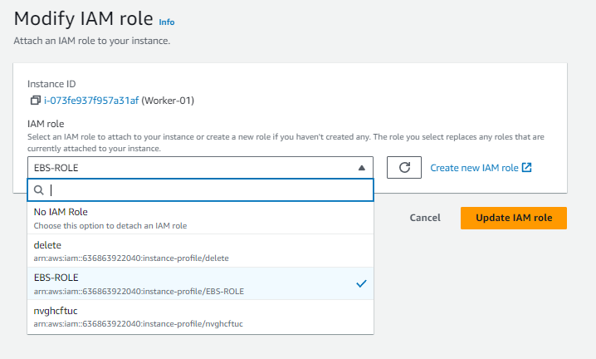

**Install AWS EBS CSI driver on k8s master node.**

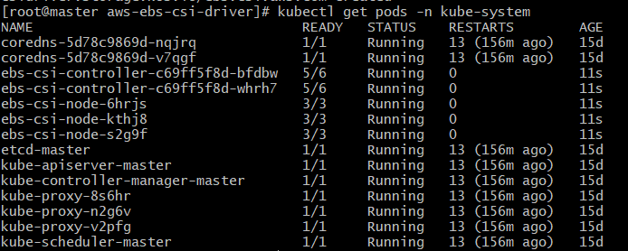

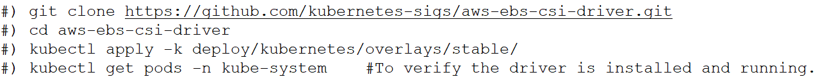

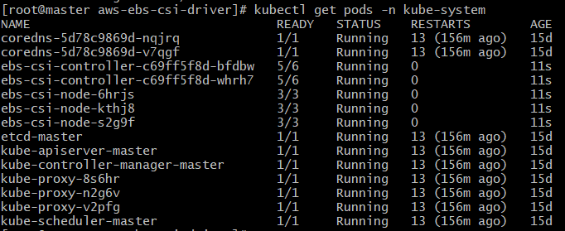

**Now we need to create one Persistent volume for our EBS.**

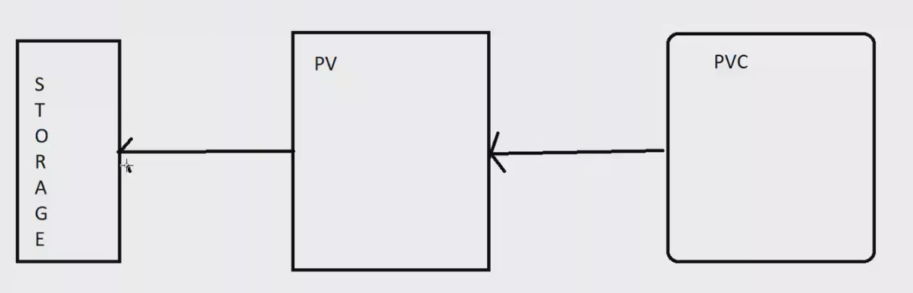

**Vi pv.yaml:**

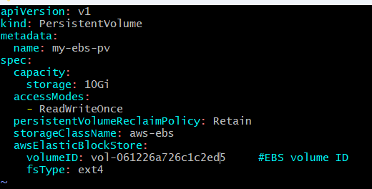



**Now, PV is in available state it not get bounded to the PVC with help of storage class name it get bounded with the PV**

**PV: creating volume   
PVC: claiming the volume to the pod**

**Vi pvc.yaml:**

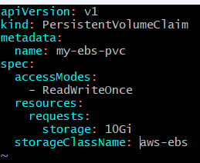

**After creating pvc it get bounded with pv as we can check in below pics:**

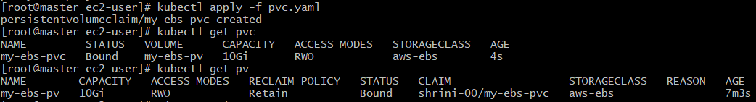

**Now we will connect our pod to EBS-storage:**

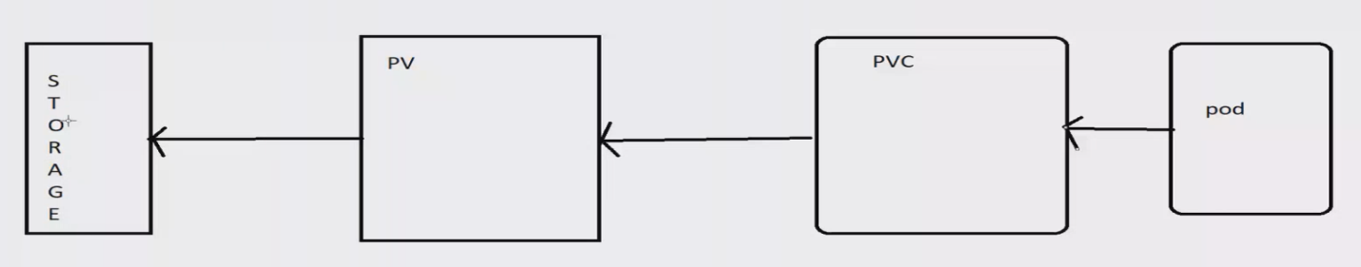

**How to test:**



**Here we can map multiple pods to the volumes but we cannot map two pods to same volume at same point of time.**

**Access Modes are of three types:**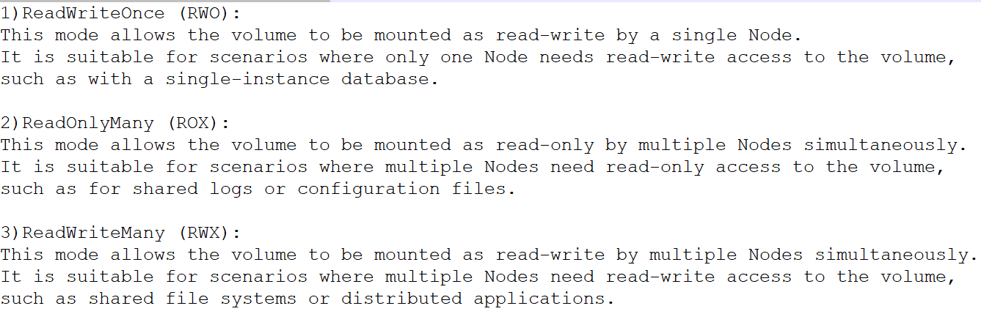

**And type of retain-policy we are using in volumes:**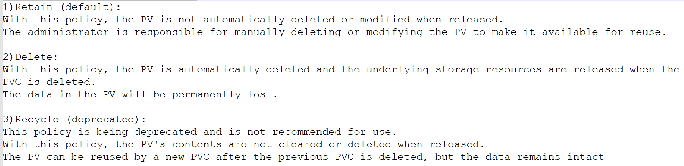

**4. Amazon Elastic File Storage:**



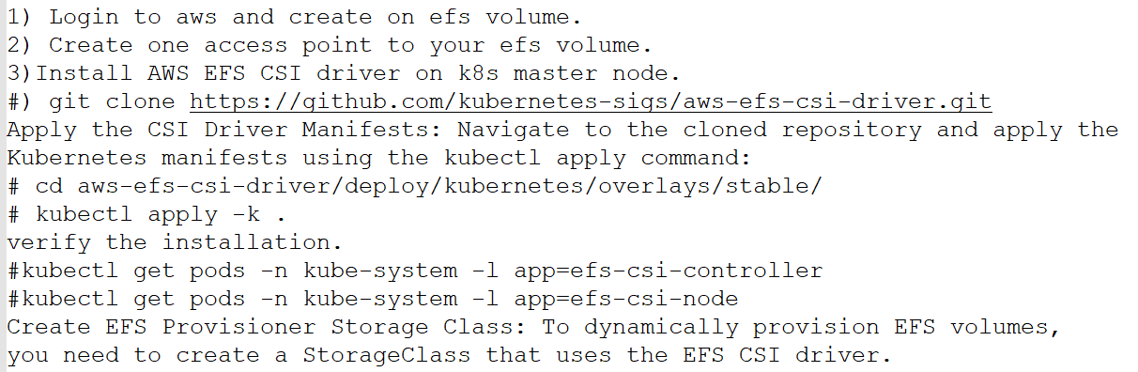

**Creation:**

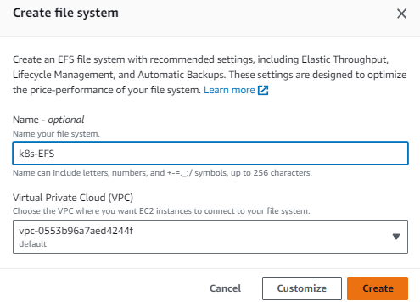

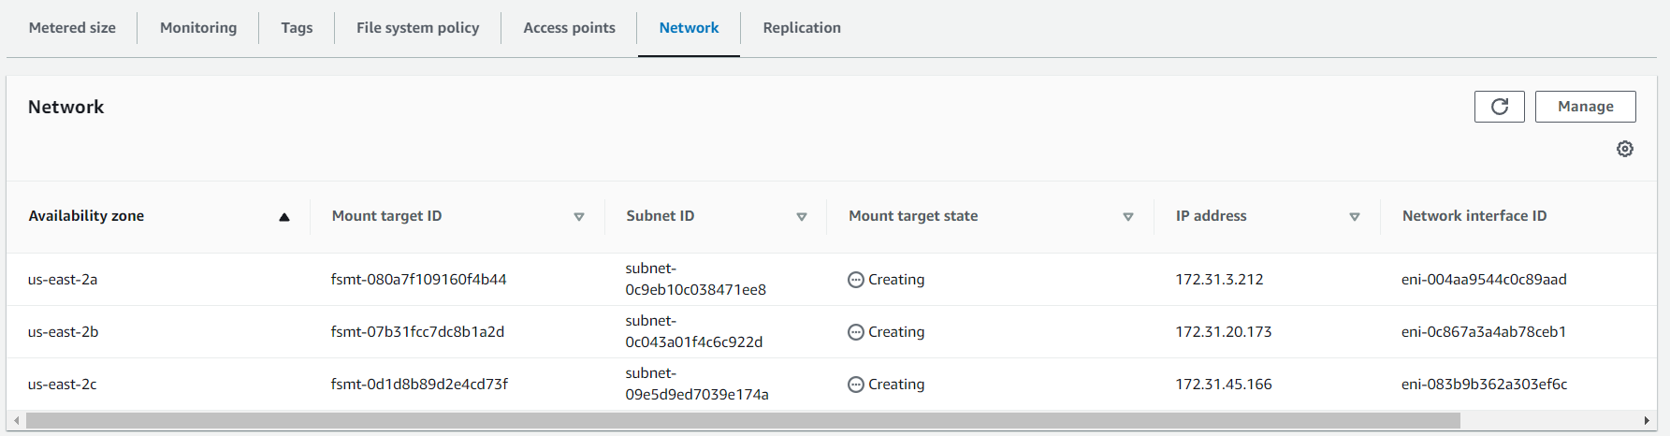

**In EBS there is availability zone issue but where as EFS there is zones issue,**

**Now we are creating access point in EFS:**

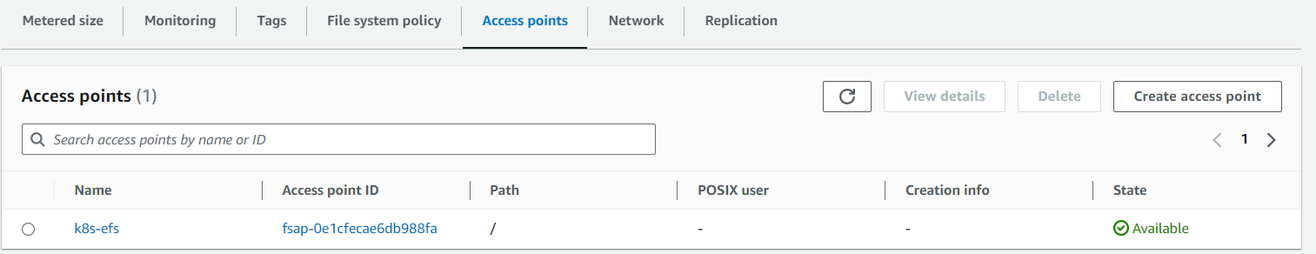

**Install AWS EFS CSI driver on k8s master node:**

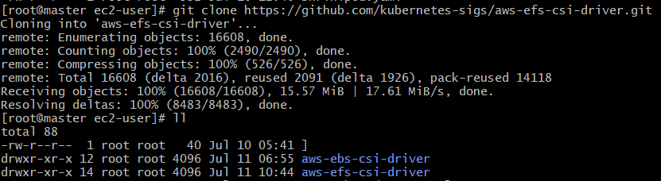

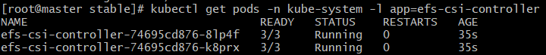

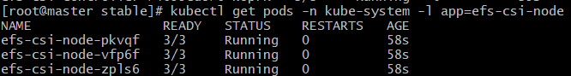



**vi storageclass.yaml**

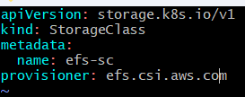





**Now, we need to create one Persistent volume for our EFS.**

**Vi efs-pv.yaml**

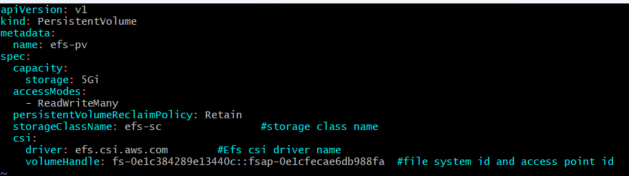



**We need to create on claim for Persistent volume (PVC) for our EBS:-**

**Vi efs-pvc.yaml**

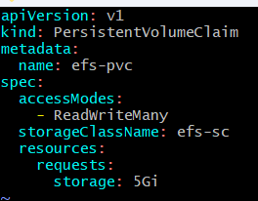

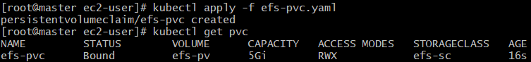

**Creating pod with PVC :-**

**Vi efs-pod.yaml**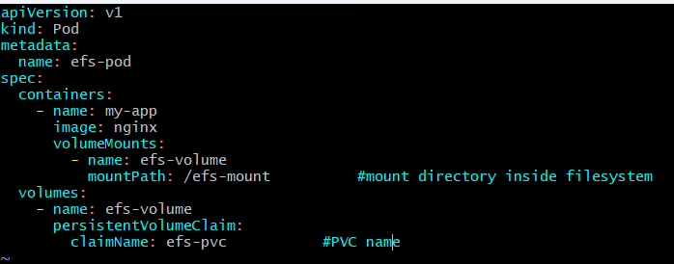

**How to test:**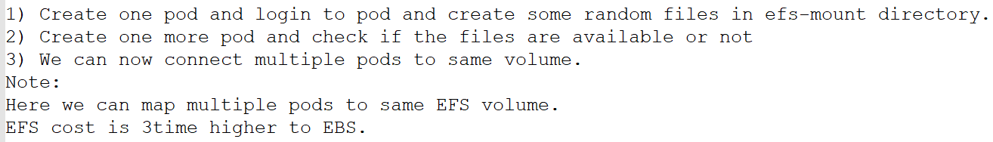



**Then we will enter to the pod and created some files on efs-mount location:**



**And now we will create another pod with the same efs configurations:**



**We can find the same file which was created by pod1 with the help of “efs”.**

**{EFS:  
 WITH THE HELP OF EFS WE CAN USE EBS VOLUME ON MULTIPLE NODES OR MULTIPLE CLUSTERS }**

**In aws we don’t need to create all these we will by default but the process will be same like below pics:-**

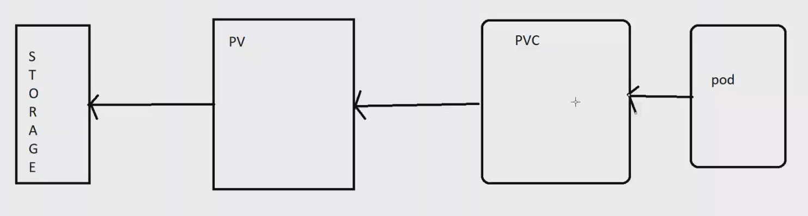

**Daemon Set in k8s:**



**Vi daemon.yaml**

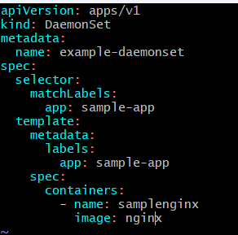

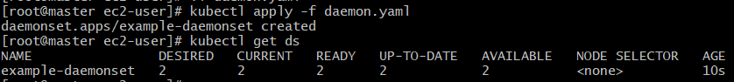

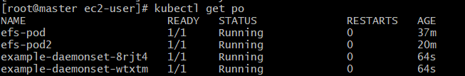

**And it will not get delete until we delete the ds :-**

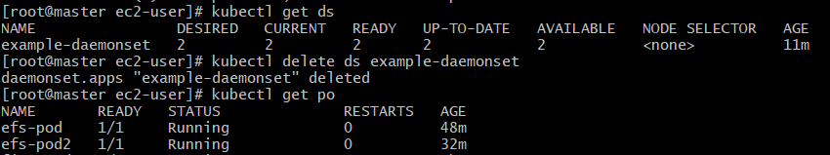

**Liveness Probe:**



**How to test ?**

**Create pod using above yaml and use describes to check the liveness.  
Or create one yaml with wrong container ports.**

**Execution:**

**Vi probe.yaml**

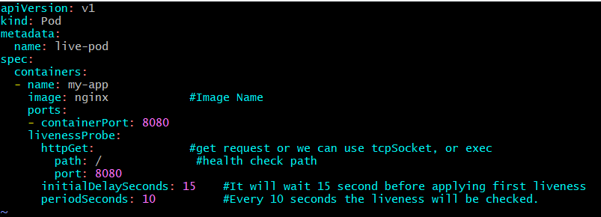

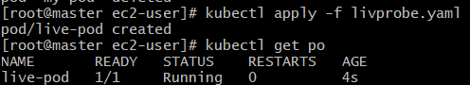



**If we give the port no different then the liveness will check and gives msg:**



**Readiness Probe:**



**Execution:**

**Vi read-pod.yaml**

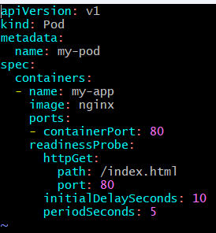



**And if we give the wrong path then it will not start the pod it will continuously find the path:**

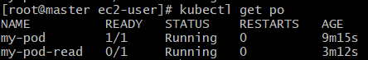

**It will give the error by probe failed:  
**

**----------------------------------Shrinivas------------------------------------**