**Kubernetes-04**

**DEPLOYMENTS:**





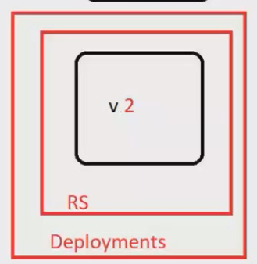

**Deployment strategy:**

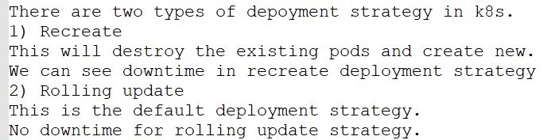

**Example:**

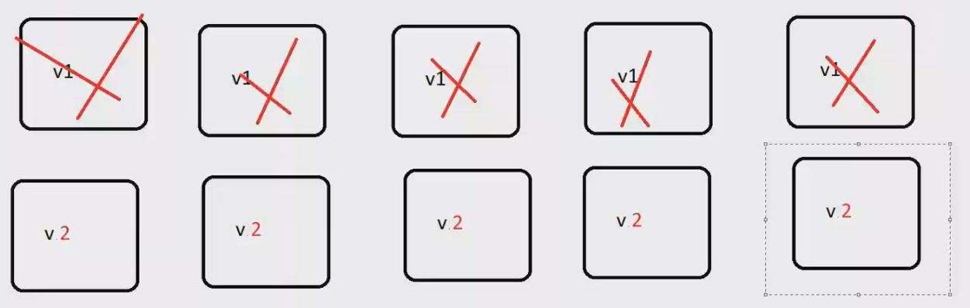

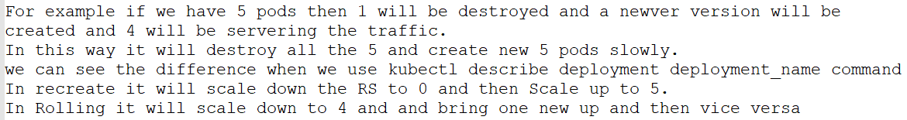

**Creation of deployment:**

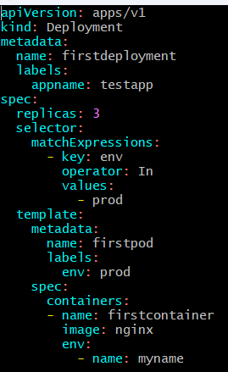

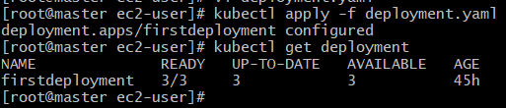

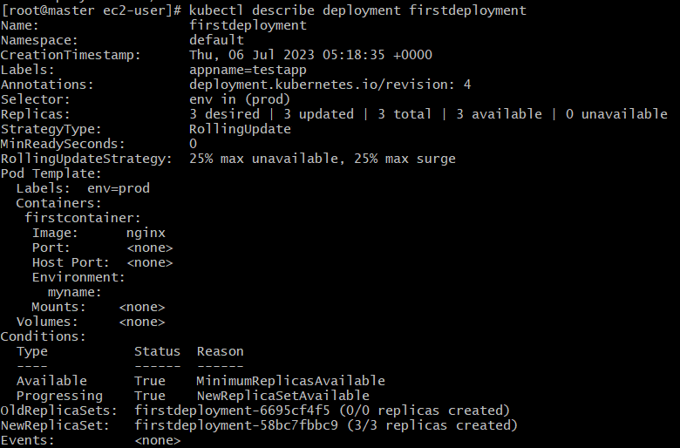

**Here we find by default it taking rolling update strategy and there is revision no. it will create when we do some changes in the deployment and with the help of revision we can rollback**

**To check the rollout status:**



**To check the history of rollout:**

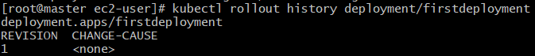

**Makes a changes in deployment with image nginx to httpd:**

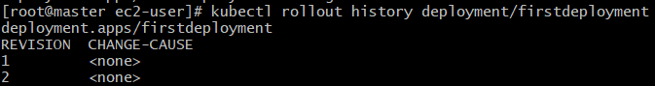

**Deployment can triggered or rollout or revision get created when we makes changes in the specification of containers only**

**To give some msg for our rollout with the help of annotations:**

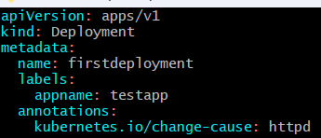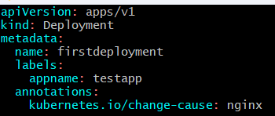

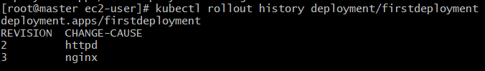

**With the help of describe command we can find our replica set:**

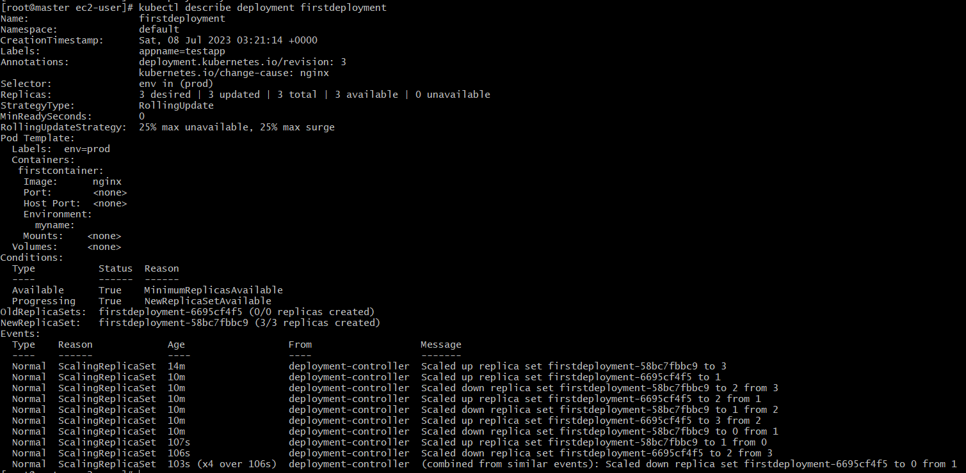

**Here in the above pic we are having two replicas and the current replica is for nginx and I want to rollback to httpd then:**

**First I will check the history :**

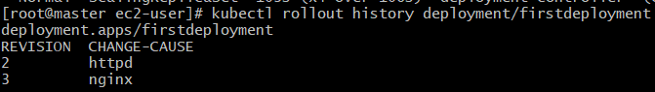**So, Now I want to change the revision number with “2” which is for httpd then I have to run the command:**



**And the history now:**

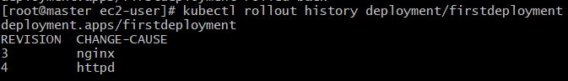

**Maxunavailable in Deployment:**



**In the rolling update strategy we find one section of max-unavailable and max-surge:**



**And by default it will set as 25% unavailable and 25% surge**

**Example for max-unavailable:**

**Current replica status of our latest deployment is 6:**

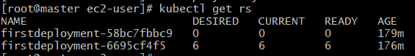

**Then we put the maxunavailable with 2 in our latest deployment and configured:**

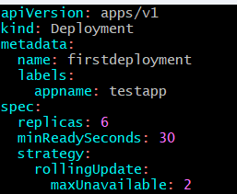

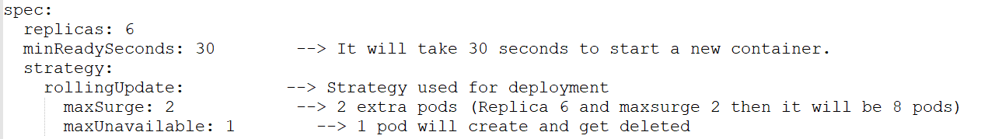



**Now if we checked the replica-set:**

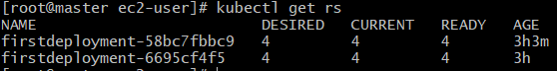

**So it create 4 at the starting time and after minReadySeconds: 30 it will adjust with “6”**

**By these it will gets the deployment faster,**

**Max-surge: This will imply the number of pods that will be there on top of total replicas being mentioned.**

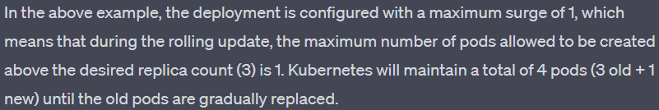

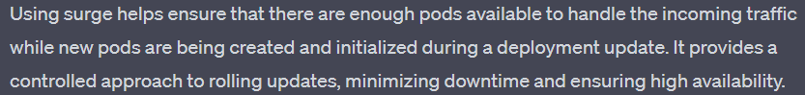

**Note: Maxunavailable and Max surge value can be passed in percentage also.**

**What will be the Maxunavailable, MaxSurge, MinReady Seconds and strategy if not mentioned in deployment?**

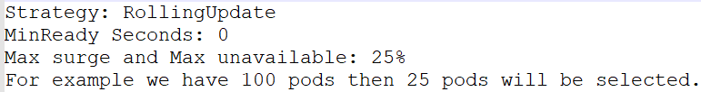

**Conclusion:**

**In rolling updates if we mention replicas=10   
then, if we deleted one pod then only 1 get newer pod created and 9 get remains as older ones and if we deleted 2 pods then 8 get remains as it is. So it is replacing the older version and creates the newer version and there will no downtime for the user.**

**Resource Request:**

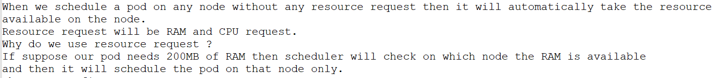

**Where to configure resource request ?  
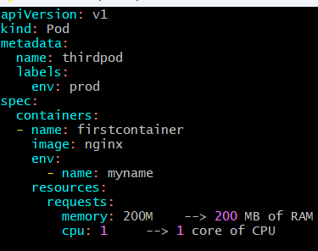**

**When we check the docker stats from container id it will show the limits of memory and cpu which mentioned in yaml file.**







**--------------------------SHRINIVAS---------------------**