LINUX COMMANDS

*To increase the Git bash terminal time out / open the file / Mention the time how much requied

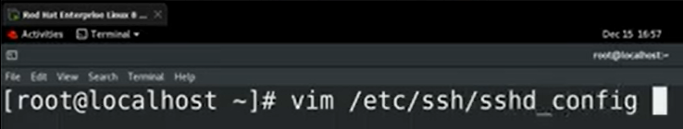

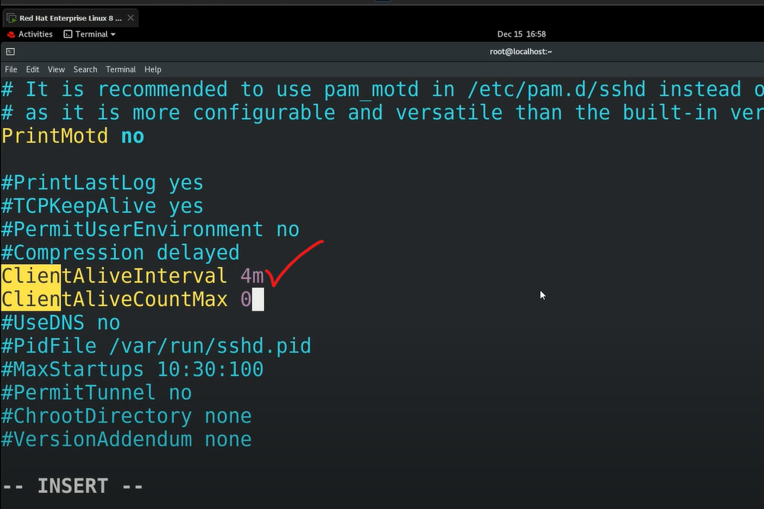

*PWD

It will show the directory path or file path

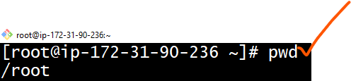

*ll

ll – it shows the list of files

it will show files and directories

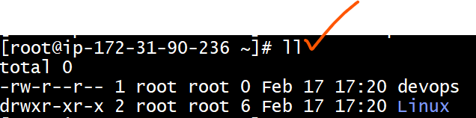

*cd AWS

Change directory from one folder to another folder

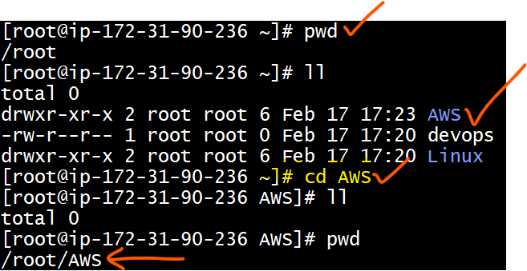

*cd ..

To go one step back from one folder to previous

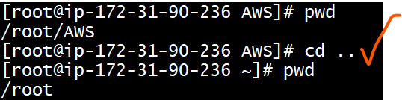

*cd ../src

This command help us to come back from one directory and directly go to other directory.

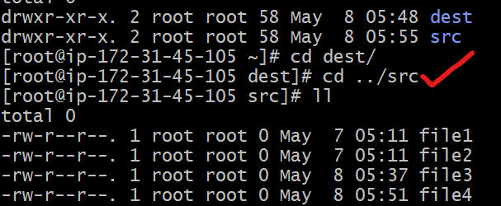

*cd ~ (Tild)

It will directly go to the home directory location

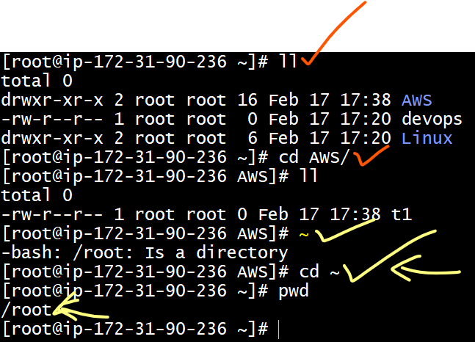

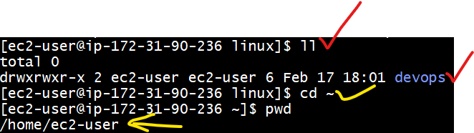

*cd / (Forward slash)

It will go to the path to root directories location

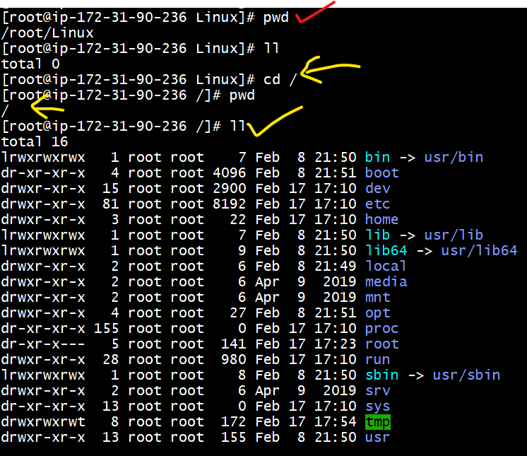

*rm –rf *

To delete the entire folders and files

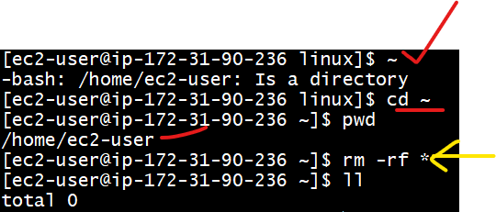

*history

We can check the recently used commands

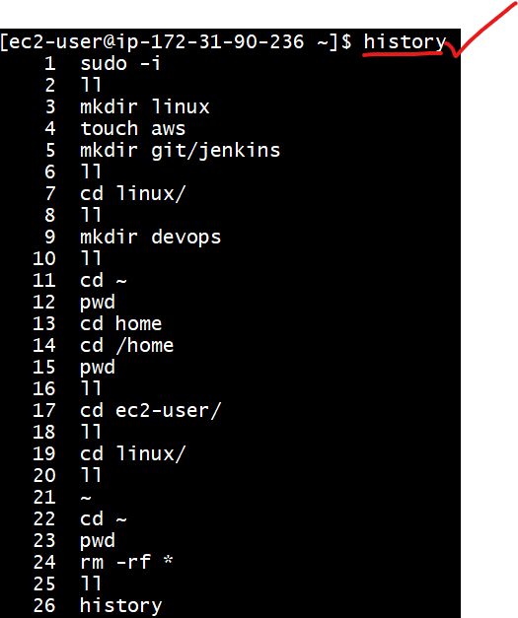

*cd ../..

2 steps back to go

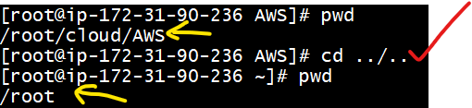

*cd ../../..

3 steps back to go

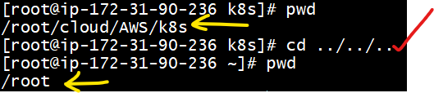

*date

Date command used to print the current date

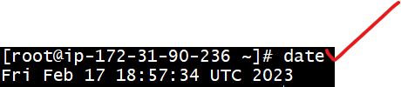

*ls –a

To view the hidden files and folders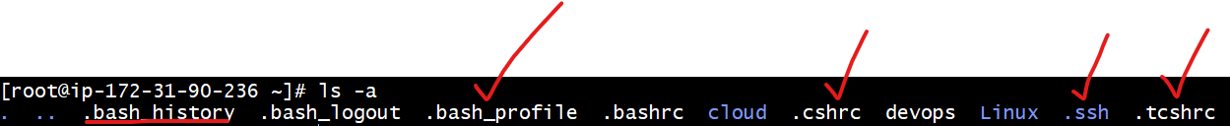

*ls

To check the list of files



* d – indicates folder

* - (ifan) indicates file

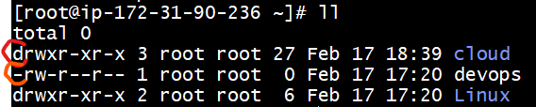

*mkdir linux

To create directory

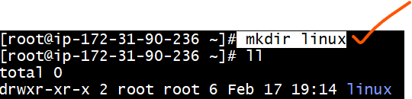

*rm –rf linux

To delete the folder

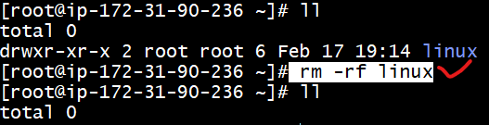

*touch devops

touch command is used to create “0” byte file

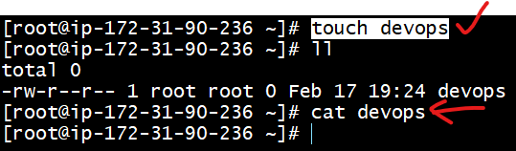

*vi file

Vi command for create new file

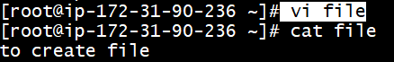

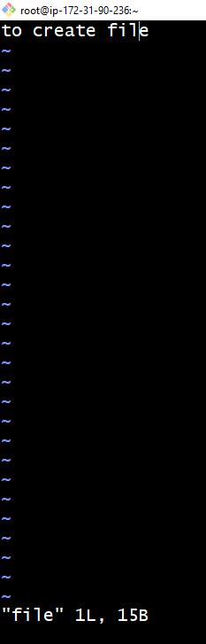

*Create file with nano command

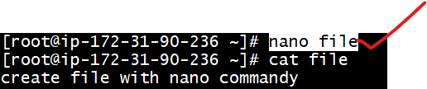

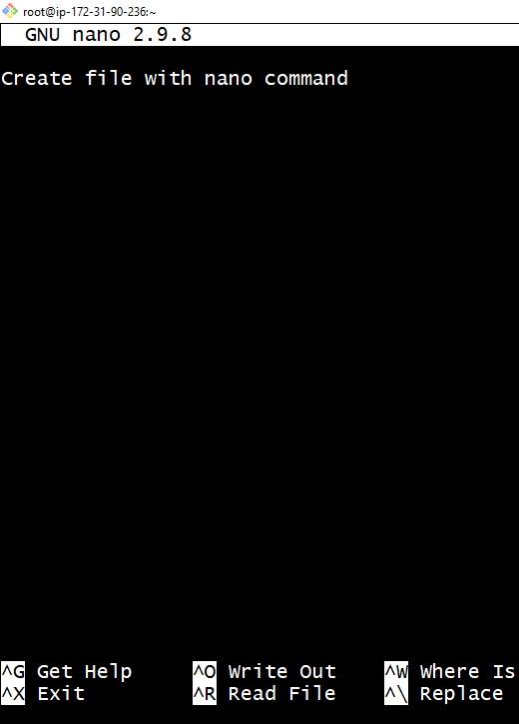

*Create file with Vim command

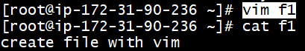

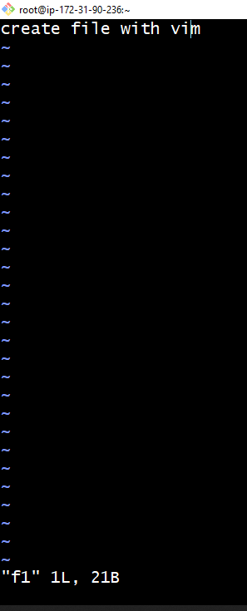

*rm f1

To delete the file

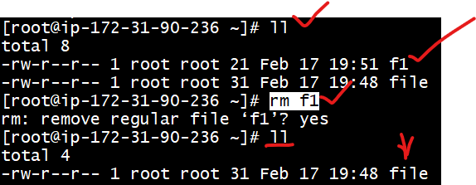

*mv cloud AWS

mv command is used to rename the folder or file

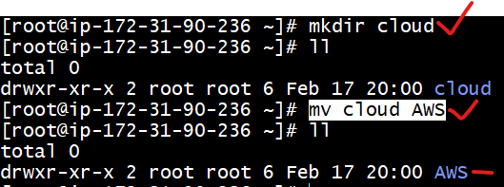

*mv file name (To move path)

Mv command is used to move file location from one place to another place

*yum install tree

(tree command is shown the complete folder structure)

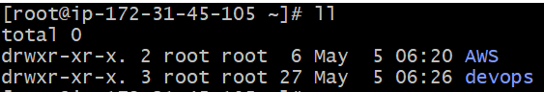

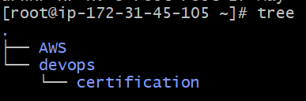

I moved file shown below like this

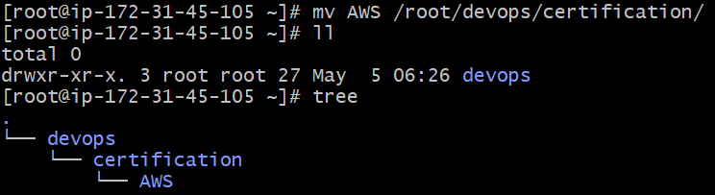

*mv file4 .file4

Converted normal file to hidden file

Check hidden file (ls -a or ls -al or ll -a)

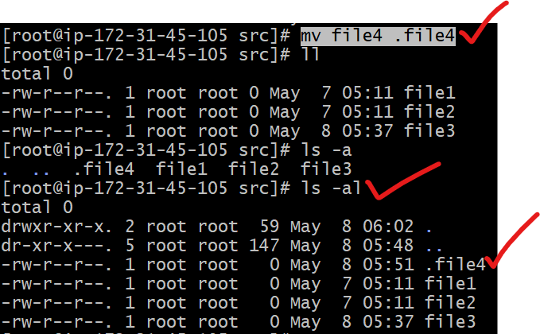

File renamed as normal file

.file4 to file4

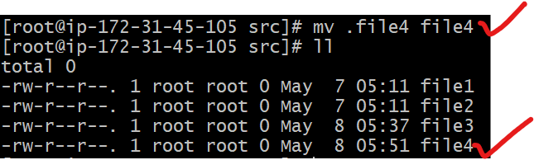

*CP

(replica of file)

Copy file method 1

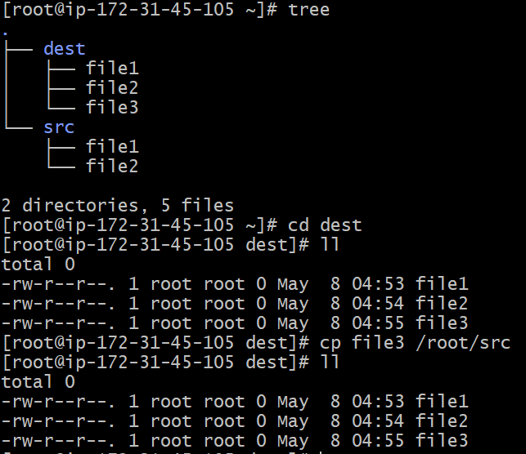

Method 2:

*We copied directory from one location another location with files

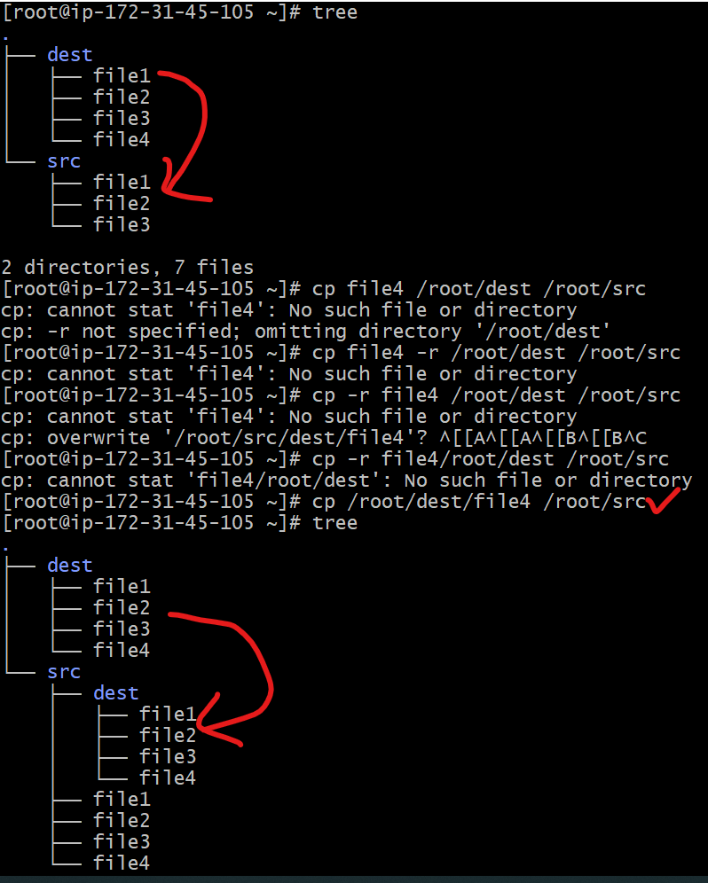

*touch dest/file3

*touch destination folder name/new file name

*we can create file by giving file destination path

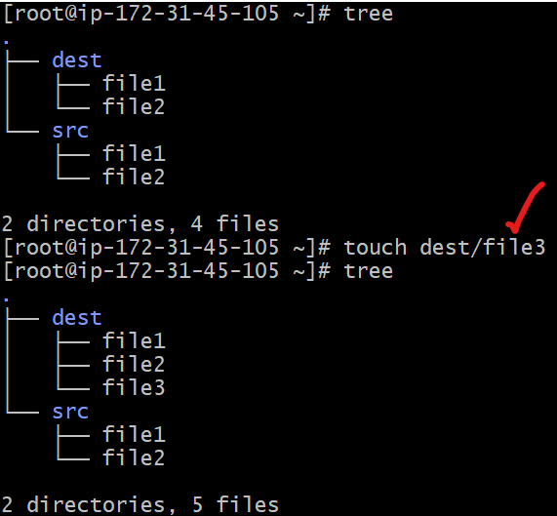

*echo “techie”

What is given input it will print the output



* echo "hello sagar" > file1

Without creating file / we can directly create the file

Add the content / while adding data 2nd time data will be overide

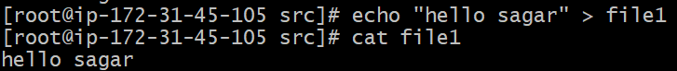

*echo “what are you doing” >> file1

When we adding data to file / data will not overided

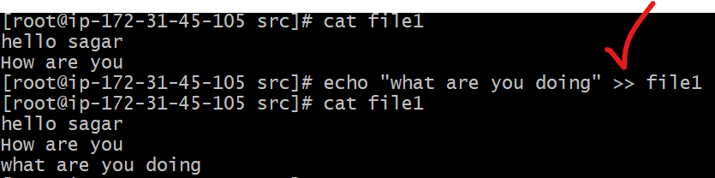

*ps -ef

To check the running process or running services

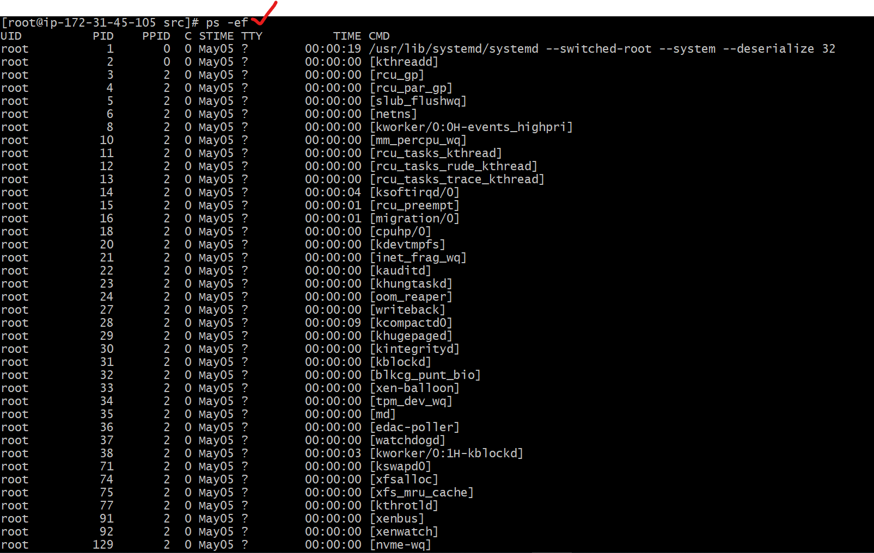

*ps -ef > file1 (file name)

Processing files output will be imported to file

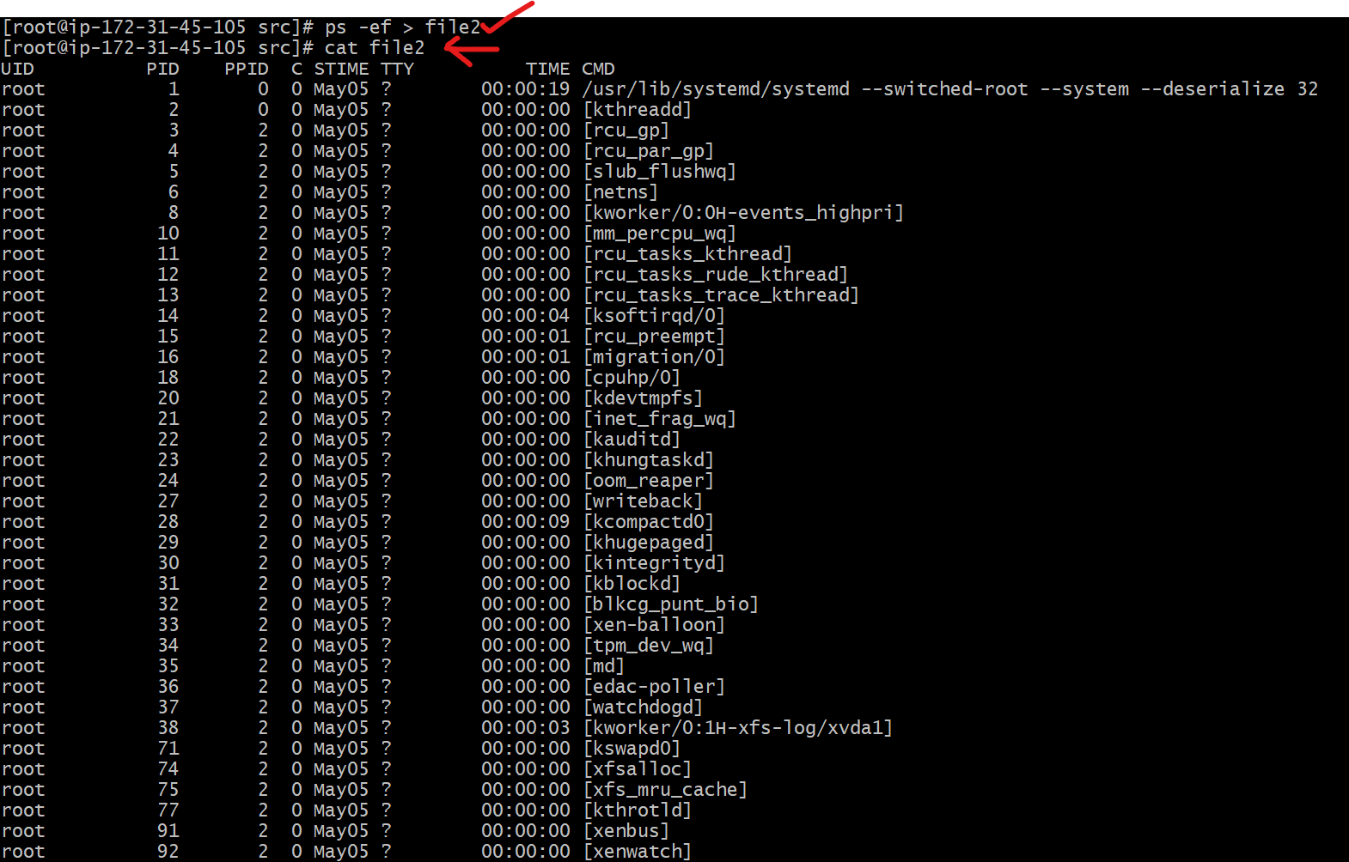

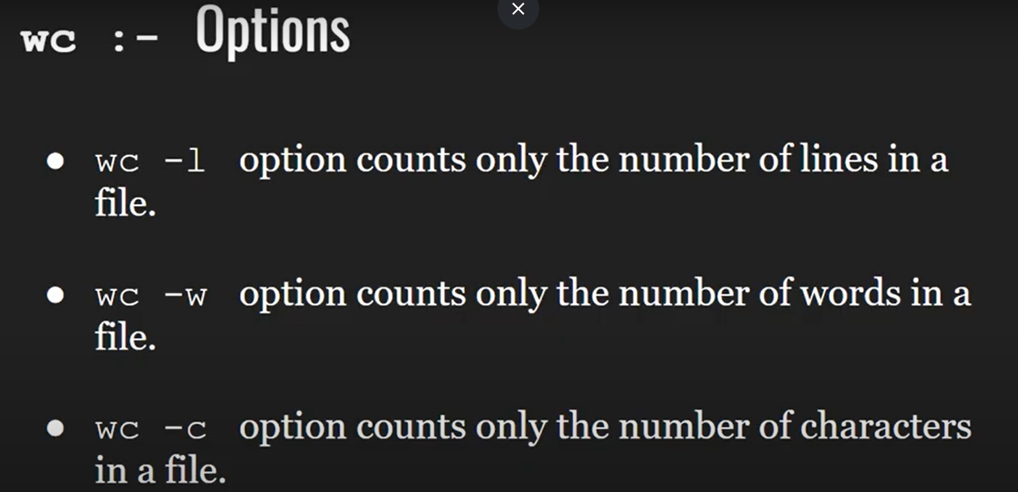

*wc file name

To show the

Rows, words, charecterstics



**\*wc -l**

**Show the only rows**





**:%d**

**To delete the file content**

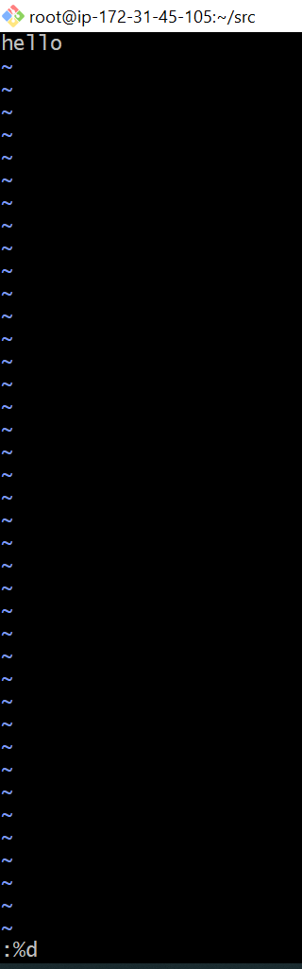

:wq!

To save the content of file

*ls -ltr

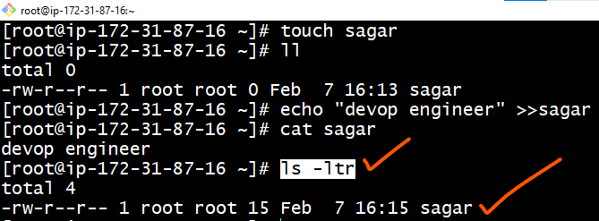

*mkdir –p Linux/AWS/DevOps

We can create multiple directories inside directories (i.e sub directories)

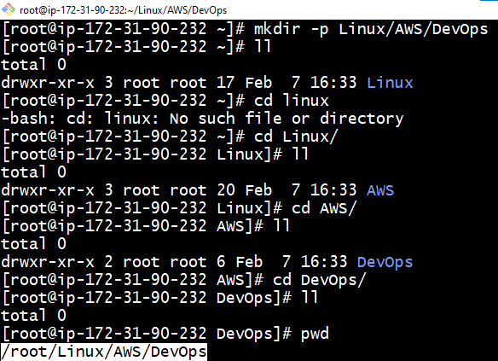

*Sed Command

*sed -i ‘s/actual name/replace name/g’ filename

*sed -i ‘s/80/81/g’ trail

Created file with data 80

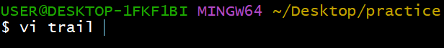

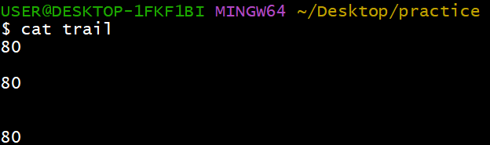

By using sed command replacing text with 80 to 81

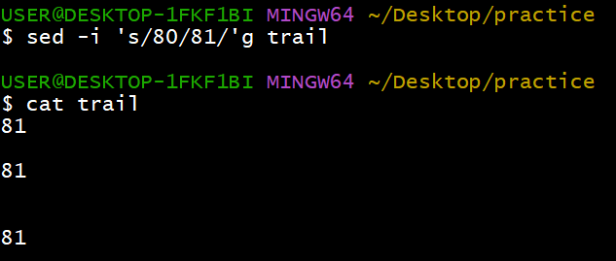

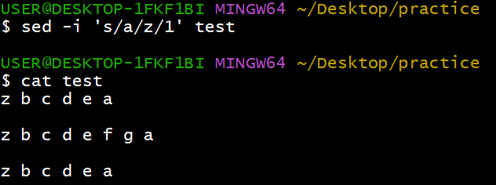

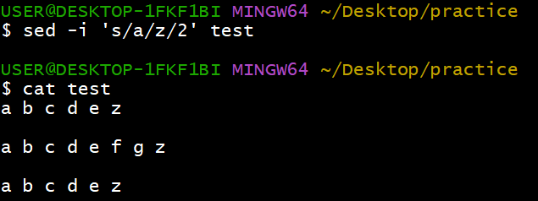

*AWK command



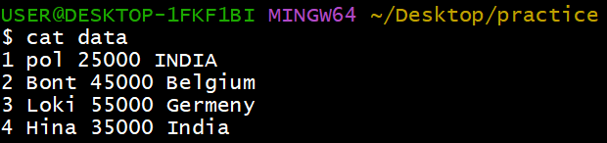

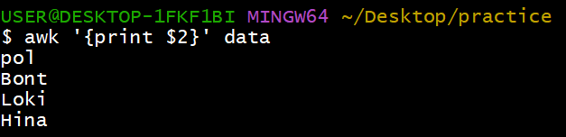

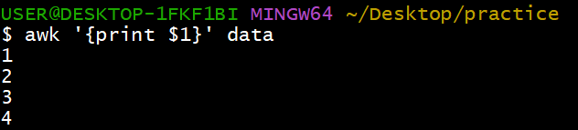

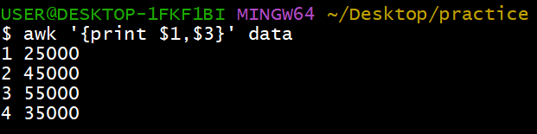

@du –sh * (To check the folders size human readable format)

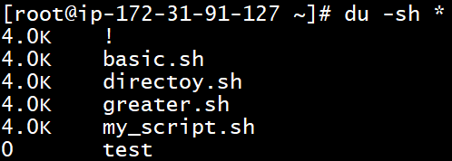

@df –h (Folder system size)

