**Terraform-06**

**Modules:**

**If we have multiples env. Like (dev, test) and want to create aws resources we will use Modules.**

**“Modules is a collection of configuration files in a directory”**

**Examples;  
if we want to create two ec2 for different environments then I can create a directory for aws-instance configuration.**

**Now in second sub folder we created for development env,**

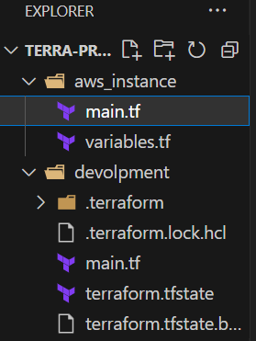

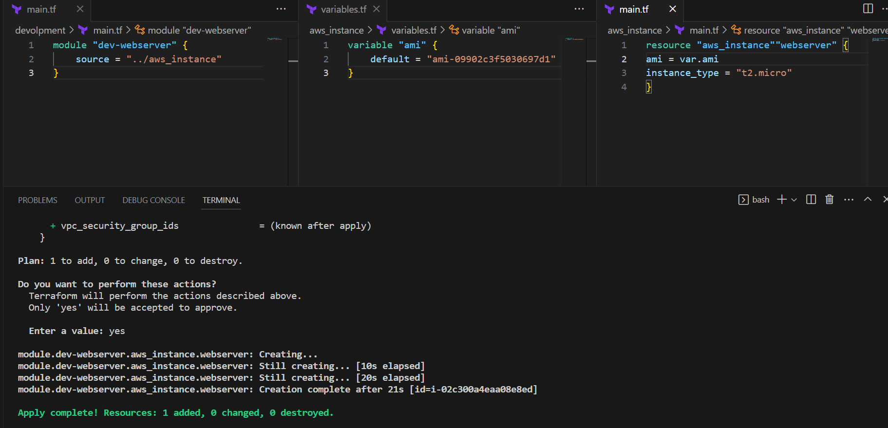

**Terraform workspaces:**

**Workspace can be used if we have multiple project/environments using the same configuration.**

**Workspace commands:**

**1) Terraform workspace new projectA --> to create a workspace names projectA**

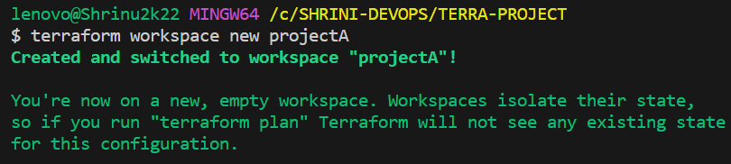**2) Terraform workspace list --> to list the workspaces available**

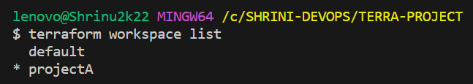**3) Terraform workspace select projectA --> to swtich to specific workspace**



**Examples:**

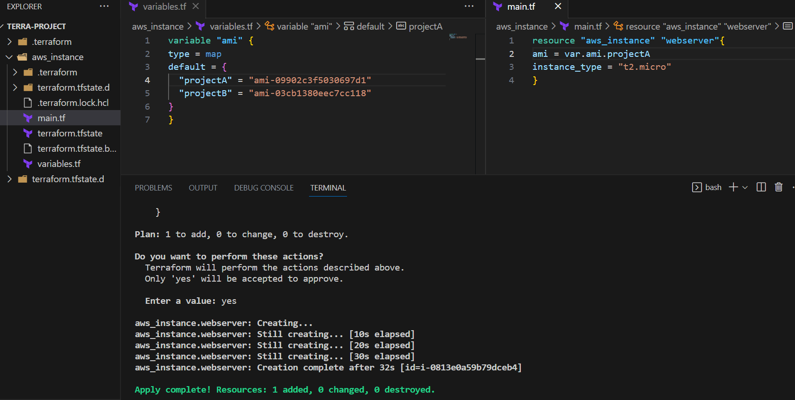

**DIFFERNECE BETWEEN MODULES AND WORKSPACES:**

**In Terraform, workspaces and modules serve different purposes:**

1. **Workspace:  
   Workspaces itself provide us the environment  
   It means we have one**[**main.tf**](http://main.tf/)**for a specific environment  
   In workspace the state file will be stored in the separate folder  
   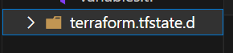**
2. **Modules:  
   Modules are smaller pieces of code which. can be used again and again to create different environments  
   in modules the state.tf file will be stored in the created env directory  
     
    