**Terraform**

**Terraform is IAC TOOL**

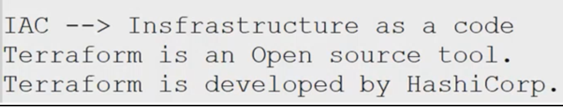



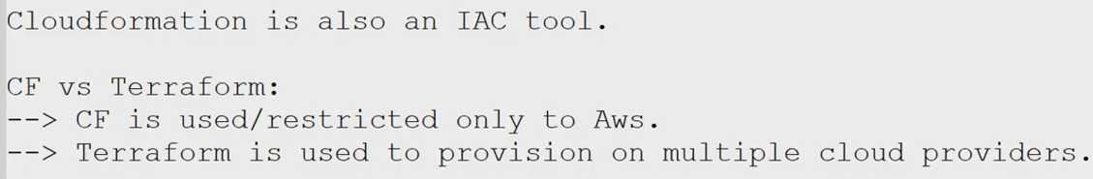

**Terraform registry;**

**“It is a place where we can find n numbers of modules, providers, it is open source and officially provided by terraform”**

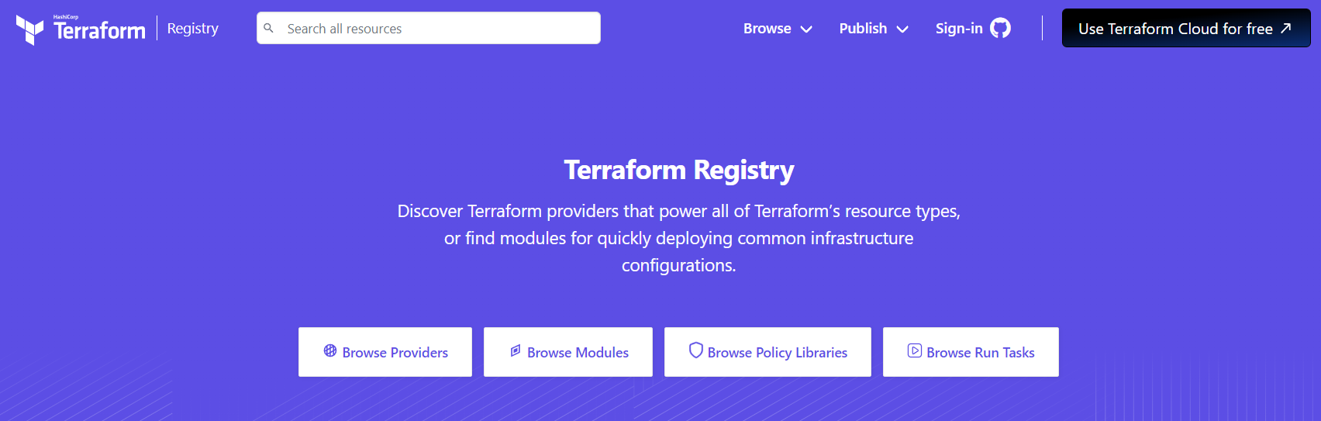

**Installation of terraform :**

* **VISUAL STUDIO- it helps to write and execute at a same time/ Also it is open source tool**
* **Go to the official page** [**https://developer.hashicorp.com/terraform/downloads?ajs_aid=eab86bec-fc46-4a32-ac7b-9885db566b41&product_intent=terraform**](https://developer.hashicorp.com/terraform/downloads?ajs_aid=eab86bec-fc46-4a32-ac7b-9885db566b41&product_intent=terraform) **and download it by according to your OS;**

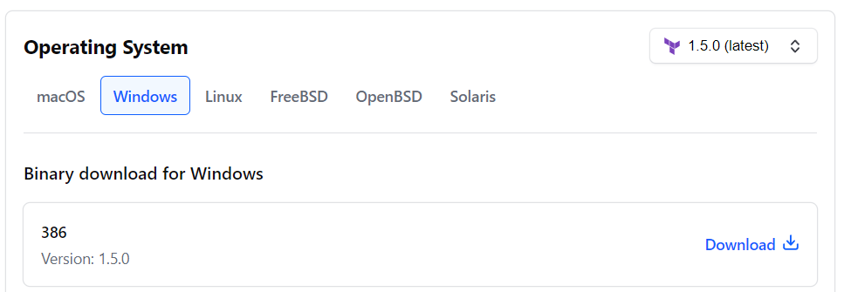

* **Then we have to extract the files in “/C/ Directory” which we download in the official page and then we will get an executable terraform application and also we configure on env variables in window machine**



* **After that we can check on our terminal by terraform commands:**

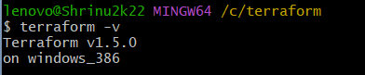

**\*\* Terraform configurations with a sample-code:**

**With the help of terraform Registry we understand what should be give the provider**

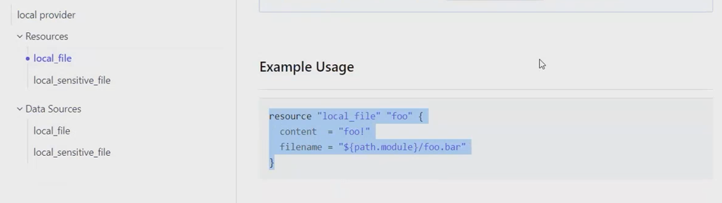

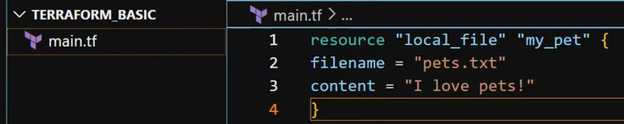

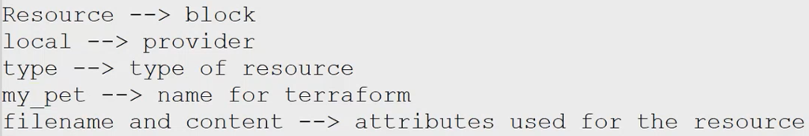

**Basic-Template:**

**BLOCK-TYPE PROVIDER RESOURCES-TYPE LOGICAL-NAME  
“resources” “local” “file” “my_pet”**

**ATTRIBUTES  
“filename” and “content”**

**After that we have to run “terraform init”**

* **It helps to download all the required dependencies**
* **And also will initialize our terraform folder**

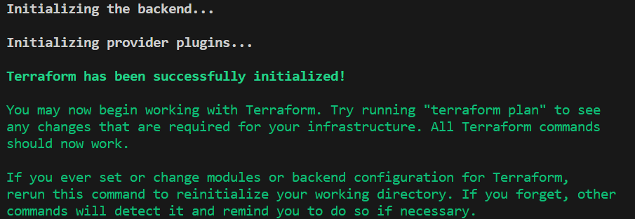

**We will get below folder and files as dependencies;**

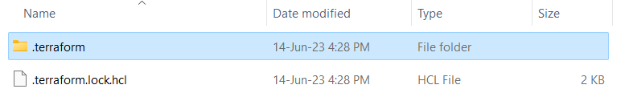

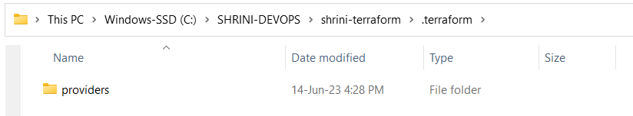

**There is a folder of providers;**



**Resources like: AWS,AZURE,GCP,LOCAL**

**Then, “terraform plan” It will only check the changes will be implemented/executed on Target server/machine  
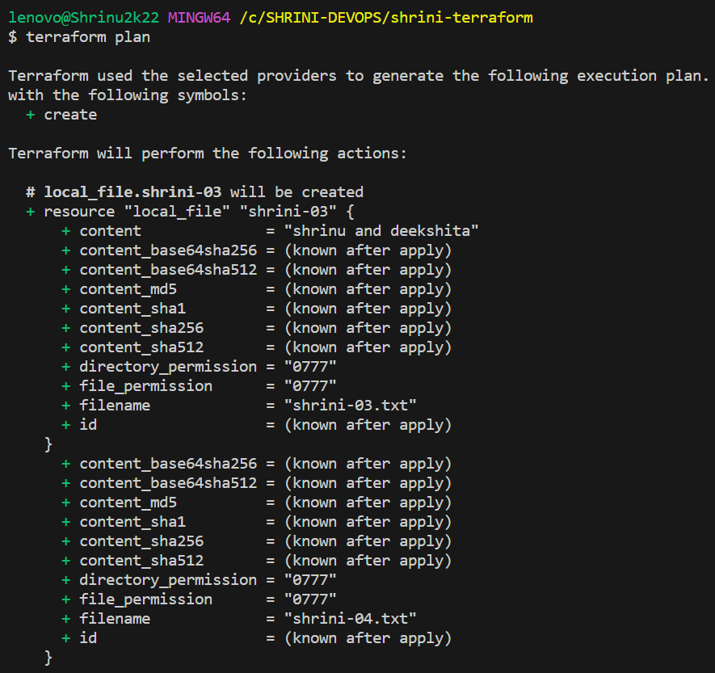**

**Terraform apply;  
it will ask for confirmation before making changes and also it gives “ID”**

**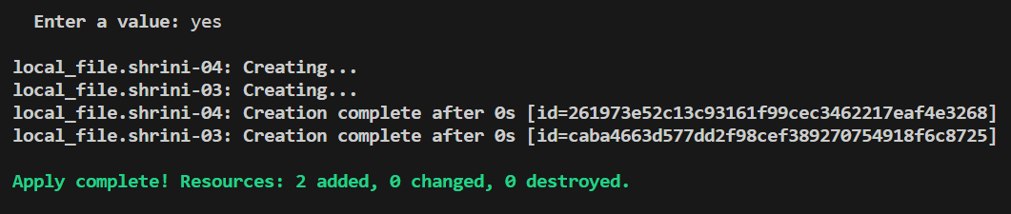  
SYMBOLS IN TERRAFORM APPLY;**

**+ : ADDED - : DELETED ~ : MODIFIED**

**While exceuting terraform apply command we will see another file named “state.tf”**

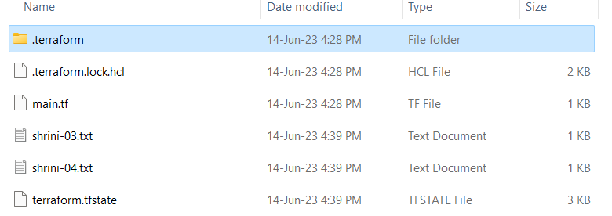

**“**[**State.tf**](http://state.tf/)**is only contians the details of infra which we have created using terraform”**

**Terraform destroy: for deleting the file from our infra**

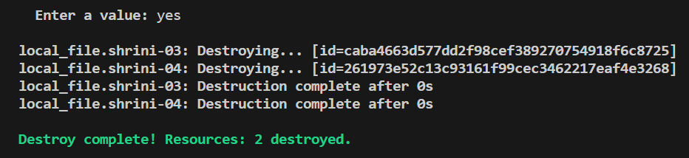

**If we want to delete only one file from our infra then;**

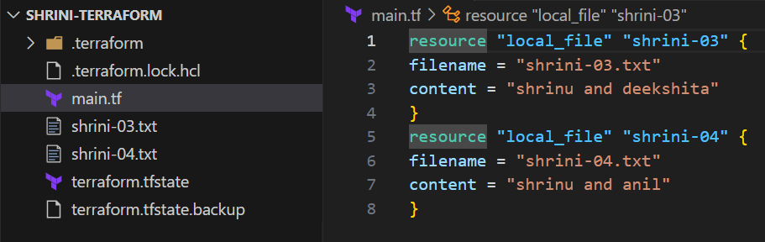

**For deleting single resources we will use :  
“terraform destroy –target”**

**“terraform destroy -target=local_file.shrini-03”**

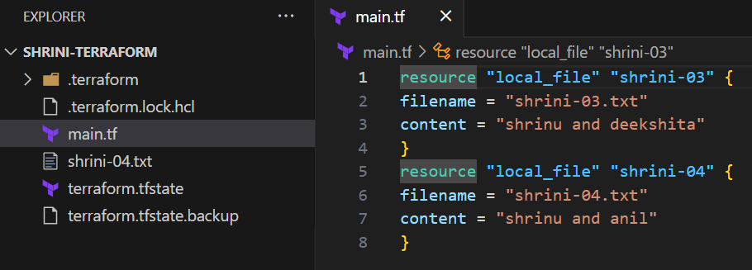

**To give a format to our script we are using “terraform fmt”**

