**Terraform-02**



**If we have Multiple Providers:**

**“We can create a new dir and create a main.tf or else we can add the resources on the existing code”**

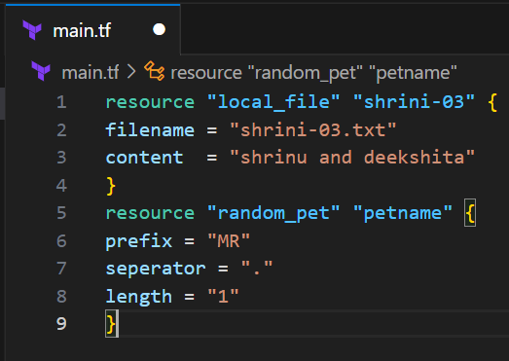

**{ In 1st provider: “local_file” we are creating a file in our local**

**In 2nd provider: “random_pet” we are creating a random name**

**\*whenever we add any new providers we have to run “terraform init” for download the dependencies (plugins, API,etc) by creating .terraform folder }**

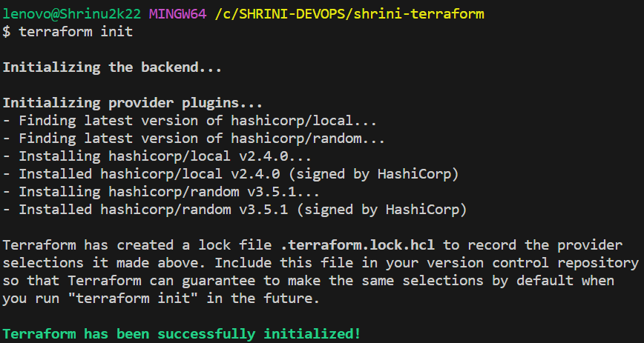

* **It installed provider with the version of: “local=2.4.0 and random=3.5.1”**
* **terraform always try to installed latest version**
* **And if we want to change the provider version we can configure  
  so why we need any specific provider version;   
  “if any application having dependences for the compatibility purpose then we have to maintain specific version” like tomcat**

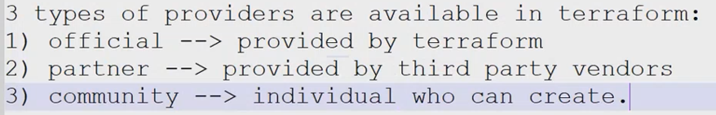

**When we execute “terraform apply” it will create “state.file”**

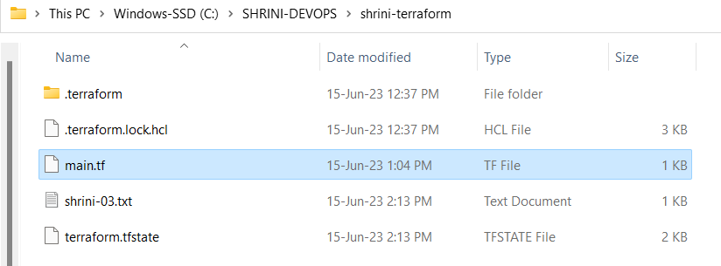**it consists the complete metadata of our file like(versions,filename,permissions etc)  
it has the complete information of our infrastructure**

**“In state.tf file we should not make any changes”**

**Terraform infrastructure:**

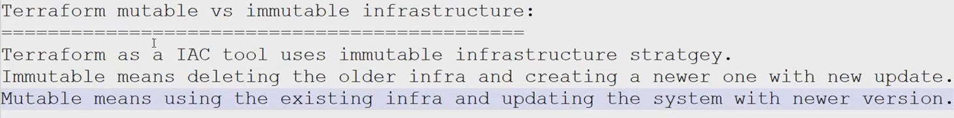

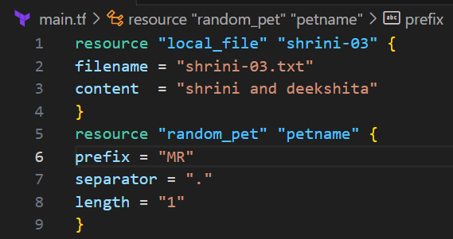 

**Here I am change the content in pic-01 so we can see in below pic that it is deleting first and then creating new resources;**

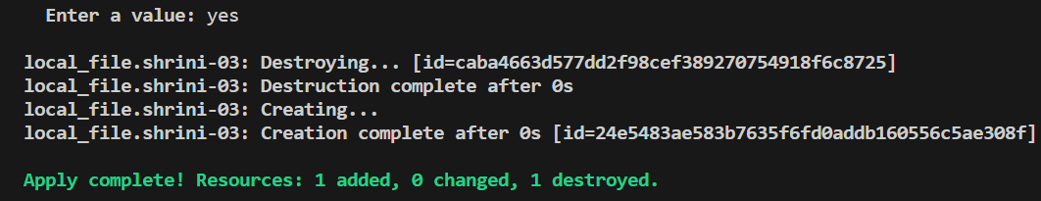

**In above we are seeing the file is deleted and creating new resources  
And, if I want to create the file and then delete it,**

**we have three life-cycle rules;   
lifecycle will be for whole resource**

**1. create_before_destroy : (works on apply command)**

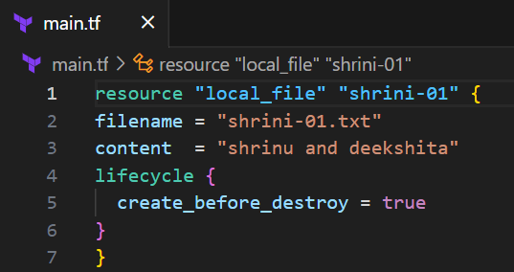

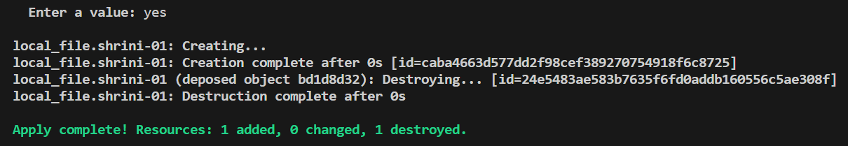

**2. prevent_destroy : (works on destroy command)**

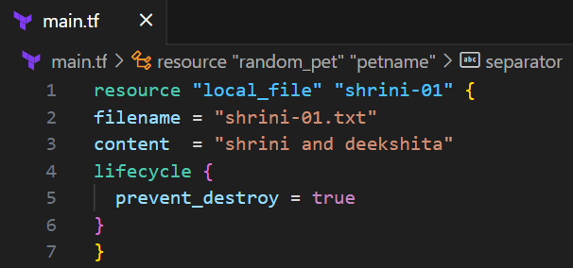

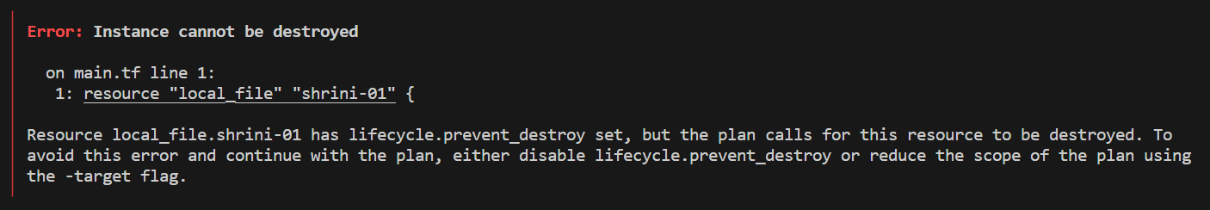

**3. Ignore_changes : (works on apply command and works between state.tf and main.tf)**

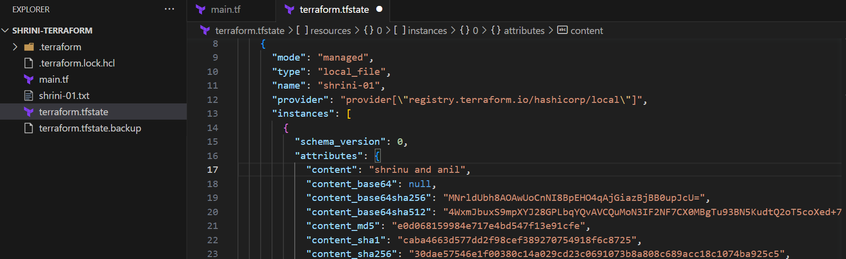

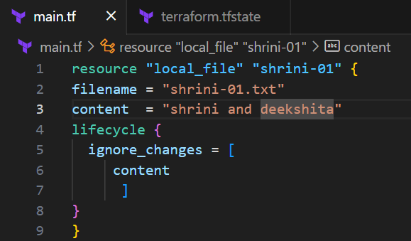

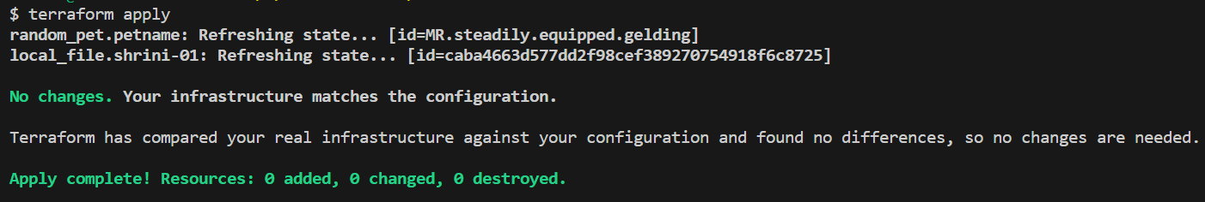

**{While executing apply command it is not changing in our main.tf file with the help of “ignore_changes”}**

**\*\* CONFIGURATIONS DIRECTORY:**

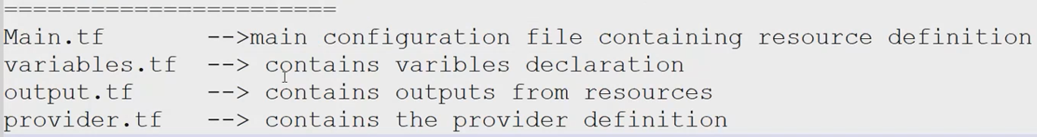

**Variables.tf:**

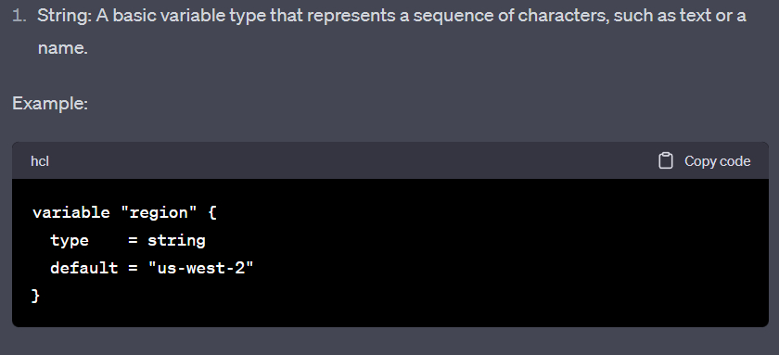

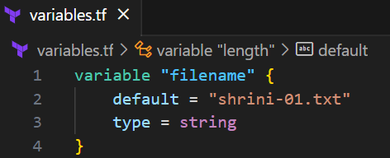

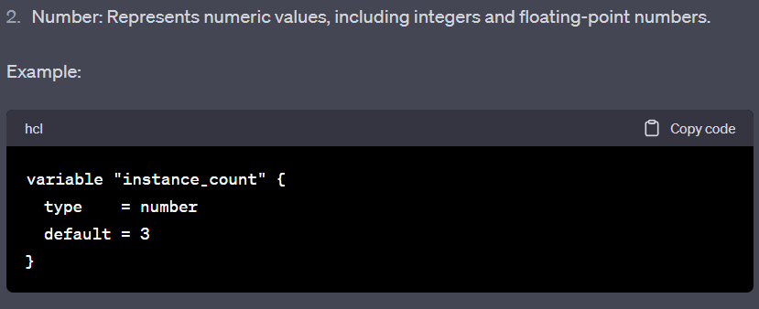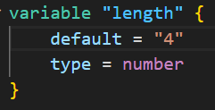

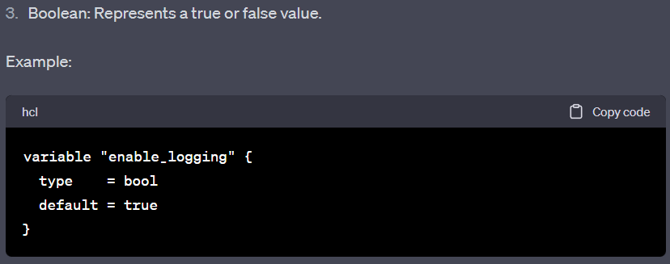

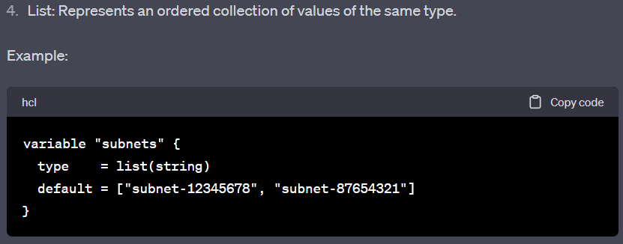

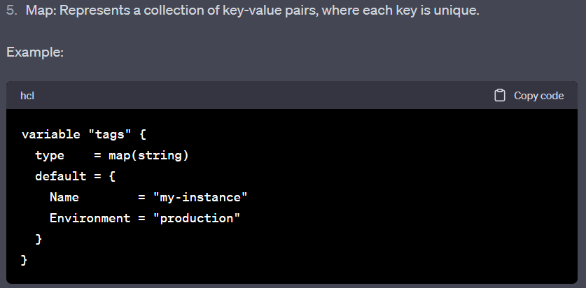

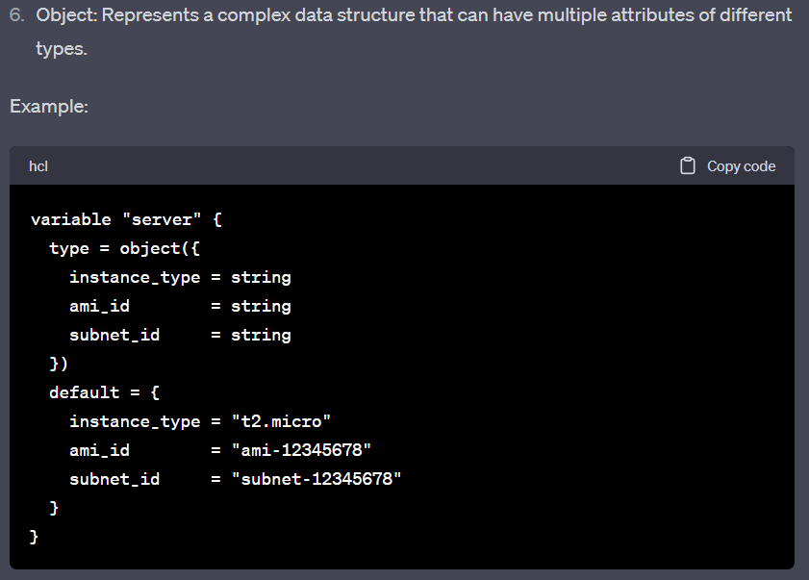

**“So we have six types of variables in (tf) as mentioned above”**

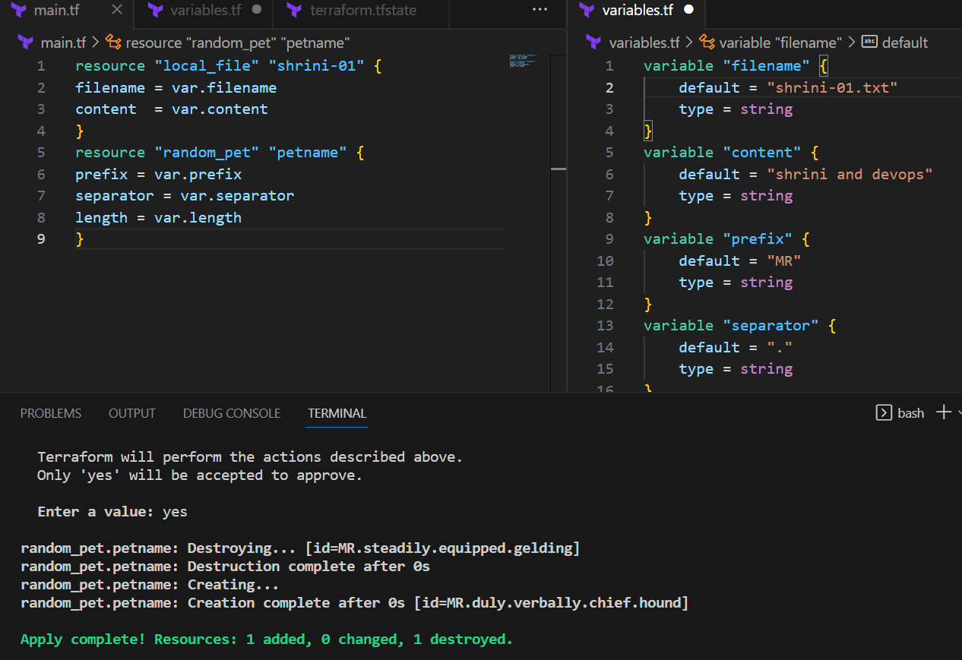

**\*\*Command line arguments:**

**If any user created any variable and did not declared any variable then terraform consider as “command line Arguments” it will ask the user to input at the run-time**

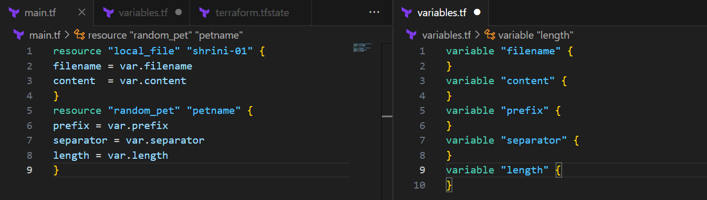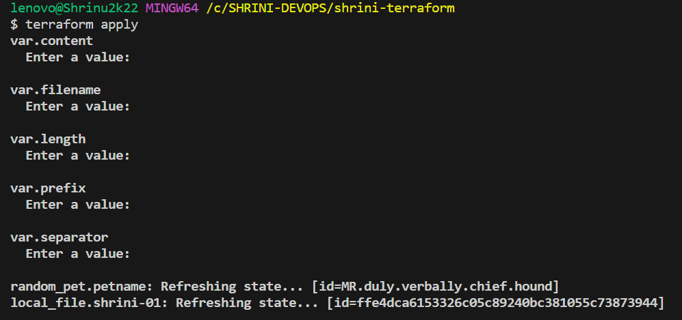

**We can push our variables at the run time by the command;  
-------------------------------------------------------------------------------------------------------------------------------**