**Jenkins-03**

**TOPICS:-**

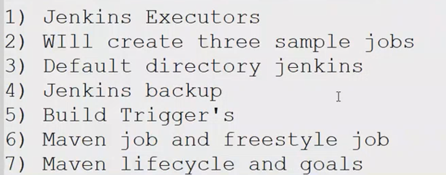

**1. Jenkins Executors:**

**Executors are responsible to build the job  
and, by default it has two executors and anyone will pick and run our job.  
We can add more executors also by which it will run multiple jobs without making any queue for the job.**

**.**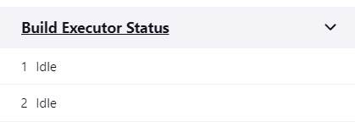

**Adding Executors in Jenkins:**

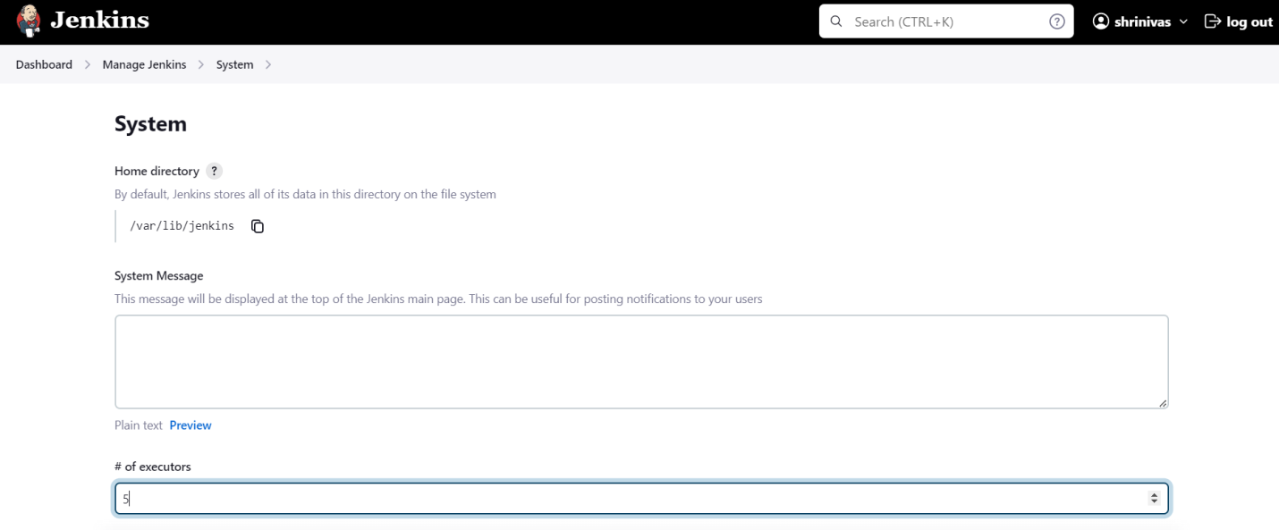

**2. Jenkins executors will be based upon the Jenkins-server memory and space; mostly it will be “3”**

**3. Default directories of Jenkins:**

**[Cd /var/lib/Jenkins]:-  
All the users related data will be saved in user’s dir:-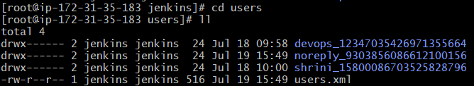And job related data will be saved in workspaces dir:-**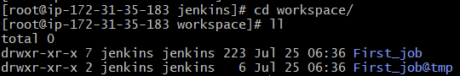

**Secrets & logs related stuff we can find out by default location**

**Points to remember in Aws-ec2 Jenkins:**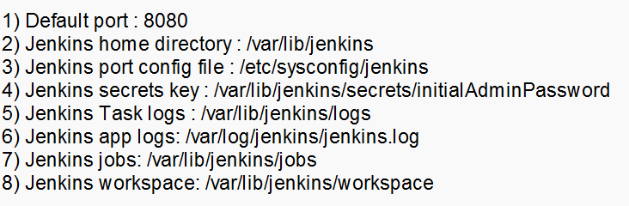

**4. Jenkins backup:**

**Two types of Jenkins backup:**

**1. Using thin backup plug-in  
2. Using shell script or tar the default dir**

**First we install Jenkins on another new-Jenkins-server:**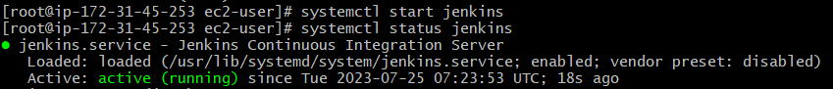

**Then, will take the backup of our existing Jenkins workspace:-  
**

**And from existing jenkins-server to new jenkins server we will move the tar.file by using SCP command:**

**For that it will required pem.file and we have to paste it on existing server by creating a file on it,**

**[Scp -i “pemfile” “desried file to move” ec2user@public-ip:/tmp ]**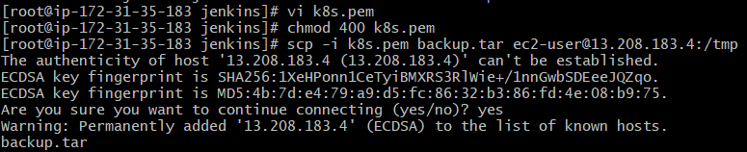

**And then on new jenkins-server:**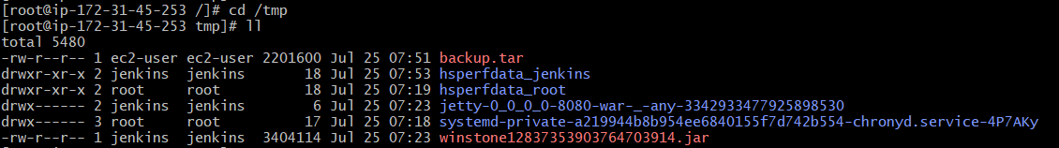

**After that we will move it to deafult location of jenkins:**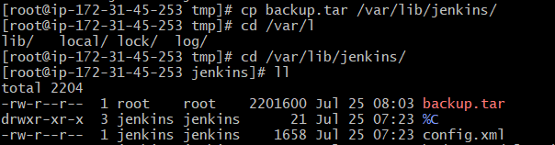

**We will follow the same process for the “jobs” and will make a tar and move it to the another Jenkins-server, **

**We will restart our jenkins-server:-**

**After that we can saw all the jobs into the new-jenkins server:**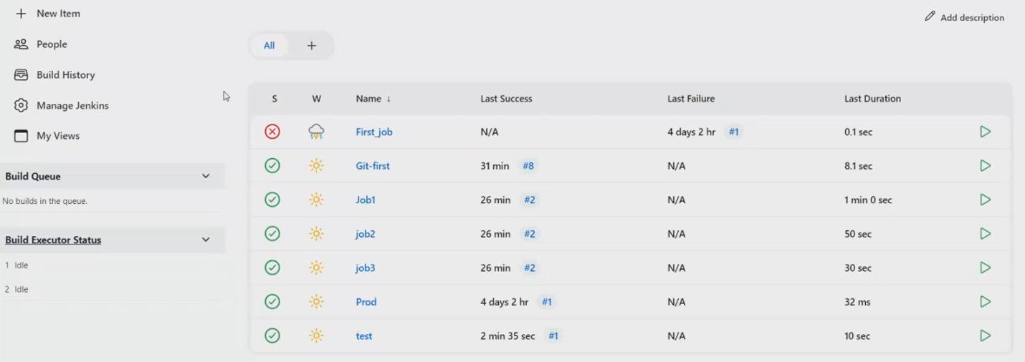

**5. Build Trigger’s:**

**We have two processes for that:**

**1. Plug-in based 2. Pipeline based**

**Plug-in based: we have below options for plug-in-based job:-**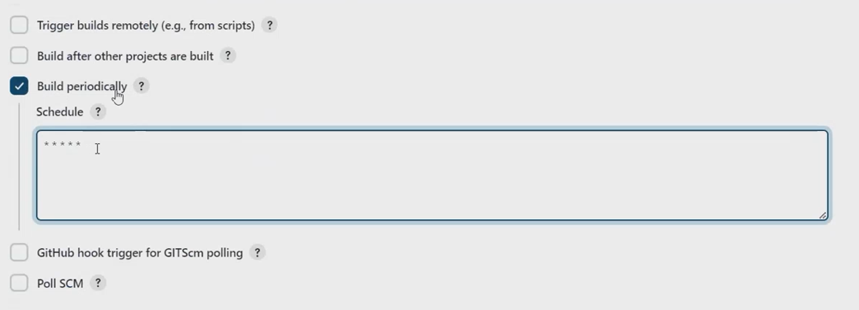

* **By GitHub whenever any changes happen then build get trigger**
* **By periodically If we want build job for every minute then we have corn-job**
* **Poll SCM is also similar to the periodically it will check the repo for every min according to the corn-job**

**6. Maven Job and freestyle job:  
In freestyle we will get different types of build steps like:-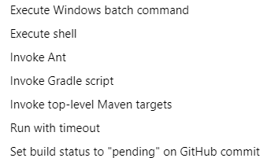   
But in Maven-job which is a plug-in   
so, by installing “MAVEN-job-plug-in” we can manage all the dependences which are required for the build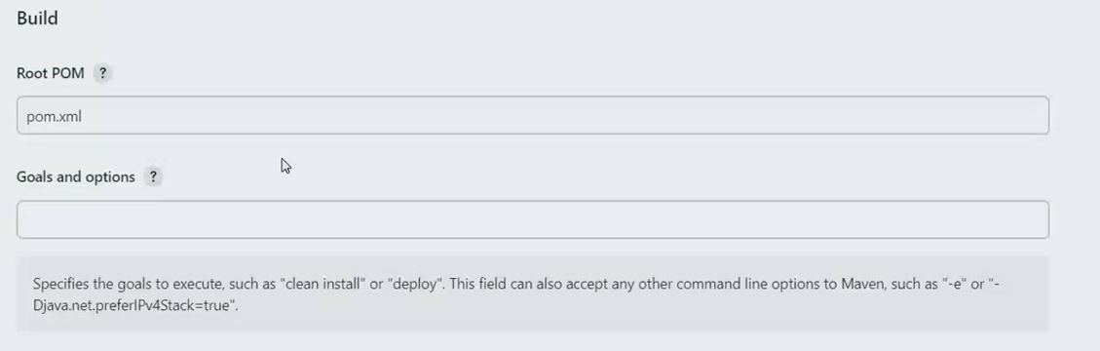7. MAVEN Life-cycle:**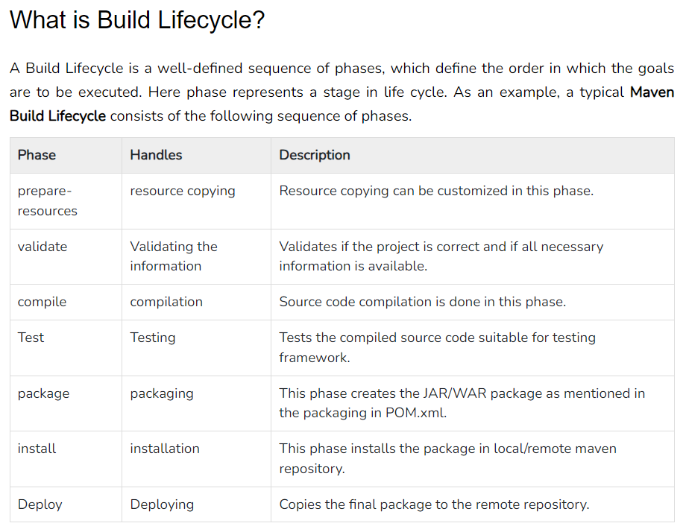

**POM.XML:-**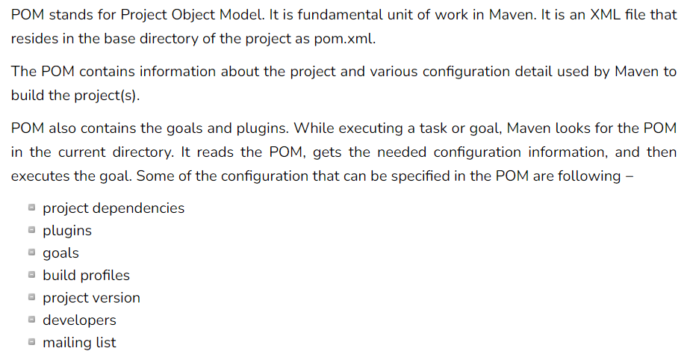

**8. STAGES IN JENKINS JOB/JENKINS FILE:**

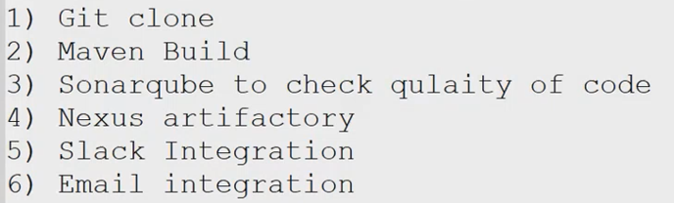

**-------------------------SHRINIVAS-------------------------**