**JENKINS-ARGOCD-K8S**

**First in git stage in mention my repo:  
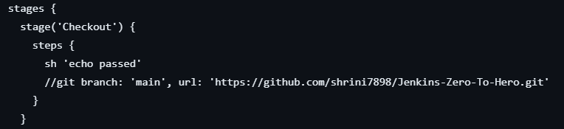**

**Then war build by maven and code quality was checked by sonarqube I mentioned the URL in stages:**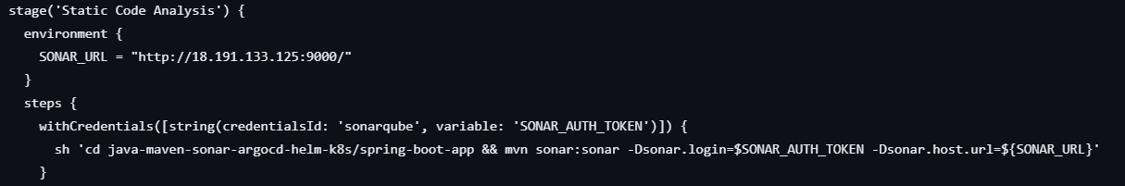

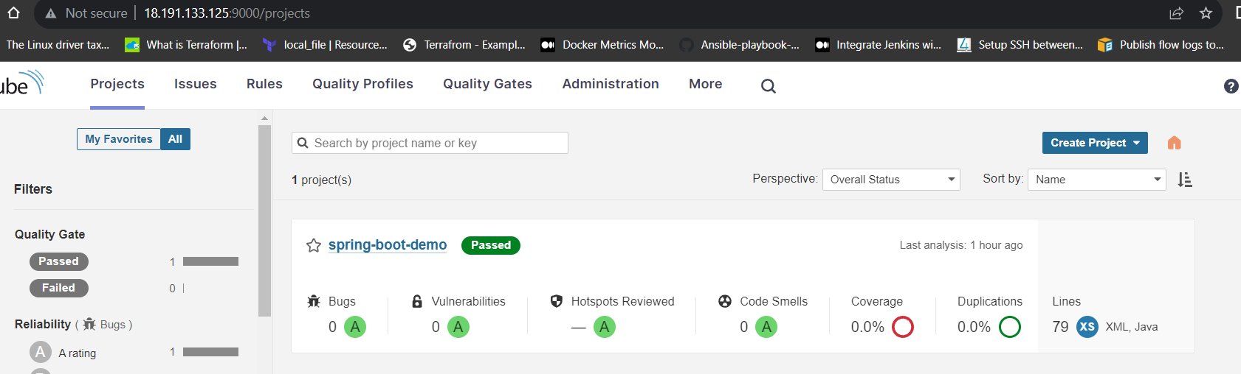

**And then created docker image and pushed to HUB:**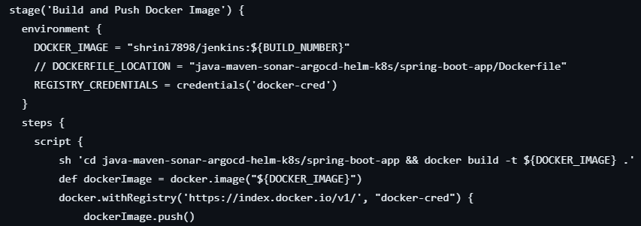

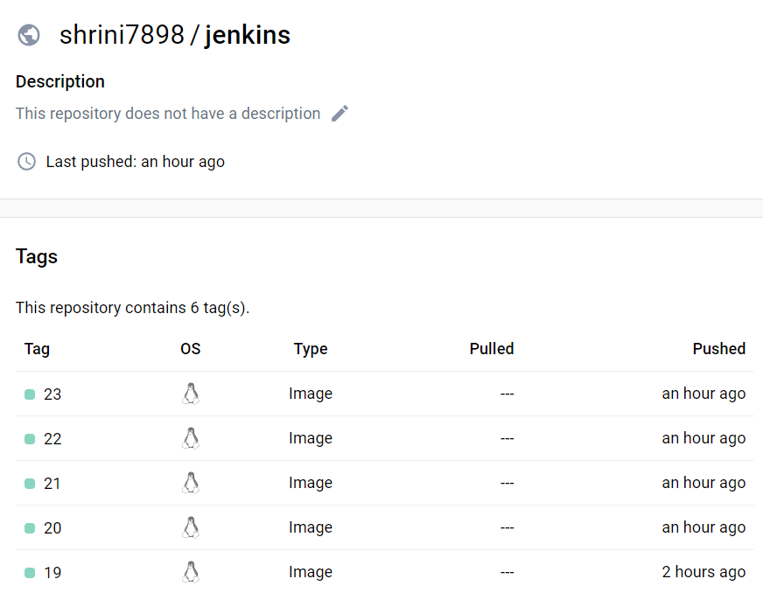

**And then updating manifest yaml files from git hub**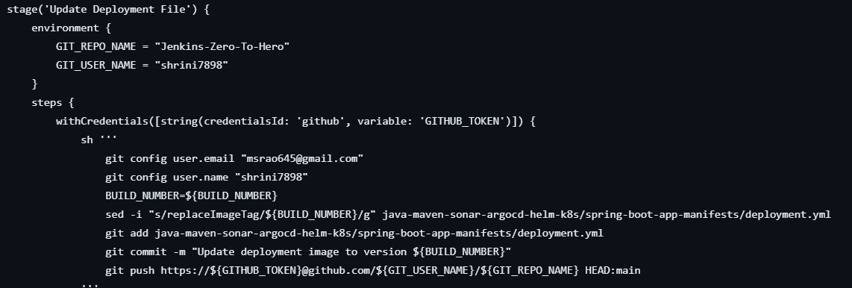

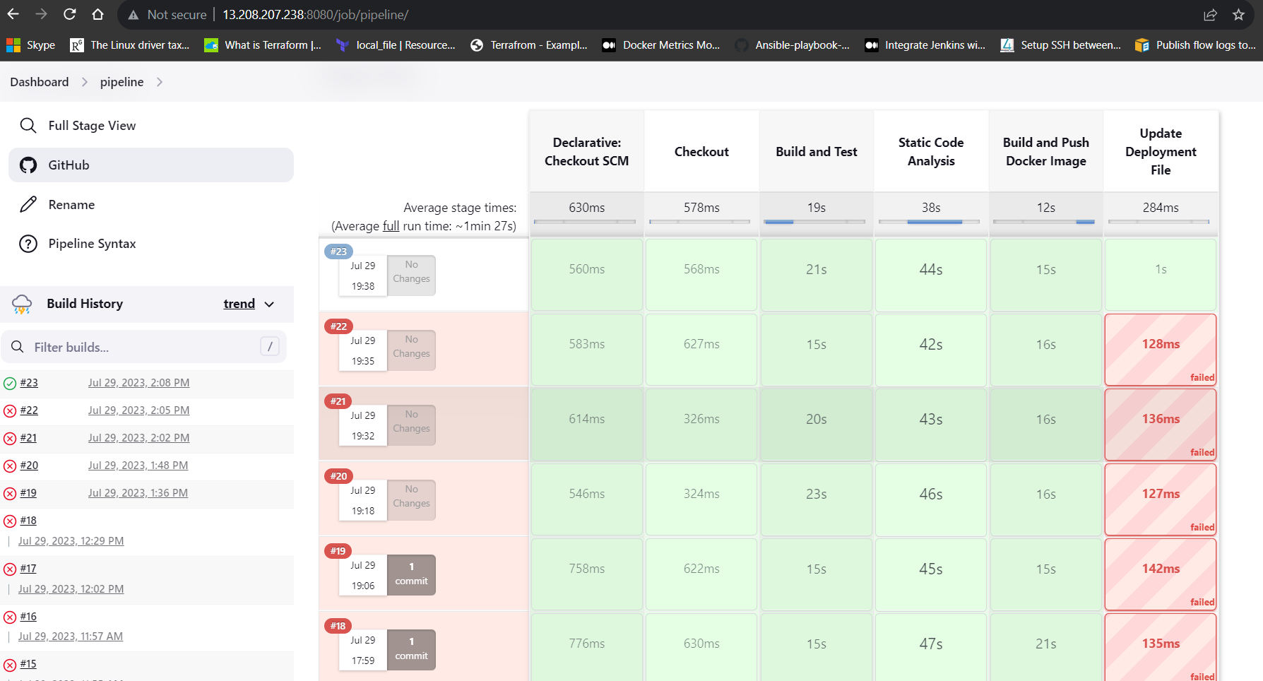

**So in Jenkins after making so many attempts we are finally get our build no.23   
like this here it is showing the job no. which is 23:**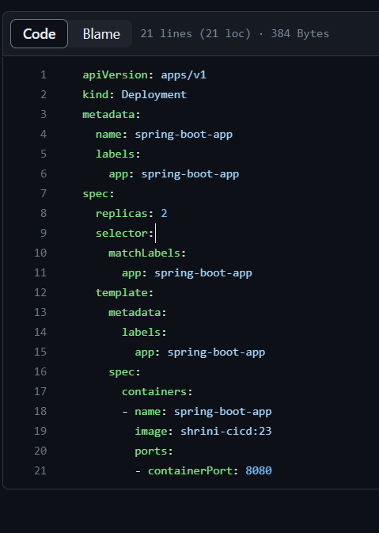

**Then, this 23 job no. will be deployed from argocd:  
Here with the help of argocd we are deploying our two applications of spring boot.  
We are accessing argocd by k8s service by “node port”**

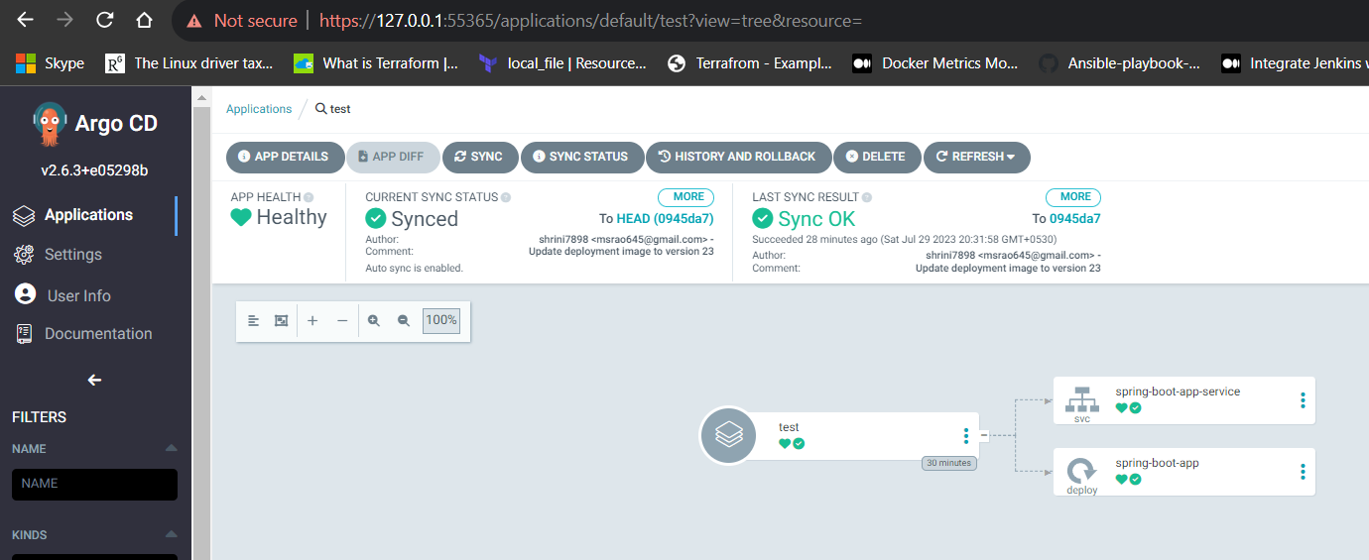

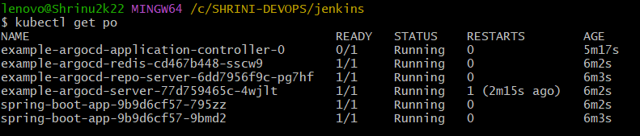

**--------------------------MAN ON A MISSION------------------------**