**EXP NO:5B TOPOLOGICAL CONNECTIONS CISCO PACKET**

**TRACER**

**DATE: 16.8.24**

**AIM:** To Design a simple topology using CiscoPacket Tracer

**1) PEER TO PEER CONNECTION:**

### 1. ****Open Cisco Packet Tracer****

* Launch Cisco Packet Tracer on your computer.

### 2. ****Add Devices****

* Drag and drop the devices you want to connect (e.g., PCs, servers) from the device list to the workspace. For a peer-to-peer connection, typically, you'll use two PCs.

### 3. ****Connect Devices****

* Use a **Copper Straight-Through cable** for the connection if connecting similar devices (like two PCs).
  + Click on the **Connections** icon (lightning bolt) from the bottom left of the Packet Tracer window.
  + Choose **Copper Straight-Through**.
  + Click on one PC and then click on the other PC to connect them.

### 4. ****Configure IP Addresses****

* You need to assign IP addresses to both PCs so they can communicate directly.

**For PC1:**

* + Click on **PC1** in the workspace.
  + Go to the **Desktop** tab.
  + Click on **IP Configuration**.
  + Set the **IP Address** (e.g., 192.168.1.1).
  + Set the **Subnet Mask** (e.g., 255.255.255.0).

**For PC2:**

* + Click on **PC2** in the workspace.
  + Go to the **Desktop** tab.
  + Click on **IP Configuration**.
  + Set the **IP Address** (e.g., 192.168.1.2).
  + Set the **Subnet Mask** (e.g., 255.255.255.0).

### 5. ****Verify the Connection****

* Use the **Command Prompt** on each PC to check connectivity.
  + On **PC1**, open **Command Prompt** from the **Desktop** tab.
  + Type ping 192.168.1.2 and press Enter. This pings PC2.
  + On **PC2**, open **Command Prompt** and type ping 192.168.1.1 to ping PC1.

If the pings are successful, the peer-to-peer connection is working.

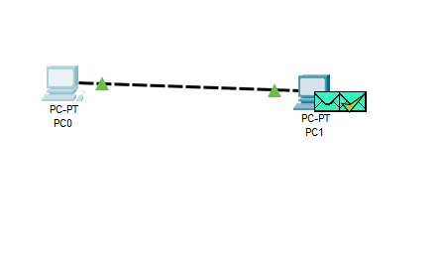

**2)2 SWITCHES, 8PC’s AND ONE ROUTER:**

#### 1. ****Open Cisco Packet Tracer:****

Launch Cisco Packet Tracer on your computer.

#### 2. ****Add a Router:****

* Click on the "Network Devices" icon (router icon) in the bottom-left pane.
* Select the "Routers" category.
* Drag and drop a router (e.g., 2901 or 1941) onto the workspace.

#### 3. ****Add a Switch:****

* Click on the "Network Devices" icon again.
* Select the "Switches" category.
* Drag and drop a switch (e.g., 2960) onto the workspace.

#### 4. ****Add PCs:****

* Click on the "End Devices" icon (computer icon).
* Select "PC" from the available options.
* Drag and drop eight PCs onto the workspace.

#### 5. ****Connect the Switch to the Router:****

* Click on the "Connections" icon (lightning bolt).
* Choose "Copper Straight-Through" cable.
* Click on the router, then select one of the Ethernet interfaces (e.g., GigabitEthernet0/0).
* Click on the switch, then select one of the switch ports (e.g., FastEthernet0/1).

#### 6. ****Connect the PCs to the Switch:****

* Using the "Copper Straight-Through" cable, connect each PC to a port on the switch:
  + Click on PC1, select the Ethernet port (usually FastEthernet0).
  + Click on the switch, and select an available port (e.g., FastEthernet0/2).
  + Repeat this process for each PC, connecting them to different ports on the switch.

#### 7. ****Configure IP Addresses:****

* For each PC, click on the PC, go to the "Desktop" tab, and then click on "IP Configuration."
* Assign a unique IP address and subnet mask to each PC. For example, use the following IP addresses:
  + **PC1:** IP Address: 192.168.1.2, Subnet Mask: 255.255.255.0
  + **PC2:** IP Address: 192.168.1.3, Subnet Mask: 255.255.255.0
  + **PC3:** IP Address: 192.168.1.4, Subnet Mask: 255.255.255.0
  + **PC4:** IP Address: 192.168.1.5, Subnet Mask: 255.255.255.0
  + **PC5:** IP Address: 192.168.1.6, Subnet Mask: 255.255.255.0
  + **PC6:** IP Address: 192.168.1.7, Subnet Mask: 255.255.255.0
  + **PC7:** IP Address: 192.168.1.8, Subnet Mask: 255.255.255.0
  + **PC8:** IP Address: 192.168.1.9, Subnet Mask: 255.255.255.0

#### 8. ****Configure the Router:****

* Click on the router and go to the "CLI" tab to enter command-line interface mode.
* Enter the following commands to configure the router:

plaintext

Copy code

enable

configure terminal

interface GigabitEthernet0/0

ip address 192.168.1.1 255.255.255.0

no shutdown

exit

#### 9. ****Verify Connectivity:****

* On each PC, open the "Command Prompt" from the "Desktop" tab.
* Use the ping command to check connectivity to the router. For example, from PC1, type ping 192.168.1.1 and press Enter.
* Ensure that all PCs can successfully ping the router's IP address and each other.

By following these steps, you should have a network with eight PCs connected through a switch to a router, with all devices properly configured for communication.

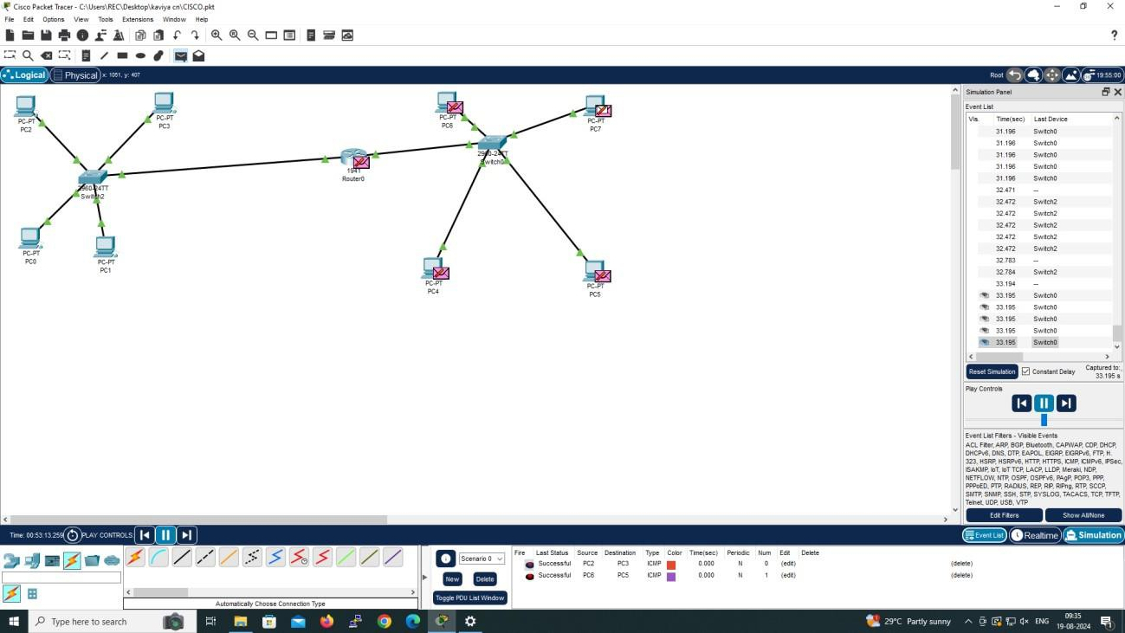

3**) 4 PC’s AND ONE HUB:**

**Open Cisco Packet Tracer:** Launch the Cisco Packet Tracer application on your computer.

1. **Add a Hub:**
   * On the bottom-left side of the interface, click on the "Network Devices" icon (it looks like a router).
   * Select the "Hubs" category.
   * Drag and drop a "Hub" onto the workspace.
2. **Add PCs:**
   * Click on the "End Devices" icon (it looks like a computer).
   * Select "PC" from the available options.
   * Drag and drop four PCs onto the workspace.
3. **Connect PCs to the Hub:**
   * Click on the "Connections" icon (it looks like a lightning bolt).
   * Select "Copper Straight-Through" cable (often shown as a solid yellow line with connectors).
   * Click on the first PC, then select the appropriate Ethernet port (usually "FastEthernet0" or similar).
   * Click on the hub, then select one of its available ports (e.g., "FastEthernet0/1").
   * Repeat this process to connect each of the remaining PCs to the hub, using different ports on the hub for each connection.
4. **Configure IP Addresses:**
   * Click on each PC and select the "Desktop" tab.
   * Click on "IP Configuration."
   * Assign a unique IP address and subnet mask to each PC. For example:
     + **PC1:** IP Address: 192.168.1.1, Subnet Mask: 255.255.255.0
     + **PC2:** IP Address: 192.168.1.2, Subnet Mask: 255.255.255.0
     + **PC3:** IP Address: 192.168.1.3, Subnet Mask: 255.255.255.0
     + **PC4:** IP Address: 192.168.1.4, Subnet Mask: 255.255.255.0
5. **Verify Connectivity:**
   * Go to one of the PCs, open the "Command Prompt" from the "Desktop" tab.
   * Use the ping command to check connectivity to the other PCs. For example, from PC1, you can ping PC2 by typing ping 192.168.1.2 and pressing Enter.
   * Ensure that all PCs can ping each other successfully.
   * By following these steps, you should be able to successfully set up a network with four PCs connected through a hub in Cisco Packet Tracer. 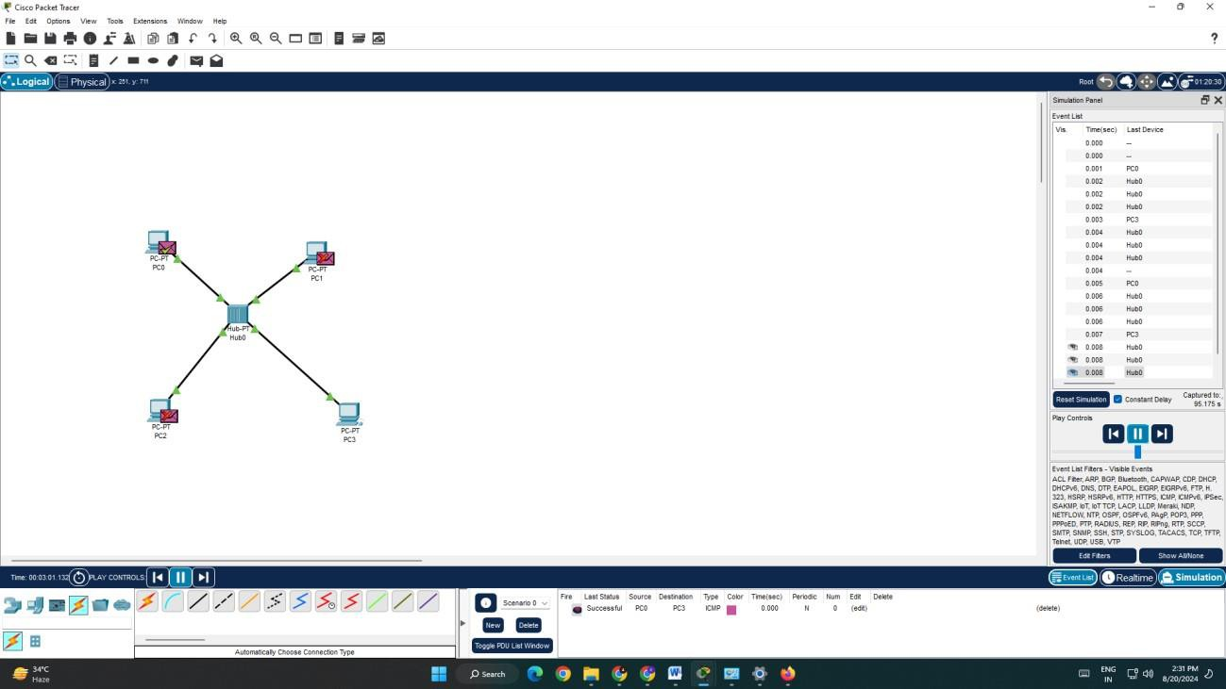

Top of Form

Bottom of Form

4**) 4 PC’s AND ONE SWITCH:**

#### 1. ****Open Cisco Packet Tracer:****

Launch the Cisco Packet Tracer application on your computer.

#### 2. ****Add a Switch:****

* Click on the "Network Devices" icon (router icon) at the bottom of the screen.
* Select the "Switches" category.
* Drag and drop a switch (e.g., 2960) onto the workspace.

#### 3. ****Add PCs:****

* Click on the "End Devices" icon (computer icon).
* Select "PC" from the available options.
* Drag and drop four PCs onto the workspace.

#### 4. ****Connect PCs to the Switch:****

* Click on the "Connections" icon (lightning bolt).
* Select "Copper Straight-Through" cable.
* Click on the first PC, select its Ethernet port (usually FastEthernet0).
* Click on the switch, select one of its available ports (e.g., FastEthernet0/1).
* Repeat this process to connect each of the remaining PCs to different ports on the switch:
  + **PC2:** Connect to FastEthernet0/2.
  + **PC3:** Connect to FastEthernet0/3.
  + **PC4:** Connect to FastEthernet0/4.

#### 5. ****Configure IP Addresses:****

* Click on each PC, go to the "Desktop" tab, and then click on "IP Configuration."
* Assign a unique IP address and subnet mask to each PC. For example:
  + **PC1:** IP Address: 192.168.1.2, Subnet Mask: 255.255.255.0
  + **PC2:** IP Address: 192.168.1.3, Subnet Mask: 255.255.255.0
  + **PC3:** IP Address: 192.168.1.4, Subnet Mask: 255.255.255.0
  + **PC4:** IP Address: 192.168.1.5, Subnet Mask: 255.255.255.0

#### 6. ****Verify Connectivity:****

* On each PC, open the "Command Prompt" from the "Desktop" tab.
* Use the ping command to check connectivity to the other PCs. For example, from PC1, you can type ping 192.168.1.3 and press Enter to ping PC2.
* Ensure that all PCs can successfully ping each other, indicating that the network is properly set up.

By following these steps, you should be able to successfully set up a network with four PCs connected through a switch in Cisco Packet Tracer.

Top of Form

Bottom of Form

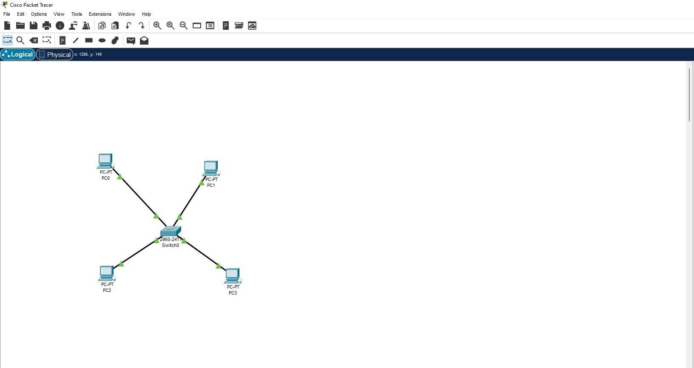

**RESULT** :

Hence , a simple topology is designed using cisco packet tracer.