Project Directory Structure

project_root/

├── features/

│ ├──Test_case.feature

│ └── steps/

│ └── my_steps_file.py

├── reports/

│ └── report.html

├── environment.py

├── run.bat

└── behave.ini

**1. Setting Up the Project**

1. **Create the Directory Structure:**
   * Create a main directory for your project (project_root).
   * Inside project_root, create the following subdirectories:
     + features
     + features/steps
     + reports
2. **Create the Required Files:**
   * Test_case.feature in the features directory.
   * my_steps_file.py in the features/steps directory.
   * environment.py in the project_root directory.
   * behave.ini in the project_root directory.
   * run.bat in the project_root directory.

**2. Installing Requirements**

To install the necessary dependencies, use the following command:

pip install -r requirements.txt

**3. Running the Tests**

To run the tests, open a terminal and navigate to the project root directory. Then execute the following command:

behave

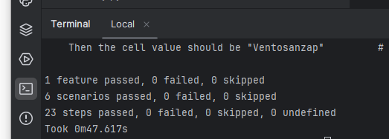

Alternatively, you can run the tests by executing run.bat

**4. Generating HTML Reports**

To generate HTML reports, use the behave-html-formatter with the following command:

behave --format html --outfile reports/report.html

**5. Project Description**

This project includes six test cases defined in Test_case.feature to interact with QE-index.html. Download the project from the given GitHub link or attached ZIP file. Install the required dependencies, navigate to the project root directory in the terminal, and type behave to see the status of the test cases. You can also generate HTML reports using the above command.

**6. Tools and Environment**

* **Tools:**
  + **Selenium**: For browser automation.
  + **Behave**: For Behavior-Driven Development (BDD) in Python.
  + **behave-html-formatter**: For generating HTML reports.
* **Environment:**
  + **Python 3.x**: Ensure you have Python 3.x installed.
  + **ChromeDriver**: Download and place it in the specified path in your project according to google version check for it in settings
  + **pycharm**

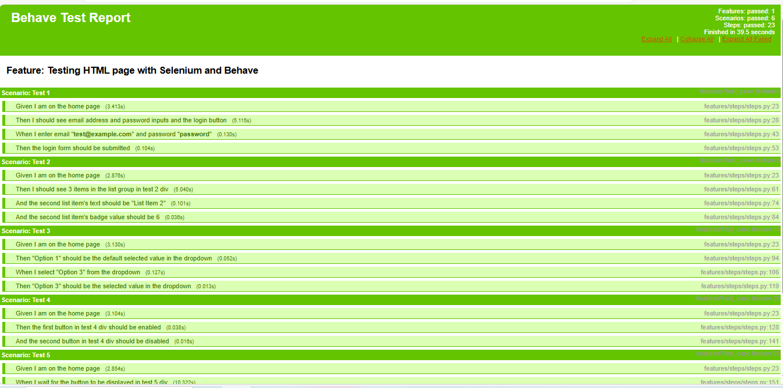

Additional Resource :

<https://behave.readthedocs.io/en/latest/>

<https://www.w3schools.com/python/>