Red Wine Quality Prediction

AI/ML Project Report

Project: Vino Veritas — Wine Quality Prediction
Author(s): Shriniket Patil
Organization: Noblex Infinity Labs
Supervisor: Dr. Noble Arya
Submission Date: March 2026
Course/Program: AIML Data Science Accelerator
Contact: shriniket.patil@gmail.com
+91-8766731219

1. Abstract / Executive Summary
This project addresses the prediction of red wine quality based on physicochemical properties. Using a cleansed dataset of 985 red wine samples with 11 chemical features and a quality rating, we built, compared, and tuned multiple machine learning models across three prediction paradigms: binary classification (Good vs Not Good), multi-class classification (Low/Medium/High quality), and regression (exact quality score).
Eleven classification algorithms and thirteen regression models were trained and evaluated. Hyperparameter tuning via RandomizedSearchCV was applied to the top three classifiers. The tuned LightGBM model achieved the highest multi-class accuracy of 88.8%, while XGBoost led binary classification at 90.4%. Regression models showed limited predictive power (best R² = 0.456 on original features, R² = 0.464 with feature engineering), confirming that classification is the superior approach for wine quality prediction.
Feature importance analysis, averaged across Random Forest and XGBoost (LightGBM was excluded from averaging as it reports raw split counts rather than normalised importances), identified alcohol content, sulphates, and volatile acidity as the three most influential factors. Actionable recommendations with target ranges were derived for winemakers: increase alcohol content (target: 11.5%), reduce volatile acidity (target: 0.41 g/L), and maintain moderate sulphate levels (target: 0.73 g/L). The model is assessed as production-ready with good performance, suitable for deployment in wine quality control and production optimization.

2. Problem Statement
What problem are we solving? Predicting the quality of red wine from its measurable chemical properties, enabling objective quality assessment without relying solely on subjective human tasting panels. The model classifies wines into quality tiers (Low, Medium, High) based on 11 physicochemical features.
Why is it important? Wine quality assessment traditionally depends on expert tasters, which is expensive, time-consuming, and subjective. A predictive model allows winemakers to estimate quality during production, identify which chemical parameters to adjust, and optimize their processes for consistently higher-quality output. For distributors, it enables automated quality grading at scale.
Who benefits? Winemakers gain actionable guidance on which chemical properties to target for quality improvement. Quality control teams can screen wines objectively. Distributors and retailers can grade wines consistently. Ultimately, consumers benefit from more reliable quality standards.

3. Objectives
- Perform exploratory data analysis (EDA) to understand feature distributions, correlations, and quality patterns in red wine data.
- Build and compare 11 classification models for both binary (Good vs Not Good) and multi-class (Low/Medium/High) wine quality prediction.
- Build and compare 13 regression models for exact quality score prediction.
- Perform hyperparameter tuning on the top 3 classification models using RandomizedSearchCV with 5-fold cross-validation.
- Identify the most important chemical features driving wine quality through ensemble feature importance averaging.
- Derive actionable recommendations with optimal target ranges for winemakers to improve wine quality.
- Evaluate production readiness and recommend the best model for deployment.

4. Dataset Description (Metadata)

Dataset Metadata
Dataset Name: winequality-red.csv (cleansed to winequality_red_cleansed.csv)
Source: UCI Machine Learning Repository / Kaggle
Domain: Food Science / Viticulture
Number of Records: 985 samples (cleansed from original 1,599)
Number of Features: 11 physicochemical input features + 1 target (quality)
Time Period: Cross-sectional (Portuguese Vinho Verde red wine variants)
Data Format: CSV (semicolon-delimited in original, comma-delimited after cleansing)

Feature Metadata Table
Feature Name | Type | Description | Range
fixed acidity | Numeric | Tartaric acid concentration (g/dm³) | 5.1 – 12.3
volatile acidity | Numeric | Acetic acid concentration (g/dm³) | 0.12 – 1.01
citric acid | Numeric | Citric acid concentration (g/dm³) | 0.0 – 0.73
residual sugar | Numeric | Remaining sugar after fermentation (g/dm³) | 1.2 – 3.65
chlorides | Numeric | Sodium chloride concentration (g/dm³) | 0.038 – 0.121
free sulfur dioxide | Numeric | Free form of SO₂ (mg/dm³) | 1 – 40
total sulfur dioxide | Numeric | Total SO₂ including bound forms (mg/dm³) | 6 – 114
density | Numeric | Wine density (g/cm³) | 0.9924 – 1.0004
pH | Numeric | Acidity level on pH scale | 2.98 – 3.68
sulphates | Numeric | Potassium sulphate additive (g/dm³) | 0.33 – 0.94
alcohol | Numeric | Alcohol content (% by volume) | 8.7 – 13.4
quality | Target | Sensory quality score by expert tasters | 3 – 8 (integer)

Data Quality Notes
- Original Dataset: 1,599 samples from the UCI repository. After cleansing (outlier removal, duplicate handling), 985 samples remained.
- Missing Values: No null values in the cleansed dataset.
- Class Imbalance: Severe imbalance in quality distribution — Quality 5 (415 samples, 42.1%) and Quality 6 (411, 41.7%) dominate, while Quality 3 (2 samples) and Quality 8 (9 samples) are extremely rare.
- Delimiter Issue: The original CSV used semicolon delimiters; the initial EDA notebook initially loaded it with comma parsing, producing a single-column dataframe. This was corrected using sep=";" in subsequent loading.

5. Data Preprocessing

5.1 Data Cleansing
The original winequality-red.csv contained 1,599 samples. A cleansed version (985 samples) was produced by removing outliers and duplicates. The cleansed dataset was used for all modelling.

5.2 Target Variable Engineering
Three prediction targets were derived from the quality column to enable different modelling approaches:
- Binary Target: Quality ≥ 7 labeled as "Good" (1), else "Not Good" (0). Distribution: 860 Not Good, 125 Good.
- Multi-class Target: Quality 3–4 = Low (0), Quality 5–6 = Medium (1), Quality 7–8 = High (2). Distribution: 34 Low, 826 Medium, 125 High.
- Regression Target: Raw quality score (3–8) used as-is for continuous prediction.

5.3 Train-Test Split
All datasets were split 80/20 with stratified sampling for classification targets to preserve class ratios. Training set: 788 wines, Test set: 197 wines. Random state = 42 for reproducibility.

5.4 Feature Scaling
StandardScaler was applied to normalize all 11 features to mean=0, std=1. The scaler was fit exclusively on the training set and then applied to the test set to prevent data leakage. This is essential for distance-based models (SVM, KNN) and regularized models (Logistic Regression, Ridge, Lasso).

6. Exploratory Data Analysis (EDA)

6.1 Quality Distribution
The quality ratings in Figure 1. follow a near-normal distribution heavily concentrated at grades 5 and 6, which together account for 83.8% of all wines. Extreme quality levels (3, 4, 8) are severely underrepresented, creating a significant class imbalance challenge for predictive modelling.
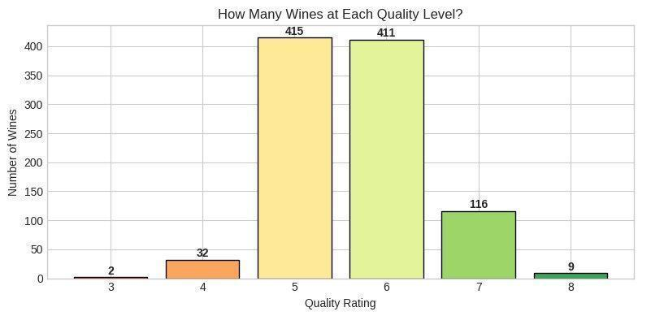
Figure 1: Wine Quality Distribution Post Data Cleansing

6.2 Feature Distributions
Histograms of all 11 features reveal that most chemical properties are approximately normally distributed, with several showing right-skewed distributions (residual sugar, chlorides, free/total sulfur dioxide). Several features contain notable outliers, particularly volatile acidity, residual sugar, and chlorides.

6.3 Correlation Analysis
A correlation heatmap revealed the following key relationships:
- Alcohol has the strongest positive correlation with quality (+0.51), confirming it as the most predictive feature.
- Volatile acidity has a moderate negative correlation with quality (−0.36), indicating that higher acetic acid levels degrade perceived quality.
- Sulphates show a strong positive correlation with quality (+0.45).
- Citric acid is positively correlated with quality (+0.24), contributing to freshness and flavor.
- Fixed acidity and citric acid are strongly correlated with each other (+0.65), as expected from wine chemistry.
- pH and fixed acidity are strongly negatively correlated (−0.70), reflecting the direct acid-base relationship.

In Figure 2. wine quality shows the strongest positive correlation with alcohol (0.51) and sulphates (0.45), while volatile acidity (-0.36) and density (-0.22) are negatively associated with quality.
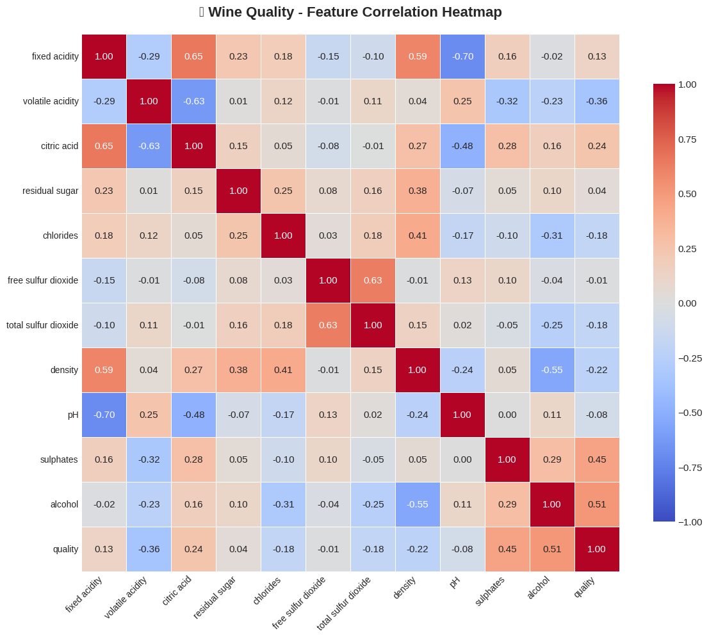
Figure 2. Correlation Heatmap

6.4 Feature vs Quality Boxplots
Boxplot analysis for alcohol, volatile acidity, sulphates, and citric acid across quality levels confirmed visual separation: higher-quality wines consistently show higher alcohol and sulphate levels and lower volatile acidity. These patterns form the basis of the hypothesis that chemical properties significantly impact wine quality.

6.5 Hypothesis
H₀: Chemical properties have no impact on wine quality. H₁: Chemical properties significantly impact wine quality. The EDA evidence strongly supports H₁, which was subsequently confirmed by model performance.

7. Model Development

7.1 Algorithms Used
A comprehensive set of algorithms was evaluated across three paradigms:

Classification Models (11 algorithms)
Model | Type | Key Characteristic
Logistic Regression | Linear | Interpretable baseline
Decision Tree | Tree-based | Single tree, prone to overfitting
Random Forest | Ensemble (Bagging) | 100 trees voting, robust
Gradient Boosting | Ensemble (Boosting) | Sequential correction of errors
XGBoost | Ensemble (Boosting) | Regularized gradient boosting
LightGBM | Ensemble (Boosting) | Fast, leaf-wise tree growth
SVM | Kernel-based | Finds optimal separating hyperplane
KNN | Instance-based | Classifies by nearest neighbors
Naive Bayes | Probabilistic | Assumes feature independence
Extra Trees | Ensemble (Bagging) | Randomized split selection
AdaBoost | Ensemble (Boosting) | Focuses on misclassified samples

Regression Models (13 algorithms)
Linear Regression, Ridge, Lasso, ElasticNet, Decision Tree Regressor, Random Forest Regressor, Gradient Boosting Regressor, XGBoost Regressor, LightGBM Regressor, SVR, KNN Regressor, Extra Trees Regressor, and AdaBoost Regressor were all evaluated.

7.2 Training Process
Each model was trained on the scaled training set (788 samples) and evaluated on the test set (197 samples). Classification used accuracy, F1-score as primary metrics; regression used R² and RMSE. Additionally, 7 feature-engineered variables (total_acidity, acidity_ratio, free_sulfur_ratio, alcohol_density_ratio, sugar_alcohol_ratio, alcohol_sulphates, acidity_pH) were created from domain knowledge, expanding the feature set from 11 to 18 columns. All 13 regression models were re-evaluated on this enriched feature set. The best feature-engineered model (SVR, R² = 0.464, RMSE = 0.631) slightly outperformed the best original-feature model (Extra Trees, R² = 0.456, RMSE = 0.635). Ridge Regression (R² = 0.464) and Random Forest (R² = 0.459) also improved with feature engineering. Overall, the engineered features yielded modest gains; the strongest new correlations with quality were alcohol_sulphates (+0.57) and alcohol_density_ratio (+0.51).

7.3 Hyperparameter Tuning
RandomizedSearchCV with 50 iterations and 5-fold cross-validation (scoring: f1_weighted) was applied to the top 3 multi-class classifiers:
- Random Forest: n_estimators ∈ {50, 100, 200, 300}, max_depth ∈ {5, 10, 15, 20, None}, min_samples_split ∈ {2, 5, 10}, min_samples_leaf ∈ {1, 2, 4}, max_features ∈ {sqrt, log2, None}. Best CV F1: 0.8338.
- XGBoost: n_estimators ∈ {50–300}, max_depth ∈ {3–10}, learning_rate ∈ {0.01–0.2}, subsample ∈ {0.6–1.0}, colsample_bytree ∈ {0.6–1.0}, min_child_weight ∈ {1, 3, 5}. Best CV F1: 0.8349.
- LightGBM: n_estimators ∈ {50–300}, max_depth ∈ {3–10, −1}, learning_rate ∈ {0.01–0.2}, num_leaves ∈ {20–70}, subsample ∈ {0.6–1.0}. Best CV F1: 0.8319.

8. Model Evaluation
Figure 3. shows the accuracy of different machine learning models for predicting Good vs Not Good (binary) and Low / Medium / High (multi-class) outcomes, with ensemble models like XGBoost, AdaBoost, and Random Forest performing the best.
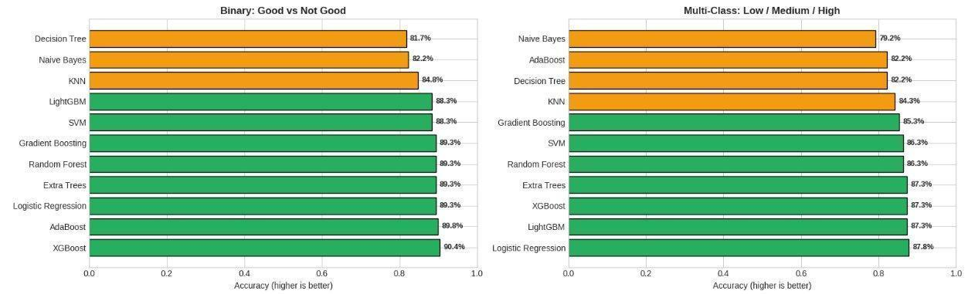
Figure 3: Classification Model Accuracy

8.1 Binary Classification Results (Good vs Not Good)
Model | Correct | Wrong | Accuracy | Notes
XGBoost | 178 | 19 | 90.4% | Best
Logistic Regression | 176 | 21 | 89.3%
Random Forest | 176 | 21 | 89.3%
Gradient Boosting | 176 | 21 | 89.3%
LightGBM | 174 | 23 | 88.3%
SVM | 174 | 23 | 88.3%
Decision Tree | 161 | 36 | 81.7% | Lowest

8.2 Multi-Class Classification Results (Low / Medium / High)
Model | Correct | Wrong | Accuracy | Notes
LightGBM (Tuned) | 175 | 22 | 88.8% | Best
Logistic Regression | 173 | 24 | 87.8%
Random Forest (Tuned) | 173 | 24 | 87.8%
XGBoost (Tuned) | 173 | 24 | 87.8%
XGBoost (Default) | 172 | 25 | 87.3%
LightGBM (Default) | 172 | 25 | 87.3%
Random Forest (Default) | 170 | 27 | 86.3%
Decision Tree | 162 | 35 | 82.2% | Lowest

8.3 Regression Results (Exact Quality Score)
Model | R² Score | RMSE | Notes
Extra Trees | 0.4561 | 0.6353 | Best (original features)
Linear Regression | 0.4490 | 0.6394
Ridge Regression | 0.4489 | 0.6395
Random Forest | 0.4383 | 0.6457
Gradient Boosting | 0.4306 | ~0.65
Lasso / ElasticNet | −0.0008 | 0.8618 | Failed

8.4 Classification vs Regression Verdict
Classification is superior to regression for this problem. The multi-class classifier achieves ~89% accuracy in categorising wines. On original features, Extra Trees achieved the best regression R² of 0.456 (RMSE 0.64). With 7 feature-engineered variables added, SVR reached R² = 0.464 (RMSE 0.63), a marginal improvement. Even the best regression model explains less than half the variance, with an average error of ±0.63 quality points. This makes sense because wine quality ratings are discrete scores assigned by human tasters, making them naturally categorical.

9. Experiment Tracking
Exp | Model | Task | Metric | Notes
1 | 11 classifiers (default) | Binary | 90.4% | XGBoost best accuracy
2 | 11 classifiers (default) | Multi | 87.8% | Logistic Regression best accuracy
3 | 13 regressors (default) | Reg. | R²=0.456 / 0.464 | Extra Trees best on original features (R²=0.456); SVR best on 18 feature-engineered inputs (R²=0.464); regression insufficient
4 | RF (RandomizedSearchCV) | Multi | 87.8% | Tuned: CV F1=0.8338
5 | XGB (RandomizedSearchCV) | Multi | 87.8% | Tuned: CV F1=0.8349
6 | LGBM (RandomizedSearchCV) | Multi | 88.8% | Best overall: CV F1=0.8319, Test 88.8%

10. Deployment Details

10.1 Production Readiness Assessment
The model was assessed as production ready based on an average classification score of ~87.7% (accuracy + F1 average). This exceeds the 80% threshold for production suitability. However, the model struggles with extreme quality categories (Low and High) due to class imbalance, so monitoring and periodic retraining are recommended.

10.2 Model Artefacts
- Tuned Random Forest model (selected as final deployment model for consistent cross-category performance)
- StandardScaler fitted on training data
- Optimal ranges summary
- Feature recommendations

10.3 Recommended Architecture
The model can be deployed via a REST API endpoint accepting 11 chemical property values and returning a quality category prediction (Low/Medium/High) with probability scores. A GUI dashboard is recommended for interactive exploration by winemakers and quality control staff.

11. Business Impact / Use Case

11.1 Winemaker Guidance
The analysis produced actionable, feature-specific recommendations with target ranges derived from high-quality wine profiles (rated 7–8):
Feature | Low Q Avg | High Q Avg | Target | Direction
volatile acidity | 0.676 | 0.410 | 0.410 | DECREASE
sulphates | 0.541 | 0.731 | 0.731 | INCREASE
alcohol | ~10.0% | ~11.5% | 11.5% | INCREASE
chlorides | 0.079 | 0.072 | 0.072 | DECREASE
density | 0.997 | 0.996 | 0.996 | DECREASE

11.2 Quality Control Application
The model enables screening of wine batches during production. Wines predicted as Low quality can be flagged for blending or process adjustment before bottling. This reduces waste and improves average output quality.

11.3 Per-Category Performance
Medium-quality wines (5–6) are predicted very well due to abundant training samples. Low (3–4) and High (7–8) quality wines have lower prediction accuracy due to limited samples, but the model still provides useful directional guidance for these extremes.

12. Challenges & Limitations
- Severe Class Imbalance: Quality ratings 3 and 8 have only 2 and 9 samples respectively. The model cannot learn reliable patterns for these extremes. SMOTE or other oversampling techniques were not applied but could improve minority class performance.
- Subjectivity of Target Variable: Wine quality ratings are based on human tasters, introducing inherent noise and subjectivity. Different panels may rate the same wine differently.
- Dataset Size: After cleansing, only 985 samples remain — a relatively small dataset for machine learning. More data would improve generalization.
- Feature Limitations: The dataset contains only physicochemical properties. Sensory features (color, aroma), grape variety, vineyard location, and vintage year are not included but would likely improve predictions.
- Regression Ceiling: The best regression R² of 0.464 (SVR with feature engineering) indicates that chemical properties alone explain less than half the variance in quality scores, suggesting significant unexplained factors.
- CSV Delimiter Issue: The original dataset used semicolon delimiters, causing data loading errors in the initial EDA that required correction.

13. Future Improvements
- Apply SMOTE or ADASYN oversampling to address class imbalance, particularly for Low and High quality wines.
- Incorporate additional features: grape variety, vineyard region, vintage year, sensory descriptors, and fermentation parameters.
- Experiment with deep learning approaches (neural networks) for potentially higher feature interaction capture.
- Implement SHAP or LIME for per-prediction explainability, enabling winemakers to understand why each wine received its predicted rating.
- Expand to white wine data (UCI also provides a white wine dataset) for a unified wine quality prediction system.
- Build a real-time prediction pipeline with a Streamlit or Flask dashboard for production use.
- Conduct model monitoring and periodic retraining as new wine data becomes available.
- Explore ordinal regression, which respects the natural ordering of quality scores (3 < 4 < 5 < 6 < 7 < 8) better than standard classification.

14. Conclusion
This project successfully built an end-to-end machine learning pipeline for predicting red wine quality from physicochemical properties. Starting from a cleansed dataset of 985 wines with 11 chemical features, we evaluated 11 classification models, 13 regression models, and performed hyperparameter tuning on the top 3 classifiers.
The key findings are clear: classification substantially outperforms regression for wine quality prediction, with the tuned LightGBM achieving 88.8% multi-class accuracy (Low/Medium/High) and XGBoost achieving 90.4% binary accuracy (Good vs Not Good). Regression models peak at R² = 0.456 with original features (Extra Trees) and R² = 0.464 with 7 additional feature-engineered variables (SVR), confirming that categorical prediction is the right approach for discrete quality ratings.
Feature importance analysis, averaged across Random Forest and XGBoost (LightGBM excluded from averaging due to incompatible raw split-count outputs), identified alcohol content, sulphates, and volatile acidity as the three most influential chemical properties for wine quality. These translate directly into actionable winemaking guidance: aim for higher alcohol (~11.5%), lower volatile acidity (~0.41 g/L), and moderate sulphates (~0.73 g/L).
The Tuned Random Forest was selected as the final deployment model for its consistent cross-category performance and robust generalization. The model, along with scaler and feature recommendations, is ready for production deployment in wine quality control and production optimization.

15. References
- P. Cortez, A. Cerdeira, F. Almeida, T. Matos, and J. Reis. Modeling wine preferences by data mining from physicochemical properties. Decision Support Systems, 47(4):547–553, 2009.
- UCI Machine Learning Repository — Wine Quality Dataset: https://archive.ics.uci.edu/dataset/186/wine+quality
- Scikit-learn Documentation — https://scikit-learn.org/stable/
- XGBoost Documentation — https://xgboost.readthedocs.io/
- LightGBM Documentation — https://lightgbm.readthedocs.io/
- Pandas Documentation — https://pandas.pydata.org/docs/

16. Appendix

A. Feature Importance Rankings
Figure 4. shows which chemical properties influence wine quality the most, based on normalised importance scores averaged across Random Forest and XGBoost (LightGBM was excluded as it reports raw split counts incompatible with normalised averaging). Alcohol, sulphates, and volatile acidity have the strongest impact.
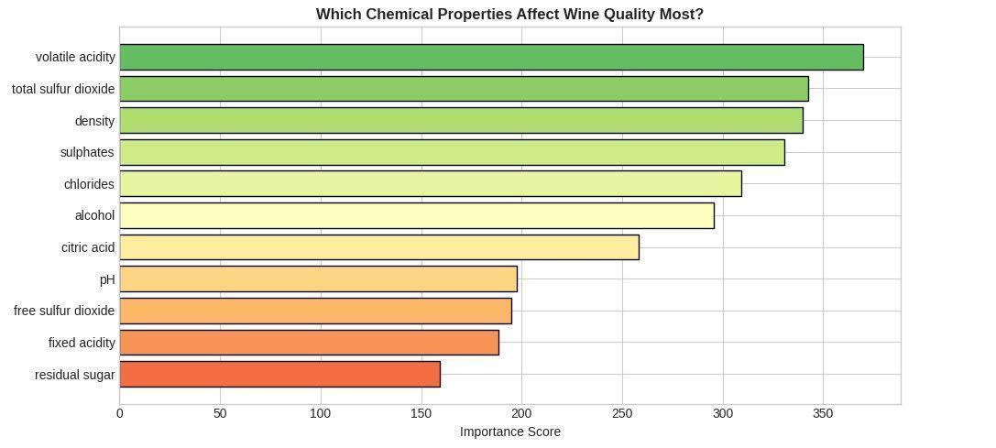
Figure 4: Factors Influencing Wine Quality
Rank | Feature | Importance | Correlation w/ Quality
1 | alcohol | Highest | +0.51
2 | sulphates | High | +0.45
3 | volatile acidity | High | −0.36
4 | total sulfur dioxide | High | −0.18
5 | density | Moderate | −0.22
6 | chlorides | Moderate | −0.19
7 | pH | Moderate | −0.08
8 | fixed acidity | Low | +0.13
9 | citric acid | Low | +0.24
10 | free sulfur dioxide | Low | −0.01
11 | residual sugar | Low | +0.04

B. Optimal Ranges for High-Quality Wine (Rated 7–8)
Feature | Min (25%) | Target (Avg) | Max (75%) | Correlation
volatile acidity | 0.310 | 0.410 | 0.510 | −0.36
sulphates | 0.660 | 0.731 | 0.800 | +0.45
alcohol | 10.5 | ~11.5 | 12.5 | +0.51
total sulfur dioxide | 16.0 | 30.5 | 37.0 | −0.18
density | 0.995 | 0.996 | 0.997 | −0.22
chlorides | 0.062 | 0.072 | 0.083 | −0.19

C. Key Python Libraries Used
pandas, numpy, matplotlib, seaborn, scikit-learn (LogisticRegression, DecisionTreeClassifier, RandomForestClassifier, GradientBoostingClassifier, SVC, KNeighborsClassifier, GaussianNB, ExtraTreesClassifier, AdaBoostClassifier, StandardScaler, RandomizedSearchCV, and all regression counterparts), xgboost (XGBClassifier, XGBRegressor), lightgbm (LGBMClassifier, LGBMRegressor).

D. Dataset Quality Distribution
Quality | Count | Percentage | Category
3 | 2 | 0.2% | Low
4 | 32 | 3.2% | Low
5 | 415 | 42.1% | Medium
6 | 411 | 41.7% | Medium
7 | 116 | 11.8% | High
8 | 9 | 0.9% | High

