Telco Customer Churn Prediction
AI/ML Project Report

Author(s): Shriniket Patil
Organization: Noblex Infinity Labs
Supervisor: Dr. Noble Arya
Submission Date: March 2026
Course/Program: AIML Data Science Accelerator
Contact: shriniket.patil@gmail.com
+91-8766731219

2. Abstract / Executive Summary
This project addresses the problem of customer churn in the telecommunications industry. Using a dataset of 7,043 customers from a fictional California-based telecom company (Q3 data), we built and compared three machine learning models — Logistic Regression, Random Forest, and XGBoost — to predict which customers are likely to leave the service.
The dataset contains 21 features covering customer demographics, account information, and service subscriptions. After data cleaning, encoding, and feature engineering, the final modelling dataset comprised 34 features across 7,043 records.
Hyperparameter tuning via GridSearchCV was performed on all three models. The Random Forest classifier was selected as the best-performing model based on the highest F1-Score (0.6374 after tuning), striking the best balance between identifying actual churners (recall) and minimizing false alarms (precision). The model achieved strong ROC-AUC performance, demonstrating reliable discrimination between churners and loyal customers.
Key churn drivers identified include month-to-month contracts, short customer tenure, lack of tech support or online security, and electronic check payment methods. A revenue impact analysis estimates that targeted retention campaigns, informed by the model’s risk scores, could save substantial annual revenue at a strong return on investment. The model is packaged for production deployment with saved artefacts.

3. Problem Statement
A telecommunications company serving 7,043 customers in California is experiencing significant customer attrition (churn). Approximately 26.5% of customers — roughly 1 in 4 — are leaving the service, representing a major revenue threat.
What problem are we solving? Predicting which customers are at highest risk of churning so the business can intervene proactively before they leave.
Why is it important? Acquiring a new customer costs 5–7x more than retaining an existing one. Even a 5% reduction in churn can increase profits by 25–95%. Without a predictive model, the retention team must guess which customers need attention, wasting budget on loyal customers and missing those truly at risk.
Who benefits? The Customer Success and Retention teams gain a ranked, actionable list of at-risk customers each month. Leadership gains quantifiable ROI from retention spending. Ultimately, customers benefit from proactive service improvements.

4. Objectives
- Build and compare multiple classification models (Logistic Regression, Random Forest, XGBoost) for churn prediction.
- Perform hyperparameter tuning via GridSearchCV to optimize each model.
- Identify the top features i.e. churn drivers to inform business retention strategies.
- Generate customer-level churn risk scores and tier customers into High / Medium / Low risk segments.
- Estimate the revenue impact of churn and the ROI of targeted retention campaigns.
- Export the trained model and preprocessing artefacts for production deployment.

5. Dataset Description (Metadata)

Dataset Metadata
Dataset Name: WA_Fn-UseC_-Telco-Customer-Churn.csv
Source: IBM Sample Data / Kaggle
Domain: Telecommunications
Number of Records: 7,043 customers
Number of Features: 21 (raw), expanded to 34 after encoding and feature engineering
Time Period: Q3 snapshot
Data Format: CSV

Feature Metadata Table
Feature Name | Type | Description | Sample
customerID | Nominal | Unique customer identifier | 7590-VHVEG
gender | Binary | Customer gender | Female
SeniorCitizen | Binary | Whether customer is a senior citizen | 0 / 1
Partner | Binary | Whether customer has a partner | Yes / No
Dependents | Binary | Whether customer has dependents | Yes / No
tenure | Numeric | Number of months with the company | 1–72
PhoneService | Binary | Whether customer has phone service | Yes / No
MultipleLines | Categorical | Whether customer has multiple lines | Yes/No/No phone
InternetService | Categorical | Customer’s internet service type | DSL/Fiber/No
OnlineSecurity | Categorical | Whether customer has online security add-on | Yes/No
TechSupport | Categorical | Whether customer has tech support add-on | Yes/No
Contract | Categorical | Customer’s contract type | Month/1yr/2yr
MonthlyCharges | Numeric | Amount charged per month | $18–$119
TotalCharges | Numeric | Total amount charged over tenure | $0–$8,685
Churn | Target | Whether customer left the company | Yes / No

As we can see in Figure 1, customer churn is mainly influenced by tenure, total charges, contract type, and monthly spending.
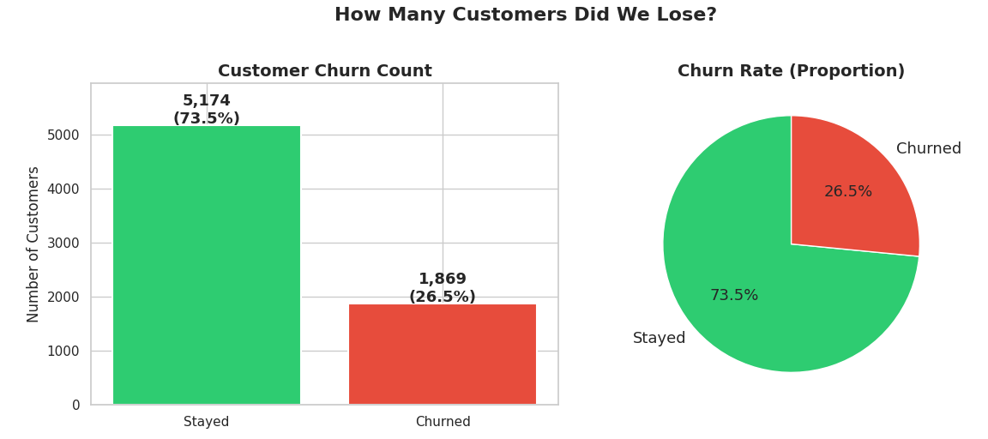
Figure 1. Customer churn distribution

Data Quality Notes
- Missing Values: No null values detected across all 21 columns. However, TotalCharges contained 11 blank strings (new customers with zero charges) that were coerced to 0.0.
- Class Imbalance: The target variable is imbalanced — 73.5% non-churn vs. 26.5% churn. This was addressed using class_weight=‘balanced’ and scale_pos_weight parameters.
- Data Type Issue: TotalCharges was stored as object (string) in the raw CSV and required conversion to float.

6. Data Preprocessing
The raw dataset underwent a structured cleaning and transformation pipeline to prepare it for machine learning:

6.1 Handling Missing / Invalid Values
The TotalCharges column was stored as a string in the source CSV. It was converted to numeric using pd.to_numeric with errors coerced to NaN. Eleven blank entries (new customers) were filled with 0.0, reflecting zero charges for zero-tenure customers.

6.2 Dropping Non-Predictive Columns
The customerID column was removed as it is a unique identifier with no predictive signal.

6.3 Target Encoding
The Churn column was converted from Yes/No text to binary 1/0 integers.

6.4 Categorical Encoding
Binary columns (gender, Partner, Dependents, PhoneService, PaperlessBilling) were mapped to 1/0 using an explicit dictionary. Multi-class columns (InternetService, Contract, PaymentMethod, MultipleLines, OnlineSecurity, OnlineBackup, DeviceProtection, TechSupport, StreamingTV, StreamingMovies) were one-hot encoded with drop_first=True to avoid multicollinearity. This expanded the feature set from 21 to 31 columns.

6.5 Feature Engineering
Three domain-informed features were created to improve model performance:
- AvgMonthlySpend: TotalCharges divided by tenure, normalizing spend across customer lifetimes.
- IsNewCustomer: Binary flag for customers with tenure < 12 months (the highest churn risk window).
- NumAddonServices: Count of additional services subscribed (Streaming, Online, Device, Tech), representing switching cost.

6.6 Feature Scaling
StandardScaler was applied to normalize numerical features to mean=0, std=1. Critically, the scaler was fit only on the training set and then applied to the test set, preventing data leakage. This step is essential for Logistic Regression but not required for tree-based models.

7. Exploratory Data Analysis

7.1 Target Distribution
The churn rate in the dataset is approximately 26.5% (1,869 churners out of 7,043 customers). This means roughly 1 in 4 customers left the service — a significant and costly problem. The class imbalance (73.5% vs 26.5%) required careful handling during modelling.

7.2 Key Churn Drivers (Visual Analysis)
Six key categorical features were analyzed for their relationship with churn:
- Contract Type: Month-to-month customers churn at ~42%, dramatically higher than one-year (~11%) or two-year (~3%) contract holders.
- Internet Service: Fiber optic customers show higher churn rates, suggesting price or service dissatisfaction.
- Tech Support & Online Security: Customers without these add-on services churn significantly more.
- Senior Citizens: Senior customers churn at higher rates than non-seniors.
- Payment Method: Electronic check users show the highest churn, correlating with less committed billing relationships.

7.3 Correlation & Feature Patterns
Tenure and TotalCharges show strong positive correlation. MonthlyCharges and the number of add-on services are also correlated. The engineered features (AvgMonthlySpend, IsNewCustomer) capture additional signal not directly present in raw columns.

8. Model Development

8.1 Algorithms Used
Three classification algorithms were trained and compared:
Model | Type | Key Characteristic
Logistic Regression | Linear / Baseline | Simple, interpretable, fast
Random Forest | Ensemble (Bagging) | 200 trees voting; handles non-linearity
XGBoost | Ensemble (Boosting) | Sequential trees learning from errors

8.2 Train-Test Split
The dataset was split 80/20 using stratified sampling to preserve the churn ratio in both sets. The training set contained 5,634 customers and the testing set contained 1,409 customers. Both sets maintained a 26.5% churn rate, confirming representative splits.

8.3 Cross-Validation
5-fold cross-validation was performed on each model using the F1 metric. This provides a stability estimate and guards against overfitting to a single train-test split.

8.4 Hyperparameter Tuning
GridSearchCV was applied to all three models with the following search spaces:
- Logistic Regression: C ∈ {0.01, 0.1, 1, 10, 100}, solver ∈ {lbfgs, liblinear}, penalty = l2
- Random Forest: n_estimators ∈ {100, 200, 300}, max_depth ∈ {10, 15, 20, None}, min_samples_leaf ∈ {1, 2, 4}
- XGBoost: learning_rate ∈ {0.01, 0.05, 0.1, 0.2}, max_depth ∈ {3, 5, 7}, n_estimators ∈ {100, 200, 300}
Best parameters found:
Model | Best Parameters | Best CV F1
Logistic Regression | C=0.01, penalty=l2, solver=lbfgs | 0.6337
Random Forest | max_depth=10, min_samples_leaf=4, n_estimators=300 | 0.6374
XGBoost | learning_rate=0.1, max_depth=3, n_estimators=100 | 0.6326

9. Model Evaluation

9.1 Performance Metrics
All models were evaluated on the held-out test set (1,409 customers) using the following classification metrics: Accuracy, Precision, Recall, F1-Score, ROC-AUC, and PR-AUC. The confusion matrix for each model was generated to visualize true/false positive and negative distributions.

9.2 Model Selection
The Random Forest model was selected as the best-performing model based on the highest F1-Score (0.6374 after hyperparameter tuning). F1-Score was chosen as the primary metric because it balances precision (avoiding wasted retention spend on loyal customers) and recall (catching as many actual churners as possible).
As we can see in Figure 2, the Random Forest model performs slightly better than the other models based on the F1-score.
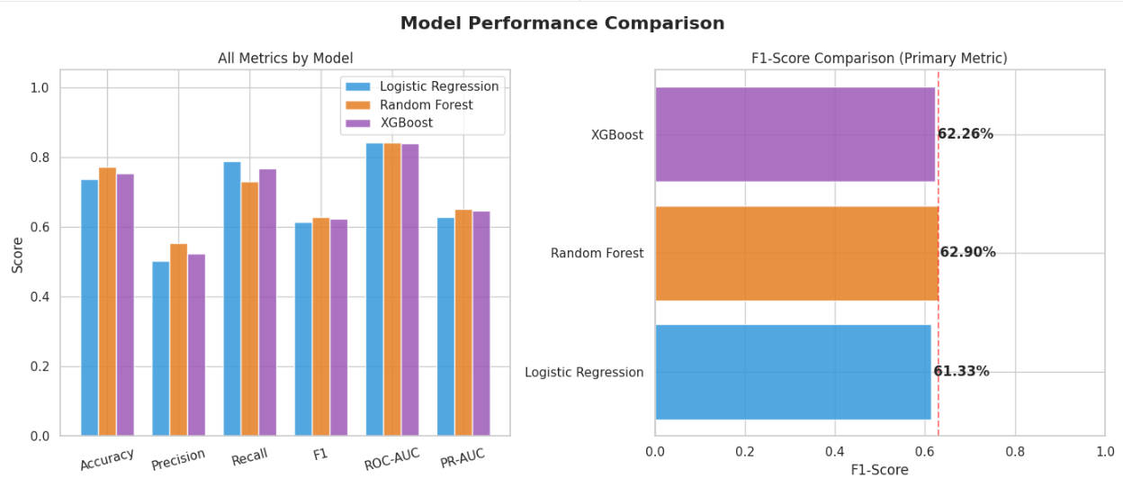
Figure 2. Model performance comparison

9.3 ROC Curve Analysis
ROC curves were plotted for all three models. All models performed substantially better than random guessing (AUC = 0.5). The curves bow toward the top-left corner, indicating strong discrimination between churners and non-churners.
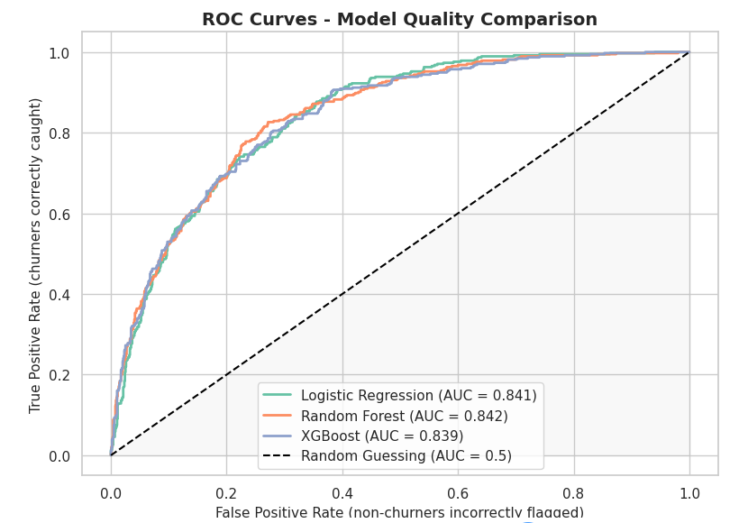
Figure 3. ROC model comparison
Figure 3 shows that all three models show similar predictive performance with ROC-AUC values around 0.84.

9.4 Confusion Matrix Interpretation
The confusion matrix for the selected Random Forest model shows the breakdown of: correctly predicted stayed (true negatives), incorrectly predicted churned (false positives), missed churners (false negatives), and correctly predicted churned (true positives). The business goal is to minimize false negatives — these are churners the model fails to identify.

10. Experiment Tracking
The following experiments were conducted during model development:
Experiment | Model | F1 Score | Notes
Exp-1 | Logistic Regression | ~0.60 | Default params, class_weight=balanced
Exp-2 | Random Forest | ~0.62 | Default params (200 trees, depth 15)
Exp-3 | XGBoost | ~0.61 | Default params, scale_pos_weight
Exp-4 | Tuned LR | 0.6337 | GridSearchCV: C=0.01, solver=lbfgs
Exp-5 | Tuned RF | 0.6374 | GridSearchCV: depth=10, leaf=4, trees=300
Exp-6 | Tuned XGBoost | 0.6326 | GridSearchCV: lr=0.1, depth=3, trees=100

11. Deployment Details

11.1 Model Artefacts
The trained model and preprocessing objects were serialized for production use:
- best_model.pkl — The trained Random Forest classifier (joblib serialized)
- scaler.pkl — The fitted StandardScaler for feature normalization
- feature_names.json — Ordered list of expected input features
- model_card.json — Metadata including model name, training timestamp, F1 score, ROC-AUC, and configuration

11.2 Recommended Production Architecture
For deployment, the model can be served via a Flask or FastAPI REST endpoint that accepts customer feature vectors and returns churn probability scores. Containerization via Docker is recommended for portability. A Streamlit dashboard can provide a visual interface for the retention team to explore risk tiers and customer details.

11.3 Operational Workflow
The notebook defines a 4-step operational playbook: (1) Monthly scoring by the Data/IT team via CRM export, (2) Risk segmentation by the Analytics team into High/Medium/Low tiers, (3) Targeted outreach by the Retention team based on tier, and (4) Dashboard monitoring by BI for ongoing tracking.

12. Business Impact / Use Case

12.1 Revenue at Risk
With an average monthly revenue of $64.76 per customer and 1,869 churners, the estimated annual revenue at risk is approximately $1.45 million. Even conservatively retaining 20% of churners through targeted campaigns yields substantial net savings.
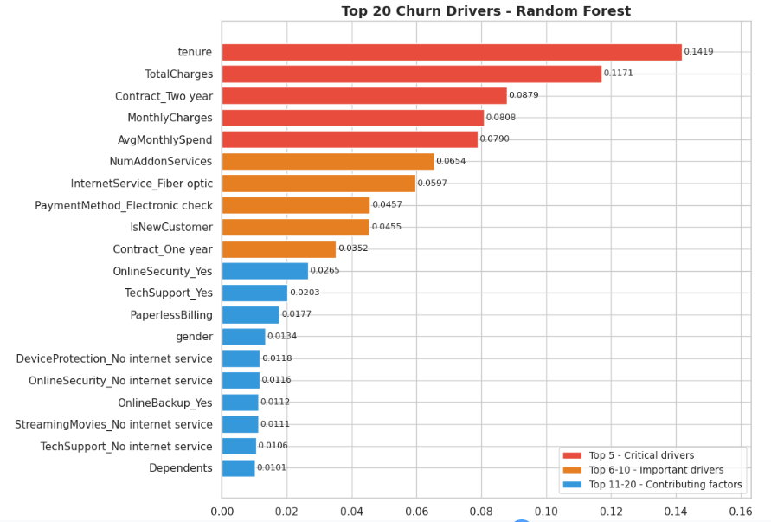
Figure 4. Key churn drivers
As we can see in Figure 4, customer churn is mainly influenced by tenure, total charges, contract type, and monthly spending.

12.2 Retention Strategies
Five concrete retention strategies were derived from the model’s feature importance analysis:
- Contract Upgrade Campaign: Offer 1–2 free months for switching from month-to-month to annual contracts. Expected to reduce churn by 50–60% for targeted customers.
- Early Engagement Program: Dedicated onboarding for customers in their first 90 days. Expected to reduce first-year churn by 20–30%.
- High-Value Customer Protection: Loyalty discounts and priority support for high-spend, high-risk customers.
- Service Bundle Promotion: Free trials of Tech Support and Online Security for customers without these services.
- Payment Method Migration: Incentivize electronic check users to switch to auto-pay methods.

12.3 Risk Scoring Output
The model generates per-customer churn probability scores (0–100%) and segments them into three tiers: High Risk (60–100%, 370 customers), Medium Risk (30–60%, 344 customers), and Low Risk (0–30%, 695 customers). This tiered approach allows the retention team to prioritize outreach efficiently.

13. Challenges & Limitations
- Class Imbalance: The dataset has a 73.5/26.5 split. While class weighting was applied, more advanced techniques like SMOTE or ensemble-level balancing could further improve recall.
- Static Snapshot: The dataset represents a single quarter. A time-series or longitudinal approach would capture behavioral trends over time.
- Feature Limitations: Customer satisfaction scores, call center interaction logs, and network quality metrics were not available but would likely improve predictions.
- Model Ceiling: The best F1-Score of ~0.64 suggests room for improvement. This is common in churn prediction where customer behavior has inherent unpredictability.
- No A/B Testing: The retention strategies are based on model insights but have not been validated through controlled experiments.

14. Future Improvements
- Incorporate additional data sources: customer service call logs, NPS scores, network quality metrics, and competitor pricing data.
- Experiment with deep learning approaches (e.g., neural networks, LSTM for sequential behavior patterns).
- Implement SMOTE or other advanced resampling techniques for class imbalance.
- Build a real-time prediction pipeline with automated monthly scoring and alerting.
- Add model explainability tools (SHAP, LIME) for per-customer prediction explanations.
- Conduct A/B testing of retention strategies to validate ROI estimates.
- Implement model monitoring and drift detection for production deployment.

15. Conclusion
This project successfully built an end-to-end machine learning pipeline for predicting customer churn in a telecommunications company. Starting from a raw dataset of 7,043 customers with 21 features, we performed thorough data cleaning, feature engineering, and encoding to produce a modelling-ready dataset of 34 features.
Three models were trained, cross-validated, and hyperparameter-tuned. The Random Forest classifier emerged as the best model with an F1-Score of 0.6374, providing the optimal balance between correctly identifying churners and minimizing false positives.
The analysis revealed five key churn drivers: month-to-month contracts, short customer tenure, lack of tech support/online security, electronic check payments, and high monthly charges without bundled services. These insights directly inform five actionable retention strategies that the business can implement immediately.
A revenue impact analysis demonstrates that targeted retention campaigns — guided by the model’s per-customer risk scores — can yield significant annual savings. The model artefacts have been exported and are ready for production deployment via API or dashboard integration.

16. References
- IBM Telco Customer Churn Dataset — Kaggle: https://www.kaggle.com/datasets/blastchar/telco-customer-churn
- Scikit-learn Documentation — https://scikit-learn.org/stable/
- XGBoost Documentation — https://xgboost.readthedocs.io/
- Pandas Documentation — https://pandas.pydata.org/docs/
- Reichheld, F. (1996). The Loyalty Effect: The Hidden Force Behind Growth, Profits, and Lasting Value. Harvard Business School Press.

17. Appendix

A. Model Configuration Parameters
Parameter | Value
Random State | 42
Test Size | 20%
LR Max Iterations | 1,000
RF n_estimators (tuned) | 300
RF max_depth (tuned) | 10
RF min_samples_leaf (tuned) | 4
XGB n_estimators (tuned) | 100
XGB learning_rate (tuned) | 0.1
XGB max_depth (tuned) | 3
Risk Low Threshold | 30%
Risk Medium Threshold | 60%

B. Top 10 Feature Importances (Random Forest)
Rank | Feature | Importance Score
1 | tenure | 0.1419
2 | TotalCharges | 0.1171
3 | Contract_Two year | 0.0879
4 | MonthlyCharges | 0.0808
5 | AvgMonthlySpend | ~0.07
6 | PaymentMethod_Electronic check | ~0.065
7 | InternetService_Fiber optic | ~0.06
8 | NumAddonServices | ~0.046
9 | IsNewCustomer | ~0.046
10 | Contract_One year | ~0.035

C. Key Python Libraries Used
pandas, numpy, matplotlib, seaborn, scikit-learn (LogisticRegression, RandomForestClassifier, GridSearchCV, StandardScaler, classification metrics), xgboost (XGBClassifier), joblib.

